Solution Building Block Document


Glencore Copper Global Template

Standardization of
Material Descriptions

Document Meta Data

Stream Name | Project Name
Material Management | Glencore Copper Global

Revision History

Version | Date | Description | Author
0.1 | 21-9-2018 | Draft | Roelof van den Heuvel
0.2 | 26-9-2018 | Draft | Sabrina Perron-Fortin
0.3 | 26/02/2019 | Final Draft | Roelof van den Heuvel
0.4 | 25/04/2019 | Draft | Carol Nevin
0.5 | 20/08/2019 | Draft | Garth Nevin
0.6 | 23/11/2020 | Draft | Garth Nevin
0.7 | 03/09/2021 | Draft | Garth Nevin

Overall Status | Ready for Core Team Review

Contents
- Introduction / Purpose 4
- Assumptions 4
- Basic Rules 4
- Solution requirements 5
Short Format Description (SFD) (40 Characters) 5
Original Equipment Manufacturer (OEM) List 5
LONG DESCRIPTION FORMAT 6
1. Class 6
2. Reference Text 7
3. PART NO 7
4. DRAWING NO 7
5. CHARACTERISTICS 7
6. ADDITIONAL FEATURES 7
7. CLEAN-UP OF ADDITIONAL FEATURES DATA 8
8. SAP MATERIAL GROUP and VALUATION CLASS 8
9. MATERIAL TYPE 11
10. LANGUAGE STANDARD 12
11. SPECIAL CHARACTERS 12
12. TOLERANCES 13
13. SERIES OF NO’S 13
14. RANGES 13
15. COLOR 14
16. DIMENSIONS, SIZES 14
17. UNIT OF MEASURES/NOTES 14
18. THREAD ABBREVIATION and NOTES 18
19. MATERIAL ABBREVIATION 20
20. GENERAL ABBREVIATION 23
21. Examples per material (item) types 25
22. Metric to Imperial Conversion 25
- • Sign-off 28

Introduction / Purpose
The Purpose of this document is so standardise all data (technical) within the value fields, this will ensure that the Master data will be created as a Standard within Glencore. The Standardisation of Noun, Modifier, Characteristics and Values will improve search functions against existing items within the Master data file. In doing so, this will further assist when duplication resolution is to be carried out on items.

This document describes the Metadata that is necessary within Material Management (Master Data to facilitate the process required for the Standardisation of Material descriptions for Glencore Copper Global.)

Cataloging of all Materials items have the following benefits for Master Data.
- Glencore will have a single point of entry for all Material Master Items with a standard format for requesting creations/changes/extension in place. No changes are to be made by anyone except the approved cataloguer.
- Enables quick and easy identification of all parts (which are manufactured by one or more manufacturers). Parts having the same form, fit, function and similar technical performance characteristics will be visible.
- Enables Glencore to establish standardised, and structured database, this will ensure accurate, consistent information which can be used throughout the Company/Group.
- Enables Glencore to identify contractors (OEM, Suppliers and Manufacturers) which can supply materials. The company at the same time can then identify preferred contractors (OEM, Suppliers and Manufacturers) thus enabling Glencore to negotiate to have items placed on contracts or current contracts can be renegotiated for better pricing for procurement purposes.
- All end users will be able to see the item description. End users will be able to do searches.
- Glencore will have visibility of poor description. Thereby addressing and ensuring a Global standard.
- By not duplicating material masters, inventory stock levels can be reduced.
- Furthermore, Free Text procurement of items can be stopped.

Assumptions
- All rules set out in this document shall be used in creation of all new Material descriptions and for the update/changes of old descriptions.
- Exceptions could occur.

Basic Rules
The follow rules are to be applied
- Always ask yourself “WHAT DO I HAVE IN MY HAND” – what is the Noun?
- Respect the format proposed for every value you want to add.
- Respect the value standardization.
- Space Allowed. Any multi-spacing within the value range is replaced with a single space.
- Correct all spelling mistakes.
- No punctuation and accent.
- Only some special characters are allowed. See p.10 of this document.
- No plural in the Noun.
- No abbreviation in the Noun.
- No Size Conversions are to be done EG 1-1/2in to 38.1mm or visa versa.
- All imperial sizes to be fractionalised – not decimals. I.e. 1-1/2 not 1.5 inches. Note the format that fractions are capture. (https://www.metric-conversions.org is a great site to use.)
- Use existing abbreviations/acronyms only. See pg.12-23 of this document.
- No base unit of measure (BUOM) in the short description.
- All data is to be in upper case.
- Additional Features – Must have direct value add to class.
- Please see below Rules for short description regarding OEM and Non-OEM items.
- Reducing sizes must be captured largest to smallest. I.e. 30 x 25mm
- Don’t fabricate / guess, only add what can be substantiated via source documents and / or internet and catalogues.
- Kits and Sets are always capture with the work Kit or Set First, then followed by the Type. E.g. Kit Valve Repair, Set Socket Wrench. These will be defined by the Taxonomy.
- Positions are always captured first and then followed by the side E.g. Left Rear = Rear Left
- REBUILD Items, These items are to be created using the material type “ZCAP”. The word “Rebuild” will be part of the description.
- Difference between Wire, Cable, Cord (electrical):
Wire - has a single Core, Generally Bulk
Cable - has multiple Cores with a common insulation, Generally Bulk
Cord - has a termination on one or both ends.
- Difference between Screw and Bolt:
Screw - cuts its own thread.
Bolt – matches a thread into which it is secured.
- Difference between Lamp, Light, Globe
Lamp – Something that emits light in various colours.
Light – A complete unit that has the lamp as well as the fittings.
Globe – A spherical dome shape that surrounds a lamp or light.
- Difference between Set vs Kit
Set – A collection of the SAME items with different sizes. I.e. O-Rings, Screws, etc.
Kit – A collection of different items supplied together. Kit Valve Repair may have seals, bearing, seat, etc.

Solution requirements
The following codification structure shall be used as a guideline to generate descriptions:

Short Format Description (SFD) (40 Characters)
The MDG will compile the Short Format Description. The rules defined in the Taxonomy tables will determine the Material description (Short) compilation.

- Maximum Length to be 40 characters
- The Classification (Noun) and Sub-classification (Modifiers) are separated by COMMA
- The Sub-classification (Modifiers) and Attribute Values are separated by SEMI-COLON
- The attribute values are separated by COMMA
- If the Sub-classification is “NO MODIFIER”, this will not appear in the final description
- The sequence of the attributes is in the same priority order as defined by the Taxonomy
- If an attribute does not have any value, then the next filled attribute value will be taken. However, if the next attribute value is not be able to fit into the 40-character limit (exceeds 40) then the next filled attribute value will been added in the Short description and henceforth
- No space will be given before or after delimiter
- Modifier will be abbreviated using standard abbreviation list, if the Class is more than 30 characters then Noun also will be abbreviated (Exception)
- Attribute values will be abbreviated using standard abbreviation list.
- The limiting of 40 char is to the nearest attribute value

The MDG will apply the following rules:-

Option 1: NON-OEM ITEMS = Class + Properties.
<NOUN>:<MODIFIER>;<ATTRIBUTE VALUES1>,< ATTRIBUTE VALUES2>,..
E.g. BEARING:ROLR;ID 15 MM,OD 35 MM,WD 11 MM
Option 2: OEM ITEMS = Class + Manufacturer Short Name (see list below) + Manufacturer Part no.
<PRODUCT NAME>,<Ref Value = OEM details, Dwg details>,..< ATTRIBUTE VALUES2>
E.g. WASHER,SPR,CUM,I7564935

Original Equipment Manufacturer (OEM) List

OEM's are those defined in SAP where the Search Term2 = OEM and the vendor code is "3XXXX"
This list of OEM's is dynamic and changes as defined and approved by the Global Taxonomy Steering Committee.
Any recommended changes / additions / deletions to these approved OEM's needs to be submitted to the GBPO Taxonomy in a format request (MDO). These will then be presented at the weekly Taxonomy Steercom for approval.

LONG DESCRIPTION FORMAT
The MDG will compile the Long Description. The rules defined in the Taxonomy tables will determine the PO Text compilation.

ALL Long Description:-
- There will be NO abbreviations used in the long description. (Exception for material names only. I.e. Ethylene Propylene Diene Monomer = EPDM)
- The characteristic name will precede the value. I.e. Inside Diameter 25mm
- The drop down list must be used to choose the desired values. If the value desired is not available – a request will need to be made to have it added.
- The part number and its manufacturer (not abbreviated will follow the description. I.e. Cummins not CUM) The MDG will compile the description automatically and use the relevant information accordingly.
- Any Glencore drawings will be part of the long description.
- Long description is a concatenation of the Classification (Noun), Sub-classification (Modifiers) and of all the attributes
- Long description is generated using the following guidelines
  - The Classification (Noun) and Sub-classification (Modifiers) are separated by COMMA
  - The “NO MODIFIER”, this will not appear in the final description
  - The Sub-classification (Modifiers) and Attribute Name are separated by SEMI COLON
  - The Attribute name and Attribute value are separated by COLON.
  - The Attribute value and corresponding Attribute name are separated by COMMA
  - Class (Noun:Modifier) will be abbreviated using standard abbreviation list, if the Class is more than 30 characters or wherever applicable
  - Attribute values will be abbreviated using standard abbreviation list which is more than 30 characters or wherever applicable
  - If attribute value is missing, then long description with attribute name label will not be added and next available attribute value will be followed
  - No space will be given before or after delimiter

NON-OEM ITEMS
<NOUN>,<MODIFIER>;<ATTRIBUTE NAME1:ATTRIBUTE VALUES1>, <ATTRIBUTE NAME2:ATTRIBUTE VALUES2>,..<ATTRIBUTE NAME N:ATTRIBUTE VALUES N>, <REFERENCE TYPE 1:REFERENCE VALUE 1>,….<REFERENCE TYPE N:REFERENCE VALUE N>
E.g. BEARING,ROLLER;INSIDE DIAMETER:15 MM,OUTSIDE DIAMETER:35 MM,WIDTH:11 MM,CAGE MATERIAL:BRASS,MNFR:SKF, PTNO:6206-2RS
OEM ITEMS
<PRODUCT NAME:PRODUCT VALUE>,<ADDITIONAL FEATURES:ATTRIBUTE VALUE>,<OEM MFR NAME>,<OEM P/N>,<REFERENCE TYPE 1:REFERENCE VALUE 1>,….<REFERENCE TYPE N:REFERENCE VALUE N>
E.g. WASHER, MNFR: CUMMINS, PTNO: I7564935

Class

The class is a combination of the Noun and Modifier within the Taxonomy of the MDG.
To accommodate the 40 character limitation within SAP for the Short description, the Noun will not be abbreviated however the Modifier may be. The modifier abbreviation will be defined within the taxonomy to ensure consistency.

Reference Text
Every material will be assigned 2 classes
- Technical class: refer taxonomy
- Reference Text: with the following characteristics
Characteristic Name | Characteristic Value (example) | Data list
Manufacturer Name | 01)SKF | Multiple Value
Manufacturer Part Number | 01)6206-2RS | Multiple Value
Drawing Number | 01)K-12362-CSD | Multiple Value
Drawing Version | 01)V1.3 | Multiple Value
Item Number | 01)422 | Multiple Value
Vendor Name | 01)ABB | Multiple Value
Vendor Part Number | 01)ABB-1236 | Multiple Value
Equipment Type | 01)CENTRIFUGAL PUMP | Multiple Value
Equipment Manufacturer | 01)KSB | Multiple Value
Equipment Model | 01)KSB-1136H | Multiple Value
Equipment Serial | 01)1123AA213 | Multiple Value
Not Part of the Description

PART NO
- The Newest OEM Part Numbers will be in the Short Description with the OEM abbreviation directly after the Class. The OEM abbreviation used is defined in the OEM list above (Original Equipment Manufacturer (OEM) List). I.e SIE E5S1234567. (This action is defined in the MDG parameters.)
- Non-OEM materials are divided into those associated to approved Manufacturers (Search Term2 = "MNFR" and the vendor code in SAP = "3XXXX" (Excluding OEM's) and Supplier/Vendors (Search Term2 is not either "MNFR" or "OEM" and the vendor code - "1XXXX"
- Non-OEM’s (MNFR) part numbers and the manufacture name will be appended to both the short description and PO Text after the Class. - This action is defined in the MDG parameters.
- Non-OEM’s (Supplier/Vendor) part numbers and the manufacture name will be appended to both the short description and PO Text after the technical descriptions. - This action is defined in the MDG parameters.
- Internal Manufactured parts that are manufactured iaw a Glencore drawing will have the drawing number captured in the Drawing number fields and appended to the Long description.

DRAWING NO
- These are always added to the Long description at the end of the Description.
- Internal Glencore Drawings numbers are the only drawings to be used in the short description.
  - If items don’t have a part number and manufacturer but only an internal drawing number, these may be added in the short description following the Class.
- Remember drawings are for a specific item to be made, regardless of the Material. The material must be captured as part of the description (Value) in both the Short and Long Description before the drawing no.

CHARACTERISTICS
Characteristics is information that defines the item more specifically. Characteristics are part of the taxonomy and are defined within classification accordingly.

ADDITIONAL FEATURES
Refers to something important that we want to add and which is not covered in the Characteristics (template).
Example, we have a motor which needs to be supplied with a Spur gear. This is normally captured in the long descriptions with the Prefix C/W (comes with).
This information that is required in the descriptions but for which there is no characteristics into which the information can be captured, is to be captured in the characteristic “Additional Features”.
There are 3 “Additional Features” characteristics per template. One each for English (EN), Spanish (ES) and French (FR).

CLEAN-UP OF ADDITIONAL FEATURES DATA
This is any information left in the original description after the reference data and characteristic values have been extracted to the Characteristic value fields. This is populated in the ADDITIONAL FEATURES characteristic.
After the value extraction is completed the ADDITIONAL FEATURES is inspected for the following:
- On items where original data is supplied for a Class Name and the characteristic for such data does not exist in the template the data will remain in the ADDITIONAL FEATURES.
- All data still left over in the ADDITIONAL FEATURES, will be cleaned according to the following guidelines:
- Remove any foreign/special characters from the ADDITIONAL FEATURES, like for example two commas next to each other, string of “*”’s, etc.
- Remove any information that has already been populated in the reference data extraction process and from allocating a Class Name. This will only apply to the material item itself and not to any subset, higher assembly, parts, etc.
- Remove the Characteristic values from the ADDITIONAL FEATURES that have been extracted and populated to the Characteristic value fields in the Template.
- Unnecessary spaces, commas, etc will be removed.

SAP MATERIAL GROUP and VALUATION CLASS
Note there is a relationship between the Material group and the Valuation class.
The Valuation class is the first two numbers of the material group followed by “00”.
Note that all material groups 0000 to 5999 are for materials. 6000 and above are reserved for Services.
Below is the comprehensive list of all the material groups and the associated valuation class. (This list is dynamic and may change due to requirements.)

Mat Group | Val Class | Description
1000 | 1000 | Capital Acquisitions (Material)
1500 | 1500 | Building Materials
1510 | 1500 | Metal plates including Steel, Iron, etc
1520 | 1500 | Cement / Fly Ash
1530 | 1500 | Cement mixers
1540 | 1500 | Nuts, Bolts, Pins, Washers and other Fasteners.
1550 | 1500 | Bushings including Brackets, Rubber Dampers and Bushes. Excluding Bearings – see 5620
1600 | 1600 | Electrical Parts including Switches
1610 | 1600 | Generators and Accessories Including Alternators for vehicles
1620 | 1600 | SX-EW Spares
1630 | 1600 | Electrical Motors
1640 | 1600 | Electrical Cables including Ties, Ferrules, Cable connectors, Electric wiring general use etc.
1650 | 1600 | Contactors and Breakers including Fuses and Circuit Breakers
1700 | 1700 | Explosives & Accessories
1800 | 1800 | Cobalt Drier & Accessories
1805 | 1800 | DMS plant spares
1810 | 1800 | Stainless Steel Blanks
1815 | 1800 | Rolled Lead Anodes
1820 | 1800 | Acid plant spares
1825 | 1800 | All gaskets
1830 | 1800 | Tanks and Accessories
1835 | 1800 | Agitators and Accessories.
1840 | 1800 | Thickener Spares
1845 | 1800 | Cyclone spares
1850 | 1800 | Vibratory spares and Accessories
1900 | 1900 | Fuel, Gas
1910 | 1900 | Propane
2000 | 2000 | Ground Support Supplies
2100 | 2100 | Fuel - Power Generation
2200 | 2200 | Pipes - Metallic & Fittings including related items but excluding hydraulic pipes and fittings – see 5910
2210 | 2200 | Pipes - Non-Metallic & Fittings including Hoses, Couplings not marked as hydraulic or metal. – see 5910
2220 | 2200 | Pipes - Victaulic & Fittings
2230 | 2200 | All Seals and associated items
2240 | 2200 | Valves
2500 | 2500 | Abrasives
2600 | 2600 | Drills, Bits & Steel
2610 | 2600 | Vee, Fan and Drive Belts Including brackets directly associated
2620 | 2600 | Welding Supplies
2700 | 2700 | Office Furniture & Supplies
2800 | 2800 | Oils, Greases, Lubricants
2900 | 2900 | Fire Protection
2920 | 2900 | PPE & Safety Supplies
3000 | 3000 | Pump Parts & Accessories
3010 | 3000 | Water Supply System
3020 | 3000 | Compressors and Accessories
3300 | 3300 | Ground Engagement Tools - Tips, Blades, Buckets, Edges etc.
3600 | 3600 | Tyres / Tires
3700 | 3700 | Surface Equipment Parts
3710 | 3700 | Tracks & Accessories - Links, Rollers, Track Pads and Parts
3720 | 3700 | ADT machine spares and accessories
3730 | 3700 | CATERPILLAR accessories and spare parts - For body parts and non-specific parts (not listed separately)
3740 | 3700 | Hitachi accessories and spare parts - For body parts and non-specific parts (not listed separately)
3750 | 3700 | Drill Rig Spares & Accessories - For body parts and non-specific parts (not listed separately)
3760 | 3700 | Volvo accessories and spare parts - For body parts and non-specific parts (not listed separately)
3765 | 3700 | P&H accessories and spare parts
3770 | 3700 | Komatsu accessories and spare parts
4000 | 4000 | Timber, Lumber, Nails
4005 | 4000 | Small Tools & Supplies - mostly consumables or minor tools e.g. Chisels, drill bits etc.
4010 | 4000 | Hand tools - The tool itself, incl specialized manufacturer tools e.g. CAT
4015 | 4000 | Aircon and accessories - For vehicle aircon specific items
4020 | 4000 | Cleaning materials
4025 | 4000 | Fencing
4030 | 4000 | Foodstuffs
4035 | 4000 | Garden Equipment & Accessories
4040 | 4000 | Hospital & First Aid Supplies
4045 | 4000 | Packaging and storage accessories
4050 | 4000 | Stationery
4055 | 4000 | Big Bags & Other packaging
4060 | 4000 | Pest control
4065 | 4000 | Paint
4070 | 4000 | Boiler Spares
4075 | 4000 | Plumbing
4080 | 4000 | Scaffolding
4090 | 4000 | Other misc Supplies
4100 | 4100 | Lighting and Accessories - Lamps and general Light Fittings (Vehicle specific items to individual vehicle types and EMV)
4200 | 4200 | Laboratory Supplies
4300 | 4300 | Ore Refinement Equipment Supplies
4400 | 4400 | Other Refining Equipment Supplies
4500 | 4500 | Computer Software & Hardware
4600 | 4600 | Water Treatment Equipment/Chemicals
4700 | 4700 | Refractory Products
4800 | 4800 | Locomotive, Rail and Track materials
4900 | 4900 | Wire Ropes and Chains including Crane Cables
5000 | 5000 | U/G Equipment Parts
5010 | 5000 | Ventilation & Accessories
5100 | 5100 | Instrumentation - Controls, Solenoid, PLC's ECU's all items related to equipment control, meters mechanical and digital and plant specific equipment i.e. Siemens
5110 | 5100 | Digital Scales and Accessories
5300 | 5300 | Bulk Oxygen
5305 | 5300 | Carbon
5310 | 5300 | Cyanide
5315 | 5300 | Lime
5320 | 5300 | Caustic Soda
5325 | 5300 | Flocculent
5330 | 5300 | Nitric Acid
5335 | 5300 | CalFoam Graphite
5340 | 5300 | Diluent - Shellsol
5345 | 5300 | Extractent - LIX
5350 | 5300 | FeSi (Ferrosilicon)
5355 | 5300 | SMBS (Sodium Metabisulfite)
5360 | 5300 | SO2 / Sulphur Dioxide
5365 | 5300 | Sulphuric Acid
5370 | 5300 | Magnesium Oxide
5375 | 5300 | Sulphur
5380 | 5300 | Other chemicals and reagents
5385 | 5300 | Magnesium Hydroxide
5390 | 5300 | Sodium Hydroxide
5395 | 5300 | Hydrochloric Acid
5400 | 5400 | Muriatic Acid
5405 | 5400 | Hydrogen Peroxide
5500 | 5500 | Grinding media #2 Mill-Slugs and Balls
5610 | 5600 | Transformers
5620 | 5600 | Power transmission and Bearings - General use Gearboxes, pulleys, tire and shaft connectors, drive shafts, sprockets, clutches, universal joints, shafts on drive train, differentials, bearing related items like cups, cones, brackets etc. (All Vehicle specific to individual vehicles types)
5700 | 5700 | Conveyor spare parts and accessories
5750 | 5700 | Assays
5800 | 5800 | Mill Liners & Supplies
5810 | 5800 | Crushing equipment and accessories
5820 | 5800 | Mill spare parts and accessories
5900 | 5900 | Brakes - All brake related items including pads, brake cylinders, valves, cylinders etc.
5905 | 5900 | Filters - including elements and fittings, driers, fuel water separators
5910 | 5900 | Hydraulic Hoses & Accessories - Only hydraulic hoses and accessories, other hydraulic items like pumps fall under the equipment. Excluding Filters and seals.
5915 | 5900 | Light Vehicle Parts - For body parts and non-specific parts (not listed separately), vehicle specific parts
5920 | 5900 | Mechanical Parts - Only use in exceptional cases where mechanical parts can't be allocated to e.g. CAT
5925 | 5900 | Road Maintenance
5930 | 5900 | Camp equipment
5935 | 5900 | Crane Spares and accessories - For body parts and non-specific parts (not listed separately), all mobile cranes Terrex, Tadano, Zoom Lion
5940 | 5900 | Geological and survey equipment
5945 | 5900 | Skid Steer Loader accessories and spares - For body parts and non-specific parts (not listed separately), Bobcats
5955 | 5900 | Other mobile equipment spare parts - For body parts and non-specific parts (not listed separately) for trucks, JCB and CAT etc. forklifts
5960 | 5900 | Security Equipment
5965 | 5900 | Hoist Parts - Hoist blocks, cables, attachments to hoisting gear

MATERIAL TYPE

Material Type | Description
ERSA | Spare Parts – Spare parts are used to replace defective parts. They may be kept in stock with stock levels. A Material Master record of this material type will contain basic data, purchasing data, Plant/Storage data, MRP and accounting data. It can be an integral part for maintenance bills of materials (BOMs) an example of a spare part would be a specific hydraulic oil filter for a truck or loader. This will also encompass parts used in manufacturing that are replace or repairable. Spare parts can be serialised with system generated internal Number rang.  Consumables and other items (e.g. Welding Rods, PPE, Clothing, etc.) will be created as a material ERSA
HIBE | Operating Supplies –  Operating supplies are all reagents used in the process Plant.  Fuels & Gases used in operations.  Mill Ball and Grinding Media used in operations.  For Example Reagents used to create other products i.e. Sulphur used to create Sulphuric Acid.
UNBW | Non-valuated materials – Low value Capital Items – Non valuated materials managed on a quantity basis, but not by value.  Insurance spares will be created with Material type UNBW
ZCAP | Capital Spares – Capital spares will be similar to spare parts in characteristics, however they will be created with separate material type in order to differentiate materials from regular spare parts. Capital spare Material will be valuated and stock items, like spare parts. A material master record of this material type will contain basic data, purchasing data, plant/storage data, MRP and accounting data.  As a business rule, all Refurbishable items will be created as capital spares with Split Valuation. Capital Spares can be serialised with eternal number range.  Since separate material type will be provided for Capital spares, setting “Critical Part” indicator becomes optional.
IBAU | Maintenance Assembly Materials
VERP | Packaging Materials
ZPRJ | Project Materials
ZZMT | MAIT Integration Materials

LANGUAGE STANDARD
Glencore as an international company uses English as the official language for all communications. This has been implemented within all SAP and MDG environments.
There are many words that in English are spelt differently depending on whether USA or UK English is being used. Below are a few examples.

English (USA) | English (UK)
Aluminium | Aluminum
Molded | Moulded
Adaptor | Adapter
Color | Colour
Tire | Tyre
Arbor | Arbour
Labor | Labour
Standardize | Standardise

SPECIAL CHARACTERS
Within the descriptions being compiled via the taxonomy in the MDG, there are specific rules defined to ensure data consistency. Although the MDG will apply these automatically when compiling the various descriptions, these rules need to be applied when entering the values in the MDG.

SPECIAL CHARACTERS | RULES FOR SPECIAL CHARACTERS
. | Full stops will be used to break decimals. No spaces are allowed on either side of a full stop. No full stop are to be at the end of description.
/ | A Forward (front) slash will only be used in Part numbers; Drawing numbers; Reference numbers or Fractions. No spaces are allowed on either side of a Front Slash.  It is also used to separate values within a property (Used instead of the word “or”). I.e. 110 or 220 VAC = 110/220 VAC
- | A hyphen (dash) is allowed in the use of Part Numbers, Drawing numbers; Reference numbers or where grammatically necessary in descriptions.  It is also used to indicate a Negative (minus) value.  It is further used to indicate a range of values. (Used instead of the word “to”). I.e 110 to 220VAC = 110-220VAC  No spacing allowed on either side.
x | An alone standing X is only allowed to denote "times" in sizes and will be in UPPER case. I.e. 20 X 50 X 10mm.  If an X is part of the keyword or brand it MUST be UPPERCASE.
& | Ampersand may be used to replace the word AND to save space
% | Percentage may NOT be used to describe proportion. The abbreviation "PCT" is to be used instead.
+ | A Plus is allowed and us typically used in Tolerance.
+/- | A Plus Minus is allowed and is typically used in Tolerance. Do not use “±”.  Note that ASCII code characters are not to be used.
≥ | The "Greater than or Equal to" symbol is to be captured as ">="  Note that ASCII code characters are not to be used.
≤ | The "Less than or Equal to" symbol is to be captured as "<="  Note that ASCII code characters are not to be used.
° | The Degree sign is to be captured as DEG  Note that ASCII code characters are not to be used.
“ | This is commonly used in industry to denote INCHES. This is not to be used. The INCH abbreviation “IN” is to be used instead.
‘ | This is commonly used in industry to denote FEET/FOOT. This is not to be used. The FEET/FOOT abbreviation “FT” is to be used instead.
* | This symbol is often used to separate different dimensions / values in industry. This symbol is NOT to be used. The “X” is to be used.  Eg. 150*100 is to be captured as 150 X 100.
Ø | This is very often used to denote “Diameter” or “Bore” and is not to be used. Use the prefix “DIA” instead.  Note that ASCII code characters are not to be used.
MM² / MM³ | The miniature “²” or “³” are not to be used. MM2 or MM3 is the correct manner of capturing these values.  Note that ASCII code characters are not to be used.
(3) DIA 10 MM HOLES | When there is more than a single quantity of a given value, the quantity is to be in brackets followed by the value.  I.e. (3) DIA 10 MM HOLES means that there are 3 holes and the holes are 10 MM in diameter.
@ | This is not to be used. The word “AT” is to be used. I.e. “350 PSI AT 120 DEG C”
; | This is not to be used in values being captured. The “;” is ONLY used as the delimiter for the Class Name. Using the “;” in values has an impact on how the descriptions are compiled and therefore may NOT be used.
# | This denotes a number, I.e. #1 or #12 etc. and “NO” is to be used. E.g. “NO 1” etc.
() | Brackets are to be used when separating similar values and not “/” as this makes for difficult legibility: -  Eg.1: SCH80/1/4 IN = SCH80 (1/4 IN)  Eg.2: 3/4 IN/19 MM = 3/4 IN (19 MM)

TOLERANCES
When Capturing Tolerances the following format is to be used.
Plus: the “+” shall be used, e.g. +0.001
Minus: the “-” shall be used, e.g. -0.0001
Plus/minus: “+/-“ shall be used, e.g. +/-0.0001

SERIES OF NO’S
Apply the following rules for where values are capture in series. This is normally used for Bits, Sockets, Kits, etc.
Single | 1,3,9,15,18
Range | 1-3  -10 TO 15
Single and Range combination | 1,3,7-9,15,18,20-25

RANGES
Please apply the following rules when capturing ranges in value fields.
Note that when a range is from a negative to a positive then the word ”to” is used.
Negative to Positive | -150 TO 120
Positive to Positive | 120-150
Minimum to Maximum | 120-150

COLOR
When capturing colour(s) of items it is normally done alphabetically. E.g. Blue, Green Dark, Green Light, Yellow.
Colors are always captured with the Color name first followed by the shade. E.g. Green Dark

NOTE: This rule is NOT APPLIED to items where the color code defines ratings. E.g. Resistors, Pipes, Gaskets etc. These colors sequences must not be changed and must be captured as per the Manufacturer specifications.

DIMENSIONS, SIZES
Prefixes are added to Descriptions. E.g. ID 25 X OD 35 MM X LG 6 M

Standard Abbreviations
ABBREVIATION - EN | ABBREVIATION - ES | ABBREVIATION - FR | DESCRIPTION
DIA | DIA | DIA | DIAMETER
DP | PROF | PROF | DEPTH
HT | LAT | HT | HEIGHT
ID | DIA INT | DIA | INSIDE DIAMETER
OD | DIE EXT | DE | OUTSIDE DIAMETER
LG | LRG | LG | LENGTH
THK | ESP | EP | THICKNESS
SQ | CUAD | CAR | SQUARE
WD | LRG | LRG | WIDTH

Format examples: Note the sequence in which these dimensions have been captured.
DIMENSION / SIZE FORMAT | EXAMPLE
DIA X HT X DP | DIA 25 X HT 15 X DP 50 MM
DIA X LG | DIA 1/2 X LG 10 IN
DIA X LG X THK | DIA 50 X LG 200 X THK10 MM
DIA X THK | DIA 10 X THK 1/2 IN
ID X OD | ID 3 X OD 4-3/4 IN
ID X OD X LG | ID 12-1/2 X OD 15 X LG 24 IN
ID X OD X LG X THK | ID 10 X OD 20 X LG 150 X THK 1.5 MM
ID X OD X THK | ID 3/4 X OD 1-1/8 X THK 1/4 IN
SQ X DP | SQ 50 X DP 200 MM
SQ X DP X THK | SQ 50 X DP 25 X THK 2 MM
SQ X LG | SQ 12 X LG 20 IN
SQ X HT | SQ 3/4 X HT 4-5/16 IN
SQ X THK | SQ 65 X THK 45 MM
WD X LG | WD 1-1/2 X LG 2-3/4 M
WD X LG X DP | WD 250 X LG 800 X DP 50 MM
WD X LG X HT | WD 3-1/2 X LG 12 X HT 2 IN
WD X LG X THK | WD 35 X LG 1200 X THK 4 MM

UNIT OF MEASURES/NOTES
(These are NOT BUOM, but rather value UOM's)
- Container Type
ABBREVIATION | DESCRIPTION
BG |  | Bag
BT |  | Bottle
BX |  | Box
CS |  | Case
CT |  | Carton
DR |  | Drum
DZ |  | Dozen
EA |  | Each
GR |  | Gross
JR |  | Jar
PD |  | Pad
PK |  | Pack
PL |  | Pallet
PR |  | Pair
TB |  | Tube

Digital
ABBREVIATION | DESCRIPTION
GB | Gigabyte
KB | Kilobyte
MB | Megabyte
TB | Terabyte

- Electrical Units/Ratings
When capturing electrical values the general order is as follows. (This is used when there is no Value field to be able to capture values per characteristic).

If you have 2 different values for the same type of Voltage/Amp etc. always capture the Lowest First
Eg.: 120/240VAC

Volts, Amps, Phase, Watts, VA Rating, followed by the rest (Horsepower, Ohm, etc.), Hertz is always last.
I.e: 120/240VAC, 5A, 2PH, 50W, 3KV, 3HP, 5 OHM, 50/60HZ

There are, however items where the Electrical rating, should be split into separate Properties, as below:
- CURRENT = Ampere (A)
- POTENTIAL = Voltage (V)
- POWER = Wattage (W)

ABBREVIATION | DESCRIPTION
A | Ampere
AH | Ampere hour
AS | Ampere second
AC/DC | Alternating current/direct current
C | Coulomb
F | Farad
H | Henry
KA | Kilo Ampere
KV | Kilovolt
KVA | Kilo volt ampere
KW | Kilowatt
KWH | Kilowatt-hour
OHM | Ohm
VA | Volt-ampere
W | Watt
KW | Kilo Watt

- Voltage units
ABBREVIATION | DESCRIPTION
V | Volt
VAC | Volt Alternative Current
VDC | Volt Direct Current

- Frequency
ABBREVIATION | DESCRIPTION
GHZ | Gigahertz
HZ | Hertz
KHZ | Kilohertz
MHZ | Megahertz

- Length
ABBREVIATION | DESCRIPTION
CM | Centimetre (Only to be used for Clothing related dimensions)
FT | Feet
IN | Inch
KM | Kilometre
LG | Length
M | Meter
MI | Mile
MM | Millimetre
RL | Roll
YD | Yard
UM | Micron
Note:
Less than 1000 MM = MM
Greater than 1000 MM = M
Greater than 1000 M = KM

- Nominal Pipe Sizes
ABBREVIATION | DESCRIPTION
SCH | Schedule
NPS | Nominal Pipe Size

- Power Unit
ABBREVIATION | DESCRIPTION
HP | Horsepower
W | Watt

- Pressure Ratings
DO NOT Convert PSIG, PSID or PSIA Ratings.
DO NOT Convert PSI to LB for Pressure Gauges, Switches and Transmitters.
DO NOT Convert PSI to PSIG

ABBREVIATION | DESCRIPTION
BAR | Bar
HPA | Hecto Pascal
KPA | Kilo Pascal
MPA | Mega Pascal
MBAR | Millibar
PA | Pascal
PSI | Pounds per Square Inch
PSID | Pounds per Square Inch Differential
PSIG | Pounds per Square Gauge

- Shape
ABBREVIATION | DESCRIPTION
RND | Round
SQ | Square
TRIA | Triangle
RECT | Rectangle
HEX | Hexagon/Hexagonal
OCT | Octagon
HEP | Heptagon

- Speed
ABBREVIATION | DESCRIPTION
CPM | Counts per minute
CW | Continuous wave
FT/MIN | Foot per minute
FT/SEC | Foot per second
KM/H | Kilometre per hour
MPH | Mile per hour
M/S | Meter per second
RPM | Revolutions per minute
RPS | Revolutions per second

- Time
ABBREVIATION | DESCRIPTION
D | Day
HR | Hour
MIN | Minutes
MS | Millisecond
S | Second
YR | Year
MNTH | Month

- Temperature Unit
ABBREVIATION | DESCRIPTION
DEG C | Degree Celsius
DEG F | Degree Fahrenheit
K | Kelvin

- Volume
ABBREVIATION | DESCRIPTION
CL | Centilitre
DL | Decilitre
DM3 | Cubic decimetre
DR | Drum
FL OZ | Fluid ounce
FT3 | Cubic foot
GAL | Gallon
L | Litre
M3 | Cubic meter
ML | Millilitre
MM3 | Cubic millimetre

- Weight
ABBREVIATION | DESCRIPTION
CG | Centigram
DG | Decigram
G | Gram
HG | Hectogram
KG | Kilogram
LBS | Pound
OZ | Ounce
T | Metric ton (UK)
TON | Short ton (US)
TES | Tesla
MG | Milligram
ST | Stone

THREAD ABBREVIATION and NOTES
Note: If there is a sequence to capture for the thread information Capture it in a string format.
Capture as Thread Direction, Series, Class, Thread Size, Thread type.

Imperial Example
A typical example and breakdown of how thread data may be found is: 1/4-20UNC-2A,
- LH = if Left Hand (No symbol required for right hand thread).
- UNC = Thread series (Unified Coarse thread).
- 2A = Thread class symbol (A = External Tread and B = Internal Thread)
- 20 = Number of Threads Per Inch (TPI).
- 1/4 = Nominal Size.
Short Description. ex. LH,UNC,2A,20,1/4 IN
Long Description ex. LH,UNC,Cl 2A,20 TPI,1/4 IN

Metric Example
A typical example and breakdown of how thread data may be found is: M10, 1.25mm BSF, 2g
- LH = if Left Hand (No symbol required for right hand thread).
- BSF = Thread Type (British Standard Fine)
- 1.25mm = Thread Pitch
- 2g = Thread Class (Capital Letter = Internal, Small Letter = External Thread)
- M10 = Nominal size
Short Description. ex. LH,BSF,2G,1.25 MM,M10
Long Description ex. LH,BSF,CL 2G,PITCH 1.25 MM,M10
Thread Class Imperial:
A = External
B = Internal

Thread Class metric:
G/H = Internal
E/F = External

Thread Direction:
RH = Right Hand (this is normally not captured as this is normally the default direction)
LH = Left Hand

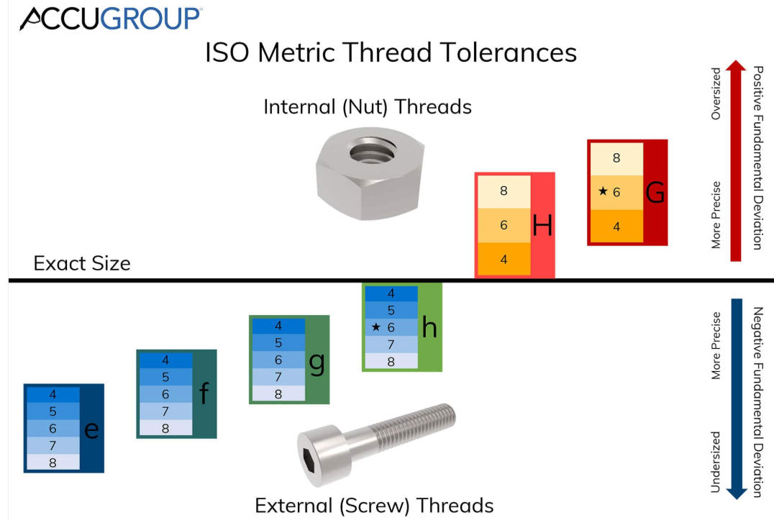

THREAD SERIES LIST
ABBRREVISION | DESCRIPTIONS
BSF | British Standard Fine
BSP | British Standard Pipe
BSPF | British Standard Pipe Fitting
BSPP | British Standard Pipe Parallel
BSPT | British Standard Pipe Taper
BSW | British Standard Whitworth
FBSP | Female British Standard Pipe
FNPT | Female National Pipe Taper
FPT | Female Pipe Taper
MPT | Male Pipe Taper
NPS | National Pipe Straight
NPT | National Pipe Taper
NST | National Standard Thread
UNC | Unified National Coarse
UNEF | Unified National Extra Fine
UNF | Unified National Fine
UNR | Unified National Round (Round Root)
UNS | Unified National Special

MATERIAL ABBREVIATION

ABBREVIATION | DESCRIPTION
AG |  | Silver
AL |  | Aluminum
AL ALOY |  | Aluminium Alloy
APL |  | Aluminium Polyethylene Laminate
AS |  | Alloy steel
SAN |  | Styrene-Acrylonitrile (plastic)
ASB |  | Asbestos
AU |  | Gold
BMS |  | Bright mild steel
BRS |  | Brass
BRS CR PLTD |  | Brass Chrome Plated
BRS FRGD |  | Brass Forged
BRS NI PLTD |  | Brass Nickel Plated
BRS PLTD |  | Brass Plated
BRS SN PLTD |  | Brass Tin Plated
BRZ |  | Bronze
C |  | Carbon
CA |  | Cellulose Acetate
CANV |  | Canvas
CD |  | Cadmium
CHN STL |  | Chain Steel
CI |  | Cast iron
CI HRD NI |  | Cast Iron Hard Nickel
CEMNT |  | Cement
COMPD |  | Compound
CNCRT |  | Concrete
CPE |  | Chlorinated Polyethylene
CPVC |  | Chlorinated Polyvinyl chloride
CR |  | Chrome/chromium
CRMO |  | Moly chrome/chrome moly
CR STL |  | Chrome steel
CS |  | Carbon steel
CS CAD |  | Carbon Steel Cadmium
CS CAD PLTD |  | Carbon Steel Cadmium Plated
CS CTD |  | Carbon Steel Coated
CS CU PLTD |  | Carbon Steel Copper Plated
CS GALV |  | Carbon Steel Galvanized
CS PLTD |  | Carbon Steel Plated
CS RUBR LND |  | Carbon Steel Rubber Lined
CS GALV |  | Carbon Steel, Galvanized
CS PP LND |  | Carbon Steel Polypropylene Lined
CS ZN CTD |  | Carbon Steel Zinc Coated
CS ZN PLTD |  | Carbon Steel Zinc Plated
SS CST |  | Cast Stainless steel
CU |  | Copper
CU ALOY |  | Copper Alloy
CU ALOY CST |  | Copper Alloy Cast
CU NI ALOY |  | Copper Nickel Alloy
CU NI PLTD |  | Copper Nickel Plated
CU SN PLTD |  | Copper Tin Plated
CVS |  | Chrome Vanadium Steel
DI |  | Ductile iron
EPTFE |  | Expanded Polytetrafluoroethylene
EP |  | Ethylene Propylene
EPDM |  | Ethylene Propylene Diene Monomer
EPM |  | Ethylene Propylene Monomer
EPR |  | Ethylene Propylene Rubber
ETFE |  | Ethylene-tetrafluoroethylene
EVA |  | Ethylene Vinyl Acetate
FBR |  | Fibre
FBRGLS |  | Fiberglass
FE |  | Iron
FE GALV |  | Iron Galvanized
FE NI PLTD |  | Iron Nickel Plated
FE OXID |  | Iron Oxide
FEP |  | Fluorinated Ethylene Propylene
FLPE |  | Fluorinated Polyethylene
GALV |  | Galvanized
GALV CTD |  | Galvanized Coated
GE |  | Germanium
GI |  | Galvanised iron
GLS SFTY |  | Glass Safety
GMS |  | Galvanised Mild Steel
GRP |  | Glass Reinforced Plastic
GS |  | Galvanised steel
HCS |  | High Carbon Steel
HDPE |  | High Density Polyethylene
HDPP |  | High Density Polypropylene
HDPU |  | High Density Polyurethane
HG |  | Mercury
HNBR |  | Hydrogenated Acrolyontrile Butadiene Rubber
HRS |  | Hot Rolled Steel
HS |  | Hassium
HSS |  | High Speed Steel
HTS |  | High Tensile Steel
LCP |  | Liquid Crystal Polymer
LDPE |  | Low Density Polyethylene
LTHR |  | Leather
LTS |  | Low Tensile Steel
MDPE |  | Medium Density Polyethylene
MG |  | Magnesium
MGO |  | Magnesium Oxide
MI |  | Malleable Iron
MN |  | Manganese
MO |  | Molybdenum
MPTFE |  | Multifull Polytetrafluoroethylene
MS |  | Mild Steel
MS EPXY CTD |  | Mild Steel Epoxy Coated
MS GALV |  | Mild Steel Galvanized
NBR |  | Nitrile Butadiene Rubber
NI |  | Nickle
NI HRD |  | Nickel Hard
NI PLTD |  | Nickel Plated
NI PLTD CU |  | Nickel Plated Copper
NI STL |  | Nickel Steel
NPR |  | Neoprene
NYL |  | Nylon
P |  | Phosphorus
PA |  | Polyamide
PAN |  | Polyacrylonitrile
PB |  | Lead
PC |  | Polycarbonate
PE |  | Polyethylene
PET |  | Polyethylene Terephthalate
PEVA |  | Polyethylene Vinyl Acetate
PI |  | Polyimide
PLSTC |  | Plastic
PLSTC FBR |  | Plastic Fibre
PLSTC HRD |  | Plastic Hard
PLTD BRS |  | Plated Brass
PLSTC FE |  | Plated Iron
PLSTC STL |  | Plated Steel
PLYMR |  | Polymers
PLYF |  | Polyolefin
PP |  | Polypropylene
PPO |  | Polypropylene Oxide
PPS |  | Polypropylene Sulphide
PT |  | Platinum
PTFE |  | Polytetrafluoroethylene
PU |  | Polyurethane
PVA |  | Polyvinyl Acetate
PVAL |  | Polyvinyl Alcohol
PVB |  | Polyvinyl Butral
PVC |  | Polyvinyl Chloride
PVCA |  | Polyvinyl chloride acetate
PVDC |  | Polyvinyl Dene chloride
PVDF |  | Polyvinyl Dene Fluoride/Difluoride
PVF |  | Polyvinyl Fluoride
PVFM |  | Polyvinyl Formal
PVS |  | Polyvinyl Siloxane
RH |  | Rhodium
RPTFE |  | Reinforce Polytetrafluoroethylene
SBR |  | Styrene Butadiene Rubber
SGI |  | Spheroidal Graphite Iron
SHT MTL |  | Sheet Metal
SHT STL |  | Sheet Steel
SI |  | Silicone/Silicon
SIC |  | Silicon Carbide
SN |  | Tin
SS |  | Stainless Steel
STL |  | Steel
TI |  | Titanium
TPE |  | Tetrafluroethylene
TPE |  | Thermoplastic Elastomer
UPES |  | Unsaturated Polyester
UPVC |  | Un-practiced polyvinyl chloride
V |  | Vanadium
WC |  | Tungsten Carbide
WI |  | Wrought Iron
WL |  | Wool
WS |  | Wrought Steel
ZN |  | Zinc
ZR |  | Zirconium

GENERAL ABBREVIATION

ABBREVIATION | DESCRIPTION
AWS | American Welding Association
AWG | American Wire Gauge
BC | Bayonet Cap (lamp)
BTU | British thermal unit
CD | Cadela (luminous Intensity)
CAL | Calorie
CARAT | Carat
CA | Centiare
Cl | Class
CES | Candelabra Edison Screw (lamp)
C/W | Come With
C | Core (cable)
CSK | Countersunk
DB | Decibel
DEG | Degree / °
DN | Dimension Nominal
DP | Double Pole
DPDT | Double Pole , Double Throw
DPST | Double Pole , Single Throw
DWG | Drawing
DUPL | Duplicate
ELECMAG | Electromagnetic
ES | Edison Screw (lamp)
F | Farad
FF | Flat Face
FL OZ | Fluid ounce
FT LBS | Foot Pound
FR | Front
HD | Head
HRS | Hours
HYDR | Hydraulic
G | Gauss
GR | Grade (material)
GES | Giant Edison Screw (lamp)
HEX | Hexagon/Hexagonal
HPS | High Pressure Sodium
IMP | Impulse
J | Joule
KJ | Kilojoule
LH | Left Hand
LBS | Pound
LM | Lumen
LES | Lilliput Edison Screw (lamp)
LDR | Light Dependent (Resistor)
LUX | Lux
M | Male
MNFR | Manufacturer
MAX | Maximum
MFD | Microfarad
MBC | Miniature Bayonet Cap
MES | Miniature Edison Screw (lamp)
MW HR | Megawatt hour
UM | Micron / μm
MIN | Minimum
MISC | Miscellaneous
N | Newton (force)
NB | Nominal Bore
N/M2 | Newton per meter squared
N/S | Newtons per second (rate of force development)
NC | Normally Closed
NO | Normally Open
OEM | Original Equipment Manufacturer
PPM | Part per million
PCT | Percent
PERM | Permanent
PCS | Piece
PLTD | Plated
P | Pole
PH | Phase
PM | Post Meridiem
PDR | Potential Duplicate Report
PSIA | Pounds per square inch absolute
PRES | Pressure
RAD | Radian
REAR | Rear
RF | Raised Face
RH | Right Hand
SBC | Small Bayonet Cap (lamp)
SCKT | Socket
SES | Small Edison Screw (lamp)
SFTWR | Software
SSR | Solid State (Relay)
SUPL | Supplier
TEMP | Temperature
THD | Thread/Threaded
VSD | Variable Speed Drive
WH | Watt-hour
YEL | Yellow

Examples per material (item) types
This section is to supply information for a particular material master type. Please note that not all material types are in examples below.

Material is to be captured as Material and Material Grade E.g. Stainless Steel 316L, further the Material Specification must be captured where available E.g ASTM A193 B8 CL1

Metric to Imperial Conversion
All imperial sizes are to be fractionalized.
E.g. 1.5 IN = 1-1/2 IN
Here is a good website to use to do conversions –
https://www.metric-conversions.org/length/inches-to-millimeters.htm
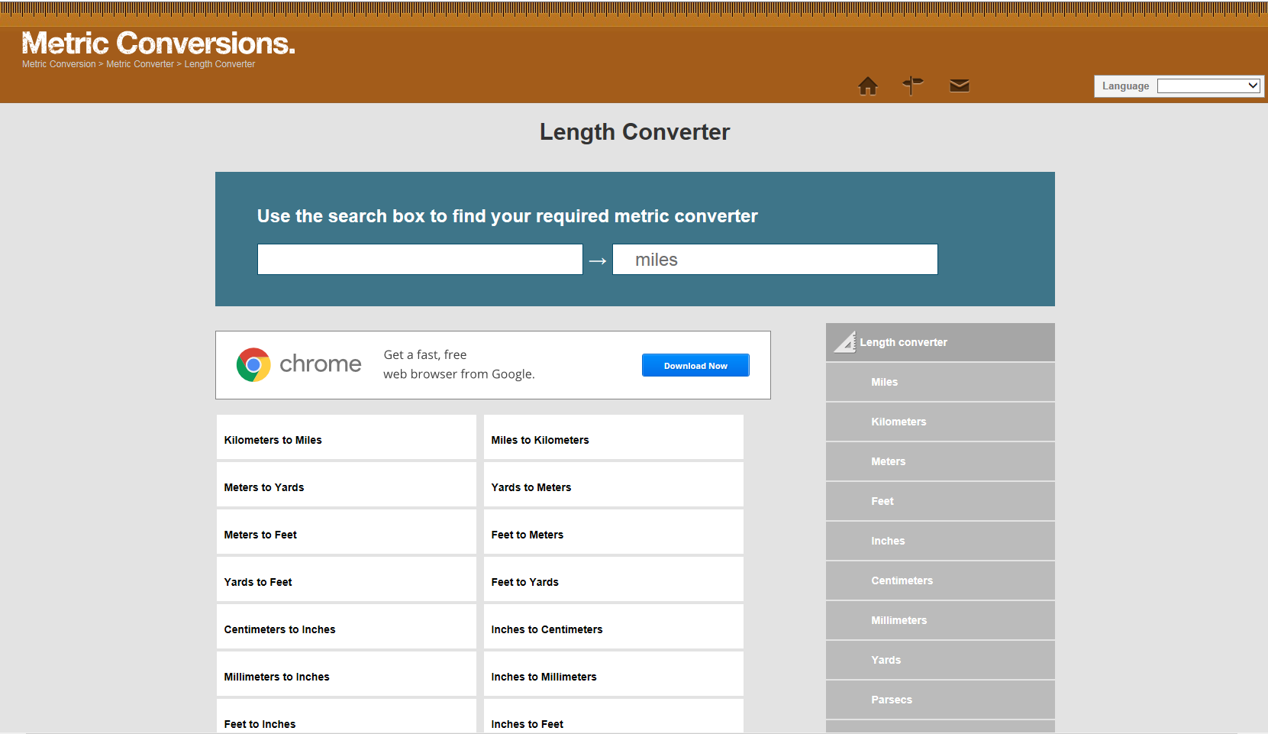
Select “Inches to “Millimetre’s”

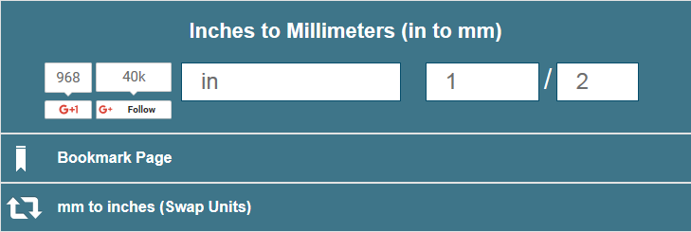
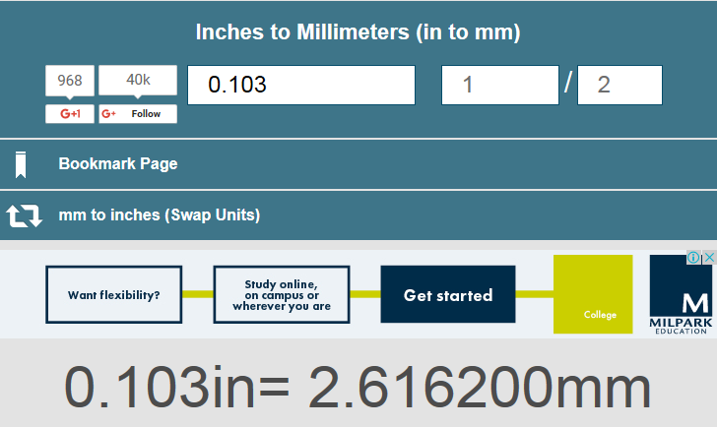
Imperial size converted to metric in millimetres.
Enter imperial decimal size.
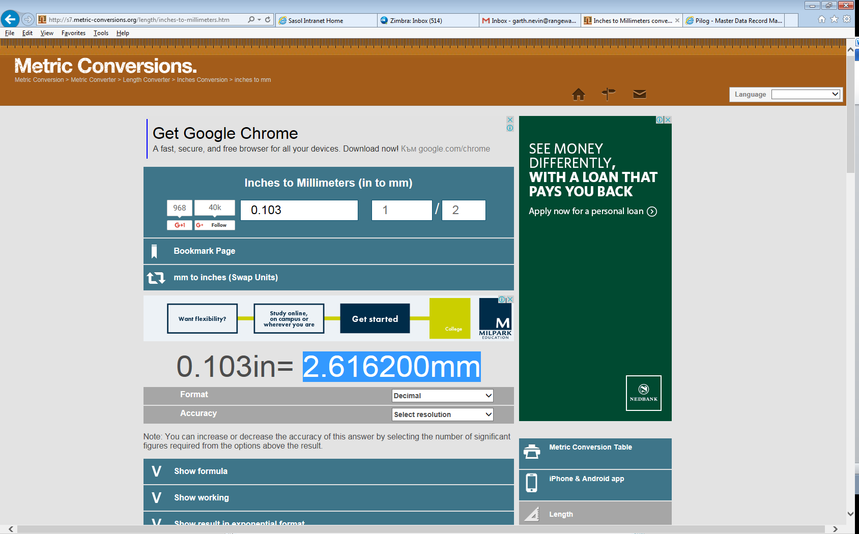
Highlight and copy.
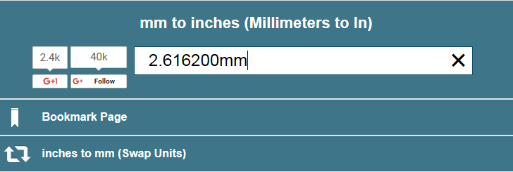
Paste copied millimetre’s value
Click on “Swap Units”
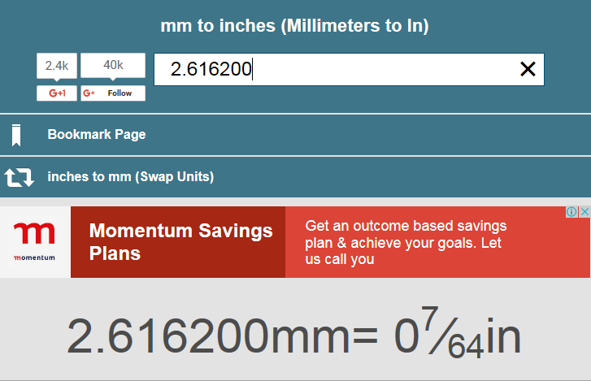
Remove “mm” at the end of number
Imperial fraction is given and to be used.

Sign-off
I/We certify that this document completely and accurately reflects Glencore Copper Global requirements for this Business Design Document. I/We understand that anything not explicitly mentioned in this document is considered out of scope for the project.
Project Role | Signature | Date

