Material Master Data Standard

Version control
Version | Date | Authors | Description | Approver | Date
1.0 | 22.9.2020 | MMDH Project | Material Master Data Standard approved | MMDH Steering Group | 22.9.2020
TABLE OF CONTENTS
1. Purpose of the document 3
2. Principles for Material Master Data Management 4
2.1 Principles for Material Creation 4
2.2 Material Changes 5
2.3 Material Replacements 5
2.3.1 Technical Replacement of Material 5
2.3.2 Political Replacement of Material 6
2.3.3 Discontinued Products 6
2.3.4 Duplicate Materials 7
3. General Instructions and Rules for Material Master Data 7
3.1 Data Format and Common Guidelines 7
3.1.1 General Instructions 7
3.1.2 Usage of Special Characters 8
3.1.3 Notation of numbers 9
3.1.4 Writing Units of Measures 9
3.1.5 Writing sizes and dimensions 11
3.1.6 Usage of Manufacturing and Material Standards 12
3.1.7 Basic Materials 13
3.1.8 Colors 13
3.2 Field Specific Instructions 14
3.2.1 SAP Material Master Fields 14
3.2.2 Units of Measure 15
3.2.3 Material Grouping 16
3.3 Material group-specific instructions 16
3.3.1 Material Descriptions - General Principles 17
3.3.2 Material Descriptions - Spare Parts 17
3.3.3 Material Descriptions - Raw Materials 21
3.3.4 Material Descriptions - Packaging Materials 21
4. Appendices 22

Purpose of the document
Client has started ERP+ program where target is to implement one common ERP, SAP S/4 Hana, across all business areas during upcoming years. The system architecture change towards consolidated ERP environment has impacts to the material master data management in the future when all Client’s business areas share common material master data. Client needs to have unified processes and definitions for global material master data when moving into SAP S/4 Hana. In order to ensure smooth transition to new system, some changes to current processes and preparatory data standardization activities are required already before implementation phase:
- Common data definitions and guidelines, I.e. Material Master Data Standard, will be documented during 2020. And these new material master data standard definitions are planned to be taken into use in new material creation already during transition period (when applicable).
- Material data from current SAP and Maximo systems will be harmonized before each ERP roll-out. Therefore, Client is planning to start data standardization project (in the year 2021) where materials across all business areas will be standardized in current systems to follow common material data definitions and instructions.

In this document is described common principles and policies for the global Material Master Data Management at Client Group. This Material Master Data Standard document defines main principles for the material creation (and other data maintenance processes), general description forming rules and guidelines for data format in all other descriptive fields. This document contains two appendices which describes rules and instructions for global material data in more detailed manner:

Appendix 1: Field-specific instructions
describes material master data definitions of to-be data model available for all parties over different material areas. It is relevant not only for material data maintenance and harmonization project, but also for future’s development projects and integration purposes, including information of technical field names and company-wide material data definitions across systems.

Appendix 2: Material group-specific instructions
describes data quality requirements for materials of different material groups. Instructions will support data maintenance team when creating a new material by giving helpful information about technical attributes to be maintained and guidance for selection of correct material group.

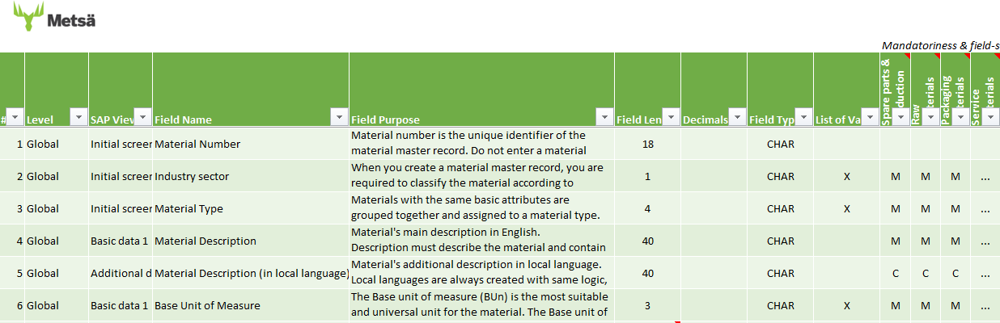

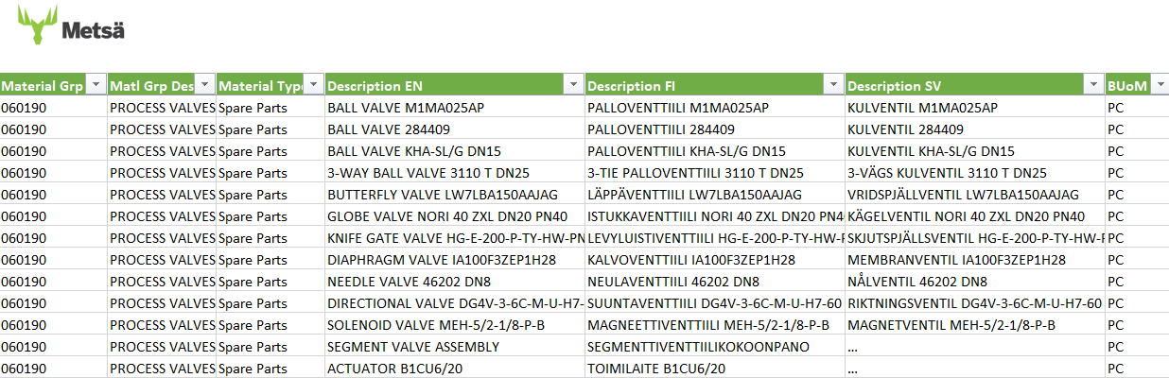

This Material Master Data standard document and its appendices together define detailed instructions and data content requirements for data harmonization project. This documentation is supporting also material data maintenance when creating new materials or changing/updating existing ones into SAP (or Maximo during transition period). Therefore, these instructions are important to keep continuously up to date if business or data content requirements are changing. And also, field-specific instructions should be extended to also cover field definitions for organizational (plant and storage location level) data during design phase of ERP+ project.

Purpose of this document is to help/support especially users who are:
- Creating and maintaining material master data in SAP
- Searching existing materials and related information from SAP
- Using SAP materials for example in purchase or warehouse management transactions
- Creating material creation or change requests (for material master data service team)
- Responsible for developing S\\AP Material Data Management (incl. instructions)
- Developing/designing SAP Material Master structure and configuration in ERP+ project
This created documentation contains instructions for following material areas and should be extended to cover definitions also for service materials in upcoming project phases. I.e. this instruction is applicable for procurement materials but not for finished and semifinished products.
Material Area | FISG Main Group
Raw Materials | 01 - Fuels Energy
 | 02 - Raw Materials
 | 03 - Pigments and Chemicals
Packaging Materials | 04 - Packaging Materials
Production Consumables,  Spare Parts &  Other Materials | 05 - Production Consumables
 | 06 - Maintenance Repair and Operation (MRO)
 | 14 - Non-Production-Related Materials

Principles for Material Master Data Management
In this chapter is described main principles for different material data maintenance processes. Please note that in the chapters below are described currently only the general principles. Detailed process and work instructions can be documented when definitions of ERP+ design and common Client processes are ready (e.g. material replacement processes cannot be documented and instructed until detailed definitions for material lifecycle statuses are available).

Principles for Material Creation
The Material in SAP has several relations to the different Business functions and the need to create a Material record into SAP is arising from business and process requirements. In general, Material records are needed for following purposes to support below processes:
- Materials are needed to support inventory management processes: e.g. planning, goods movement postings and physical inventory
- Material is needed for purchasing e.g. when they are purchased frequently, have high value or when required in automatized procurement processes
- Plant Maintenance needs to have material in Bill of Material (material or equipment BOM).

Material record is needed if some of the above-mentioned reasons is present. E.g. Distributor materials (that are managed in the supplier's shelving service stock) are not needed to be purchased nor warehoused but are needed to be maintained in Bills of Materials. Therefore, material is required to support Plant maintenance processes.

For certain material groups, materials are not be created. These material groups are typically managed via supplier's shelving service stock as distributor materials or purchased without materials. Sourcing strategy for each material groups is to be documented in part of Material Group-specific instructions (See worksheet: FISG Material Groups). Below is presented few examples of material groups that are managed mainly without Material Master record:
- Fuels and Energy: Material Groups 010101-010312
- Tool and Accessories: Material Groups 062201-062207
- Fastening Materials: Material Group 062090
- Protective Clothing & Protection and Safety Supplies: Material Groups 140101-140102
- Office Supplies and Utility Goods: Material Group 140405

If a new material needs to be created in any material groups belonging to material groups presented above (and in more detail in the Material Group-specific instructions), this needs to be confirmed with responsible category manager.
Notes
It has been recognized that certain materials may be treated differently, depending if they are considered Packaging materials or Spare parts.
For example, Tapes are to be created as materials, when considered Packaging materials. But as Spare parts, they may not be needed, if handled via Shelving services.
Similarly, Glues as Raw materials are to be created with material record. But as Spare parts, not, if handled via Shelving services.

General principles for Material Creation
- Materials must be always created according to general guidelines defined on this Material Master Data Standard document and its appendices.
- Materials must contain all required information so that material can be identified unambiguously. It is not allowed to create new materials to the system with incomplete information, even if the data would be completed later.
- Manufacturer-specific materials (see chapter 3.3.2) must be identified with type designation and/or product ID’s of manufacturer. It is not allowed to use supplier’s codes or other reference codes (such as national federation codes) as a primary identifier.
- Duplicate materials are not allowed (see chapter 2.3.4). When creating a new material, it must be always ensured that same material is not already existing in the system. To avoid duplicates it is important to search for the material in different ways from the system before creating a new material.

Material Changes
General principles for Material Changes
- Existing material data in the system should not be changed so that the material is changed to another physical item.
- Material’s global data is allowed to be changed only when material descriptions or other descriptive fields contain misspellings or due to errors or incomplete material information.

Material Replacements
General of Material Replacements
A material can be replaced by another material when the existing material is no longer available or the plant has decided to use another material instead. Materials can be replaced and blocked globally or just on plant level. There can be identified different material replacement cases:

Technical Replacement of Material
The material is no longer available but there is a replacing material
- Manufacturer’s type designation or product ID has changed, otherwise same product.
- Product is no longer available but there is a replacing (new series) product which has exactly the same technical/physical characteristics than the previous model and can be therefore used in all the same equipment or devices.

Principles for technical replacement
- It is not allowed to update information about the replacing product (new type designation or product ID) for original material. Always create a new material for the replacing product.
- The replaced material is blocked from use in global level (see notes) and information about the replacing material is indicated in the Material description (e.g. USE Matl. No.).
- The replaced material is flagged for deletion, but materials cannot be removed (archived) from the system as replacement information must be retained for reference purposes.
Notes
Material cannot be completely blocked from use if material is in active use in some plant (e.g. some plant is still having material in stock or material has open purchase orders). Then should be used cross-plant material status that is only preventing purchasing of material and material usage in bill of materials.
When material is not in active use anymore in any plant, it can be blocked from use by setting global cross-plant material status that prevents material usage in all transactions.
Detailed instructions to be documented after ERP+ design phase when detailed definitions for different material lifecycle statuses are available.

Local Replacement of Material
The material is still available, but some plant decides to use another material instead. This is a local decision and must not affect other plants. Therefore, material is blocked from use only on plant level because some other plant may still use it.

Local replacements are allowed only in special cases and plants cannot independently make decision that is conflicting Client Group sourcing strategy. Therefore, local replacements must be always approved by category managers.

Principles for local replacement
- It is not allowed to update information about the replacing product (new type designation or product ID) for original material. Always create a new material for the replacing product (if it does not exist).
- Material is blocked from use in plant level and information about the replacing material is indicated in the Basic Data Text field in Basic Data 1 view (containing information on plant and by who and when request for local replacement has been made).
- The replaced material is flagged for deletion only on plant level.

Discontinued Products
The product is no longer available and there is no substitute product. Sometimes manufacturer might have replacing product (or new series which is replacing discontinued product) but it does not have exactly the same technical/physical characteristics than the previous model. Therefore, it cannot be used as a replacing material for all purposes (i.e. in all equipment).

Principles for discontinued products
- Usually discontinued products are blocked globally, but material can be also blocked only on plant level if the product is still available somewhere else (some suppliers may still have this product in stock, even though it cannot be purchased from the original manufacturer).
- Information about replacing material is not informed on material. If discontinued material has been used as a component on material BOM (Bill of Material) or as a spare part on equipment BOM, replacing material for the particular Bill of Material must be always updated separately.

Duplicate Materials
Duplicate material means that there are two or more material numbers in the system that actually mean the same physical item. All duplicate materials should be blocked from use, flagged for deletion and the correct (substitutive) material number should be used instead.

Usually the material that has been created later in the system should be blocked and flagged for deletion. However, in some cases may be easier to block the material that is created to the system earlier. E.g. if there are no stocks for the older material or if the material that is created later has been used more widely or has more open purchase orders or requisitions. Due to this, the checks described in this document (and more specifically on duplicate handling instructions) must be done for both materials in order to decide which material should be blocked and flagged for deletion.

Principles for duplicate materials
- Investigate always how widely materials have been used in order to make decision which materials will be kept in use and which one should be marked for deletion. Always check the following from both materials:
  - Activeness of materials: does the materials have open purchase documents (requisitions, orders etc.) or stock balance in one or more plants
  - Wideness of material usage: in which plants materials are in use; are materials used in Bill of Materials or in Plant Maintenance documents etc.
- Actions for remaining material (that is decided to keep in use):
  - Extend the material to all needed organizations (plants, storage locations and distribution channels)
  - If there are purchase info record(s) for the duplicate material, create new info records for the material and flag the duplicate material’s info record(s) for deletion.
  - If there are source lists or outline agreements for the duplicate material, maintain source lists or outline agreements for the material in the plant(s) in question.
  - If duplicate material has stock balance and/or is used in material or equipment Bill of Materials, plants must transfer stock balances for material and update BOMs.
- Actions for duplicate material:
  - Before blocking duplicate material, ensure that material does not have open purchasing requisitions and orders
  - Inform plant(s), where duplicate material has been used, that the material was a duplicate and is marked for deletion and inform about the replacing material number to be used in the future. Ask plants to transfer stock balances for material and update replacing material for material or equipment Bill of Materials, if needed.
  - Block duplicate material from use in global level and information about the replacing material is indicated in the Material description (e.g. USE Matl. No.).
  - Flag material for deletion in global level.

General Instructions and Rules for Material Master Data

Data Format and Common Guidelines
The following chapters describe common guidelines for all materials concerning the format and usage of special characters and abbreviations in all descriptive fields (excluding Material long texts such as Basic data text and Purchase order text) of SAP Material Master Data.

General Instructions
General instructions concerning the format of all Material Master fields:
- Material descriptions and other information in all other descriptive fields are written using CAPITAL LETTERS
- No space characters are allowed in the beginning of the fields.
- Two or more consecutive space characters are not allowed.

Usage of Special Characters
Multiplication sign is a capital letter X without space characters. Do not use any other multiplication signs.
Examples: M12X30 100X200X50
Comma (,) is used if it is included in the type designation and in numbers as a decimal symbol.
Examples: O-RING 31,5X3,6 INSTALLATION CABLE MMJ 3X2,5 S
Point (.) is used if it is included in the type designation or if word needs to be abbreviated.
Examples: TIME RELAY CT-APS.22S PRESS.GAUGE 111.10.100 10BAR G1/2B
Ampersand (&) is used if it is a part of the type designation or manufacturer's name. In general, it is not allowed to replace word 'and'.
Example: KRAUSS & NAIMER
Hyphen (-) is used to express numeric range or if it is part of the type designation.
Examples: 4-20MA DEEP GROOVE BALL BEARING 6024-2RS1
Diagonal (/) is used in fractional numbers, in units of measures, to separate two different values/ranges or if it is part of the type designation.
Examples: EXTERNAL THREAD R1/4 110M3/H 400/690V TAPERED ROLLER BEARING 32016 X/Q
Plus sign (+) can be used instead of word ‘and’ or sign ‘&’, e.g. when material consist of multiple items, types or when required in technical information
Examples: BALL VALVE+ACTUATOR 2NO+2NC
Brackets ( ) are used only in special cases when it is part of the type designation and for raw materials as stated in material group specific examples. Use only the simple brackets (), not other types [ ] and { }.
Examples: CABLE UNITRONIC LIYCY (TP) 2X2X0,5 HYDRAGLOSS 90 (72%)
Percent sign (%) can be used e.g. to specify the concentration of chemicals or tolerance of electrical components.
Examples: SODIUM HYDROXIDE 90%. RESISTOR 250 OHM 0,1%
Greater than sign (>) are used only in special cases e.g. when type designation (or other required information to identify material) cannot be fully written in description field. Sign is indicating that complete information is maintained in classification fields or purchase order texts.
Example: IMPELLER S 530 B49 Z6 APP53-250,>
The following special characters are not allowed:
Special character |  | To be replaced with marking/abbreviation
Ø | Diameter | D, example: D150
# | Crosshatches
’ | Apostrophe
* | Asterisk | X for multiplication sign, example: 1100X800X600
° | Sign of degree | DEG for angular measures, example: 90DEG and  C, F, K for temperature, example: 30C
; | Semicolon
” | Quotation mark | IN for inches
? | Question mark
! | Exclamation mark
\ | Back slash
| | Vertical bar
[ ] | Square brackets
{ } | Curly brackets
= | Equal sign

Notation of numbers
The decimal symbol in numbers is comma (,).
Example: 1,25MM
Use only as many decimals as is needed to express the number. The reason for this is that the decimal numbers have to be written always with the same logic and in the same order, otherwise it is impossible to search for materials by sizes or other numerical values.
Examples: 3MM - not 3,0MM 12X2MM - not 12,0X2,0MM
No thousands separator (space, comma or dot) is used in numbers.
Example: 1000RPM - not 1.000RPM or 1 000RPM
The separator in fractional numbers is diagonal (/). The separator of full numbers is a space character.
Examples: 5/32IN R1 1/2

Writing Units of Measures
This chapter contains instructions on writing the units of measure and allowed abbreviations in the descriptive Material Master Data fields. For the usage of Base Units of Measure for materials, see the field specific instructions for Base Units of Measure in chapter 3.2.2.

The unit of measure is written without a space character after the number. Exception to this are the unit of resistance OHM and unit of weight OZ (ounce) which are written with a space to avoid O being misinterpreted as a zero.
Examples: 50CM 5KOHM 50 OHM 50 OZ

If the unit of measure is not given in the description, it is considered as millimeter (MM). If the Unit of Measure is any other than millimeter it must be specifically written. For the threads, unit of measure (IN) does not need to be written separately when thread type (e.g. R, G or UNC) is specified.
Examples: L500 L1,2M R3/4 G1 1/2

The following tables contain the abbreviations to be used for the units of measure in the all descriptive fields including descriptions also in other languages. Other units of measure are not allowed to be used.
Units of length: Units of time:
Unit of Measure | Abbreviation
Micrometer | UM
Millimeter | MM
Centimeter | CM
Meter | M
Inch | IN
Foot | FT
Yard | YD
Unit of Measure | Abbreviation
Millisecond | MS
Second | S
Minute | MIN
Hour | H
Week | WK
Month | MON
Year | A

Units of weight: Units of volume:
Unit of Measure | Abbreviation
Gram | G
Kilogram | KG
Ton | T
Dry ton | DT
Ounce | OZ
Pound | LB
Unit of Measure | Abbreviation
Milliliter | ML
Liter | L
Cubic millimeter | MM3
Cubic centimeter | CM3
Cubic decimeter | DM3
Cubic meter | M3

Units of force and power: Units of pressure:
Unit of Measure | Abbreviation
Newton | N
Kilonewton | KN
Watt | W
Kilowatt | KW
Volt-ampere | VA
Kilovolt-ampere | KVA
Horsepower | HP
Unit of Measure | Abbreviation
Pascal | PA
Kilopascal | KPA
Hectopascal | HPA
Megapascal | MPA
Millibar | MBAR
Bar | BAR
Pounds per square inch | PSI

Electrical Units: Other units:
Unit of Measure | Abbreviation
Microampere | UA
Milliampere | MA
Ampere | A
Kiloampere | KA
Millivolt | MV
Volt | V
Kilovolt | KV
Ohm | OHM
Kilo Ohm | KOHM
Microfarad | UF
Millifarad | MF
Farad | F
Watt-hour | WH
Kilowatt-hour | KWH
Megawatt-hour | MWH
… | …
… | …
Unit of Measure | Abbreviation
Rounds per min | RPM
Hertz | HZ
Kilohertz | KHZ
Megahertz | MHZ
Degree: Angle | DEG
Degree: Celsius | C
Degree: Fahrenheit | F
Degree: Kelvin | K
Meters per sec | M/S
Acceleration | M/S2
Square millimeter | MM2
Square meter | M2
Liter per second | L/S
Liter per minute | L/MIN
Cubic meter per hour | M3/H
Displacement | CM3/R
… | …

Writing sizes and dimensions
The general rule is that the letter expressing the dimension is written without the equal sign (=).
If the unit of measure is not given in the description, it is considered as millimeter (MM). If the Unit of Measure is any other than millimeter it must be specifically written.

The following abbreviations should be used for dimensions:

Dimension | Abbreviation | Example
Length | L | L600
Width | W | W60CM
Height | H | H20M
Thickness | S | S0,8
Diameter | D | D150
Outer diameter | OD | OD25
Inner diameter | ID | ID20

If there are several dimensions (e.g. length, width and height), the letters expressing the dimensions are not given and the values are separated with a capital X letter.
Example: BOX 1100X800X600 (length 1100mm, width 800mm and height 600mm)

The dimensions should always be given in the same order for similar materials. The order should be from most fixed dimension to the most variable one.
Examples: SCREW M12X30
SCREW M12X45

Diameter is abbreviated with letter D. If both the outer and inner diameter are given, the outer diameter is written first and the diameters are separated with a diagonal (/) character.
Examples: D150 D36/16

Usage of Manufacturing and Material Standards
The guideline is to use international ISO standards or (regional) European EN standards as manufacturing (and material) standards and always same standards for similar materials.

If there is no equivalent international or regional standard available, the most commonly used national standard can be used (for example DIN standards for fasteners). Otherwise usage of national standards is not allowed.
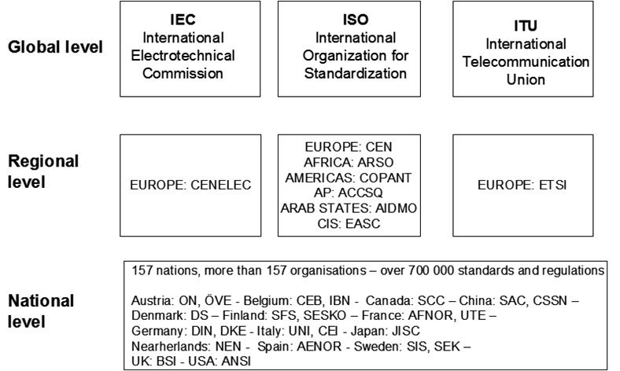

Basic Materials
The target is to use material codes defined in the European EN standards for basic material. For example, basic materials for standard steel products (steel tubes and flanges etc.) can be marked in most cases with material codes or designations according to EN standards.
Examples: S355J0 - EN 10025-2 (Unalloyed structural steels)
1.4436 - EN 10088-3 (Stainless steels)

If there is no equivalent material code in EN-standards for the basic material, the most commonly known/used national standard or trade name of the material can be used.
Examples: AISI 316 RAEX 300

In other materials where accurate material code is not needed or available, the following commonly used basic material abbreviations should be used in all languages:
Plastic and rubber materials: Metals and other materials:
Material | Abbreviation
Polyamide (Nylon) | PA
Polyethylene * | PE
Polyoxymethylene (Acetal) | POM
Polypropylene | PP
Polystyrene | PS
Polytetrafluoroethylene (Teflon) | PTFE
Polycarbonate | PC
Polyvinyl Chloride | PVC
Polyurethane | PU
Polyvinylidene fluoride | PVDF
Nitrile (butadiene) rubber | NBR
Natural rubber | NR
Chloroprene rubber | CR
Fluorocarbon rubber ** | FPM
Ethylenepropylenediene rubber | EPDM
Styrene butadiene rubber | SBR
Material | Abbreviation
Copper | CU
Aluminium | AL
Iron | FE
Steel | ST
Cast iron *** | CI
Wrought iron | WI
Stainless steel | SS
Zink | ZN
Gold | AU
Silver | AG
Nickel | NI
Chromium | CR
Platinum | PT
Brass | BRS
Bronze | BRZ
… | …

* other allowed variations of polyethylene: PE-LD (low-density polyethylene) and PE-HD (high-density polyethylene)
** other equivalent material designations: Viton and FKM
*** other abbreviations that defines material more accurately: GJL (Grey Cast Iron) and GJS (Ductile Cast Iron)

Colors
When it is needed to use color abbreviations (e.g. for cables and wires) in description fields, colors are always written using abbreviations based on standard IEC 60757.
In case of a single color the following two letter abbreviations are used:

Color | EN | FI | SV | DE | PL | ET | SK | RU
Black | BK | MU | SV | SW | BK | MU | BK | Ч
Brown | BN | RU | BR | BR | BN | PR | BN | КЧ
Red | RD | PU | RÖ | RT | RD | PU | RD | К
Orange | OG | OR | OR | OR | OG | OR | OG | Ж
Yellow | YE | KE | GU | GE | YE | KO | YE | Ж
Green | GN | VI | GN | GN | GN | RO | GN | З
Blue | BU | SI | BL | BL | BU | SI | BU | С
Violet | VT | VT | VL | VI | VT | LI | VT | Ч
Gray | GY | HA | GÅ | GR | GY | HA | GY | Б
White | WH | VA | VT | WS | WH | VA | WH | Б
Pink | PK | VP | RO | RS | PK | HP | PK | К
Turquoise | TQ | TU | TQ | TK | TQ | TS | TQ | БЗ

When combining multiple colors, abbreviations are combined without space or any special character.
Example: GNYE (Green/Yellow)

Light and dark version of each color is expressed with a prefix L (light) or D (dark).
Examples: LBU (Light blue) DGY (Dark gray)

RAL colors will be expressed with a text RAL combined with 4-digit colour code without space in between.
Example: RAL7001

Field Specific Instructions
The following chapters contains illustration of global Material Master Data structure in SAP and describe general principles and guidelines for the usage of Units of Measures and the instructions for Material grouping.

SAP Material Master Fields
Instructions for the SAP Material Master Data fields are described in more detail in the Appendix 1 - Field-specific instructions which describes material master data definitions of to-be data model available for all parties including field purposes, rules, list of values and information of technical field names, types and lengths.

Please note that instruction currently contains definitions only for the global fields, but it should be extended to also cover organization specific (plant and storage location level) data.

The picture below illustrates the structure of SAP Material Master Data tables and related fields which are common for all organizations and business areas at Client Group.

SAP Material Basic Data
Material Texts
Basic data text and purchase order text that are common for all organizations

Units of Measure
Alternative Units of Measure and the factors for converting them to the BUoM

Classification
Characteristic
Manufacturer
Manufacturers Item
Type
Type2/Other Product Code
Measure1/Value1
Measure2/Value2
Measure3/Value3
Measure4/Value4
Measure5/Value5
Material
Standard
Drawing
Descriptions
Material Description in English and additional descriptions in local languages
General Data
Industry sector
Material Type
Base Unit of Measure
Material Group
Division
Product hierarchy
X-plant matl status
Gross Weight
Net Weight
Weight Unit
Volume
Volume Unit
Size/dimensions
EAN/UPC
EAN category
General Item Category Group
Industry Standard Description
Order Unit
Material Master Record

Units of Measure
The Base Unit of Measure (BUoM) is the most suitable and universal unit for the material. The BUoM is a smallest default unit in which stocks of the material are managed and unit that is used by default in different transactions such as purchase orders.

In addition to the Base unit of measure, other Alternative Units of Measure can be used e.g. as Order unit, Units of issue, Sales units and WM unit. If Alternative Units of Measure are used, also conversion factors to the Base Unit of Measure need to be maintained in ‘add. data: units of measure’ view. Please note that conversion factors are global information and they should not restrict other Client plants to use the material.

Most common Base Units of Measures are presented in the table below:
Value | Description
PC | Piece
KG | Kilogram
L | Liter
M | Meter
M2 | Square meter
M3 | Cubic meter
T | Ton
… | …
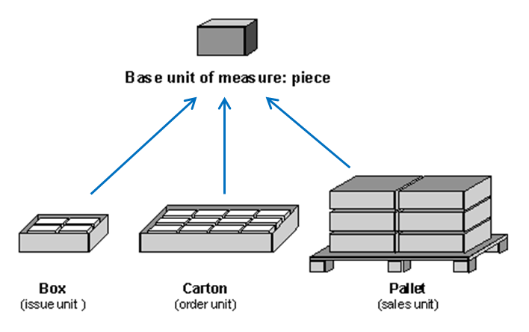

As an exception it is allowed to use also other Base Units of Measure for certain Material Types, e.g. DT (Dry Ton) for Raw Materials or H (Hour) for Service Materials. Allowed Base Units of Measure per each material area are presented in Appendix 1 - Field-specific instructions (see worksheet: List of Values).
When selecting the Base Unit of Measure for a material it should be noted that
- similar materials should have the same base unit of measure and
- other business areas (and plants) should be able to use the material as well.

See the detailed instructions for the allowed Base Units of Measure in the Appendix 2 - Material group-specific instructions, to find the correct BUoM for the material in question.

Material Grouping
Client Group use a common material grouping (Forest Industry Standard Grouping i.e. FISG Material Groups) and it is divided into three hierarchy levels: Main group, Sub group and Material Group. The first two levels of hierarchy are mainly intended to gather similar materials together. Material group is mandatory information for all materials. FISG grouping is maintained by the Procurement Source to Sign and Request to Pay processes.

Material Group (6-digit long code) is the third and lowest level of hierarchy that is maintained on Material Master Record. Material Groups are also used for reporting purposes and are linked with spend reporting categories. See example of FISG Material Group hierarchy below:
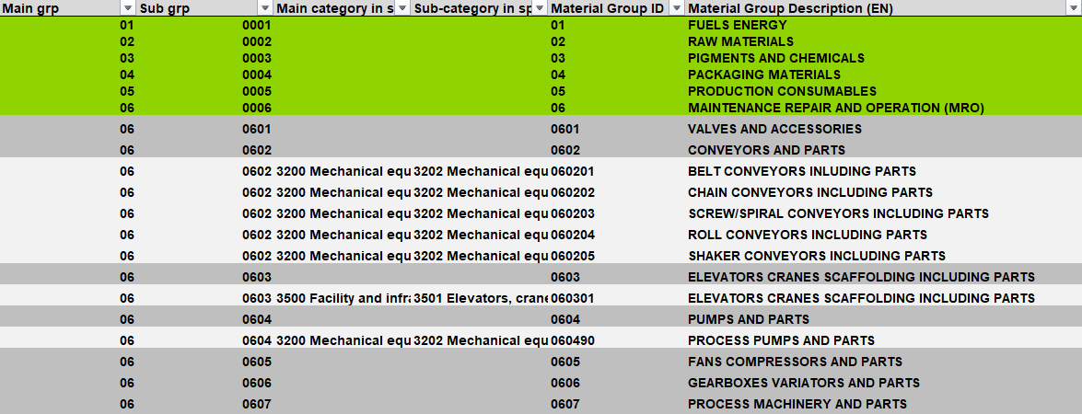
General principles on how to select correct material group for the different materials:
- Similar materials are always classified into same material groups
- Material is always classified to Material Group, which is most applicable for the material and describes generally what kind of product is in question, not where material is used.
- Exception for the above-mentioned principle are ‘Equipment supplier-specific spare parts’, ‘Drawing items’ and ‘Spare Parts or Spare Part Kits’ which are classified according to equipment or machines where specific spare parts are meant to be used. E.g. Seal kits and gaskets that are specific spare parts to certain valve, should be classified into Material Group: 060190 - PROCESS VALVES AND ACCESSORIES.

Material group-specific instructions
The following chapters describe general description forming rules for different material types.

Please note that the material group specific instructions (Appendix 2) override these general instructions and they should always be used for types of materials for which they are available. In material group specific instructions is described examples for the most common materials within material group, including definitions of basic names and their translations, Base Units of Measure and additional information to be maintained in classification data fields.

Material Descriptions - General Principles
Material description is a text describing the material as exactly as possible. The information in the material description consists of basic name and/or supplementary part that together identify material unambiguously.

Basic name should be commonly used name which describes material accurately. However, the basic name should not be too long, because in addition to the basic name, at least the most important supplementary information has to be included in the material description.
The supplementary part specifies uniquely the material with the basic name. The required supplementary information varies between different types of materials so that materials can be identified accurately.
The supplementary part may contain the following information:
- Type designation or product ID
- Technical specifications
- Sizes and dimensions
- Basic Material
- Manufacturing standard
- Drawing number
- Trade name of the material

General principles for material descriptions
- Material description should describe the physical item as exactly as possible. Description should contain all information that is required to identify the material.
- However, for some materials all required information is not possible to include in material description due to field length limitation (40 characters) and thus some of material information can be maintained only on classification data fields.
- Material’s main description will be written in English. In addition, translations of descriptions to local languages will be created in all needed languages. Other global descriptive fields (such as classification data fields) are to be maintained also in English.
- Material descriptions for the similar materials are always created following the same logic and using same basic names (even though different manufacturers or suppliers may have varying descriptions for the similar products).
- The description should not contain information where the material is used as materials can be used in many locations.
- Exception for the previous rule are “spare part kits”, “Equipment supplier-specific spare parts” and “Drawing items” that are meant only for certain equipment or machine, and therefore can contain information where the material is used.

General material description forming rules for different material types are presented in the chapters below and detailed instructions and examples in the Appendix 2 - Material group-specific instructions.

Material Descriptions - Spare Parts
Spare part materials can be divided into five different categories:
- Manufacturer-specific spare parts
- Standard items
- General items
- Equipment supplier-specific spare parts
- Drawing items

Material Description forming rules (and short explanation) for each type of spare part materials are described below.

Manufacturer-specific spare parts:
- Materials that can be used commonly in various locations and equipment.
- Identified always with type designation and/or product id of original manufacturer*.
- Can be purchased from multiple different suppliers or directly from manufacturer.

* In addition, material can have other reference codes (such as national federation codes or supplier’s codes) but it is not allowed to use them as only identifier for the material.

Description forming rule for Manufacturer-specific spare parts:
[Basic Name]* + [Type / Product ID]**

Material Description: Classification Data:
Description
TIME RELAY CT-APS.22S
DEEP GROOVE BALL BEARING 6024-2RS1
BALL VALVE M1MA025AP
Field | Value
Characteristic | TIME RELAY
Manufacturer | ABB
Manufacturers Item | 1SVR730180R3300
Type | CT-APS.22S
Type2/Other Prod. Code | SNRO2712210
Measure1/Value1 | 2C/O
Measure2/Value2 | 24-48VDC/24-240VAC
Measure3/Value3 | 0.05S-300H
Measure4/Value4 | OFF-DELAY
Measure5/Value5
Material
Standard
Drawing

* Basic name or agreed abbreviation:
If basic name needs to be abbreviated due to field length, in the description should be used basic name abbreviation defined on material group specific instructions, and complete basic name should be written in Characteristic field.

** Type / Product ID:
In case where both type and Product ID exist, type should be written in description field.

Standard items:
- Manufactured according to size/dimension standard (manufacturing standard)
- Identified with information of ‘size/dimension’, ‘basic material’ and ‘manufacturing standard’
- Have typically several manufacturers and can be purchased from different suppliers.

The manufacturer (and manufacturers item) is never maintained for standard items because they typically have multiple manufacturers.

Description forming rule for standard items:
[Basic Name] + [Size] + [Basic Material] + [Manufacturing Standard]

Material Description: Classification Data:
Description
FLAT BAR 6X40 S235JR EN 10058
LOOSE PLATE FLANGE DN200 PN10 1.4404
THREADED ROD M24 A4-70 DIN 976-1
Field | Value
Characteristic | FLAT BAR
Manufacturer
Manufacturers Item
Type
Type2/Other Prod. Code
Measure1/Value1 | 6X40
Measure2/Value2
Measure3/Value3
Measure4/Value4
Measure5/Value5
Material | S235JR
Standard | EN 10058
Drawing

General items:
- General items (like standard items) have several different manufacturers but are not manufactured according to any specific standard.
- Identified with generic identifiers such as ‘size/dimension’ and ‘basic material’ or ‘commonly used type designation’ and ‘Technical specifications / other additional information’ but general items never contain information of manufacturer or supplier.

Material Description forming rules for general items:
[Basic Name] + [Size] + [Basic Material] or
[Basic Name] + [Type] + [Technical specifications / other additional information]

Material Description:
Description
O-RING 139,3X5,7 NBR 70
TAPER LOCK BUSH TL2012-28
HUB SPROCKET 16B-1 Z=16 D60H7
INSTALLATION WIRE H07V2-K 1,5 BK 250M

Equipment supplier-specific spare parts:
- Are meant to be used as spare parts in some specific equipment or machines and are supplied by original equipment supplier.
- Identified always with supplier’s ID or drawing number.
- In some cases, these might be general or standard items but must be purchased only from original equipment supplier/manufacturer e.g. for warranty reason.

Material Description forming rule for Equipment supplier-specific spare parts:
[Basic Name] + [Other additional information*] + [supplier’s ID or drawing number]
Material Description: Classification Data:
Description
SHAFT DWG 113714
TOP FRAME H032543
GASKET 82/63X3 20029882
Field | Value
Characteristic | SHAFT
Manufacturer | AHLSTRÖM
Manufacturers Item | DWG 113714
Type | DWG 113714
Type2/Other Prod. Code
Measure1/Value1 | [Equipment]
Measure2/Value2
Measure3/Value3
Measure4/Value4
Measure5/Value5
Material
Standard
Drawing

* Other additional information can be included
into description for materials where it is needed. E.g. additional dimensions might be useful information in some cases when searching for certain material.

Note:
If there are drawing numbers available from both supplier and Client, Client’s drawing number is used in Description and is written also in Drawing field in classification data.

Drawing items:
- Equipment or spare parts that are made according Client’s own manufacturing drawing
- Material description contains basic name and a drawing number with ‘DWG’ prefix
- Manufacturer information is never maintained for drawing items because items can be manufactured by different manufacturers or machined internally.

Material Description forming rule for drawing items:

[Basic Name] + [Drawing Number]

Material Description: Classification Data:
Description
SHAFT DWG K431939 POS 1
Field | Value
Characteristic | SHAFT
Manufacturer
Manufacturers Item
Type
Type2/Other Prod. Code
Measure1/Value1 | [Equipment]
Measure2/Value2 | D80
Measure3/Value3 | L1740
Measure4/Value4
Measure5/Value5
Material | 42CRMO4-09
Standard
Drawing | DWG K431939 POS 1

Material Descriptions - Raw Materials
Within Raw Materials there is lot of variation and accepted exceptions between different material groups and even within material groups in some cases due to business reasons. For example, different business areas are using commonly accepted basic name abbreviations or Brand name as the basic name. Therefore, general description forming rule cannot be formulated, see instruction for description of Raw Materials in the Appendix 2 - Material group-specific instructions.

Examples of Raw Materials below:

Material Description:
Description
SPRUCE WOOD CHIPS
SULFURIC ACID 98%
PULP SF ECF BUKOCEL
BOTNIA KSK EUCA

Material Descriptions - Packaging Materials
The general principles for material description (described in chapter 3.3.1) are applicable to packaging materials. Description contains information of dimensions and other specifications or additional information that is relevant for material. However, there are some variation and exceptions for some material groups, see Appendix 2 - Material group-specific instructions.

General description forming rule for packaging material:
[Basic Name] + [Size/Dim.] + [Add. Info]

Material Description:
Description
CORE 76,2X15X1270 WITH NOTCH
REEL WRAPPING PRINTED 290G/M2 167CM
TIMBER HOOD MW 3,6M
LABL 70X70 NAPK MIGROS 40CM 50-3U 359

Appendices
Appendix 1: Field-specific instructions
Appendix 2: Material group-specific instructions

