Contents
1. Cleansing & Enrichment Process 3
2. Description Format 5
3. UNSPSC 6
4. Model / Part number 6
5. General 7
6. Clarification 8
7. Duplicate Report 8

Cleansing & Enrichment Process

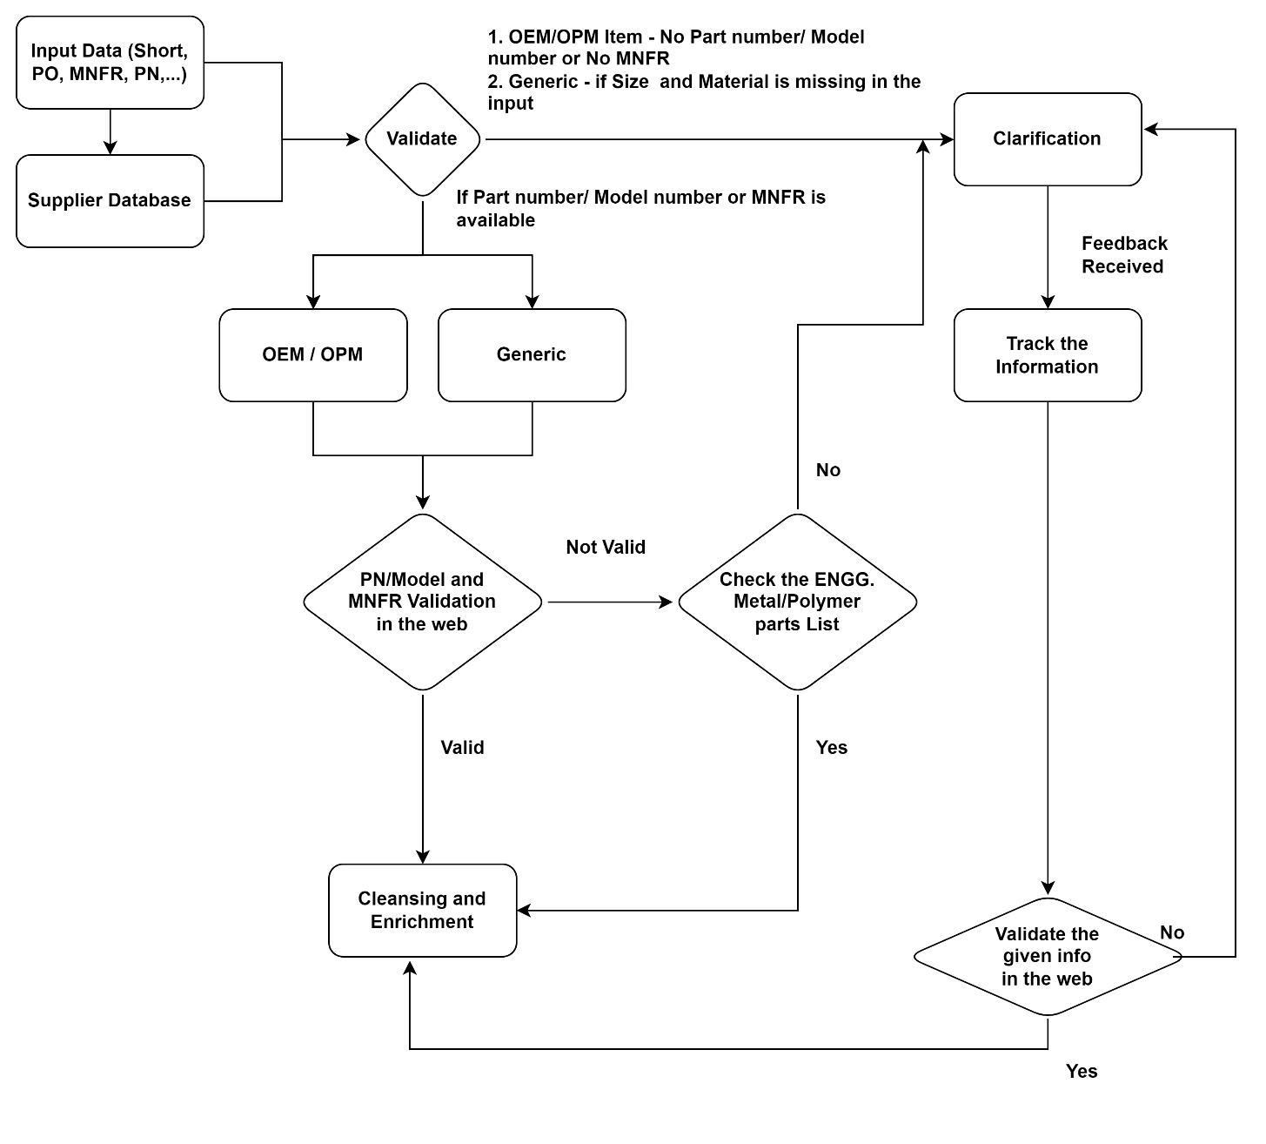
Flow Chart Process:
- Manufacturer Name: Identify the OPM/OEM/Distributor/ENGG Parts based on our research.
GS Query: Please define OPM,OEM and Generic and how it is differentiated.
I hope you are clear with this from the discussion we had in the call, if you still have any questions, we can go over them with the examples scenarios that can be found in the samples records that were sent in the mail.

- Manufacturer Name: If there is an old & new OPM available for the same material, we need to choose the new OPM.
- Manufacturer Name: For the GENERIC items with mandatory values available, and if OPM name not available we need to populate OPM NAME as “GENERIC".
- OPM: When the CLIENT input data having no OPM but part number available, Prospecta - while enriching the data finds that the item is having multiple OPM in the Web, Prospecta will raise a clarification to confirm preferred OPM.
- Item is ENGG. Metal/Polymer parts, given details identified as OEM & OEM part number Prospecta will cleanse those items with the available details. And in the additional features Prospecta needs to mention as “ENGG. Metal/Polymer parts”. (Refer: REFER TO ENGG. METAL / POLIMER & GENERIC NOUNS LIST.)
- For NON-ENGG. part & given details identified as Distributor and Distributor Part number, then Prospecta needs to identify OPM & Manufacturer Part number from Web source if not Prospecta will raise as clarification.
GS Query: What do NON-ENGG Part means? Are those the classes that is not listed in file “ENGG. PARTS & GENERIC_20230309”??
Yes… You are right on this.

- For NON-ENGG. and ENGG. Metal Metal/Polymer part & given details identified as Distributor and Distributor Part number, then Prospecta needs to identify OPM & Manufacturer Part number from Web source if not Prospecta will raise as clarification.
- OEM: If Item is NON ENGG. Metal/Polymer part and given details as identified as OEM & OEM part number Prospecta will raise a clarification to get true OPM & MPN.
- Prospecta will validate the available information, if the MNFR / Model or / and Part number is not available, Prospecta will raise the clarification. Else start the validation with web.
- If the Model or / and Part number is not validating in the web, Then Prospecta will check the ENGG. Metal/Polymer parts, if not Prospecta will raise the clarification.
GS Query: Does this mean that if the Number is not validating in web and the Class is not available in ENGG. Metal/Polymer parts list we don’t want to process the material?
Yes… If the product is neither validating on the web, nor its class is not the ENGG Metak/Polymer parts list, we can straight away raise those records for clarification.

- If the Model or / and Part number is validating in the web, Prospecta will start the cleansing/ Enrichment process.
- Generic items - Prospecta will raise the clarification if Model or / and Part number and / or manufacturer is not available. CLIENT will give feedback on whether we can go with Generic cleansing or not. Still if we need the Mandatory information like Size, Material will raise the “clarification on clarification”.
- Once CLIENT sends the feedback on clarification, Prospecta will validate the given information. If the Model or / and Part number is not validating in the web, again Prospecta will raise the clarification on clarification. If the Model or / and Part number is validating in the web, Prospecta will start the cleansing/ Enrichment process.
- Whatever the OEM Manufacturer (OEM Like ACMA and SYNTEGON…) and it’s not validating in the web, Prospecta needs to raise the clarification.
- Post clarification – If Part number/ Model number is nowhere validating except “EBAY”, “AMAZON”, then Prospecta will send the material to CLIENT review.
- Post clarification if we received the feedback with Drawing photo, drawing number (Fabrication/ENGG Metal/Polymer part materials) with Local vendor name, Prospecta will do the Cleansing with available information.
- In some special cases, Model/Type number needs to be captured from photo, example Lubrication oil (Grade).
- Do not use “Distributer” as Manufacturer for Cleansing / Enrichment activity.
- OPM or OEM PART NUMBER should not be less than 3 characters and always have consistent format.
GS Query: There are chances of some Product has will have less than 3 characters.
If this is the case, we’ll mark those records and address them into client and get the way on how we can proceed further.
- When designation only is available and, but the model number is not available, then designation moved to model column.
GS Query: How do this impact in Part Number field if it is also not available. This Query is with reference to point 21.
- Part number column should not be empty, if part number is not available model will be moved to part number column and vice versa.
GS Query: Does this mean that we need to populate same number as both Model and Part Number for the material?
Considering both questions.
Yes, if only the MPN is available and not the model, or if only the model is available but not the MPN, in that case, we can consider them to be the same.
- For same Model number or / and Part number and / or manufacturer - Noun Modifier should be same.
- Push-In / Push-Out Connectors also cleanse under the classes like Union, Tee, Adapter, Wye.
- OPM: Each batch submission, Prospecta will update OPM will be having model & part number or not as per image attached ----->>>>
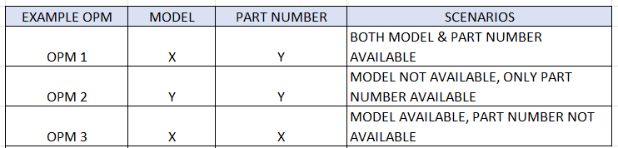

Description Format

  - Generation of Short Description for Material Master
CATEGORY | SHORT DESCRIPTIOIN REQUIREMENTS & SET UP
CATEGORY 1 – OPM | IF IT´S OPM PART AND MODEL AVAILABLE: NOUN, MODIFIER, MODEL, OPM NAME^{(g)}, ATTRIBUTE1,…
 | IF IT´S OPM PART AND MODEL NOT AVAILABLE: NOUN, MODIFIER, MPN, OPM NAME^{(g)}, ATTRIBUTE1,…
 | IF IT´S ENGINEERED PART BASED ON DRAWING: NOUN, MODIFIER, MPN^{(h)}, OPM NAME ^{(g)}, ATTRIBUTE1,…
CATEGORY 2 - OEM | IF IT´S OEM PART AND MODEL AVAILABLE: NOUN, MODIFIER, MODEL, OEM NAME^{(g)}, ATTRIBUTE1,…
 | IF IT´S OEM PART MODEL NOT AVAILABLE: NOUN, MODIFIER, MPN, OEM NAME^{(g)}, ATTRIBUTE1,…
CATEGORY 3 - GENERIC | IF IT´S A GENERIC MATERIAL: NOUN, MODIFIER, MPN^{(4.3.2)}, OPM NAME^{(i)}, ATTRIBUTE1…
      - Maximum length to be 40 characters. If part number exceeds 40 characters in the short description, Prospecta will “…” in last 3 characters of short description to indicate complete is available in the long description or part number column.
      - Modifier abbreviation used as per abbreviation master. (Vide taxonomy translation files)
      - NOUN should not be in plural.
      - If an attribute does not have any value, then the next filled attribute value will be taken.
      - The Noun is not abbreviated, and Modifier will be abbreviated using the abbreviation master (As mentioned in the Taxonomy).
      - No more N/A's in the short description.
      - Manufacturer name abbreviation is used in the short description. Abbreviation will be provided by CLIENT in the Harmonized MNFR file.
      - ENGG. Metal Metal/Polymer part which are fabricated based on drawing, MPN must be built based on drawing number. The mask to build the part number is “DWG+Number/letter”. Example: DWG#12345 or DWG#AB34. Note: “CLIENT” is not required in the mask.
      - For Generic material, OPM name always go be “Generic Manufacturer”

  - Generation of Long Description for Material Master
    - Long description is an unabbreviated text field and is a concatenation of the Classification (Noun), Sub-classification (Modifiers) and of all the attributes.
    - NOUN, MODIFIER, Attribute Name 1: Attribute 1 value, Attribute Name 2: Attribute 2 value, ETC,..MODEL, PART NUMBER, OPM/OEM.
    - “Not available” needs to be maintained in the Mandatory attributes if values not available and not in the optional attributes.
    - The manufacturer’s full name will be used in the long description.

UNSPSC

  - Prospecta will follow the standard UNSPSC codification rules.
  - Prospecta will assign the commodity level UNSPSC code to all the materials wherever possible.
  - Prospecta will give the UNSPSC against each material in the review file. However, that is not loaded in the SAP against material.

Model / Part number

  - Model/Part number:
    - When the CLIENT data is missing one of those model numbers or part number, that needs to be captured properly from the web source by Prospecta.
    - Part number column should not be empty. (if Part number not available model will be moved to Part number column)
  - Model:
    - When part numbers don’t exist, duplicate model numbers will be differentiated by its dimensions. Especially for conveyor belts (habasit, forbo…. )(example: input: fab-5e, output:fab-5e 1000x1800).
    - When designation is available but model not available, then designation moved to model column. (Example: belts, lubricants…).
    - When given model for belt is incomplete with the color details, example: forbo, we will consider white color as common standard
  - Part number:
    - When OPM model & part number not available after clarification, but OEM part number is available that will be moved to part number column.
    - When part number is not available for the generic items, mandatory attributes values need to add as part number. (Example: 28x48in)
    - For OPM, some cases drawing number can be used as OPM part number (some local OPM parts). After confirmation from CLIENT.
    - OPM part number should not be less than 3 characters and must have consistent format along same manufacturer.
    - When part numbers are incomplete in the CLIENT input data & also we couldn't get mandatory details then Prospecta will raise clarification to confirm part number
    - Part number standardization should be done based on OPM and OEM websites.
    - When the given CLIENT part number is discontinued by OPM then Prospecta need to find the new part number. And the existing part number moved to reference text.
  - When the part number is not available for the material, only the model number is there. In this case, we need to add the dimensions to avoid duplication. Especially for a Conveyor belt, Size + Model number.
  - If the part number exceeds 40 chars, we will remove the space first, still exceeding 40 chars will abbreviate the possible values, and still exceeding 40 chars will send to the business for confirmation.

General

  - Abbreviations & UOM are maintained as per approved masters.
  - Additional characteristics will be maintained with proper tagging under the additional features attribute.
  - For the same model number noun modifiers should not be vary
  - When the input noun is INVERTER, it needs to change as variable frequency drive.
  - Non-MRO materials will be separated from enrichment.
  - All the equipment details, drawing number & serial number captured properly.
  - All the filled attributes concatenated properly.
  - Fraction format: "fraction to be displayed with a hyphen as 1-1/2 not 1. 1/2.
  - Decimals always preceded by 0, ex: .50 to be 0.50”.
  - Decimals – If value is 0.5 IN means we are converting into 1/2IN (Decimals and IN convert to Fraction IN)
  - UOM captured without space ex: 10V, 20MM etc.… Example: 10 VDC (long description),10VDC (short description)
  - Repetitive sizes: If a pipe or tubing size is repeated, use only once ex: 1/2X1/2IN is denoted as 1/2IN.
  - Reducing sizes: largest to smallest ex: 45 X 20MM
  - Trailing zero: Example: 1.5000 = 1.5TON.
  - Tolerances: plus - "+", minus - "-", plus/minus “+/-“ +/-5 PCT
  - Special characters: Mention use of &, /, %, >= etc.
  - Range values: Capture range values with a to ex: 24 TO 30V and not 24 – 30V 20-80 DEG C (if value is negative: -20 TO 80 DEG C)
  - Language standard: US English Example: ALUMINIUM, COLOR.
  - Spell check: check all the spellings before delivery.
  - Multi space will be removed with single space within the value field.
  - No punctuation allowed.
  - All upper case.
  - DIMENSION FORMAT: DIA, ID, OD, SQ, WD, LG, HT, DP, THK (Example: 4 DIA X 6 LG IN 4 ID X 5 OD X 8 LG IN)
  - We referred UOM Master for Attribute Values UOM (Refer the Below embedded file).
  - DIMENSION FORMAT: if dimension or size contain two or more values is separated by "X", and provide space between "X" Example 150*100 MM is captured as 150 X 100 MM
  - For temperature rating UOM should be DEG C or DEG F Example: 50 DEG C
  - If two more attribute value available it should be in alphabetical order, Example: COLOR: BLACK, GREY, YELLOW.
  - The miniature “MM²” or “MM³” is captured as SQ MM OR CU MM.
  - Remove space before and after comma, &, / etc. (Example: 5 IN/100 MM)
  - Abbreviation should not in attribute value and long description and short description only
  - All the attributes enriched from web source.

Clarification

  - Clarification items should contain valid remarks.
  - Raise the clarification: Should not have valid part number & OPM.
  - Raise the clarification: For the generic items should not have enough mandatory details.
  - Raise the clarification: Short description & part number column conflict.
  - Raise the clarification: Short & PO text conflict (CLIENT input)

Duplicate Report
  - Prospecta will attempt to identify duplicates based on the following criteria:
    - Manufacturer name & Manufacturer Part Number & Model number.
  - Upon identifying duplicates, Prospecta will group the records with a valid group ID and deliver them to CLIENT for their review.
  - CLIENT team will review the Potential Duplicate Groups and identify the final records. Also, Prospecta will provide the guidance for CLIENT for the Duplicate identification report.
Rule for Creating the Global ID in MDO: Same MNFR + P/N + Model no
- If same instance and all (MNFR + P/N + Model no) is same, Prospecta will send the list to CLIENT to review. Once the material is finalized from the duplicate and based on the CLIENT feedback, will conclude the Global number.

Translation

  - We are using GOOGLE / DEEPL Translators for Attribute values Language translation. Taxonomy Master translation taken care of by CLIENT.

Document Referred

