Knowledge about sleep in humans

Age – Sleep Hours
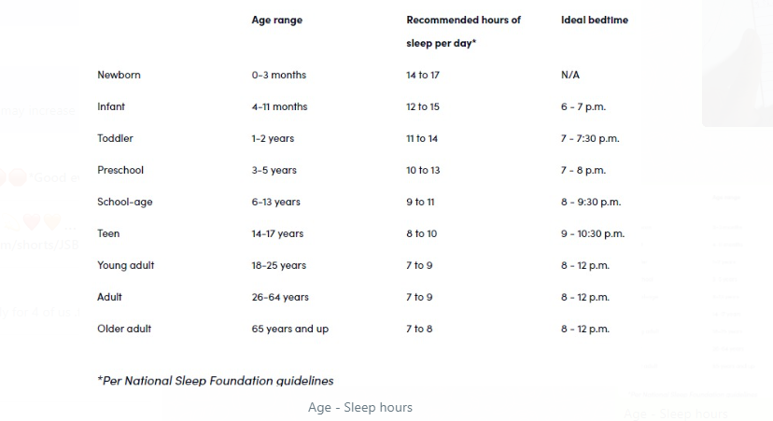
Health issues happening because of not having enough sleep
1. may affect your physical and mental health
2. may have frequent headaches or trouble concentrating
3. may have low energy during the day or have noticeably dark circles under your eyes
Health issues caused by regularly oversleeping may increase your risk of several health conditions, including:
1. obesity
2. cardiovascular disease
3. stroke
4. coronary heart disease
5. diabetes
Some ways to help you get up and going after oversleeping include drinking water, doing yoga, eating food, splashing water in your face, and getting physical activity
10 benefits of consuming Sunflower Seeds
- Rich in Nutrients
Sunflower seeds are packed with essential nutrients like vitamin E, magnesium, selenium, and zinc, supporting overall health and well-being.
- Nutrient-Rich Snacks
Sunflower seeds are nutrient-rich snacks, packed with vitamins, minerals, and healthy fats. They support heart health, digestion, bone strength, and skin vitality, making them a versatile and beneficial addition to any diet.
- Heart Health
The high content of heart-healthy fats, including monounsaturated and polyunsaturated fats, in sunflower seeds may help lower cholesterol levels and reduce the risk of heart disease.
- Antioxidant Properties
Sunflower seeds are rich in antioxidants like vitamin E and selenium, which help protect cells from damage caused by free radicals and reduce inflammation in the body.
- Improved Digestion
Sunflower seeds are a good source of dietary fiber, promoting digestive health by preventing constipation, regulating bowel movements, and supporting a healthy gut microbiome.
- Bone Health
Sunflower seeds are rich in minerals like magnesium, phosphorus, and calcium, which are essential for maintaining strong and healthy bones and reducing the risk of osteoporosis.
- Weight Management
The protein and fiber content in sunflower seeds can help increase feelings of fullness and satiety, reducing overall calorie intake and aiding in weight management when consumed as part of a balanced diet.
- Skin Health
The antioxidants, vitamin E, and healthy fats found in sunflower seeds promote skin health by protecting against oxidative damage, reducing inflammation, and supporting collagen production.
- Energy Booster
Sunflower seeds are a concentrated source of calories and nutrients, providing a quick and convenient energy boost when consumed as a snack or added to meals and recipes.
- Mood Enhancement
Sunflower seeds contain amino acids like tryptophan, which are precursors to serotonin, a neurotransmitter that regulates mood and promotes feelings of relaxation and well-being.

