OPERATOR USER MANUAL

Purpose of the System
- The Pneumatic Laser QC System automatically inspects laser welding depth during production, determines PASS / FAIL results, and generates QR-based traceability for accepted parts.
- The system is designed for continuous shop-floor operation with minimal operator intervention.

Operator Login & Access
- System runs in kiosk mode
- No login required for normal operation
- Operators cannot access settings
- Critical actions are password-protected

Main Operator Screen (Dashboard)
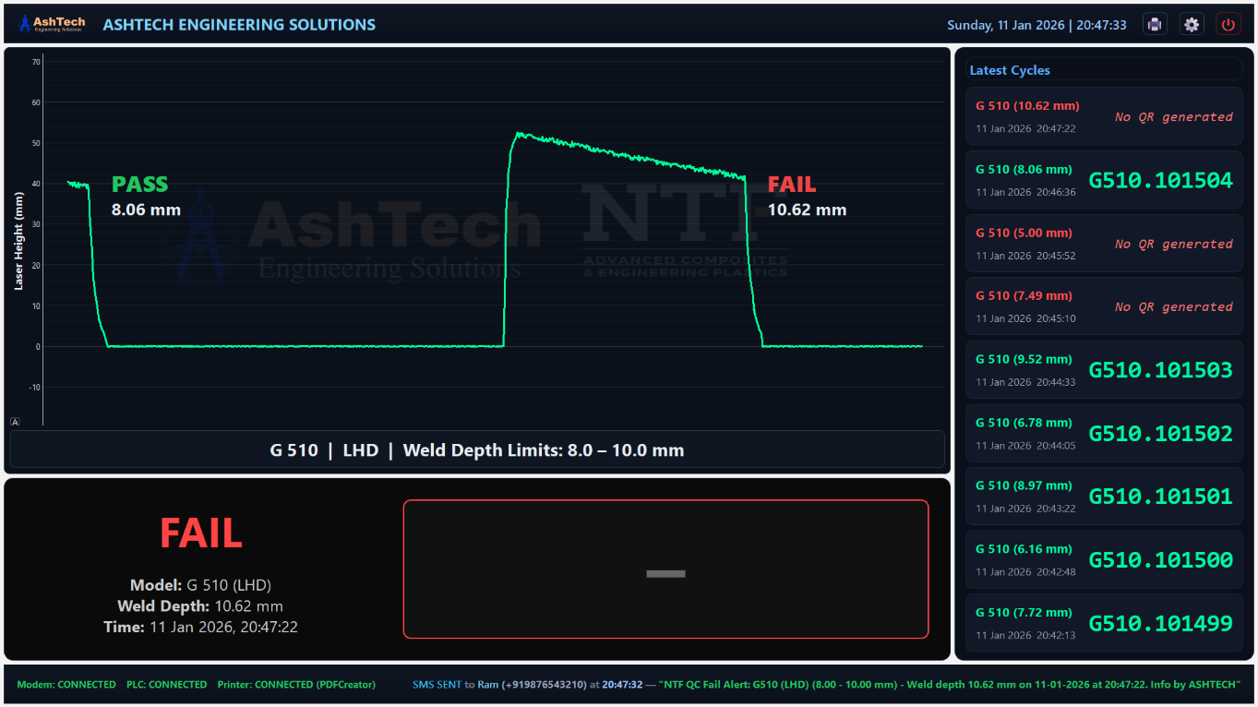
Figure 1: Main Dashboard

What the Operator Sees
- Live laser waveform graph
- Latest inspection result (PASS / FAIL)
- QR code (PASS only)
- Recent production cycles
- System health indicators (PLC, Printer, Modem)

Operator Responsibilities
- Monitor PASS / FAIL status
- Ensure printer is online
- Respond to FAIL conditions as per SOP
- Inform supervisor if system error appears

Understanding PASS / FAIL Results
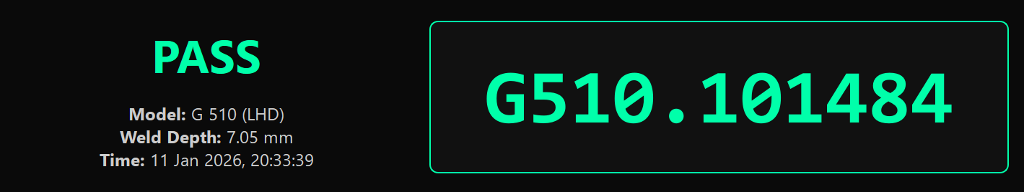
Figure 2: Result Panel - Pass
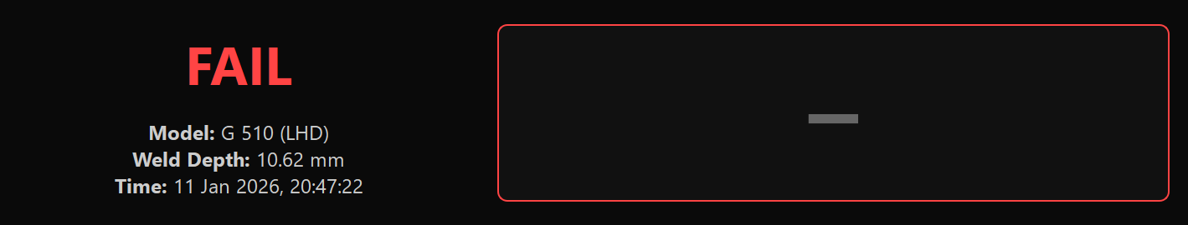
Figure 3: Result Panel - Fail

PASS
- Weld depth within configured limits
- QR code generated automatically
- Part allowed to move to next process

FAIL
- Weld depth outside limits
- No QR code generated
- Part must be segregate

QR Label Printing (Operator)

Automatic Printing
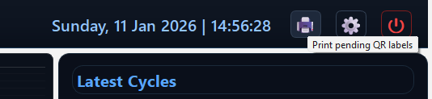
Figure 4: Print icon in Header

- PASS parts are queued automatically
- Labels are printed without manual action
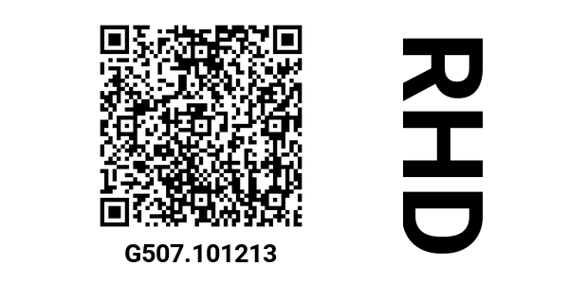
Figure 5: QR Label - RHD

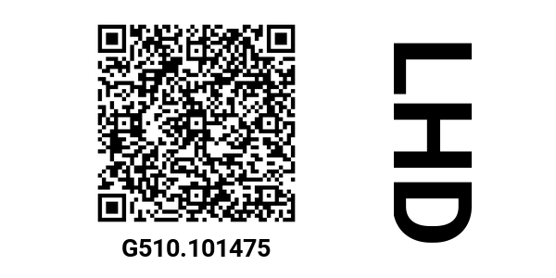
Figure 6: QR Label - LHD

Manual Printing (Pending Queue
- Open QR Printing
- Select “Pending QR Labels”
- Select required rows
- Click Print Selected
- Confirm print
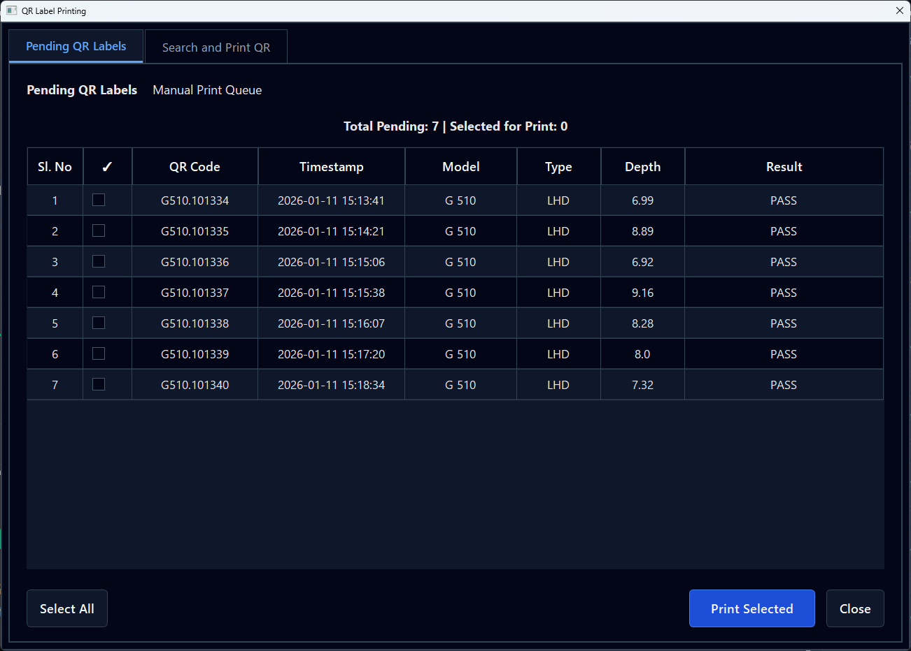
Figure 7: Pending QR Labels - Unselected

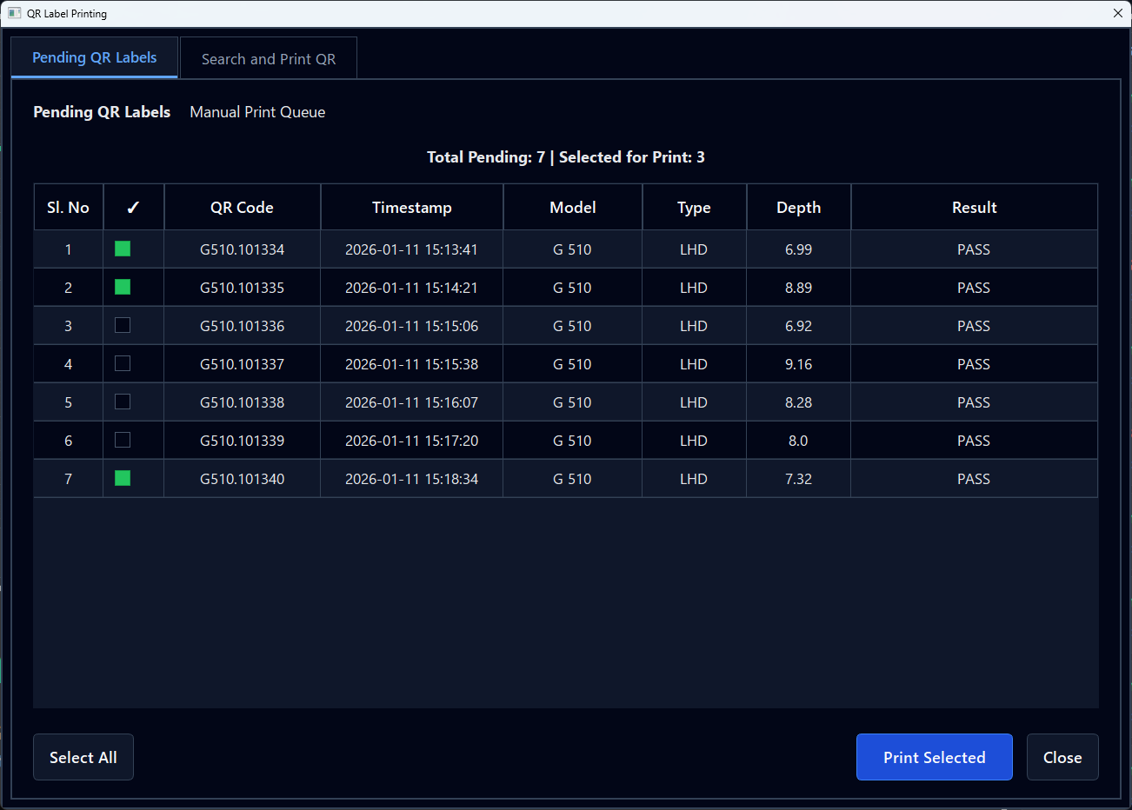
Figure 8: Pending QR Labels - 3 rows selected

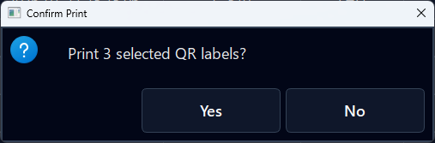
Figure 9: Print Dialogue - Confirmation to print QR Labels

Manual QR Search & Reprint
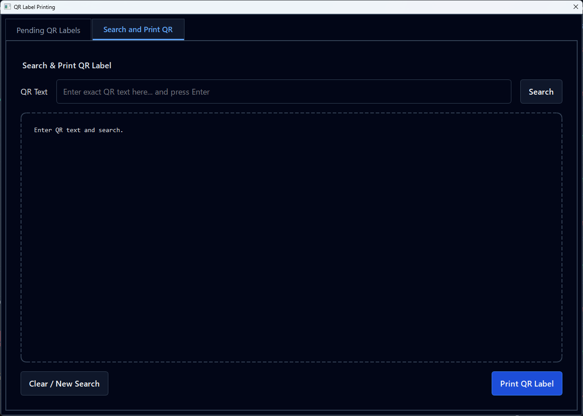
Figure 10: Search and Print QR Label Screen – Pre-Search

When to Use
- QR label damaged
- Printer failure during print
- Audit or verification request
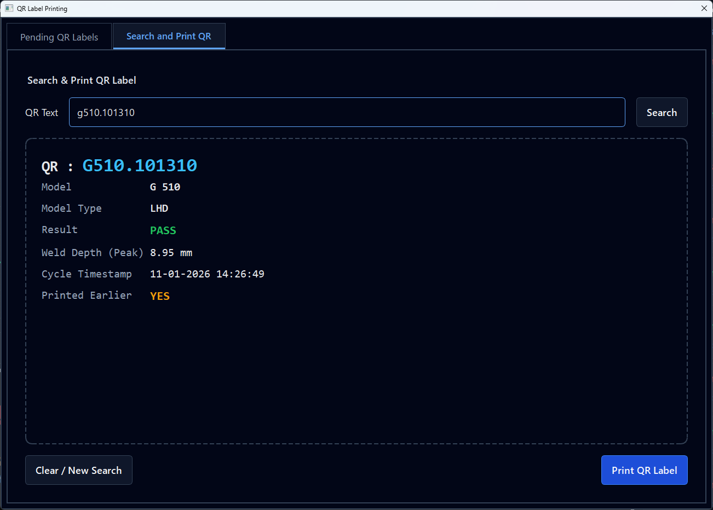
Figure 11: Search and Print QR Label Screen - Post Search

Steps
- Open Search & Print QR
- Enter exact QR text
- Click Search
- Verify preview details
- Click Print QR Label

Operator Access & Security
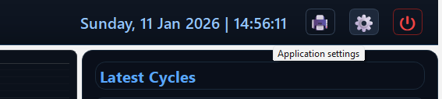
Figure 12: Application Settings Icon in Header

Operator access is protected by a settings password.
Protected functions include:
- Model management
- QR configuration
- Alert contact management
- System shutdown
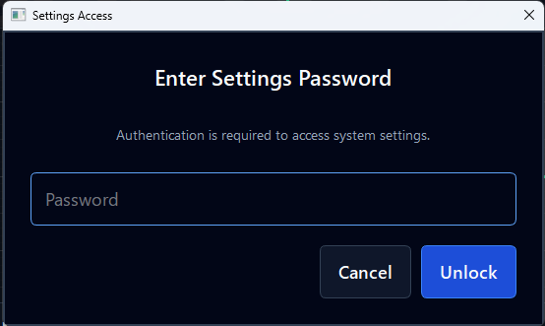
Figure 13: Prompt for entering the security password to access settings

Model Management
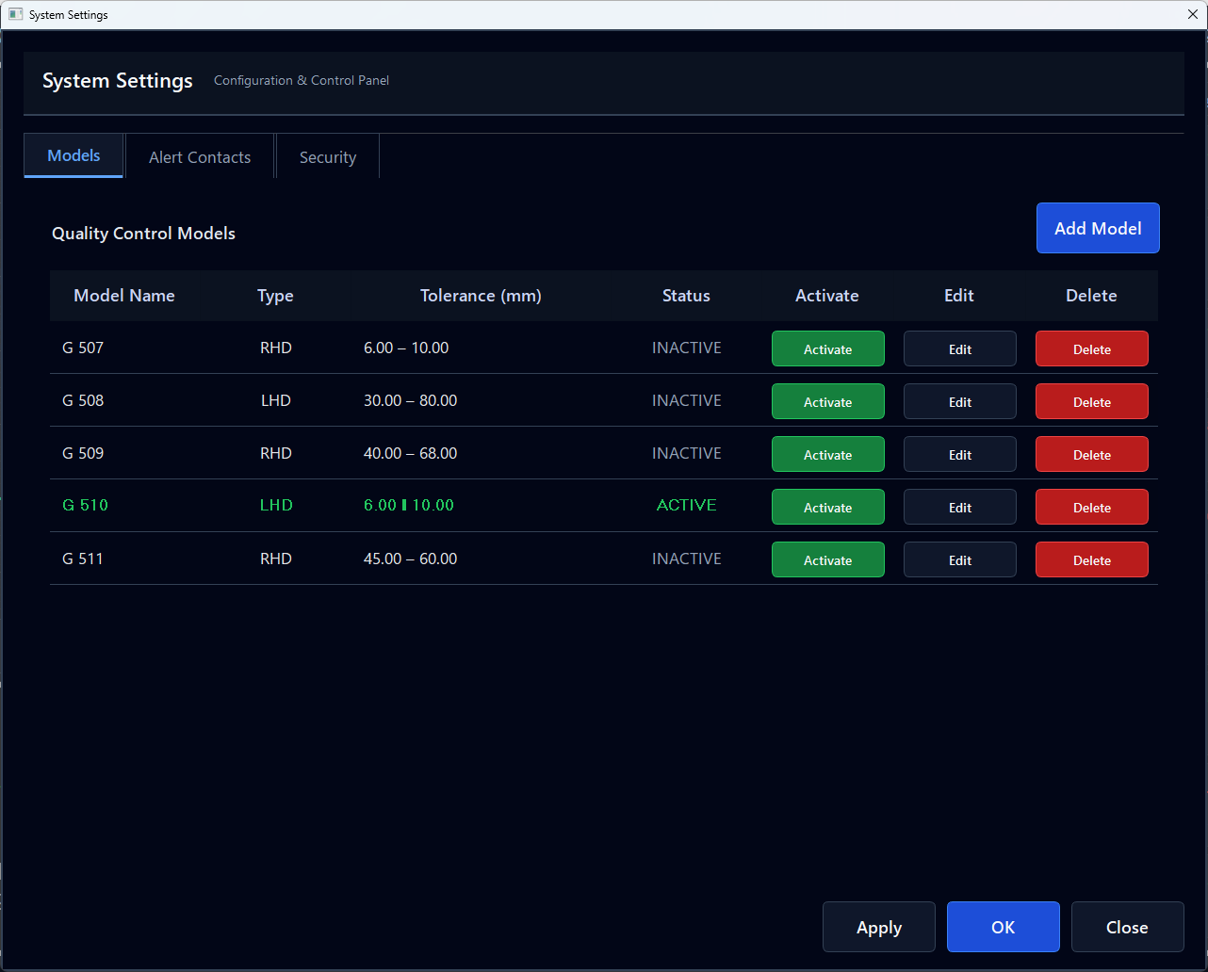
Figure 14: Model Management screen

Each model represents a product with:
- Welding tolerance limits
- Model type (RHD / LHD)
- QR behavior
Supervisor Actions
- Add new models
- Edit tolerance limits
- Activate one model at a time
- Delete inactive models only
✔ Only one model can be active
✔ Active model is clearly highlighted in green colour

Model Activation & QR Rules
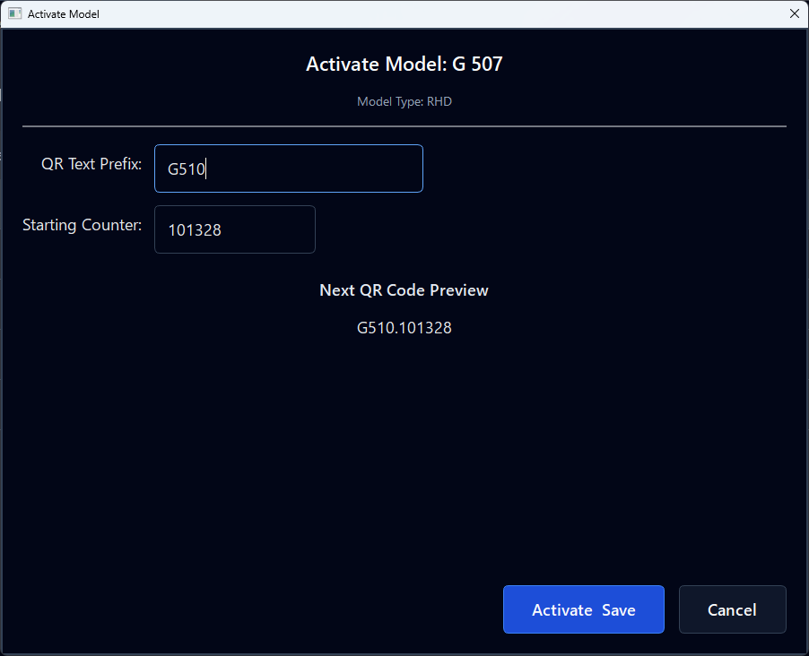
Figure 15: Activate Model Screen

During Activation, Supervisor can:
- Set QR prefix
- Set starting QR counter
- Preview next QR label
✔ Prevents duplicate QR codes
✔ Ensures traceability consistency

Add and Edit Models
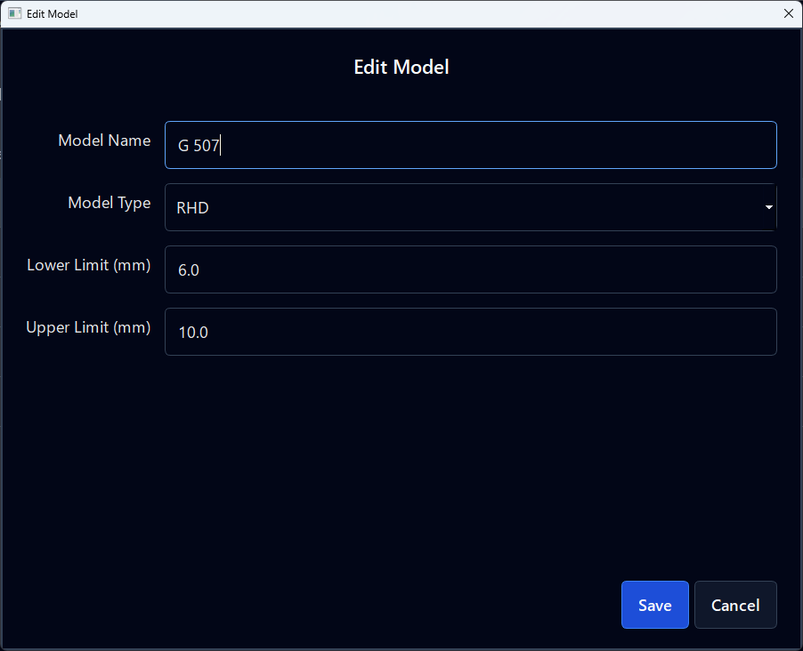
Figure 17: Edit Existing Model Screen

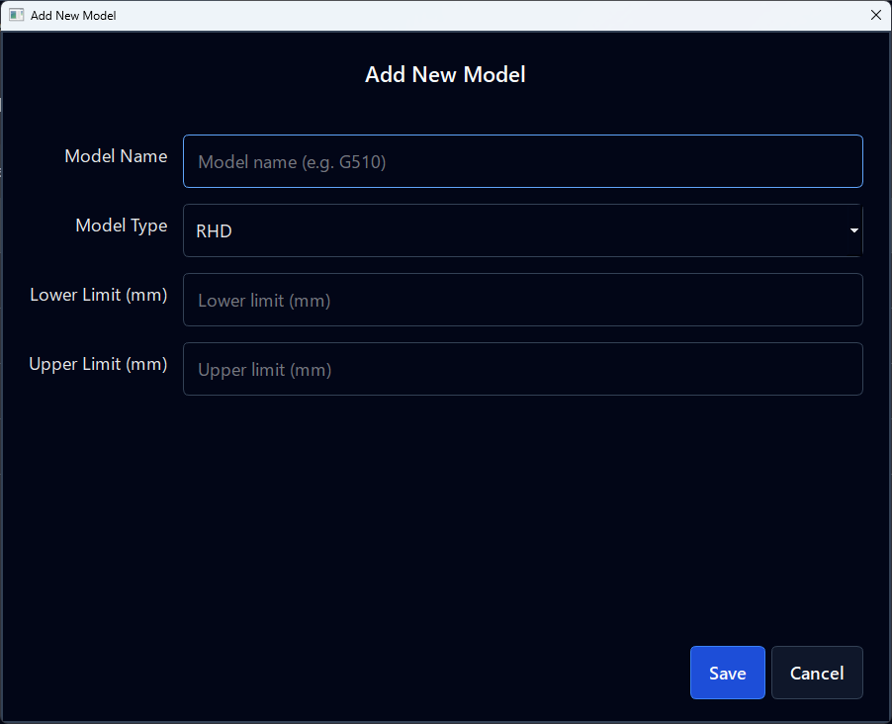
Figure 16: Add New Model Screen

Alert Contact Management
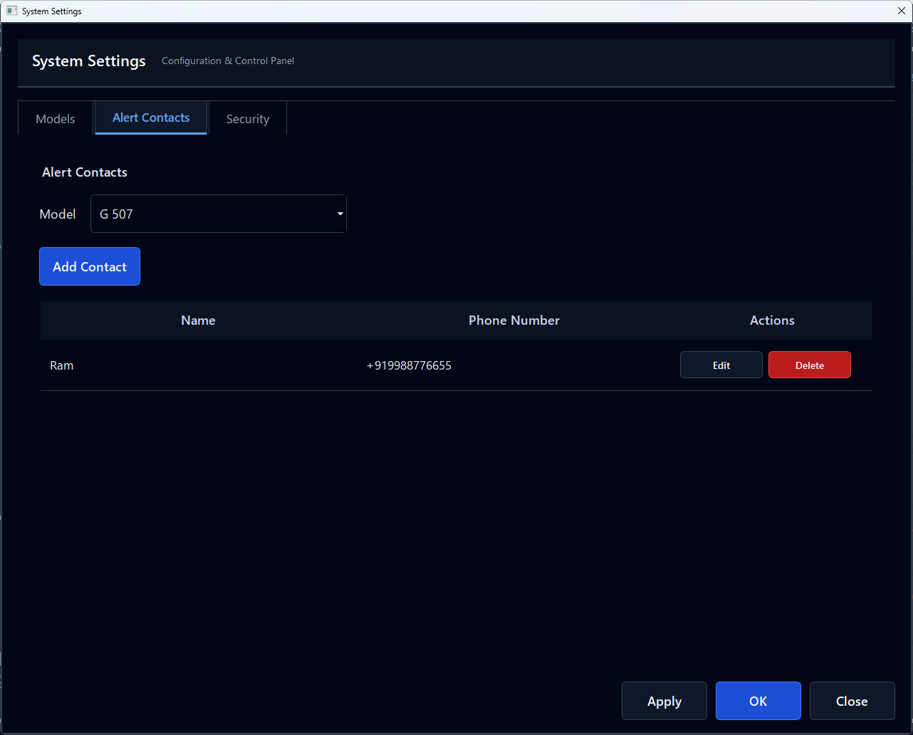
Figure 18: Alert Contacts Screen

Define who receives SMS alerts for quality/system events.
- Model-specific contacts
- Add / Edit / Delete contacts
- Phone number validation

Password Management
- Maintain confidentiality
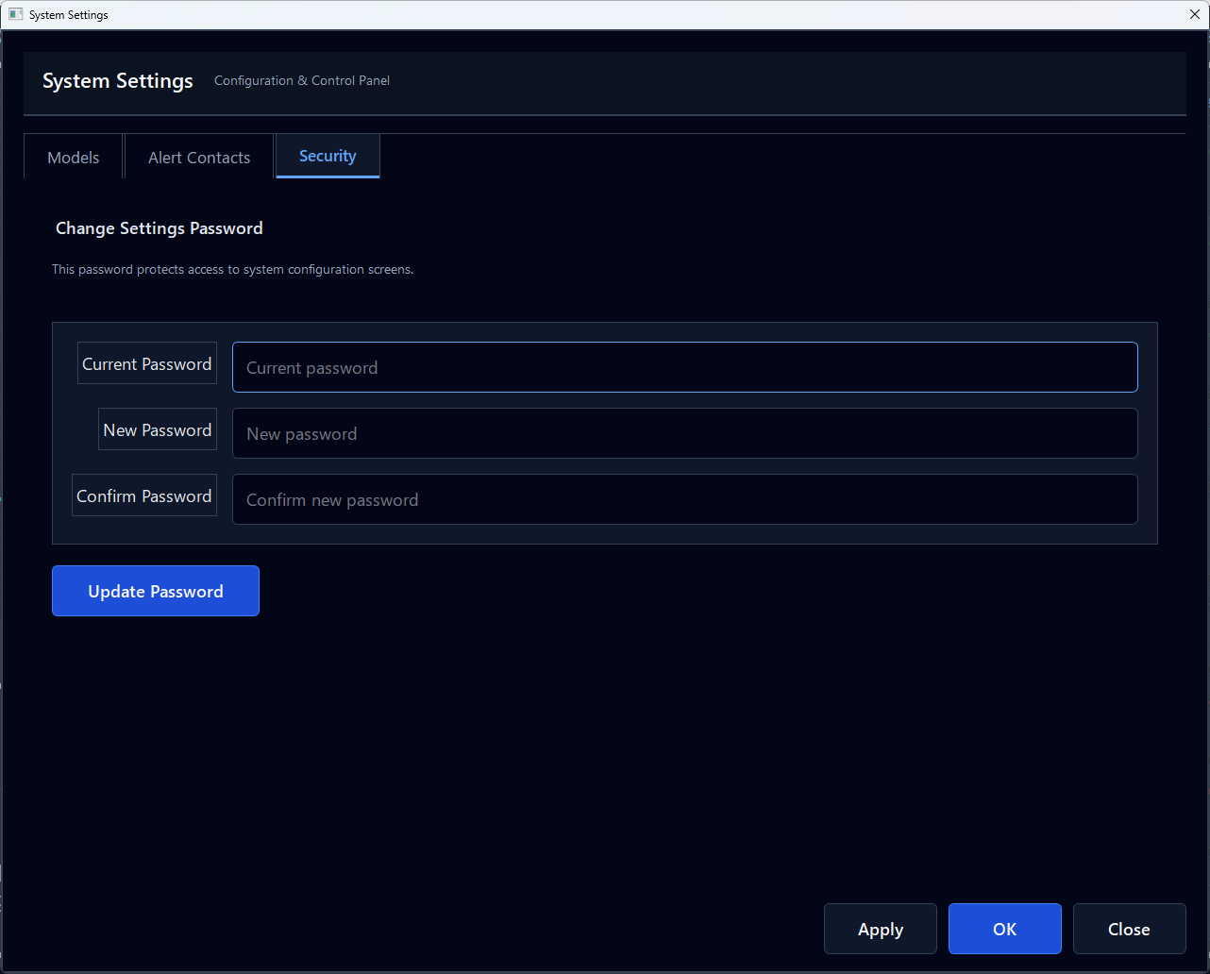
Figure 19: Change Security Password Screen

- Change password periodically
- Ensure only authorized access

Safe Shutdown Procedure
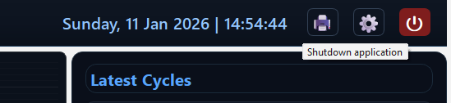

- Authenticate with password
- Confirm shutdown warning
- Ensure no active cycle is running
- Exit application safely

