**Higher National Diploma in Information Technology**

**Object Oriented Programming (Java)**

**Year 1 Semester 2 – 2019**

**NG hospital blood donation bank Project report**

|  |  |
| --- | --- |
| **Student Registration Number** | **Student Name** |
| IT 19777146 | M.F.M.Samly |
| IT 19202778 | M.R.A.Akeel |
| IT 19777078 | N.M.V.S Navarathnass |
| IT 19777382 | P.R.Rajamathri |
| IT 19017570 | P.G.K.Jayasinghe |

**Contents**

**Chapter 01**

1. **Introduction**
2. **Scope and Objectives**
3. **Problem Definition of Existing system**
4. **Limitations**

**Chapter 02**

1. **Benefits**
2. **Functional requirements**

**Chapter 03**

1. **Login**

**3.1 Admin**

**3.2 User**

1. **Two types of admin**

**3.3 Admin level user**

**3.4 General level user**

**Chapter 04**

1. **Main Page**
   1. **Main window**
   2. **Registration page**
   3. **Donor login**

**Chapter 05**

1. **Codding parts**

**5.1 Logging (password, user Id)**

**5.2 Home**

**5.2.1- Patient**

**5.2.2- Donor**

**5.2.3- Doctor & Nurse**

**5.2.4- Alert**

**5.2.5- View (Daily and monthly)**

**5.2.6- Settings**

**5.2.7- Log out**

**5.2.8- Doctor save**

**5.2.9- Doctor table show**

**5.2.10- Doctor reset**

**5.2.11- Donor save**

**5.2.12- Donor table show**

**5.2.13- Reset**

**Chapter 01**

* **Introduction**

BLOOD DONATION is a website based on PHP. The purpose of this project was to develop a blood management information system to assist in the management of blood donor records and ease or control the distribution of blood in various part of country basing on the hospitals demand. . This project includes mainly two modules i.e. login and main page.

* **Scope and Objectives**

The specification builds on the experience of users of IT technology in blood transfusion that is currently available and informs both Connecting for Health and commercial companies producing both hardware and software.

• Routine blood transfusion.

• Transfusion for special requirements.

• Emergency issue of blood

• Management of returned and unused blood units.

* **Problem Definition of Existing system**

Entering the details about the blood groups, members, addresses etc. And tracking the database is complicated when the details are maintained manually**.** This make really hard.

* **Limitations**

It is time consuming.

It leads to error prone results.

It consumes lot of men power to better results.

It lacks of data security.

**Chapter 02**

* **Benefits**

1. Blood donation management.
2. Blood procurement.
3. Blood safety.
4. Blood and blood component production.
5. Blood and blood component storage and distribution.
6. Blood transfusion management.
7. Routine blood transfusion.
8. Emergency issue of blood.
9. Management of returned and unused blood units.
10. To provide online information flow for the management Of blood donors and recipients.

* **Functional requirements**

1. Login of admin.
2. Blood Donor.
3. Change the login password of admin.
4. Register the donor by himself.
5. Register the donor by system admin.
6. Login of the donor
7. Change the login password of the donor.
8. Change personal, contact details by the donor himself.
9. Change personal, contact details by system admin.
10. Withdraw reg. details by the donor.
11. Withdraw reg. details by the admin.

**Chapter 03**

**• LOGIN**

**3.1 ADMIN**

The page require user name and password to start the application. Login is a process by which individual access to a computer system is controlled by identifying and authenticating the user through the cardinalities presented by the user. Admin can add update or delete the user, city, state, camp etc.

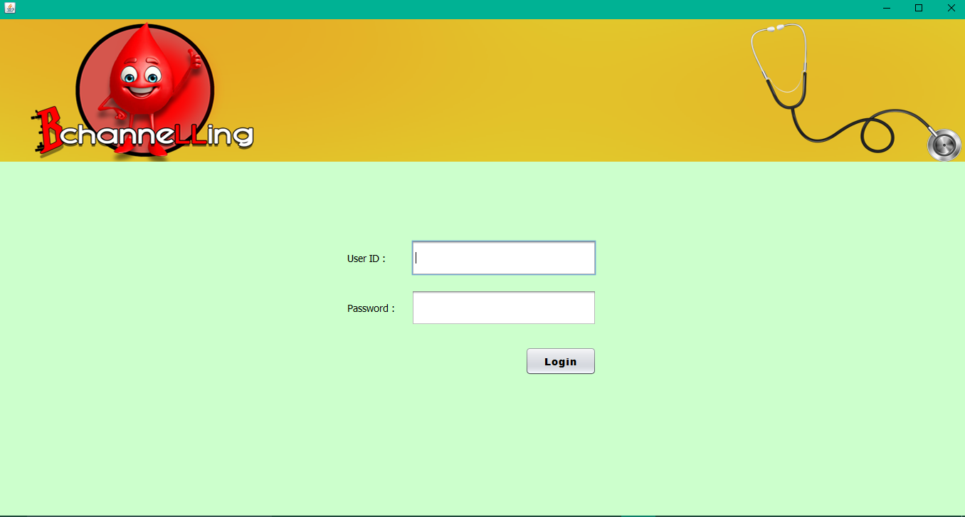

**3.2 USER**

User can register the account by fill the information about you and click on save button. He/she can add the account for the further enquiry of the blood donation. The user have to login to get more information about the blood bank.

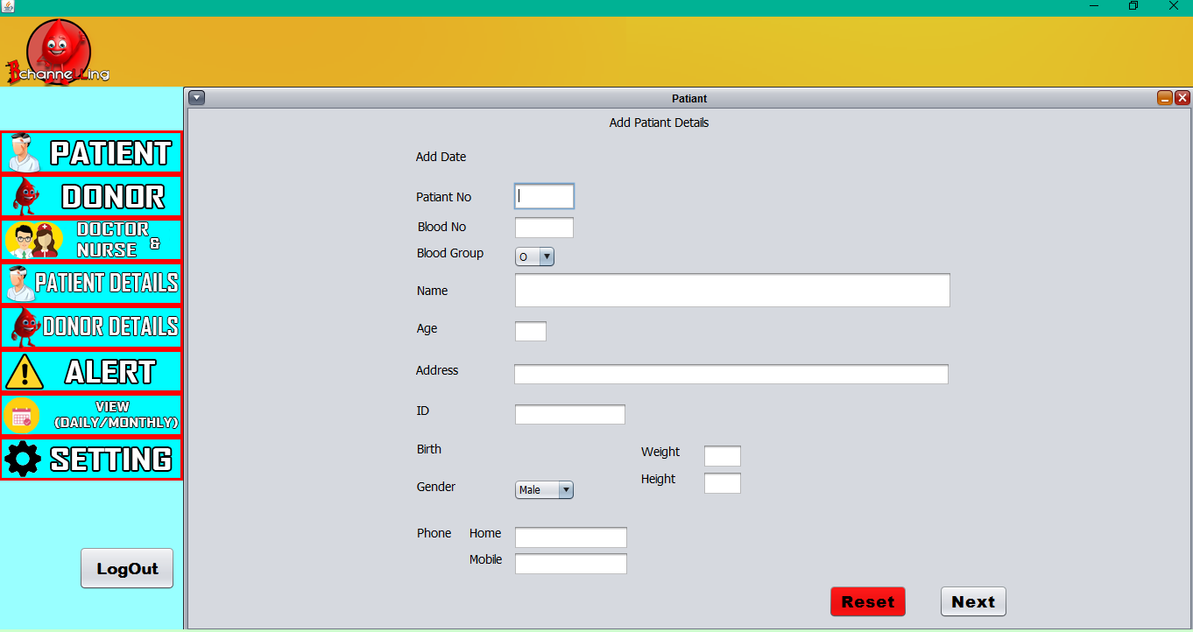

* **TWO TYPES OF ADMINS**

**3.3 ADMIN LEVEL USER**

Admin level user are a admin user, if he/she login a admin panel they work on a all the pages of the admin site like add user, update user, delete user, add city, update city, delete city etc.

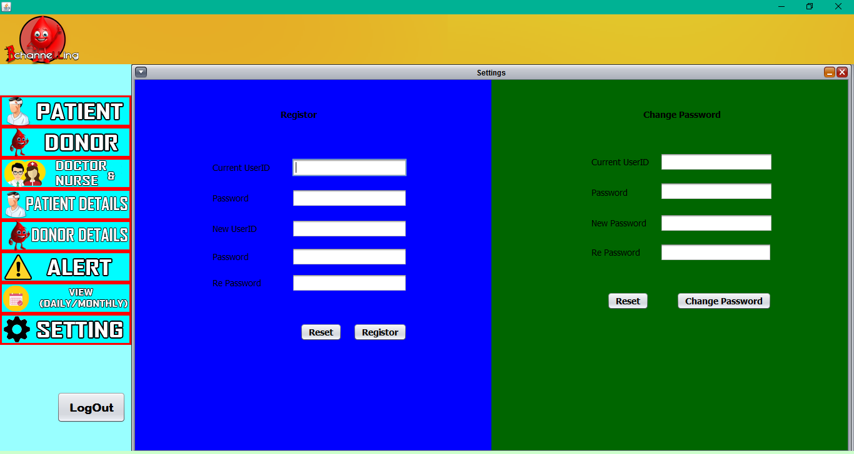

**3.4 GENERAL LEVEL USER**

General level user is a general user, if he/she login a admin panel they do not see all the pages of the admin site like add user, update user, delete user, add city, update city, delete city etc. They work on only an addition of the new user, city, state, camp etc.

**Chapter 04**

**• Main Page**

**4.1 Main Window**

The BLOOD BANK MANAGEMENT SYSTEM is great project. this project is designed for successful completion of project on blood bank management system. The basic building aim is to provide blood donation service to the city recently. Blood Bank Management System (BBMS) is a browser based system that is designed to store, process, retrieve and analyze information concerned with the administrative and inventory management within a blood bank. This project aims at maintaining all the information pertaining to blood donors, different blood groups available in each blood bank and help them manage in a better way.

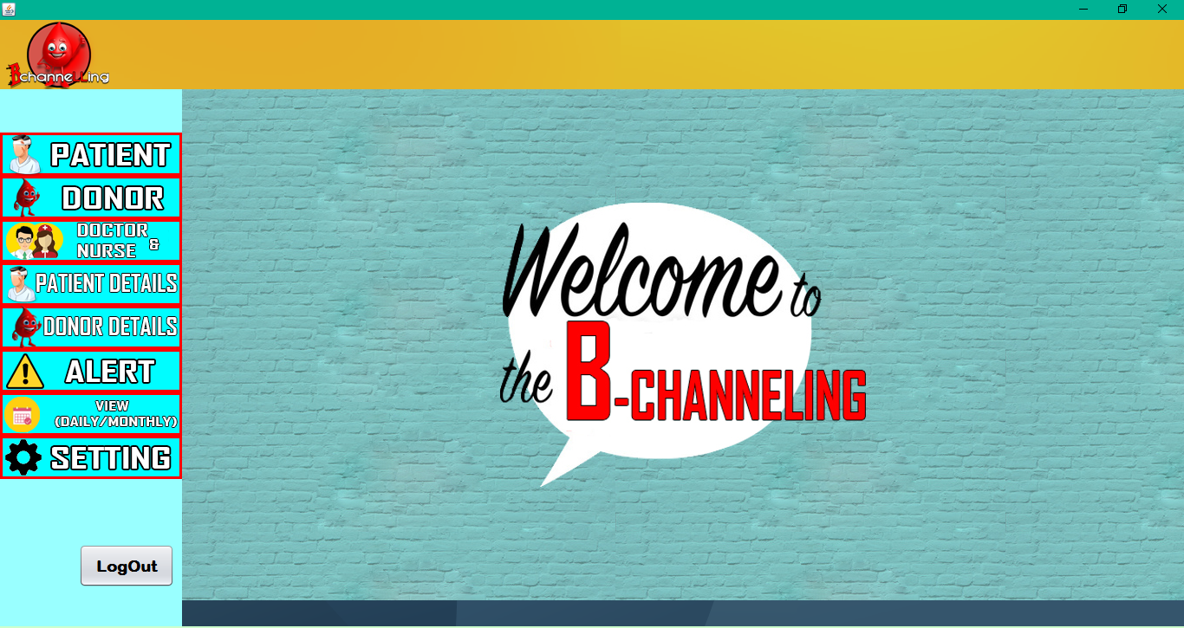

**4.2 Registration Page**

Registration page includes the information of the donor who want to register. Donor can register the account by clicking on new register. He/she can add the account for the further enquiry of the blood donation.



**4.3 Donor Login**

The page require donor id and password to open the donor pannel. Login is a process by which individual access to a computer system is controlled by identifying and authenticating the user through the cardinalities presented by the user. Donor can change password, update profile or view donations etc.

User Id = Admin

Password = 123



**Chapter 05**

* **Codding parts**

5.1 Login (Password,User Id)

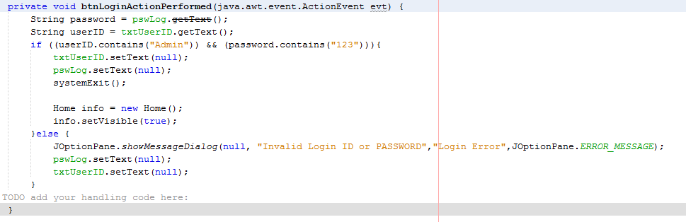

5.2 Home

5.2.1 Patient

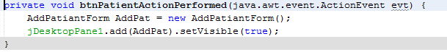

5.2.2 Donor

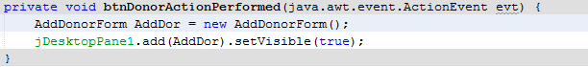

5.2.3 Doctor & Nurse

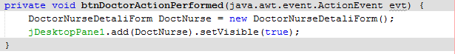

5.2.4 Alert

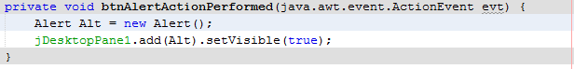

5.2.5 View (Daily and Monthly)

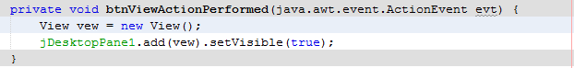

5.2.6 Settings

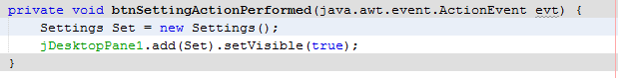

5.2.7 Log Out

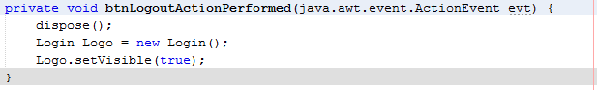

* **Codding parts(Database part)**

**5.2.8 Doctor save**

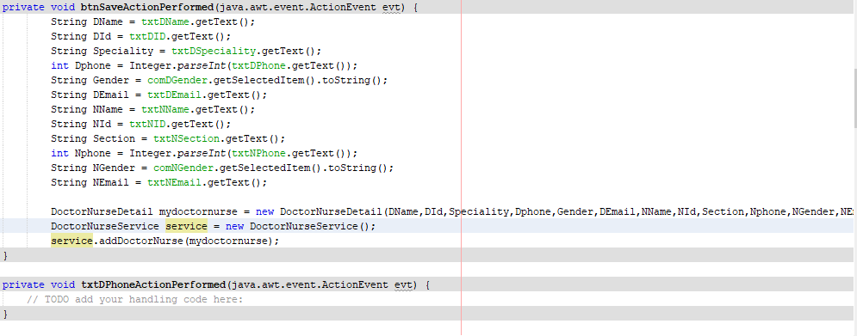

**5.2.9 Doctor table show**

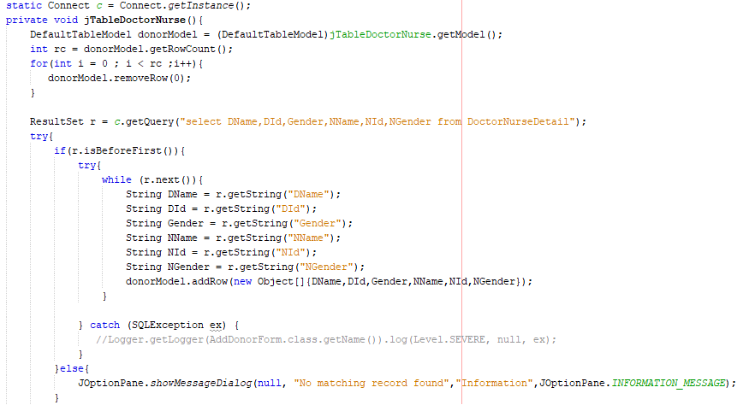

**5.2.10 Doctor reset**

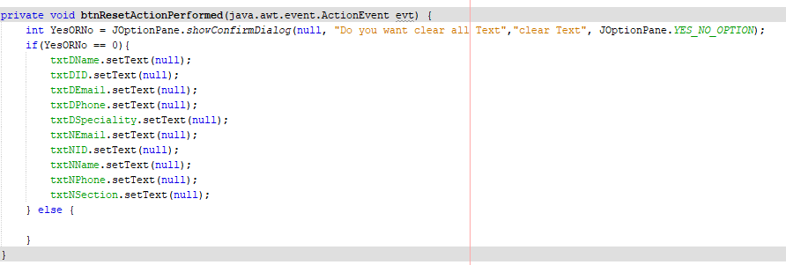

**5.2.11 Donor save**

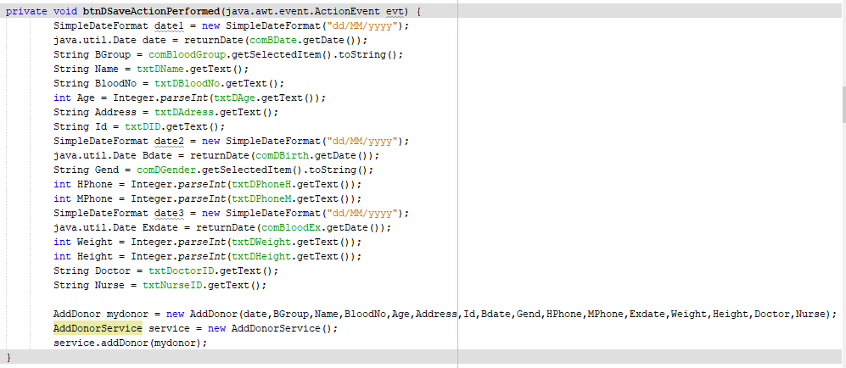

**5.2.12 Donor table show**

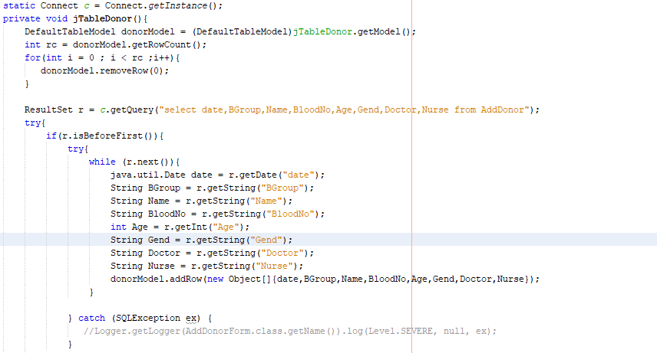

**5.2.13 Reset**

