Author

Name : Vinod Kumar

Mail : [vinodsharma0202@gmail.com](mailto:vinodsharma0202@gmail.com)

Description:-

This project demonstrate creation and control of progress bar with Jquery. Also a nice demonstration of testing framework QUnit is provided to test the widget js code. The project following MVC architecture with java script object approach. The widget is compatible with all browsers and works fine even on tab or mobile. HTML5 element had been used to demonstrate the usage with jquery.

SET UP

1. Please Create a web dynamic project in eclipse.

2. Create a package for ui as com.vinod.ui.progressbars

3. Create various files as given in this project. Please note that a number of jquery library files had been downloaded here and added in path. This was done to avoid any online dependency.

4. Create the test ui and test java script. We are using QUnit here as test framework.

5. Add the logic of progressbar value update and test it using controller_test.

6. Controller.js is the class which has all the control logic of this widget.

7. View.html is the view part of our widget. Please see the result by opening view.html in any browser.

8. Please see the testing result by opening view_test.html in any browser.

9. This widget is compatible with all the browsers.

Demo

1. Test case Running

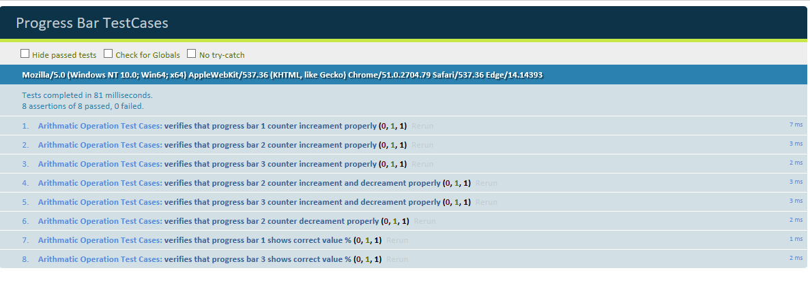

1. Application Running

a.)

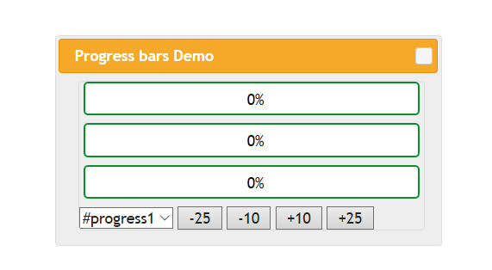

b.)

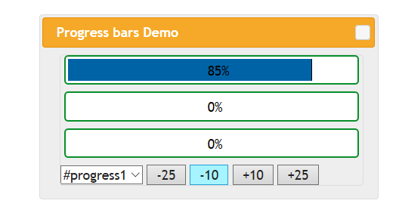

c.)

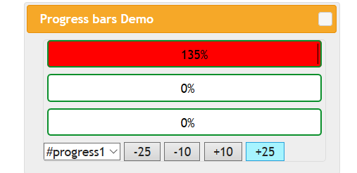

d.)

