**REMOTE DESKTOP LOGIN WORKFLOW**

Table of Contents

1. Objective 3

2. Prerequisites 4

3. Instructions 5

4. Argument Description 7

5. Handled Exceptions and Errors 8

# Objective

The Remote Desktop Login workflow will enable users to connect to the specified remote machine using ‘**Windows Remote Desktop Connection’** application. The workflow uses **‘Orchestrator Asset’** and ‘**Windows Credential Manager’**, as specified in the REFramework, for retrieving the credentials to login into the remote system. The users can use the workflow by invoking it and passing the IP address of the system to be accessed and name of the credential to be used.

# Prerequisites

1. The package **‘UiPath.Credentials.Activities’** should be installed.

# Instructions

Follow the below steps to use the RDP Login workflow:

1. Paste the **‘RDPLogin’** folder in the project’s folder where the workflow is intended to be used as depicted in Figure 1.

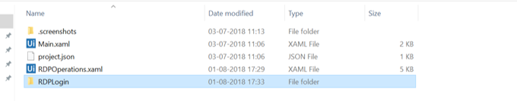

Figure 1: Adding the RDPLogin folder

1. Open the project in UiPath Studio. The files will appear in the ‘**Project’** tab under **‘RDPLogin’** folder as shown in Figure 2.

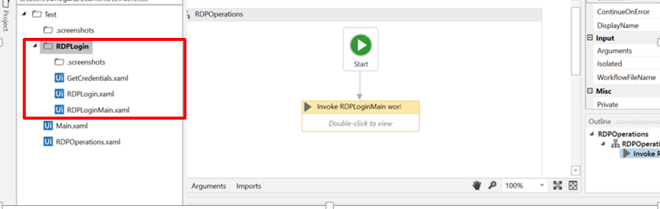

Figure 2: RDPLogin files in Project tab

1. Use the activity **‘Invoke Workflow File’** and select the file **‘RDPLogin\RDPLoginMain.xaml’** or drag and drop **‘RDPLoginMain.xaml’** at the desired position as shown in Figure 3.

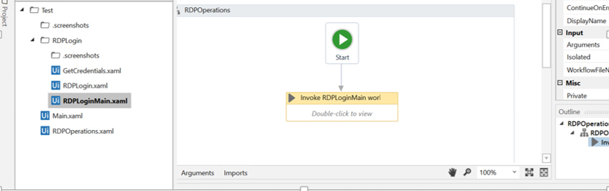

Figure 3: Invoking ‘RDPLoginMain.xaml’

1. Double click on **‘Invoke RDPLoginMain workflow’** and click on ‘**Import Arguments**’ as shown in Figure 4.
2. Add values to the arguments ‘**in_IPAddress’** and ‘**in_CredentialName’** using variables or type the values as shown in Figure 4.

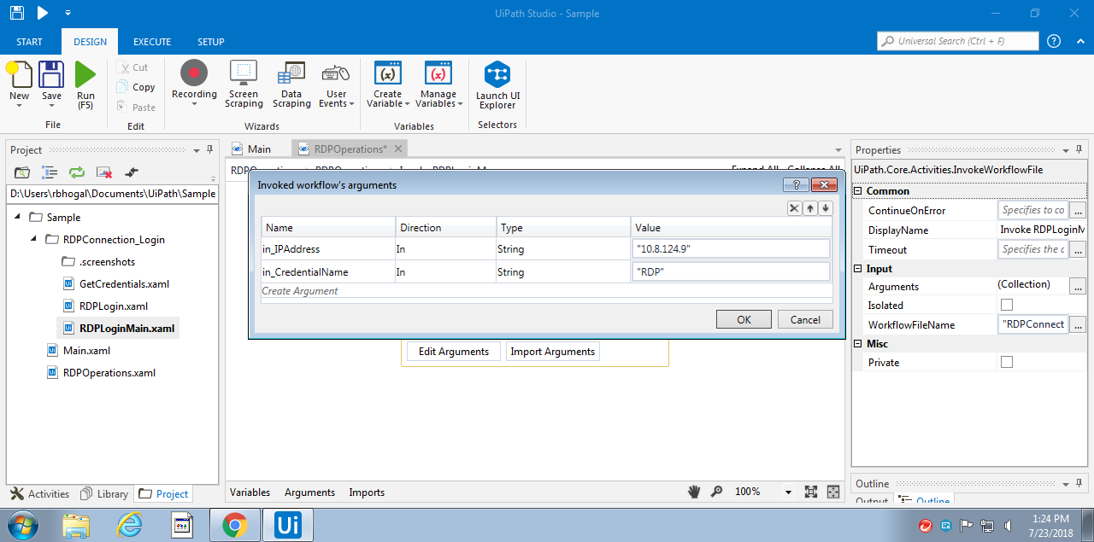

Figure 4: Importing arguments and adding values to arguments

# Argument Description

The workflow takes the following arguments as input:

|  |  |  |  |
| --- | --- | --- | --- |
| **S.No.** | **Argument Name** | **Direction** | **Description** |
| 1. | in_CredentialName | In | The name of the Orchestrator Asset or Windows Credential from where user name and password for the remote desktop connection are to be retrieved. |
| 2. | in_IPAddress | In | The IP Address of the remote system to be accessed. |

# Handled Exceptions and Errors

The following scenarios have been handled in the workflow:

|  |  |  |
| --- | --- | --- |
| **S.no.** | **Scenario** | **Outcome** |
| 1. | The name of the credential is not specified | User is asked to enter the username and password |
| 2. | The specified credential does not exist in Orchestrator | The credential is searched for in Windows Credential Manager. If the credential is found, the workflow continues with the username and password specified in the credential. If the credential does not exist in the Windows Credential Manager, a dialog box appears where user is asked to enter the username and password and a Windows Credential is created. The workflow then continues. |
| 3. | User saved blank username | Workflow ends and a log message is added stating ‘Username is blank’. |
| 3. | IP address is blank or contains invalid characters | Workflow ends and a log message is saved stating ‘Blank or invalid IP Address. |
| 4. | Unable to connect to the specified remote machine | Workflow ends and a log message is saved stating ‘Cannot connect to the remote computer’ |
| 5. | The specified IP cannot be found | Workflow ends and a log message is added stating ‘Cannot find the computer specified’ |
| 6. | Unable to login with the specified credentials | The workflow ends and a log message is saved stating ‘Unable to login with the Orchestrator Asset (or Windows Credential, whichever is applicable) ‘*credential name*’*’.* |
| 7. | Certificate error warning after successfully logging in | The button ‘Yes’ is clicked and workflow ends. |