Get Excel Data from Citrix Workflow

Table of Contents

1. Objective 3

2. Introduction 4

3. Prerequisites 5

4. Instructions 6

5. Argument Description 9

6. Handled Exceptions and Errors 10

# Objective

Automating in Citrix environment is always a challenging task. Moreover if the automation deals with a lot of Excel files then fetching the data from Citrix environment and performing operations on it is even more challenging. Hence, I have decided to bring the Excel data from Citrix environment into local datatable.

# Introduction

This workflow enables users to get the Excel data from Citrix environment and store it in a Datatable. This workflow works similarly to the ‘Read Range’ Excel activity where the range is provided and the output is stored in a Datatable. To use this workflow, users have to pass below details as parameters:

1. **FilePath**: the path of excel file in the Citrix environment.
2. **SheetName**: the sheet on which the read operations has to be performed. If no value is provided, then the first sheet is considered for reading.

# Prerequisites

Following are the prerequisites for this workflow to run properly:

1. Microsoft Excel must be installed in both Citrix and Local Environment.
2. Microsoft Excel activities must be installed in Uipath.
3. Citrix client must be indicated inside the workflow before the first run.

# Instructions

Follow the below steps to use the workflow:

1. Paste the **‘GetExcelData_Citrix’** folder in that project’s folder where this workflow is intended to be used as depicted in Figure 1.

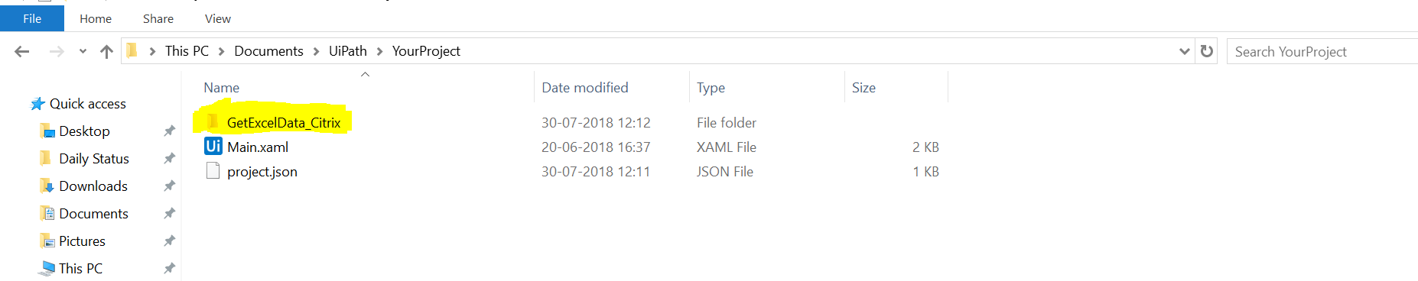

Figure 1: Adding the GetExcelData_Citrix folder

1. Open the project in UiPath Studio. The files will appear in the ‘**Project’** tab under **‘GetExcelData_Citrix’** folder as shown in Figure 2.

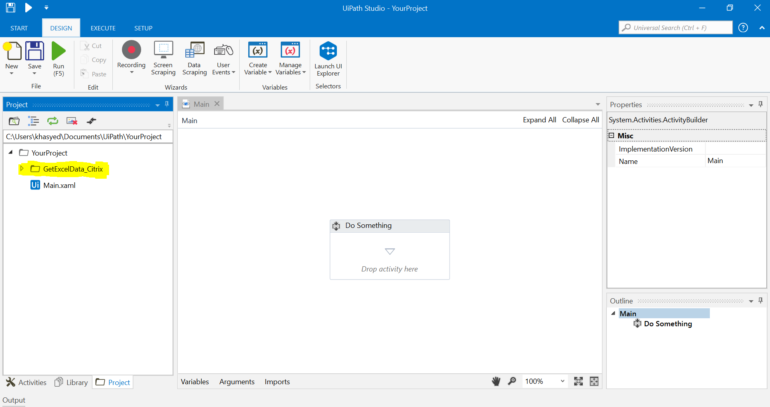

Figure 2: GetExcelData_Citrix files in Project tab

1. Open the **‘Open_Excel_Citrix’** workflow from the folder **‘GetExcelData_Citrix\Workflows’** as shows in the Figure 3.

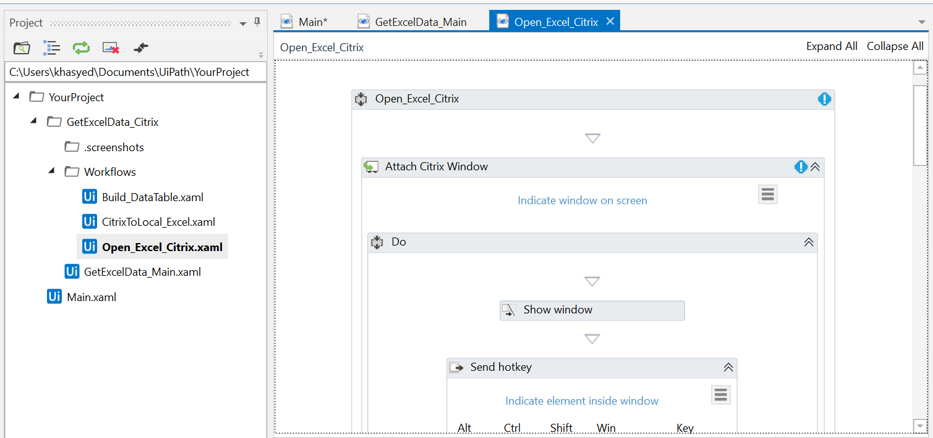

Figure 3: Open ‘Open_Excel_Citrix’ workflow

1. Attach the Citrix window by clicking ‘Indicate window on screen’ as shown in the Figure 4 and save the workflow.

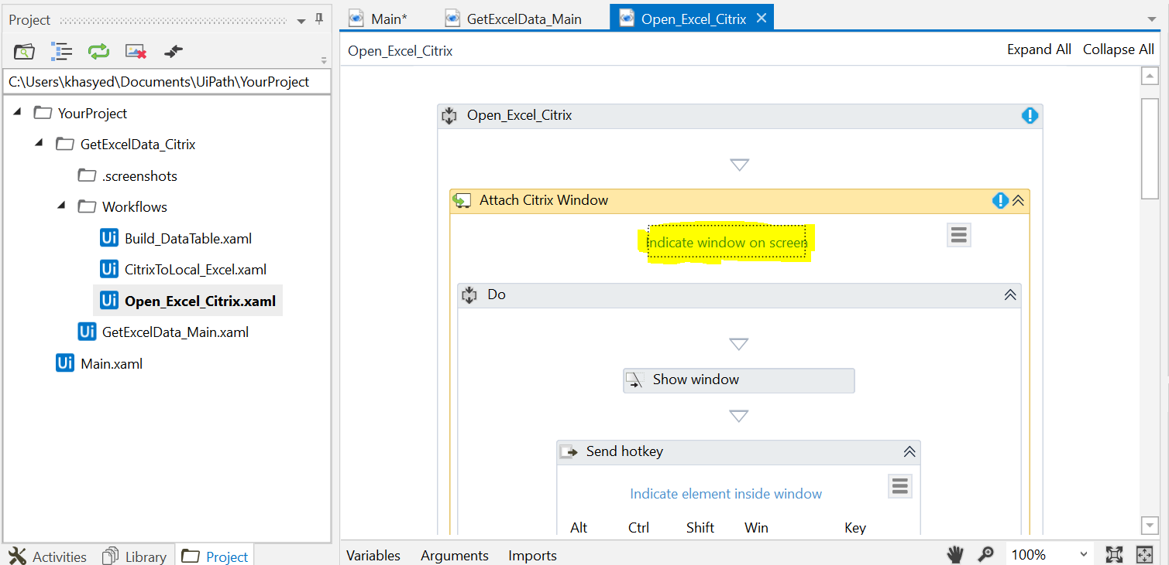

Figure 4: Attaching Citrix window in **‘Open_Excel_Citrix’** workflow

1. Drag and drop **‘GetExcelData_Main’** at the desired position as shown in Figure 5.

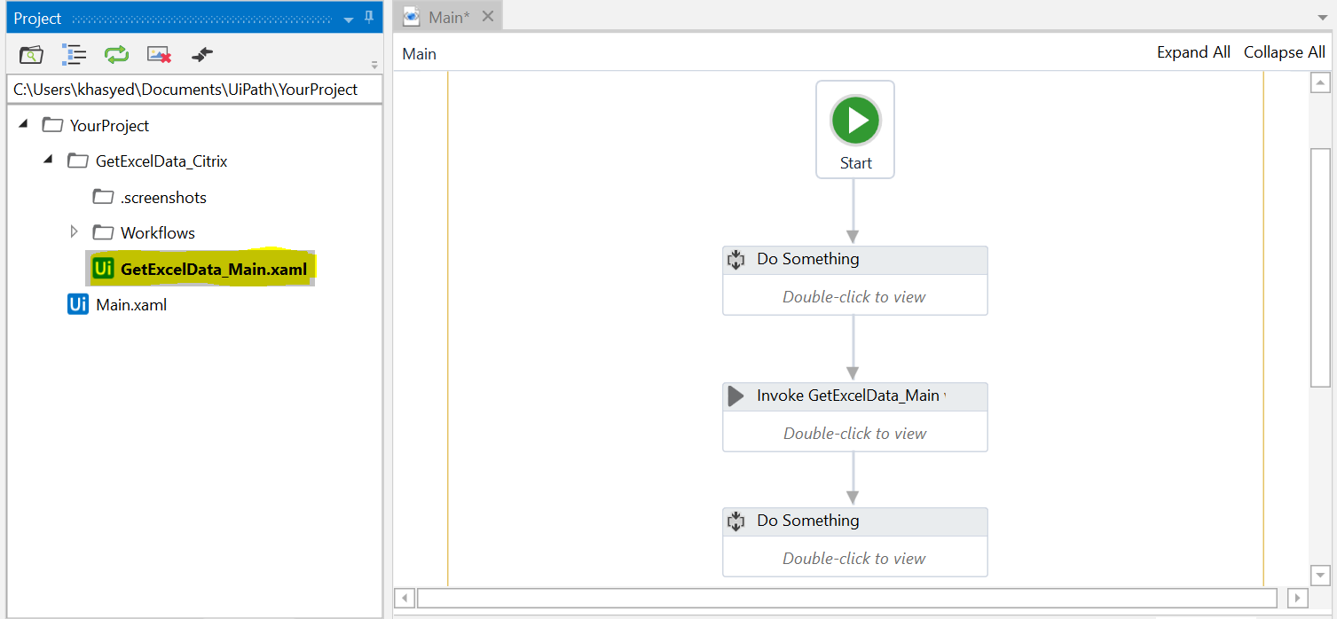

Figure 5: Invoking ‘GetExcelData_Main.xaml’

1. Double click on **‘Invoke GetExcelData_Main workflow’** and click on ‘**Import Arguments**’ as shown in Figure 6.
2. Add values to the arguments ‘**in_ExcelPath’**, ‘**in_SheetName’** and **‘out_dt_Excel’** using variables or type the values as shown in Figure 6.

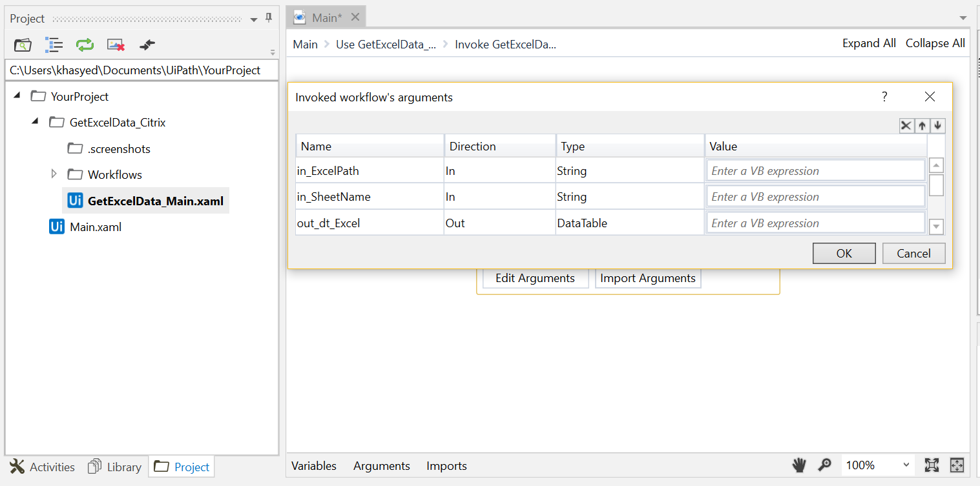

Figure 6: Importing/Exporting arguments

# Argument Description

The workflow takes the following arguments as input/output:

|  |  |  |  |
| --- | --- | --- | --- |
| **S.No.** | **Argument Name** | **Direction** | **Description** |
| 1. | in_ExcelPath | In | The path of the Excel file in the Citrix environment. |
| 2. | in_SheetName | In | The name of the Sheet on which read operations have to be performed. If this argument is empty, it will take the first sheet from the Excel file. |
| 3. | out_dt_Excel | Out | A Datatable containing all the excel data. |

# Handled Exceptions and Errors

The following scenarios have been handled in the workflow:

|  |  |  |
| --- | --- | --- |
| **S.no.** | **Scenario** | **Outcome** |
| 1. | Excel file is not opened | Retrying for the second time. If unable to open again then End state is triggered. |
| 2. | Cannot find image to select all the data | Hotkey is sent to select all the data |
| 3. | If no data in excel file | Transition to the End state |