**SERVICE NOW TICKET CREATION WORKFLOW**

Table of Contents

1. Objective 3

2. Prerequisites 4

3. Instructions 5

4. Argument Description 8

5. Handled Exceptions and Errors 9

# Objective

The ‘**Service Now Ticket Creation Workflow’** facilitates users to create tickets inService Now (ticketing tool) using REST web service. The workflow uses **‘Orchestrator Asset’** and ‘**Windows Credential Manager’**, as specified in the REFramework, for retrieving the credentials to login into service now.

The user can utilize this workflow by invoking it and passing the below arguments:-

* **Credential Name** – Name of the Orchestrator Asset or Windows Credential to be used for instance login.
* **Service Now Instance** – Instance URL to be accessed
* **Ticket Creation File** - Details for ticket (in csv format)

# Prerequisites

Following are the prerequisites for this workflow:-

1. Web activities must be installed from Manage package - **uipath.web.activities**
2. Credential activities must be installed from Manage package - **Uipath.credential.activities**

# Instructions

1. Paste the **‘ServiceNow_Ticket_Creation**’ folder in that project’s folder where Service Now Ticket Creation workflow is intended to be used as depicted in Figure 1.

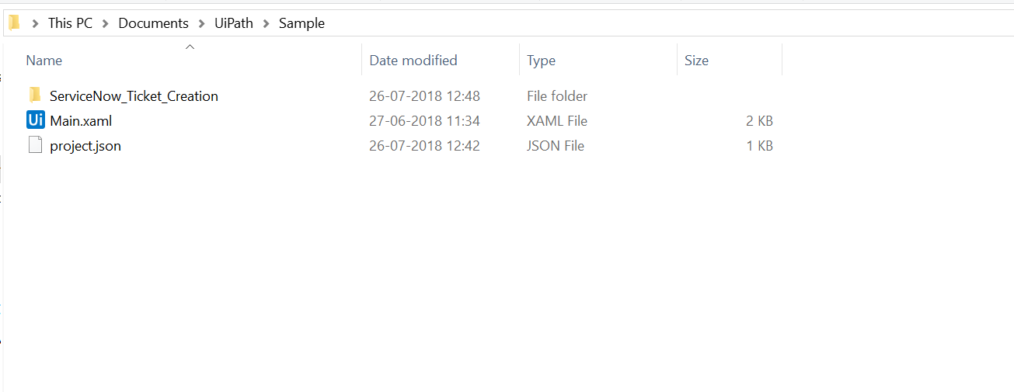

**Figure 1:** Adding the ServiceNow_Ticket_Creation folder

1. Open the **ServiceNow_Ticket_Creation** folder and open **webservice.csv file** and provide details (as per requirement) and specify the Ticket_ type – Incident/Request as shown in Figure2.2

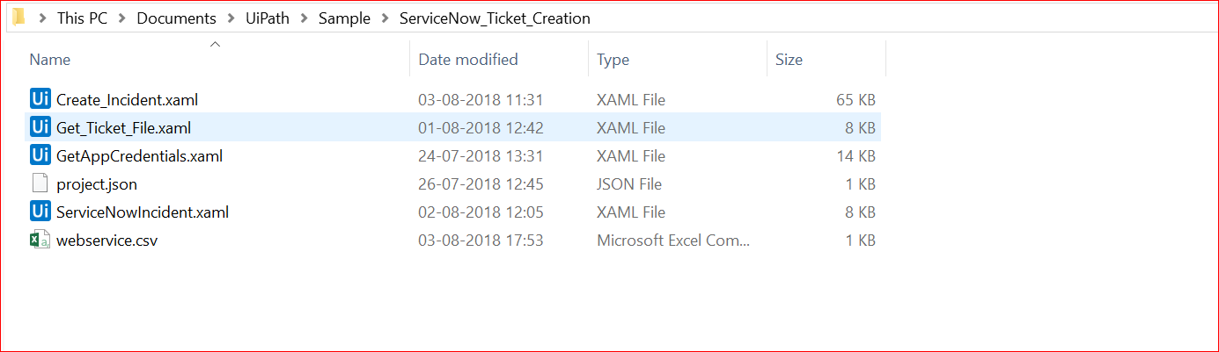

**Figure 2.1:** Opening the Ticket creation file (webservice.csv)

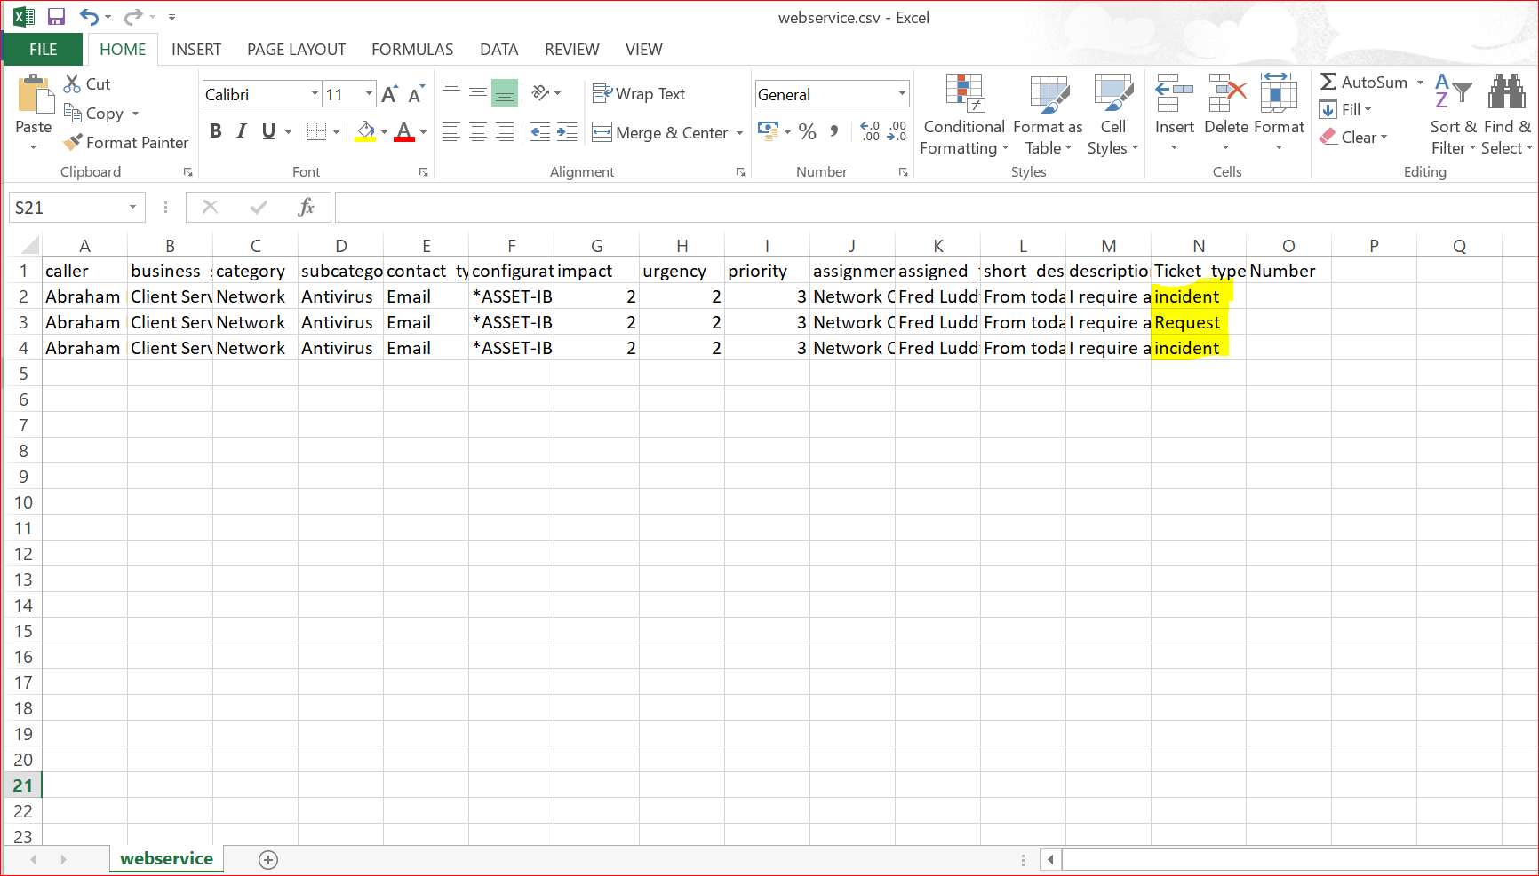

**Figure 2.2:** Adding Details in Ticket Creation File(webservice.csv)

1. Open the project in UiPath Studio. The files will appear in the ‘**Project’** tab under **‘ServiceNow_Ticket_Creation** ‘folder as shown in Figure 2.

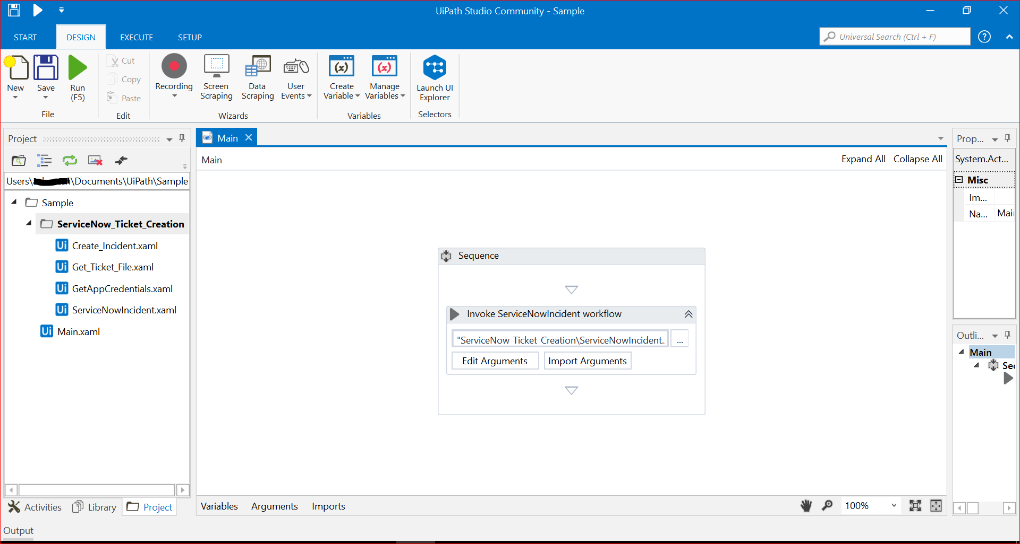

**Figure 2:** ServiceNow_Ticket_Creation files in Project tab

1. Use the activity **‘Invoke Workflow File’** and specify the workflow path as **‘ServiceNow_Ticket_Creation** **\ServiceNowIncident.xaml’** or drag and drop **‘ServiceNowIncident.xaml** at the desired position.
2. Double click on **‘Invoke ServiceNowIncident workflow’** and click on ‘**Import Arguments**’.
3. Add values to the arguments, ‘**In_Credential’**, ‘**In_ServiceNowInstance’** and‘**In_Ticket_file’** using variables or type the values as shown in Figure 3.

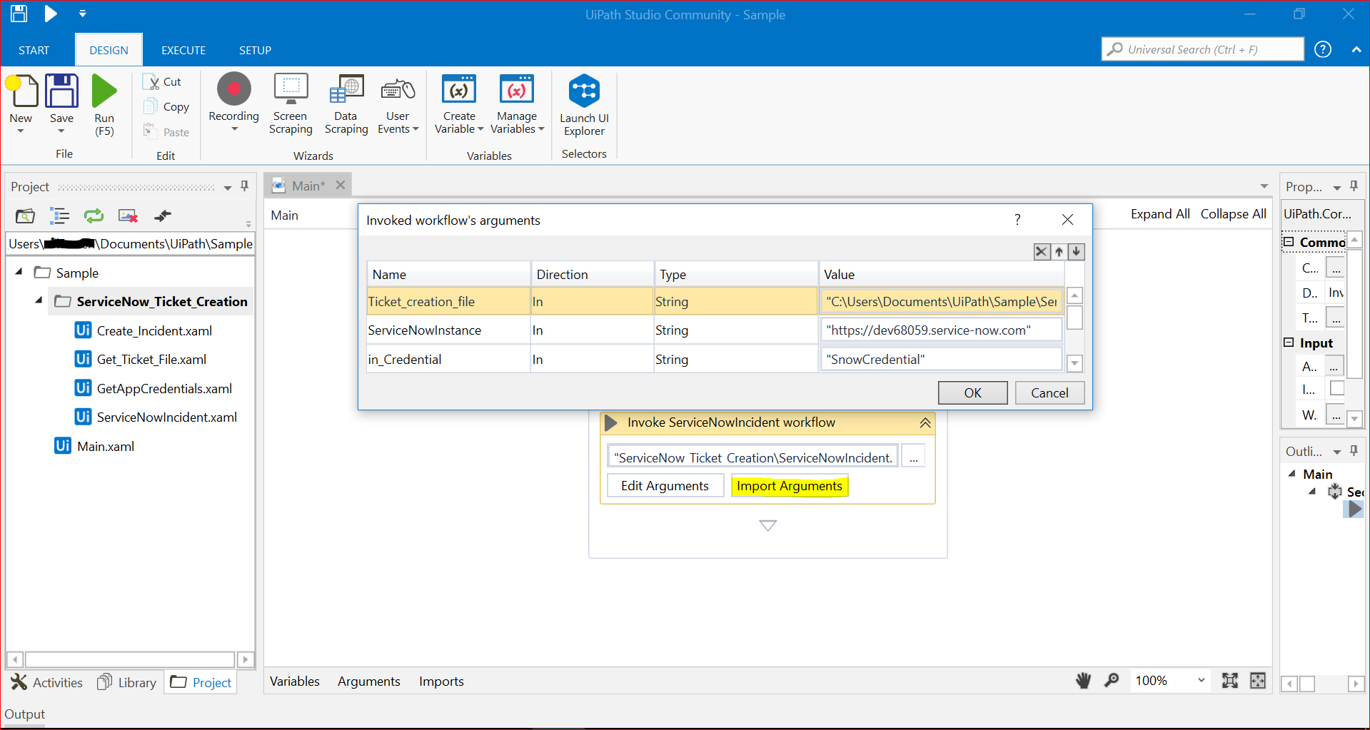

**Figure 3:** Importing arguments and adding values to arguments

# Argument Description

The workflow takes the following arguments as input:

|  |  |  |  |
| --- | --- | --- | --- |
| **S.No.** | **Argument Name** | **Direction** | **Description** |
| 1. | In_Credential | In | The name of the Orchestrator Asset or Windows Credential from where user name and password for the Service Now instance are to be retrieved. |
| 2. | In_ServiceNowInstance | In | The URL of Service Now to be accessed for creation of tickets. |
| 3. | In_Ticket_file | In | File which consists of ticket details (csv format). |

# Handled Exceptions and Errors

The following scenarios have been handled in the workflow:

|  |  |  |
| --- | --- | --- |
| **S.no.** | **Scenario** | **Outcome** |
| 1. | The name of the credential is not specified | User is asked to enter the username and password |
| 2. | The specified credential does not exist in Orchestrator | The credential is searched for in Windows Credential Manager. If the credential is found, the workflow continues with the username and password specified in the credential. If the credential does not exist in the Windows Credential Manager, a dialog box appears where user is asked to enter the username and password and a Windows Credential is created. The workflow then continues. |
| 3. | User saved blank username | Login is attempted with the blank username. A log message is added stating ‘Invalid Credential’ and the workflow ends. |
| 3. | Service Now instance URL is blank or invalid | Workflow ends and a log message is saved stating ‘Invalid Service now instance’. |
| 4. | Service Now instance is in sleep mode | Workflow ends and a log message is saved stating ‘Service now instance is in sleep mode’. |
| 5. | Ticket Creation file path is blank | Workflow ends and a log message is added stating ‘Ticket creation file not found’ |
| 6. | Ticket Creation file path is Invalid | Workflow ends and a log message is added stating ‘Invalid File Format’ |
| 7. | Ticket type is not specified in .csv file. | Workflow ends and a log message is added stating ‘Specify the ticket type – incident/request |