Assignment – 1

• Install Power BI Desktop and share the final screenshot of the report view page which appears when power desktop starts.

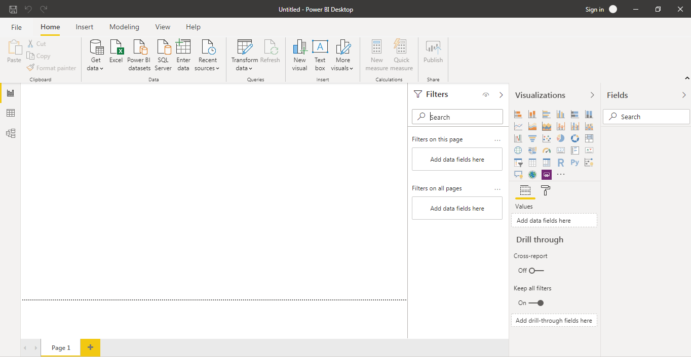

• Prepare a document and with the following screenshot

− Report View

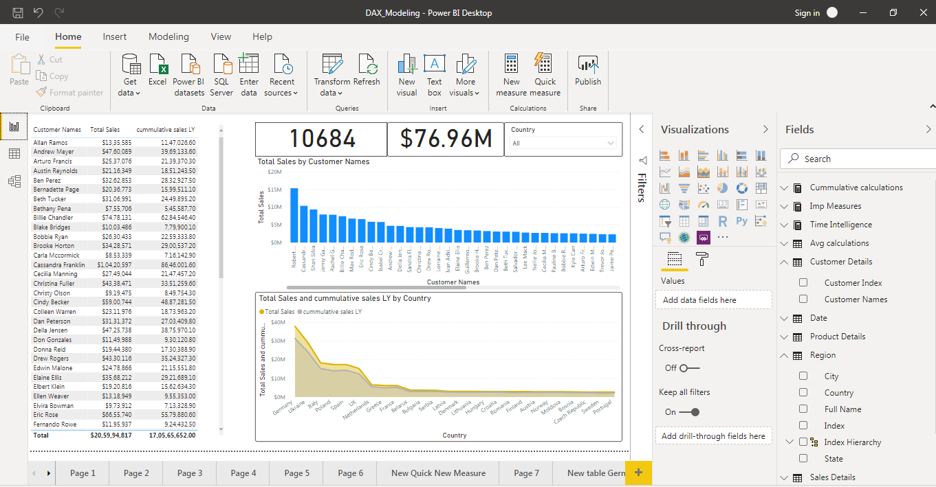

− Data View

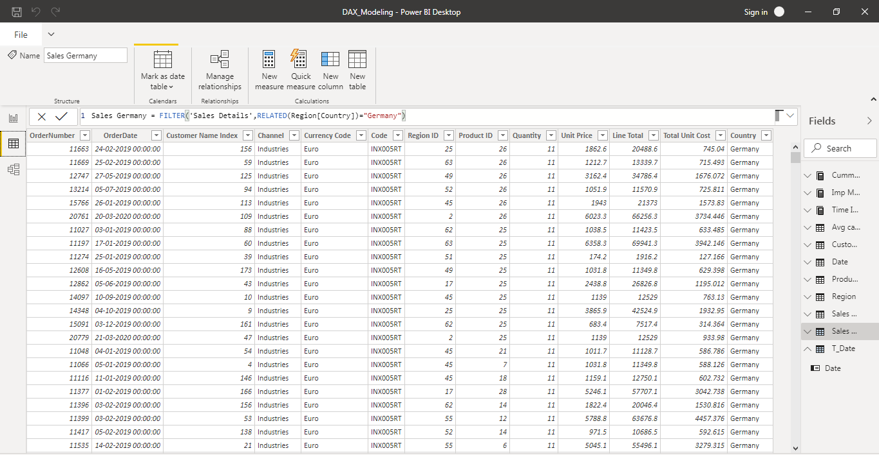

− Model View

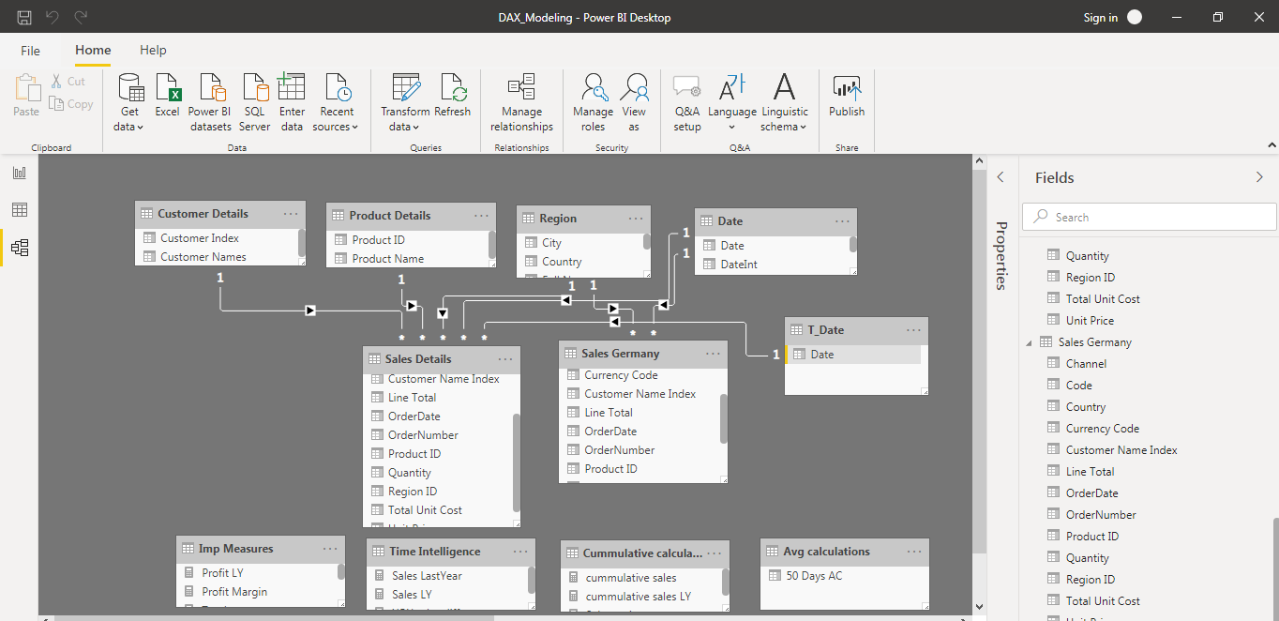

− Power Query Editor

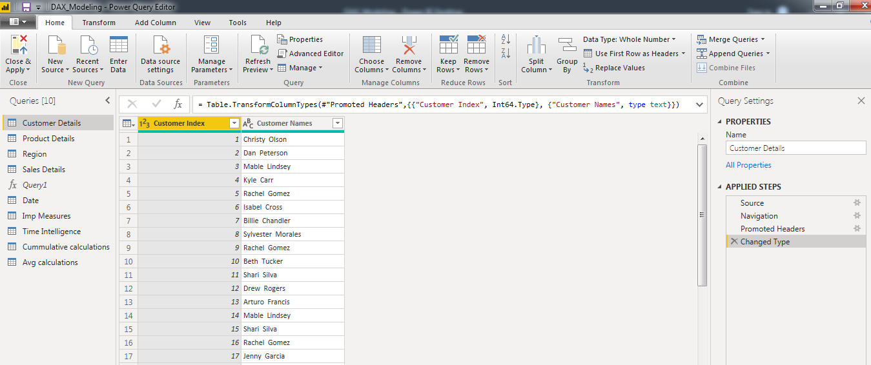

− Advance Editor

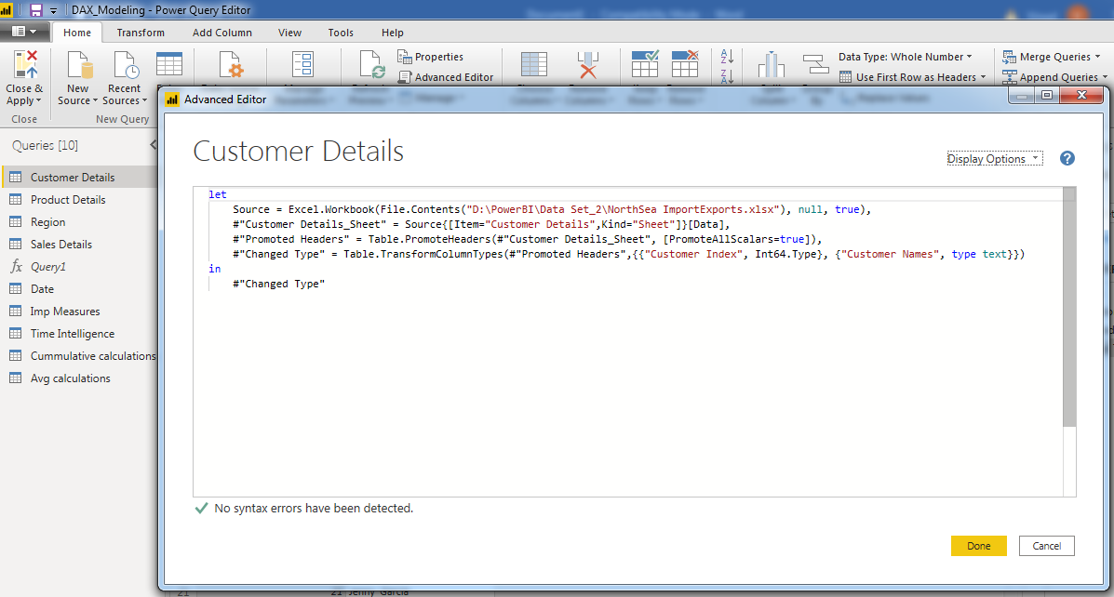

• Prepare a document with details of the following along with their price

− Power BI Desktop

− Power BI Pro

− Power BI Premium

**Power BI Desktop:** Power BI Desktop is basically the version of Power BI that you install on to your local system / computer to access the basic features of Power BI. and act as a companion to the main, cloud-based application. It is the ideal version to start with no matter your skill level Power BI Free enables you to connect to 70+ data sources, analyse data, publish to the web, export to excel and much more. this version of Power BI is free to download and use while giving you all the basic features of Power BI.

**Price: Free**

**Power BI Pro:** Power BI Pro is the full version of Power BI, which means it comes complete with the ability to use Power BI for both building dashboards, reports and unlimited viewing, sharing and consumption of your created reports (and reports shared by others) which is not possible with Power BI Desktop. The biggest difference of Power BI Pro vs. Free is the fact that with Pro you have the option and the ability to share the data, reports, and dashboards with a large number of other users that also have a Power BI Pro license while also being able to create an app based workspace. Furthermore, in Power BI Pro vs. Free you have a 10 GB per Pro user data storage limit.

**Price: $9.99 Monthly per user**

The Power BI Premium licence is not a per-user licence like a Free or Pro Licence. Instead, Power BI Premium licence provides a dedicated unit of capacity for all users in the organisation. This dedicated capacity (aka Premium Workspace) can be used to host large datasets up to 50GB while offering a total storage of 100TB in the cloud. It enables the organization to use your own dedicated capacity and hardware rather than relying on Microsoft’s shared capacity. Although you will in fact need to determine said capacity accurately and ensure that it has the capabilities to handle your reporting and analysis needs. This allows for much larger scale and better performance if you size the capacity properly. Microsoft offers three sizes for Premium capacity and each come with a different number of v-cores and memory size.

**Price: $4,995 Monthly price per dedicated cloud compute and storage resource with annual subscription**