OverView Of Projects

Details And SnapShots

Details =>

1. Project is About Job Poratal Like Linkedin and Naukri.
2. Technology Used

* React.Js
* Node.Js
* MongoDB
* Express.js
* Css and TailwindCss

1. two Role for the app

* Employer – Add job , Delete Job ,Manage Job list for the company, send notification about job to candidate.
* Candidate = can apply for job, edit and improve profile, see the feedback by given Employer

1.Landing Page

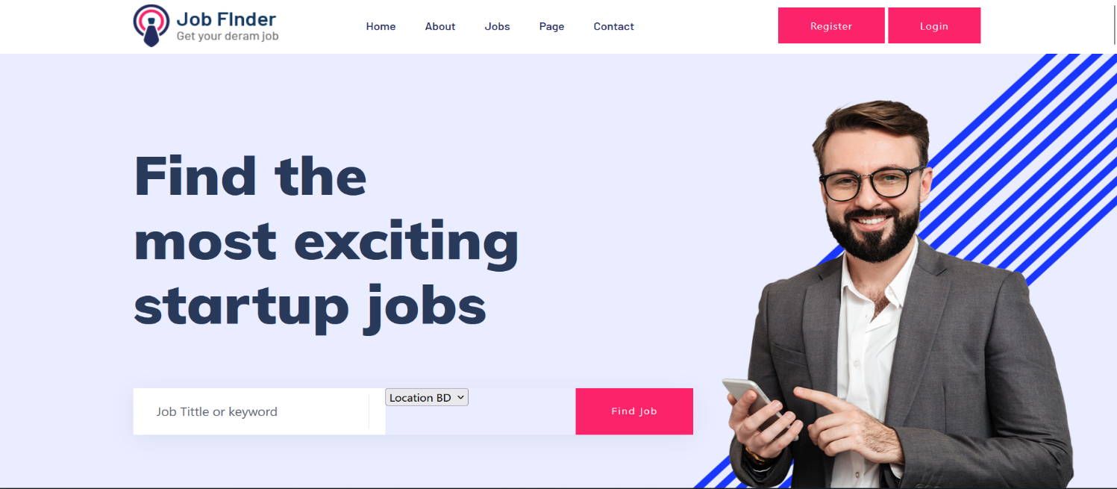

2.After Login(Candiate)

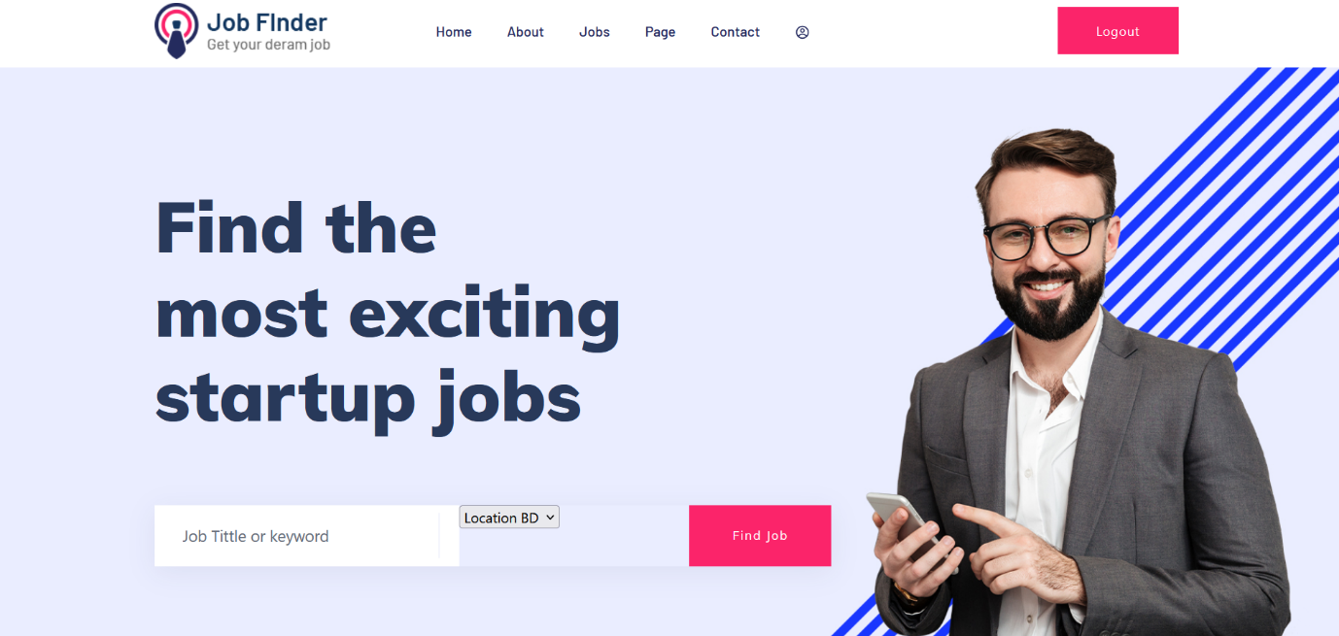

3.Candidate Can Find Job By Category or title

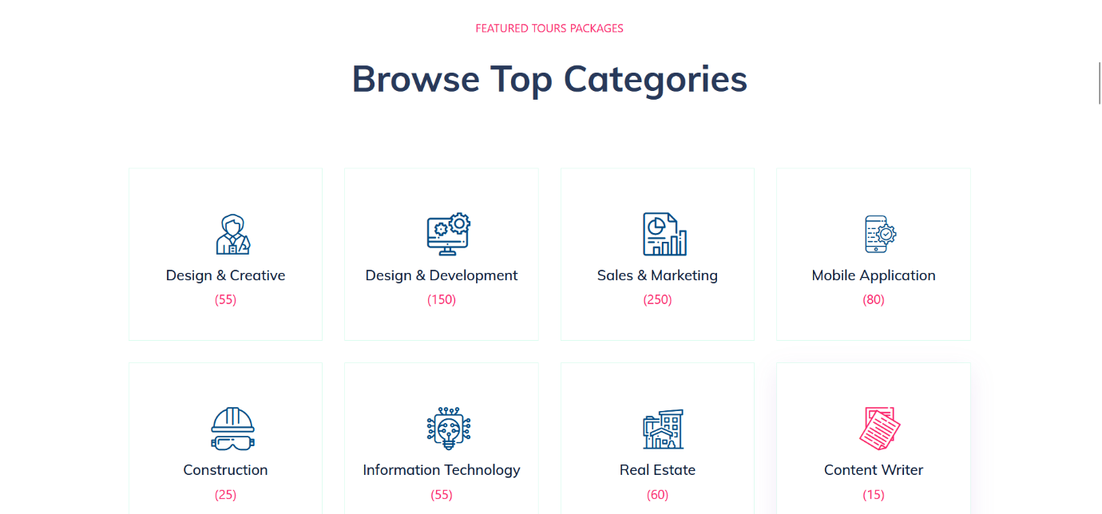

4.After Click On Category w can land on Job List of releted category.

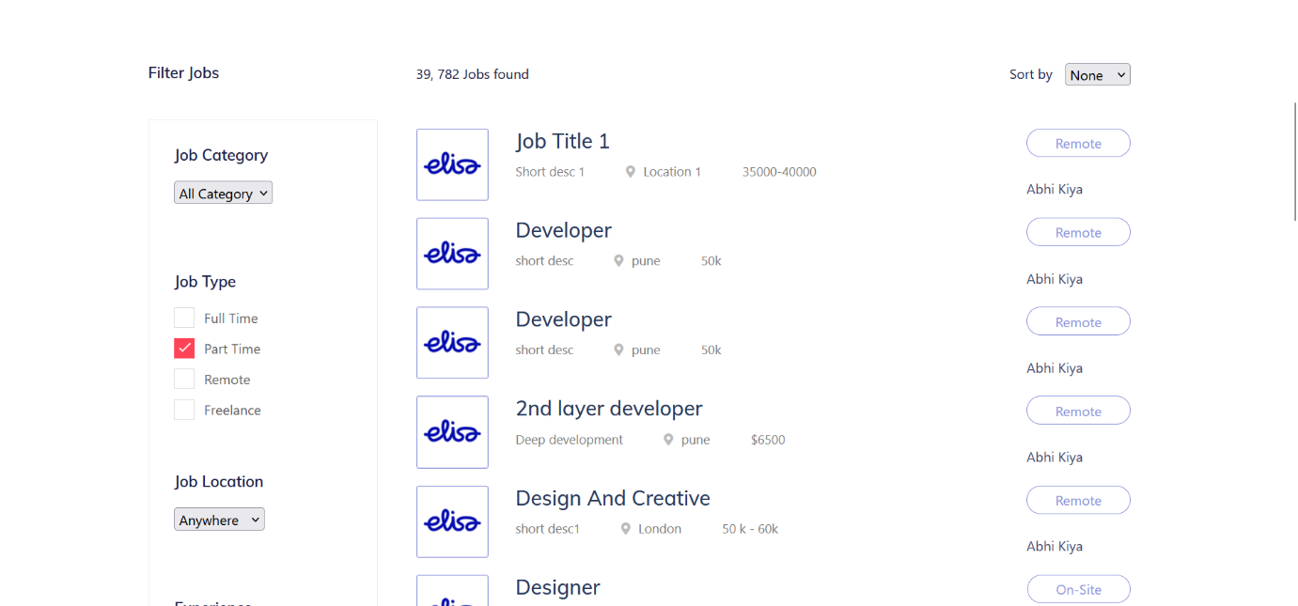

5. On Job list after click on the job , Job Details Page Open.

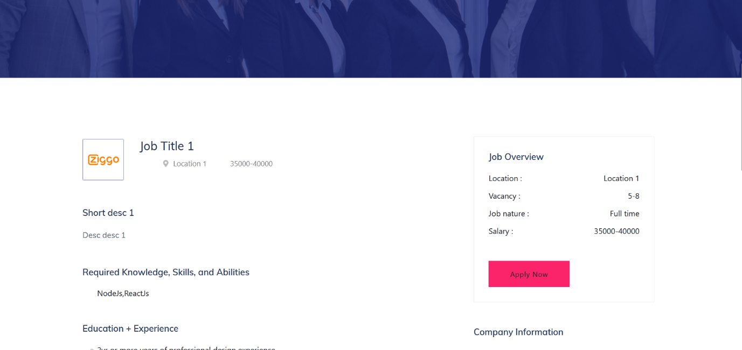

6. Candidate Profile Deatail Page.

Candidate can Edit the details and also complete 100% profile from this page.

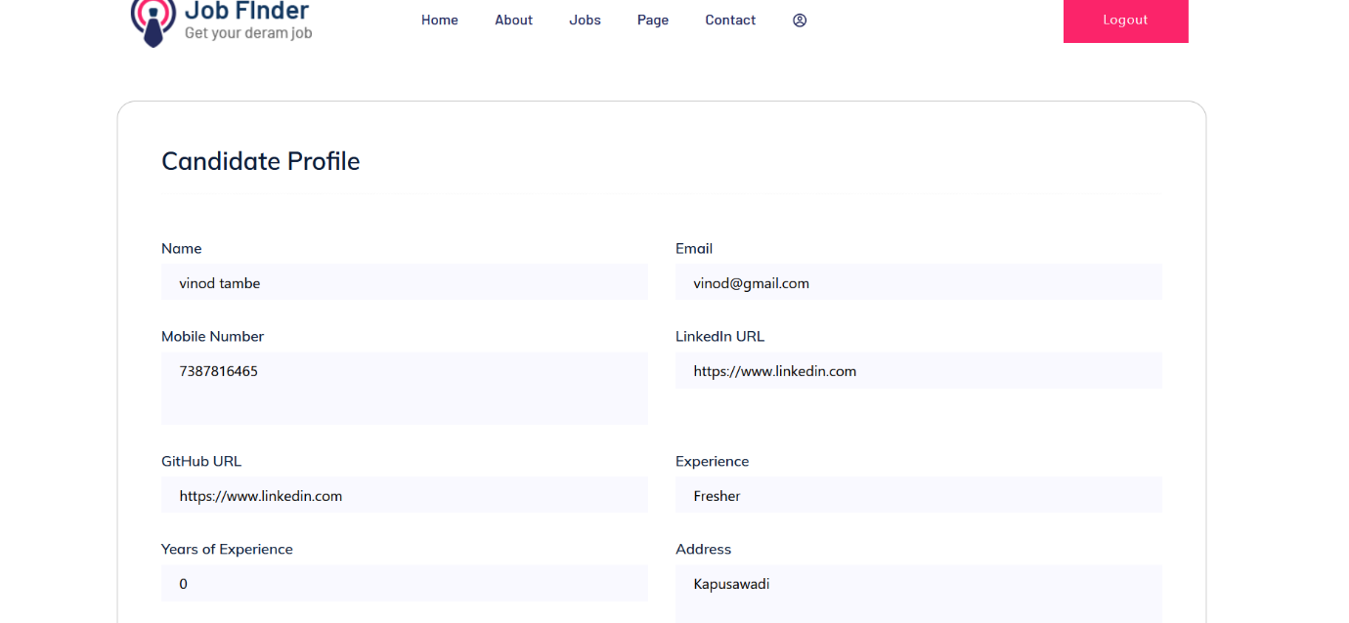

7.Employer Navbar

After Employer login ,

On navbar we can see the employer access

Like add job , and edit the job details.

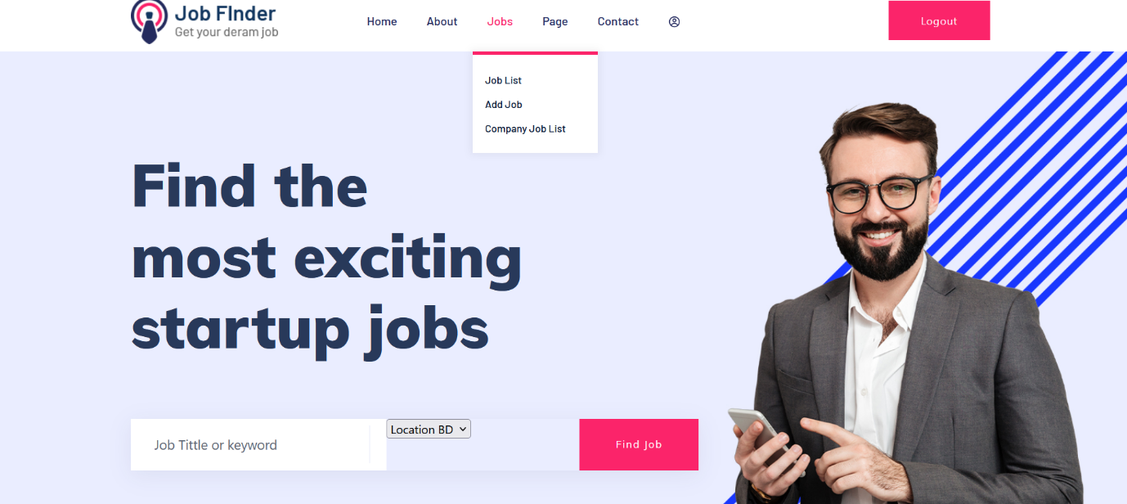

8.Add job Page

Employer can add job

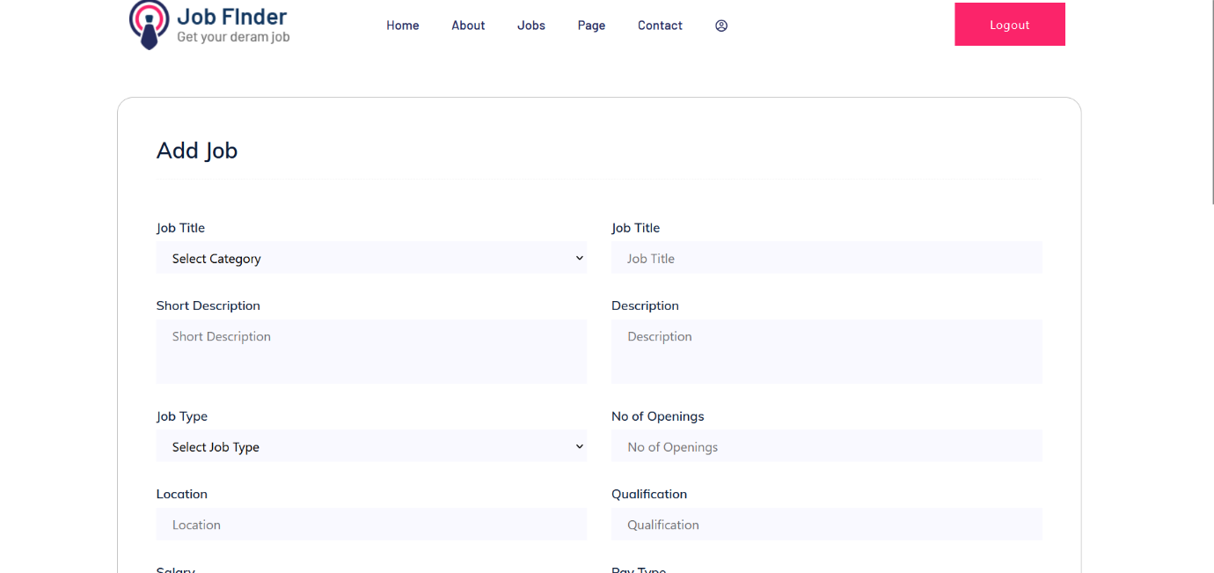

9. Job View

Employer can get list of candidate who applied for the employer job only candidate visible that has been applied to login employer.

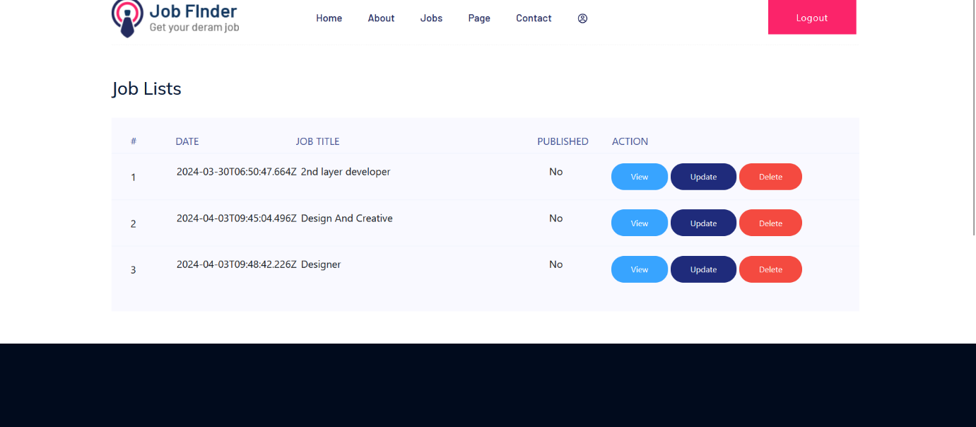

On above page we can view update the information for the candidate.

10.Company Detail page

Here employer can edit job information



* Database Screenshot

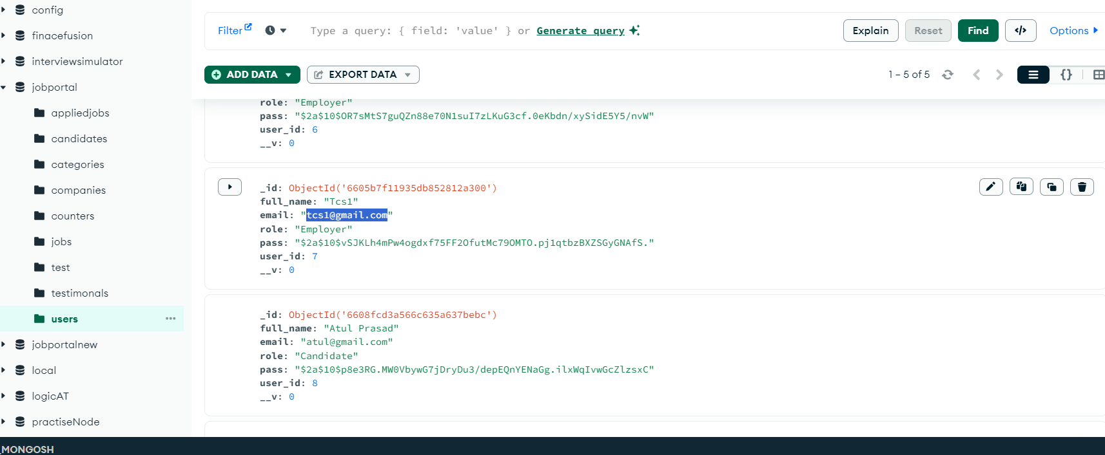

* Postman (Api Testing)