Details and SnapShot Of Web Pages

Details=>

1. We consider this provider app as the clone of urban clap.
2. Implemented Same app with same working as urban clap.
3. In this Service Provider App, there are 2 role:  
    a. user  
    b. Provider   
    c. admin -> admin can have both the access of provider and user not in terms of privacy, but it can track the history or booking details , so user can get the smooth service provider help.
4. Also after completion of service user can add the feedback for the service provider on the scale of 1 to 5.
5. Library used in the project  
   => Google Map.  
   => Axios for data fetching.  
   => WebSocket   
   =>JsonWebToken  
   =>Icons.  
   =>Bcrypt …….. etc.

SnapShots =>

1.Login Page.

2.User Login.

3.Provider Registration.

4.Provider Login .

5.Home Page.

6.Provider Profile Page.

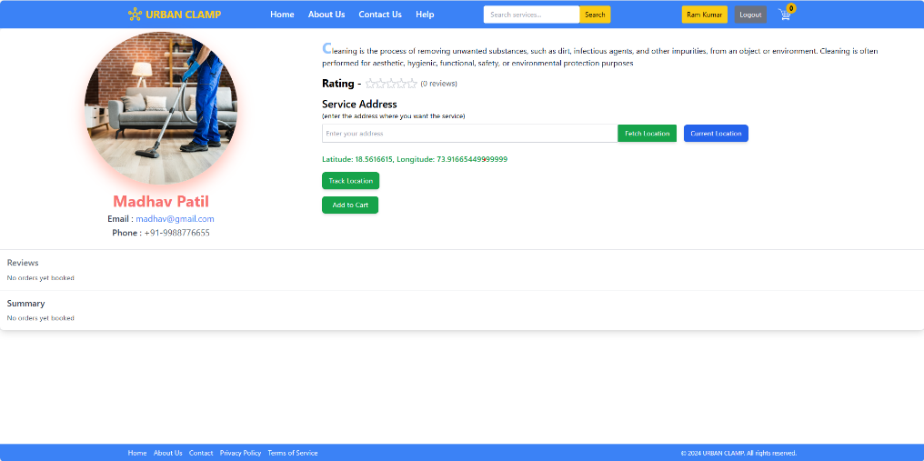\

7.User Profile Page

8.ADMIN Home Page.  
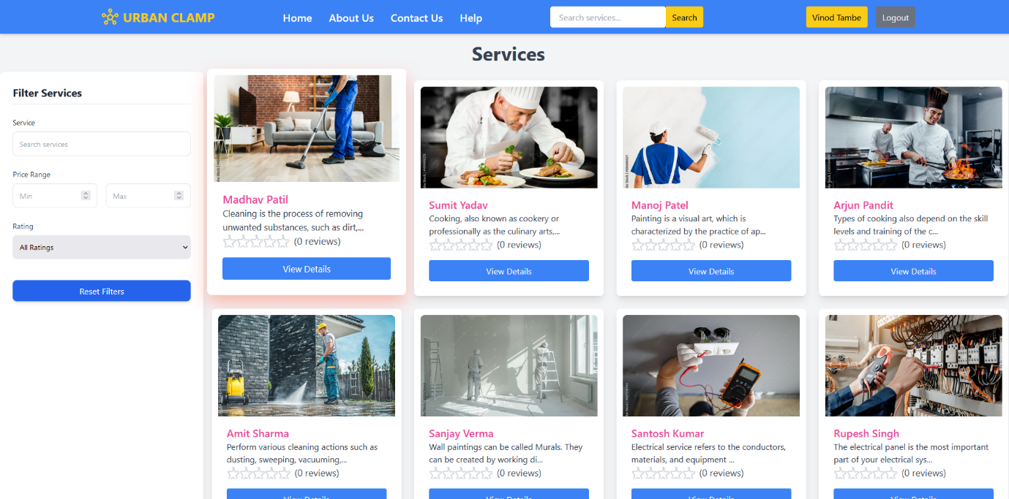

Please Consider => Due To Deprecation Of some javascript library google maps not working .