DOCKER

**STEP1: Create the amazon linux server and connect.**

sudo su -

yum install docker –y

docker version

systemctl start docker **( docker start)**

service docker status **( see the service status)**

docker version **( it gives the entire client and server information)**

docker images **( see the all images)**

docker search images

**Now create the docker file image:**

**vi Dockerfile It is basically a text file which contains some set of instructions. Automation of Docker image creation. Always D is capital letters on Docker file. And Start Components also be Capital letter.**

**Vi Dockerfile**

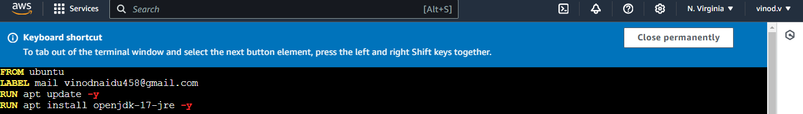

**FROM: For base image this command must be on top of the file. Ex: ubuntu, Redis, Jenkins.**

**LABEL: Labeling like EMAIL, AUTHOR, etc.**

**RUN:** **To execute commands and commit the layer.**

Docker build –t image1 **. ( Build the image)**

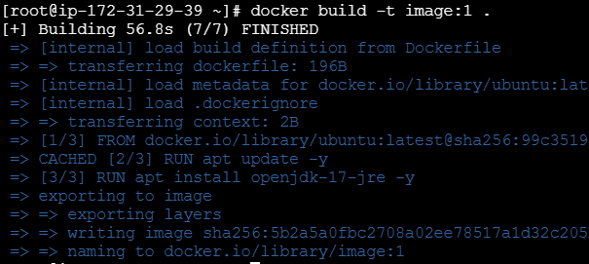

Docker image is created.

**Apache installation inside of the docker :**

* **Open vi Dockerfile**
* **RUN apt install apache –y**

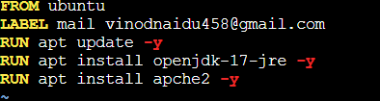

* **docker run –it --name cont1 –p 80:80 image2 ( to create the image and continer)**

**->> after inside the continer apache2 is running**

* Pwd **( see the present working directry)**
* ll
* cd var/www/html **(here index file came)**
* ll
* cd
* ll
* cd /usr **( inside of the usr sbin/came)**
* ll
* cd sbin
* ll

->> Here one default apache file came all the applications came and start with the apachectl.

**NOTE: using apachectl start continuslly.**

* Cd
* Cd /usr
* Ll
* Cd bin

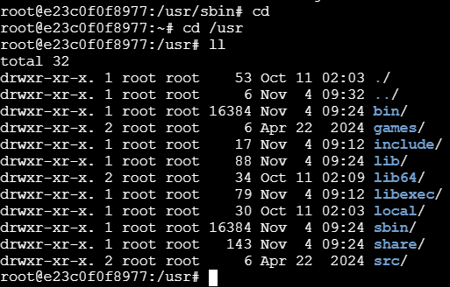

* Cd (exit here)
* Ctrl /p/q ( your going inside continer and install something after install also run continer it is used to execute based.
* Docker ps –a ( only see the running continers)



->> After go to the edit inbound rules for apache give the (all traffic ).

**To start the apace open the Dockerfile:**

**vi Dockerfile**

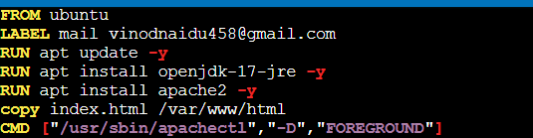

**Next open the index file:**

**vi index.html**

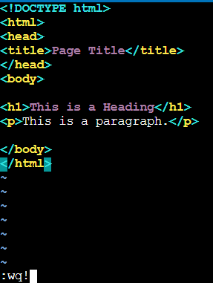

* **Docker build –t image3 .**
* **Docker run –it –name cont2 –p 81:80 image**

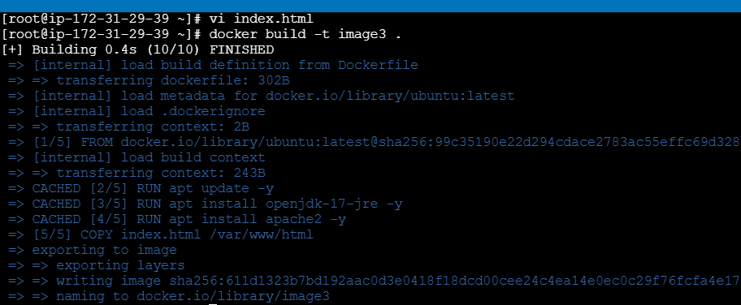

* Ctrl /p/q ( your going inside continer and install something after install also run continer it is used to execute based.

Using instance Public IPv4 address and port number open the server

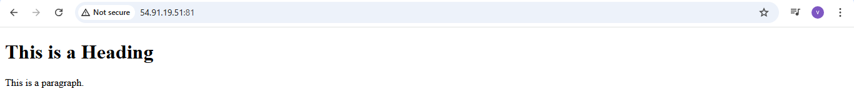

**How to Push the files in docker hub:**

**Stpe1: create the repository in docker hub**

**Step2: docker login**

**With username and password**

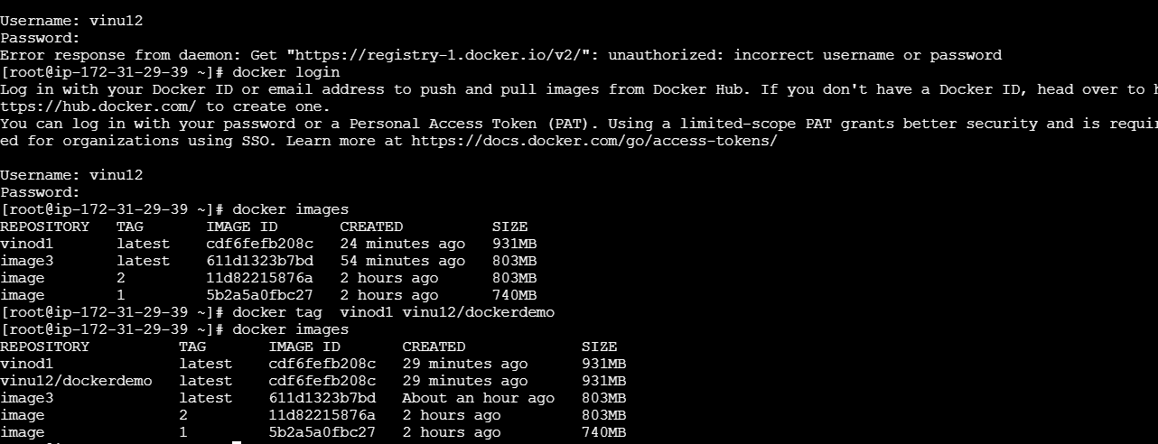

**Step 3: using rspository push the dockerhub**

* **Docker push vinu12/dockerdemo**

