**SONAR**

**ubuntu@ip-172-31-93-95:~$ sudo su -**

**root@ip-172-31-93-95:~# apt update –y**

**root@ip-172-31-93-95:~# apt install openjdk-11-jre**

**root@ip-172-31-93-95:~# apt install unzip**

**root@ip-172-31-93-95:~# su - sonar**

**sonar@ip-172-31-93-95:~$ pwd**

**/home/sonar**

**sonar@ip-172-31-93-95:~$ wget https://binaries.sonarsource.com/Distribution/sonarqube/sonarqube-9.4.0.54424.zip**

**sonar@ip-172-31-93-95:~$ ll**

**sonar@ip-172-31-93-95:~$ unzip sonarqube-9.4.0.54424.zip**

**sonar@ip-172-31-93-95:~$ lltotal 561876**

**drwxr-x--- 3 sonar sonar 4096 Oct 15 03:59 ./**

**drwxr-xr-x 4 root root 4096 Oct 14 16:09 ../**

**-rw------- 1 sonar sonar 94 Oct 14 16:14 .bash_history**

**-rw-r--r-- 1 sonar sonar 220 Oct 14 16:09 .bash_logout**

**-rw-r--r-- 1 sonar sonar 3771 Oct 14 16:09 .bashrc**

**-rw-r--r-- 1 sonar sonar 807 Oct 14 16:09 .profile**

**drwxr-xr-x 11 sonar sonar 4096 Apr 1 2022 sonarqube-9.4.0.54424/**

**-rw-rw-r-- 1 sonar sonar 287666040 Apr 1 2022 sonarqube-9.4.0.54424.zip**

**-rw-rw-r-- 1 sonar sonar 287666040 Apr 1 2022 sonarqube-9.4.0.54424.zip.1**

**sonar@ip-172-31-93-95:~$ cd sonarqube-9.4.0.54424/**

**sonar@ip-172-31-93-95:~/sonarqube-9.4.0.54424$ ll**

**total 100**

**drwxr-xr-x 11 sonar sonar 4096 Apr 1 2022 ./**

**drwxr-x--- 3 sonar sonar 4096 Oct 15 03:59 ../**

**-rw-r--r-- 1 sonar sonar 7651 Apr 1 2022 COPYING**

**drwxr-xr-x 6 sonar sonar 4096 Apr 1 2022 bin/**

**drwxr-xr-x 2 sonar sonar 4096 Apr 1 2022 conf/**

**drwxr-xr-x 2 sonar sonar 4096 Apr 1 2022 data/**

**-rw-r--r-- 1 sonar sonar 46490 Apr 1 2022 dependency-license.json**

**drwxr-xr-x 7 sonar sonar 4096 Apr 1 2022 elasticsearch/**

**drwxr-xr-x 4 sonar sonar 4096 Apr 1 2022 extensions/**

**drwxr-xr-x 6 sonar sonar 4096 Apr 1 2022 lib/**

**drwxr-xr-x 2 sonar sonar 4096 Apr 1 2022 logs/**

**drwxr-xr-x 2 sonar sonar 4096 Apr 1 2022 temp/**

**drwxr-xr-x 5 sonar sonar 4096 Apr 1 2022 web/**

**sonar@ip-172-31-93-95:~/sonarqube-9.4.0.54424$ cd ..**

**sonar@ip-172-31-93-95:~$ chown -R sonar:sonar sonarqube-9.4.0.54424**

**sonar@ip-172-31-93-95:~$ chmod 777 sonarqube-9.4.0.54424 -R**

**sonar@ip-172-31-93-95:~$ ll**

**total 561876**

**drwxr-x--- 3 sonar sonar 4096 Oct 15 03:59 ./**

**drwxr-xr-x 4 root root 4096 Oct 14 16:09 ../**

**-rw------- 1 sonar sonar 94 Oct 14 16:14 .bash_history**

**-rw-r--r-- 1 sonar sonar 220 Oct 14 16:09 .bash_logout**

**-rw-r--r-- 1 sonar sonar 3771 Oct 14 16:09 .bashrc**

**-rw-r--r-- 1 sonar sonar 807 Oct 14 16:09 .profile**

**drwxrwxrwx 11 sonar sonar 4096 Apr 1 2022 sonarqube-9.4.0.54424/**

**-rw-rw-r-- 1 sonar sonar 287666040 Apr 1 2022 sonarqube-9.4.0.54424.zip**

**-rw-rw-r-- 1 sonar sonar 287666040 Apr 1 2022 sonarqube-9.4.0.54424.zip.1**

**sonar@ip-172-31-93-95:~$ cd sonarqube-9.4.0.54424/**

**sonar@ip-172-31-93-95:~/sonarqube-9.4.0.54424$ ll**

**total 100**

**drwxrwxrwx 11 sonar sonar 4096 Apr 1 2022 ./**

**drwxr-x--- 3 sonar sonar 4096 Oct 15 03:59 ../**

**-rwxrwxrwx 1 sonar sonar 7651 Apr 1 2022 COPYING\***

**drwxrwxrwx 6 sonar sonar 4096 Apr 1 2022 bin/**

**drwxrwxrwx 2 sonar sonar 4096 Apr 1 2022 conf/**

**drwxrwxrwx 2 sonar sonar 4096 Apr 1 2022 data/**

**-rwxrwxrwx 1 sonar sonar 46490 Apr 1 2022 dependency-license.json\***

**drwxrwxrwx 7 sonar sonar 4096 Apr 1 2022 elasticsearch/**

**drwxrwxrwx 4 sonar sonar 4096 Apr 1 2022 extensions/**

**drwxrwxrwx 6 sonar sonar 4096 Apr 1 2022 lib/**

**drwxrwxrwx 2 sonar sonar 4096 Apr 1 2022 logs/**

**drwxrwxrwx 2 sonar sonar 4096 Apr 1 2022 temp/**

**drwxrwxrwx 5 sonar sonar 4096 Apr 1 2022 web/**

**sonar@ip-172-31-93-95:~/sonarqube-9.4.0.54424$ cd bin**

**sonar@ip-172-31-93-95:~/sonarqube-9.4.0.54424/bin$ ll**

**total 24**

**drwxrwxrwx 6 sonar sonar 4096 Apr 1 2022 ./**

**drwxrwxrwx 11 sonar sonar 4096 Apr 1 2022 ../**

**drwxrwxrwx 2 sonar sonar 4096 Apr 1 2022 jsw-license/**

**drwxrwxrwx 3 sonar sonar 4096 Apr 1 2022 linux-x86-64/**

**drwxrwxrwx 3 sonar sonar 4096 Apr 1 2022 macosx-universal-64/**

**drwxrwxrwx 3 sonar sonar 4096 Apr 1 2022 windows-x86-64/**

**sonar@ip-172-31-93-95:~/sonarqube-9.4.0.54424/bin$ cd linux-x86-64/**

**sonar@ip-172-31-93-95:~/sonarqube-9.4.0.54424/bin/linux-x86-64$ ll**

**total 144**

**drwxrwxrwx 3 sonar sonar 4096 Apr 1 2022 ./**

**drwxrwxrwx 6 sonar sonar 4096 Apr 1 2022 ../**

**drwxrwxrwx 2 sonar sonar 4096 Apr 1 2022 lib/**

**-rwxrwxrwx 1 sonar sonar 16393 Apr 1 2022 sonar.sh\***

**-rwxrwxrwx 1 sonar sonar 111027 Apr 1 2022 wrapper\***

**sonar@ip-172-31-93-95:~/sonarqube-9.4.0.54424/bin/linux-x86-64$ ./sonar.sh\***

**Usage: ./sonar.sh { console | start | stop | force-stop | restart | status | dump }**

**sonar@ip-172-31-93-95:~/sonarqube-9.4.0.54424/bin/linux-x86-64$ ./sonar.sh* start**

**Starting SonarQube...**

**Started SonarQube.**

**sonar@ip-172-31-93-95:~/sonarqube-9.4.0.54424/bin/linux-x86-64$ ./sonar.sh* status**

**SonarQube is running (6179).**

**sonar@ip-172-31-93-95:~/sonarqube-9.4.0.54424/bin/linux-x86-64$ ll**

**total 148**

**drwxrwxrwx 3 sonar sonar 4096 Oct 15 04:08 ./**

**drwxrwxrwx 6 sonar sonar 4096 Apr 1 2022 ../**

**-rw-r--r-- 1 sonar sonar 5 Oct 15 04:08 SonarQube.pid**

**drwxrwxrwx 2 sonar sonar 4096 Apr 1 2022 lib/**

**-rwxrwxrwx 1 sonar sonar 16393 Apr 1 2022 sonar.sh\***

**-rwxrwxrwx 1 sonar sonar 111027 Apr 1 2022 wrapper\***

[**sonar@ip-172-31-93-95:~/sonarqube-9.4.0.54424/bin/linux-x86-64$**](mailto:sonar@ip-172-31-93-95:~/sonarqube-9.4.0.54424/bin/linux-x86-64$)

* **After google search the binaries.sonarsource.com**
* **And go to distribution**

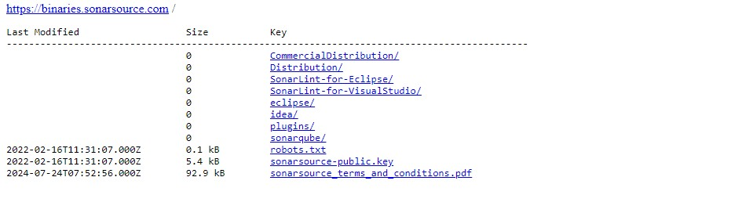

**Select the sonarqube**

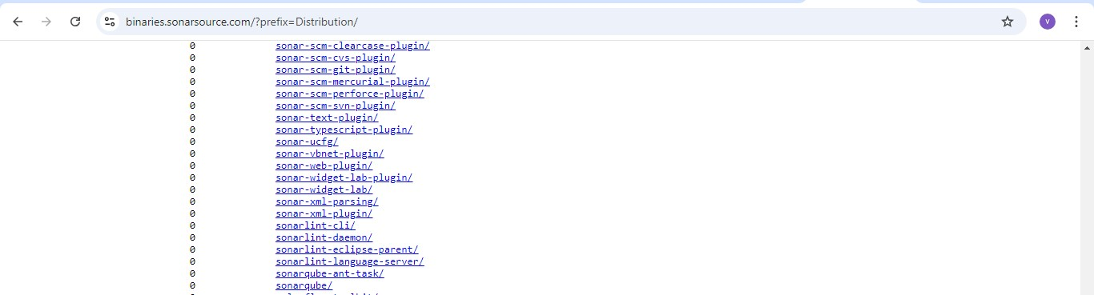

* **After instance sever ip address copy and give the port number**

**Like:** PublicIPs: 3.91.213.232:9000

Step1: log in to sonaroube

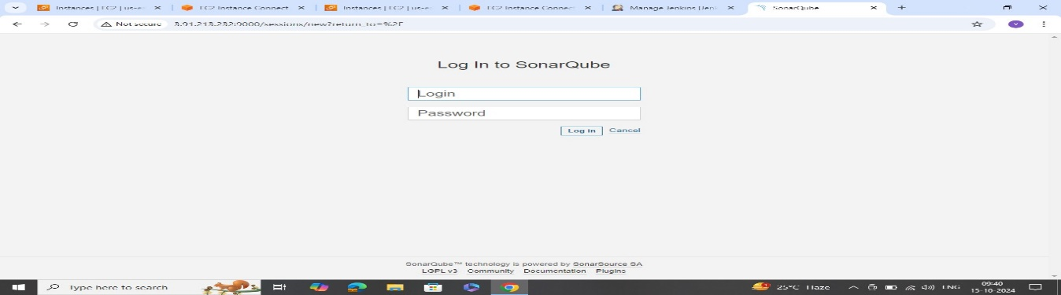

Step2: created the java based

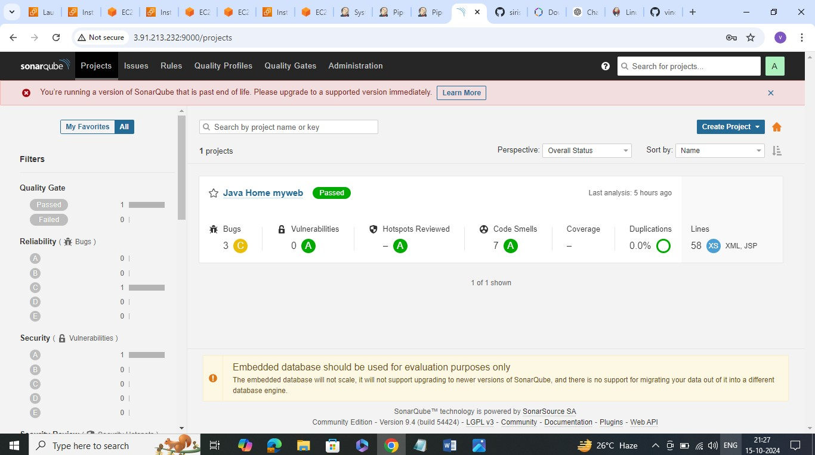

After go to jenkins and manage junkins select

* Install the available plugins

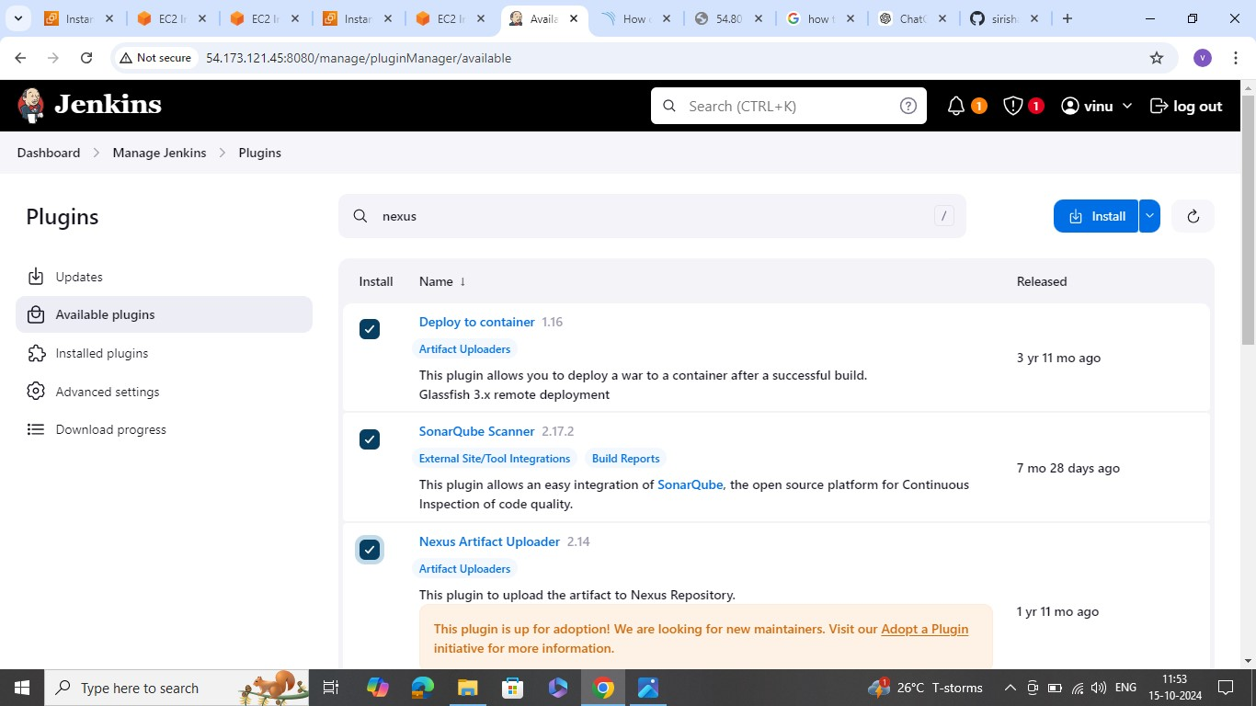

**And environment variables apply and save**

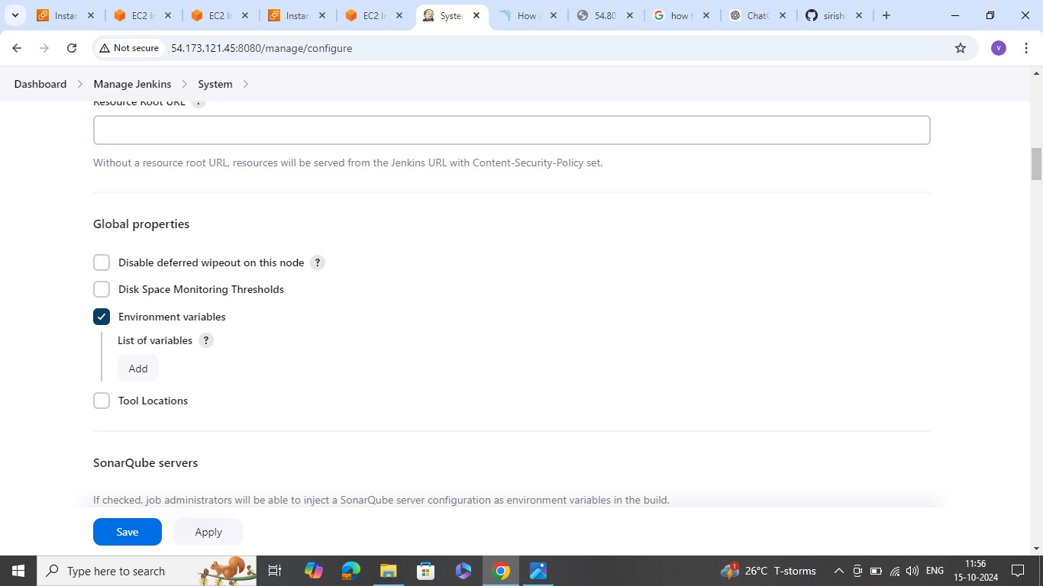

* Jenkins credentials provide

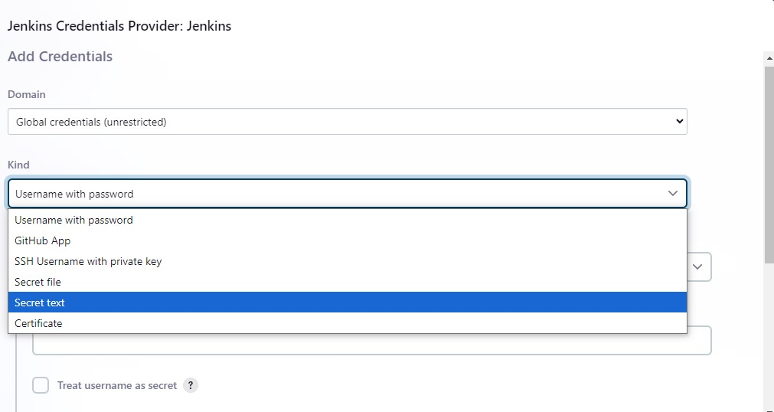

* **Running version of sonarqube and give the github url**

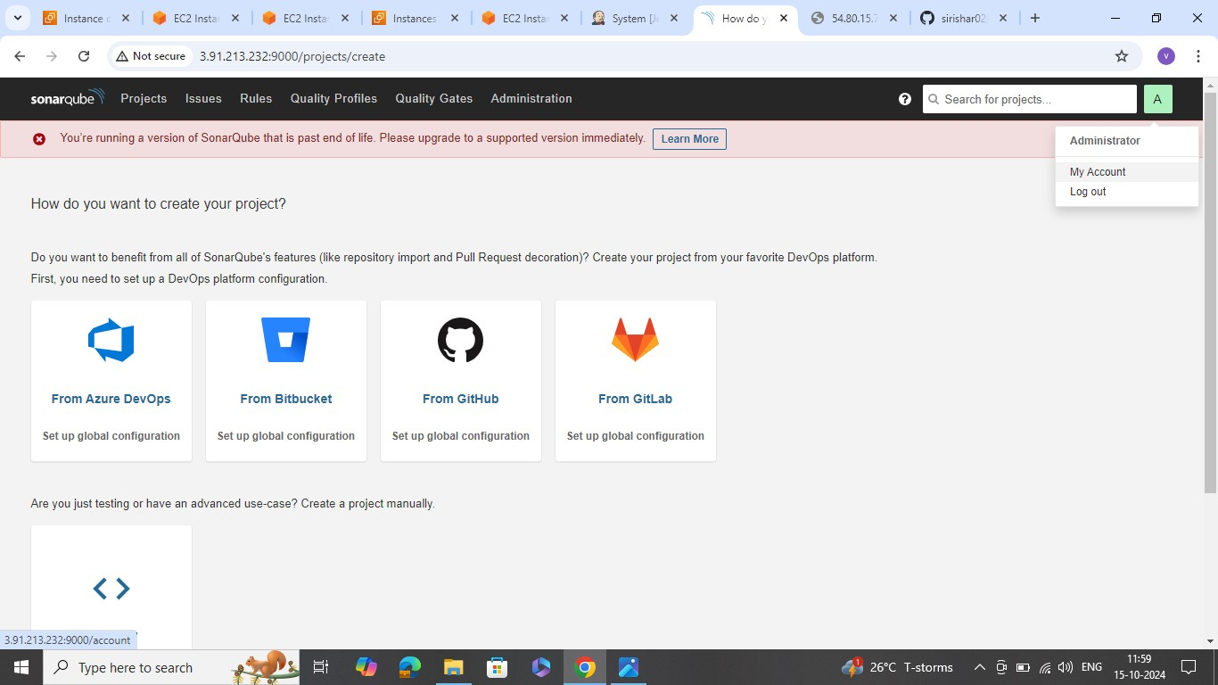

**After go to security and give the token name and generate password**

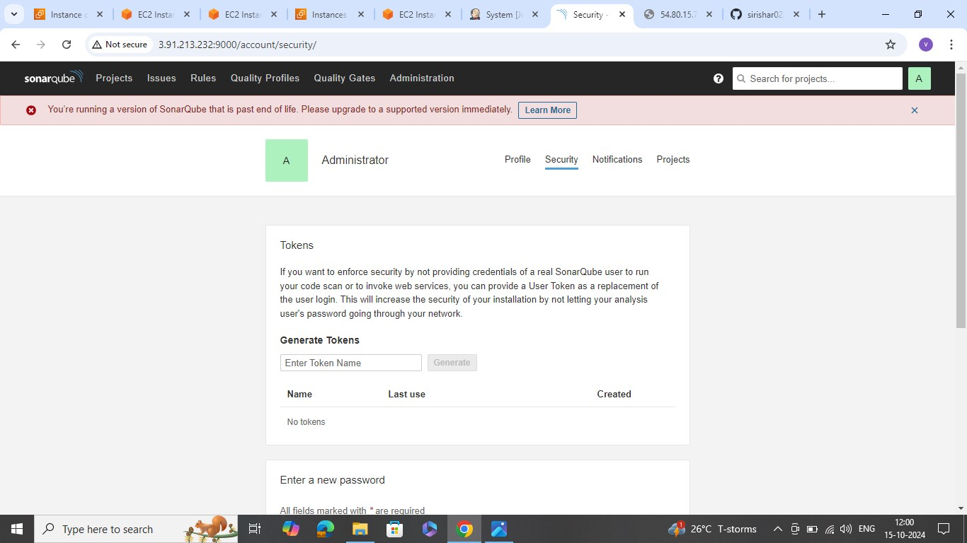

**Jenkin credentials provide and add**

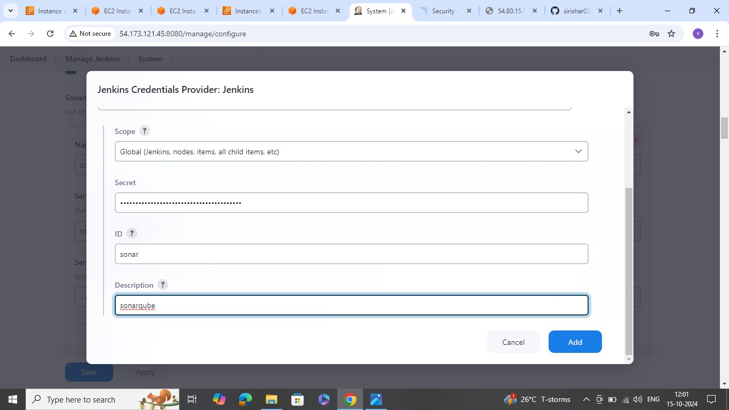

**Prepare sonarqube scanner environment save apply**

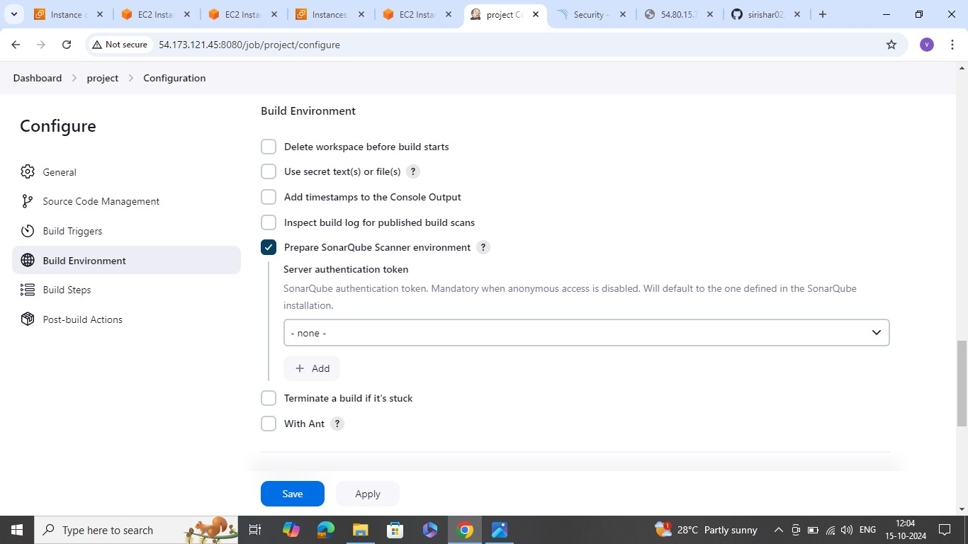

**After complete the process build and go to console out put**

**USING PIPLINE and connect the sonarqube**

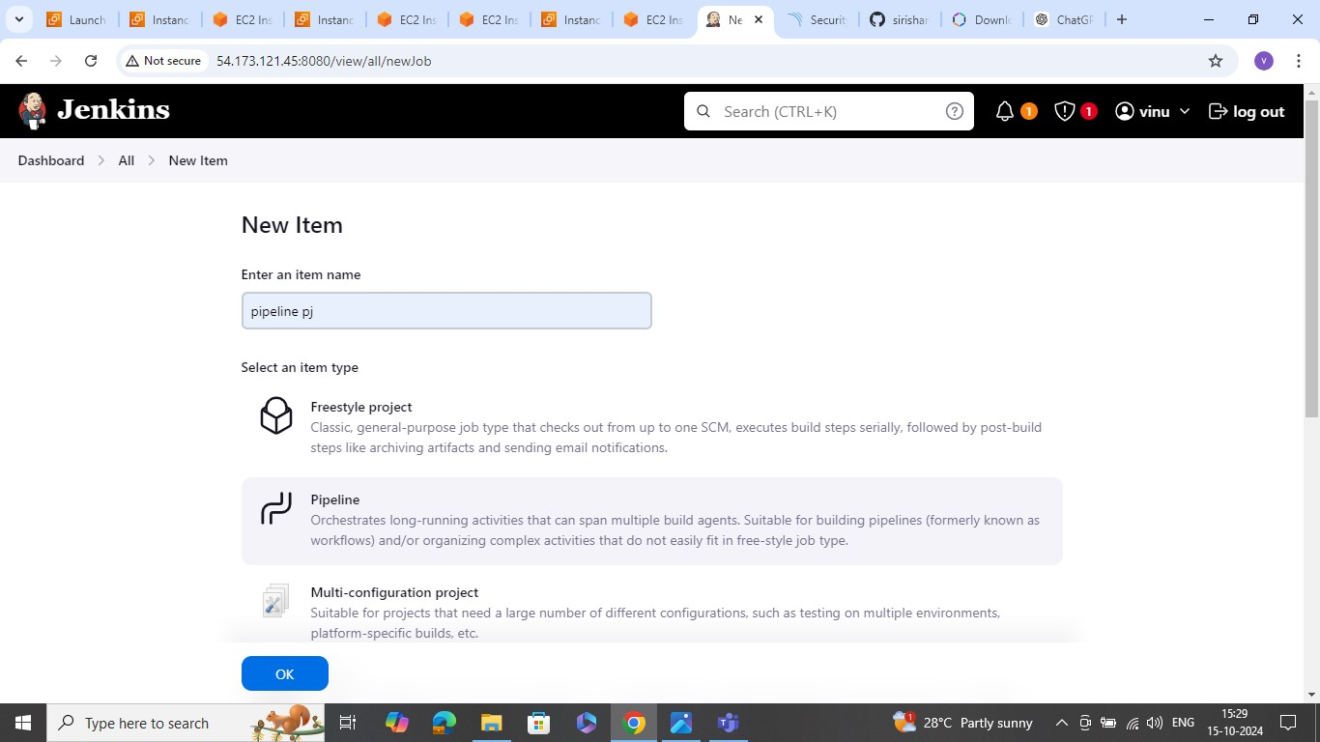

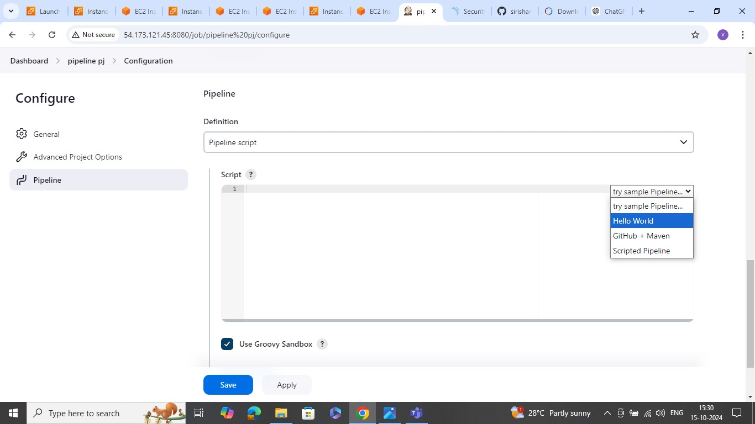

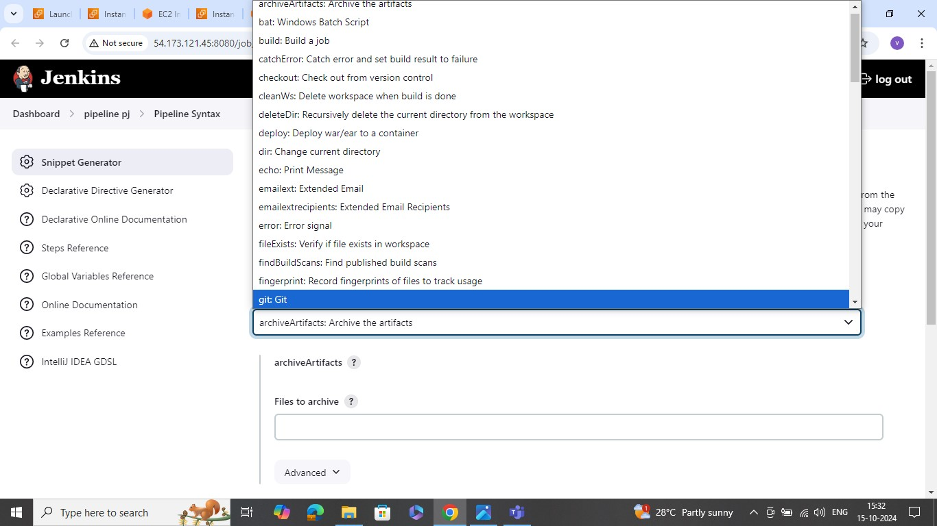

Here using git repo url and branch name

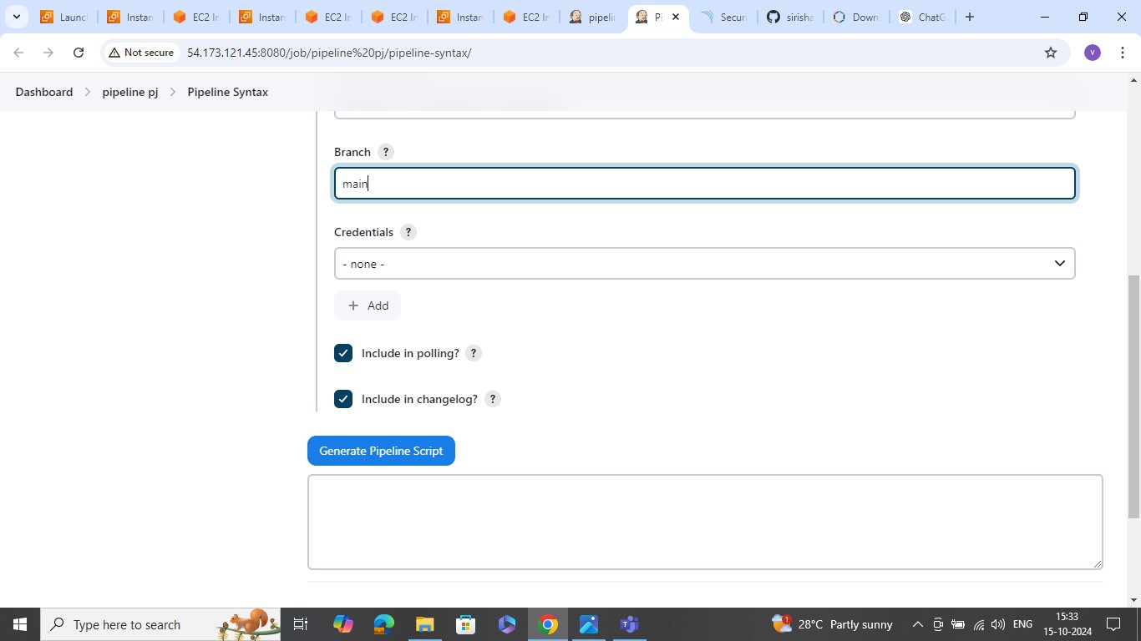

And generate the pipeline script , pipeline script edit and save

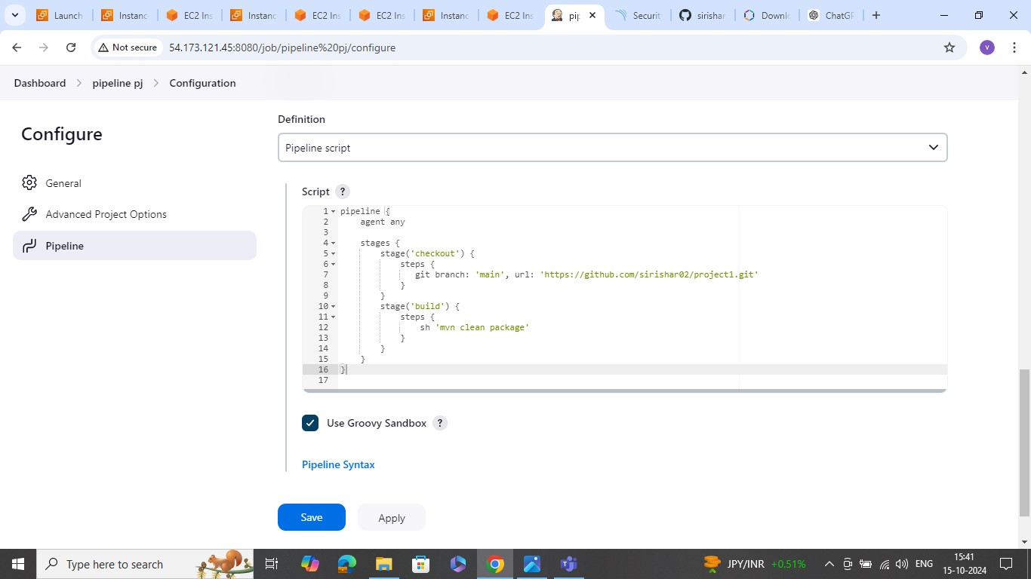

Now with sonarqube prepare sonarqube scanner environment perfume and select

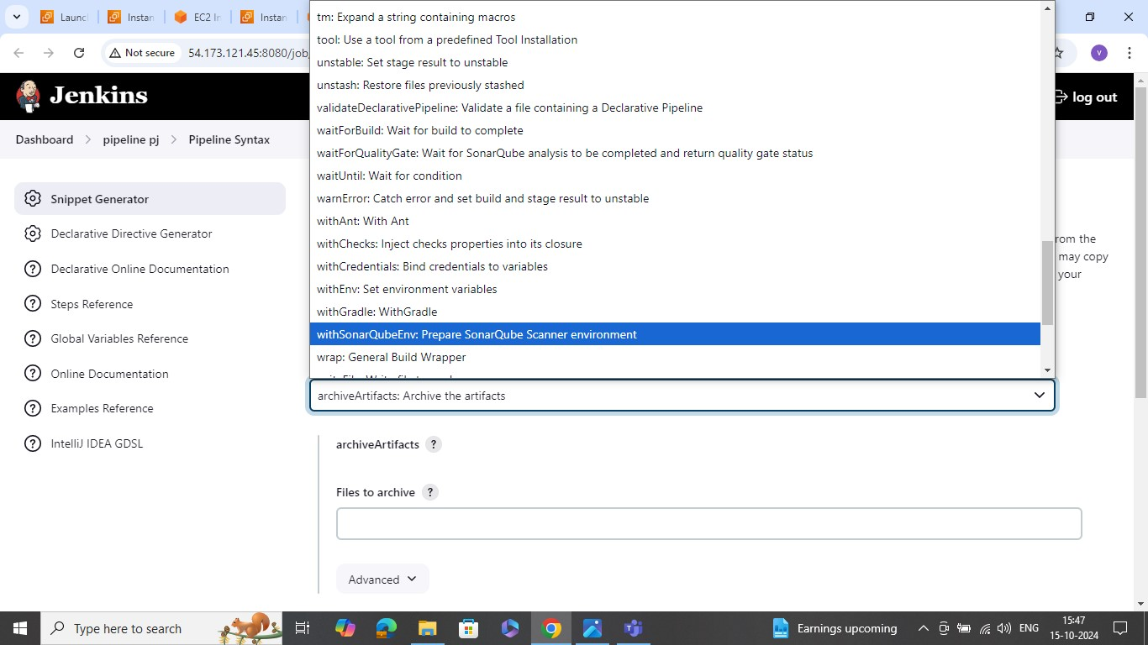

And generate the pipeline script

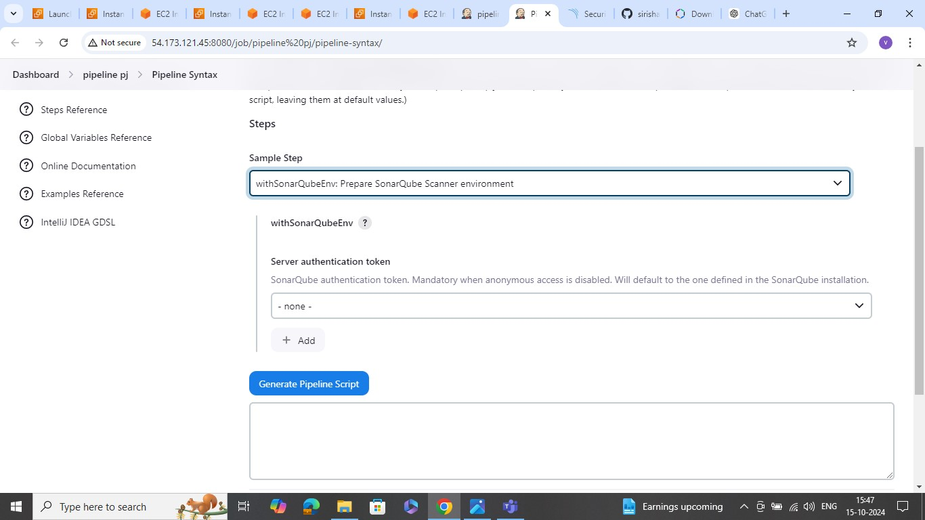

**Save and apply the code and after build**

