E-Invite

Reference : <http://en.youvivid.net/>

All event/ function invitation at one place, easy to create customize your own data’s. Publish and share link with your friends.

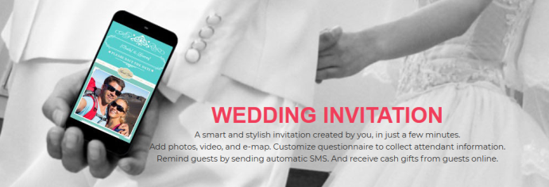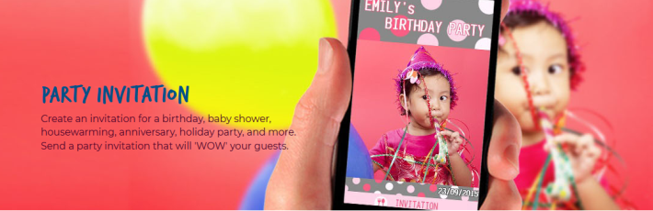

Wedding, birthday, baby shower, housewarming, party, opening, seminar, roadshow, promotion ads, or any business events.

Flow Diagram:



Share Invitatio