ADR-001: MongoDB to AWS Migration
Boardroom-grade ADR with updated visuals and directional cost framing

Executive Summary
This ADR recommends migrating MongoDB workloads to an AWS-native polyglot architecture using Amazon RDS for PostgreSQL as the system of record and Amazon OpenSearch Service as the search layer. Amazon DocumentDB may be used as a transitional bridge when migration simplification is the dominant near-term requirement.

Target Reference Architecture
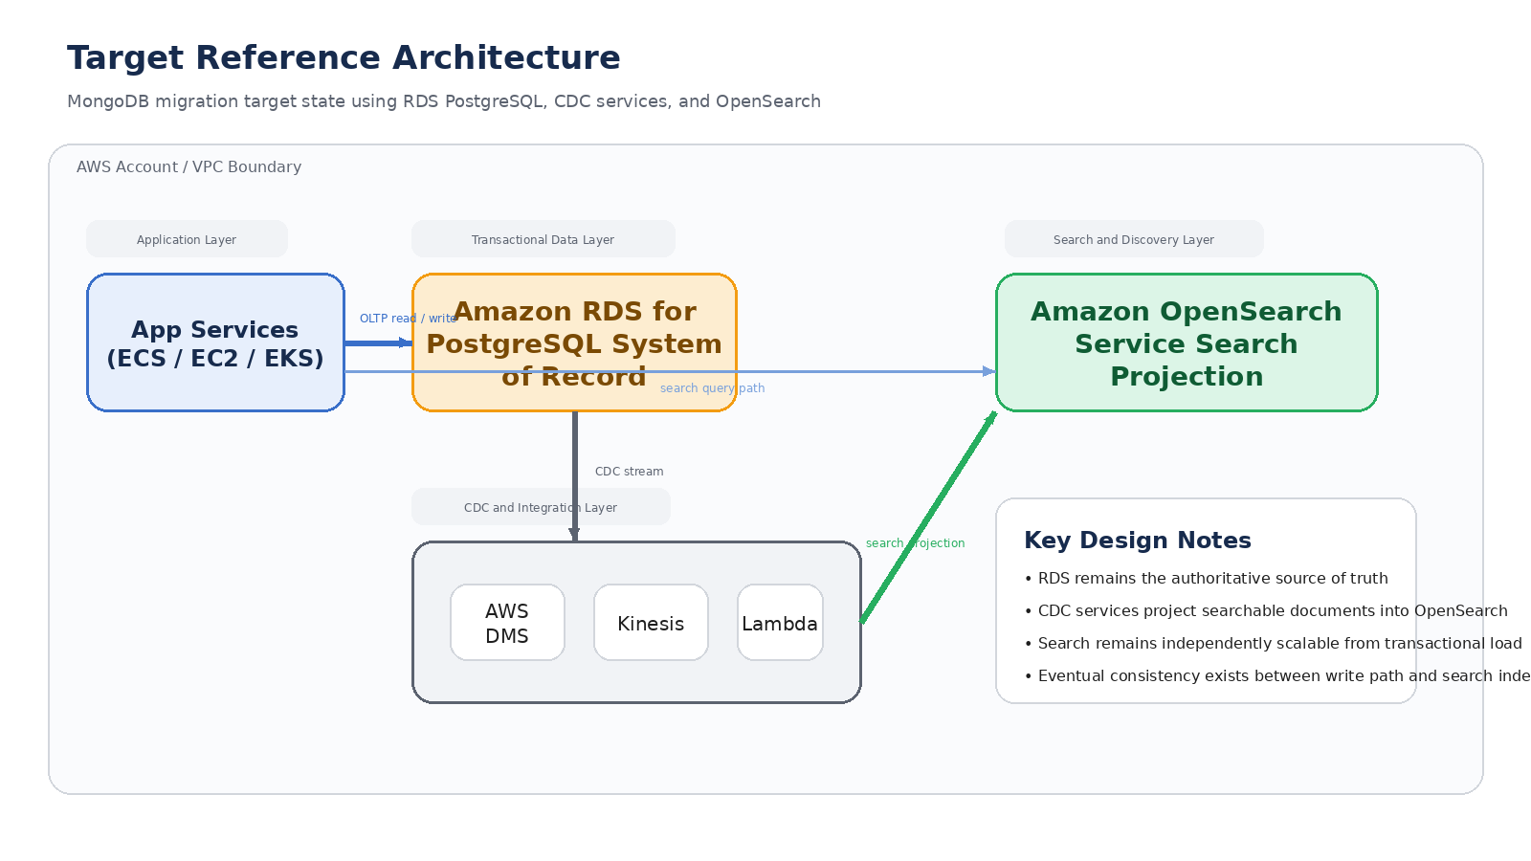

Decision Framework
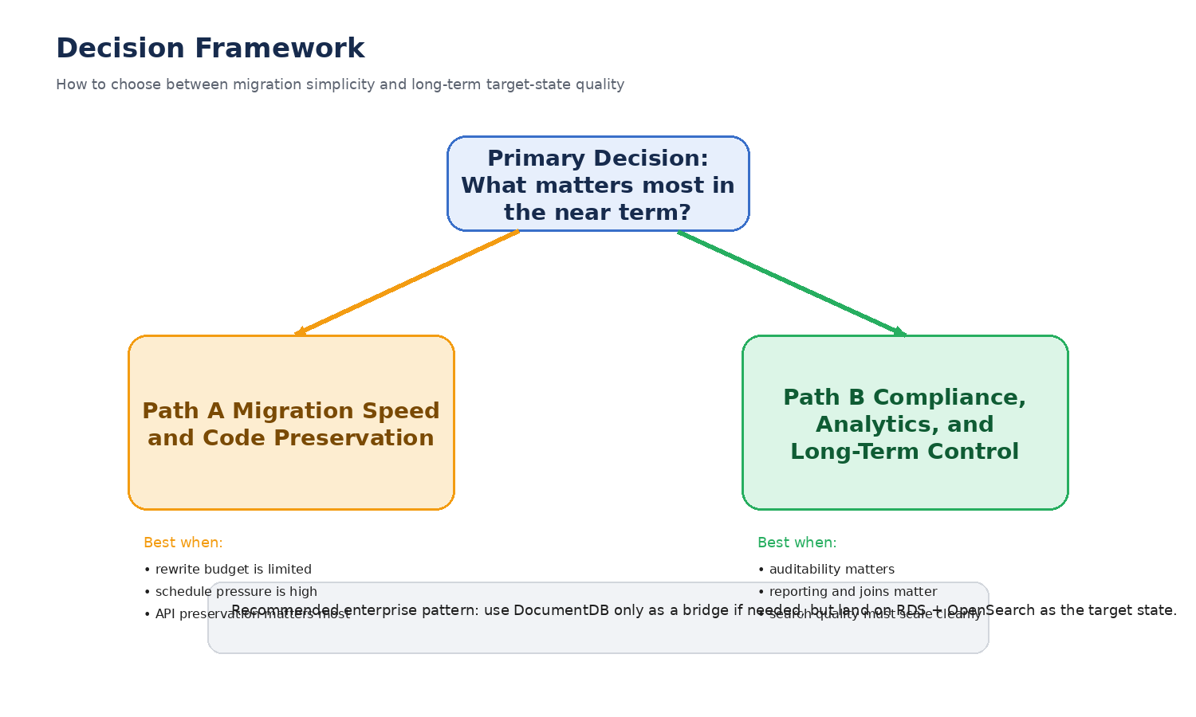

Directional Cost and Value Model
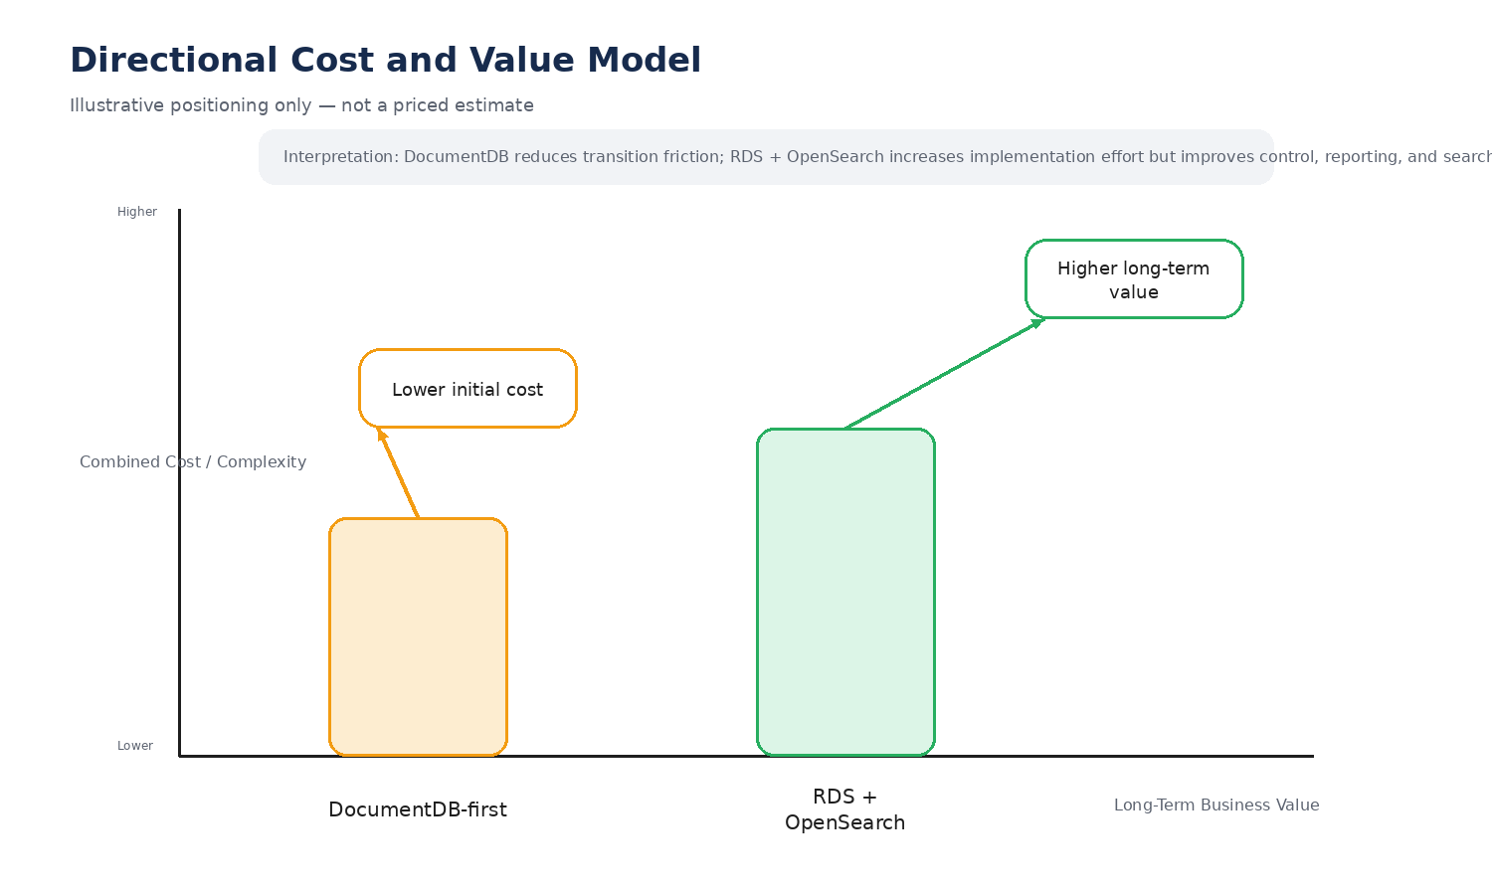

Decision Drivers
- Regulatory compliance and auditability
- Full-text search quality and flexibility
- Backup and restore maturity
- Data governance and reporting capability
- Migration speed versus long-term target-state quality

Recommendation
Track | Position
Target state | RDS PostgreSQL + OpenSearch
Bridge option | DocumentDB only when migration friction is the primary concern

Migration Roadmap
Phase | Description
Assess | Inventory MongoDB clusters, collections, query patterns, and search usage.
Design | Define the RDS target model, OpenSearch index model, and CDC path.
Build | Stand up RDS, CDC services, monitoring, and OpenSearch.
Migrate | Run bulk migration plus incremental synchronization.
Refactor | Update application reads, writes, and search calls.
Cut over | Switch traffic, verify reconciliation, and retire MongoDB.

