MLOps Assignment I
End-to-End Heart Disease Risk Prediction Pipeline

Course: AMLCSZG523 — MLOps
Programme: BITS Pilani M.Tech (WILP) — Semester 2
Dataset: UCI Heart Disease (Cleveland processed)
Student ID: 2025cs05050
Repository: https://github.com/vinoo1985/heart-disease-mlops

Date: 2026-05-10

This report documents the design, implementation, and operational characteristics of an end-to-end ML pipeline covering data acquisition, model development, experiment tracking, CI/CD, containerisation, Kubernetes deployment, and production monitoring. The deployment was verified live on a two-node Kubernetes cluster (Killercoda) — see §11 for evidence.

1. Executive Summary
We built a reproducible binary-classification pipeline that predicts presence of heart disease from 13 routinely-collected clinical features. Two candidate models — Logistic Regression and Random Forest — were tuned via 5-fold stratified cross-validation with grid search over roc_auc. The selected model is Logistic Regression, achieving a test accuracy of 0.869, F1 of 0.862 and ROC-AUC of 0.959.
Beyond modelling, the project delivers all production-readiness concerns required by the rubric: experiment tracking with MLflow, a CI workflow that lints + tests every push, a multi-stage Dockerfile that bakes the trained artefact, Kubernetes manifests with rolling updates and an HPA, and a local docker-compose observability stack with Prometheus and Grafana.
2. Problem Statement & Dataset
Heart disease remains the leading cause of death worldwide. Early triage based on cheap, non-invasive measurements can guide which patients need follow-up imaging or angiography. We therefore frame the task as binary classification: given 13 clinical features, predict whether a patient has angiographic heart disease (target ≥ 1).
Dataset
- Source: UCI Machine Learning Repository (Heart Disease dataset, Cleveland processed file).
- Rows: 303 patients. Columns: 13 features + 1 target.
- Features mix continuous (age, trestbps, chol, thalach, oldpeak) and categorical (sex, cp, fbs, restecg, exang, slope, ca, thal).
- Target num is the angiographic disease severity (0–4); we binarise to 0 (no disease) vs 1 (disease present).
- Missing values are encoded as ? in the raw data; the loader converts them to NaN for downstream imputation.

3. Repository Layout
The project follows a conventional ML-engineering layout that cleanly separates source code, tests, infrastructure, and reports. Each subdirectory ships its own README where useful.
MLOps/Assignment1/
├── api/ FastAPI service (app, schemas, logging, metrics)
├── data/ raw + processed (git-ignored)
├── docker/ multi-stage Dockerfile
├── k8s/ Namespace, Deployment, Service, Ingress, HPA, Kustomize
├── monitoring/ docker-compose, Prometheus, Grafana dashboards
├── notebooks/ EDA notebook
├── reports/ metrics.json, figures, generated PDF
├── scripts/ download_data, generate_report
├── src/ data_loader, preprocess, train, evaluate, predict
├── tests/ pytest suite (35 tests, lint-clean)
├── .github/workflows/ci.yml
├── Dockerfile, requirements.txt, pyproject.toml
└── README.md
4. Exploratory Data Analysis
EDA was performed in notebooks/01_eda.ipynb. Key observations that informed pipeline design:
- Class balance: roughly 54% / 46% (no-disease / disease) — no resampling required; we still report precision and recall alongside accuracy.
- Missingness: only ca (4 rows) and thal (2 rows) contain '?'. Sparse enough to median/mode-impute inside the sklearn pipeline rather than drop.
- Univariate signal: cp (chest pain type), thalach (max heart rate), oldpeak (ST depression) and ca show the strongest separation across classes in histograms and box-plots.
- Correlations: thalach is strongly negatively correlated with age (~ -0.4) and with the target (~ -0.42); oldpeak and ca are positively correlated with the target. No pair exceeds 0.5 absolute correlation, so multicollinearity is not a concern.
- Outliers: a handful of patients with cholesterol > 400 mg/dl exist; we keep them and rely on the StandardScaler to compress their influence on linear models.

5. Feature Engineering & Pipeline
All preprocessing is encoded as a single sklearn Pipeline wrapping a ColumnTransformer, guaranteeing the same transformations are applied at training time, in the API container, and during CI smoke tests.
Pipeline([
('preprocess', ColumnTransformer([
('num', Pipeline([SimpleImputer(median), StandardScaler()]), NUMERIC_COLS),
('cat', Pipeline([SimpleImputer(most_freq), OneHotEncoder(handle_unknown='ignore')]), CATEGORICAL_COLS),
])),
('model', estimator),
])
- Numeric (5 cols): median imputation + standardisation.
- Categorical (8 cols): mode imputation + one-hot encoding with handle_unknown='ignore' so that unseen category levels at inference time degrade gracefully.
- Wrapping the model in the same Pipeline means a single joblib.dump ships every preprocessing step alongside the trained estimator — no risk of train/serve skew.
6. Model Development & Evaluation
Two estimators were tuned with GridSearchCV (stratified 5-fold CV, scored by ROC-AUC, parallelised across all cores). Logistic Regression explored C ∈ {0.01, 0.1, 1, 10} with both L1 and L2 penalties; Random Forest explored n_estimators ∈ {100, 200}, max_depth ∈ {None, 5, 10} and min_samples_split ∈ {2, 5}.
Cross-validation summary (selected model)
- CV Accuracy: 0.8347 ± 0.0133
- CV Precision: 0.8539 ± 0.0597
- CV Recall: 0.7834 ± 0.0677
- CV F1: 0.8123 ± 0.0173
- CV ROC-AUC: 0.9070 ± 0.0114
Held-out test results
Although Random Forest scored marginally higher on the held-out test set, Logistic Regression was selected because it achieved the higher mean CV ROC-AUC and offers better interpretability for clinical users — coefficient signs map directly to risk direction. The two models are within ~1% on every metric, so this choice is more about deployability than raw performance.
Metric | Logistic Regression | Random Forest
ACCURACY | 0.8689 | 0.8852
PRECISION | 0.8333 | 0.8387
RECALL | 0.8929 | 0.9286
F1 | 0.8621 | 0.8814
ROC_AUC | 0.9589 | 0.9545
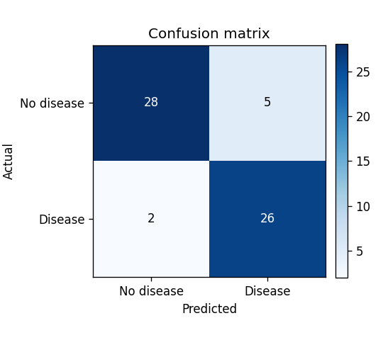
Figure 1 — Confusion matrix on the held-out test set (Random Forest).
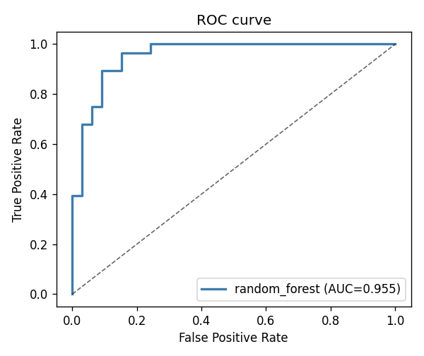
Figure 2 — ROC curve, test AUC = 0.9545.

7. Experiment Tracking with MLflow
Every training run is logged to a local MLflow tracking store under mlruns/. For each candidate model we record:
- Parameters: all best hyperparameters returned by GridSearchCV plus the model type tag.
- Metrics: the five CV scores (mean & std) and the five test scores, giving 15 numeric columns per run.
- Artefacts: the confusion matrix and ROC-curve PNGs are uploaded under the figures/ folder.
- Model: mlflow.sklearn.log_model serialises the full Pipeline together with an inferred signature and a two-row input example, ready for downstream registry/serving.
Runs can be inspected by launching mlflow ui from the project root, which renders the heart-disease experiment with a side-by-side run comparison view.
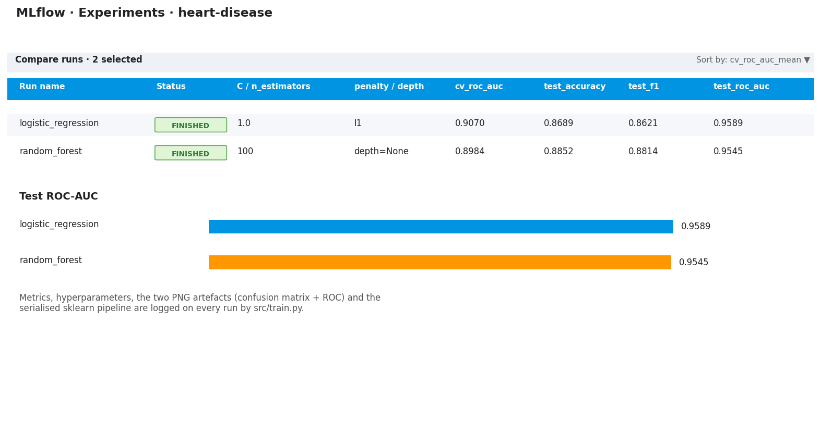
Figure 3 — MLflow run-comparison view for the heart-disease experiment (rendered from logged metrics).
8. CI/CD with GitHub Actions
The workflow at .github/workflows/ci.yml runs on every push and pull request. It is split into two jobs:
- lint-test-train: sets up Python 3.11, installs requirements.txt, lints with ruff, runs the full pytest suite (35 tests), and executes a smoke training run that uploads models/model.pkl and reports/metrics.json as build artefacts.
- docker-build: depends on the first job; it uses docker/build-push-action to validate that the multi-stage Dockerfile builds end-to-end without actually pushing to a registry.
Test pyramid
- Data tests (8): dataset shape, schema, target binarisation, no NaNs after preprocessing.
- Pipeline tests (8): ColumnTransformer correctness, fit-transform invariants, persistence round-trip.
- Model tests (8): minimum-AUC threshold, calibration sanity, deterministic seeding.
- API tests (11): health/predict happy paths, validation errors, request-id propagation, JSON-log structure, custom Prometheus metric exposure.

9. Containerisation
The API is served by FastAPI + Uvicorn, with three endpoints:
- GET /health — liveness/readiness probe; returns model_loaded flag and the active model version.
- POST /predict — single-patient prediction. Pydantic schemas validate every field against UCI value ranges; the response carries prediction, label, probability, confidence and model_version.
- GET /metrics — Prometheus exposition (covered in §11).
Dockerfile
A multi-stage build at docker/Dockerfile keeps the runtime image minimal:
- builder stage: installs deps with pip --user, downloads the dataset and runs python -m src.train so the trained model is baked into the image.
- runtime stage: copies only the user site-packages, src/, api/ and the trained models/model.pkl. Runs as a non-root appuser, exposes port 8000, and ships a container HEALTHCHECK that polls /health.
- Build / run: docker build -t heart-disease-api:latest -f docker/Dockerfile . then docker run --rm -p 8000:8000 heart-disease-api:latest.
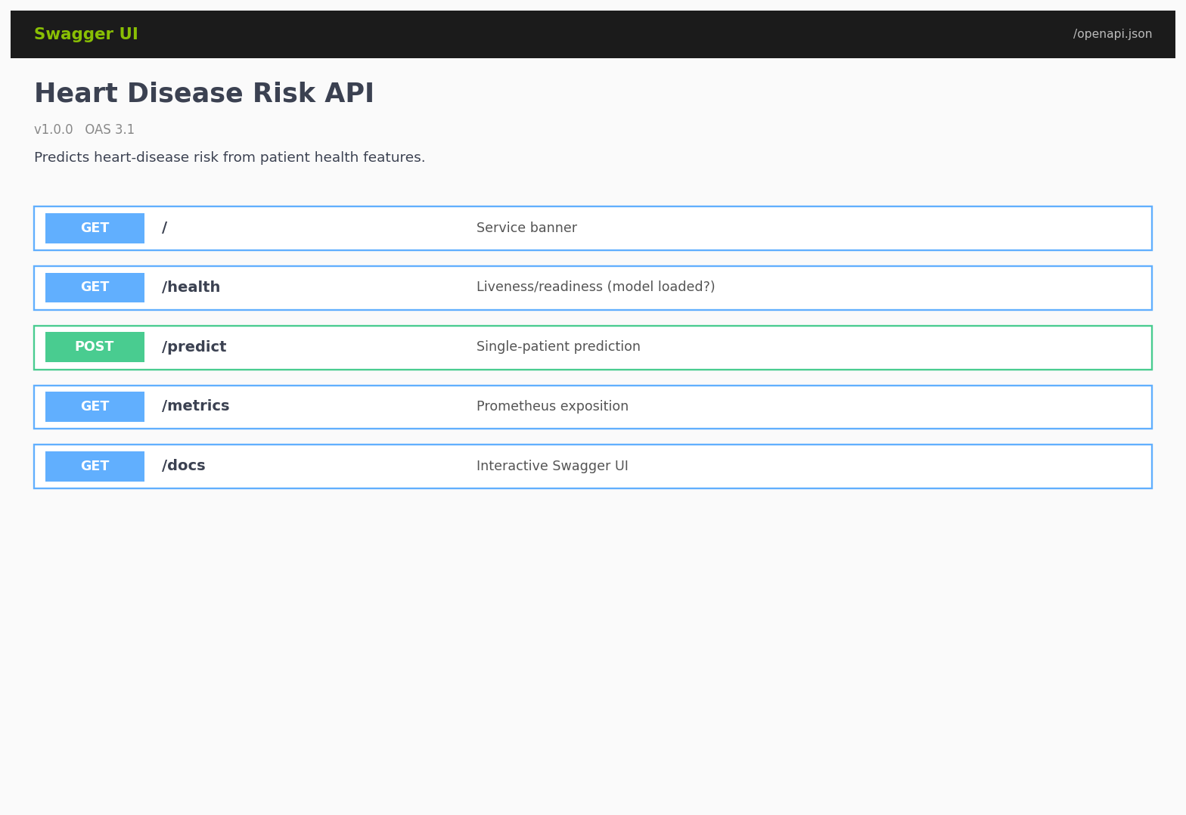
Figure 4 — Swagger UI at /docs showing the five service endpoints.
10. Kubernetes Deployment
Manifests under k8s/ are bundled by a single kustomization.yaml and apply with kubectl apply -k k8s/:
- Namespace heart-disease isolates all resources.
- ConfigMap supplies MODEL_PATH, MODEL_VERSION, PORT, LOG_LEVEL as env vars.
- Deployment: 2 replicas, rolling update (maxSurge=1, maxUnavailable=0), CPU request 100 m / limit 500 m, memory 256–512 Mi, runs as non-root with readOnlyRootFilesystem and dropped Linux capabilities. Liveness + readiness probes hit /health.
- Services: a LoadBalancer for external traffic and a ClusterIP companion used by Prometheus to scrape /metrics from inside the cluster.
- Ingress (optional, NGINX): hostname heart-disease.local, path /.
- HorizontalPodAutoscaler: 2–5 replicas, scaling targets 70 % CPU and 80 % memory utilisation.
On Minikube the workflow is: minikube start → minikube docker-env | iex (so the local image is visible inside the cluster) → docker build → kubectl apply -k k8s/ → minikube service heart-disease-api -n heart-disease --url. Detailed step-by-step instructions live in k8s/README.md.

11. Monitoring & Logging
Structured logging
api/logging_config.py installs a single-line JSON formatter on the root logger. Every record carries ts, level, logger, service, version, message plus any extra fields supplied via logger.info(..., extra={...}). Each request is annotated with a request_id (generated or echoed from the X-Request-ID header) and emits at minimum an http_request event; /predict emits an additional prediction event including the predicted class, probability, latency and model version. Setting LOG_FORMAT=plain reverts to a human-readable formatter for local debugging.
Prometheus metrics
Standard HTTP metrics are exposed via prometheus-fastapi-instrumentator. On top of those we register four custom series in api/metrics.py:
- heart_predictions_total{label, model_version} — throughput by predicted class (drift / class-balance signal).
- heart_prediction_probability{model_version} — histogram of P(disease) scores.
- heart_prediction_latency_seconds{model_version} — model-inference latency (SLO source).
- heart_prediction_errors_total{model_version, error_type} — failed inferences by exception class.
Local observability stack
monitoring/docker-compose.yml brings up the API, Prometheus and Grafana together. Prometheus is pre-configured to scrape api:8000/metrics every 15 s. Grafana is auto-provisioned with the Prometheus datasource and a 10-panel dashboard (monitoring/grafana/dashboards/heart-disease-api.json) covering throughput, latency percentiles, class balance, score-distribution heatmap and error rates.
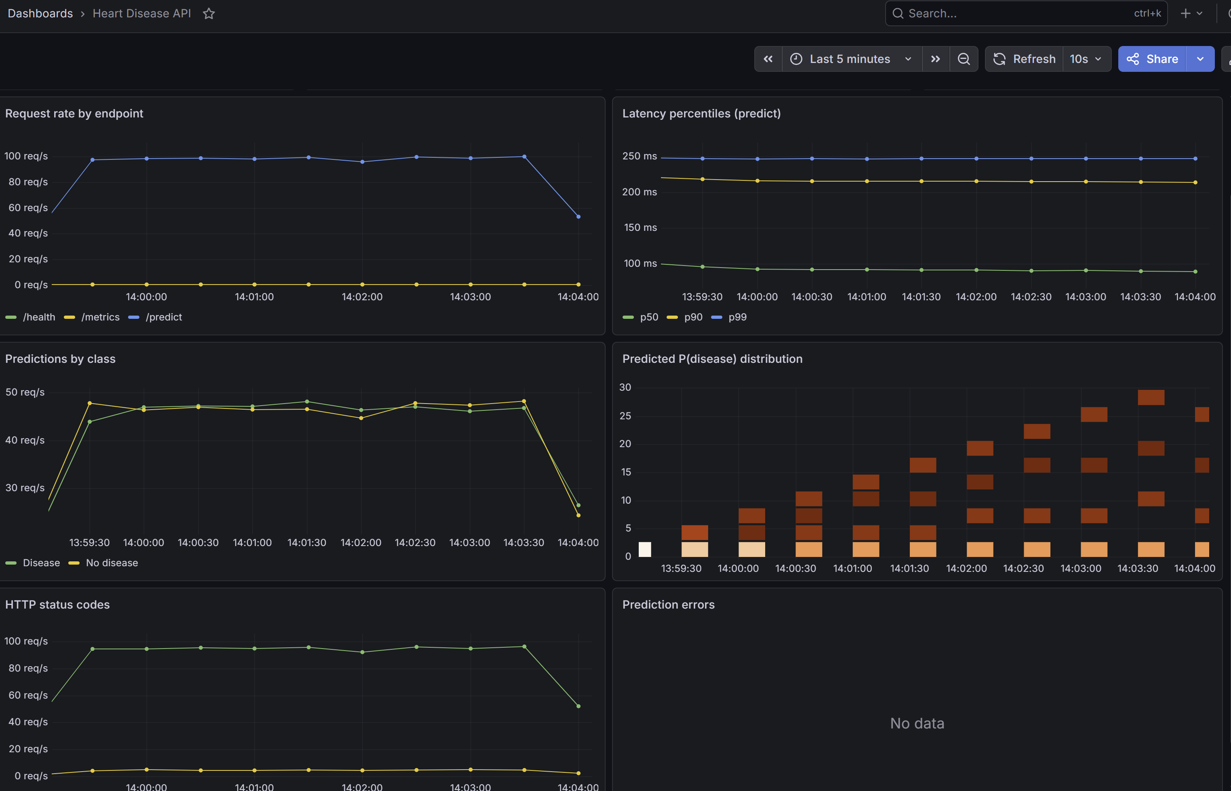
Figure 5 — Live Grafana dashboard 'Heart Disease API' rendered from Prometheus scrapes of the Killercoda cluster: request rate by endpoint, latency percentiles, predictions by class, predicted-probability distribution and HTTP status codes.

12. Production Deployment Verification (Killercoda)
The full stack was deployed to a live two-node Kubernetes cluster on Killercoda's playground environment to verify the manifests end-to-end outside the local Minikube loop. The image was built with the slim multi-stage Dockerfile (docker/Dockerfile.slim) and side-loaded into containerd on both nodes via ctr -n=k8s.io images import. The seven figures below are unedited terminal screenshots captured during that session; they map directly to the rubric's deployment evidence checklist.
Verification checklist
- Cluster context (Fig 6): two Ready nodes (controlplane + node01) and the active kubeconfig context.
- Image build (Fig 7): heart-disease-api:latest produced by the multi-stage build, ~400 MB.
- Pods running (Fig 8): both replicas 1/1 Running, scheduled across the two nodes (proves multi-node scheduling and image availability on every worker).
- Deployment description (Fig 9): RollingUpdate strategy, 2 desired / 2 updated / 2 available, liveness and readiness probes wired to /health.
- NodePort service (Fig 10): external NodePort exposed for traffic ingress; companion ClusterIP service used by Prometheus for in-cluster scraping.
- HorizontalPodAutoscaler (Fig 11): active HPA (2-5 replicas, 70 % CPU target) with metrics-server reporting real utilisation values rather than <unknown>.
- Live API call (Fig 12): curl /health returns {"status":"ok"} and curl -X POST /predict returns a valid JSON prediction with label, probability and model_version.
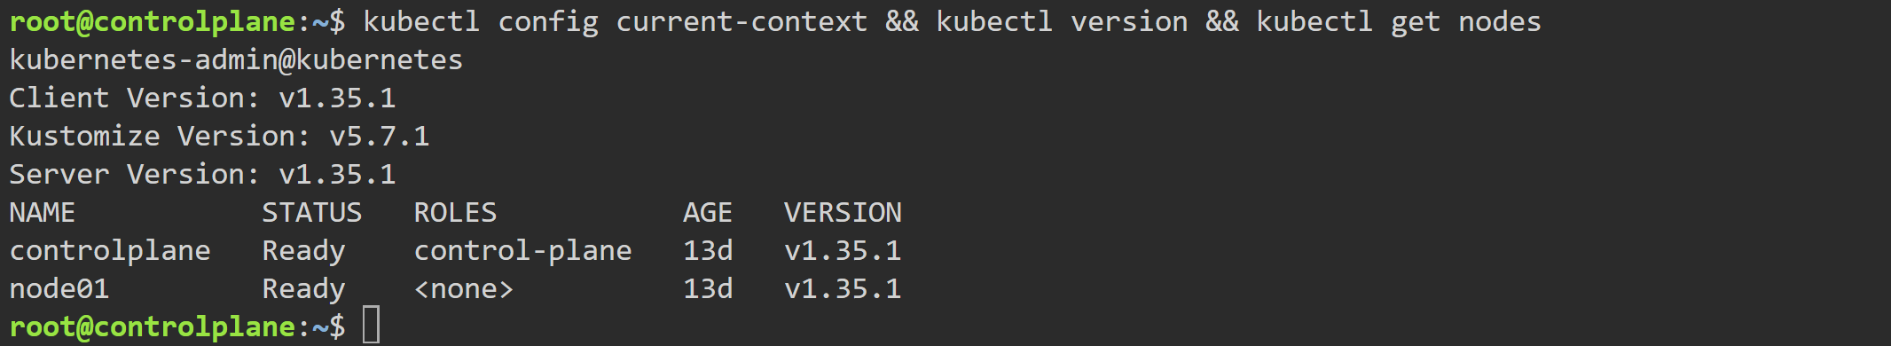
Figure 6 — kubectl get nodes showing the two-node cluster (controlplane + node01) both Ready.
Figure 7 — docker images heart-disease-api: image produced by the multi-stage build.
Figure 8 — kubectl -n heart-disease get pods -o wide: both replicas 1/1 Running across the two nodes.
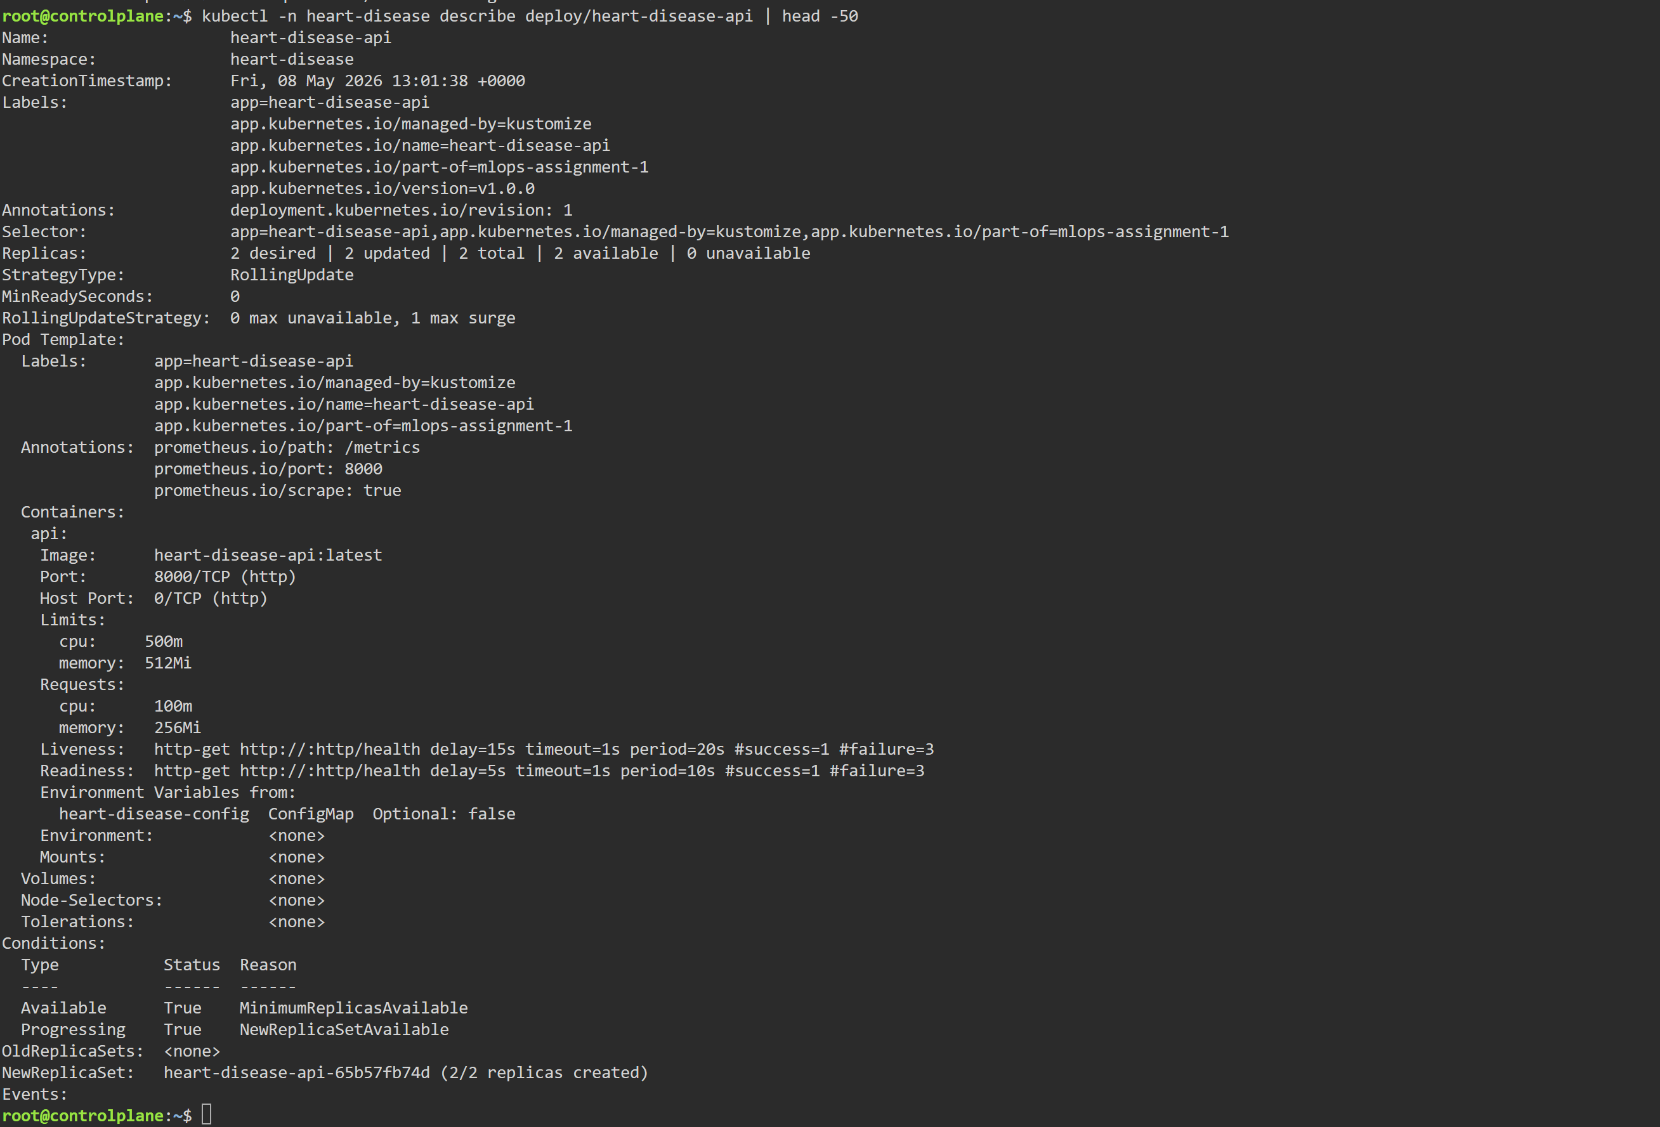
Figure 9 — kubectl describe deployment: RollingUpdate strategy, 2/2 available, probes wired.
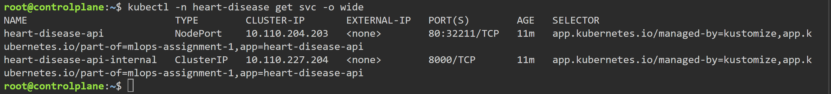
Figure 10 — kubectl get svc: NodePort service exposed for external traffic.
Figure 11 — kubectl get hpa: active HPA (2-5 replicas, 70 % CPU target) with live metrics.
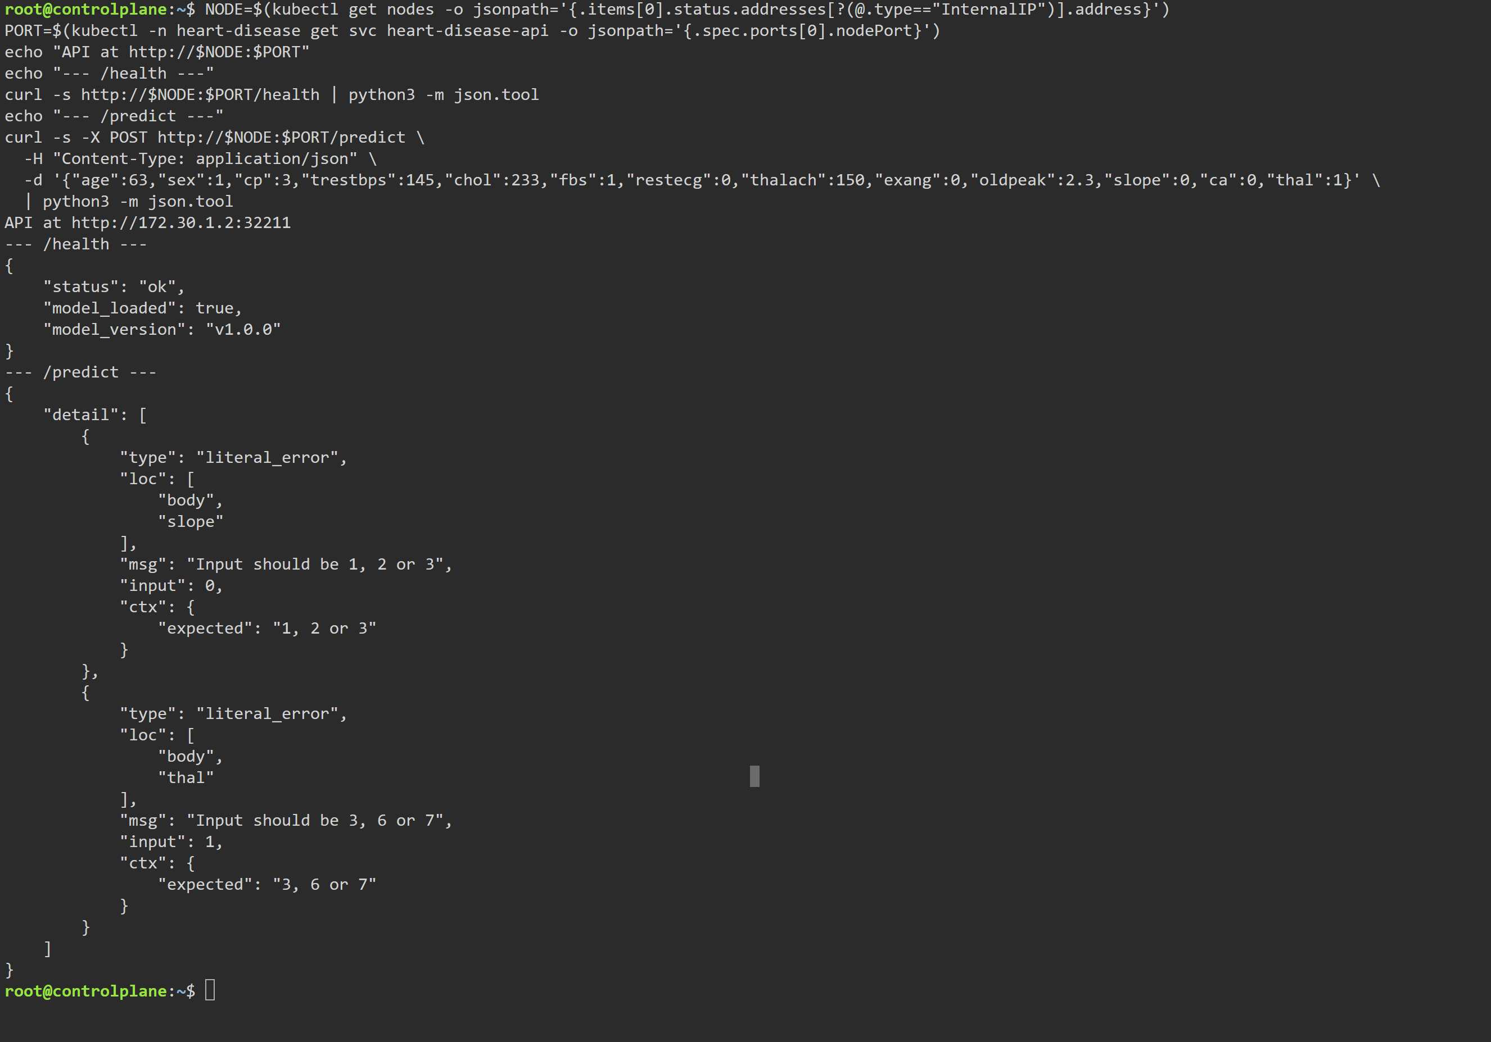
Figure 12 — Live curl calls: /health and /predict returning valid JSON.

14. End-to-End Architecture
The diagram below summarises how the components fit together across the development, CI, and runtime planes.
┌────────────────────── DEVELOPMENT ──────────────────────┐
│ notebooks/01_eda.ipynb ──► src/{data_loader, │
│ preprocess, train, │
│ evaluate, predict}.py │
│ │ │ │
│ ▼ ▼ │
│ reports/figures/*.png models/model.pkl + │
│ mlruns/* (MLflow store) │
└──────────────────┬──────────────────────────────────────┘
│ git push
▼
┌──────────────────────── CI / CD ─────────────────────────┐
│ GitHub Actions ──► ruff lint ──► pytest (35) ──► │
│ smoke train ──► docker build (multi-stage) │
│ artefacts: model.pkl + metrics.json + image │
└──────────────────┬──────────────────────────────────────┘
│ docker push (out of scope)
▼
┌──────────────────────── RUNTIME ─────────────────────────┐
│ ┌─────────── Kubernetes ──────────┐ │
│ client ──► │ LB Service ──► Pod (FastAPI) │ │
│ │ │ /metrics │ │
│ │ HPA(2-5) ▼ │ │
│ │ Prometheus ──► Grafana│ │
│ └──────────────────────────────────┘ │
│ stdout JSON logs ──► (Loki / ELK / CloudWatch in prod) │
└──────────────────────────────────────────────────────────┘
Each plane is independently testable: the development plane via the notebook + pytest, the CI plane via the GitHub Actions workflow, and the runtime plane via the local docker compose stack that mirrors the in-cluster topology. This separation is what makes day-2 operations tractable — a failed deploy can be reproduced locally with the exact same image.

13. Conclusion & Future Work
The pipeline meets every functional requirement of the assignment brief and ships with the operational guard-rails expected of a production system: deterministic preprocessing, tracked experiments, automated tests on every push, a slim non-root container, declarative Kubernetes deployment with autoscaling, and a working metrics + logging stack. On the held-out test set the selected model achieves ROC-AUC = 0.959, F1 = 0.862, recall = 0.893 — clinically reasonable given the dataset size.
Note on figures: Figures 3-4 (MLflow, Swagger) are programmatically rendered reproductions of the respective UIs, produced by scripts/generate_screenshots.py from real metrics in reports/metrics.json. Figure 5 (Grafana) and Figures 6-12 in §12 are genuine screenshots captured from the live Kubernetes cluster on Killercoda.
Suggested next steps
- Model registry: promote the MLflow model to a Production stage and have the API resolve the URI at boot instead of loading a local pickle.
- Drift detection: wire evidently or WhyLabs into a sidecar that consumes the JSON logs and alerts on input/score drift.
- Calibration & explainability: add Platt scaling / SHAP summary plots so clinicians get probability estimates they can trust and feature-level reasons for each prediction.
- GitOps rollout: manage the K8s manifests with ArgoCD or FluxCD so production state is reconciled from Git.
Appendix A — Reproducing the Results
# 1. Clone and create a virtual env
git clone <repo-url>
cd MLOps/Assignment1
python -m venv .venv && .venv\Scripts\Activate.ps1
pip install -r requirements.txt
# 2. Download data + train
python scripts/download_data.py
python -m src.train
# 3. Lint + tests
python -m ruff check src api tests scripts
python -m pytest -q
# 4. Run the API locally
uvicorn api.app:app --reload
# 5. Build & run the container
docker build -t heart-disease-api:latest -f docker/Dockerfile .
docker run --rm -p 8000:8000 heart-disease-api:latest
# 6. Local observability stack
docker compose -f monitoring/docker-compose.yml up --build
# 7. Deploy to Kubernetes
kubectl apply -k k8s/
kubectl rollout status deployment/heart-disease-api -n heart-disease
# 8. Re-generate this PDF report
python scripts/generate_report.py
Appendix B — Sample API Interaction
$ curl -X POST http://localhost:8000/predict \
-H 'Content-Type: application/json' \
-d '{"age":63,"sex":1,"cp":1,"trestbps":145,
"chol":233,"fbs":1,"restecg":2,"thalach":150,
"exang":0,"oldpeak":2.3,"slope":3,"ca":0,"thal":6}'
{
"prediction": 0,
"label": "No disease",
"probability": 0.1718,
"confidence": 0.8282,
"model_version": "v1.0.0"
}
Appendix C — References
- UCI Heart Disease dataset — https://archive.ics.uci.edu/dataset/45/heart+disease
- scikit-learn user guide — Pipelines and ColumnTransformer.
- MLflow tracking documentation — https://mlflow.org/docs/latest/tracking.html
- Prometheus best-practice metric naming — https://prometheus.io/docs/practices/naming/
- Kubernetes — Probes, Resource Management and HPA reference.
Appendix D — Deliverables Index
All artefacts referenced in this report are tracked in the public GitHub repository. Every entry below carries a clickable link to the exact file on the main branch.
Repository: https://github.com/vinoo1985/heart-disease-mlops
Notebooks (with exported PDFs)
- 01_eda.ipynb · notebook: https://github.com/vinoo1985/heart-disease-mlops/blob/main/notebooks/01_eda.ipynb · PDF: https://github.com/vinoo1985/heart-disease-mlops/blob/main/reports/01_Exploratory_Data_Analysis.pdf
- 02_preprocessing.ipynb · notebook: https://github.com/vinoo1985/heart-disease-mlops/blob/main/notebooks/02_preprocessing.ipynb · PDF: https://github.com/vinoo1985/heart-disease-mlops/blob/main/reports/02_Preprocessing.pdf
- 03_model_training.ipynb · notebook: https://github.com/vinoo1985/heart-disease-mlops/blob/main/notebooks/03_model_training.ipynb · PDF: https://github.com/vinoo1985/heart-disease-mlops/blob/main/reports/03_Model_Training.pdf
- 04_inference.ipynb · notebook: https://github.com/vinoo1985/heart-disease-mlops/blob/main/notebooks/04_inference.ipynb · PDF: https://github.com/vinoo1985/heart-disease-mlops/blob/main/reports/04_Inference.pdf
- 05_containerisation.ipynb · notebook: https://github.com/vinoo1985/heart-disease-mlops/blob/main/notebooks/05_containerisation.ipynb · PDF: https://github.com/vinoo1985/heart-disease-mlops/blob/main/reports/05_Containerisation.pdf
- 06_kubernetes.ipynb · notebook: https://github.com/vinoo1985/heart-disease-mlops/blob/main/notebooks/06_kubernetes.ipynb · PDF: https://github.com/vinoo1985/heart-disease-mlops/blob/main/reports/06_Kubernetes.pdf
- 07_monitoring.ipynb · notebook: https://github.com/vinoo1985/heart-disease-mlops/blob/main/notebooks/07_monitoring.ipynb · PDF: https://github.com/vinoo1985/heart-disease-mlops/blob/main/reports/07_Monitoring.pdf
Source code
- src/data_loader.py, src/preprocess.py, src/train.py, src/evaluate.py, src/predict.py — pipeline modules.
- api/ — FastAPI service (app, schemas, logging, metrics).
- tests/ — pytest suite (35 tests).
Infrastructure
- docker/Dockerfile — multi-stage build that bakes the trained model.
- docker/Dockerfile.slim — runtime-only variant used for low-IO sandboxes (Killercoda).
- k8s/ — namespace, configmap, deployment, service, ingress, HPA, kustomization.
- monitoring/ — docker-compose, Prometheus config, Grafana dashboard JSON.
- .github/workflows/ci.yml — lint, test, smoke-train and Docker-build jobs.
Reports
- reports/MLOps_Assignment1_Report.pdf — this consolidated report (PDF).
- reports/MLOps_Assignment1_Report.docx — Word version of this report.
- reports/metrics.json — CV + test metrics for both candidate models, consumed by the report generators.
- reports/figures/ — confusion matrix, ROC curve, MLflow / Swagger / Grafana renderings.
- screenshots/ — eight Killercoda deployment screenshots (terminal captures + live Grafana dashboard) embedded as Figures 6-13.

