Vinothini S
Oddanchatram, Dindigul, TamilNadu.
8072303474
vinosamiyappan@gmail.com
LinkedIn : https://www.linkedin.com/in/vinothini-s-603259244

OBJECTIVES
To enhance my professional skills, capabilities, and knowledge by working in a dynamic organization that values hard work and provides opportunities for growth, responsibility, and challenges.

EDUCATION

Karpagam Academy of Higher Education, Coimbatore
MCA - CGPA-8.6
June 2023 - May 2025

Kongu Arts and Science College, Erode
B.Sc(Computer Science)- CGPA-8.3
June 2019 - May 2022

EXPERIENCE
Atozerv India Pvt Ltd, Coimbatore —Web Developer Intern
July 2025 - November 2025

- Completed a Web Development Internship focusing on front-end and basic back-end tasks.
- Built responsive interfaces using HTML, CSS, JavaScript, Bootstrap, and React.
- Developed dynamic features with PHP and SQL.
- Assisted in designing and optimizing modules for live client projects.

PROJECTS

Online Flat Promoting System— Built with ASP. Net and MSSQL.
A web platform that allows users to advertise, search, and manage rental or sale properties through a simple and user-friendly interface.

Enhanced Software Defect Prediction Using Hybrid Deep Learning Models and Feature Engineering — Built with Deep Learning Algorithms(CNN,RNN).
Developed a hybrid deep learning model with feature engineering to improve software defect prediction accuracy to 85.4%
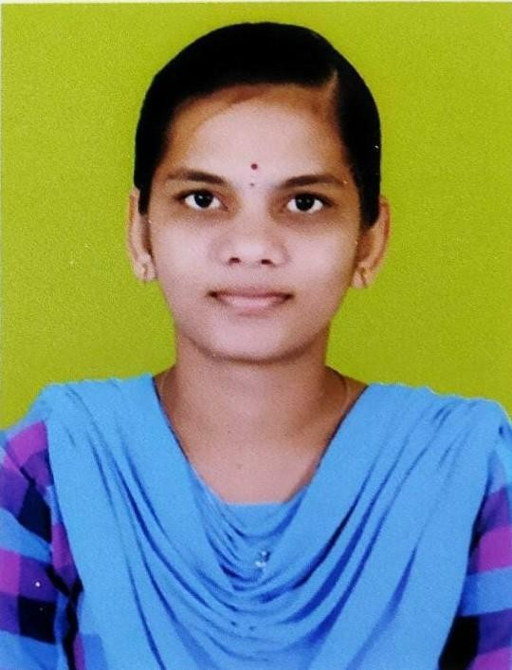

TECHNICAL SKILLS
Web Design : HTML5, CSS, JavaScript,Bootstrap

Programming Language: Python

Frameworks: React
Database: SQL Programming
Tools : VS Code, Eclipse, NetBeans

CERTIFICATES

IOT Security Using Machine Learning Techniques
Published in ICRTCSDA’24 on February 02, 2024.

Artificial Intelligence Enabled Distributed Edge Computing for IoT Applications
Published in NCRTAS-2024 on January 24, 2024.

STRENGTH

- Time management
- Analytical thinking
- Problem Solving
- Team work

