**Tables, Datatypes and Description:**

**Account Table:**

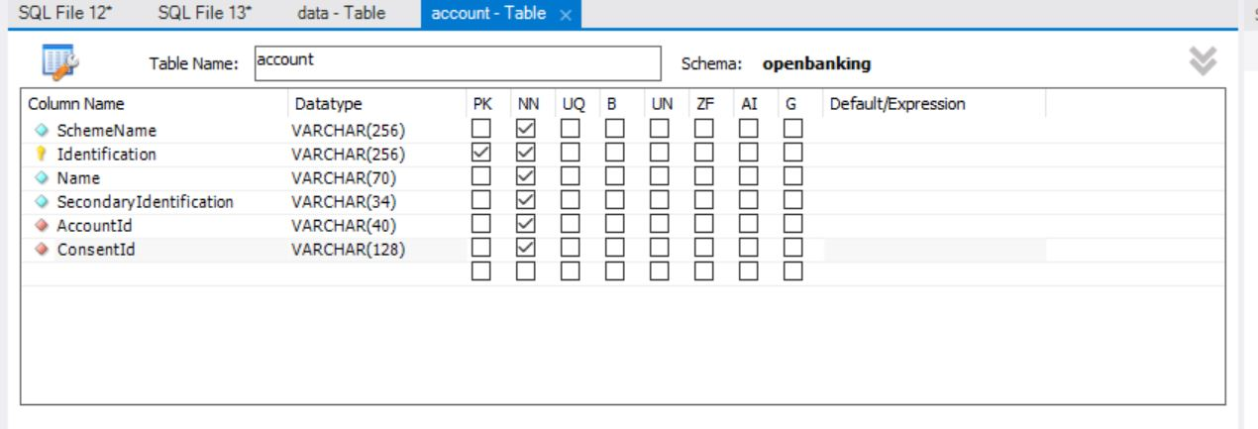

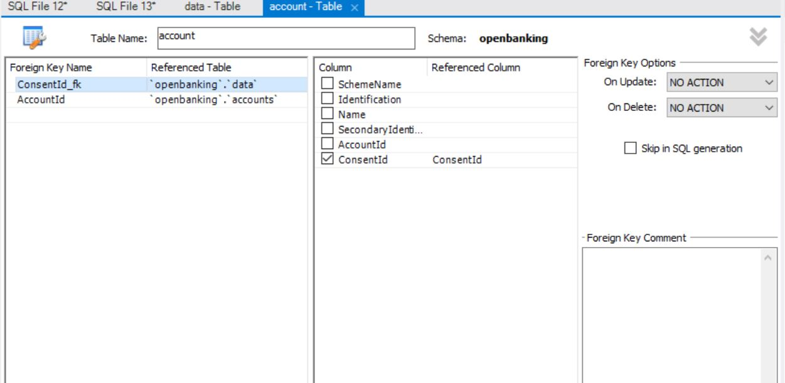

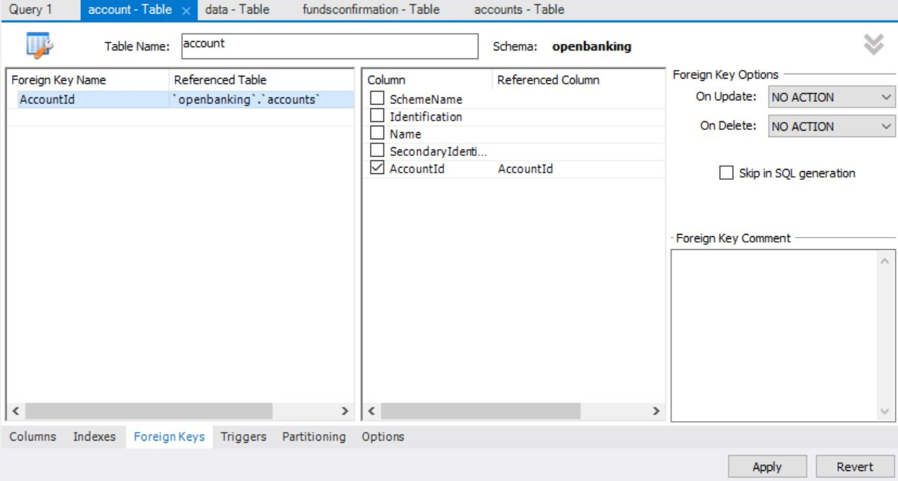

**Accounts Table:**

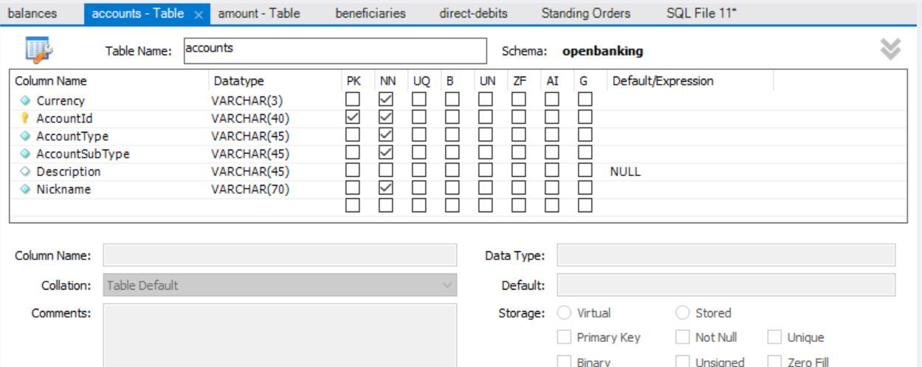

|  |  |
| --- | --- |
| Column Name | Codes |
| Currency | ^[A-Z]{3,3}$ |
| AccountType | |  |  | | --- | --- | | Business  Personal |  | |
| AccountSubType | ChargeCard  CreditCard  CurrentAccount  EMoney  Loan  Mortgage  PrePaidCard  Savings |

**Party Table:**

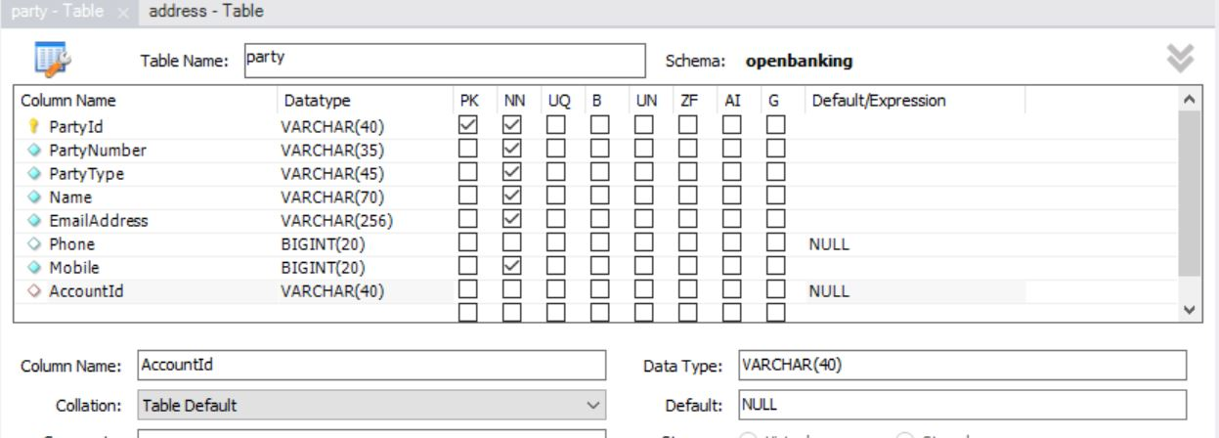

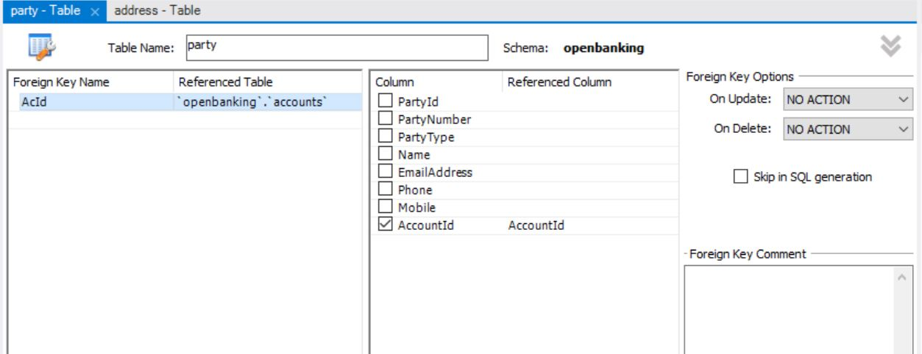

|  |  |  |
| --- | --- | --- |
| **Column Name** | **Code** | **Pattern** |
| PartyType | Delegate Joint Sole |  |
| Phone |  | \+[0-9]{1,3}-[0-9()+\-]{1,30} |
| Mobile |  | \+[0-9]{1,3}-[0-9()+\-]{1,30} |

**Address Table:**

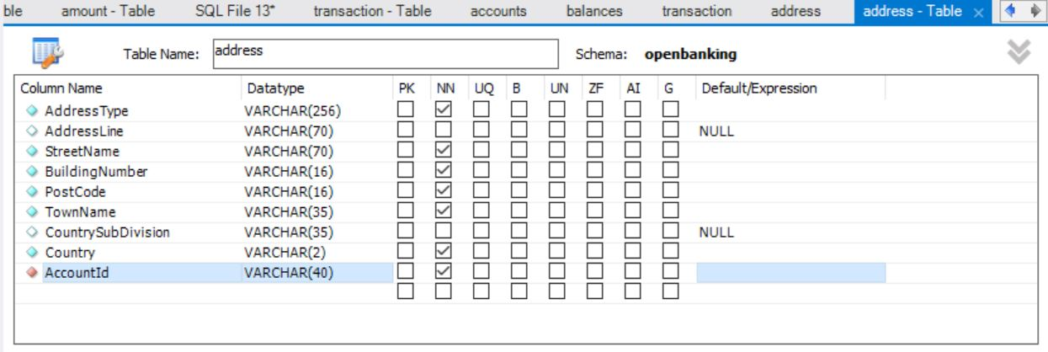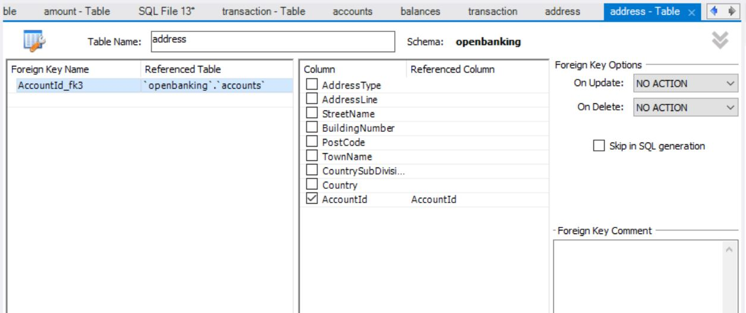

|  |  |  |
| --- | --- | --- |
| Column Name | Code | Pattern |
| AddressType | Business Correspondence DeliveryTo MailTo POBox Postal Residential Statement |  |
| Country |  | ^[A-Z]{2,2}$ |

**Offers Table:**

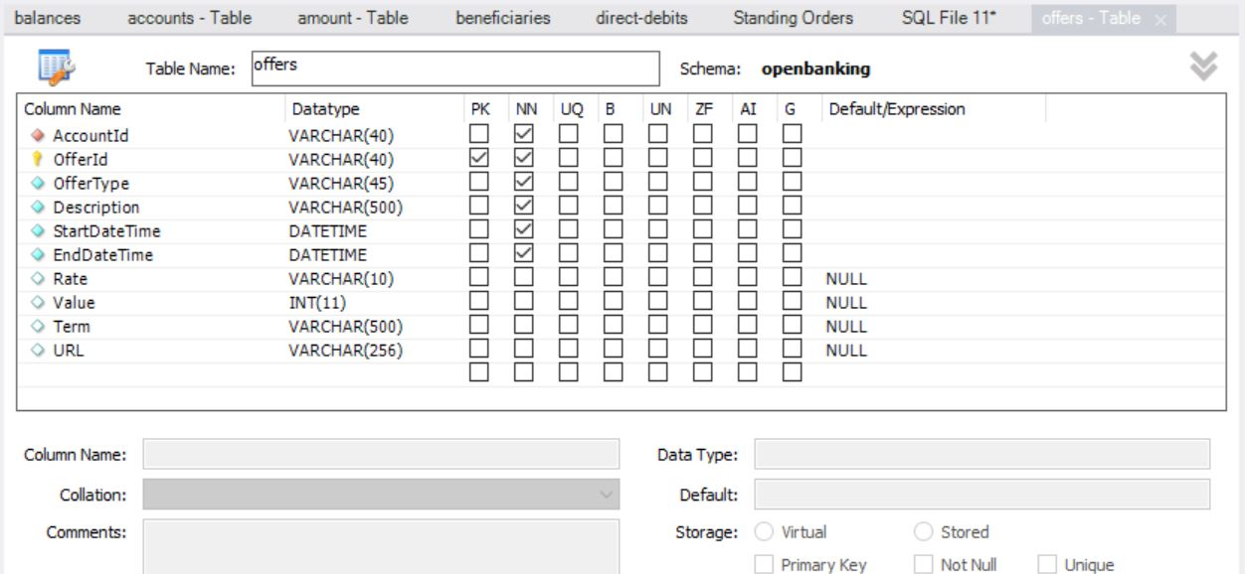

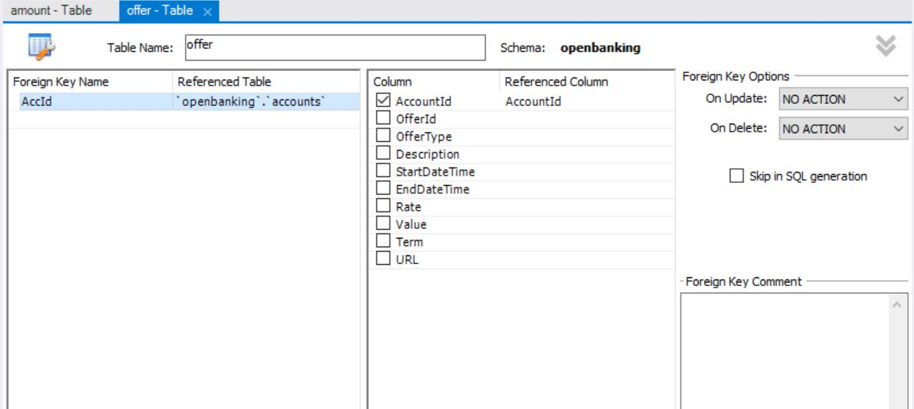

|  |  |  |  |
| --- | --- | --- | --- |
| **Column Name** | **Codes** | **Description** | **Pattern** |
| OfferType | BalanceTransfer  LimitIncrease  MoneyTransfer  Other  PromotionalRate |  |  |
| Description |  | Further details of the offer. |  |
| Rate | ^(-?\d{1,3}){1}(\.\d{1,4}){0,1}$ |  | ^(-?\d{1,3}){1}(\.\d{1,4}){0,1}$ |

**Payments Table:**

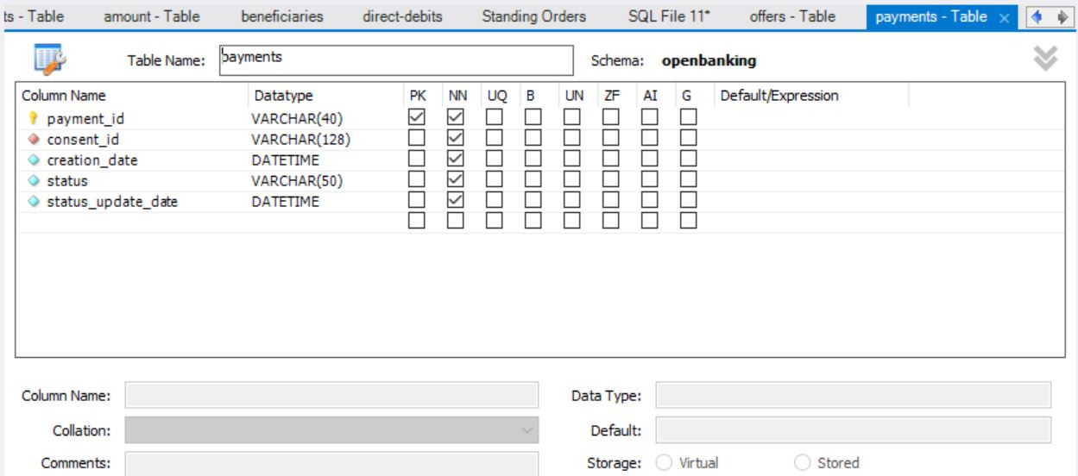

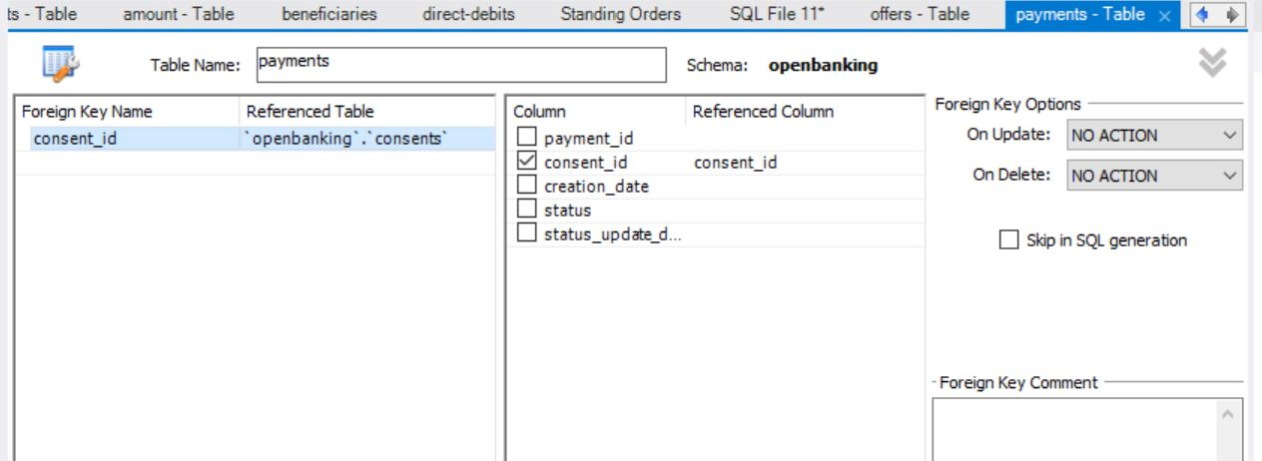

**Consents Table:**

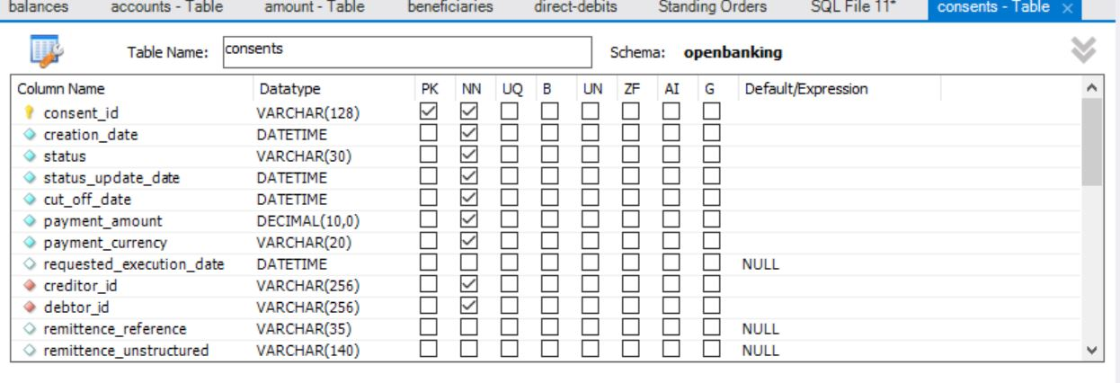

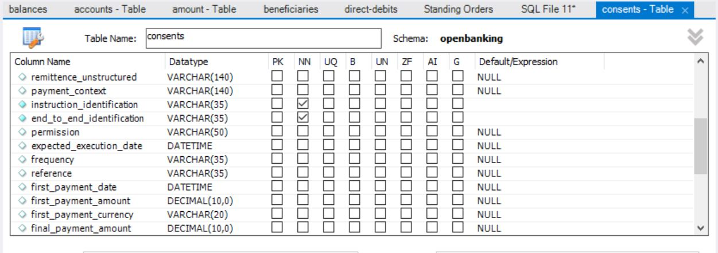

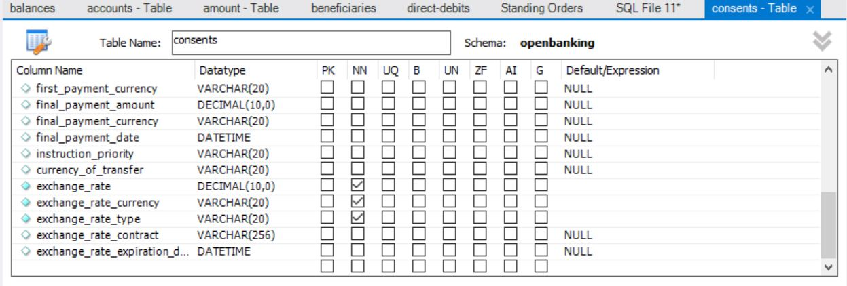

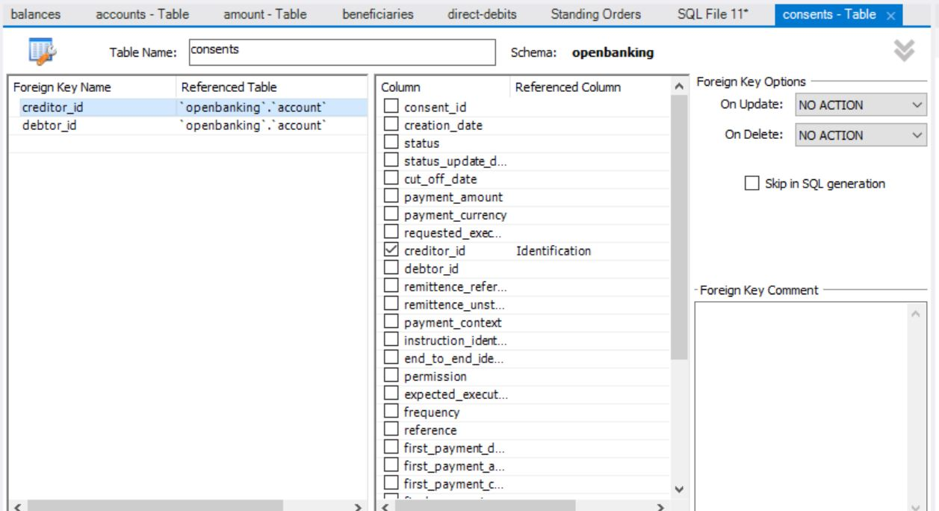

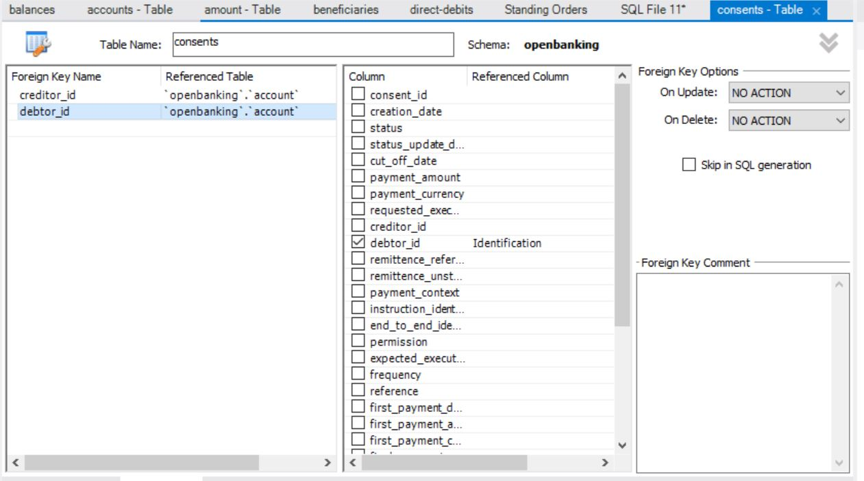

**Data Table:**

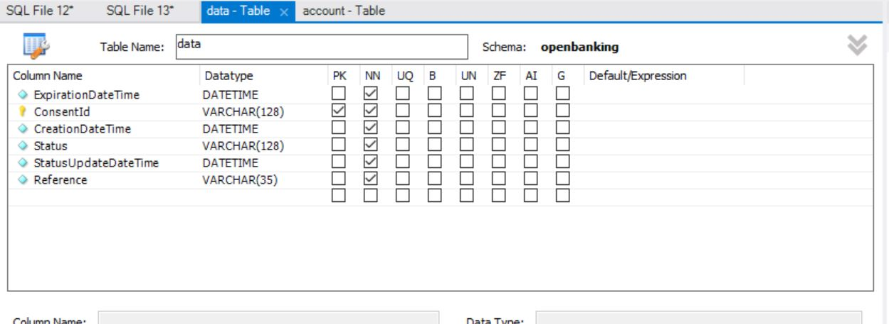

|  |  |
| --- | --- |
| Column Name | Codes |
| Status | Authorised AwaitingAuthorisation Rejected Revoked |

**Transaction Table:**

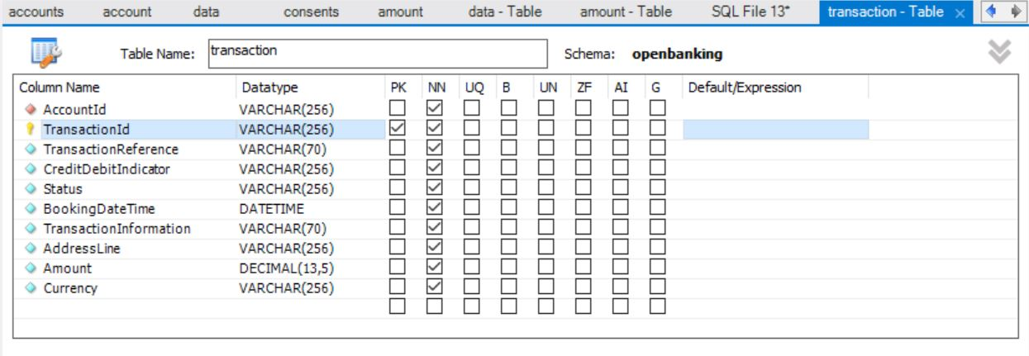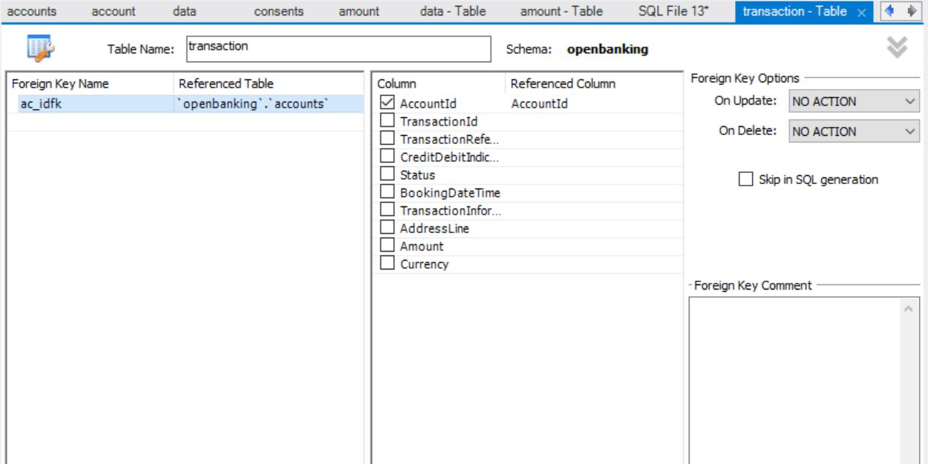

| **Type** | **Null** | **Field** | **Key** | **Default** | **Pattern** |
| --- | --- | --- | --- | --- | --- |
| datetime | NO | BookingDateTime |  |  | ISODateTime |
| decimal(13,5) | NO | Amount |  |  | ^\d{1,13}\.\d{1,5}$ |
| varchar(256) | NO | AccountId | MUL |  |  |
| varchar(256) | NO | TransactionId | PRI |  |  |
| varchar(256) | NO | CreditDebitIndicator |  |  |  |
| varchar(256) | NO | Status |  |  |  |
| varchar(256) | NO | AddressLine |  |  |  |
| varchar(5) | NO | Currency |  |  | ^[A-Z]{3,3}$ |
| varchar(70) | NO | TransactionReference |  |  |  |
| varchar(70) | NO | TransactionInformation |  |  |  |

**DirectDebit Table:**

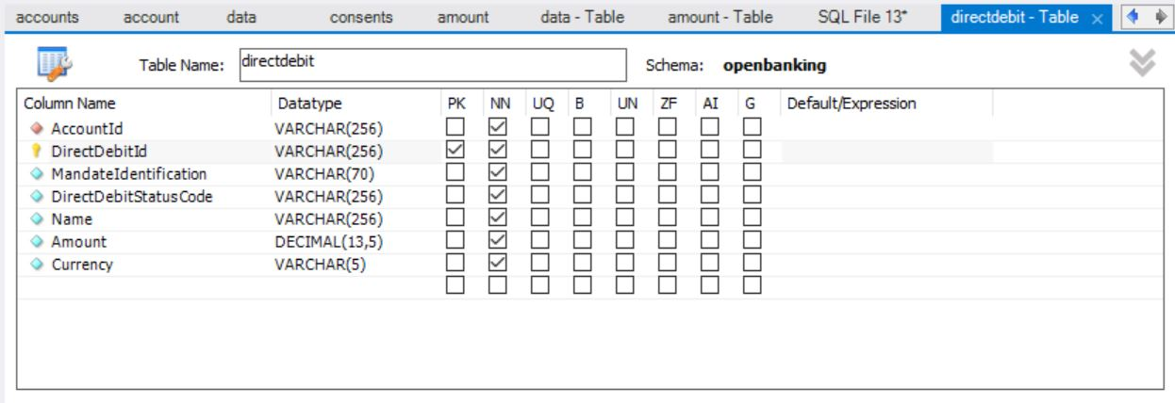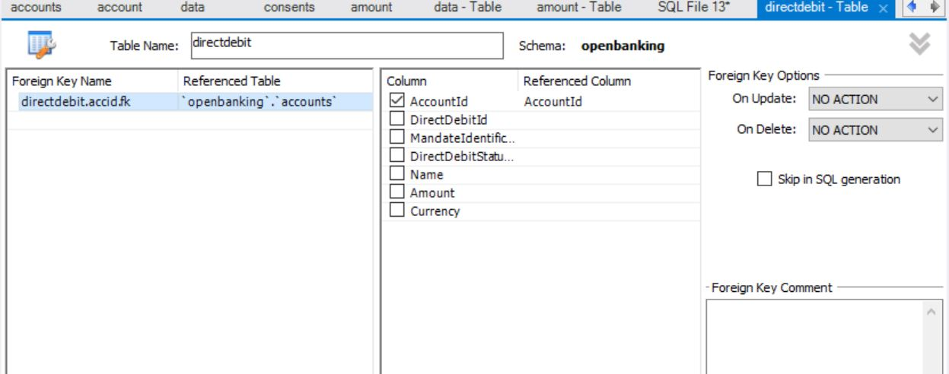

| **Field** | **Type** | **Null** | **Key** | **Default** | **Pattern** |
| --- | --- | --- | --- | --- | --- |
| AccountId | varchar(256) | NO | MUL |  |  |
| DirectDebitId | varchar(256) | NO | PRI |  |  |
| MandateIdentification | varchar(70) | NO |  |  |  |
| DirectDebitStatusCode | varchar(256) | NO |  |  |  |
| Name | varchar(256) | NO |  |  |  |
| Amount | decimal(13,5) | NO |  |  |  |
| Currency | varchar(5) | NO |  |  |  |

**Balances Table:**

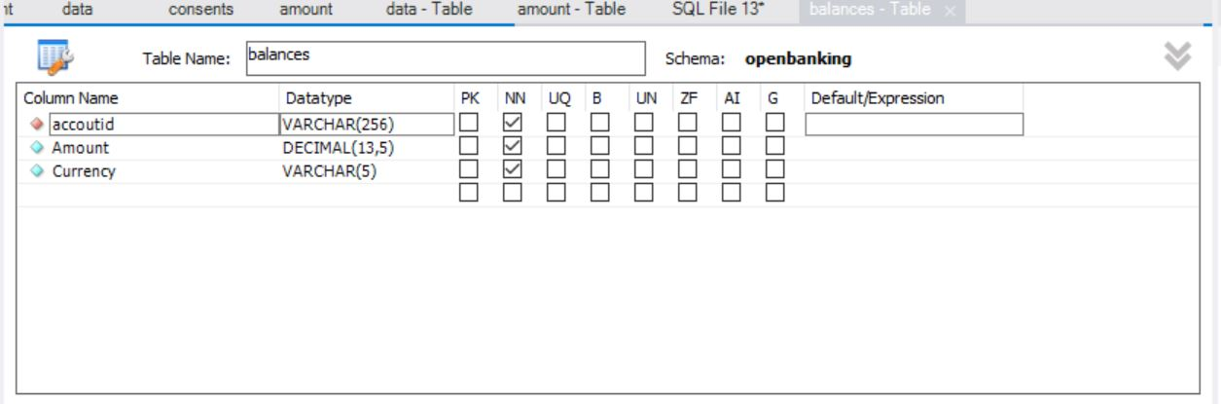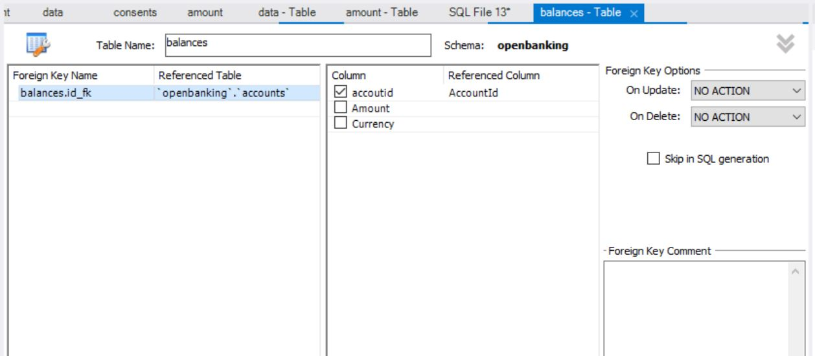

|  |  |
| --- | --- |
| Column Name | Codes |
| Amount | |  | | --- | | ^\d{1,13}\.\d{1,5}$ | |  | |
| Currency | ^[A-Z]{3,3}$ |