Vehicle Rental Booking System Documentation

Overview
The Vehicle Rental Booking System (VRBS) is developed to simplify the process of renting vehicles such as cars, bikes, and vans. It helps in managing customer bookings, vehicle availability, rental charges, and payment processing through a centralized system.
Features of the Vehicle Rental Booking System:
- Vehicle Availability Check
Users can search for rental vehicles (Car, Bike, Van) based on type, availability dates, and status. The system filters out vehicles that are currently booked or under maintenance and shows only those marked as Available.
- Vehicle Booking
Customers can reserve a vehicle by selecting available vehicles, along with pickup and return dates. The system ensures no conflicting bookings and updates the vehicle status to Booked.
- Customer Information Management
The system allows storing and managing customer details including name, contact info, address, and driver’s license. It supports adding new customers, updating existing records, and retrieving data for billing and bookings.
- Vehicle Information Management
Admins can manage the fleet of vehicles. They can add, update, or remove vehicle details such as make, model, year, license plate, daily rate, mileage, and current status (Available, Booked, In Service).
- Booking Management
Each booking is linked to a customer and a vehicle. The system records the booking date, pickup and return dates, and booking status (e.g., Confirmed, Cancelled, Completed).
- Billing and Invoicing
The system calculates rental charges based on the number of days and the daily rate of the vehicle. It generates an invoice with details like total days, total amount, payment date, and payment mode.
- Payment Processing
The application supports various payment modes (cash, card, online transfer). Payments are recorded along with the invoice and associated booking ID. Payment date and mode are stored for reference.
- User-Friendly Interface:
A menu-driven interface allows users to navigate between the functionality with ease.
System Modules
The application should consist of the following modules:
1. Customer Module-Store and manage customer information
2. Vehicle Module -Contains details of all rental vehicles
3. Booking Module-Manages reservation data and status
4. Billing Module - Handles payment processing

Required Software and Modules:
- Eclipse IDE: For developing and managing the project code base.
- XAMPP/MySQL: For database management and local server setup.
- Required JAR files: MySQL connector for database connectivity.
Here are the table requirements for a Vehicle Rental Booking System:

Vehicle Table:

Column Name | Data Type | Constraints
vehicleId | VARCHAR(10) | PRIMARY KEY
make | VARCHAR(50) | NOT NULL
model | VARCHAR(50) | NOT NULL
year | INT | NOT NULL
vehicleType | VARCHAR(20) | NOT NULL
licensePlateNumber | VARCHAR(20) | NOT NULL
dailyRate | DECIMAL(10,2) | NOT NULL
status | VARCHAR(20) | NOT NULL
mileage | INT | NOT NULL

Customer Table:

Column Name | Data Type | Constraints
customerId | VARCHAR(10) | PRIMARY KEY
firstName | VARCHAR(50) | NOT NULL
lastName | VARCHAR(50) | NOT NULL
email | VARCHAR(100) | NOT NULL
phone | VARCHAR(15) | NOT NULL
address | VARCHAR(200) | NOT NULL
driverLicenseNumber | VARCHAR(20) | NOT NULL

Booking Table:

Column Name | Data Type | Constraints
bookingId | VARCHAR(15) | PRIMARY KEY
customerId | VARCHAR(10) | FOREIGN KEY REFERENCES Customer(customerId)
vehicleId | VARCHAR(10) | FOREIGN KEY REFERENCES Vehicle(vehicleId)
bookingDate | Date | NOT NULL
pickupDate | Date | NOT NULL
returnDate | Date | NOT NULL
bookingStatus | VARCHAR(10) | NOT NULL

Billing Table:

Column Name | Data Type | Constraints
invoiceId | INT(11) | PRIMARY KEY
bookingId | VARCHAR(15) | FOREIGN KEY REFERENCES Booking(bookingId)
totalDays | INT | NOT NULL
totalAmount | DECIMAL(10,2) | NOT NULL
paymentDate | Date | NOT NULL
paymentMode | VARCHAR(20) | NOT NULL

Functionality Involved

1. Customer Information Management
Stores and manages customer details, including name, contact, and driver’s license. Ensures proper identity verification and links customers to their bookings and invoices.

2. Vehicle Management
Handles vehicle details such as make, model, type, and rental rate. Tracks the availability and status of vehicles to ensure accurate reservations.

3. Booking Management
Facilitates the reservation of vehicles, ensuring correct customer-vehicle pairing. Tracks booking dates and status while preventing overlapping reservations.

4. Billing and Payment Management
Calculates rental charges based on vehicle rate and rental duration. Generates invoices and stores payment details after each completed booking.

Project Structure:
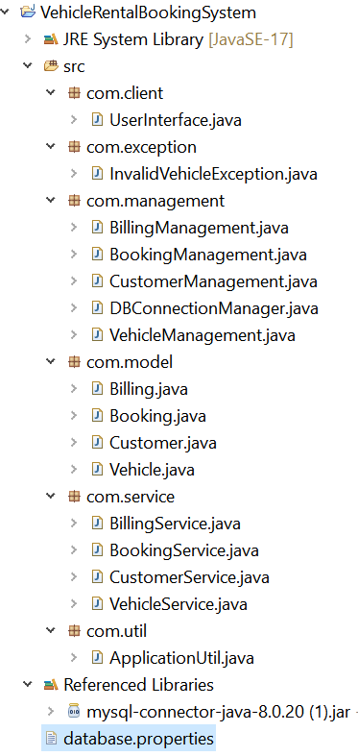
Project Flow:
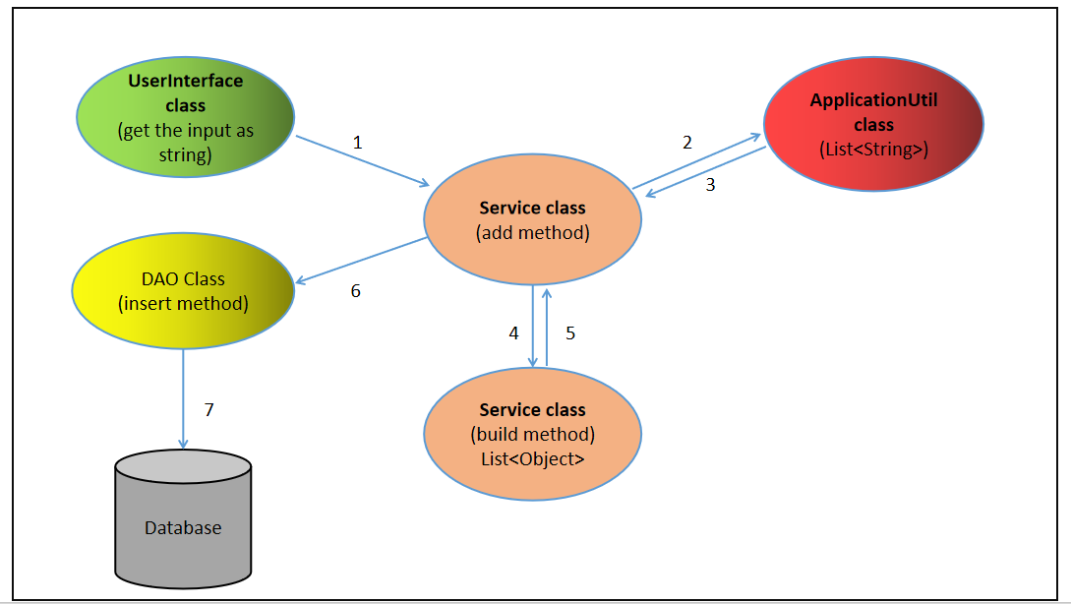
Scope of the Vehicle Rental Booking System Service classes:
Module/Class | Responsibility
CustomerService | - Build Customer List: Parses and processes customer records to create a list of Customer objects with attributes like customer ID, name, contact details, address, and driver's license information.  - Add Customer Records: Adds new customer records to the database through CustomerDAO.  - Update Customer Records: Updates existing customer information based on customer ID.  - Delete Customer Records: Removes a customer record based on customer ID.  - Retrieve Customer By ID: Fetches customer details by ID and formats them for display.
VehicleService | - Build Vehicle List: Parses and processes vehicle records to create a list of Vehicle objects with attributes like vehicle ID, make, model, year, type, license plate, daily rate, status and mileage.  - Generate Vehicle ID: Creates unique IDs for each vehicle.  - Add Vehicle Records: Adds new vehicle records to the database through VehicleDAO.  - Update Vehicle Status: Updates the status of vehicles (Available, Booked, In Service) based on vehicle ID.  - Delete Vehicle Records: Removes a vehicle record based on vehicle ID.  - Retrieve Vehicle By ID: Fetches vehicle details by ID and formats them for display.  - Retrieve Vehicle By Type: Retrieves and formats vehicle details based on vehicle type (Car, Bike, Van).  - Retrieve Available Vehicles: Filters and returns only vehicles marked as available for specific dates.
BookingService | Build Booking List: Parses booking records to create a list of Booking objects with attributes like booking ID, customer details, vehicle details, booking date, pickup date, return date, and status.  - Create Booking: Facilitates the creation of vehicle bookings by associating customers and vehicles, storing them in the database through BookingDAO.  - Generate Booking ID: Creates unique IDs for each booking.  - Check Vehicle Availability: Verifies if a vehicle is available for the requested dates before booking.  - Retrieve Booking Details: Retrieves and formats booking details based on booking ID for display.  - Update Booking Status: Changes booking status (Confirmed, Cancelled, Completed) based on booking ID.  - Cancel Booking: Handles the cancellation process for bookings and updates vehicle availability.  - Calculate Booking Duration: Computes the number of days between pickup and return dates.
  BillingService
  - Build Billing List: Parses invoice records to create a list of Billing objects with attributes like invoice ID, booking information, total days, total amount, payment date, and payment mode.
  - Calculate Bill Amount: Computes the total amount for a vehicle booking based on booking duration and vehicle daily rate.
  - Generate Invoice ID: Creates unique IDs for each invoice.
  - Retrieve Bill Details: Fetches and formats billing details based on booking ID or invoice ID for display.

Scope of the Management Module:

Module/Class | Responsibility
Customer Management | - Insert Customer Records: Add new customer information including personal details, contact information, and driver's license details to the database.  - Check Customer ID Existence: Verify if a customer ID exists in the database to prevent duplication of records.  - Update Customer Information: Modify existing customer details such as address, phone number, or email when information changes.  - Retrieve Customer Details: Fetch complete customer information based on customer ID for verification and booking purposes.  - Delete Customer Record: Remove a customer from the system based on customer ID while maintaining referential integrity.
Vehicle Management | - Insert Vehicle List: Add multiple vehicle records using batch insertion, including make, model, year, and rental rates.  - Check Vehicle ID Existence: Verify if a vehicle ID exists in the database to prevent duplication of records.  - Update Vehicle Status: Modify vehicle status (Available, Booked, In Service) based on bookings or maintenance requirements.  - Retrieve Vehicle Details by Vehicle ID: Fetch specific vehicle details based on vehicle ID for individual lookup and booking.  - Retrieve Vehicles by Type: Get all vehicles based on their type (e.g., Car, Bike, Van) to present options to customers.  - Retrieve Available vehicles: Get all vehicles based on available status.  - Delete Vehicle Record: Remove a vehicle record based on the vehicle ID when it's no longer part of the fleet.
Booking Management | - Insert Booking Details: Add a new booking record associating a customer with a vehicle for specific dates.  - Check Booking ID Existence: Verify if a booking ID exists in the database to prevent duplication of records.  - Update Booking Status: Change the status of a booking (Confirmed, Canceled, Completed) as it progresses.  - Retrieve Booking Details: Fetch complete booking information based on booking ID for customer service and billing.  - Cancel Booking: Process booking cancellation, update vehicle availability, and trigger any applicable refund process.  - Fetch Available Vehicles: Fetch complete booking information based on the availability.
  Billing Management
  - Insert Invoice: Add the invoice for a completed booking to the database.
  - Check Invoice ID Existence: Verify if a invoice ID exists in the database to prevent duplication of records.
  - Retrieve Bill Details: Fetches and formats billing details based on booking ID or invoice ID for display.

Scope of Database module:
Module | Responsibilities
DBConnectionManager | The DBConnectionManager module is responsible for managing and providing database connections to other modules in the application. Its primary responsibilities include:  Loading Database Properties: It reads the database connection properties from a configuration file, such as database.properties, which typically contains details like the database URL, driver name, username, and password.  Establishing Database Connection: It establishes a connection to the database using the properties loaded from the configuration file. This connection is created through the Java Database Connectivity (JDBC) API.  Handling Exceptions: It handles exceptions related to file IO (e.g., IOException), database drivers (e.g., ClassNotFoundException), and SQL errors (e.g., SQLException) that may occur during the connection process.

Scope of the Exception module
Module Name | Responsibility
InvalidVehicleException | The InvalidVehicleException class is a custom exception class that extends the standard Exception class. It's responsible for handling scenarios where vehicle data fails validation checks or operations on vehicles cannot be completed due to data integrity issues.

Scope of the Utility Module
Module/Class Name | Responsibility
ApplicationUtil | ApplicationUtil provides essential utility methods to support various functionalities within the Vehicle Rental Booking system.  Responsibilities:  Extract Details:  Parses input strings related to vehicle, customer, booking, and billing details into structured objects or lists for further processing.  Date Conversion Utilities:  Converts between String, java.util.Date, and java.sql.Date formats to ensure consistent handling of date fields such as booking date, pickup date, return date, and payment date.  Console Input Reading:  Reads input directly from the console, parsing user-provided details related to customers, vehicles, bookings, and payments for creating and managing records.  Date Formatting:  Ensures standardized date formatting (dd-MM-yyyy) is used across the system for all date fields to maintain consistency in storage, display, and comparisons.  Exception Handling:  Manages IOExceptions and ParseExceptions during input reading or date conversion, ensuring robust and user-friendly error handling during interaction with the system.

