## **Ritzy Technewell Solution**

# **Employee Leave Form**

DATE:

**Employee Name: : Mani Kannan. S**

**Reg No :**

**Role of Designation : Developer**

**Leave Date: : 14-12-2022**

**Total Days : 1**

**Reason for leave : Personal (marriage function)**

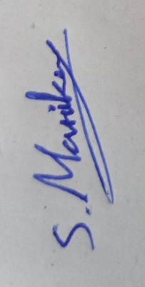

**Employee Signature**

Description:

After you submit all of the details here. You should mail this form to your HR And the CEO in the official Email id.

**CEO & Founder**: vanaraj@ritzyts.com

**HR Manager:** knagaraja.rts@gmail.com