EX.NO:10 REG.NO:210701311

DATE:

**HADOOP DEMONSTRATE THE MAP REDUCE PROGRAMMING MODEL BY**

**COUNTING THE NUMBER OF WORDS IN A FILE**

**AIM:**

To demonstrate the MAP REDUCE programming model for counting the number

of words in a file.

**PROCEDURE**

Step 1 - Open Terminal

$ su hduser

Password:

Step 2 - Start dfs and mapreduce services

$ cd /usr/local/hadoop/hadoop-2.7.2/sbin

$ start-dfs.sh

$ start-yarn.sh

$ jps

Step 3 - Check Hadoop through web UI

// Go to browser type http://localhost:8088 – All Applications Hadoop Cluster

// Go to browser type http://localhost:50070 – Hadoop Namenode

Step 4 – Open New Terminal

$ cd Desktop/

$ mkdir inputdata

$ cd inputdata/

$ echo “Hai, Hello, How are you? How is your health?” >> hello.txt

$ cat>> hello.txt

Step 5 – Go back to old Terminal

$ hadoop fs –copyFromLocal /home/hduser/Desktop/inputdata/hello.txt

/folder/hduser // Check in hello.txt in Namenode using Web UI

Step 6 – Download and open eclipse by creating workspace

Create a new java project.

Step 7 – Add jar to the project

You need to remove dependencies by adding jar files in the hadoop source folder. Now Click

on Project tab and go to Properties.Under Libraries tab, click Add External JARs and select

all the jars in the folder (click on 1st jar, and Press Shift and Click on last jat to select all jars

in between and click ok)

/usr/local/hadoop/hadoop-2.7.2/share/hadoop/commonand

/usr/local/hadoop/hadoop-2.7.2/share/hadoop/mapreduce folders.

Step -8 – WordCount Program

Create 3 java files named

● WordCount.java

● WordCountMapper.java

● WordCountReducer.java

**WordCount.java**

import org.apache.hadoop.conf.Configured;

import org.apache.hadoop.fs.Path;

import org.apache.hadoop.io.IntWritable;

import org.apache.hadoop.mapred.FileInputFormat;

import org.apache.hadoop.mapred.FileOutputFormat;

import org.apache.hadoop.mapred.JobClient; import

org.apache.hadoop.mapred.JobConf;

import org.apache.hadoop.util.Tool;

import org.apache.hadoop.util.ToolRunner;

import org.apache.hadoop.io.Text;

public class WordCount extends Configured implements Tool {

@Override

public int run(String[] arg0) throws Exception {

// TODO Auto-generated method

stub if(arg0.length<2)

{

System.out.println("check the command line arguments");

}

JobConf conf=new JobConf(WordCount.class);

FileInputFormat.setInputPaths(conf, new Path(arg0[0]));

FileOutputFormat.setOutputPath(conf, new

Path(arg0[1])); conf.setMapperClass(WordMapper.class);

conf.setReducerClass(WordReducer.class);

conf.setOutputKeyClass(Text.class);

conf.setOutputValueClass(IntWritable.class);

conf.setOutputKeyClass(Text.class);

conf.setOutputValueClass(IntWritable.class);

JobClient.runJob(conf);

return 0;

}

public static void main(String args[]) throws Exception

{

int exitcode=ToolRunner.run(new WordCount(),

args); System.exit(exitcode);

}

}

WordCountMapper.java

import java.io.IOException;

import org.apache.hadoop.io.IntWritable;

import org.apache.hadoop.io.LongWritable;

import org.apache.hadoop.mapred.MapReduceBase;

import org.apache.hadoop.mapred.OutputCollector;

import org.apache.hadoop.mapred.Reporter;

import org.apache.hadoop.io.Text;

import org.apache.hadoop.mapred.Mapper;

public class WordCountMapper extends MapReduceBase implements

Mapper<LongWritable,Text,Text,IntWritable>

{

@Override

public void map(LongWritable arg0, Text arg1, OutputCollector<Text,

IntWritable> arg2, Reporter arg3)

throws IOException {

// TODO Auto-generated method stub

String s=arg1.toString();

for(String word:s.split(" "))

{

arg2.collect(new Text(word),new IntWritable(1));

}

}

}

WordCountReducer.java

import java.io.IOException;

import java.util.Iterator;

import org.apache.hadoop.io.IntWritable;

import org.apache.hadoop.mapred.JobConf;

import org.apache.hadoop.mapred.OutputCollector;

import org.apache.hadoop.mapred.Reducer;

import org.apache.hadoop.mapred.Reporter;

import org.apache.hadoop.io.Text;

public class WordCountReducer implements

Reducer<Text,IntWritable,Text,IntWritable> { @Override

public void configure(JobConf arg0) {

// TODO Auto-generated method stub

}

@Override

public void close() throws IOException {

// TODO Auto-generated method stub

}

@Override

public void reduce(Text arg0, Iterator<IntWritable> arg1,

OutputCollector<Text, IntWritable> arg2, Reporter arg3)

throws IOException {

// TODO Auto-generated method

stub int count=0;

while(arg1.hasNext())

{

IntWritable i=arg1.next();

count+=i.get();

}

arg2.collect(arg0,new IntWritable(count));

}

}

Step 9 - Create JAR file

Now Click on the Run tab and click Run-Configurations. Click on New Configuration

button on the left top side and Apply after filling the following properties.

Step 10 - Export JAR file

Now click on File tab and select Export. under Java, select Runnable Jar.

In Launch Config – select the config fie you created in Step 9 (WordCountConfig).

➢ Select an export destination (let’s say desktop.)

➢ Under Library handling, select Extract Required Libraries into generated JAR and click

Finish. ➢ Right-Click the jar file, go to Properties and under Permissions tab, Check

Allow executing file

as a program. and give Read and Write access to all the users

Step 11 – Go back to old Terminal for Execution of WordCount Program $hadoop jar

wordcount.jar/usr/local/hadoop/input/usr/local/hadoop/output

Step 12 – To view results in old Terminal

$hdfs dfs -cat /usr/local/hadoop/output/part-r-00000

Step 13 - To Remove folders created using hdfs

$ hdfs dfs -rm -R /usr/local/hadoop/output

**OUTPUT**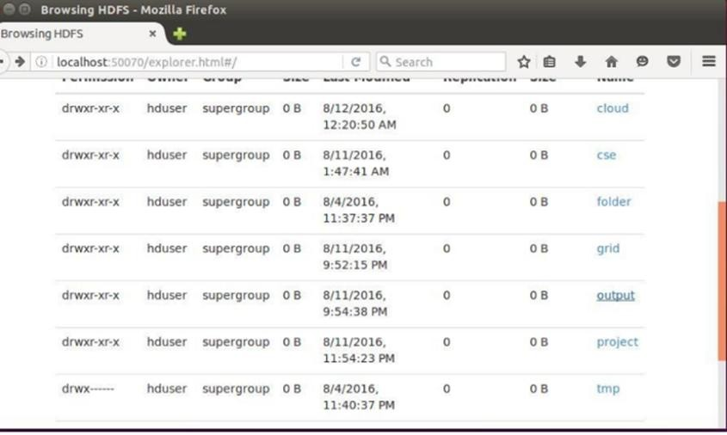

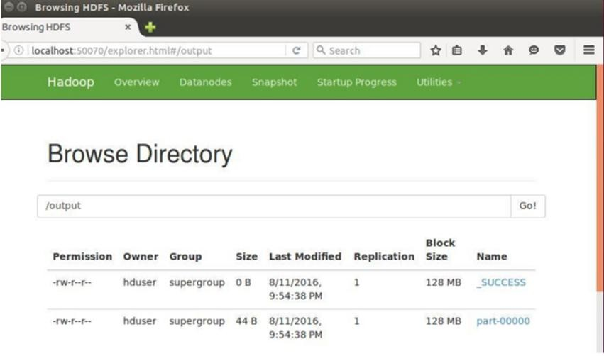

**RESULT:**

Thus the map reduce programming model for counting the number of words in a file has been executed successfully.