**EX.NO: 8 REGISTER NO: 210701311**

**DATE:**

**IMPLEMENT SVM/DECISION TREE CLASSIFICATION TECHNIQUES**

**AIM:**

To implement SVM/Decision tree classification techniques.

**PROGRAM CODE:**

**SVM IN R:**

# Install and load the e1071 package (if not already installed)

install.packages("e1071")

library(e1071)

# Load the iris dataset

data(iris)

# Inspect the first few rows of the dataset

head(iris)

# Split the data into training (70%) and testing (30%) sets

set.seed(123) # For reproducibility

sample_indices <- sample(1:nrow(iris), 0.7 * nrow(iris))

train_data <- iris[sample_indices, ]

test_data <- iris[-sample_indices, ]

# Fit the SVM model

svm_model <- svm(Species ~ ., data = train_data, kernel = "radial")

# Print the summary of the model

summary(svm_model)

# Predict the test set

predictions <- predict(svm_model, newdata = test_data)

# Evaluate the model's performance

confusion_matrix <- table(Predicted = predictions, Actual = test_data$Species)

print(confusion_matrix)

# Calculate accuracy

accuracy <- sum(diag(confusion_matrix)) / sum(confusion_matrix)

cat("Accuracy:", accuracy * 100, "%\n")

**Decision tree in R:**

# Install and load the rpart package (if not already installed)

install.packages("rpart")

library(rpart)

# Load the iris dataset

data(iris)

# Split the data into training (70%) and testing (30%) sets

set.seed(123) # For reproducibility

sample_indices <- sample(1:nrow(iris), 0.7 * nrow(iris))

train_data <- iris[sample_indices, ]

test_data <- iris[-sample_indices, ]

# Fit the Decision Tree model

tree_model <- rpart(Species ~ ., data = train_data, method = "class")

# Print the summary of the model

summary(tree_model)

# Plot the Decision Tree

plot(tree_model)

text(tree_model, pretty = 0)

# Predict the test set

predictions <- predict(tree_model, newdata = test_data, type = "class")

# Evaluate the model's performance

confusion_matrix <- table(Predicted = predictions, Actual = test_data$Species)

print(confusion_matrix)

# Calculate accuracy

accuracy <- sum(diag(confusion_matrix)) / sum(confusion_matrix)

cat("Accuracy:", accuracy * 100, "%\n")

**OUTPUT:**

**SVM in R:**

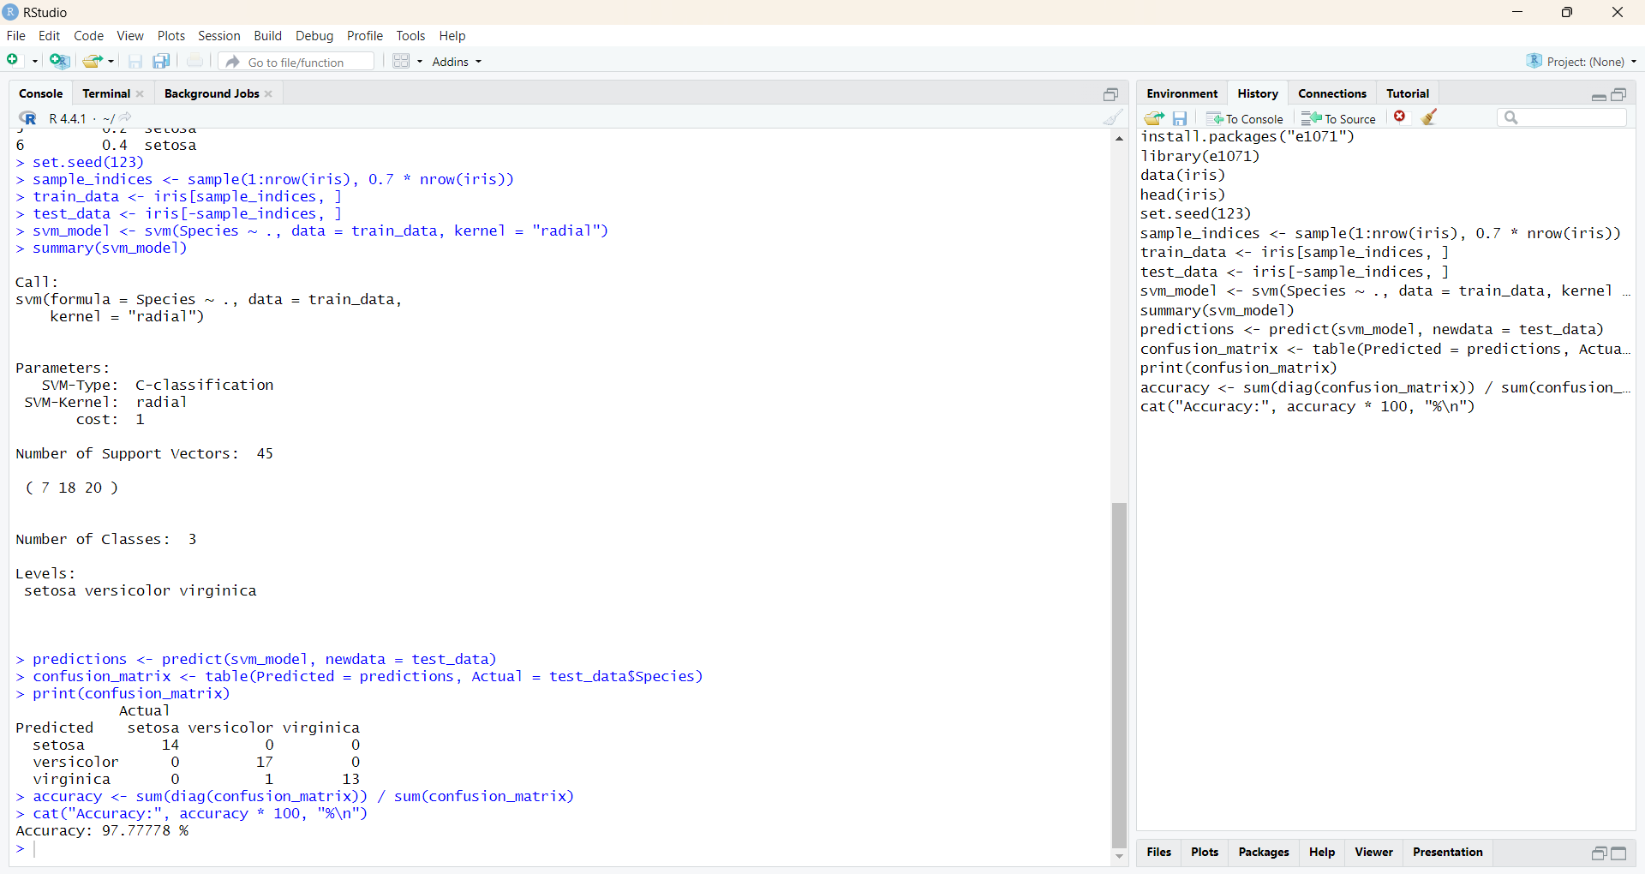

**Decision Tree in R:**

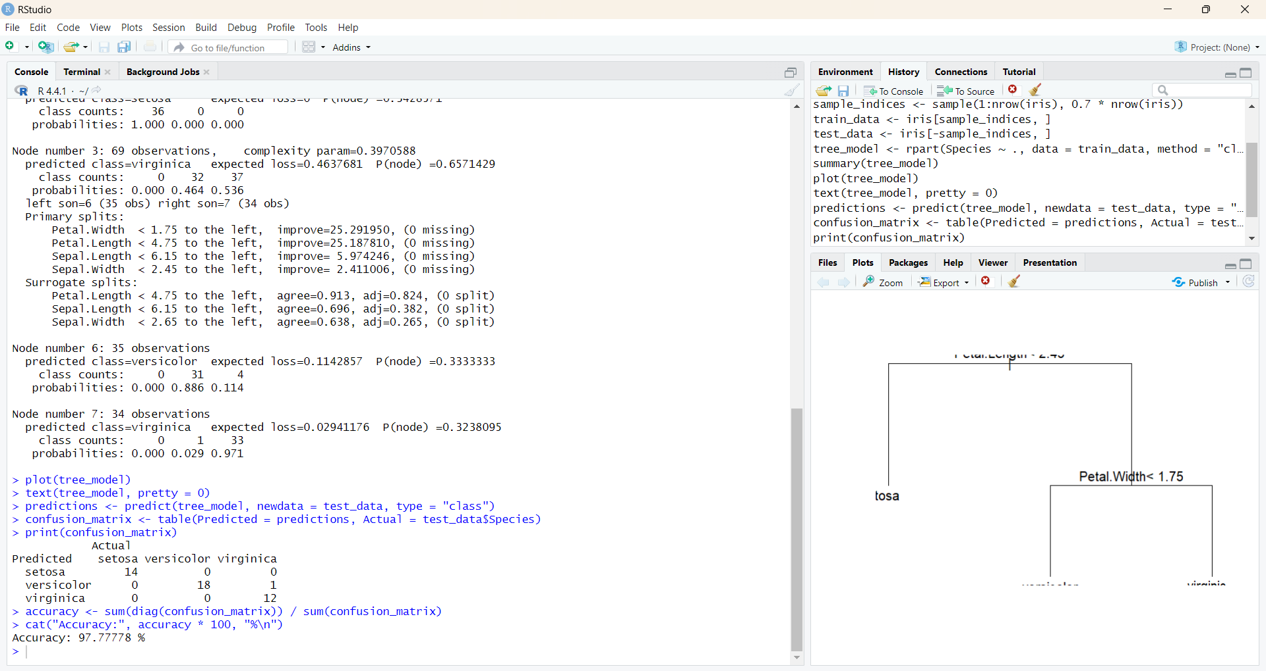

**RESULT:**

Thus the implementation of SVM/Decision tree classification techniques done successfully.