Create a new folder

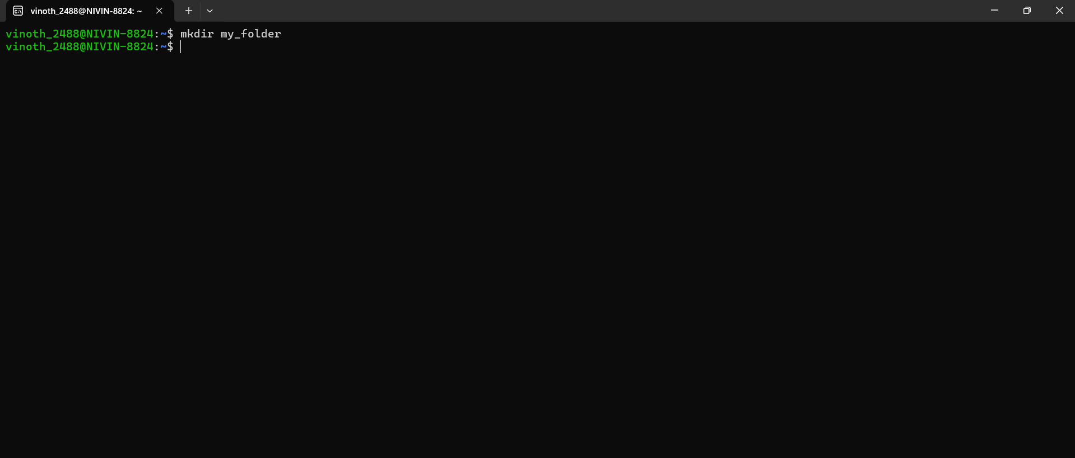

Navigate to new folder

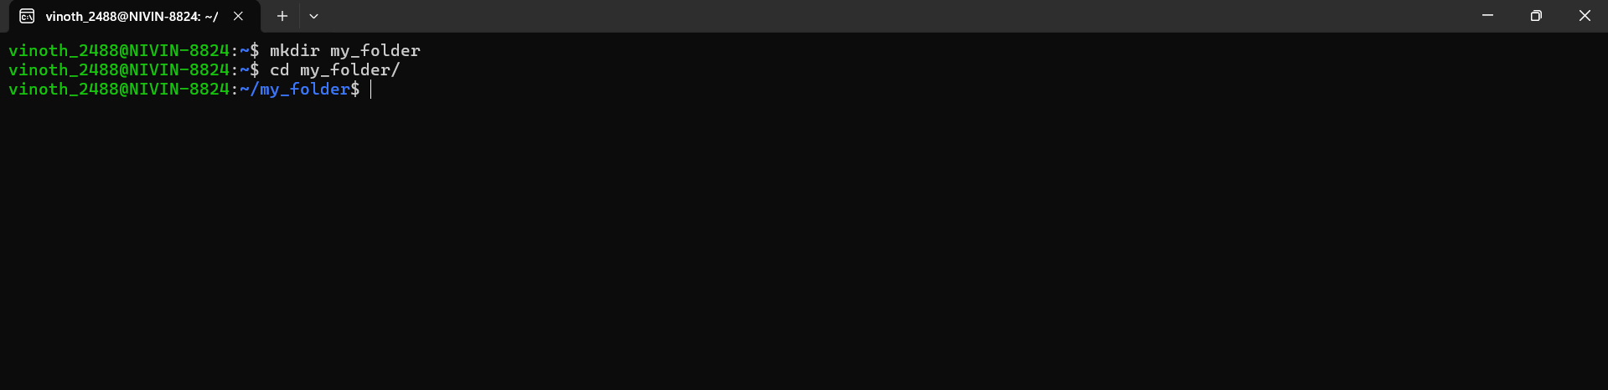

Create new file with content

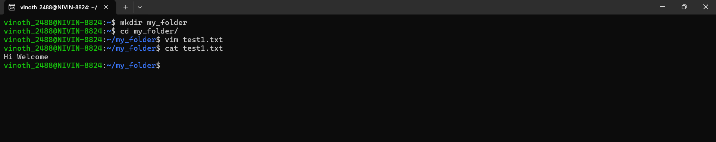

Create another file with content

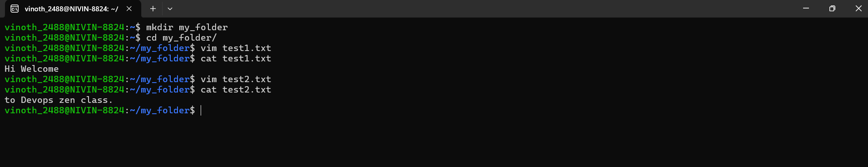

Concatenate and display the contents in new file

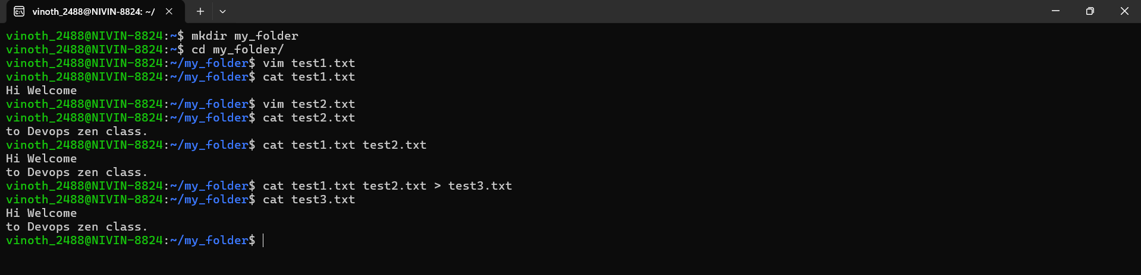

List down the files inside the folder

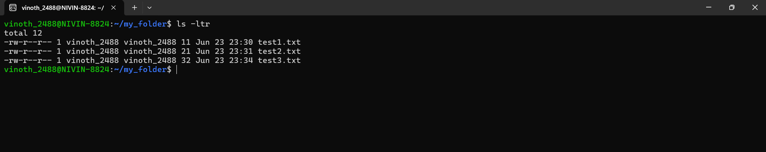

Create 20 txt file inside folder (**command used:** touch file{1..20}.txt)

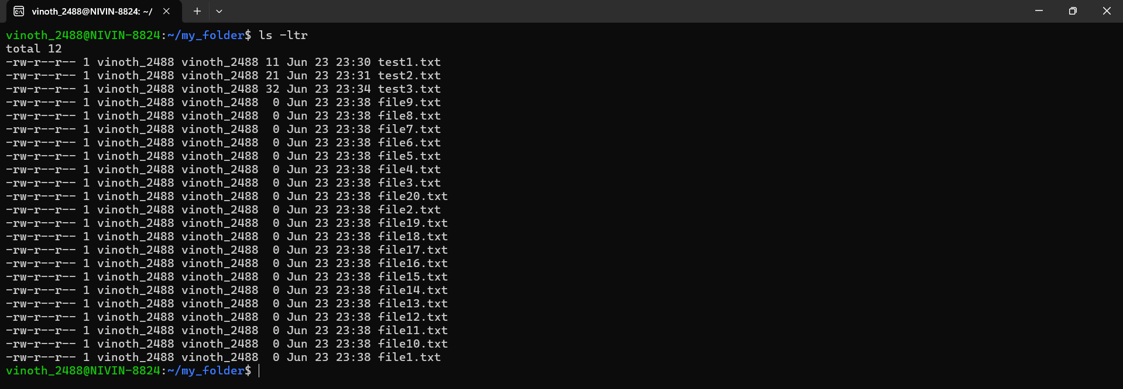

Renamed first 5 files to yml using mv command

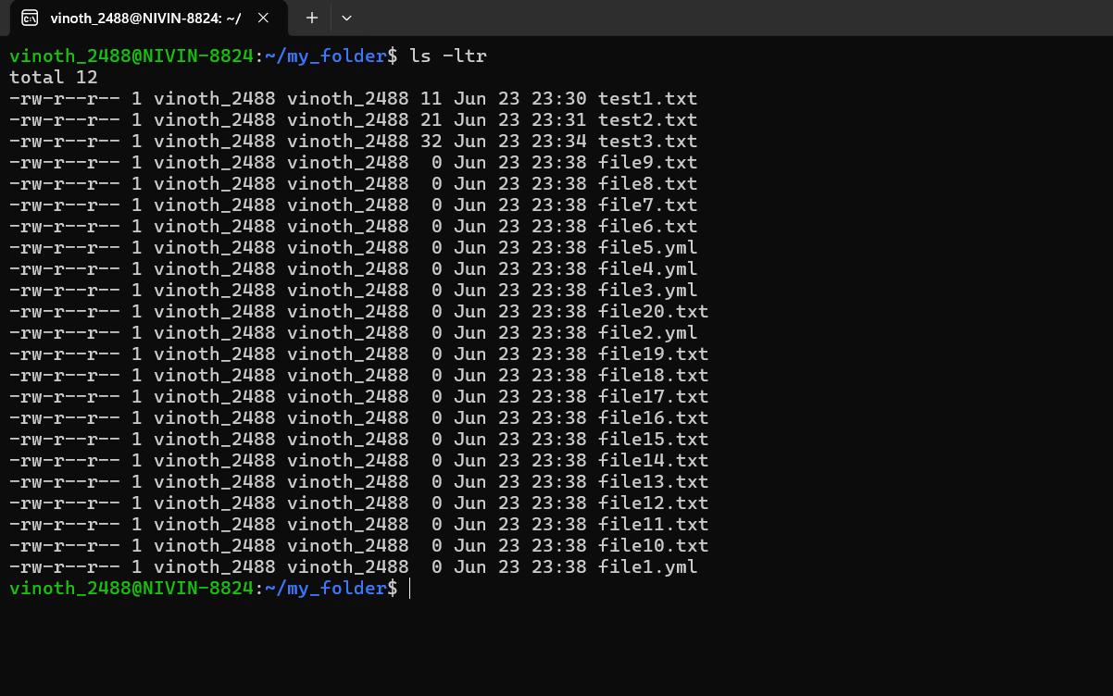

Display 5 newly created file. (there is some time difference in recursive file creation)

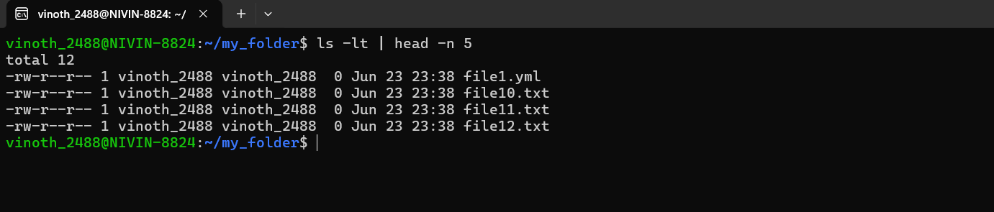

Ls -t displays 5 files, but above display only 4

