INSTALL DOCKER

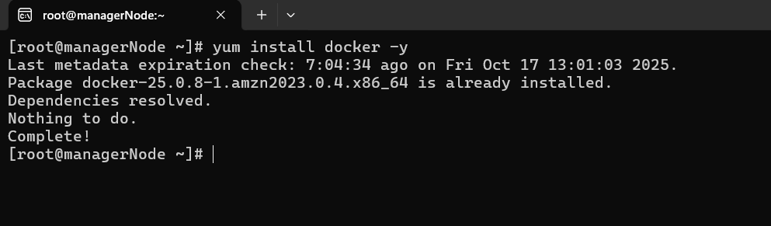

DOKCER IMAGES

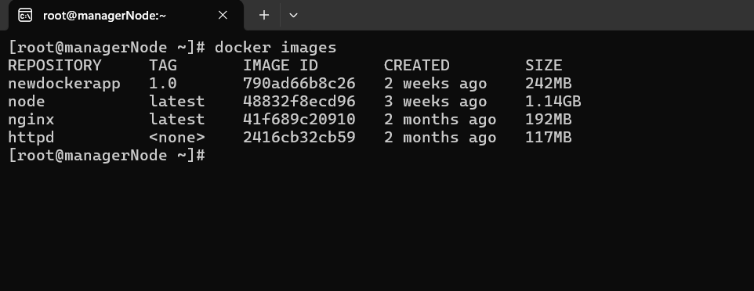

Remove docker image

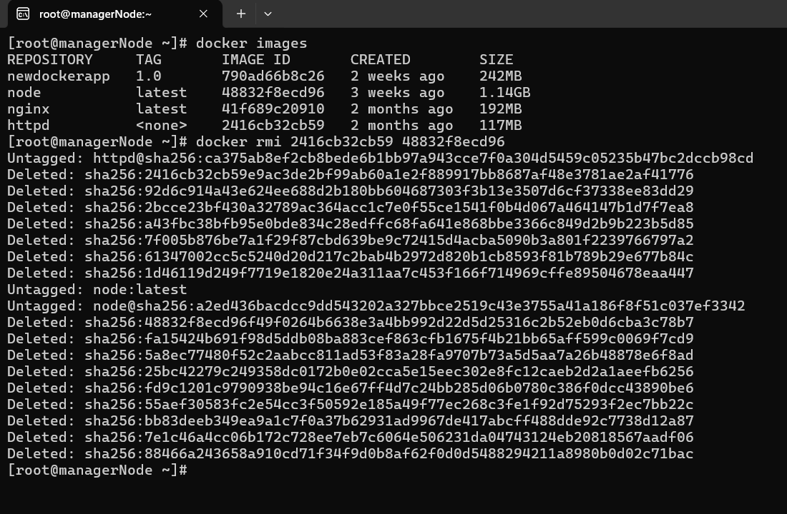

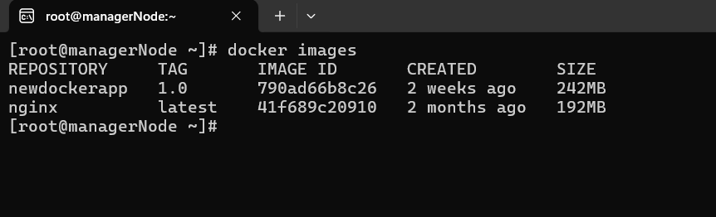

Pull docker image

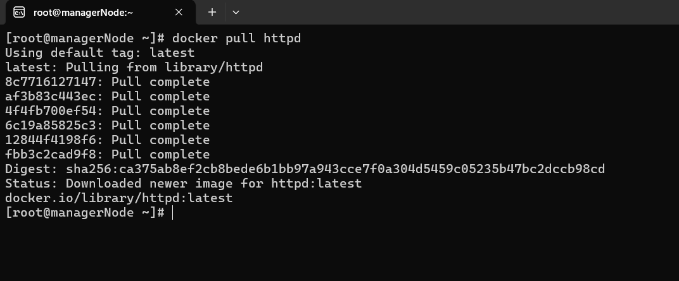

Create and run container

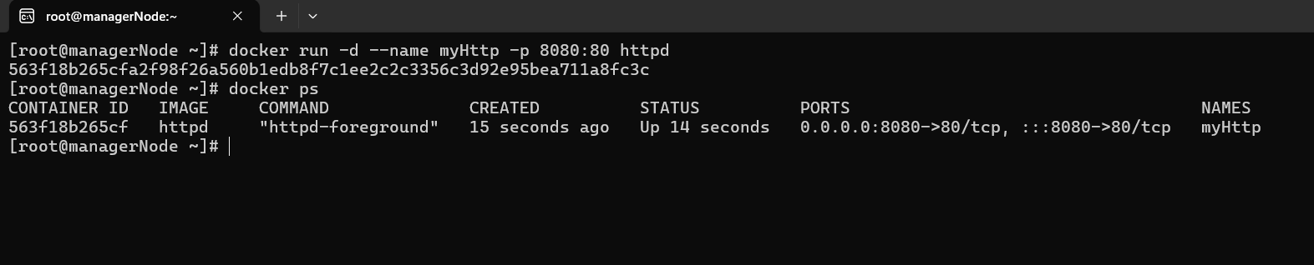

Docker stats

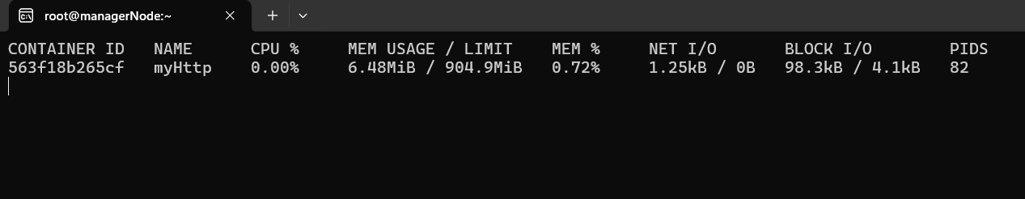

Stop container

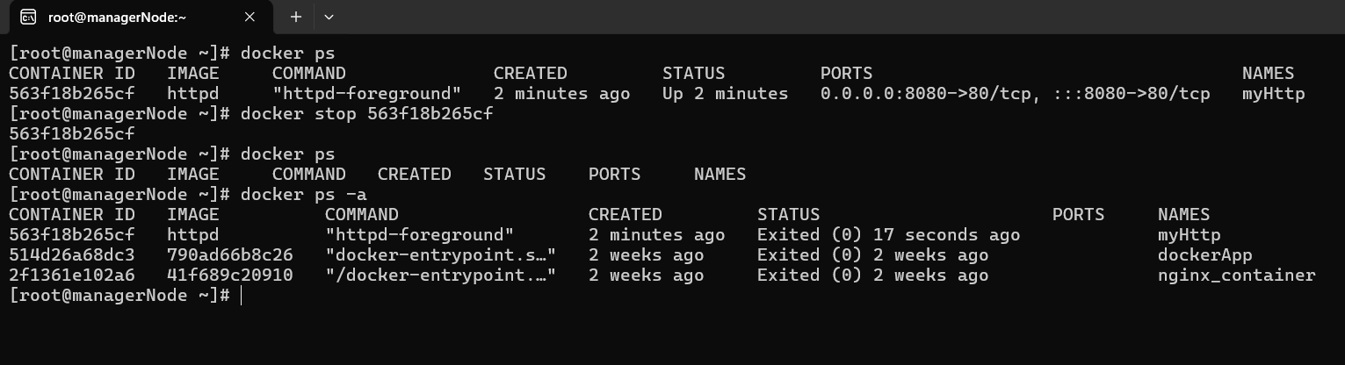

Start container

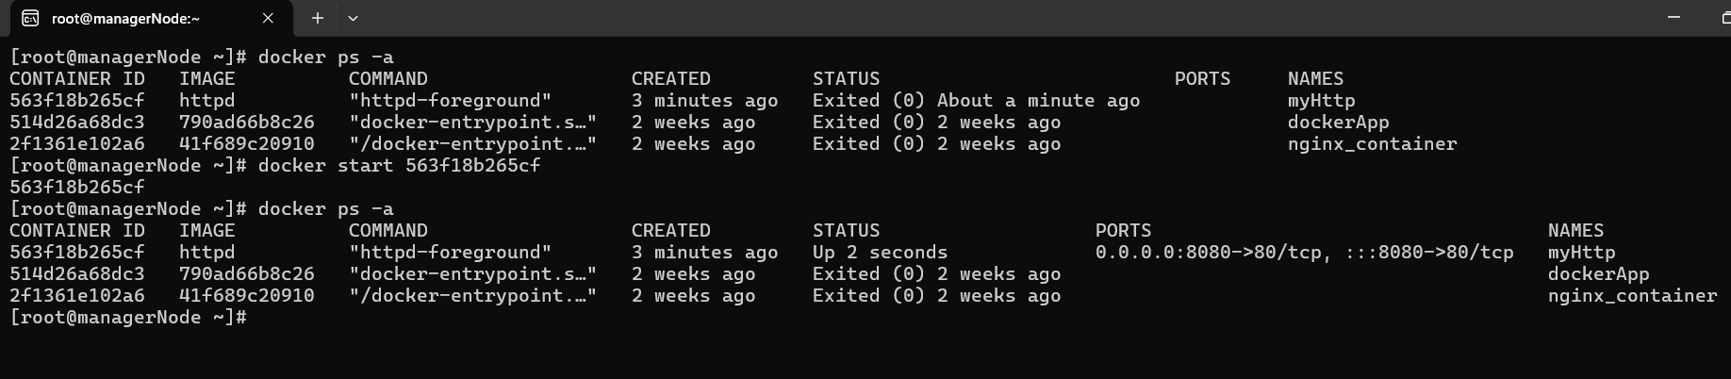

Check logs

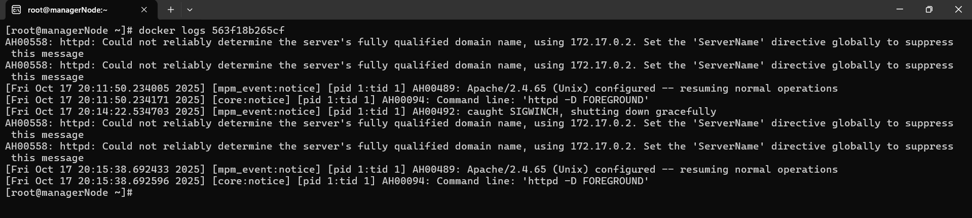

COPY FILES TO CONTAINER

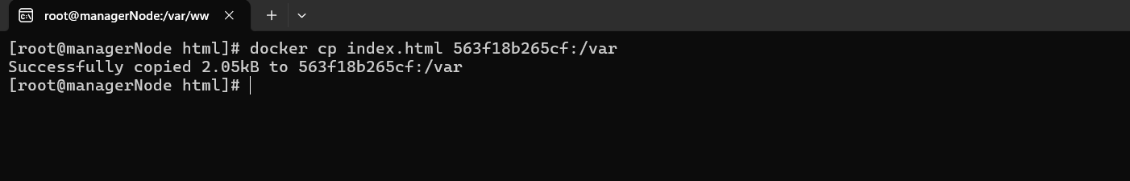

Login to container

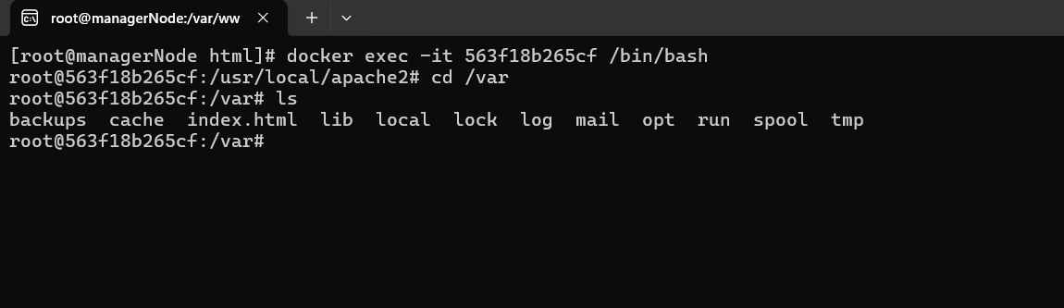

Create image from container

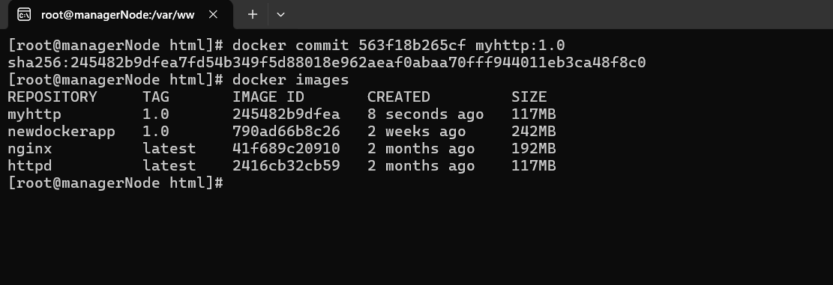

Delete container

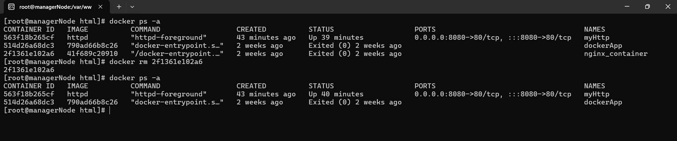

Create and List VOLUME

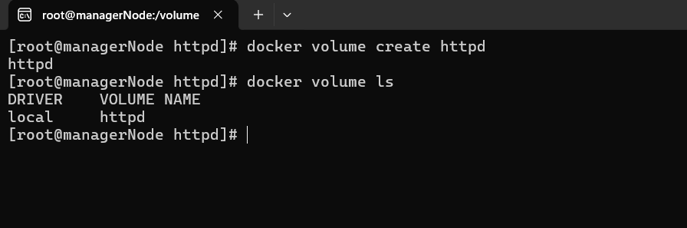

Inspect Volume

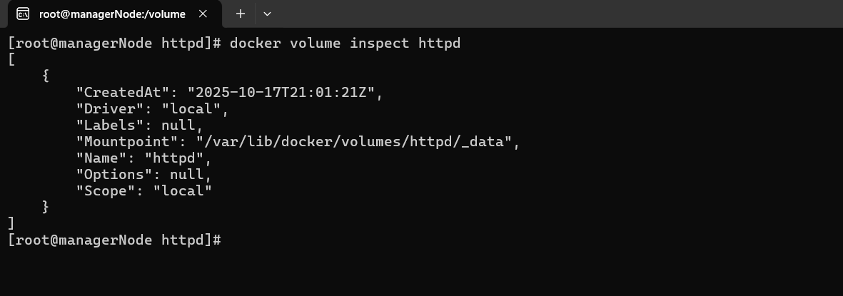

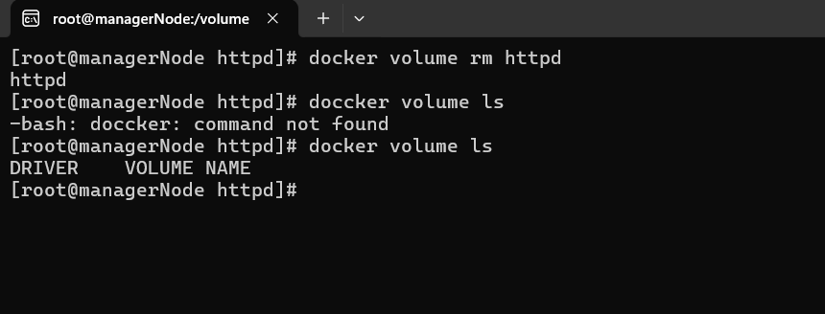

Create container referring Docker Volume

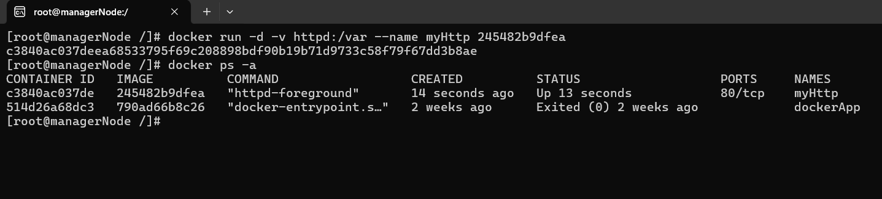

Create Container from actual folder as docker volume

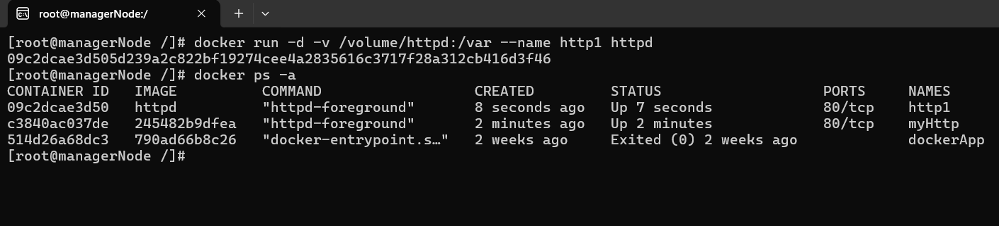

DOCKER NETWORK

Create and list network

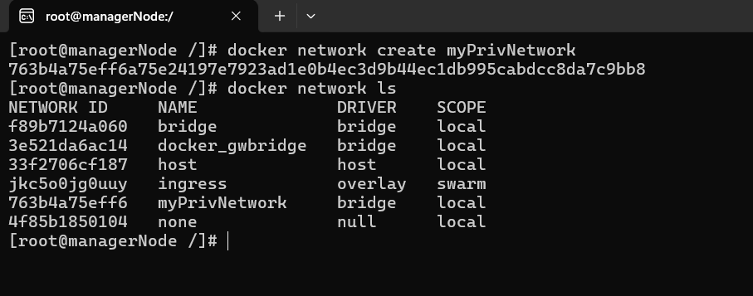

Inspect Network

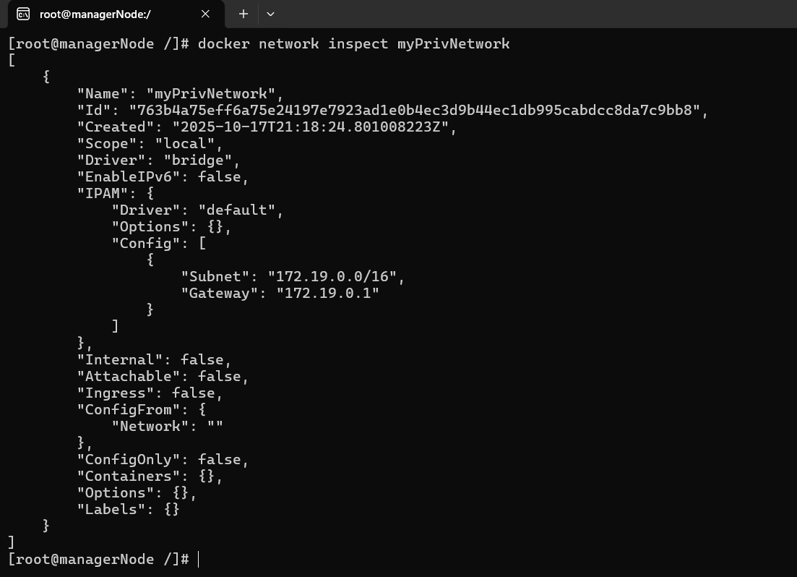

Connect Network to container

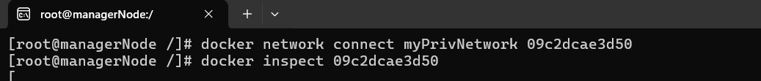

Disconnect Network

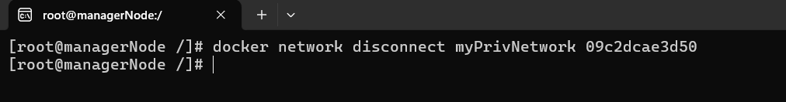

Create Container with Network

