**Ip Lookup**

NsLookup

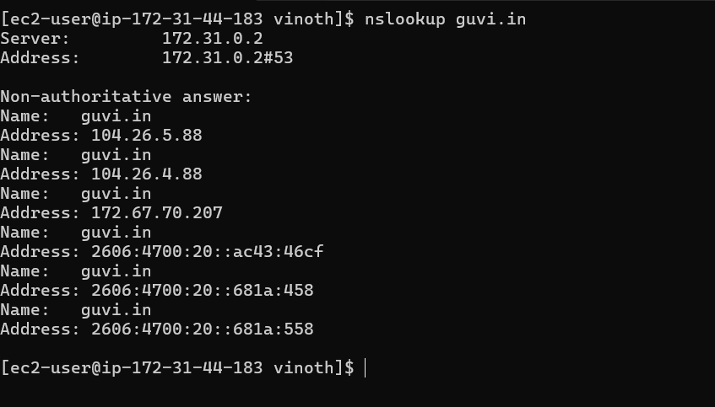

Ping command

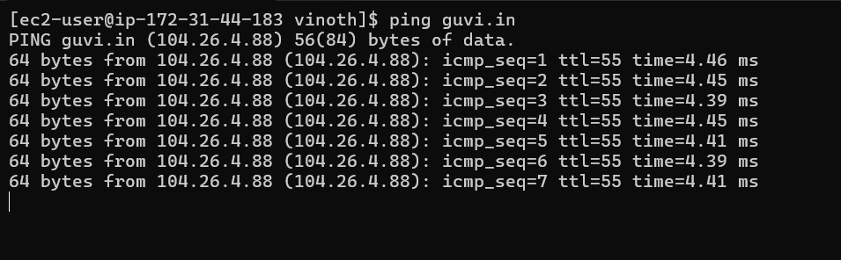

Dig command

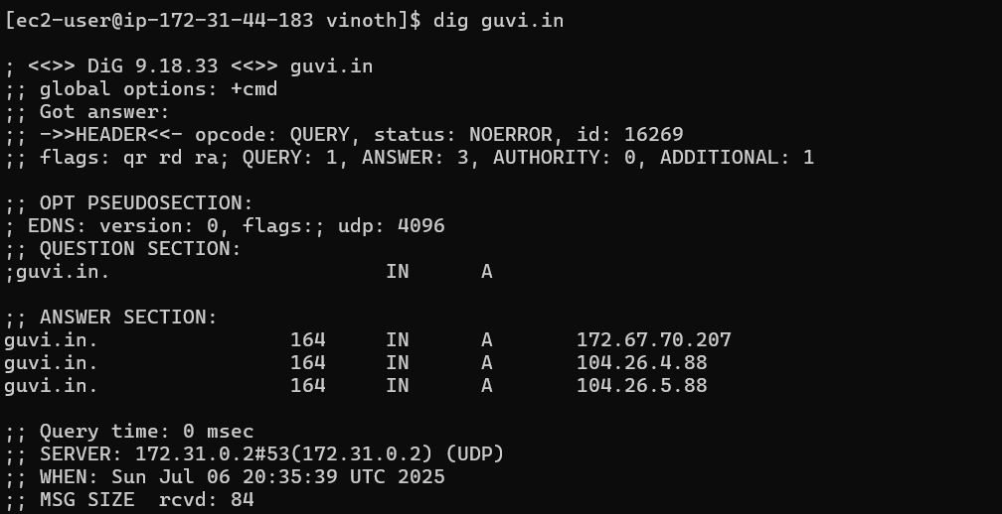

Curl command

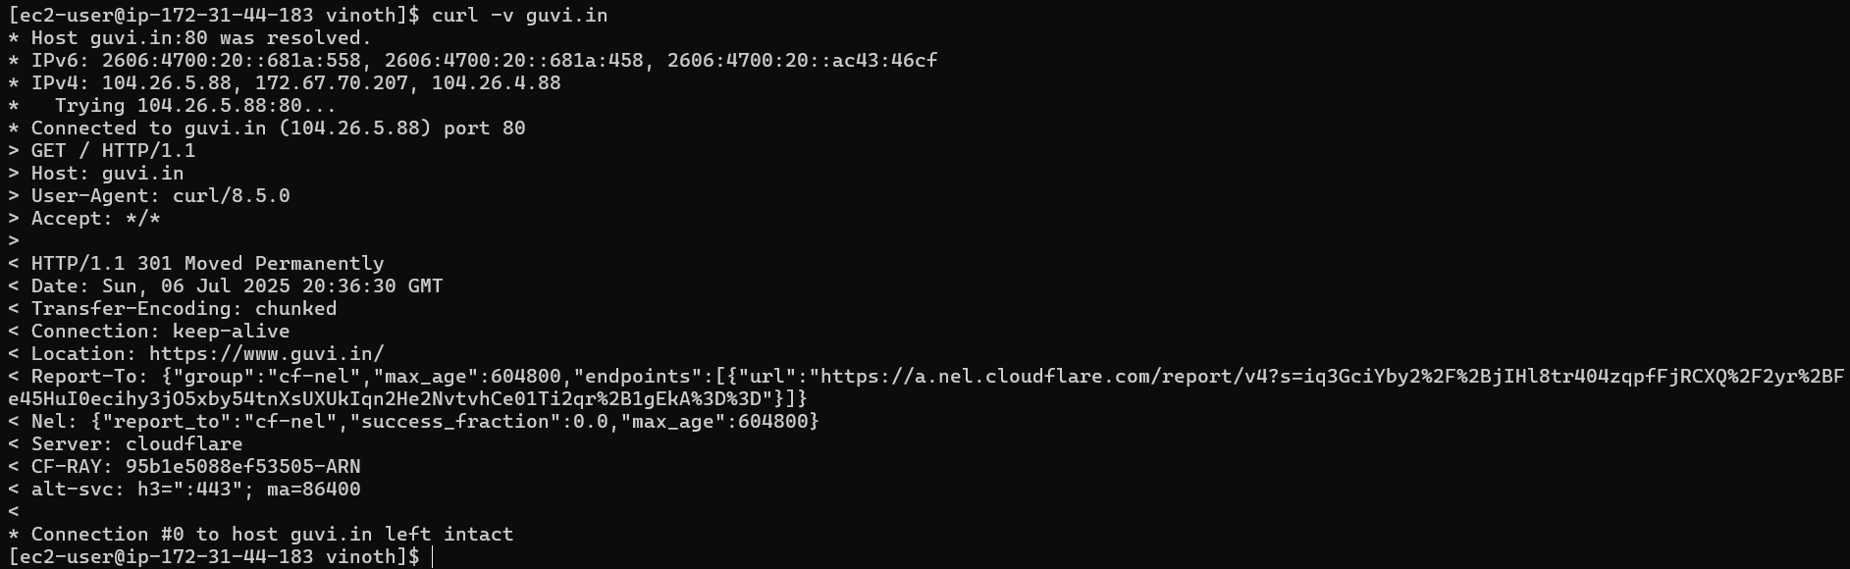

**CPU USAGE**

TOP command

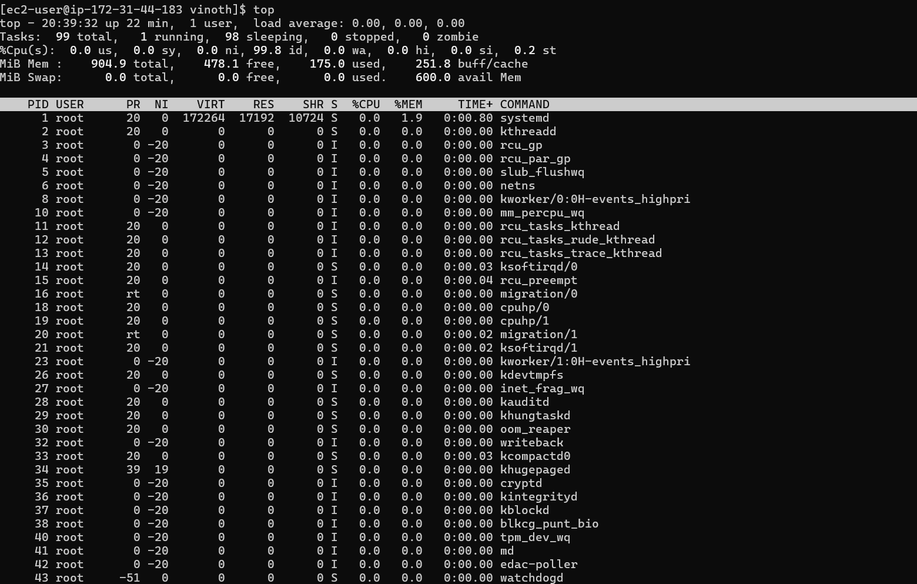

**Connectivity between nodes**

**Telnet**

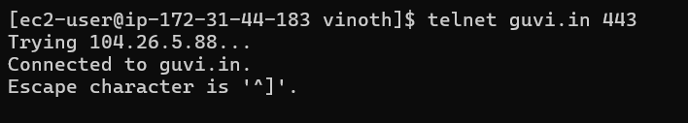

**Traceroute**

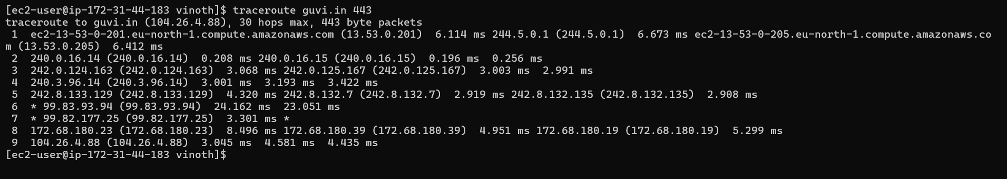

**Test port Connection**

**Telnet**

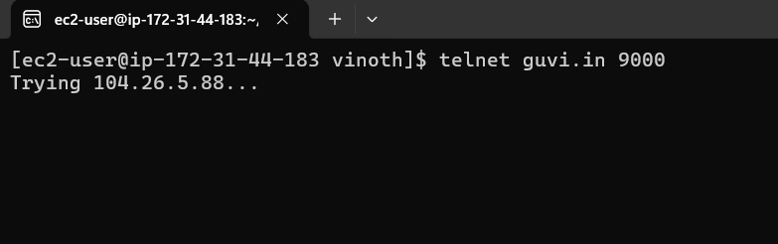

**NC**

