HTTP_RESPONSE Task Script execution
Valid URL
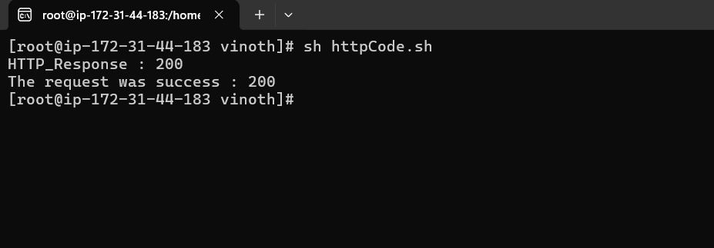
Invalid URL
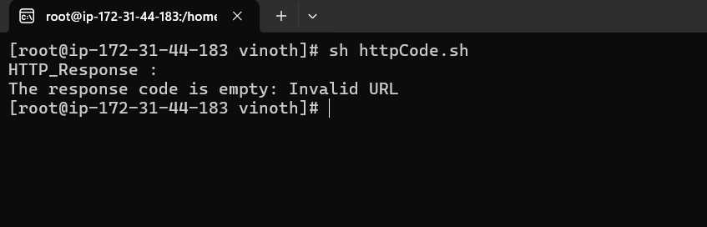

Text replace
Initial File
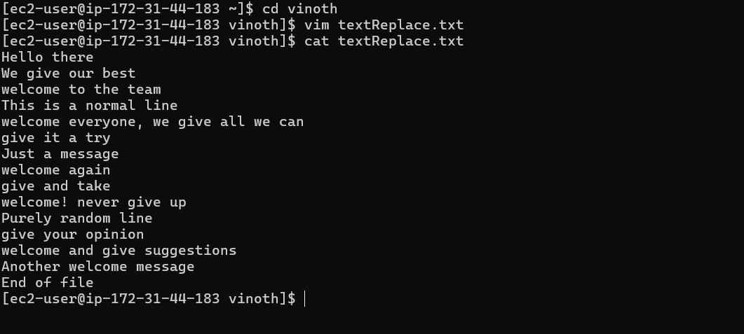
Command
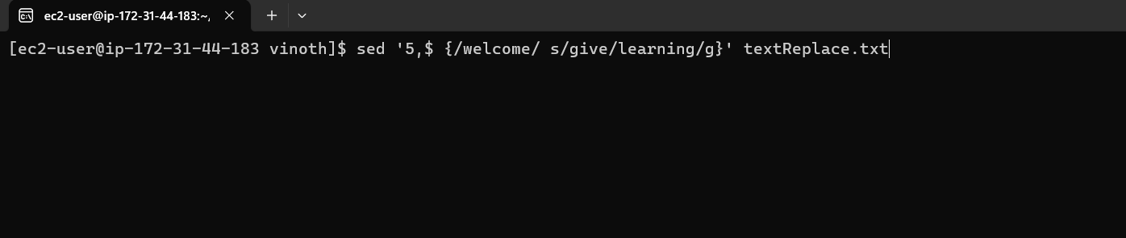
Replaced Output
