Download holding statement with current portfolio date:

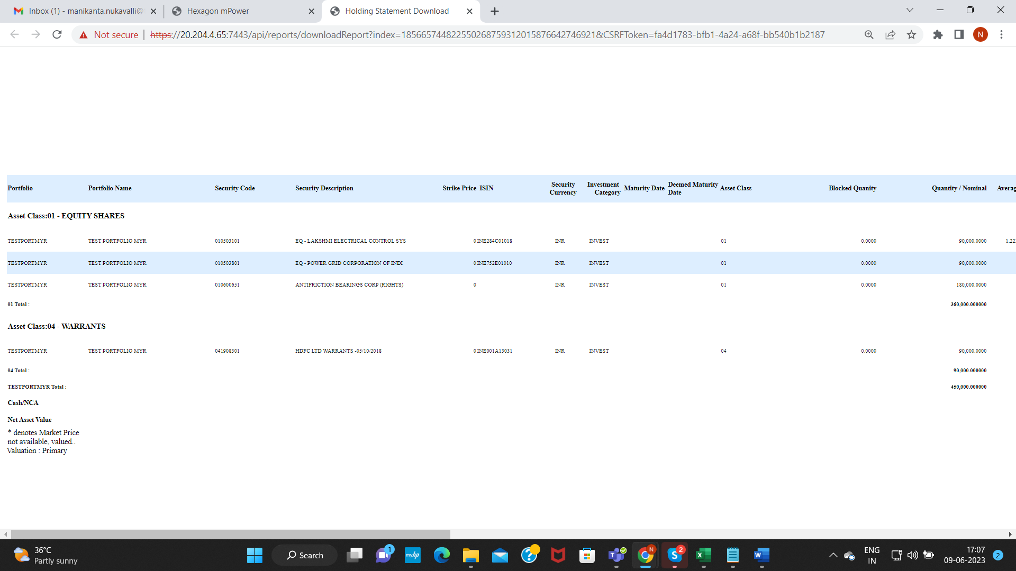

Verify Face values of both the security codes EQ’S:

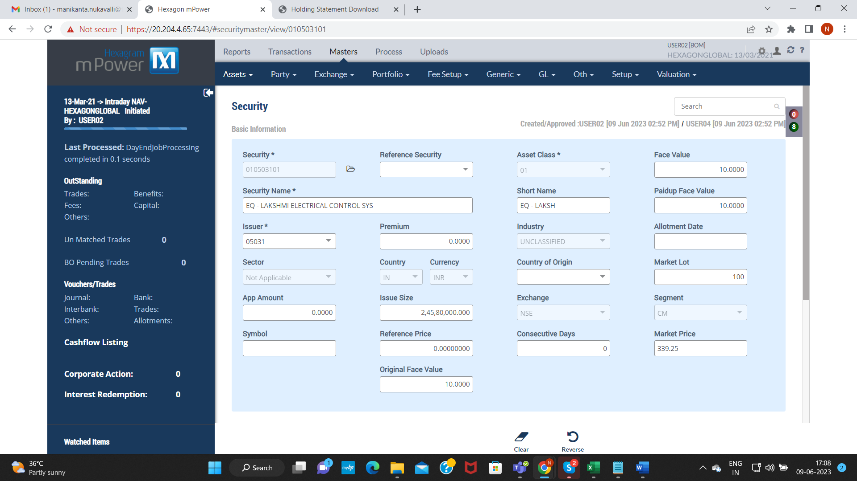

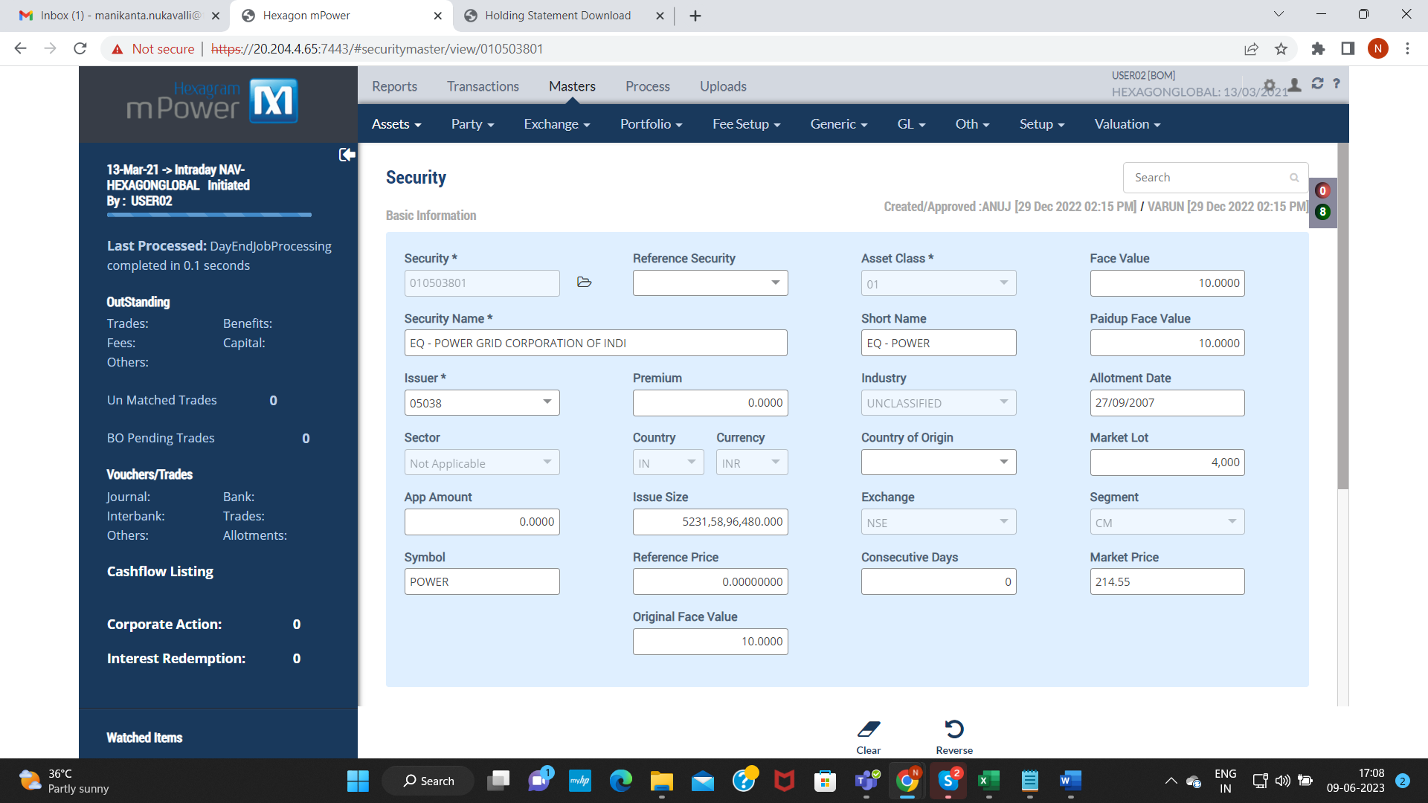

Corporate Action: BF210000466

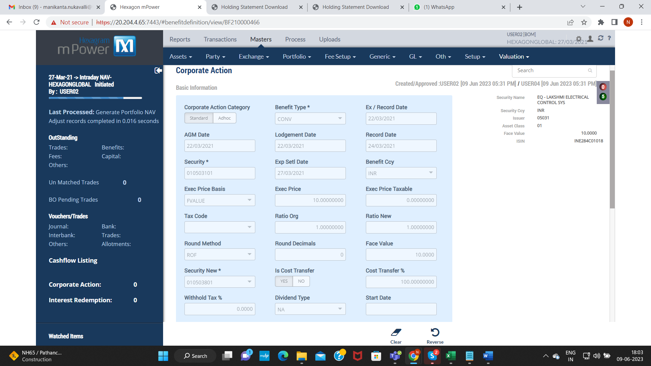

Kindly ignore that Exec Price : 10.00000000 that is not required to provide in Corporate Action.

Settlement transaction: TS21008307480000010

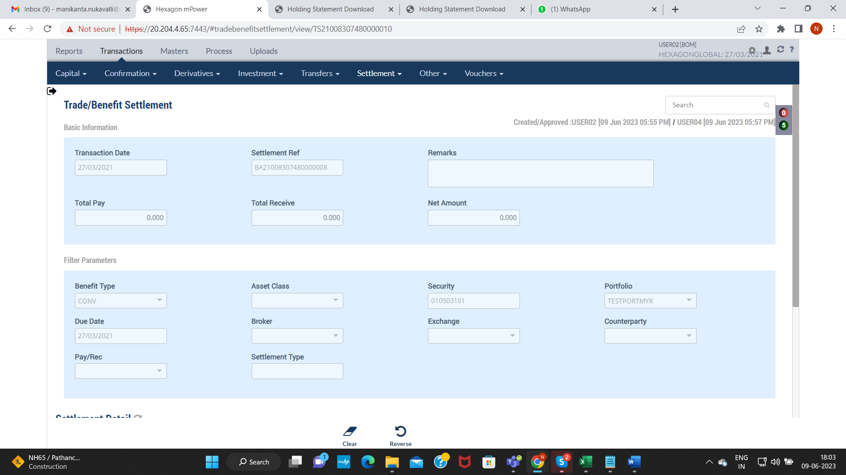

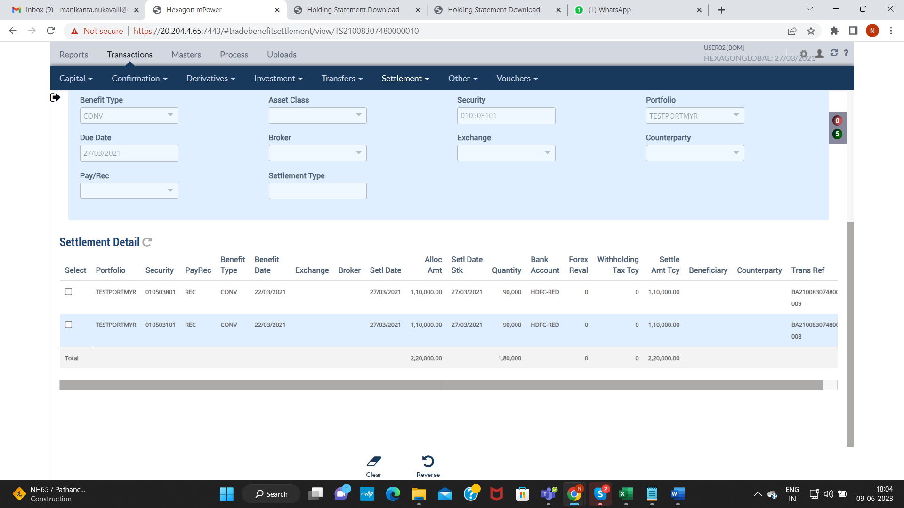

VERIFY HOLDING STATEMENTS ON SETTLEMENT DATE:

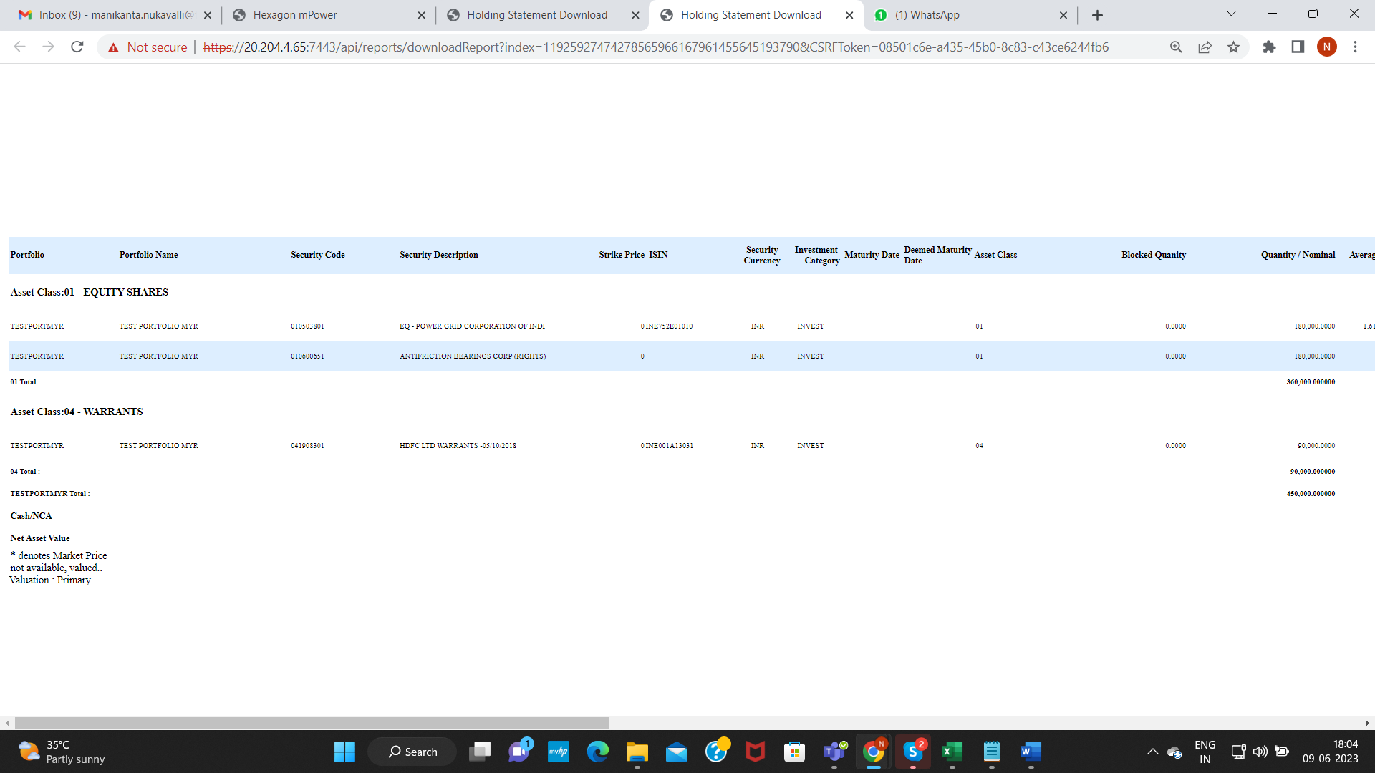

VERIFY FACEVALUES OF TWO EQ- SECURITY CODES:

