RIGHTS:

current portfolio Date: 18-01-2021

Download the holding Statement with current portfolio date 18-01-2021. in HS we have Last ran RSPLIT Security 010503101 with QTY 45,000.0000 .

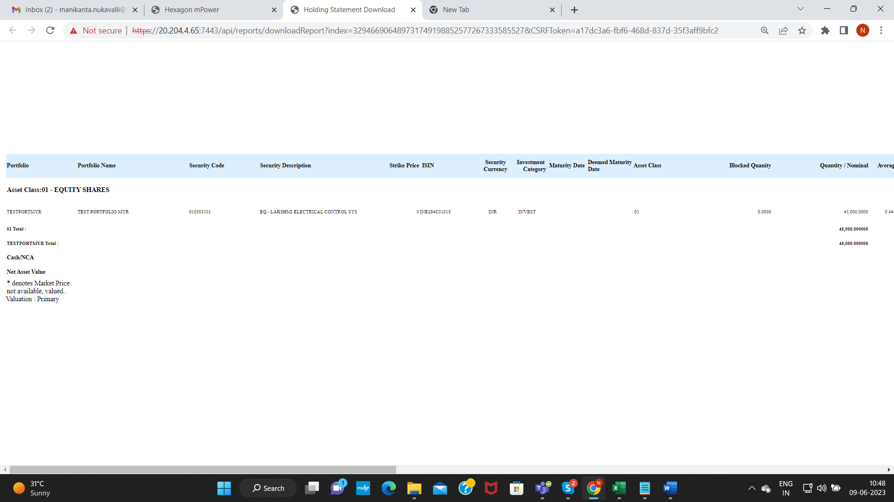

Verify Security Code face value in Security screen. Security code: 010503101

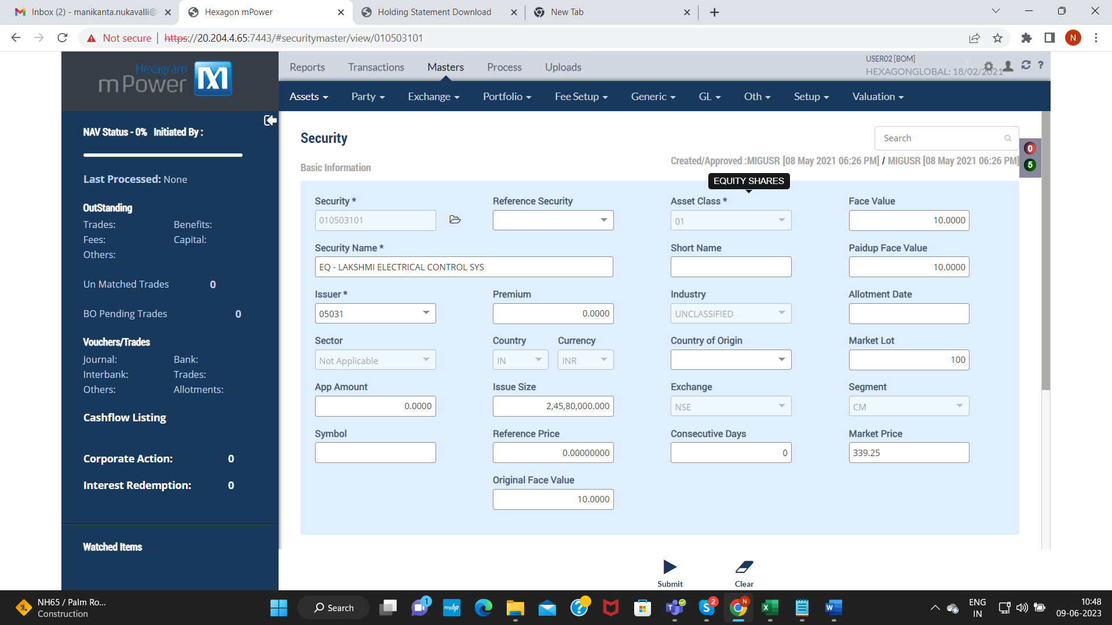

Corporate Action Module: BF210000464

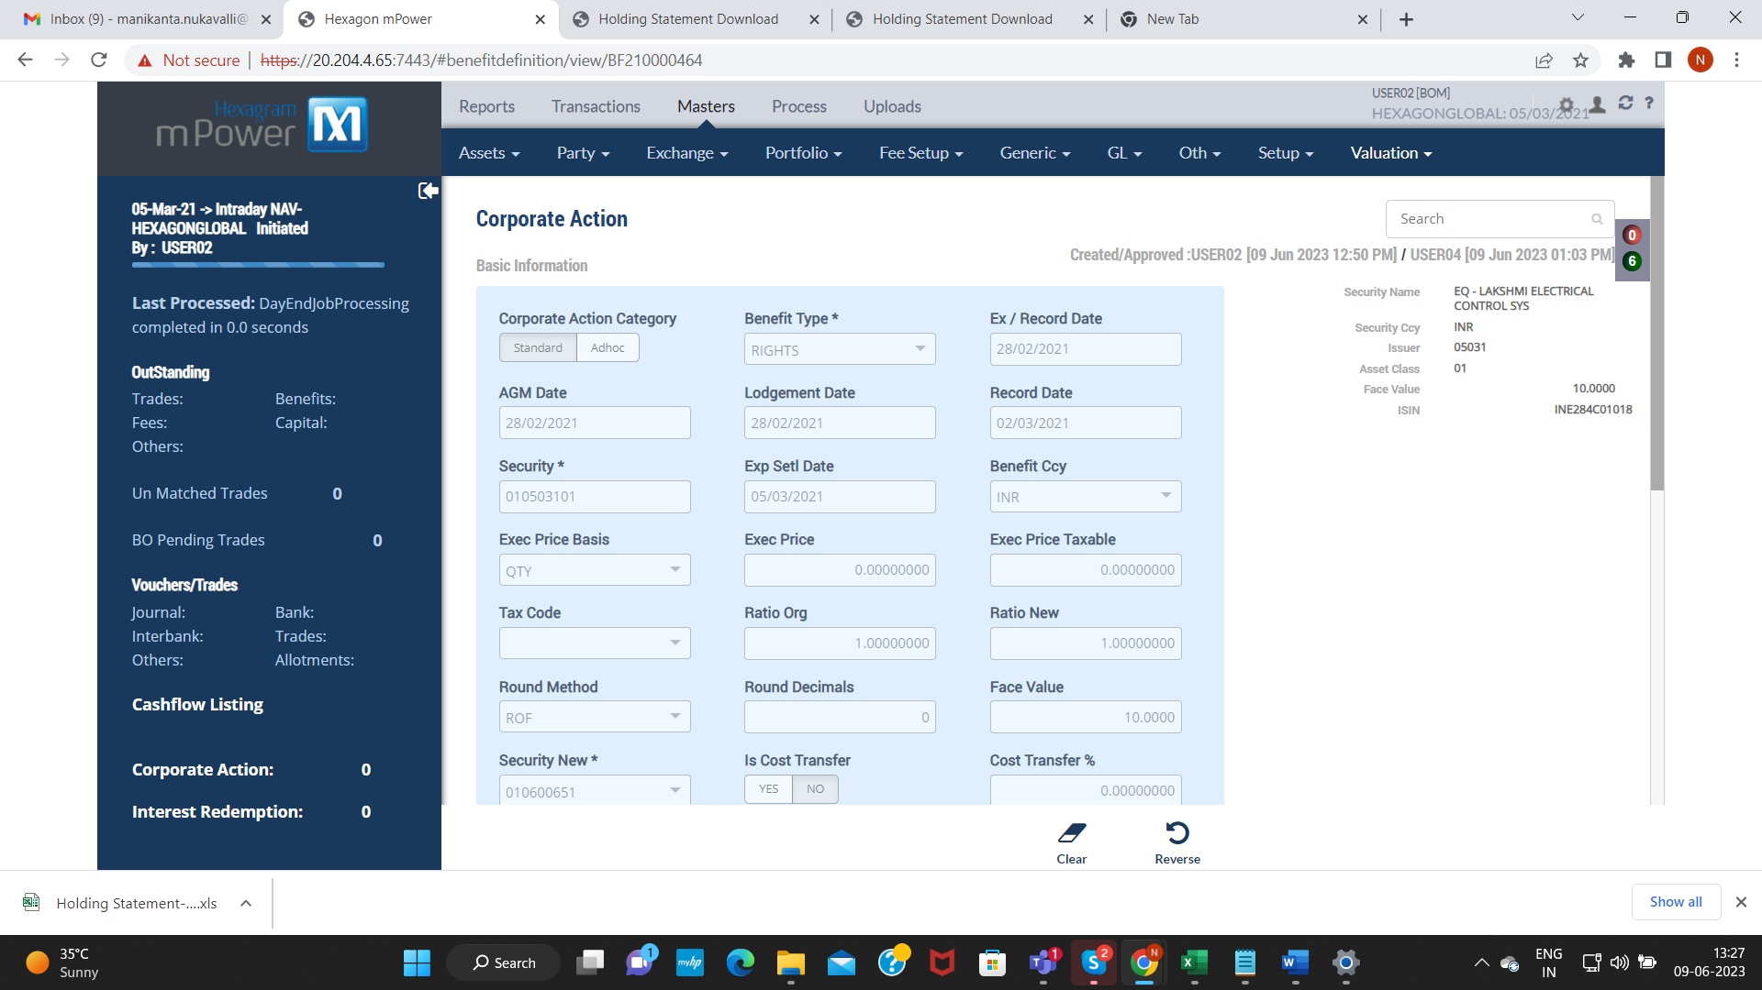

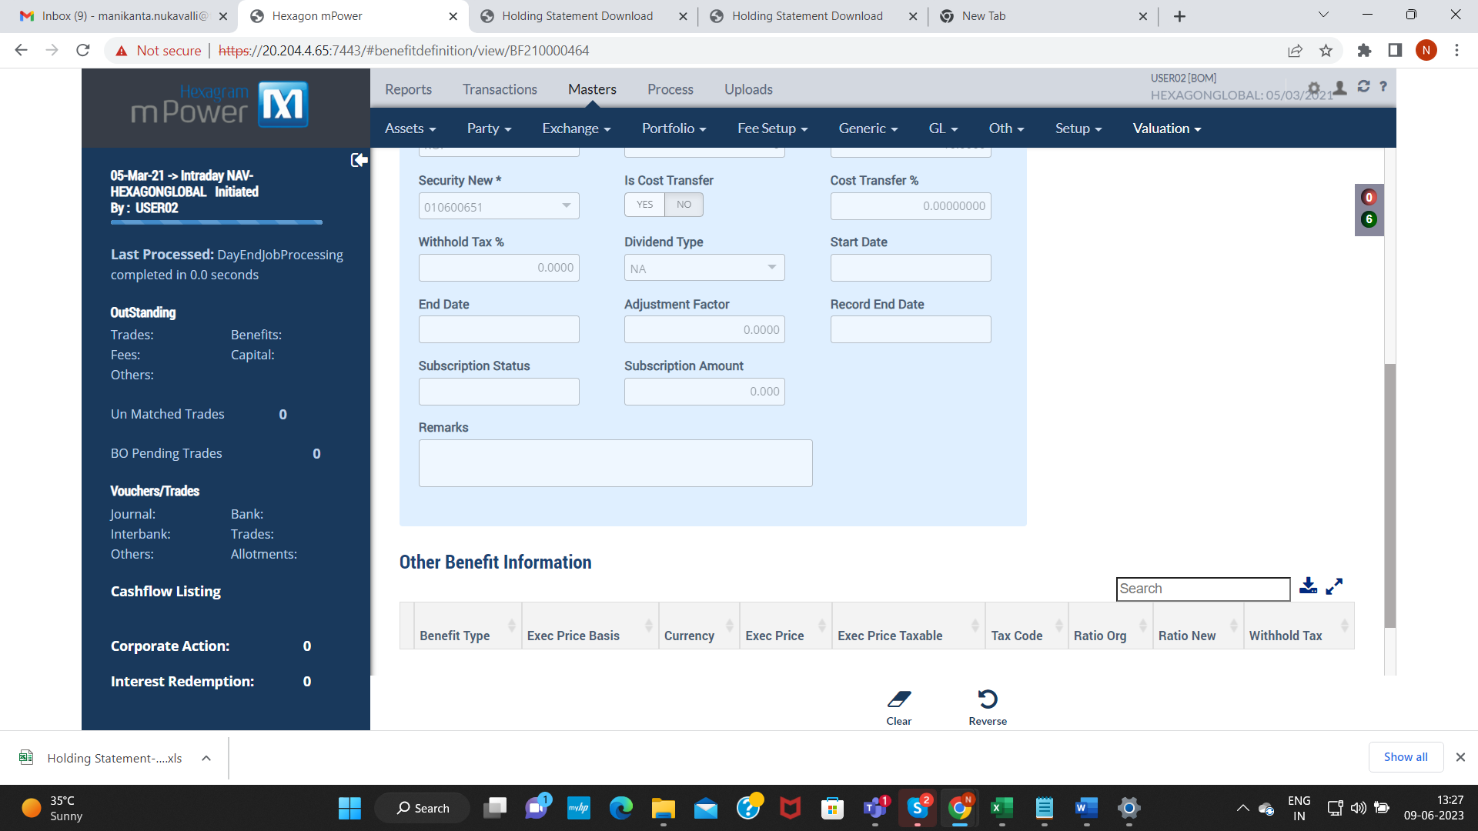

Primary Market Module: PM21008307460000003

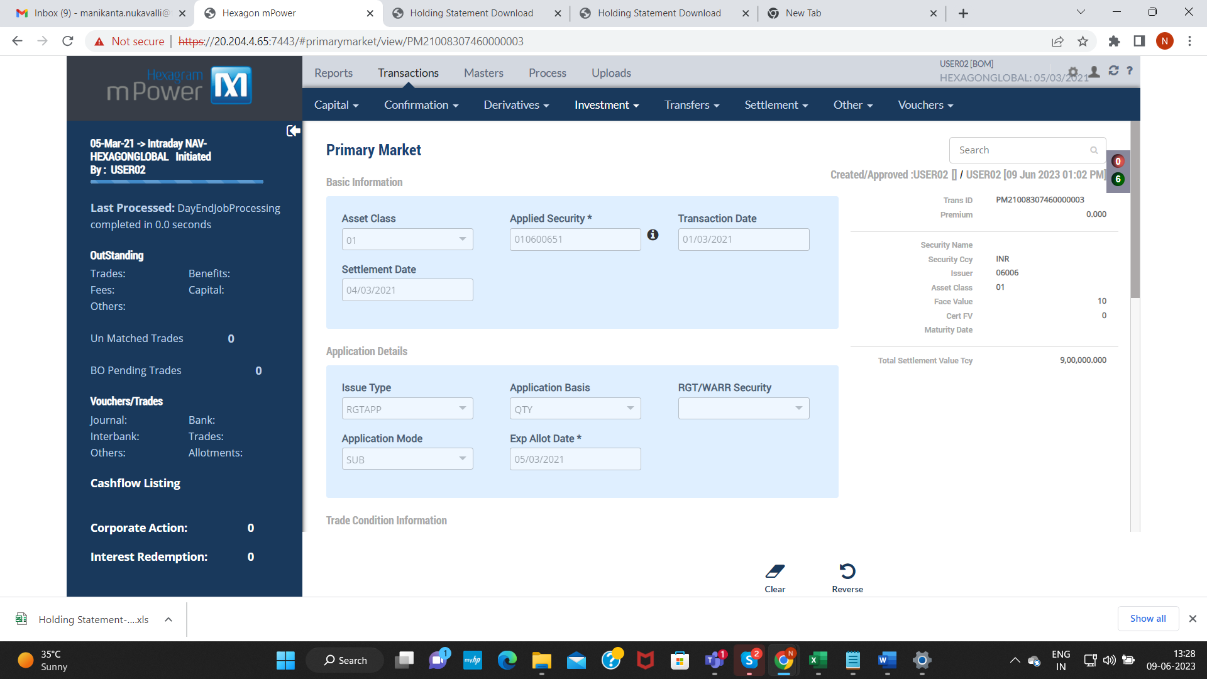

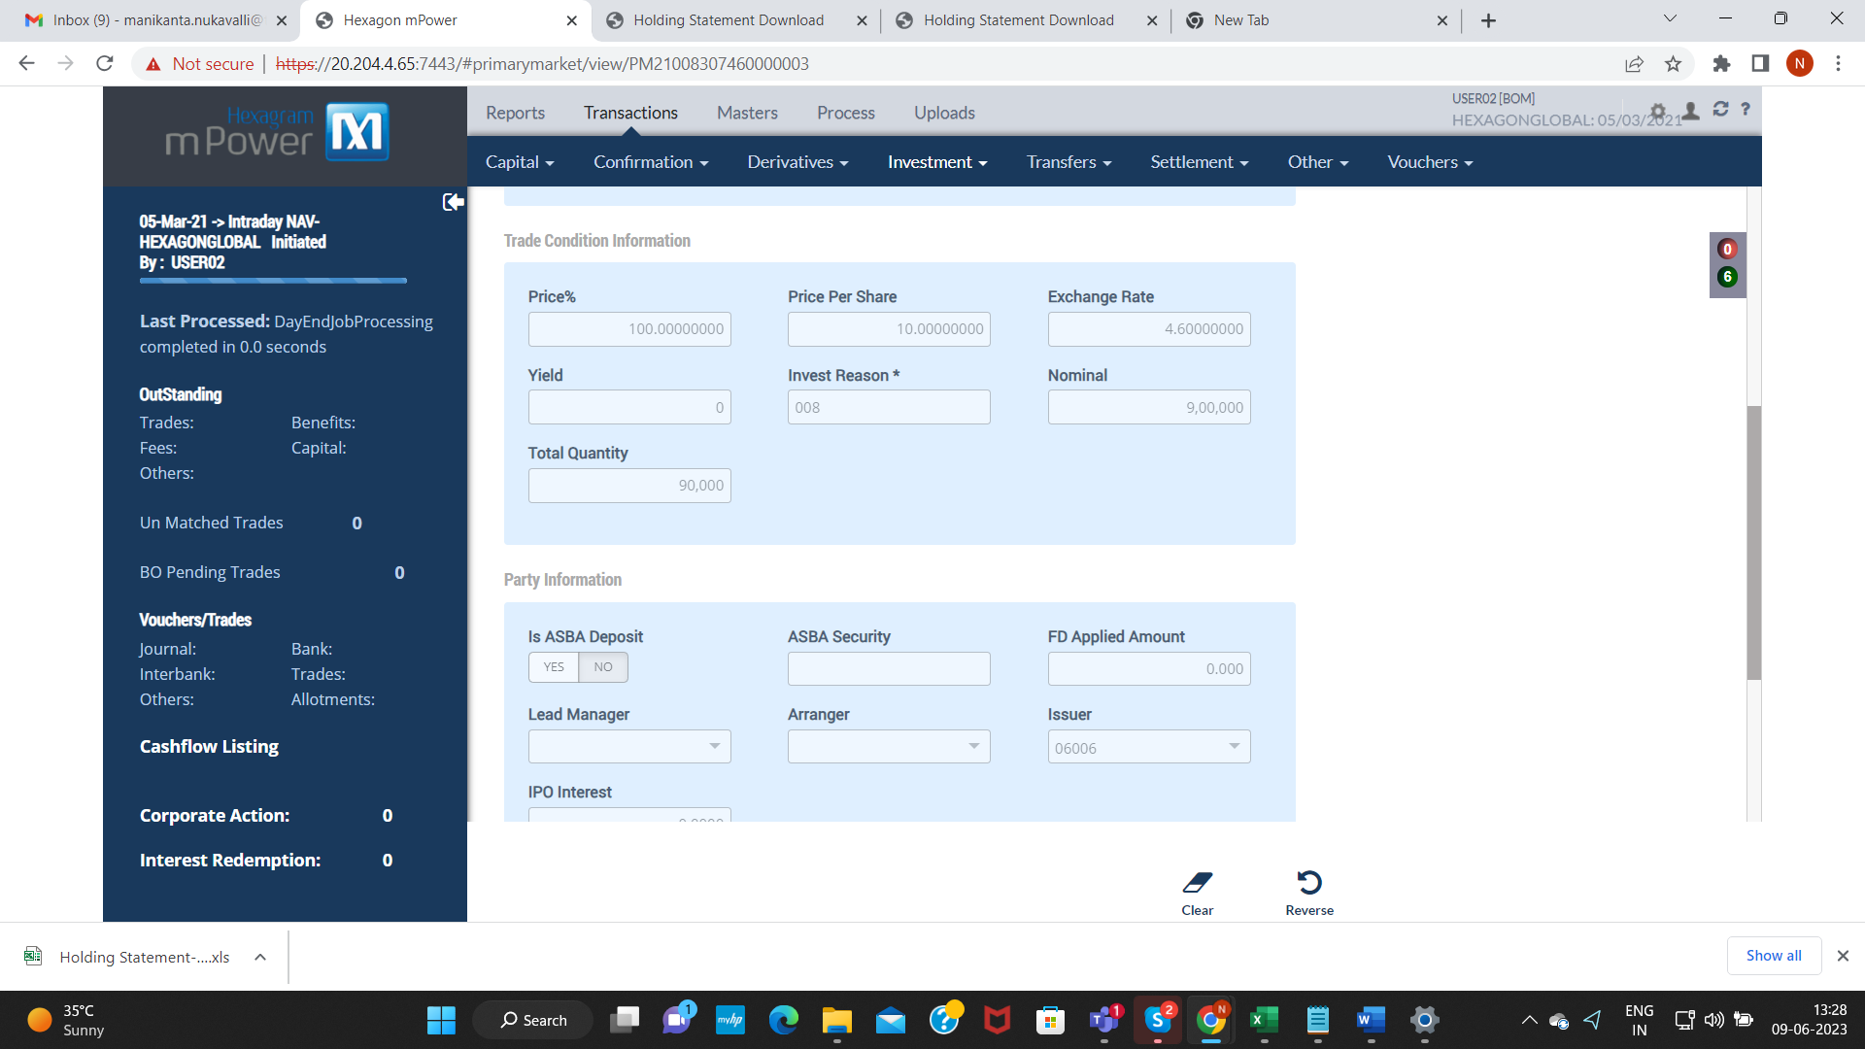

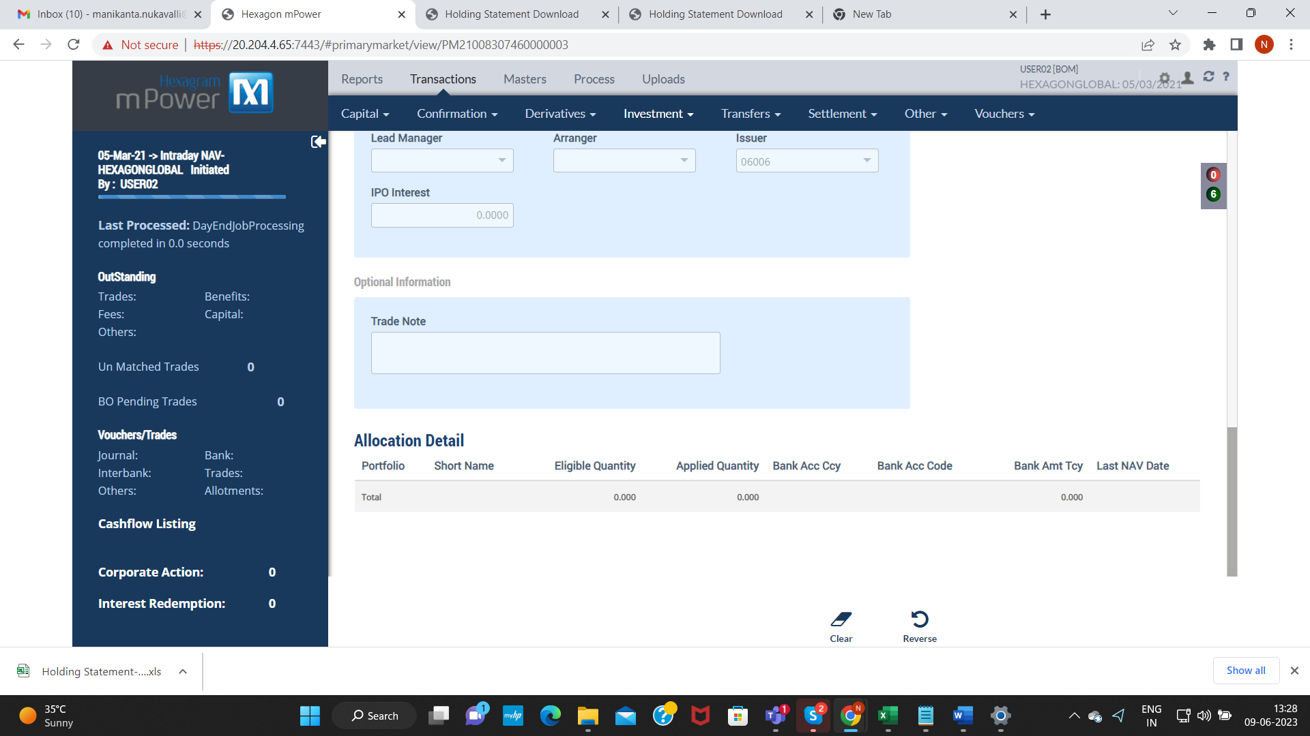

Settlement Transaction: TS21008307480000007

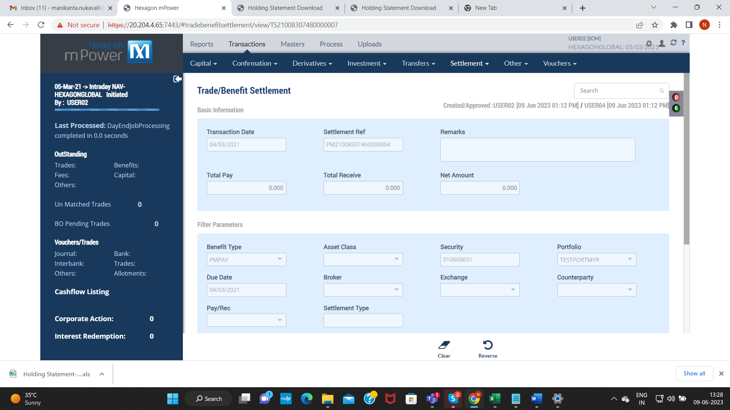

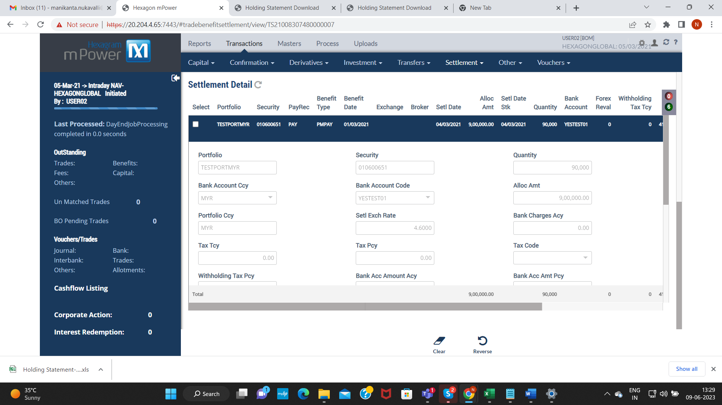

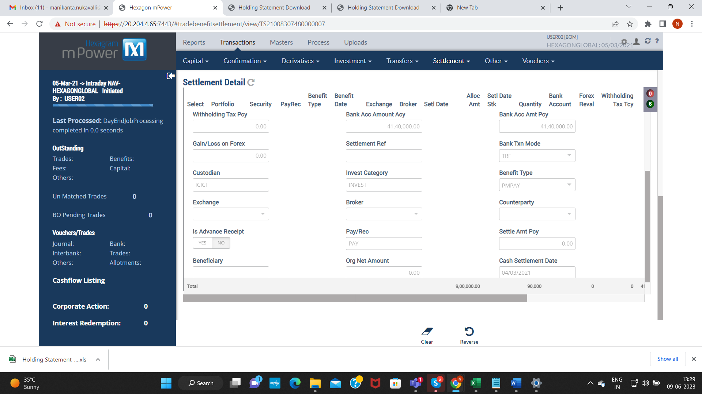

Primary Allotment: PA21008307460000002

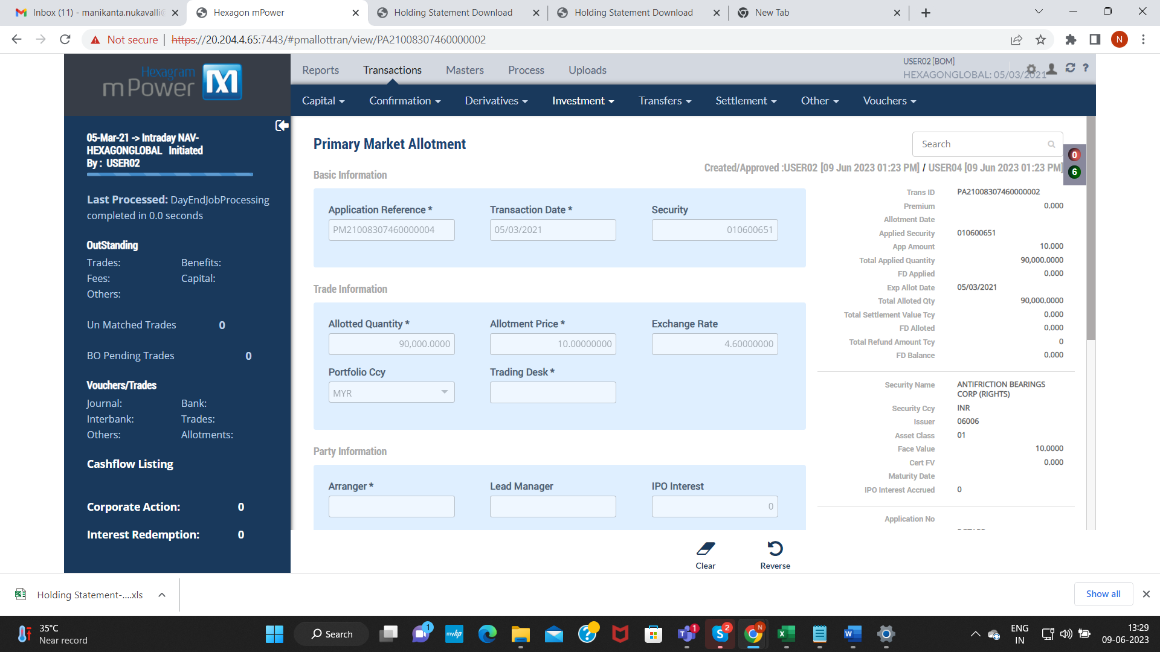

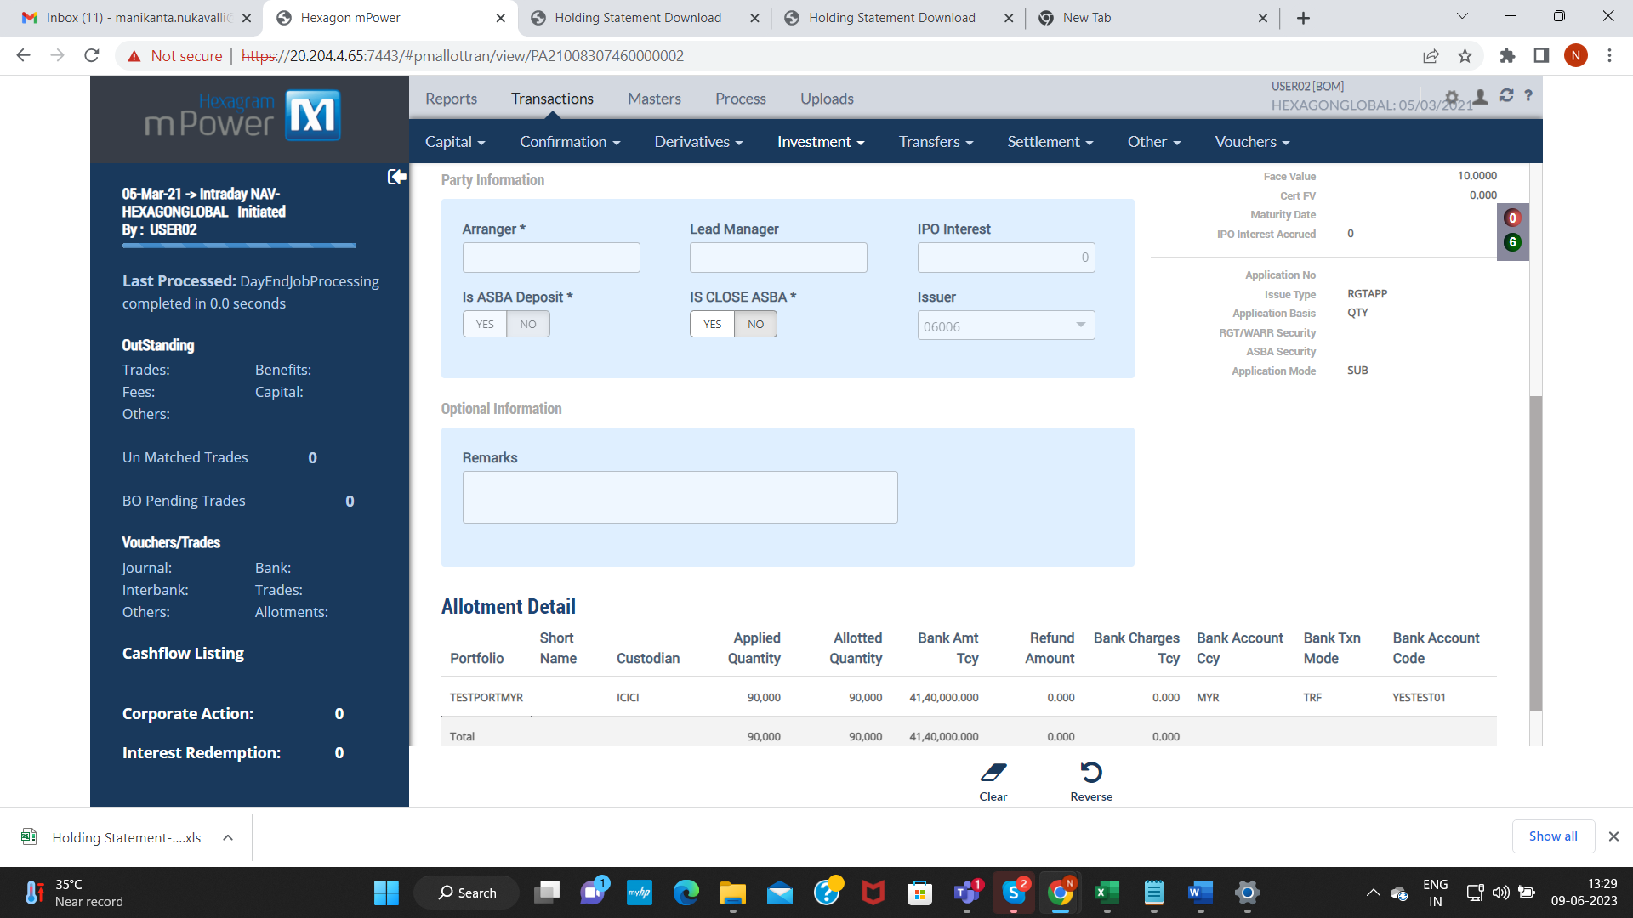

VERIFY HOLDING STATEMENT WITH CURRENT PORTFOLIO DATE: 05-03-2021

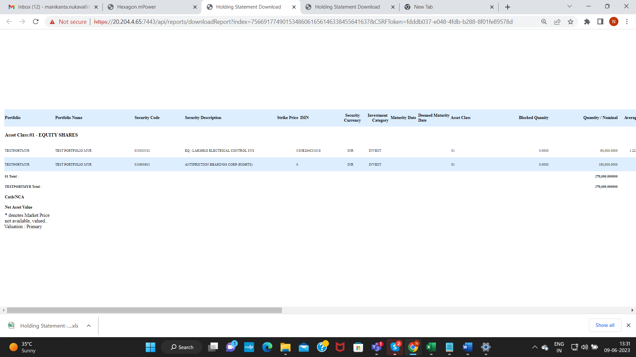

Verify Security Face Value:

