DOWNLOAD THE HOLDING STATEMENTS FOR CURRENT PORTFOLIO DATE

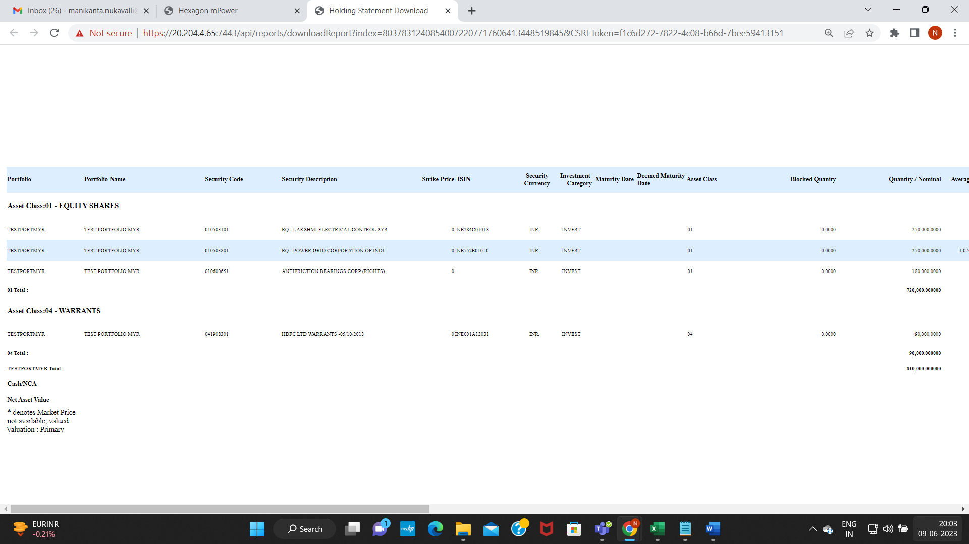

VERIFY FACE VALUE FOR 2 SECURITIES:

Corporate Action: BF210000468

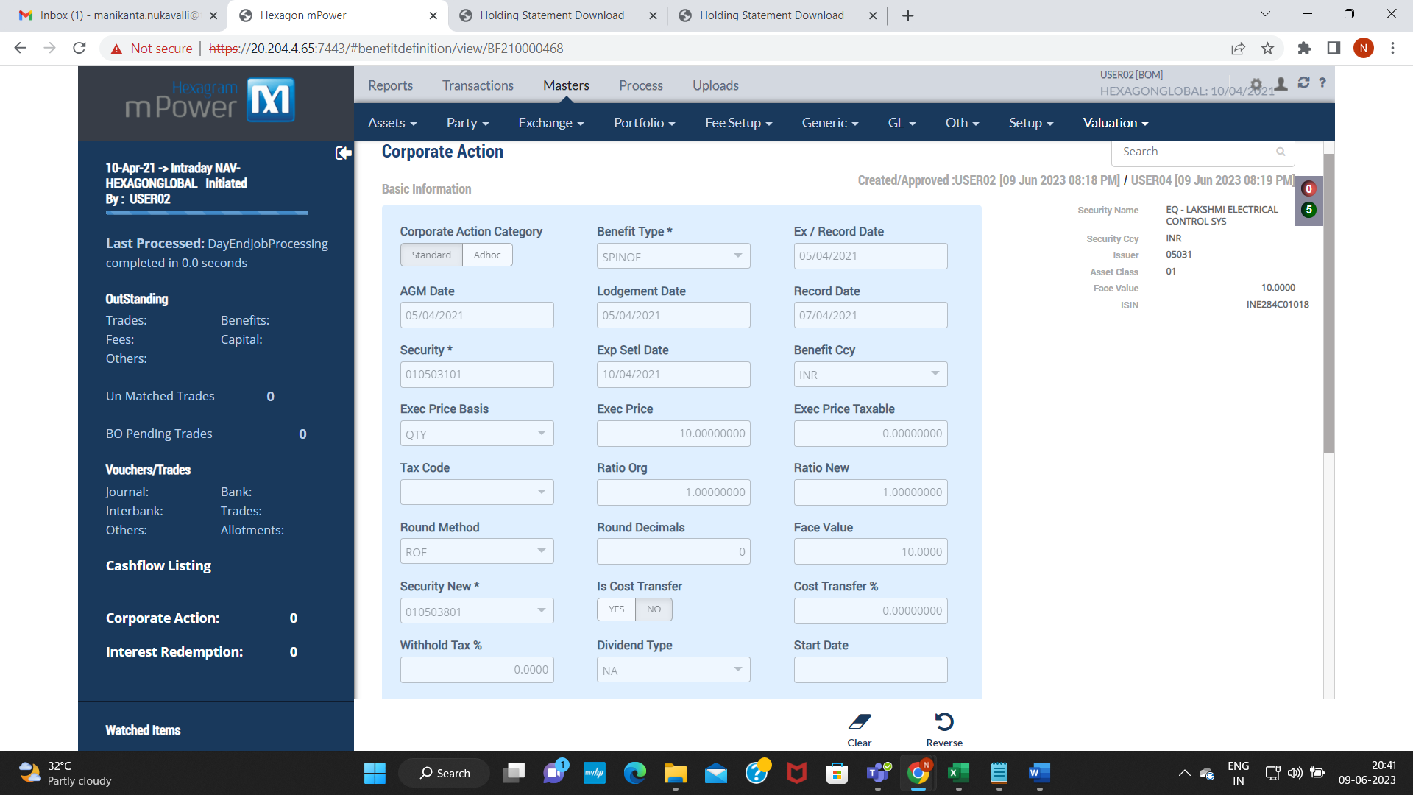

Settlement Transaction: TS21008307480000012

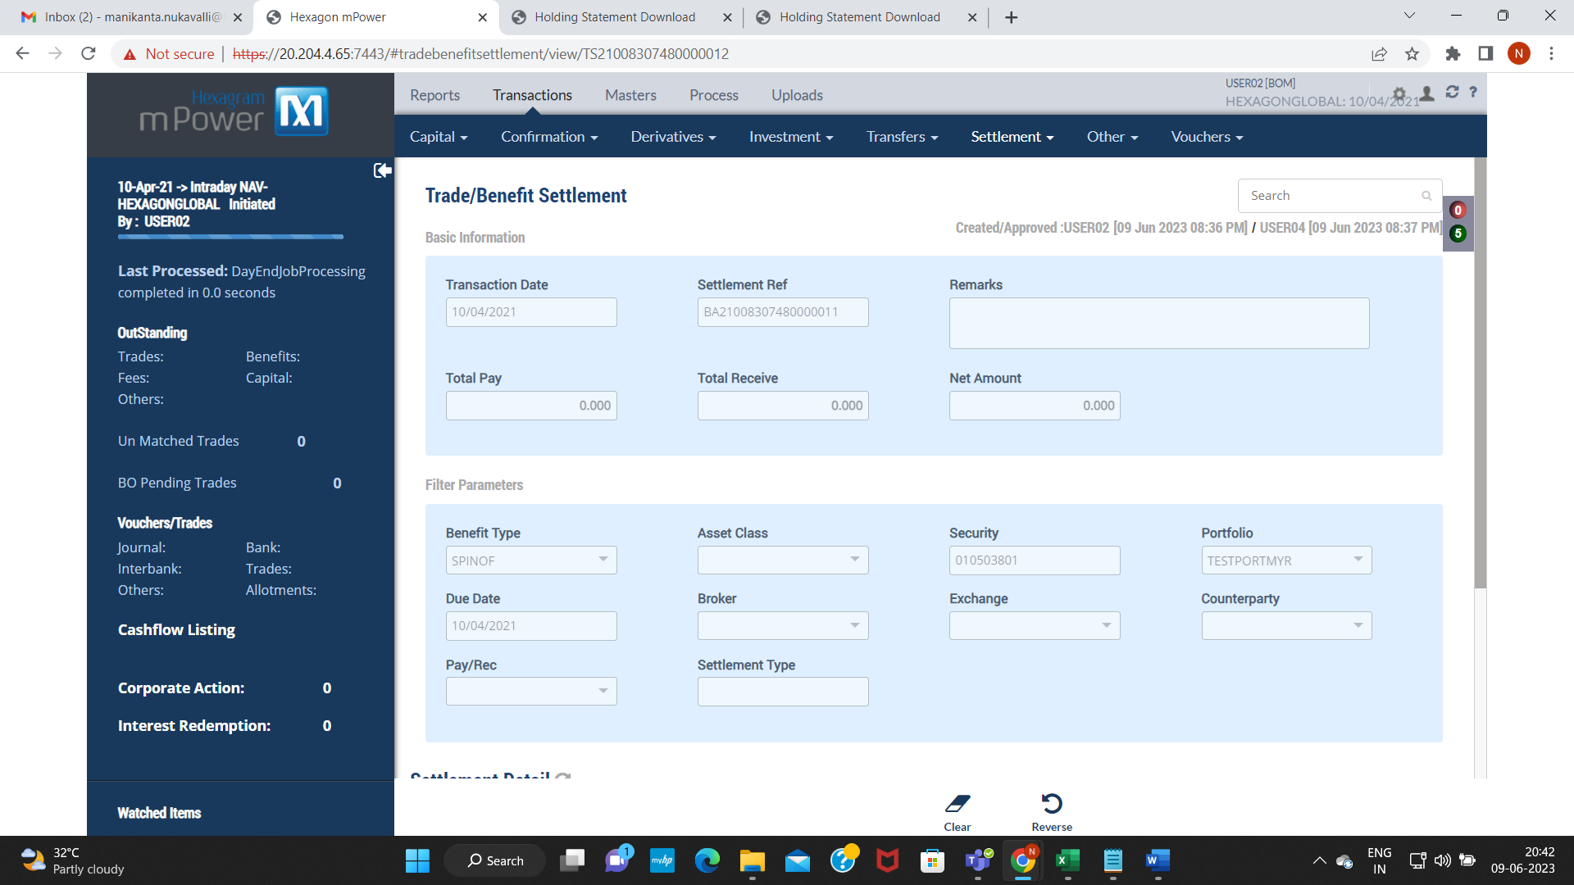

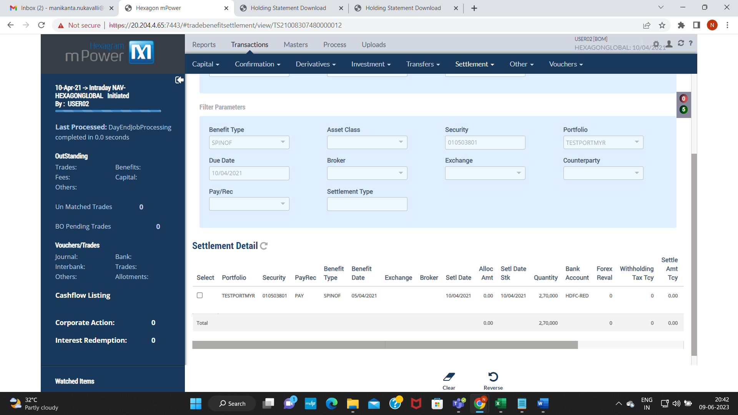

Download Holding Statements with settlement date:

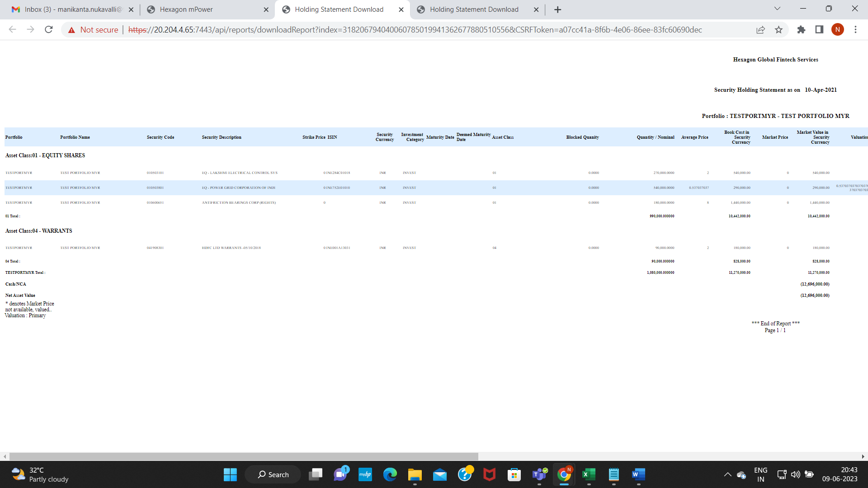

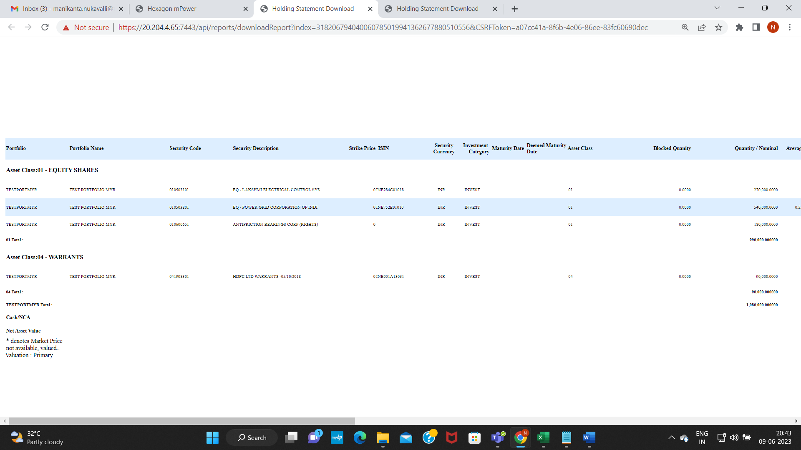

Verify face value for both the securities:

