WARRANT:

DOWNLOAD HOLDING STATEMENT FOR CURRENT PORTFOLIO DATE: 05-03-2021

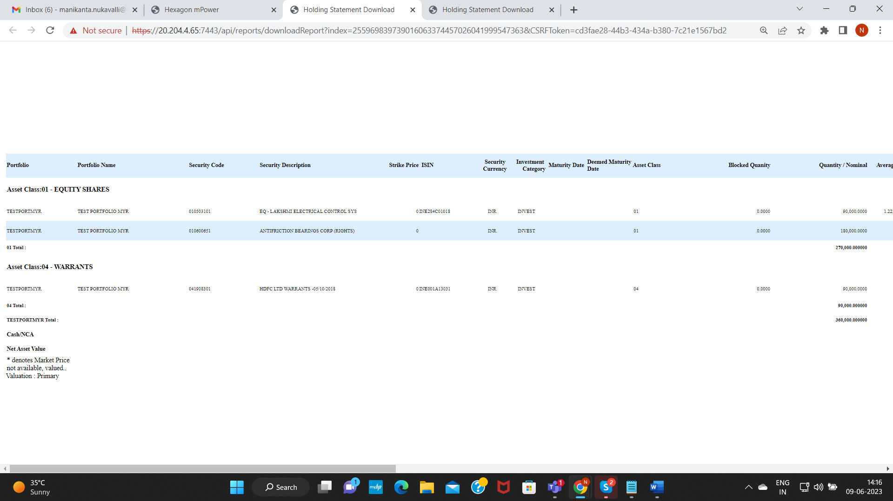

VERIFY FACE VALUES FOR BOTH THE SECURITY CODES:

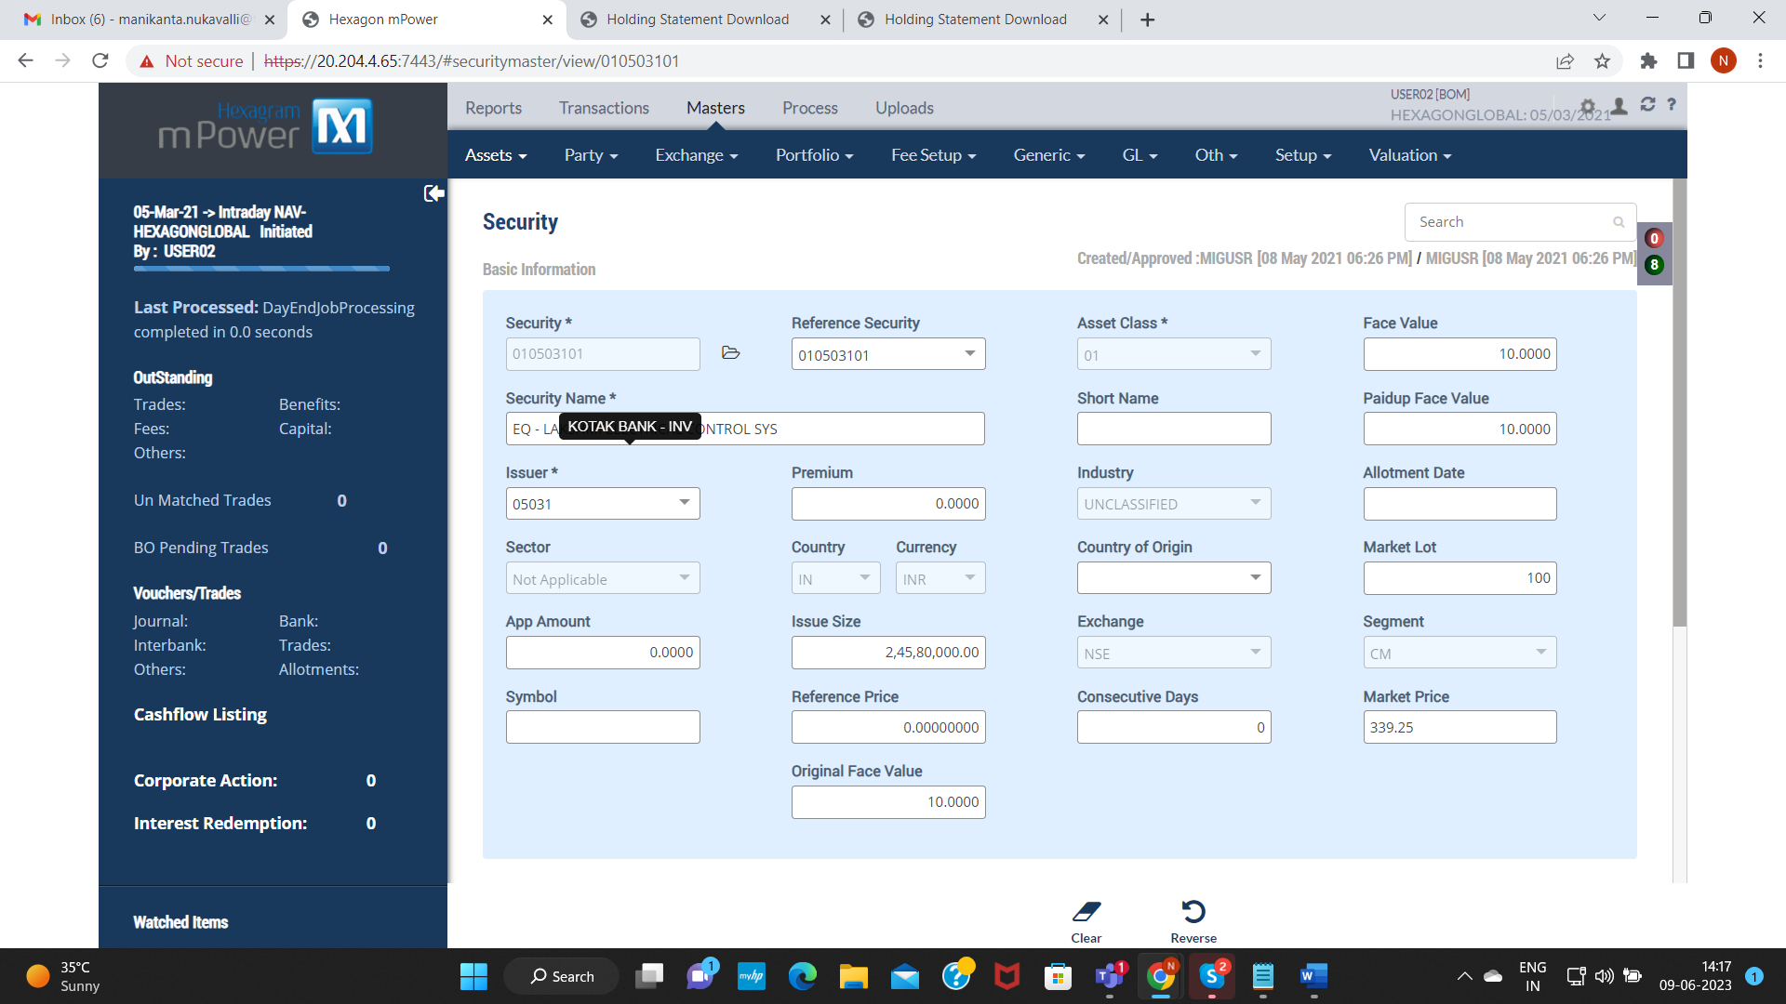

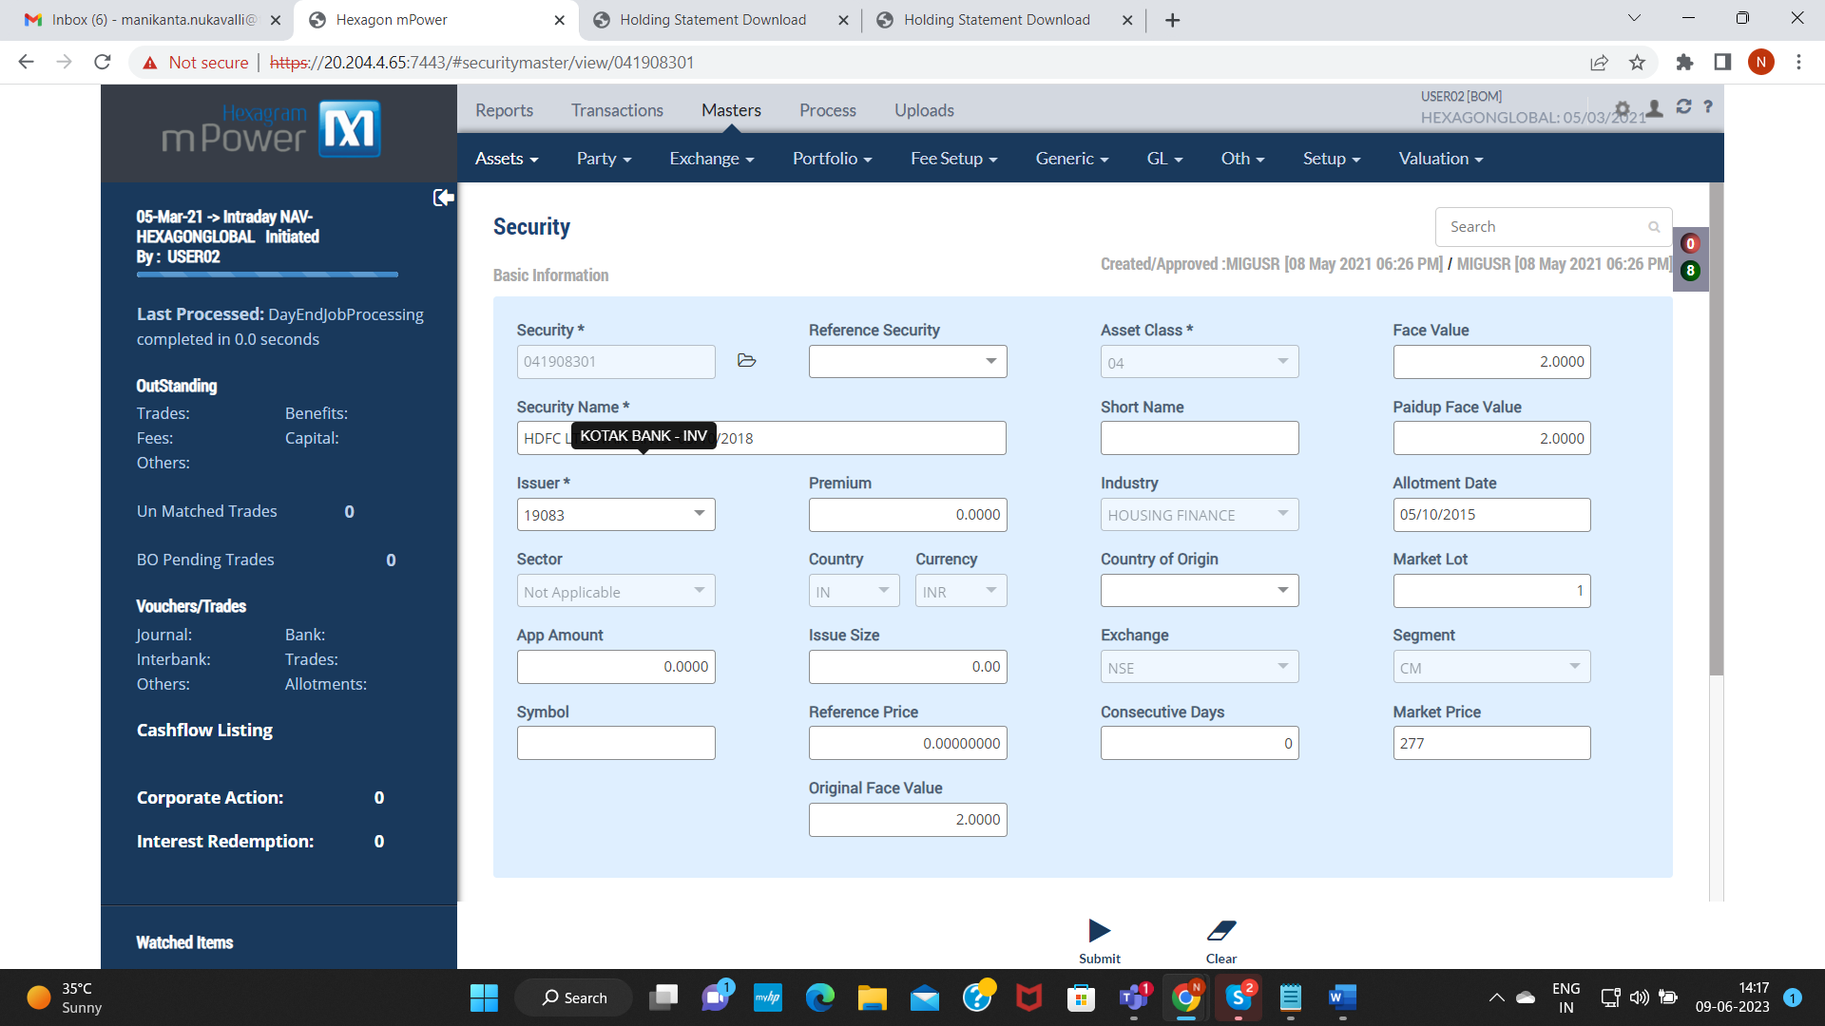

NO CORPORATE ACTION FOR WARRANT MODULE

PRIMARY MARKET: PM21008307460000005, PM21008307460000007

Settlement Transaction: TS21008307480000008, TS21008307480000009

PRIMARY ALLOTMENT : PA21008307460000004, PA21008307460000005