- Screen – Derivative Param Master.
Issue- After filling all the required details in derivative param form, the Start Date is not displaying in the Grid Information section.
- Udhaya

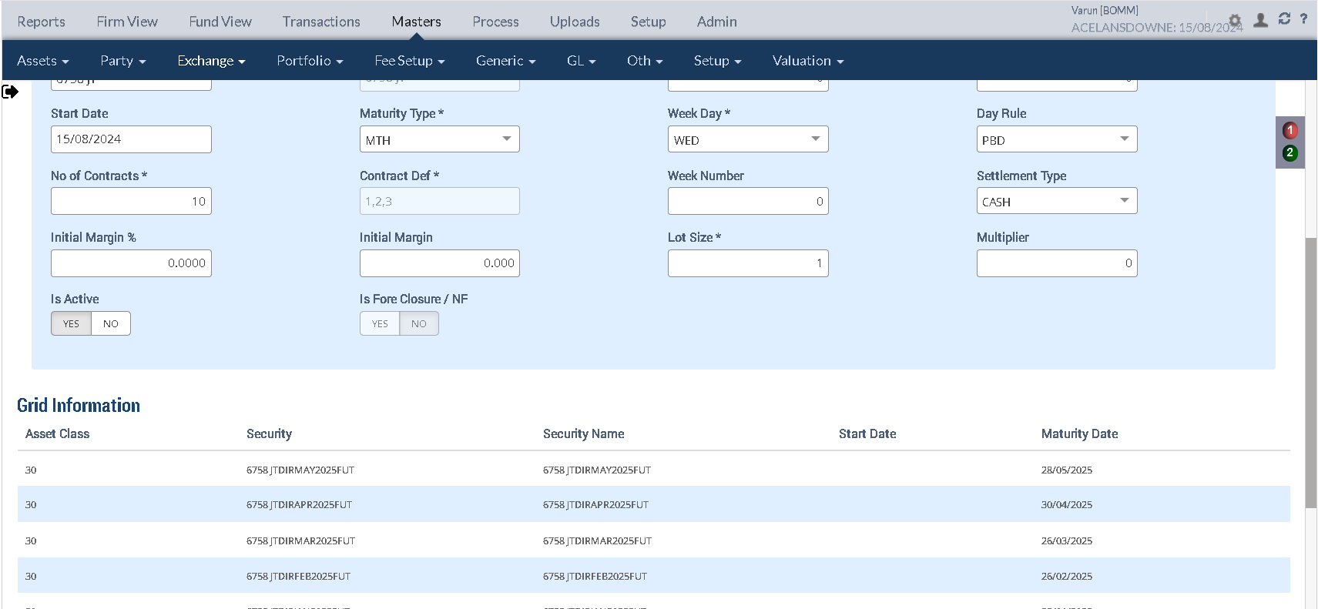

- Screen – Derivative Transaction.
Issue - “Fees” is not fully visible In the Fees Breakdown section
Udhaya

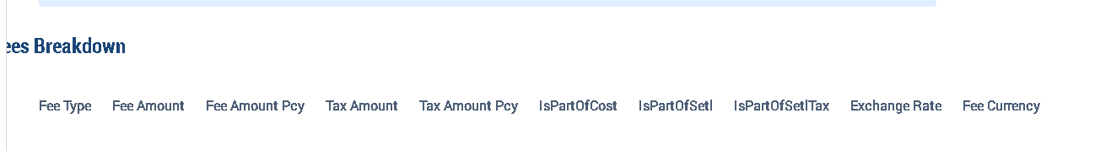

- Screen – Derivative Param Master.
Issue - After filling all the required details in derivative param form and when keeping maturity type as Month end where Maturity Date is not updated to month end date for following months if month end of start date falls on Saturday/Sunday. – Greeshma

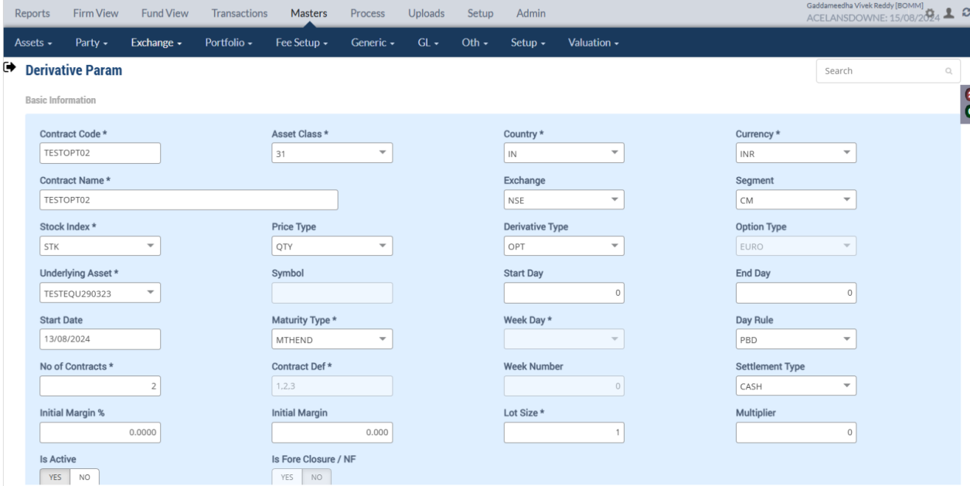
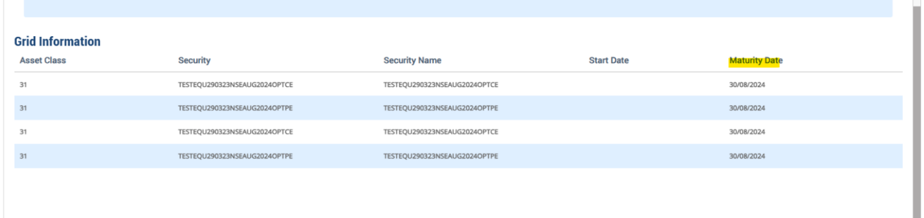

- Screen – Derivative Transaction.
Issue - While retrieving the approved derivative transaction form from Derivative Transaction screen through search bar, the form doesn’t show some details (No of Lots, Portfolio Name, Security Name, Acquisition cost) -Vaishnavi

Details shown while retrieving the form after approval:
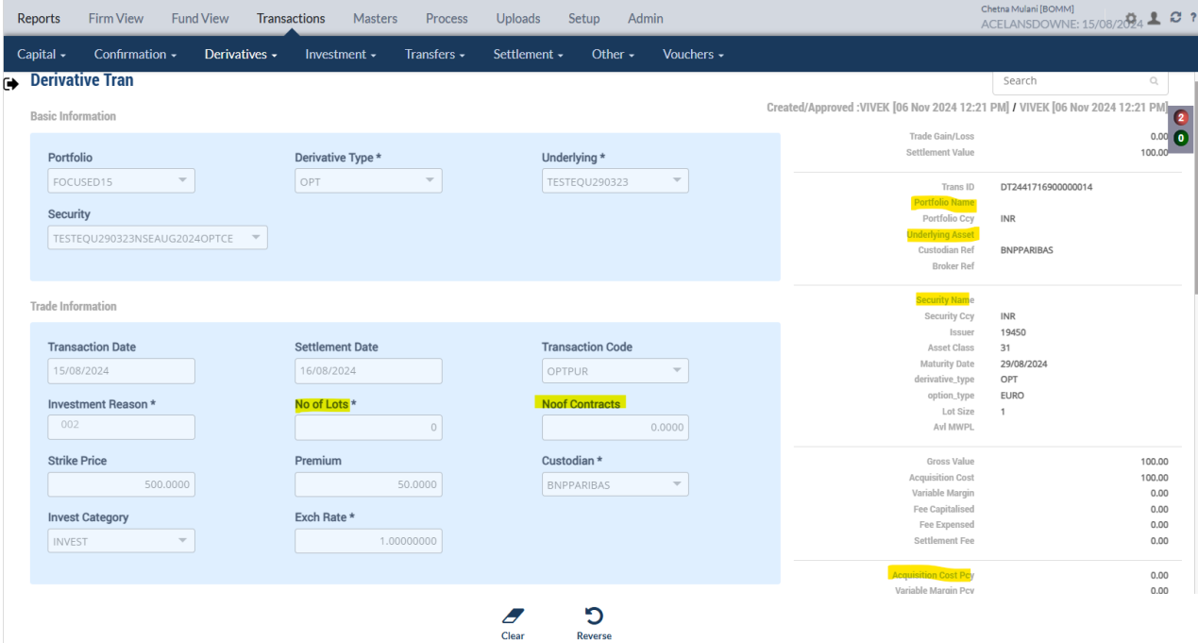

- Screen - Derivative Transaction.
Issue - Getting internal error validation error while submitting Derivative Tran form if remarks is filled.
(Vaishnavi)
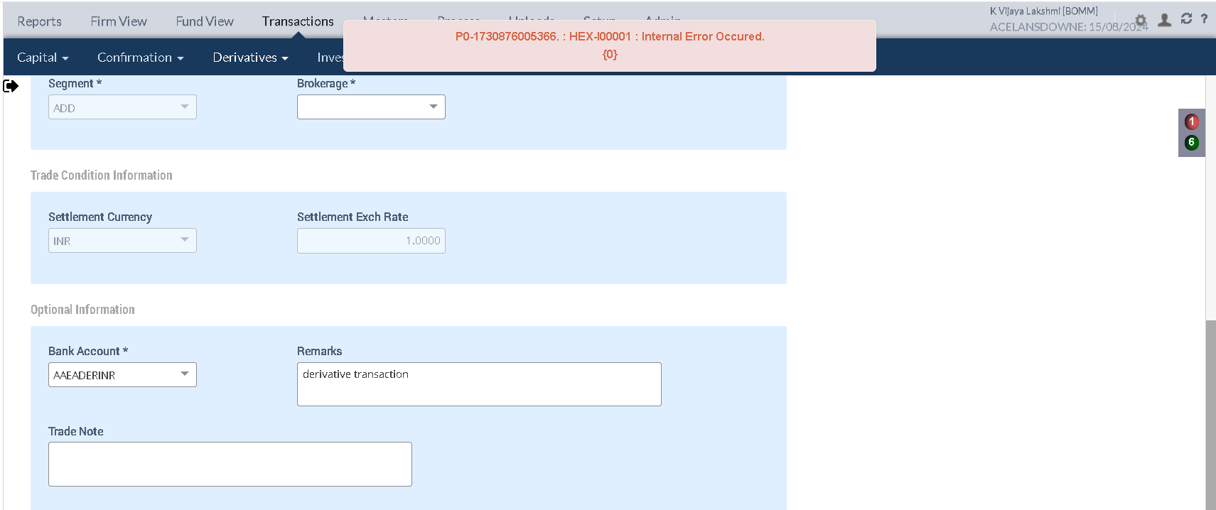

- Screen – Upload Dashboard.
Issue - After uploaded Derivative Transaction upload file through BOMM id, the status is showing complete (Still transaction pending approval in MOE confirmation screen).
- Greeshma

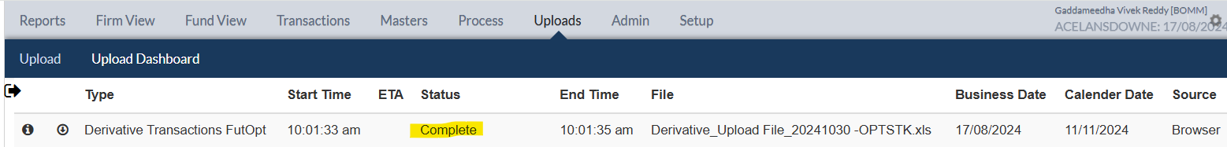

- Screen – MOE Confirmation.
Issue – After upload/manual entry of Derivative Transaction form, Fee Amount TCY is not converting to Fee Amount PCY (Fee Amount TCY*Exchange Rate) during multicurrency transaction. -Greeshma

Trans Submit:
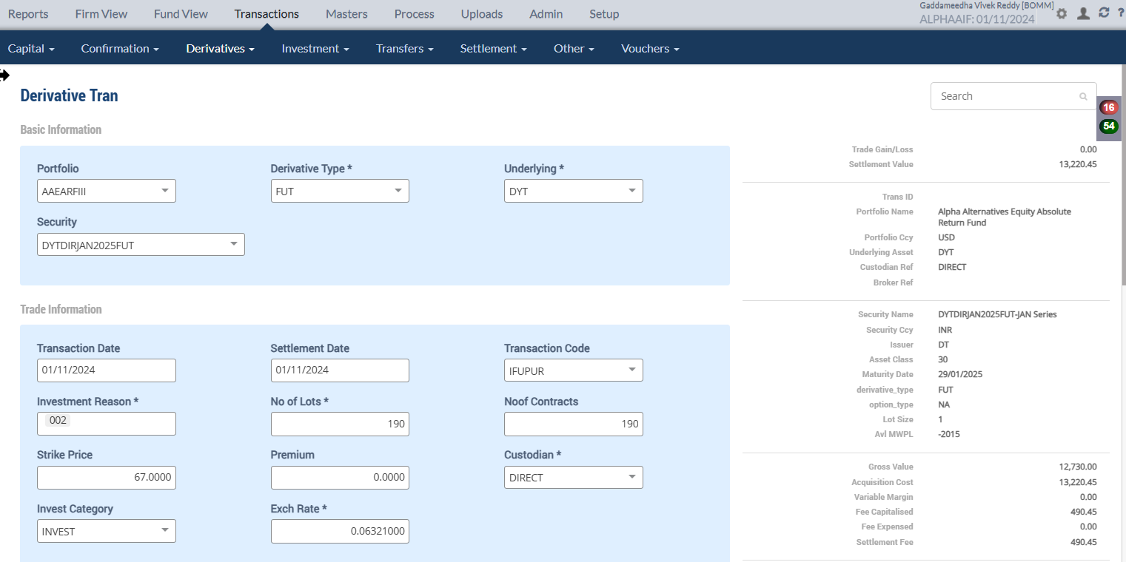
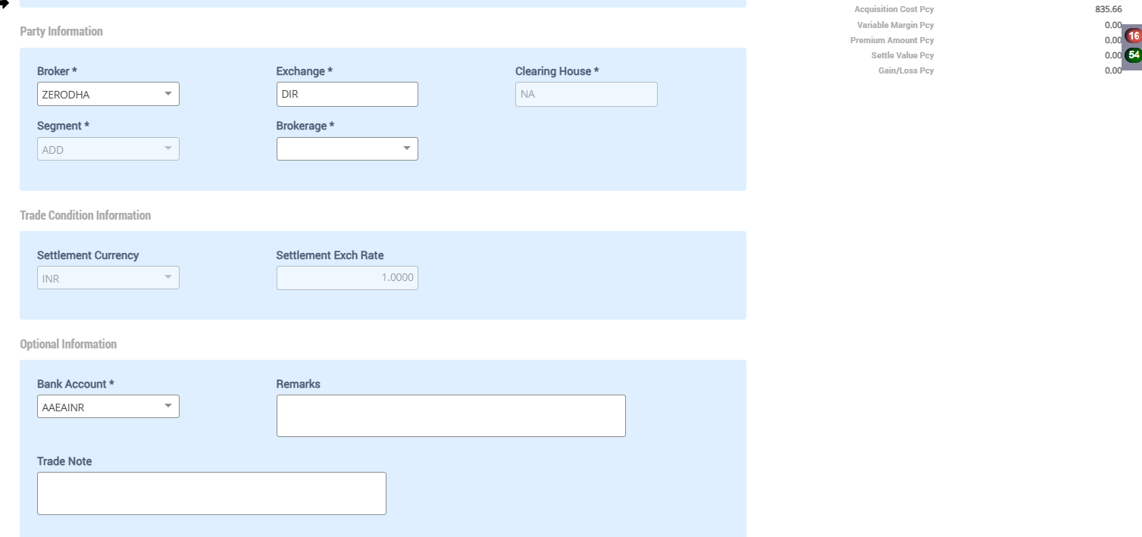
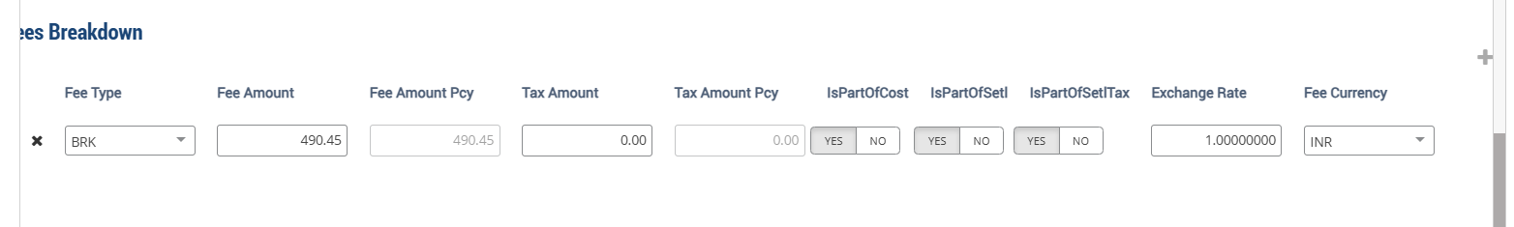

In MOE Confirmation:
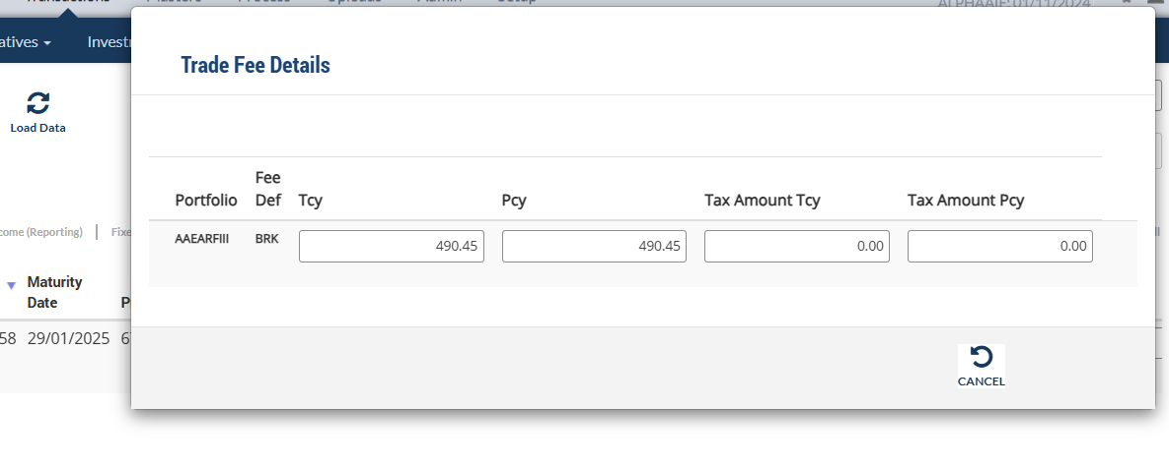

- Screen – Accounting Enquiry Report
Issue - In Futures Asset Class(30)- After uploaded derivative trans file,
Profit/Loss is not computing when do Purchase and Sale of quantity on same transaction date in single transaction. - Greeshma

