|  |  |  |  |
| --- | --- | --- | --- |
| S.no | Paper | Predictors |  |
| 1. | Impact of feature selection on the accuracy and spatial uncertainty of per-field crop classification using Support Vector Machines | Paper1 |  |
| 2. | Efficient corn and soybean mapping with temporal extendibility: A multi-year experiment using Landsat imagery | EVI, NDTI (normalized difference tillage  Index) and NDSVI (normalized  differential senescent vegetation index)  Growing-degree-day (GDD) |  |
| 3. | Assessing the robustness of Random Forests to map land cover with  high resolution satellite  image time series over large areas | Paper2 |  |
| 4. | Automated mapping of  soybean and corn using phenology | Paper3 |  |
| 5. | Examining earliest identifiable timing of crops using all available Sentinel 1/2 imagery and Google Earth Engine | Enhanced Vegetation Index  (EVI), Land Surface Water Index (LSWI), and Red Edge Position (REP) |  |
| 6. | Spatial-temporal patterns of features selected using random forests: a case study of corn and soybeans mapping in the US | Paper4 |  |
| 7. | A 30-m Landsat-derived cropland extent product of Australia and China using random forest machine learning algorithm on Google Earth Engine cloud computing platform |  |  |

Paper 1:

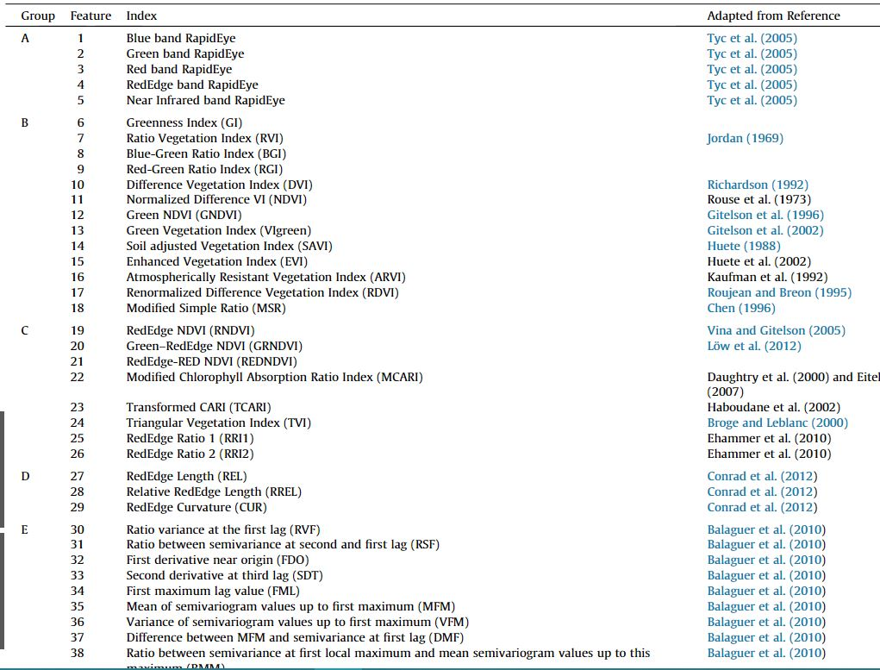

Paper2:

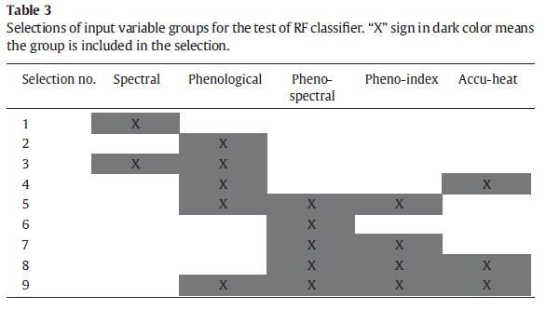

Paper 3:

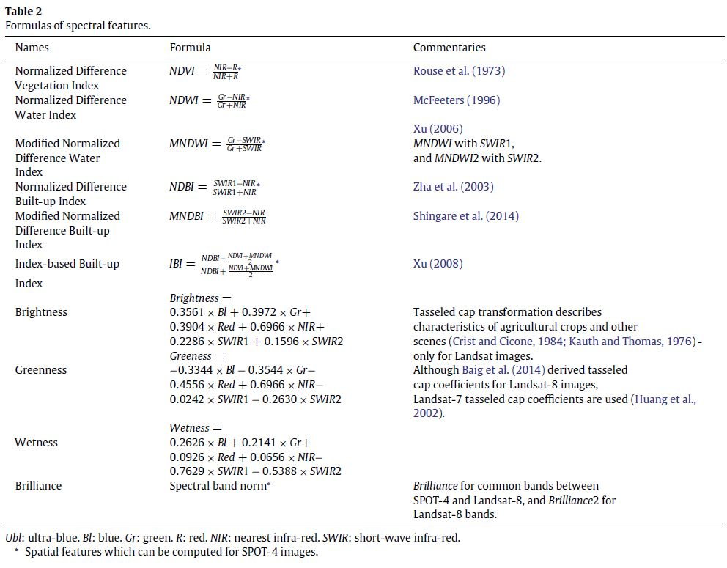

Paper 4:

