# C:\Users\ADMIN\Pictures\Screenshots\Screenshot (80).png

# 1. INTRODUCTION

# 1.1 overview

A Subscribers to a channel on the video –sharing you tube is user who has chosen to receive the channel’s “subscribe” button, and each user’ subscription feed consists of video published by channel to which the user is subscribed. The ability to subscribe to user was introduced in October 2005. YouTube began publishing a list of its most-subscribed channel in April 2006. An early archive of the list dates to May 2006.

The following table list the 50 most- Subscribed YouTube channels, as well as the primary language and content category of each channel. The channels are ordered by number of subscribers; those whose displayed subscriber counts are identical are listed so that the channel whose current growth rate indicates that its displayed subscriber count will exceed that of the other channel is listed first.

Automatically generated channel that lack their own videos(such as Music and News) and channel that have been made effectively obsolete as a result of the transferal of their content (such as Justin Bieber VEVO and Taylor Swift VEVO) are excluded.

# 1.2Purpose

The main purpose of YouTube is to provide a platform for users to watch ,share, and create videos.

You tube for business offers brands a great opportunity to engage audiences and share their stories. Next to Goolge, it’s the second largest search engine-and the number one for video. And with video being one of the most popular and effective pieces of content there’s no better plat for for video marketing.

**2. Problem Definition & Design Thinking**

# 2.1 Empathy Map

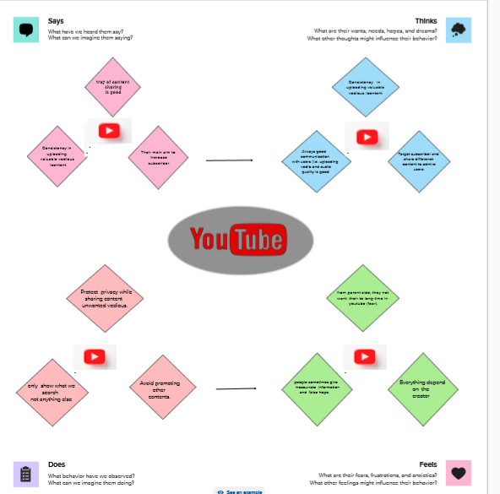

# 2.2 Ideation & Brainstorming Map

# C:\Users\ADMIN\Pictures\Screenshots\Screenshot (70).png

# 3 RESULT

# Dashboard 1: List of country with Number of subscribers and . . . channel C:\Users\ADMIN\Pictures\Screenshots\Screenshot (30).png

# Dashboard 2: Rank wise channel and channel with brand and . subscriber

# C:\Users\ADMIN\Pictures\Screenshots\Screenshot (36).png

# Dashboard 3: Number of channel with Brand and Language

# C:\Users\ADMIN\Pictures\Screenshots\Screenshot (40).pngDashboard 4: List of subscribers in Language

# category and country

# C:\Users\ADMIN\Pictures\Screenshots\Screenshot (46).png

# Dashboard 5: Country wise subscriber and Primary . language

# C:\Users\ADMIN\Pictures\Screenshots\Screenshot (41).png

# Dashboard 6: Like wise Measure and subsribers

# C:\Users\ADMIN\Pictures\Screenshots\Screenshot (42).png

# Dashboard 7: Subscriber of category by brand

# C:\Users\ADMIN\Pictures\Screenshots\Screenshot (71).png

# Dashboard 8: Measure value of sub and name by primary . language of Subscriber

# C:\Users\ADMIN\Pictures\Screenshots\Screenshot (50).png

# 4, ADVANTAGES :

* + Gives access to huge video content.
  + Gives the opportunity to earn money through video.
  + Facilitates to store video offline.
  + Easy to use and share content with other.
  + Can be utilized for study purposes.

# DISADVANTAGES :

* + Some content has got paid access
  + A huge advertisement takes places.
  + Some content is adult rated but still, the under-aged children can access it.
  + There is no limit to view videos on You tube.

# 5 APPLICATIONS

* + You tube channel is the official You tube app from Google for creators.
  + This free tool makes it easier and faster to manage your channel from anywhere.
  + Marketing on You tube will Help you Found on Google.

# 6 CONCLUSION

In my point of view, You tube is one of the best sites to use for all kinds of purpose. It is the second Google . Any information that crosses our mind we can find the answer either on the web of Google or in the videos of You tube .

Social media addition will rise in future. More networking website like Facebook and You tube will develop in future.

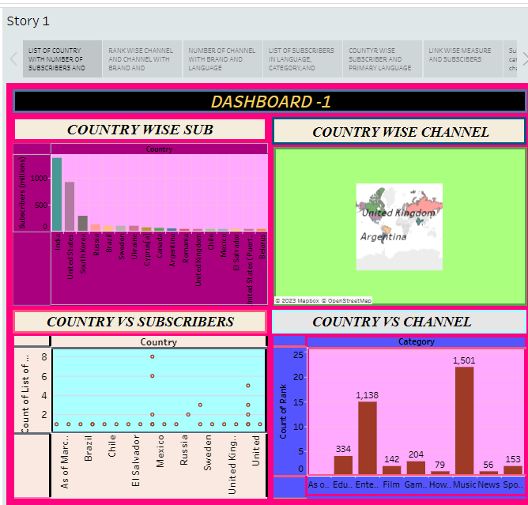

# 7 FUTURE SCOPE

You tube as a career is definitely rising as a current sensation. It does have a lot of scope, exposure and of course , leads you to popularity and fame in your field of choice. But like every other profession , You Tube carrier too has it own pros and cons.

