NAME: VINOTHA MURUGAN
CLASS: SYBSCIT
ROLL NO: 18070
SUBJECT: VSC - KOTLIN (PROJECT)
SUBMITTING TO: VIRGIN MAM

- WRITE A KOTLIN PROGRAM FOR LIBRARY MANAGEMENT SYSTEM

AIM: TO WRITE A KOTLIN PROGRAM FOR LIBRARY MANAGEMENT SYSTEM

PROGRAM:
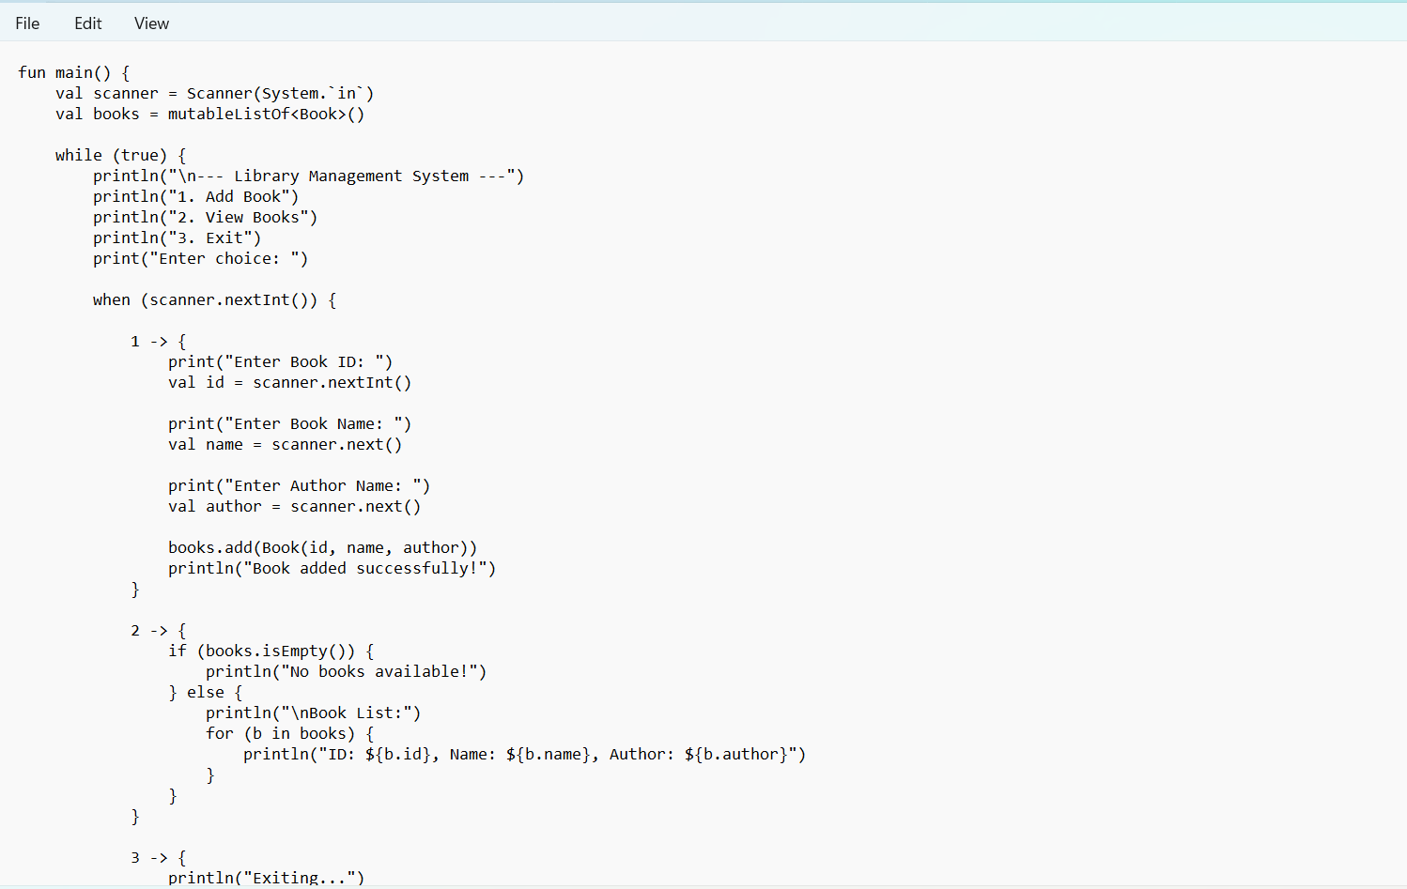

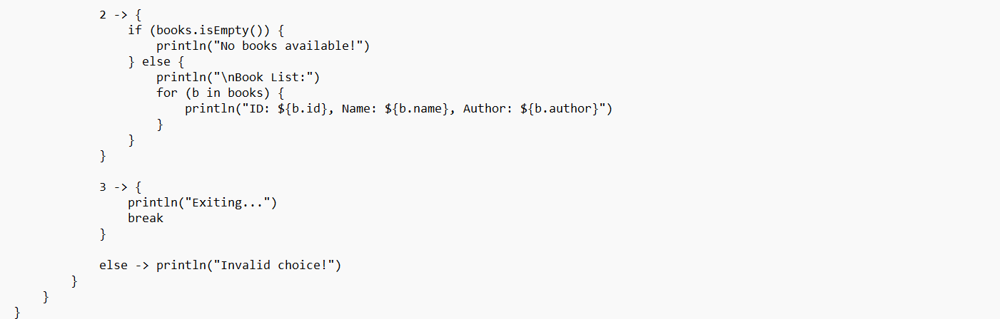

OUTPUT:
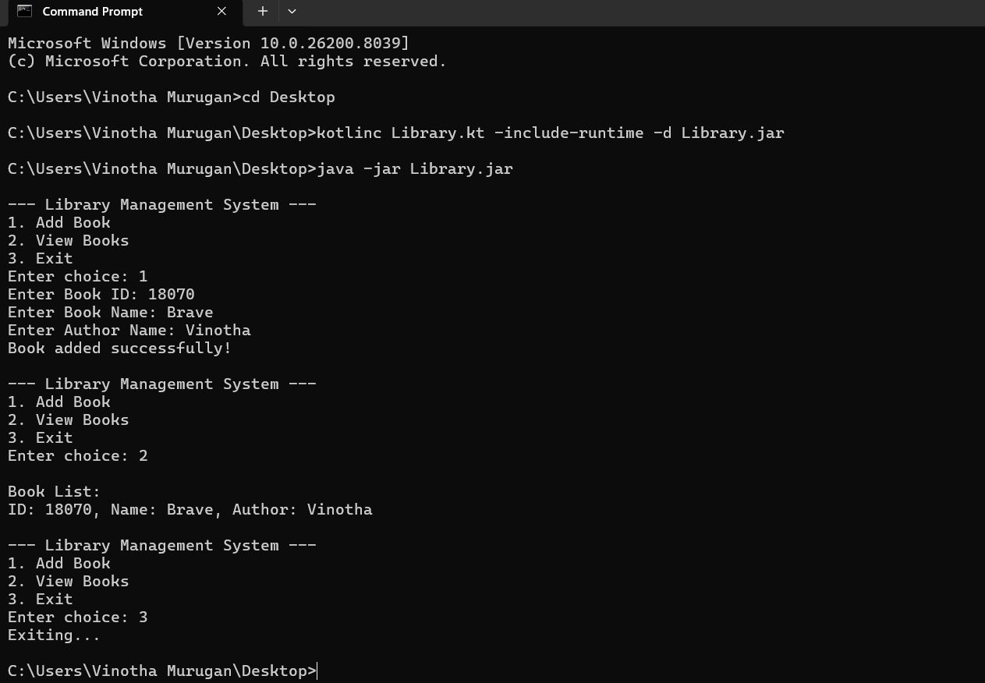

CONCLUSION: THE ABOVE PROGRAM HAS BEEN EXECUTED SUCCESSFULLY.

