NAME: VINOTHA MURUGAN
CLASS: SYBSCIT
ROLL NO: 18070
SUBJECT: VSC - KOTLIN (PROJECT)
SUBMITTING TO: VIRGIN MAM

2.WRITE A KOTLIN PROGRAM FOR HOSPITAL MANAGEMENT SYSTEM

AIM: TO WRITE A KOTLIN PROGRAM FOR HOSPITAL MANAGEMENT SYSTEM

PROGRAM:
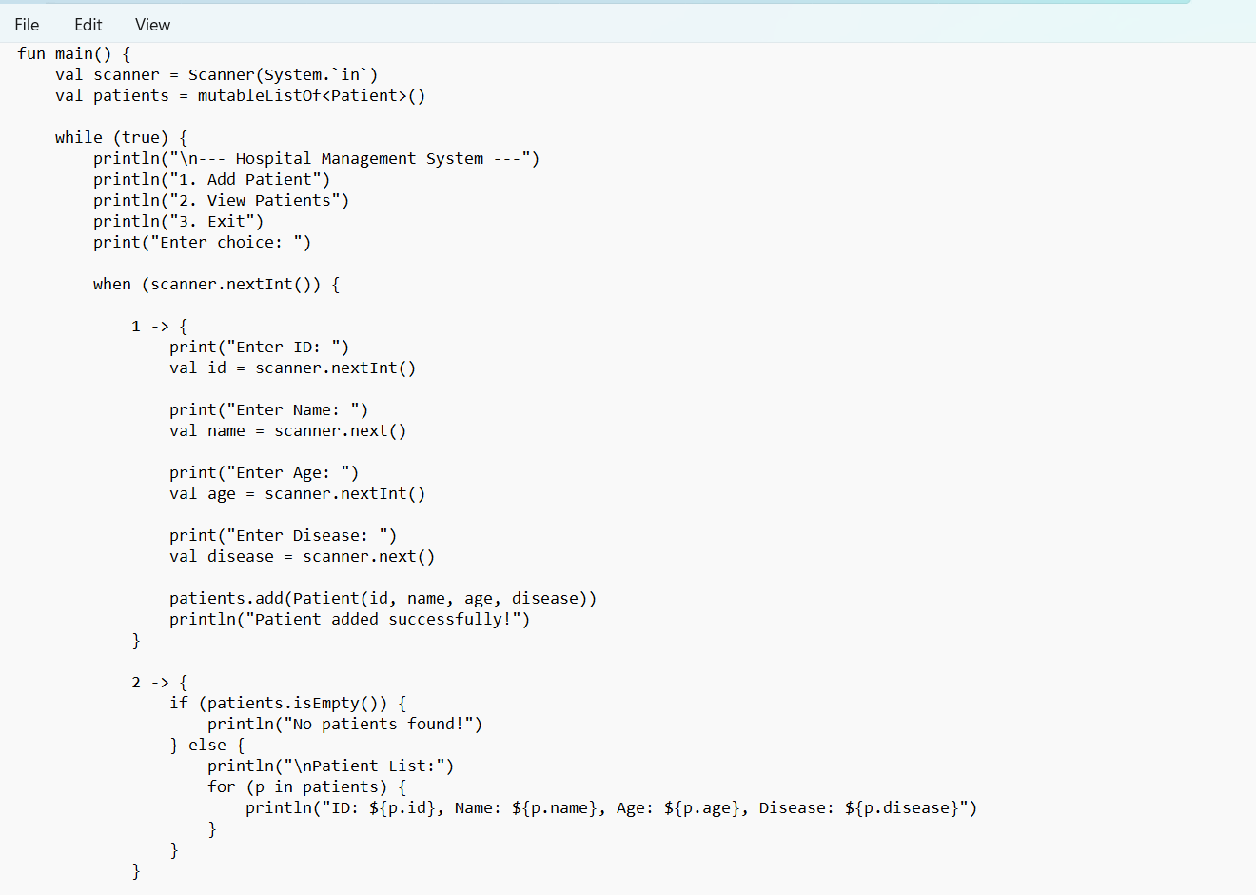

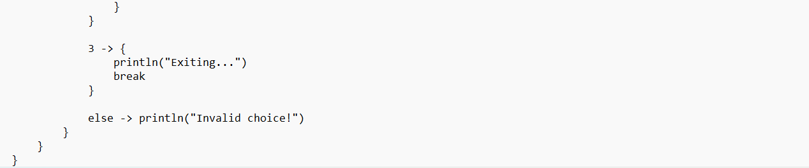

OUTPUT:
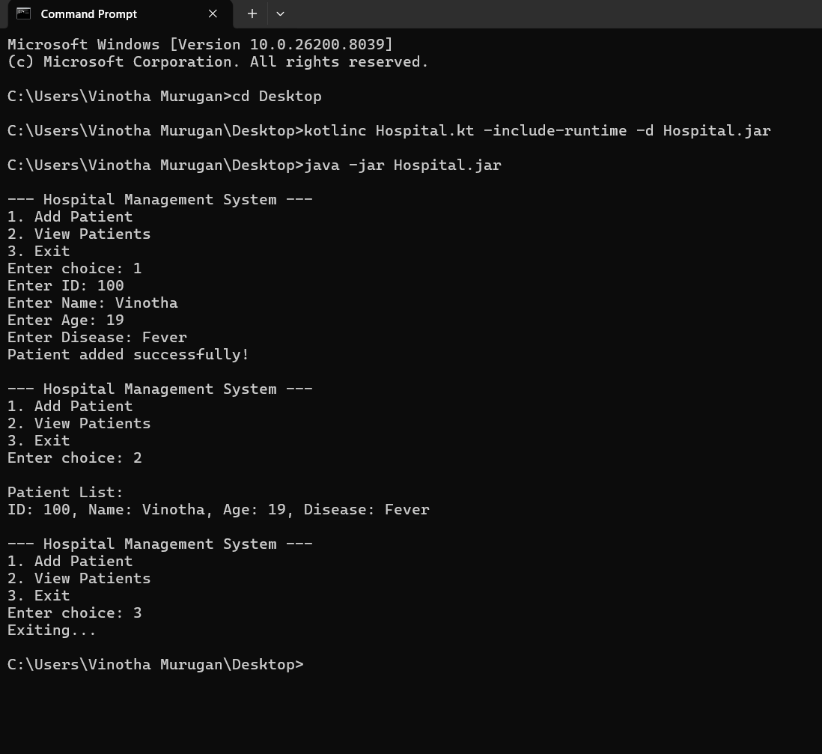

CONCLUSION: THE ABOVE PROGRAM HAS BEEN EXECUTED SUCCESSFULLY.

