End-to-End Cloud Migration (Infra + Application + Data)

Cloud Platform : AWS (us-east-1) as the target

Task1: Migration assessment and strategy
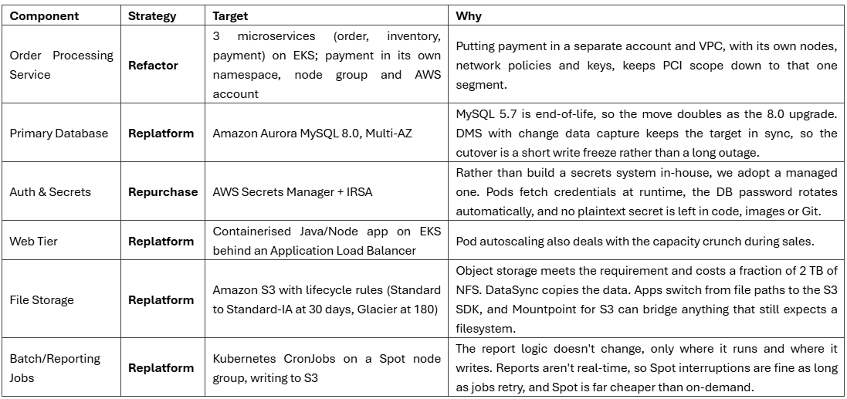Retire and Retain: The Nginx load balancer, VMware VMs and the NFS share are retired once their replacements are live. The on-prem MySQL server is retained, read-only, for about two weeks after cutover as a rollback target, and then retired too.

Dependency map: picture below is the current state with the target strategy for each box. The thing to notice is that every service ends up at the MySQL database, and every service reads its database password from a plaintext config file. Those two facts drive the migration order. Requests flow from customers through the Nginx load balancer to the web tier, then to the order service, which calls inventory and payment. All three services write to MySQL. The web tier and the nightly batch jobs share the NFS share, and the batch jobs also run heavy report queries against the database.
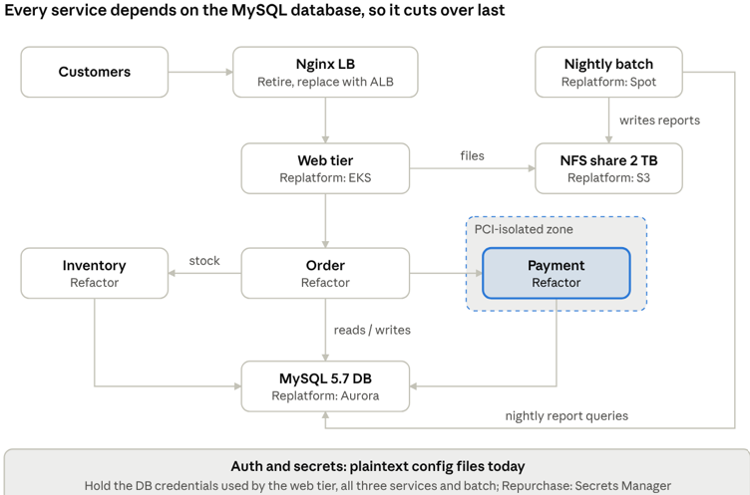
- DB cutover risk: Prevent data loss with DMS full load, row-count/checksum validation, read-only source during cutover, and reverse replication for rollback.
- Cutover timing: Rehearse twice, use a 60-second Route 53 TTL, and pre-scale pods so the cutover stays within the 5-minute window.
- MySQL compatibility: Validate MySQL 5.7 to Aurora MySQL 8.0 using schema conversion, reserved-word/collation/authentication tests, and full workload replay.
- PCI risk: Isolate payment in a separate AWS account/VPC, allow only required order-to-payment traffic, use mTLS and tokenised card data, and complete QSA review.
- Hybrid risk: Test and size VPN or Direct Connect early and keep the period where cloud applications depend on on-prem systems as short as possible.
- Phase 1 – Foundation: Build the landing zone, PCI account, VPC, connectivity, EKS, Terraform, CI/CD, and move secrets to Secrets Manager with credential rotation.
- Phase 2 – Storage & Batch: Move NFS data to S3 using DataSync, move nightly batch to EKS CronJobs on Spot, and start DMS full load + CDC without cutover.
- Phase 3 – Applications: Deploy web, order, inventory, and payment on EKS; keep payment in the PCI segment and validate everything in staging with Aurora and replayed traffic.
- Phase 4 – Cutover: Freeze writes for under 5 minutes, switch Aurora, then move traffic gradually through Route 53 5% → 25% → 100%, keeping on-prem as the rollback target.
- Phase 5 – Optimise & Decommission: Right-size resources, apply Savings Plans and autoscaling improvements, then retire VMware/Nginx/NFS and the on-prem replica after two stable weeks.

Task2: Target architecture and infrastructure as code
Customer traffic comes in through the internet gateway to an HTTPS-only Application Load Balancer, which forwards only the application port to the EKS pods. Pods reach the internet outbound through NAT gateways, talk to Aurora on 3306 over TLS, and reach Secrets Manager, S3, ECR and KMS privately through VPC endpoints, so that traffic never touches the public internet.

Target-state architecture (production, AWS us-east-1)
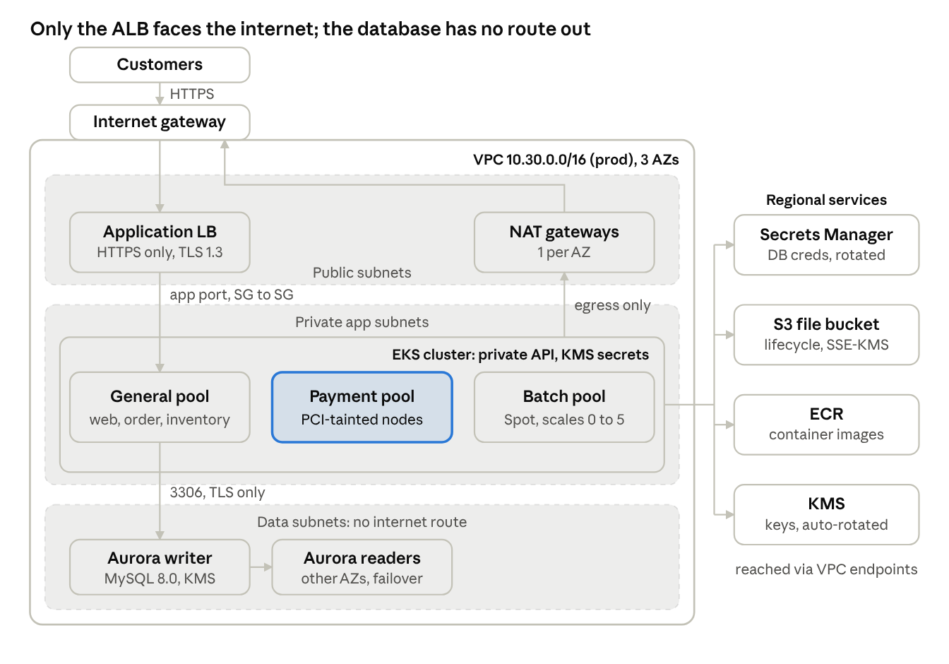

- Database cutover risk: Prevent data loss by using DMS full load plus row-count/checksum validation, making the on-prem DB read-only before switching, and keeping reverse replication for rollback.
- Cutover timing: Rehearse the cutover twice in staging, use a 60-second Route 53 TTL, and pre-scale pods so the 5-minute window can be met.
- Secrets security: Move secrets first, rotate all DB credentials during cutover, use KMS encryption, and apply least-privilege IRSA so old credentials become useless.
- PCI isolation: Keep payment in a separate AWS account/VPC, allow only the required order-to-payment port, use mTLS and tokenised card data, and complete QSA review before go-live.
- Hybrid connectivity: Test and size VPN/Direct Connect early and keep the period where cloud services depend on on-prem resources as short as possible.
- Terraform reuse: Use one common root Terraform stack for all environments, with only small environment-specific tfvars and backend files changing.
- State management: Store Terraform state in an S3 bucket per AWS account, enable versioning/KMS encryption, block public access, and use S3-native locking with use_lockfile = true.
- Environment isolation: Dev, staging, and prod each have separate AWS accounts, state buckets, and state keys; only the environment's CI deploy role can modify its state.
- Security by default: Aurora is private with no public endpoint; IAM, RBAC, and IRSA use least privilege; payment runs on a dedicated tainted node pool; IMDSv2 is enforced.
- Encryption: Use customer-managed KMS keys for data at rest and require TLS in transit—including Aurora TLS 1.2+, HTTPS-only ALB with TLS 1.3, secure S3 policies, and mTLS between order and payment.

Task:3- Application containerisation and deployment
- Application: Node.js 22 order API creates/reads orders and uses Idempotency-Key to prevent duplicate orders; DB credentials come from Secrets Manager.
- Container: Uses a 3-stage Docker build, keeping npm, apt, curl, and development tools out of the final runtime image.
- Deployment: Runs 3 replicas across AZs with rolling updates using maxSurge: 1 and maxUnavailable: 0 for zero capacity loss.
- Security: Containers run as non-root with read-only filesystem, dropped capabilities, seccomp RuntimeDefault, and image pinned by digest.
- Health checks: Startup allows up to 60s; liveness checks /healthz; readiness checks /readyz and removes unhealthy pods from traffic.
- Networking: ClusterIP exposes port 80 → 8080, while ALB Ingress provides HTTPS 443 with TLS 1.3 and /readyz health checks.
- Scaling & availability: HPA scales 3–12 pods based on 65% CPU and 75% memory; PodDisruptionBudget keeps at least 2 pods available.
- Access control: ServiceAccount uses IRSA with permission only to read the database secret; NetworkPolicy is default-deny and allows only required application/database/payment/VPC-endpoint traffic.
- Payment deployment: Uses Argo Rollouts Blue/Green—Green runs 3 replicas behind a preview service while Blue continues serving 100% production traffic.
- Payment rollback: Automated sandbox tests run before promotion; after approval, Green becomes active, is monitored for 10 minutes, and can automatically switch back to Blue on failures, with Blue kept for 1 hour.

Task3: Database migration
- Migration approach: Use AWS DMS to perform an initial full load of the 800 GB database, followed by continuous CDC into Aurora MySQL 8.0 while the source remains live.
- Source preparation: Enable MySQL binary logging with ROW format, binlog_row_image=FULL, and at least 7 days of retention.
- Target preparation: Create the Aurora schema and indexes beforehand; use DO_NOTHING so DMS does not recreate the tables.
- Migration user: Create a dedicated dms_migration user with only SELECT, REPLICATION SLAVE, and REPLICATION CLIENT; store its password in Secrets Manager.
- Network setup: Provide a private VPN/Direct Connect path from DMS to on-prem and restrict the DMS security group to database port 3306.
- DMS setup: Create the Multi-AZ, non-public DMS replication instance, configure source/target endpoints, test connectivity, create the full-load-and-CDC task, and start replication.
- Cutover start: Put the on-prem application into write maintenance mode, pause batch jobs, fence application accounts, and make the source read-only.
- CDC validation: Write a marker on the source and wait for it to appear in Aurora; this confirms that all pending CDC changes have reached the target before cutover.
- Traffic switch: Stop DMS, perform quick data checks, scale the cloud application, shift 100% traffic through Route 53/ALB, and place a synthetic test order before reopening writes.
- Rollback: Keep reverse CDC from Aurora to on-prem after cutover; if a problem occurs, fence Aurora, wait for the reverse marker, switch traffic back, and use the practiced 5–10 minute rollback process.

Task 5: Networking, security and secrets
- Network Segmentation: Public subnets contain only the ALB and NAT Gateways; application workloads run in private subnets, while Aurora stays in isolated data subnets.
- Payment Isolation: Production payment has a separate AWS account, VPC, EKS cluster, and Aurora database with no peering to the order VPC.
- Default-Deny Security: Traffic is denied by default and allowed only through required Security Groups and Kubernetes NetworkPolicies.
- Application Traffic: Internet reaches the ALB on HTTPS 443; the ALB communicates with application pods on 8080.
- Payment Traffic: Order services reach the payment gateway only through PrivateLink on 8443 with mTLS.
- Database Traffic: Order/Batch pods connect to Aurora on 3306 with TLS, restricted by Security Groups and NetworkPolicies.
- AWS Service Access: Pods access Secrets Manager, STS, ECR, Logs, and S3 through VPC endpoints instead of the public internet.
- Secrets Management: Database passwords are moved from plaintext configuration into AWS Secrets Manager, encrypted with a customer-managed KMS key and accessed through IRSA.
- Least Privilege: The order-service role gets only secretsmanager:GetSecretValue and kms:Decrypt for the required resources; no long-lived AWS keys are stored in pods.
- Secret Rotation: Secrets are fetched at runtime, reads are audited in CloudTrail, old credentials are rotated, and the application can refresh credentials without a restart.

Task :6 CI/CD pipeline
- Flow: GitHub PR/Push → Test → Build → Security Scan → Push to ECR → Dev → Staging → Prod Approval → Prod.
- Test: Run npm ci, ESLint, unit tests, Kustomize rendering, and kubeconform; failures stop the pipeline.
- Build: Build the Docker image once using a multi-stage build and layer caching.
- Security Scan: Trivy scans the image, Dockerfile, Kubernetes YAML, and Terraform; unaccepted HIGH/CRITICAL findings stop the pipeline.
- Push to ECR: On main, GitHub Actions uses OIDC and a limited IAM role to push the image to ECR.
- Deploy: Deploy using the SHA256 image digest, not latest; wait for rollout and run a smoke test.
- Promotion: Dev deploys automatically; Staging runs only after Dev passes; Prod requires two reviewers before deployment.
- Security: Use least-privilege IAM roles managed through Terraform; environment access is restricted and deploy roles cannot read secrets or change network policies.
- Same Image: The exact image digest tested in Staging is promoted to Prod, ensuring Prod runs the same tested artifact.
- Rollback: Failed deployments or smoke tests trigger kubectl rollout undo; Argo Rollouts can switch the payment service back to Blue, and database changes use expand-and-contract.

Task 7: Cost and optimisation
- Current AWS cost: Dev + Staging + Prod costs about $4,316/month, compared with an assumed $5,400/month on-prem, giving roughly 20% savings.
- After optimisation: The first four optimisation steps can reduce AWS cost to about $3,351/month, around 38% lower than the assumed on-prem cost.
- Main cost areas: Compute, Aurora database, networking/NAT, storage, and monitoring/secrets.
- Savings Plan: After observing real production usage, use a 1-year Compute Savings Plan for the steady baseline; estimated saving is about $261/month.
- Aurora right-sizing: Load-test first, then reduce Aurora from three instances to two and use Aurora Auto Scaling; estimated saving is about $380/month.
- Non-production scheduling: Scale Dev and Staging resources down overnight and on weekends; estimated saving is about $302/month.
- S3 lifecycle: Move older data from S3 Standard → Standard-IA → Glacier Flexible Retrieval; estimated saving is about $23/month.
- Spot for batch: Use Spot instances for interruptible batch workloads and scale them only when batch jobs require capacity.
- Network optimisation: Use the S3 gateway endpoint to avoid unnecessary NAT costs and review whether all interface endpoints need three AZs in non-production.

