Resources
Type | Link
Course | https://www.youtube.com/watch?v=Q86qzJ1K1Ss&list=PLoROMvodv4rOCXd21gf0CF4xr35yINeOy&index=9
Material | https://cme295.stanford.edu/syllabus/

Transformers: A Beginner's Guide

Table of Contents
- What are Transformers?
- Transformer Architecture
- Detailed Explanation
- Encoder
- Decoder
- Encoder-Only vs Decoder-Only: BERT vs GPT
- The Attention Mechanism
- The Attention Formula
- Example: "The cat sat on the mat"
- Step 1: Q × K^T (Similarity Scores)
- Step 2: Softmax (Normalize to Percentages)
- Step 3: Multiply by V (Mix Information)
- Complete Flow
- Why This Works
- Positional Encoding: Teaching Position to Transformers
- Absolute Positional Encoding (Sinusoidal)
- RoPE (Rotary Position Embedding)
- T5 Relative Position Bias
- ALiBi (Attention with Linear Biases)
- Key Clarification: ALiBi vs RoPE
- Bias Matrix: What It Looks Like
- Comparison: All Positional Encoding Methods
- Multi-Head Attention: Looking at Words from Different Perspectives
- How It Works
- What Each Head Learns
- How Heads Specialize During Training
- How Multi-Head Attention Learns: Backpropagation
- Transformer Block Internals: MHA, FFN, and Loss Computation
- Component Overview
- 1. Attention Scores: How Words Find Related Words
- 2. Shape Flow Through Transformer
- 3. FFN Purpose & Loss Computation
- FFN Explained for Beginners
- 4. Where Loss is Computed: End-to-End Flow
- 5. Backpropagation: How ALL Layers Learn
- Key Takeaways
- Real-World Analogy
- Layer Normalization
- Pre-Norm vs Post-Norm: LayerNorm Placement
- Post-Norm (Original Transformer, 2017)
- Pre-Norm (Modern: GPT-3, GPT-4, LLaMA)
- Post-Norm vs Pre-Norm: Representation Collapse & Stability
- Pre-Norm vs Post-Norm vs ResiDual
- Backpropagation: Why Pre-Norm is Better
- Sparse Attention
- Common Sparse Attention Patterns
- Example: Longformer (Combined Patterns)
- Key Models Using Sparse Attention
- Benefits & Trade-offs
- Sharing Attention Heads
- MHA vs MQA vs GQA
- Sharing Strategies
- Example: ALBERT (A Lite BERT)
- Key Models Using Shared Heads
- Transformer-Based Models
- Encoder-Only (BERT-style)
- Encoder-Decoder (T5/BART-style)
- Decoder-Only (GPT/LLaMA-style)

Resources
- https://cme295.stanford.edu/syllabus/

What are Transformers?
Neural network architecture from 2017 ("Attention is All You Need") - foundation for GPT, BERT, and modern AI models.
Key Idea: Process entire sentences at once (not word-by-word) using "attention" to understand word relationships.
Old RNNs: "The" → "cat" → "sat" (slow, forgets earlier words)
Transformers: All words at once! (fast, remembers everything)

Transformer Architecture
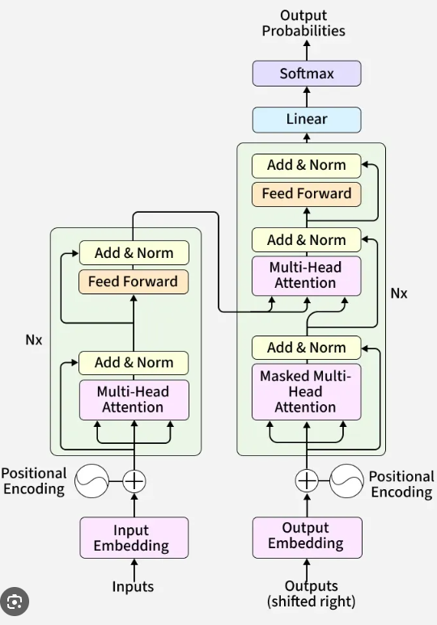

Detailed Explanation
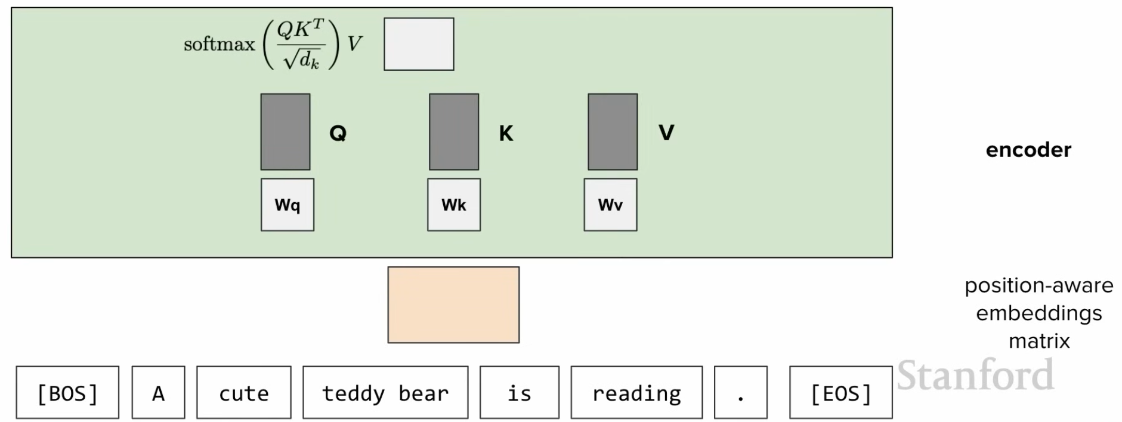
Q & K^T

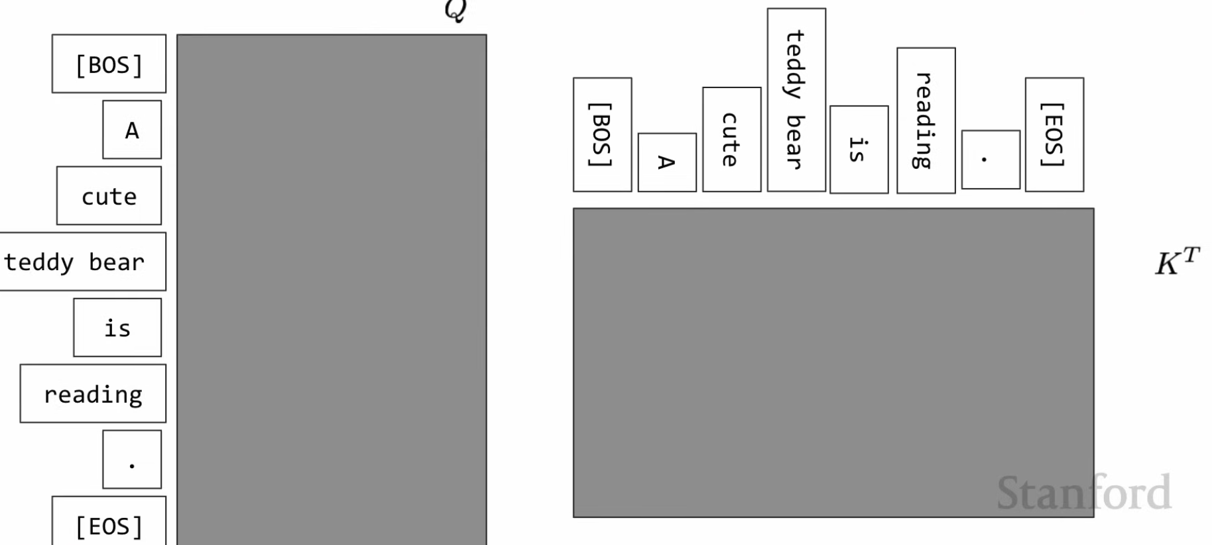
Q × K^T

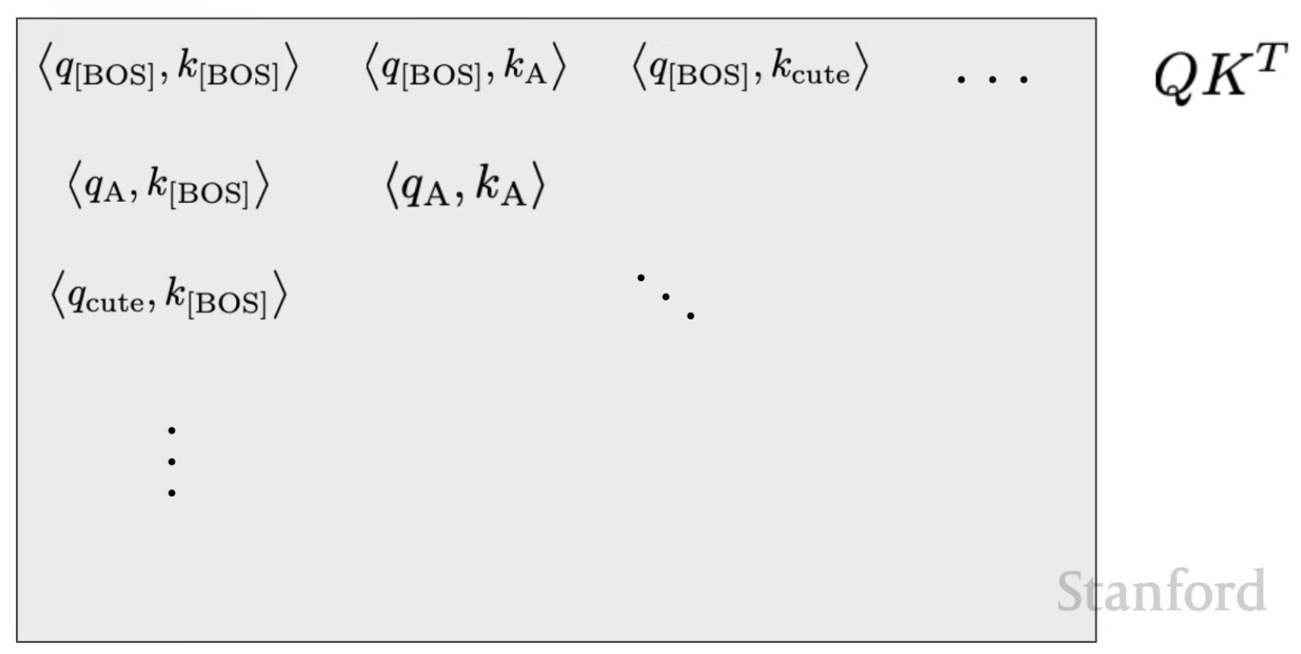

Encoder
Purpose: The encoder's job is to understand and encode the input into rich contextual representations.

What Does the Encoder Do?
- Bidirectional Understanding: Processes all input tokens simultaneously, allowing each token to attend to every other token (both left and right context)
- Context Extraction: Creates deep contextual embeddings that capture the meaning and relationships of input tokens
- Feature Extraction: Transforms raw input into meaningful representations that capture semantic and syntactic information

How It Works:
Input: "The cat sat on the mat"
↓
Encoder processes ALL tokens at once:
↕ ↕ ↕ ↕ ↕ ↕
Each word can see ALL other words
↕ ↕ ↕ ↕ ↕ ↕
↓
Output: Rich contextual embeddings for each token

Key Components:
- Self-Attention: Each token attends to all other tokens in the input
- Feed-Forward Networks: Further processes the attended representations
- Layer Normalization & Residual Connections: Stabilizes training and preserves information
- Stacked Layers (typically 6-12): Each layer refines the understanding

Use Cases:
- BERT-style models: Classification, sentiment analysis, named entity recognition
- Translation (Encoder part): Understanding the source language
- Question Answering: Understanding both the question and context
- Semantic Search: Creating meaningful embeddings for similarity matching
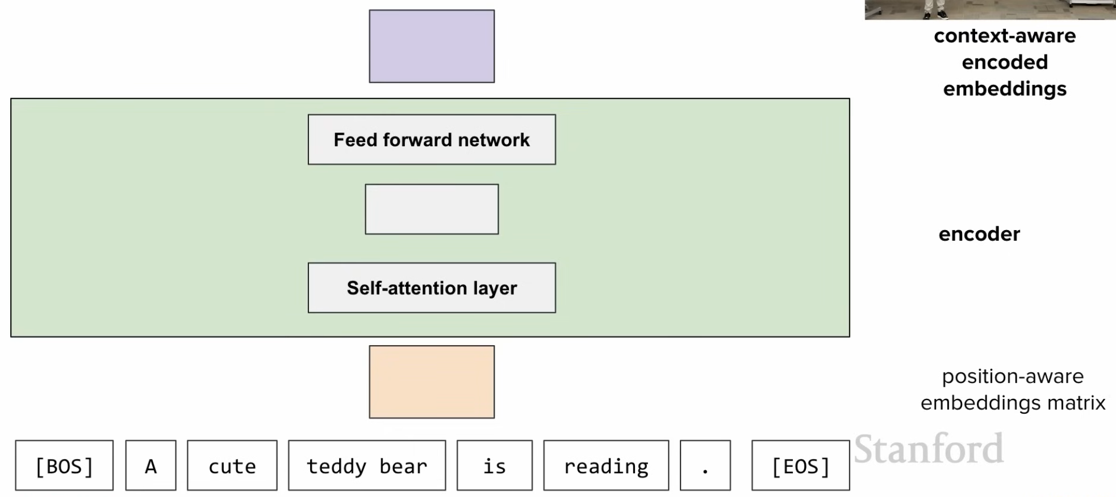

Decoder
Purpose: The decoder's job is to generate output sequences one token at a time, using previously generated tokens and optionally encoder outputs.

What Does the Decoder Do?
- Sequential Generation: Produces output tokens one at a time in an autoregressive manner
- Causal/Masked Attention: Each token can only attend to previously generated tokens (left-to-right, no future peeking)
- Cross-Attention (in Encoder-Decoder models): Attends to encoder outputs to incorporate source information
- Conditional Generation: Generates outputs conditioned on the input context

How It Works:
Generation Process (e.g., GPT):
Input: "The cat sat on the"
↓
Decoder generates sequentially:
Token 1: "The" → can see: [The]
Token 2: "cat" → can see: [The, cat]
Token 3: "sat" → can see: [The, cat, sat]
Token 4: "on" → can see: [The, cat, sat, on]
Token 5: "the" → can see: [The, cat, sat, on, the]
Token 6: "mat" ✨ → prediction!
↓
Output: "The cat sat on the mat"

Key Components:
- Masked Self-Attention: Prevents tokens from attending to future positions (maintains causality)
- Cross-Attention (in full Transformers): Attends to encoder outputs to use source context
- Feed-Forward Networks: Processes the attended representations
- Output Projection: Maps decoder outputs to vocabulary for next token prediction

Two Types of Decoder Usage:
1. Decoder-Only (GPT, LLaMA, etc.)
Input → Decoder Stack → Output
(No encoder, self-contained generation)
2. Encoder-Decoder (Original Transformer, T5, BART)
Input → Encoder → Rich Representations
↓
Previous Outputs → Decoder → Next Token
(uses both masked self-attention and cross-attention)

Use Cases:
- Text Generation: GPT models for creative writing, completion
- Translation (Decoder part): Generating target language from encoded source
- Summarization: Generating concise summaries from encoded documents
- Code Generation: Producing code from natural language descriptions
- Conversational AI: Generating responses in chatbots
Important Note: Send your already decoded words along with encoded embeddings from Encoder (in encoder-decoder models) to generate next words.
self-attention layer in the decoder represents Masked self-attention (causal attention).
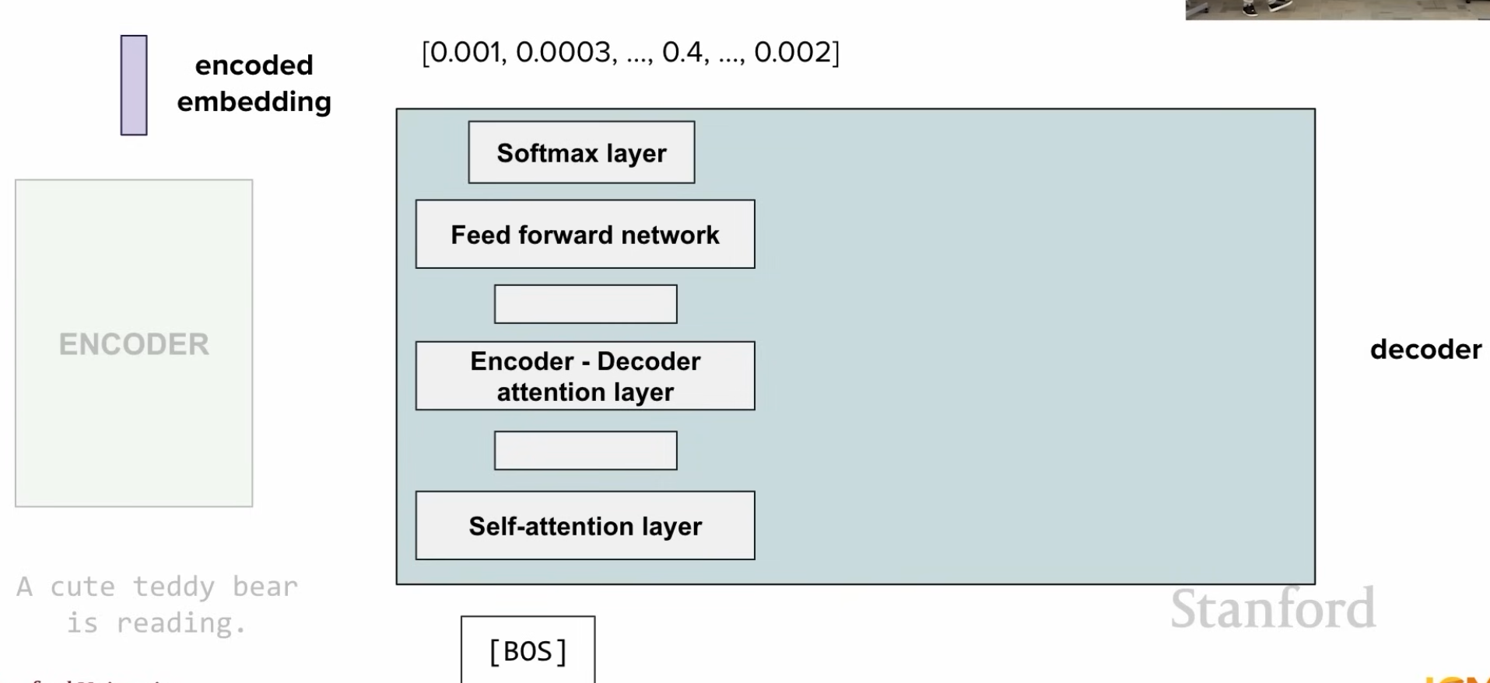
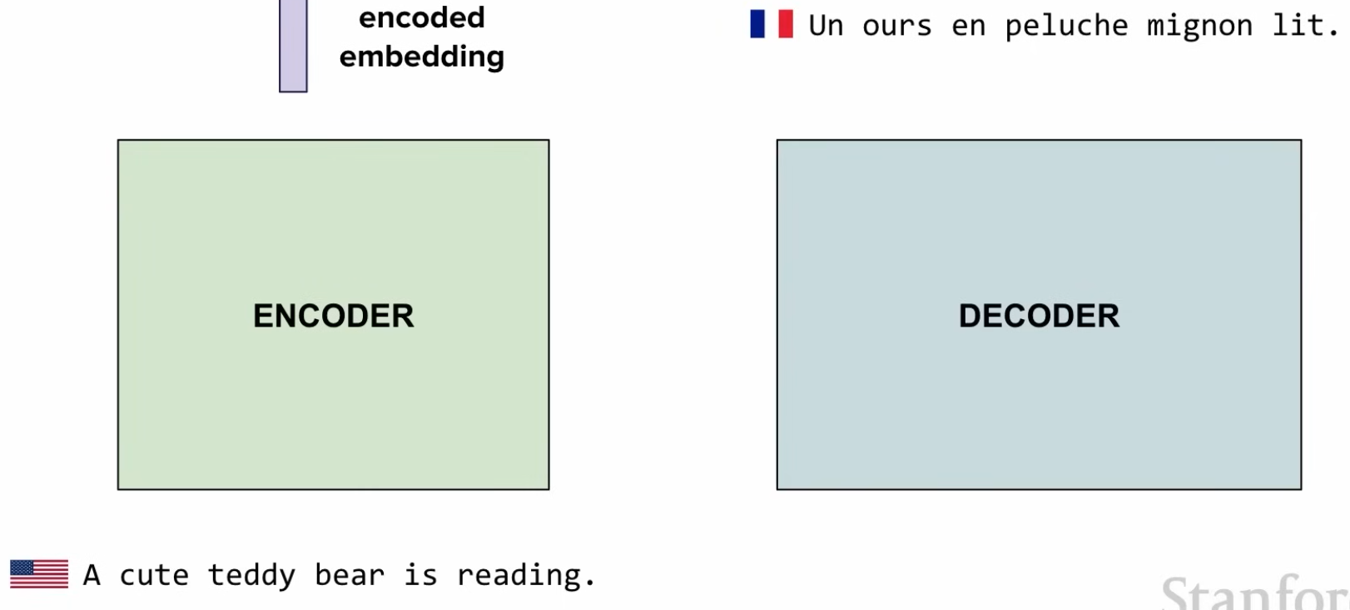

Encoder-Only vs Decoder-Only: BERT vs GPT
Why different architectures? Different tasks need different designs.
Model Type | Architecture | Use Case | Example
BERT | Encoder Only | Understanding/Reading | "Is this email spam?"
GPT | Decoder Only | Generation/Writing | "Write a story about cats"

BERT: Encoder-Only (Bidirectional Understanding)
Why encoder only? Needs to understand context from BOTH directions.
Task: "Is this email spam?"
Email: "Congratulations! You won a prize. Click here."
↕ ↕ ↕ ↕ ↕ ↕
BERT looks BOTH ways (left + right context)
↕ ↕ ↕ ↕ ↕ ↕
Understanding: "won" + "prize" + "click" → Pattern = SPAM
BERT sees full context → Better understanding
Key Features:
- Reads entire sentence at once
- Sees future and past words simultaneously
- Perfect for: classification, question answering, sentiment analysis

GPT: Decoder-Only (Autoregressive Generation)
Why decoder only? Generates text one word at a time, left-to-right.
Task: "Write a story about cats"
Generated: "The cat sat on the ___"
↓ ↓ ↓ ↓ ↓ ?
Can only see LEFT context (already generated)
↓ ↓ ↓ ↓ ↓
Predicts next: "mat"
GPT generates sequentially → Natural text generation
Key Features:
- Masked attention (can't see future words)
- Generates one token at a time
- Perfect for: text generation, completion, creative writing
Important Clarification:
❌ MISCONCEPTION:
"GPT uses a pretrained encoder"
✓ TRUTH:
GPT has NO encoder at all!
GPT architecture:
┌─────────────────────────────────┐
│ Input Embedding │
│ ↓ │
│ Positional Encoding │
│ ↓ │
│ Decoder Blocks (ONLY) │
│ - Masked Self-Attention │
│ - Feed Forward │
│ (No encoder, no cross-attention) │
│ ↓ │
│ Output Prediction │
└─────────────────────────────────┘
Why GPT doesn't need an encoder:
- Self-Sufficient: The decoder blocks process input directly
- Causal Attention: Each position can only attend to previous positions
- Simple Architecture: Input → Decoder Stack → Output
- No Separate Understanding Phase: Understanding happens within decoder layers
What GPT actually does:
Input: "The cat sat on the"
↓
Embedding + Positional Encoding
↓
Decoder Layer 1 (masked self-attention)
"The" sees: [The]
"cat" sees: [The, cat]
"sat" sees: [The, cat, sat]
"on" sees: [The, cat, sat, on]
"the" sees: [The, cat, sat, on, the]
↓
Decoder Layer 2, 3, 4... (stacked)
Each layer refines understanding
↓
Output: Predict next word → "mat"
Contrast with Original Transformer (Encoder + Decoder):
Original Transformer (Translation):
┌──────────────┐ ┌──────────────┐
│ ENCODER │────────→│ DECODER │
│ │ │ │
│ Input: "Cat" │ │ Output: "Chat"│
│ (English) │ │ (French) │
└──────────────┘ └──────────────┘
↓ ↓
Understands input Generates output using
bidirectionally encoder's understanding
GPT (Generation only):
┌──────────────┐
│ DECODER │
│ (ONLY) │
│ │
│ Input: "Cat" │
│ Output: "sat"│
└──────────────┘
↓
Everything happens
in decoder layers

Visual Comparison
BERT (Encoder):
┌─────────────────────────────────────┐
│ "The cat sat on the mat" │
│ ↕ ↕ ↕ ↕ ↕ ↕ │
│ All words see ALL other words │
│ (bidirectional attention) │
└─────────────────────────────────────┘
Output: Understanding/Classification
GPT (Decoder):
┌─────────────────────────────────────┐
│ "The cat sat on the ___" │
│ ↓ ↓ ↓ ↓ ↓ │
│ Each word only sees previous words │
│ (masked/causal attention) │
└─────────────────────────────────────┘
Output: Next word prediction "mat"

Why Not Use Both?
Original Transformer (2017) used both:
- Encoder: Understands input (e.g., English sentence)
- Decoder: Generates output (e.g., French translation)
Modern Trend - Specialization:
- Understanding tasks → Encoder-only (BERT) - simpler, faster
- Generation tasks → Decoder-only (GPT) - simpler, scalable
- Translation tasks → Encoder-Decoder (T5, BART)

Quick Summary
Need to understand? → BERT (Encoder-only)
- Classification
- Question answering
- Named entity recognition
Need to generate? → GPT (Decoder-only)
- Text completion
- Story writing
- Code generation
Need both? → Full Transformer (Encoder + Decoder)
- Translation
- Summarization

The Attention Mechanism
When you read "The cat sat on the mat", your brain links "cat" with "sat" and "mat", ignoring "the" and "on".
Attention does exactly this!

Three Components (Library Analogy):
Component | Purpose | Analogy
Query (Q) | What am I looking for? | Your question
Key (K) | What's available? | Library catalog
Value (V) | Actual information | The books

V (Value) contains the actual information we want to extract. The attention weights from softmax tell us "how much of each value to use," and multiplying creates a weighted sum of values based on relevance.
The Intuitive Explanation Think of it like a weighted average:
Question: "What should I focus on?"
Keys: "I can help with this topic"
Values: "Here's the actual information"
Attention = "How much to focus" × "What to focus on"
= softmax weights × Values
1. Each Component's Role
Q (Query): "What am I looking for?"
- Represents what the current token needs
K (Key): "What do I contain?"
- Represents what information each token offers
V (Value): "Here's my actual content"
- Contains the actual information to be passed forward
2. The Attention Process
Step 1: Q·K^T → "How relevant is each position?"
Produces attention SCORES (relevance measures)
Step 2: softmax(Q·K^T/√dk) → "What percentage for each?"
Converts scores to WEIGHTS that sum to 1
Step 3: weights × V → "Extract weighted information"
Creates final output by mixing Values

The Attention Formula
Attention(Q, K, V) = softmax(Q × K^T / √d_k) × V
Step-by-step:
- Q × K^T → Find similarity scores between all word pairs
- ÷ √d_k → Scale down (prevents large numbers)
- softmax → Convert to percentages (sum = 100%)
- × V → Mix information based on percentages

Example: "The cat sat on the mat"

Step 1: Q × K^T (Similarity Scores)
Why? Calculate how related each word is to every other word. What? Dot product gives higher scores for related words, lower for unrelated.
Q(cat) · K(The) = 1.25 (low)
Q(cat) · K(cat) = 5.40 (HIGH)
Q(cat) · K(sat) = 4.80 (HIGH)
Q(cat) · K(on) = 1.20 (low)
Q(cat) · K(the) = 1.25 (low)
Q(cat) · K(mat) = 4.10 (high)
Visual:
The cat sat on the mat
▁ ████ ███ ▁ ▁ ███
Why K^T? Creates attention matrix comparing every word with every word.

Step 2: Softmax (Normalize to Percentages)
Why? Raw scores are hard to interpret - need probabilities that sum to 100%. What? Converts scores to attention weights showing "how much" to focus on each word.
Before: [1.25, 5.40, 4.80, 1.20, 1.25, 4.10]
After: [4%, 41%, 29%, 4%, 4%, 19%] ← Sums to 100%
Attention Map for "cat":
The cat sat on the mat
▁▁▁ ████████ ██████ ▁▁ ▁▁ ████
4% 41% 29% 4% 4% 19%

Purpose of Dividing by √dk in Scaled Dot-Product Attention
- √dk scaling prevents softmax saturation by keeping dot products in a reasonable range
- Normalizes variance back to 1, regardless of dimension size
- Enables stable training by preventing vanishing gradients
- Works for any dimension - automatically adjusts as dk changes
- Simple but crucial - without it, transformers wouldn't train effectively!
The Detailed Explanation:
1. The Attention Formula Where:
Q (Query): shape (seqlen, dk) K (Key): shape (seqlen, dk) dk: dimension of key/query vectors
2. Why Division is Needed
Problem: Dot products grow with dimension
When computing QK^T, each element is a dot product of two dk-dimensional vectors:
If Q and K have mean 0 and variance 1 (typical after initialization):
Variance of dot product = dk Standard deviation = √dk
Example with Numbers: Small dimension (dk=4):
q = [0.5, -0.3, 0.8, -0.2]
k = [0.4, 0.6, -0.5, 0.7]
q·k = 0.5×0.4 + (-0.3)×0.6 + 0.8×(-0.5) + (-0.2)×0.7
= 0.2 - 0.18 - 0.4 - 0.14 = -0.52
Large dimension (dk=64):
q·k could be around ±8 to ±16 (grows with √64 = 8)
3. The Softmax Problem
Without scaling(√dk division), large dot products cause softmax to saturate:
# Without scaling (dk=64) - Not divided by √dk
scores = [15, 12, -18, 2] # Large values!
softmax([15, 12, -18, 2])
= [0.952, 0.047, 0.000, 0.001] # One value dominates!
Problems:
❌ Softmax becomes almost one-hot (one value ≈ 1, others ≈ 0) ❌ Gradients become extremely small (vanishing gradients) ❌ Model can't learn effectively
With scaling (divide by √64 = 8):
scores = [15, 12, -18, 2] scaled = [1.875, 1.5, -2.25, 0.25] # Smaller values!
softmax([1.875, 1.5, -2.25, 0.25]) = [0.465, 0.319, 0.007, 0.091] # More balanced!
✅ Gradients remain healthy ✅ Model can learn from multiple positions

Step 3: Multiply by V (Mix Information)
Why? Need to actually extract and combine information from relevant words. What? Weighted average - take more info from high-attention words, less from low-attention words.
Output for "cat" = 41% × V(cat)
+ 29% × V(sat)
+ 19% × V(mat)
+ 11% × others
Result: "cat" now has context from related words!

Complete Flow
INPUT: "The cat sat on the mat"
↓
Create Q, K, V (learned transformations)
↓
Q × K^T → Similarity scores
↓
÷ √d_k → Scale
↓
softmax → Percentages
↓
× V → Context-aware output
↓
OUTPUT: Each word understands its context!

Communication between Transformer Layer
Initialize K,V,Q Matrix
"The" "cat" "sat"
↓ ↓ ↓
[Token ID: 464] [Token ID: 3797] [Token ID: 3332]
↓ ↓ ↓
┌────────────────────────────────────────────────┐
│ Embedding Matrix E (50,257 rows × 768 cols) │
│ Fetch row for each token ID → 768-dim vector │
└────────────────────────────────────────────────┘
↓ ↓ ↓
emb("The") emb("cat") emb("sat") ← static lookup, same always
↓ ↓ ↓
+ pos_enc(0) + pos_enc(1) + pos_enc(2) ← add position info
↓ ↓ ↓
Stack into matrix X [3 × 768]
│
├── × W_Q [768×64] → Q [3×64] "What am I looking for?" ← NOT cached
├── × W_K [768×64] → K [3×64] "What do I offer for matching?" ← CACHED
└── × W_V [768×64] → V [3×64] "What do I contribute?" ← CACHED
↓
Attention(Q, K, V) = softmax(QKᵀ/√d) × V
↓
Each token enriched with context from all others
Layer 1 → Layer 2: Step by Step Let's trace "The cat sat" through two full layers:
Layer 1 Input — Raw Embeddings
H_in (Layer 1):
"The" → [0.30, 0.70, 0.20, 0.10] ← raw embedding + position
"cat" → [0.21, -0.53, 0.87, 0.12] ← raw embedding + position
"sat" → [0.60, 0.10, -0.40, 0.50] ← raw embedding + position
Layer 1 — Self Attention
Compute Q, K, V from H_in using Layer 1's OWN weight matrices:
Q_L1 = H_in × W_Q_L1
K_L1 = H_in × W_K_L1
V_L1 = H_in × W_V_L1
Attention runs:
"cat" attends to "The" (low), "cat" (medium), "sat" (high)
→ learns: "cat is the one doing the sitting"
"sat" attends to "cat" (high), "The" (low)
→ learns: "sitting was done by cat"
attn_output:
"The" → [0.11, 0.33, 0.05, 0.22] ← slightly updated
"cat" → [0.55, 0.41, 0.73, 0.38] ← now knows it's the subject
"sat" → [0.43, 0.62, 0.29, 0.71] ← now knows who did it
Layer 1 — Residual Connection
H_mid = LayerNorm(H_in + attn_output)
"cat":
H_in = [0.21, -0.53, 0.87, 0.12] ← original
attn_out = [0.55, 0.41, 0.73, 0.38] ← what attention added
sum = [0.76, -0.12, 1.60, 0.50] ← added together
LayerNorm → [0.44, 0.33, 0.91, 0.61] ← normalized
The residual connection is crucial — it ensures the original embedding is never lost. Attention adds ON TOP of what was already there.
Layer 1 — Feed Forward Network (FFN)
FFN processes each token independently:
ffn_out("cat") = FFN([0.44, 0.33, 0.91, 0.61])
H_out = LayerNorm(H_mid + ffn_out)
Final Layer 1 output for "cat":
H_out_L1("cat") = [0.67, 0.22, 0.85, 0.74]
← "cat" enriched with Layer 1 understanding
This H_out Becomes Layer 2's Input
Layer 1 H_out: Layer 2 H_in:
"The" → [0.31, 0.45, 0.18, 0.29] → "The" → [0.31, 0.45, 0.18, 0.29]
"cat" → [0.67, 0.22, 0.85, 0.74] → "cat" → [0.67, 0.22, 0.85, 0.74]
"sat" → [0.52, 0.78, 0.33, 0.61] → "sat" → [0.52, 0.78, 0.33, 0.61]
Same values, just relabeled as the new layer's input.
Layer 2 — Freshly Computes Its Own Q, K, V
Layer 2 has its OWN weight matrices: W_Q_L2, W_K_L2, W_V_L2
(completely different from W_Q_L1, W_K_L1, W_V_L1)
Q_L2 = H_in_L2 × W_Q_L2 ← different projection than Layer 1
K_L2 = H_in_L2 × W_K_L2 ← different projection than Layer 1
V_L2 = H_in_L2 × W_V_L2 ← different projection than Layer 1
The Q, K, V in Layer 2 are completely new vectors — but they are computed from a richer hidden state. So they implicitly carry Layer 1's knowledge.
Layer 1 K("cat"): "I am a noun, I can be a subject"
(computed from raw embedding)
Layer 2 K("cat"): "I am the specific agent who performed 'sat'"
(computed from Layer 1's enriched hidden state)
Layer 2's K, Q, V are more meaningful because the hidden state they're built from already contains Layer 1's insights.

Why This Works
Q × K^T: Dot product measures similarity
- Similar vectors → High score → Related words
- Different vectors → Low score → Unrelated
Softmax: Converts scores to probabilities (0-100%)
× V: Weighted sum - blend information from important words

Positional Encoding: Teaching Position to Transformers
The Problem: Transformers process all words simultaneously - they don't know word order!
- "cat chased dog" vs "dog chased cat" would look identical without position info
The Solution: Add positional information to word embeddings.
There are multiple approaches:
- Absolute Positional Encoding (Original Transformer, BERT) - Add fixed position patterns
- Relative Positional Encoding (RoPE) (LLaMA, GPT-NeoX) - Rotate Q/K by position
- T5 Relative Position Bias (T5, FLAN-T5) - Add learned bias to attention scores
- ALiBi (BLOOM, MPT) - Add linear bias based on distance

Absolute Positional Encoding (Sinusoidal)

Core Concept
Why? Transformers process all words simultaneously - need to tell them word order. What? Add unique sine/cosine wave patterns to each word's embedding.
Word Embedding + Positional Encoding = Final Input
"The cat sat" → [E_The+PE_0] [E_cat+PE_1] [E_sat+PE_2]

The Formula
PE(pos, 2i) = sin(pos / 10000^(2i/d))
PE(pos, 2i+1) = cos(pos / 10000^(2i/d))
pos = position (0, 1, 2, ...)
i = dimension index (which slot in the vector)
d = embedding dimension (e.g., 512, 768)

Understanding "i" = Dimension Index 🎯
Think of each word as a vector (list of numbers):
Word "cat" at position 1 has a positional encoding vector:
PE_cat = [value_0, value_1, value_2, value_3, ..., value_511]
↑ ↑ ↑ ↑ ↑
dim 0 dim 1 dim 2 dim 3 dim 511
"i" tells us WHICH SLOT in this vector we're calculating!
Step-by-step calculation:
If embedding dimension d = 512, we calculate:
For dimension 0 (i=0):
PE(pos, 0) = sin(pos / 10000^(0/512)) ← Even dimension uses sin
PE(pos, 1) = cos(pos / 10000^(0/512)) ← Odd dimension uses cos
For dimension 2 (i=1):
PE(pos, 2) = sin(pos / 10000^(2/512)) ← Even dimension uses sin
PE(pos, 3) = cos(pos / 10000^(2/512)) ← Odd dimension uses cos
For dimension 4 (i=2):
PE(pos, 4) = sin(pos / 10000^(4/512)) ← Even dimension uses sin
PE(pos, 5) = cos(pos / 10000^(4/512)) ← Odd dimension uses cos
...continues until dimension 511
Formula breakdown:
- 2i = even dimensions (0, 2, 4, 6...) → use sin
- 2i+1 = odd dimensions (1, 3, 5, 7...) → use cos
- i starts from 0 and goes to (d/2 - 1)
Example for position 1, dimension 0 (i=0):
PE(1, 0) = sin(1 / 10000^(0/512))
= sin(1 / 10000^0)
= sin(1 / 1)
= sin(1)
≈ 0.84
Example for position 1, dimension 1 (i=0):
PE(1, 1) = cos(1 / 10000^(0/512))
= cos(1 / 10000^0)
= cos(1 / 1)
= cos(1)
≈ 0.54

Why Sine/Cosine Instead of Simple Numbers (0, 1, 2...)?
Problem | Simple Indexing | Sine/Cosine
Bounded | ✗ Grows to infinity | ✓ Always [-1, +1]
Normalized | ✗ Hard to learn | ✓ Consistent range
Extrapolation | ✗ Fails on unseen positions | ✓ Continues pattern
Relative distance | ✗ No pattern | ✓ Encodes distance

Example:
Simple: Position 1000 = [1000, 1000, ...] ← Never seen in training!
Sine/Cosine: Position 1000 = [sin(1000/...), cos(1000/...)] ← Still [-1,+1]

How It Creates Unique Position Patterns
Different frequencies = Different change speeds 🎵

Understanding Dimensions and Frequencies
Key Insight: Each dimension pair uses a different frequency (how fast the wave oscillates).
Lower dimension index (i) → HIGHER frequency → Changes FAST
Higher dimension index (i) → LOWER frequency → Changes SLOW
Why? Look at the formula exponent: 10000^(2i/d)
- When i=0 (dim 0,1): 10000^(0/512) = 10000^0 = 1 (small divisor → high freq)
- When i=1 (dim 2,3): 10000^(2/512) = 10000^0.0039 ≈ 1.018 (bigger divisor → lower freq)
- When i=255 (dim 510,511): 10000^(510/512) ≈ 9772 (huge divisor → very low freq)

Real Example with Actual Numbers 📊
Let's see dimensions 0, 2, and 510 for positions 0-5 in a 512-dimensional encoding:
Dimension 0 & 1 (i=0) - HIGH FREQUENCY = Changes FAST:
Position: 0 1 2 3 4 5
dim 0 (sin): 0.00 0.84 0.91 0.14 -0.76 -0.96 ← Changes rapidly!
dim 1 (cos): 1.00 0.54 -0.42 -0.99 -0.65 0.28 ← Every position differs
Wave oscillates quickly → Good for detecting NEARBY positions
"Is 'cat' right next to 'The'?" → YES! dim 0 changed from 0.00→0.84
Dimension 2 & 3 (i=1) - MEDIUM FREQUENCY = Changes MEDIUM:
Position: 0 1 2 3 4 5
dim 2 (sin): 0.00 0.001 0.002 0.003 0.004 0.005 ← Changes slowly
dim 3 (cos): 1.00 1.00 1.00 1.00 1.00 1.00 ← Almost constant
Wave oscillates moderately → Good for detecting MEDIUM-RANGE positions
"Is 'mat' within 10 words of 'The'?" → Check these dimensions
Dimension 510 & 511 (i=255) - LOW FREQUENCY = Changes VERY SLOW:
Position: 0 1 2 3 4 5
dim 510: 0.00000 0.00010 0.00020 0.00030 0.00040 0.00050 ← Barely changes!
dim 511: 1.00000 0.99999 0.99999 0.99999 0.99999 0.99999 ← Almost flat
Wave oscillates very slowly → Good for GLOBAL position in long sequences
"Is this word in the first half or second half of a 512-word document?"

Why This Multi-Speed Design Works 🎯
Think of it like measuring distances:
🏃 Fast Dimensions (dim 0, 1, 2, 3):
Like a millimeter ruler - precise for nearby words
Position 5 vs 6: BIG difference in these dimensions
Use case: "The cat" (adjacent words)
🚶 Medium Dimensions (dim 100, 101, ...):
Like a meter stick - measures within a paragraph
Position 5 vs 6: Small difference, but 5 vs 50: BIG difference
Use case: Words in the same sentence/paragraph
🚗 Slow Dimensions (dim 510, 511):
Like a kilometer marker - tracks global position
Position 5 vs 6: Tiny difference, but 5 vs 500: BIG difference
Use case: Beginning vs end of a long document

Clock Analogy - Revisited with Clarity ⏰
Imagine a position as a time:
Dimension 0-1 (i=0): 🕐 SECOND HAND (fast)
Position 0: 0 seconds
Position 1: 1 second ← Noticeable change!
Position 2: 2 seconds ← Every step is visible
Dimension 100-101: 🕐 MINUTE HAND (medium)
Position 0: 0 minutes
Position 1: Still ~0 ← Barely moved
Position 60: 1 minute ← Now we see a difference!
Dimension 510-511: 🕐 HOUR HAND (slow)
Position 0: 12 o'clock
Position 1: Still 12 ← Can't see movement
Position 100: Still 12
Position 300: Now ~1 PM ← Only changes over long sequences

Combined Effect - Unique Fingerprints
Each position gets a UNIQUE combination across ALL dimensions:
Position 0: [0.00, 1.00, 0.00, 1.00, ..., 0.00000, 1.00000] ← Unique fingerprint
Position 1: [0.84, 0.54, 0.001, 1.00, ..., 0.00010, 0.99999] ← Different!
Position 2: [0.91,-0.42, 0.002, 1.00, ..., 0.00020, 0.99999] ← Also unique!
Position 50: [0.26,-0.97, 0.05, 0.999, ..., 0.00512, 0.99997] ← Completely different!
Think of it like:
- Fast dims: Distinguish position 1 from 2
- Slow dims: Distinguish position 1 from 100
- Together: Every position has a unique pattern!

Summary Table 📋
Dimension Index (i) | Dimensions | Frequency | Change Speed | Good For
i = 0 | dim 0, 1 | Highest | Very Fast | Adjacent words (1-2 positions apart)
i = 1 | dim 2, 3 | High | Fast | Nearby words (3-10 positions)
i = 50 | dim 100, 101 | Medium | Medium | Same paragraph (10-50 positions)
i = 100 | dim 200, 201 | Low | Slow | Same section (50-200 positions)
i = 255 | dim 510, 511 | Lowest | Very Slow | Document-level (200-512 positions)

Bottom Line:
- Low dimension indices (i=0,1,2) → High frequency → Fast changes → Detect NEARBY positions
- High dimension indices (i=254,255) → Low frequency → Slow changes → Detect FAR-APART positions
- Together: Every position gets a unique encoding that captures both local and global position!

Key Terms Clarified
❌ CONFUSION: "512 dimensions"
✓ TWO separate numbers:
1. Sequence Length (context window): 512, 2048, 4096 tokens
→ How many words the model can process
2. Embedding Dimensions (vector size): 512, 768, 12288 dims
→ Size of each word's representation
Example - BERT:
- Context: 512 tokens (trained on sequences ≤ 512 words)
- Embedding: 768 dims (each word = 768-dim vector)
- PE: 768-dim vector for each of 512 positions

Training vs Inference
During Training:
Model trained on max 512 tokens:
- Sees positions 0-511 only
- NEVER sees position 513, 1000, etc.
During Inference:
Can still handle longer sequences:
✓ Position 513: sin(513/10000^x) ← Continues the wave pattern
✓ Position 1000: Works (quality may degrade)
Why? Sine/cosine formulas work for ANY position!

Can We Change These After Training?
Both parameters are FIXED at training:
Parameter | Examples | Can Change?
Sequence length | BERT: 512, GPT-3: 2048, LLaMA-2: 4096 | ✗ Fixed
Embedding dims | BERT: 768, GPT-3: 12288 | ✗ Fixed

Extending context (extrapolation):
- Sinusoidal PE: Works but degrades
- RoPE: Better (2K → 32K with scaling)
- ALiBi: Best (2K → 10K+ easily)

Visual Representation
Frequency Formula (ω_i)
This shows the frequency parameter used in positional encoding. The value 10000 controls how quickly the sine/cosine waves oscillate. Different dimension indices (i) create different frequencies, allowing each position to have a unique pattern.
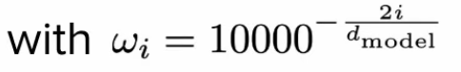
Position Encoding for Different Positions
This diagram shows how the same sine/cosine formulas create different encoding vectors for different word positions (m and n). Each position gets its own unique combination of sine and cosine values across all dimensions (2i, 2i+1, etc.).
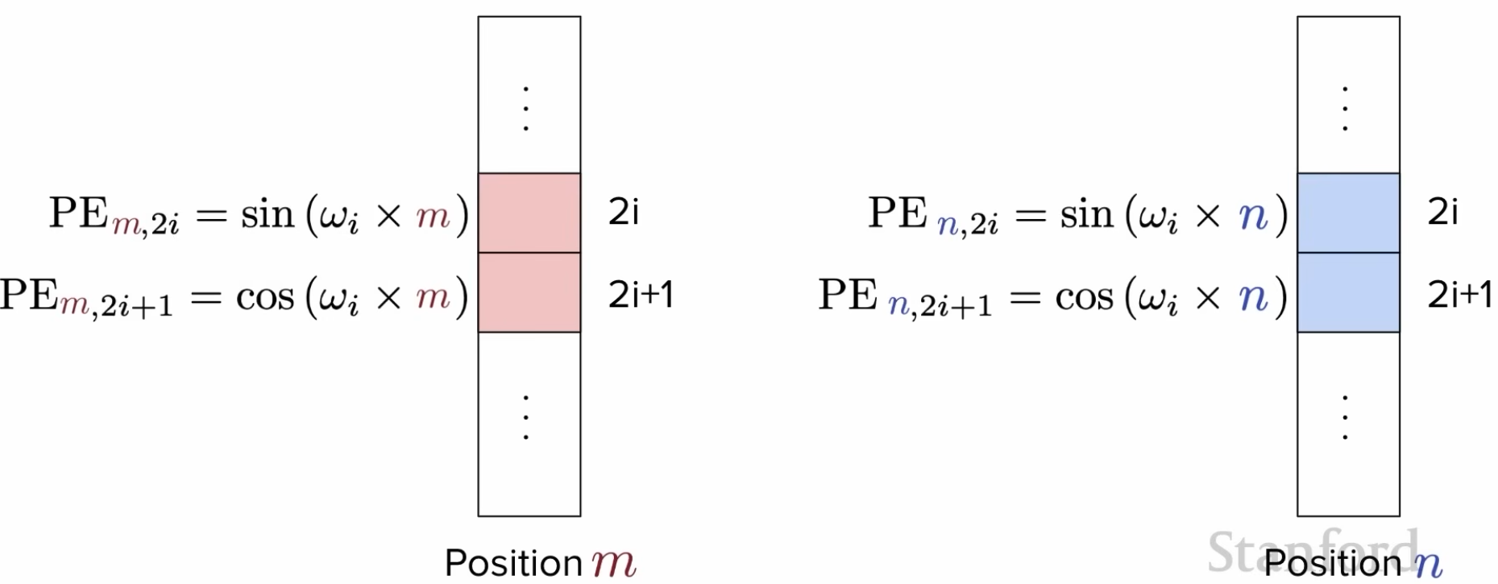
Relative Position Property
This explains a key advantage of sine/cosine encoding: the dot product between two position encodings (PEm, PEn) depends only on their relative distance (m - n), not their absolute positions. This helps the model understand word relationships regardless of where they appear in the sentence.
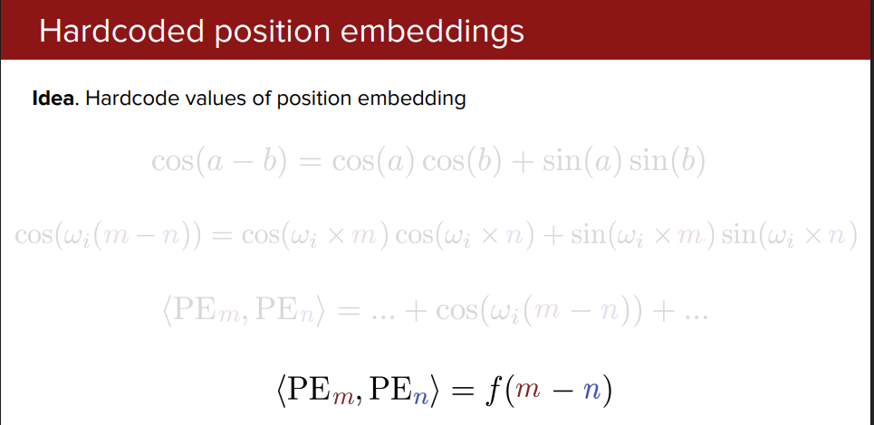

Visual Example (Sinusoidal PE)
What does PE_dim0, PE_dim1 mean?
- Each word gets a positional encoding vector with multiple dimensions (e.g., 512 dimensions)
- PE_dim0 = value at dimension 0 of the vector
- PE_dim1 = value at dimension 1 of the vector
- Different dimensions use different frequency sine/cosine waves
- Lower dimensions (dim0, dim1) = slow-changing patterns (low frequency)
- Higher dimensions (dim2, dim3) = fast-changing patterns (high frequency)
Sentence: "The cat sat on mat"
Position: 0 1 2 3 4
─────────────────────────
PE_dim0: 0.0 0.84 0.91 0.14 -0.76 (sin wave - low freq)
PE_dim1: 1.0 0.54 -0.42 -0.99 -0.65 (cos wave - low freq)
PE_dim2: 0.0 0.01 0.02 0.03 0.05 (sin wave - high freq)
PE_dim3: 1.0 1.0 1.0 1.0 1.0 (cos wave - high freq)
Pattern visualization:
Pos 0: ████████████████ (unique pattern)
Pos 1: ██████ ████ (different pattern)
Pos 2: ████████ ██ (another unique pattern)
Pos 3: ██ ████ ████ (each position = unique fingerprint)
Example for position 1 ("cat"):
PE vector for "cat" (position 1) = [0.84, 0.54, 0.01, 1.0, ...]
↑ ↑ ↑ ↑
dim0 dim1 dim2 dim3 (continues to dim511)

Why Sine/Cosine?
- Unique patterns: Each position gets a distinct encoding
- Relative positions: Model can learn "distance" between words
- Generalization: Works for sequences longer than training data
- Smooth: Nearby positions have similar encodings

Complete Picture (Sinusoidal PE)
INPUT: "The cat sat"
↓
Word Embeddings: [E_The] [E_cat] [E_sat]
+ + +
Positional Encodings: [PE_0] [PE_1] [PE_2]
↓
Final Input: [E_The+PE_0] [E_cat+PE_1] [E_sat+PE_2]
↓
Now transformer knows WHAT each word is AND WHERE it appears!
↓
Feed to Attention Mechanism...

RoPE (Rotary Position Embedding)
Used in: LLaMA, GPT-NeoX, PaLM, and most modern LLMs

The Problem with Sinusoidal PE (Absolute Encoding)
Issue 1: Position added BEFORE attention
Sinusoidal PE:
Word "cat" at position 1:
Embedding[cat] + PE[1] → [combined vector]
↓
Goes to attention
↓
Problem: Position info mixed with word meaning from the start
Issue 2: Can't directly measure relative distance
When "sat" (pos 2) looks at "cat" (pos 1):
❌ Model doesn't naturally know they are 1 position apart
❌ Has to LEARN this from the added position values
❌ Harder to extrapolate to longer sequences

What is RoPE?
Purpose: Encode relative positions directly into the attention mechanism.
Key Idea: Instead of adding position to embeddings, rotate the Q and K vectors based on their positions.
Sinusoidal PE:
Q = Embedding + Position (addition - mixes position with meaning)
RoPE:
Q = Rotate(Embedding, position) (rotation - preserves both separately)

Why Rotation Instead of Addition?
Mathematical Magic: When you rotate two vectors by different angles and compute their dot product, the result automatically depends on the angle difference!
Simple analogy - Clock hands:
Sinusoidal PE (Addition):
Hour hand at 3 o'clock: Add +3 to the hand
Hour hand at 5 o'clock: Add +5 to the hand
Distance between them? Have to calculate: 5 - 3 = 2
RoPE (Rotation):
Hour hand at 3 o'clock: Rotate by 90°
Hour hand at 5 o'clock: Rotate by 150°
Distance between them? Automatically in the angle: 150° - 90° = 60°
The angle DIFFERENCE is built into the rotation!

Why RoPE?
What it solves:
- Relative distances: Attention scores naturally depend on distance between tokens
- Better extrapolation: Can handle sequences longer than training length
- Decaying attention: Farther tokens get naturally lower attention
- No position limit: No fixed maximum sequence length

How RoPE Works
Core Concept: Rotate Q and K vectors by angles proportional to their positions.
For tokens at position m and n:
Q_m = Rotate(Q, angle = m × θ)
K_n = Rotate(K, angle = n × θ)
When computing attention:
Q_m · K_n depends on (m - n) ← Relative distance!

Visual Comparison
Sinusoidal PE (Absolute):
┌─────────────────────────────┐
│ Position 0: Add [0.0, 1.0] │
│ Position 1: Add [0.84, 0.54]│
│ Position 2: Add [0.91,-0.42]│
└─────────────────────────────┘
Problem: Same PE regardless of context
RoPE (Relative):
┌─────────────────────────────┐
│ Token at pos 3 looking at: │
│ pos 1: distance = -2 │
│ pos 2: distance = -1 │
│ pos 4: distance = +1 │
└─────────────────────────────┘
Benefit: Attention knows relative distances

Concrete Example: Sinusoidal vs RoPE
Scenario: "The cat sat on mat" - when "sat" (pos 2) attends to other words

Sinusoidal PE (Absolute):
Step 1: Add position to embeddings BEFORE attention
"The" (pos 0): E_The + PE_0 = [combined_0]
"cat" (pos 1): E_cat + PE_1 = [combined_1]
"sat" (pos 2): E_sat + PE_2 = [combined_2]
Step 2: Compute attention
Q_sat · K_The = ? ← Distance not directly encoded
Q_sat · K_cat = ? ← Model has to LEARN distance from PE values
Problem:
- Position 0 and Position 1 have DIFFERENT PE vectors
- But their DISTANCE (1 apart) is not directly visible
- Model needs many layers to learn "PE_1 - PE_0 = distance 1"

RoPE (Relative):
Step 1: Rotate Q and K by their positions
Q_sat rotated by: 2×θ (angle = 2θ)
K_The rotated by: 0×θ (angle = 0θ)
K_cat rotated by: 1×θ (angle = 1θ)
K_on rotated by: 3×θ (angle = 3θ)
Step 2: Compute attention (dot product)
Q_sat · K_The → Depends on (2θ - 0θ) = 2θ ← Distance = 2!
Q_sat · K_cat → Depends on (2θ - 1θ) = 1θ ← Distance = 1!
Q_sat · K_on → Depends on (2θ - 3θ) = -1θ ← Distance = -1!
✓ Advantage:
- Relative distance AUTOMATICALLY encoded in dot product
- No need to learn distance from position values
- Works better for unseen sequence lengths

Visual Comparison
Sinusoidal PE:
┌────────────────────────────────────────┐
│ "The cat sat" │
│ pos0 pos1 pos2 │
│ ↓ ↓ ↓ │
│ +PE0 +PE1 +PE2 (addition first) │
│ ↓ ↓ ↓ │
│ [mix][mix][mix] (position + meaning) │
│ ↓ ↓ ↓ │
│ Attention computes Q·K │
│ Distance? Not directly visible │
└────────────────────────────────────────┘
RoPE:
┌────────────────────────────────────────┐
│ "The cat sat" │
│ pos0 pos1 pos2 │
│ ↓ ↓ ↓ │
│ ∠0° ∠θ ∠2θ (rotation by position) │
│ ↓ ↓ ↓ │
│ [E0] [E1] [E2] (meaning preserved) │
│ ↓ ↓ ↓ │
│ Q·K automatically knows distance │
│ pos2 - pos0 = 2θ angle difference ✓ │
└────────────────────────────────────────┘

Why Modern LLMs Use RoPE
Feature | Sinusoidal PE | RoPE
Position info | Absolute | Relative
Extrapolation | Poor | Excellent
Long sequences | Struggles | Handles well
Attention scores | Indirect | Direct relative distance
Used in | Original Transformer, BERT | LLaMA, GPT-NeoX, PaLM

Real-World Benefits
Example: Trained on 2K tokens, used on 8K tokens
Sinusoidal PE:
Training: Saw positions 0-2047
Inference: Position 5000 uses sin(5000/10000^x)
❌ Problem: Position 5000 NEVER seen during training
❌ Result: Model confused, quality drops significantly
RoPE:
Training: Learned "distance 1", "distance 2", "distance 100"
Inference: Position 5000 looking at position 4999
✓ Distance = 1 (SAME as training!)
✓ Distance = 100 (SAME as training!)
✓ Result: Works well because relative distances are familiar
Why this works:
Sinusoidal learns: "Position 0 looks like [0.0, 1.0, ...]"
"Position 512 looks like [0.5, 0.8, ...]"
"Position 5000 looks like ???? ← UNKNOWN"
RoPE learns: "Distance 1 = rotate by 1θ"
"Distance 10 = rotate by 10θ"
"Distance 1 at position 5000? Same as distance 1 at position 0!"
✓ KNOWN pattern!

Key Takeaways (RoPE)
- Rotation, not addition: Positions encoded as rotations in Q/K space
- Relative by design: Attention naturally sees token distances
- Better for long contexts: Works beyond training sequence lengths
- Standard in modern LLMs: Default choice for new models
- Mathematical elegance: Angle difference automatically encodes distance

Analogy
Sinusoidal PE: Like giving everyone a name tag with their seat number (absolute)
- "I'm seat 5", "I'm seat 6"
RoPE: Like everyone knowing their relative position to others (relative)
- "You're 2 seats to my left", "You're 1 seat to my right"
More flexible and natural for understanding relationships!

RoPE Scaling: Extending Context Length
Problem: Pre-trained model with 4K max length → Want to use 32K tokens
The Issue:
Model trained on positions 0-4095
Using position 20000 at inference → Out-of-distribution!
Result: Degraded performance, hallucinations ❌
Solution: RoPE Scaling
Scale position values to compress longer sequences into the training range:
# Linear scaling (simplest)
scaled_position = actual_position / scale_factor
# Example: Extend 4K → 32K (scale_factor = 8)
position 32000 / 8 = position 4000 ✓ (within training range)
Why Fine-tuning is Required:
Just RoPE scaling alone:
├─ Positions compressed mathematically
├─ BUT: Model weights never trained on scaled positions
└─ Result: Poor quality ❌
RoPE scaling + Fine-tuning:
├─ Scale positions (factor = 8 for 4K→32K)
├─ Fine-tune on 3-5K long documents (8K-32K tokens)
├─ Model learns to work with compressed positions
└─ Result: Good quality ✅
Common Scaling Methods:
Method | How it works | Quality
Linear | Divide all positions by factor | Good
NTK-aware | Scale different frequencies differently | Better
YaRN | Sophisticated multi-frequency scaling | Best

Example: Llama-2 Extension:
# Extend from 4K → 32K context
config = LlamaConfig(
max_position_embeddings=32768,
rope_scaling={"type": "linear", "factor": 8.0}
)
# Then fine-tune on long documents for 1K-3K steps
Benefits:
- 100x cheaper than pre-training from scratch
- Extends context 4x-8x efficiently
- Preserves base model capabilities
Use Cases: Long document QA, book analysis, large codebase understanding

T5 Relative Position Bias
Used in: T5, FLAN-T5, UL2

What is T5 Bias?
Purpose: Add learnable biases directly to attention scores based on relative distance.
Key Idea: Instead of modifying embeddings, add a bias term to the attention matrix.
Standard Attention:
Attention = softmax(Q × K^T / √d)
T5 Attention:
Attention = softmax(Q × K^T / √d + Bias)
where Bias depends on distance between tokens

How T5 Bias Works
Token distances are bucketed and learned:
Distance 0 (self): Bias = learned_bias[0]
Distance 1: Bias = learned_bias[1]
Distance 2-3: Bias = learned_bias[2] (bucketed)
Distance 4-7: Bias = learned_bias[3]
...
Very far (>128): Bias = learned_bias[max_bucket]
These biases are LEARNED during training!

Example
Sentence: "The cat sat"
Attention from "cat" to:
"The" (distance -1) → Add bias_bucket_1
"cat" (distance 0) → Add bias_bucket_0
"sat" (distance +1) → Add bias_bucket_1
Model learns optimal bias values through training!

Why T5 Bias?
Advantages:
- Simple and effective
- No positional embeddings needed
- Learns task-specific position importance
- Works well for various sequence lengths

ALiBi (Attention with Linear Biases)
Used in: BLOOM, MPT, Falcon (some variants)

What is ALiBi?
Purpose: Add simple linear penalties to attention scores based on distance.
Key Idea: Farther tokens get linearly lower attention scores - no learning required!
Standard Attention:
Attention = softmax(Q × K^T)
ALiBi Attention:
Attention = softmax(Q × K^T - distance × slope)
slope is fixed per attention head

How ALiBi Works
Core concept: Penalize distant tokens with a linear slope.
For each attention head, use a fixed slope:
Head 1 (slope = 0.5):
Distance 0: penalty = 0.0
Distance 1: penalty = -0.5
Distance 2: penalty = -1.0
Distance 3: penalty = -1.5
Head 2 (slope = 0.25):
Distance 0: penalty = 0.0
Distance 1: penalty = -0.25
Distance 2: penalty = -0.50
Distance 3: penalty = -0.75
Different heads use different slopes!

Visual Example
Sentence: "The cat sat on mat"
When "sat" attends to others (using slope = 1.0):
Token Distance Penalty Attention Score
─────────────────────────────────────────────
"The" -2 -2.0 Q·K - 2.0
"cat" -1 -1.0 Q·K - 1.0
"sat" 0 0.0 Q·K - 0.0 ← No penalty
"on" +1 -1.0 Q·K - 1.0
"mat" +2 -2.0 Q·K - 2.0
Farther words get lower scores automatically!

Key Clarification: ALiBi vs RoPE
ALiBi is often confused with RoPE. They touch completely different parts of the pipeline:
Sinusoidal: add position to input embeddings → modifies X
RoPE: rotate Q and K vectors → modifies Q, K before dot product
ALiBi: subtract penalty from score matrix → modifies scores AFTER Q·Kᵀ
In ALiBi, Q and K are never touched — the raw attention score matrix gets a distance penalty applied on top.

Bias Matrix: What It Looks Like
For a 5-token sequence with slope = 1.0:
tok0 tok1 tok2 tok3 tok4
tok0 [ 0 -1 -2 -3 -4 ]
tok1 [ 0 0 -1 -2 -3 ]
tok2 [ 0 0 0 -1 -2 ]
tok3 [ 0 0 0 0 -1 ]
tok4 [ 0 0 0 0 0 ]
formula: bias[i][j] = -slope × |i - j|
This matrix is added to Q·Kᵀ / √d before softmax. Farther apart → more negative → softmax gives less attention weight automatically.

Simple Analogy
Sinusoidal — stamp each word's name tag before the meeting starts RoPE — rotate how each person faces when talking (affects who they address) ALiBi — after everyone speaks, penalize conversations between people sitting far apart
All three teach the model about position — but at completely different stages.

Why ALiBi?
Advantages:
- No learned parameters: Just fixed slopes
- Extreme extrapolation: Trained on 512 tokens, works on 10K+ tokens
- Simple: One line of code to implement
- Efficient: No extra computation beyond a subtraction
How slopes are chosen:
For 8 heads: slopes = [1/2^1, 1/2^2, 1/2^3, ..., 1/2^8]
= [0.5, 0.25, 0.125, 0.0625, ...]
Different heads have different distance sensitivities!

Comparison: All Positional Encoding Methods
Method | Type | Where Applied | Parameters | Extrapolation | Used In
Sinusoidal | Absolute | Add to embeddings | None (fixed) | Poor | BERT, Original Transformer
RoPE | Relative | Rotate Q/K | None (fixed) | Good | LLaMA, GPT-NeoX, PaLM
T5 Bias | Relative | Add to attention | Learned | Good | T5, FLAN-T5
ALiBi | Relative | Subtract from attention | None (fixed slopes) | Excellent | BLOOM, MPT, Falcon

Quick Guide
Choose Sinusoidal if:
- Using original Transformer/BERT architecture
- Fixed sequence lengths
Choose RoPE if:
- Building modern LLM (most popular choice)
- Need good long-context performance
Choose T5 Bias if:
- Want model to learn position importance
- Encoder-decoder architecture
Choose ALiBi if:
- Need extreme length extrapolation
- Want simplest implementation
- Don't want any position parameters

Multi-Head Attention: Looking at Words from Different Perspectives
The Problem: Single attention focuses on one type of relationship at a time.
- Can't simultaneously capture "what is the subject doing?" AND "where is it happening?"
The Solution: Run multiple attention mechanisms in parallel (multiple "heads").

How It Works
Why? Different heads learn different types of relationships (syntax, semantics, position). What? Split into multiple attention operations, then combine results.
Instead of 1 attention:
Input → Attention → Output
Use 8 heads (typical):
Input → Head 1 (syntax relationships) ─┐
→ Head 2 (semantic meaning) │
→ Head 3 (positional context) ├→ Concat → Linear → Output
→ Head 4 (subject-verb links) │
→ ... │
→ Head 8 (long-range dependencies) ─┘

Visual Example: "The cat sat on the mat"
Single-Head Attention:
cat → sat, mat (captures one relationship pattern)
Multi-Head Attention (8 heads):
Head 1 (Subject-Verb): Head 2 (Object-Location):
cat → sat (90%) mat → on (80%)
Head 3 (Adjective-Noun): Head 4 (Long-range):
The → cat (70%) The → mat (60%)
Head 5-8: Other patterns...
Combined: Rich understanding from all perspectives!

Architecture Diagram
What does Q₁, K₁, V₁ mean?
- The subscript (1, 2, 3...) indicates which head it belongs to
- NOT which word it processes
- All heads receive the SAME input, but use DIFFERENT learned weights
Notation:
Q₁ = Query for Head 1 (learned transformation W_Q₁)
K₁ = Key for Head 1 (learned transformation W_K₁)
V₁ = Value for Head 1 (learned transformation W_V₁)
Q₂ = Query for Head 2 (DIFFERENT learned transformation W_Q₂)
K₂ = Key for Head 2 (DIFFERENT learned transformation W_K₂)
V₂ = Value for Head 2 (DIFFERENT learned transformation W_V₂)
...and so on for all 8 heads
INPUT: "The cat sat on the mat" (with positional encoding)
│
│ SAME input goes to ALL heads
│
├──────────────────────────────────────────────────-┐
│ │
▼ ▼ ▼ ▼
┌──────────┐ ┌──────────┐ ┌──────────┐ ┌──────────┐
│ Head 1 │ │ Head 2 │ │ Head 3 │ ...│ Head 8 │
│ │ │ │ │ │ │ │
│ Q₁ K₁ V₁ │ │ Q₂ K₂ V₂ │ │ Q₃ K₃ V₃ │ │ Q₈ K₈ V₈ │
│ (W_Q₁) │ │ (W_Q₂) │ │ (W_Q₃) │ │ (W_Q₈) │
│ ↓ │ │ ↓ │ │ ↓ │ │ ↓ │
│ Attn₁ │ │ Attn₂ │ │ Attn₃ │ │ Attn₈ │
└────┬─────┘ └────┬─────┘ └────┬─────┘ └────┬─────┘
│ │ │ │
└───────────────┴───────────────┴───────────────┘
│
▼
┌─────────────┐
│ Concatenate │ [64 + 64 + 64 + ... + 64 = 512]
└─────────────┘
│
▼
┌─────────────┐
│ Linear │ (combine information)
└─────────────┘
│
▼
OUTPUT
Key Insight:
V₁ doesn't mean "Value of word 1"
V₁ means "Value transformation by Head 1"
For word "cat":
Head 1 creates: Q₁(cat), K₁(cat), V₁(cat) using W_Q₁, W_K₁, W_V₁
Head 2 creates: Q₂(cat), K₂(cat), V₂(cat) using W_Q₂, W_K₂, W_V₂
...
Head 8 creates: Q₈(cat), K₈(cat), V₈(cat) using W_Q₈, W_K₈, W_V₈
Same word, 8 different transformations!

Splitting Dimensions
How are heads created? Each head gets its own learned Q, K, V transformations.
Why 512 dimensions? It's a design choice (hyperparameter):
- GPT-2 small: 768 dims
- BERT base: 768 dims
- Original Transformer: 512 dims
- Larger = more capacity, but slower and needs more data
Original embedding: 512 dimensions (design choice)
8 heads: 512 ÷ 8 = 64 dimensions per head
Example for word "cat":
┌─────────────────────────────────────┐
│ Full vector: [512 dimensions] │
└─────────────────────────────────────┘
│
┌─────────┴─────────┐
│ Each head has │
│ its OWN learned │
│ W_Q, W_K, W_V │
└───────────────────┘
↓
Transform to 64 dims each
↓
┌───────┐ ┌───────┐ ┌───────┐ ┌───────┐
│ 64dim │ │ 64dim │ │ 64dim │...│ 64dim │
│Q₁K₁V₁ │ │Q₂K₂V₂ │ │Q₃K₃V₃ │ │Q₈K₈V₈ │
│Head 1 │ │Head 2 │ │Head 3 │ │Head 8 │
└───────┘ └───────┘ └───────┘ └───────┘
Each head processes independently with different weights

Why Each Head Has Its Own Q, K, V
Key Point: H1 doesn't "focus on V1" by position - each head learns different transformation weights.
Input (512 dim) goes to ALL heads:
Head 1: Head 2:
Input [512] → W_Q₁ → Q₁ [64] Input [512] → W_Q₂ → Q₂ [64]
Input [512] → W_K₁ → K₁ [64] Input [512] → W_K₂ → K₂ [64]
Input [512] → W_V₁ → V₁ [64] Input [512] → W_V₂ → V₂ [64]
Different W matrices = Different patterns learned!
Why this matters:
Same input "cat" [512 dims] processed by different heads:
Head 1 (W_Q₁, W_K₁, W_V₁):
Learns to focus on: SYNTAX (subject-verb relationships)
"cat" → pays attention to "sat" (verb)
Head 2 (W_Q₂, W_K₂, W_V₂):
Learns to focus on: LOCATION (spatial relationships)
"cat" → pays attention to "mat" (where)
Head 3 (W_Q₃, W_K₃, W_V₃):
Learns to focus on: ARTICLES (determiners)
"cat" → pays attention to "The"
Each head sees the SAME input but through DIFFERENT "lenses"!
Concrete Example:
Word "cat" [512 dimensions]
↓
Head 1 transforms:
Q₁ = [512] × W_Q₁[512×64] = [64] ← Learns "syntax questions"
K₁ = [512] × W_K₁[512×64] = [64] ← Learns "syntax keys"
V₁ = [512] × W_V₁[512×64] = [64] ← Learns "syntax values"
Head 2 transforms:
Q₂ = [512] × W_Q₂[512×64] = [64] ← Learns "semantic questions"
K₂ = [512] × W_K₂[512×64] = [64] ← Learns "semantic keys"
V₂ = [512] × W_V₂[512×64] = [64] ← Learns "semantic values"
Different W matrices → Different learned behaviors!

What Each Head Learns
Example attention patterns in 8 heads:
Head 1: Subject → Verb
The [cat] → [sat] ████████
Head 2: Verb → Object
[sat] → [mat] ██████
Head 3: Preposition → Object
[on] → [mat] █████
Head 4: Article → Noun
[The] → [cat], [the] → [mat] ███
Head 5: Position-based (nearby words)
Each word → neighbors ████
Head 6-8: Abstract patterns learned from data

Complete Flow
INPUT: [The, cat, sat, on, the, mat]
↓
Multi-Head Attention:
├─ Head 1 learns: syntax structure
├─ Head 2 learns: semantic relationships
├─ Head 3 learns: positional patterns
└─ ... (parallel processing)
↓
Concatenate all head outputs
↓
Linear transformation (mix information)
↓
OUTPUT: Each word has context from MULTIPLE perspectives

Why Multi-Head Works
- Diverse perspectives: Each head specializes in different patterns
- Redundancy: If one head fails, others compensate
- Richer representations: Captures multiple relationship types simultaneously
- Parallelizable: All heads run at the same time (fast!)

Analogy
Reading a book with multiple experts:
- Single attention: One expert reads and explains
- Multi-head: 8 experts read simultaneously
- Expert 1: Grammar analysis
- Expert 2: Character relationships
- Expert 3: Plot structure
- Expert 4: Themes and motifs
- Experts 5-8: Other aspects
You get a richer, more complete understanding!

How Multi-Head Attention Learns: Backpropagation
The Question: How do WQ₁, WK₁, W_V₁ (and all other W matrices) learn to specialize?
The Answer: Backpropagation - gradients flow back from the loss to update each head's weights.

The Learning Process (Training)
Why? Need to adjust weights so predictions match actual outputs. What? Compute error, send it backwards, update weights to reduce error.
FORWARD PASS (Prediction):
Input → Multi-Head Attention → Output → Loss (error)
↓ ↓ ↓ ↓
"cat" 8 heads process "sat"? How wrong?
BACKWARD PASS (Learning):
Loss → Gradients → Update Weights ← Each head gets feedback
↓ ↓ ↓
Error Flow back Adjust W matrices

Detailed Backpropagation Flow
FORWARD PASS:
────────────────────────────────────────────────
Input: "The cat sat"
↓
├────────┬────────┬────────┐
▼ ▼ ▼ ▼
Head1 Head2 Head3 ... Head8
W_Q₁ W_Q₂ W_Q₃ W_Q₈ (current weights)
W_K₁ W_K₂ W_K₃ W_K₈
W_V₁ W_V₂ W_V₃ W_V₈
↓ ↓ ↓ ↓
Out₁ Out₂ Out₃ Out₈
└────────┴────────┴────────┘
↓
Concatenate
↓
Linear
↓
Prediction: "mat"
Actual: "sat"
↓
Loss = 0.8 (high error!)
BACKWARD PASS:
────────────────────────────────────────────────
Loss = 0.8
↓
∂Loss/∂Output = gradient
↓
Linear (backprop)
↓
Split gradients
↓
├────────┬────────┬────────┐
▼ ▼ ▼ ▼
∂Loss/∂W_Q₁ ∂L/∂W_Q₂ ∂L/∂W_Q₃ ∂L/∂W_Q₈
∂Loss/∂W_K₁ ∂L/∂W_K₂ ∂L/∂W_K₃ ∂L/∂W_K₈
∂Loss/∂W_V₁ ∂L/∂W_V₂ ∂L/∂W_V₃ ∂L/∂W_V₈
↓ ↓ ↓ ↓
UPDATE WEIGHTS:
W_Q₁ = W_Q₁ - learning_rate × ∂Loss/∂W_Q₁
W_K₁ = W_K₁ - learning_rate × ∂Loss/∂W_K₁
W_V₁ = W_V₁ - learning_rate × ∂Loss/∂W_V₁
(Same for all heads)

Simple Example: Learning Step by Step
Example: Model predicts wrong word
─────────────────────────────────
Sentence: "The cat ___ on the mat"
Correct: "sat"
Predicted: "mat" (WRONG!)
Step 1: Calculate Loss
Loss = |Predicted - Actual|² = high error
Step 2: Which head contributed to the error?
Head 1 output: 0.3 → small contribution
Head 2 output: 0.1 → small contribution
Head 3 output: 0.8 → LARGE contribution (main problem!)
...
Step 3: Compute gradients for each head
∂Loss/∂W_Q₃ = large (Head 3 needs big update)
∂Loss/∂W_Q₁ = small (Head 1 is mostly fine)
Step 4: Update weights
W_Q₃ = W_Q₃ - 0.01 × (large gradient) ← Big change
W_Q₁ = W_Q₁ - 0.01 × (small gradient) ← Small change

Weight Update Formula
For each weight matrix in each head:
W_new = W_old - learning_rate × gradient
Example for Head 1's Query matrix:
W_Q₁[new] = W_Q₁[old] - α × ∂Loss/∂W_Q₁
Where:
- α (alpha) = learning_rate (e.g., 0.001)
- ∂Loss/∂W_Q₁ = how much W_Q₁ contributed to error

How Heads Specialize During Training
Initially (random weights):
─────────────────────────────
Head 1: random patterns
Head 2: random patterns
Head 3: random patterns
...all heads look similar
After 1000 updates:
─────────────────────────────
Head 1: Starting to focus on nearby words
Head 2: Starting to focus on verbs
Head 3: Still random
...gradual specialization
After 100,000 updates:
─────────────────────────────
Head 1: SPECIALIZED in syntax (subject-verb)
Head 2: SPECIALIZED in semantics (word meaning)
Head 3: SPECIALIZED in position (word order)
...each head found its "role"

Why Different Heads Learn Different Patterns
Key Insight: Random initialization + different gradients = specialization
Iteration 1:
W_Q₁ = [random values A] ← Slightly different
W_Q₂ = [random values B] ← Slightly different
↓
Process data
↓
Head 1 gets gradient for syntax
Head 2 gets gradient for semantics
↓
Update weights
↓
W_Q₁ adjusted toward syntax
W_Q₂ adjusted toward semantics
↓
Difference AMPLIFIES over time!
Iteration 100,000:
W_Q₁ = [syntax specialist]
W_Q₂ = [semantic specialist]

Gradient Flow Diagram
LOSS
│
▼
┌────────────────┐
│ ∂Loss/∂Out │ (gradient from output)
└────────────────┘
│
▼
┌────────────────┐
│ Linear Layer │
│ (backprop) │
└────────────────┘
│
┌─────────┴─────────┐
│ │
▼ ▼
┌─────────┐ ┌─────────┐
│ Head 1 │ │ Head 2 │
│Gradient │ │Gradient │
└─────────┘ └─────────┘
│ │
▼ ▼
Update W_Q₁ Update W_Q₂
Update W_K₁ Update W_K₂
Update W_V₁ Update W_V₂
Each head receives its OWN gradient and updates independently!

Analogy: Learning Like Students
8 Students (Heads) learning to analyze sentences:
Day 1 (Random):
All students guess randomly
Teacher gives feedback (gradients) to each
Day 100:
Student 1: Getting better at grammar
Student 2: Getting better at meaning
Student 3: Still confused
(Each gets different feedback based on their mistakes)
Day 10,000:
Student 1: Expert in grammar (W_Q₁ specialized)
Student 2: Expert in meaning (W_Q₂ specialized)
Student 3: Expert in word order (W_Q₃ specialized)
WHY? Each started randomly different, received different
feedback, and specialized over time!

Key Points
- Each head has separate weights (WQ, WK, W_V) that update independently
- Gradients flow back from loss through each head differently
- Random initialization + different gradients → specialization
- Thousands of updates → heads become experts in different patterns
- No manual assignment - heads discover their roles automatically!

Transformer Block Internals: MHA, FFN, and Loss Computation

Component Overview
Component | Purpose | Input Shape | Output Shape | Computes Loss?
MHA | Gathers context from related tokens | [n × d] | [n × d] | ❌ No
FFN | Transforms each token individually | [n × d] | [n × d] | ❌ No
Final Linear | Projects to vocabulary space | [n × d] | [n × vocab_size] | ❌ No
Loss Layer | Compares prediction with true label | [vocab_size] | Scalar | ✅ YES

1. Attention Scores: How Words Find Related Words
Question: Do related words like "cat" and "sat" have higher dot product values?
Answer: ✅ Yes! The model learns to give higher scores to related words.
Visual Example: "The cat sat on the mat"
Attention scores when "cat" looks at other words:
The cat sat on the mat
▁▁ ████ █████ ▁ ▁ ▁
10% 30% 40% 10% 5% 5%
(self) (HIGH!)
↑
Strong subject-verb relationship
How it works:
Step 1: QK^T Step 2: Softmax Step 3: Mix with V
───────────────── ──────────────── ─────────────────
"cat" · "sat" Raw → Probabilities Weighted average
= HIGH score 40% to "sat" = 40% × V(sat)
+ 30% × V(cat)
"cat" · "on" 10% to "on" + 10% × V(on)
= LOW score + ...

2. Shape Flow Through Transformer
Question: Does MHA output n×1 (one value per token)?
Answer: ❌ No! MHA outputs n × d (rich vector per token).
Why `d` dimensions instead of 1?
If output was [n × 1]: With [n × d]:
───────────────────── ──────────────
"cat" → 0.5 (single number) "cat" → [0.2, 0.8, -0.3, ...] (768 values)
↓ ↓
❌ Lost all meaning! ✅ Rich representation:
- Semantics
- Syntax
- Context
Complete Shape Flow (3 tokens, 768 dims):
Input: [3 × 768] "The cat sat"
↓
MHA: [3 × 768] (context-aware)
↓
Add&Norm: [3 × 768] (residual + normalize)
↓
FFN: [3 × 768] (individual transformation)
↓
Add&Norm: [3 × 768] (residual + normalize)
↓
Next Layer or Output

3. FFN Purpose & Loss Computation
Question: Does FFN compute loss?
Answer: ❌ No! FFN is just an intermediate transformation. Loss computed once at the end.
What FFN Does (Expand → Compress):
FFN Architecture:
[n × d=768] Input
↓
Linear + ReLU
↓
[n × 4d=3072] ← Expansion (more capacity)
↓
Linear
↓
[n × d=768] Output (back to original size)
Formula: FFN(x) = Linear₂(ReLU(Linear₁(x)))

FFN Explained for Beginners
One-line summary:
MHA lets tokens talk to each other. FFN lets each token think about what it heard.
What happens inside FFN:
MHA output (token "bank" now knows river is nearby)
↓
FFN Hidden Layer (2048 neurons / perceptrons)
↓ each neuron asks one yes/no question:
Neuron #89: "Is water nearby?" → 2.3 fires!
Neuron #4: "Is this financial?" → 0.0 silent
Neuron #1203: "Is there a landscape?" → 3.1 fires!
↓
Only ~2% of neurons fire (ReLU kills negatives)
↓
Compress back → "river bank" features confirmed
Is the hidden layer (2048) just neurons with weights? Yes. Each neuron holds a row of pre-trained weights W1 (512 numbers). It computes: score = dot(W1_row, input) + bias
- High score → ReLU fires → pattern matched
- Low/negative → ReLU outputs 0 → ignored
How did neurons learn "Is this financial?"? Nobody labeled them. During pretraining on millions of sentences, backpropagation adjusted weights so that neurons which recognized useful patterns reduced the loss. The pattern detectors emerged automatically.
FFN vs MHA — simple analogy:
 | MHA | FFN
Analogy | Group discussion — tokens talk | Individual thinking — token reflects
Operates on | All tokens together | Each token independently
Role | Route & blend information | Transform & store knowledge

Key insight: FFN weights are the model's long-term memory. Lower layers store grammar facts. Upper layers store world knowledge (capitals, people, events).

4. Where Loss is Computed: End-to-End Flow
Single Loss Computation at the Very End:
┌─────────────────────────────────────────────────────────────┐
│ FORWARD PASS │
├─────────────────────────────────────────────────────────────┤
│ │
│ Input: "The cat sat on" + Target: "the" │
│ ↓ │
│ ┌──────────────────────────────────────┐ │
│ │ Layer 1: MHA → FFN │ [n × d] │
│ └──────────────────────────────────────┘ │
│ ↓ │
│ ┌──────────────────────────────────────┐ │
│ │ Layer 2: MHA → FFN │ [n × d] │
│ └──────────────────────────────────────┘ │
│ ↓ │
│ ... (78 more layers) │
│ ↓ │
│ ┌──────────────────────────────────────┐ │
│ │ Layer 80: MHA → FFN │ [n × d] │
│ └──────────────────────────────────────┘ │
│ ↓ │
│ ┌──────────────────────────────────────┐ │
│ │ Final Linear Projection │ │
│ │ [4 × 768] → [4 × 50000] │ (vocab size) │
│ └──────────────────────────────────────┘ │
│ ↓ │
│ Last token "on" → [50000] logits │
│ ↓ │
│ Softmax: P("the")=0.35, P("a")=0.25... │
│ ↓ │
│ ╔══════════════════════════════════════╗ │
│ ║ LOSS = -log(0.35) = 1.05 ║ ← ONLY HERE! │
│ ╚══════════════════════════════════════╝ │
│ │
└─────────────────────────────────────────────────────────────┘
┌─────────────────────────────────────────────────────────────┐
│ BACKWARD PASS │
├─────────────────────────────────────────────────────────────┤
│ │
│ Loss = 1.05 │
│ ↓ (gradients flow backward) │
│ ┌──────────────────────────────────────┐ │
│ │ Final Linear (update weights) │ ∂Loss/∂W │
│ └──────────────────────────────────────┘ │
│ ↓ │
│ ┌──────────────────────────────────────┐ │
│ │ Layer 80: FFN₈₀ + MHA₈₀ │ ∂Loss/∂W₈₀ │
│ └──────────────────────────────────────┘ │
│ ↓ │
│ ... (backprop through all 80 layers) │
│ ↓ │
│ ┌──────────────────────────────────────┐ │
│ │ Layer 2: FFN₂ + MHA₂ │ ∂Loss/∂W₂ │
│ └──────────────────────────────────────┘ │
│ ↓ │
│ ┌──────────────────────────────────────┐ │
│ │ Layer 1: FFN₁ + MHA₁ │ ∂Loss/∂W₁ │
│ └──────────────────────────────────────┘ │
│ ↓ │
│ All weights updated to minimize loss │
│ │
└─────────────────────────────────────────────────────────────┘

5. Backpropagation: How ALL Layers Learn
Question: Is backpropagation performed in all 80 layers' FFNs?
Answer: ✅ YES! Gradients flow through EVERY layer (all 80 FFNs and all 80 MHAs).
How it Works:
Loss (computed once) → Gradients flow backward to ALL components:
Layer 80: FFN₈₀ receives gradients → Updates W₈₀
Layer 79: FFN₇₉ receives gradients → Updates W₇₉
Layer 78: FFN₇₈ receives gradients → Updates W₇₈
...
Layer 2: FFN₂ receives gradients → Updates W₂
Layer 1: FFN₁ receives gradients → Updates W₁
ALL layers learn from the SAME loss!
Gradient Flow Visualization:
SINGLE LOSS VALUE
(1.05)
↓
╔══════════════════════════╗
║ Compute ∂Loss/∂Output ║
╚══════════════════════════╝
↓
┌─────────────────┴─────────────────┐
│ │
▼ ▼
┌─────────┐ ┌─────────┐
│ Layer 80│ │ Layer 80│
│ FFN₈₀ │ ← ∂L/∂W₈₀ │ MHA₈₀ │ ← ∂L/∂W₈₀
└─────────┘ └─────────┘
↓ ↓
┌─────────┐ ┌─────────┐
│ Layer 79│ │ Layer 79│
│ FFN₇₉ │ ← ∂L/∂W₇₉ │ MHA₇₉ │ ← ∂L/∂W₇₉
└─────────┘ └─────────┘
↓ ↓
... ...
↓ ↓
┌─────────┐ ┌─────────┐
│ Layer 1 │ │ Layer 1 │
│ FFN₁ │ ← ∂L/∂W₁ │ MHA₁ │ ← ∂L/∂W₁
└─────────┘ └─────────┘
↓ ↓
Update ALL weights simultaneously
Real Example with Numbers:
Loss = 1.05 (high error - prediction was wrong)
↓
Compute gradients for EVERY layer:
Layer 80 FFN: gradient = 0.02 → W₈₀ = W₈₀ - 0.001 × 0.02
Layer 79 FFN: gradient = 0.03 → W₇₉ = W₇₉ - 0.001 × 0.03
Layer 78 FFN: gradient = 0.01 → W₇₈ = W₇₈ - 0.001 × 0.01
...
Layer 2 FFN: gradient = 0.04 → W₂ = W₂ - 0.001 × 0.04
Layer 1 FFN: gradient = 0.05 → W₁ = W₁ - 0.001 × 0.05
ALL 80 layers updated based on the SINGLE loss value!
Why This Works:
Chain Rule of Calculus:
∂Loss/∂W₁ = ∂Loss/∂Output × ∂Output/∂Layer₈₀ × ... × ∂Layer₂/∂W₁
└─────────────────────────────────────────────────┘
Gradient flows backward through ALL layers

Key Takeaways
Concept | Truth
Loss computed in FFN? | ❌ No - FFN is intermediate transformation
Loss computed where? | ✅ Once at final output (after all 80 layers)
Backprop in all FFNs? | ✅ Yes - gradients flow through all 80 FFNs
Backprop in all MHAs? | ✅ Yes - gradients flow through all 80 MHAs
MHA output shape? | [n × d] - rich vectors, NOT [n × 1]
Related words score? | ✅ Higher attention scores (learned automatically)

Mental Model:
- Loss: Computed once at the end (like a final exam score)
- Backpropagation: Feedback distributed to ALL layers (like reviewing all your mistakes from the exam)
- FFN/MHA: Workers that ALL receive feedback from the final score and improve

Key Takeaways
- Transformers use attention to find which words relate to each other
- Q × K^T computes all pairwise similarities
- Softmax normalizes to percentages
- Multiply by V mixes information based on attention weights
- Parallel processing - all words simultaneously (unlike RNNs)
- Positional encoding injects word order using sine/cosine patterns
- Multi-head attention captures multiple relationship types (syntax, semantics, position) simultaneously
- Everything is learned - model discovers optimal Q, K, V during training

Real-World Analogy
Conference networking:
- Q: Your interests
- K: Others' name tags (expertise)
- Q × K^T: Scan room for relevant people
- Softmax: Decide time allocation (%)
- V: Their actual knowledge
- Output: Weighted knowledge from conversations
This is transformer attention with words!

Layer Normalization
Purpose: Stabilize training by normalizing layer outputs to consistent scale (mean=0, std=1).

The Problem & Solution
Without LayerNorm:
Layer outputs: [100, 0.5, -50, 200] ← Wild variation, unstable training
With LayerNorm:
Normalized: [-0.5, 0.2, -1.0, 1.3] ← Consistent scale, stable training

The Formula
LayerNorm(x) = γ × (x - μ) / √(σ² + ε) + β
Steps:
1. μ (mean) = average of values
2. σ (std) = standard deviation
3. Normalize: (x - μ) / σ → mean=0, std=1
4. Scale & shift: γ and β (learned parameters)

Example Calculation
Input: x = [10, 20, 5, 15]
Step 1 - Mean:
μ = (10+20+5+15)/4 = 12.5
Step 2 - Standard deviation:
σ = √[((10-12.5)² + (20-12.5)² + (5-12.5)² + (15-12.5)²)/4]
= √31.25 ≈ 5.59
Step 3 - Normalize:
x_norm = (x - μ) / σ
= [(10-12.5)/5.59, (20-12.5)/5.59, (5-12.5)/5.59, (15-12.5)/5.59]
= [-0.45, 1.34, -1.34, 0.45] ← mean≈0, std≈1
Step 4 - Scale & Shift (γ=1, β=0 initially):
output = γ × x_norm + β = [-0.45, 1.34, -1.34, 0.45]

Where Used in Transformers
Two locations per transformer block:
INPUT
↓
Multi-Head Attention
↓
Add & Normalize ← LayerNorm 1 (residual + normalize)
↓
Feed Forward Network
↓
Add & Normalize ← LayerNorm 2 (residual + normalize)
↓
OUTPUT
"Add & Normalize" breakdown:
input = [1, 2, 3]
layer_output = [0.5, 1.0, 1.5]
Step 1 - Residual (Add):
combined = input + layer_output = [1.5, 3.0, 4.5]
Step 2 - LayerNorm:
normalized = LayerNorm([1.5, 3.0, 4.5]) → mean=0, std=1

Why It Helps
Problem | Without LayerNorm | With LayerNorm
Scale variation | [0.1] → [100] → [0.001] | [0.1] → [0.5] → [0.3]
Training | Unstable, slow | Stable, fast
Gradients | Exploding/vanishing | Consistent flow
Learning rate | Must be small | Can be larger

Layer Norm vs Batch Norm
Batch Norm (CNNs):
Sentence 1: [10, 20, 5, 15]
Sentence 2: [8, 18, 3, 13]
Sentence 3: [12, 22, 7, 17]
↓ ↓ ↓ ↓
Normalize each column (across batch)
Layer Norm (Transformers):
Sentence: [10, 20, 5, 15]
←──────────────→
Normalize across features (within example)
Why Transformers use Layer Norm:
- Works with variable sequence lengths
- No batch size dependency
- Better for sequential data

Visual Example: Full Flow
INPUT: [The, cat, sat]
↓
Multi-Head Attention → [10, 20, 5]
↓
Residual: [10, 20, 5] + input
↓
LayerNorm 1 → [-0.8, 1.2, -0.4] ← Normalized!
↓
Feed Forward → [100, 50, 75]
↓
Residual: [100, 50, 75] + previous
↓
LayerNorm 2 → [0.5, -1.0, 0.5] ← Normalized!
↓
Next Block

Analogy
Standardized test scoring:
Without normalization:
Math: 0-100, English: 0-50, Science: 0-200 ❌ Different scales
With normalization:
All tests: mean=0, std=1 ✓ Comparable scores
Layer Norm does the same for neuron outputs!

Key Takeaways
- Formula: γ × (x - mean) / std + β
- Purpose: Normalize to mean=0, std=1 for stable training
- Location: After attention & feed-forward (2× per block)
- Benefits: Faster training, stable gradients, higher learning rates
- Combined with: Residual connections ("Add & Norm")

Pre-Norm vs Post-Norm: LayerNorm Placement
The Question: Should LayerNorm be applied BEFORE (Pre-Norm) or AFTER (Post-Norm) the sublayer?
1st is Post-Norm and next is Pre-Norm
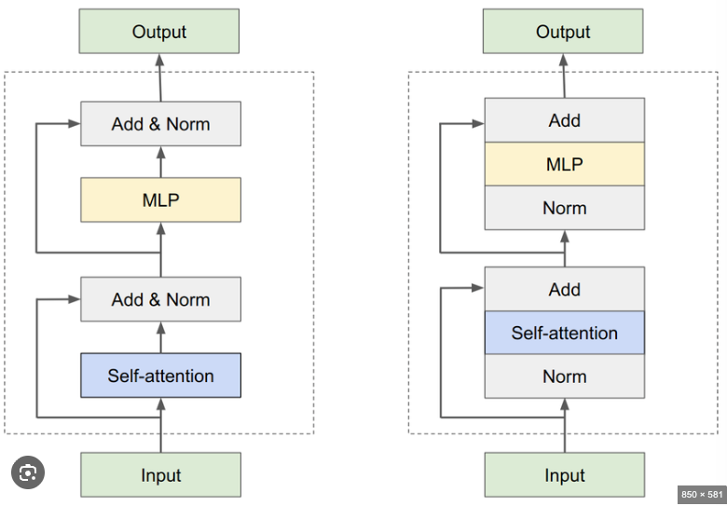
alt text

Post-Norm (Original Transformer, 2017)
Structure: LayerNorm applied AFTER adding residual connection.
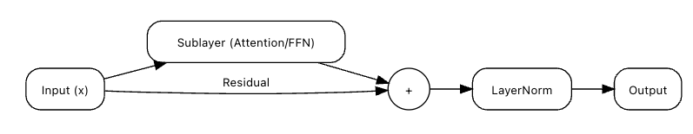
alt text
┌─────────────────────────────────────────────────────────┐
│ POST-NORM ARCHITECTURE │
├─────────────────────────────────────────────────────────┤
│ │
│ Input (x) │
│ ↓ │
│ Attention(x) │
│ ↓ │
│ Add: x + Attention(x) │
│ ↓ │
│ LayerNorm ← Applied AFTER Add │
│ ↓ │
│ FFN(x) │
│ ↓ │
│ Add: x + FFN(x) │
│ ↓ │
│ LayerNorm ← Applied AFTER Add │
│ ↓ │
│ Output │
│ │
└─────────────────────────────────────────────────────────┘
Formula:
# Post-Norm
x = LayerNorm(x + Attention(x))
x = LayerNorm(x + FFN(x))
Representation Collapse risk — Post-Norm normalizes after every residual, compressing token differences at each layer. Combined with vanishing gradients in early layers, deep Post-Norm networks are prone to all tokens converging to similar vectors.
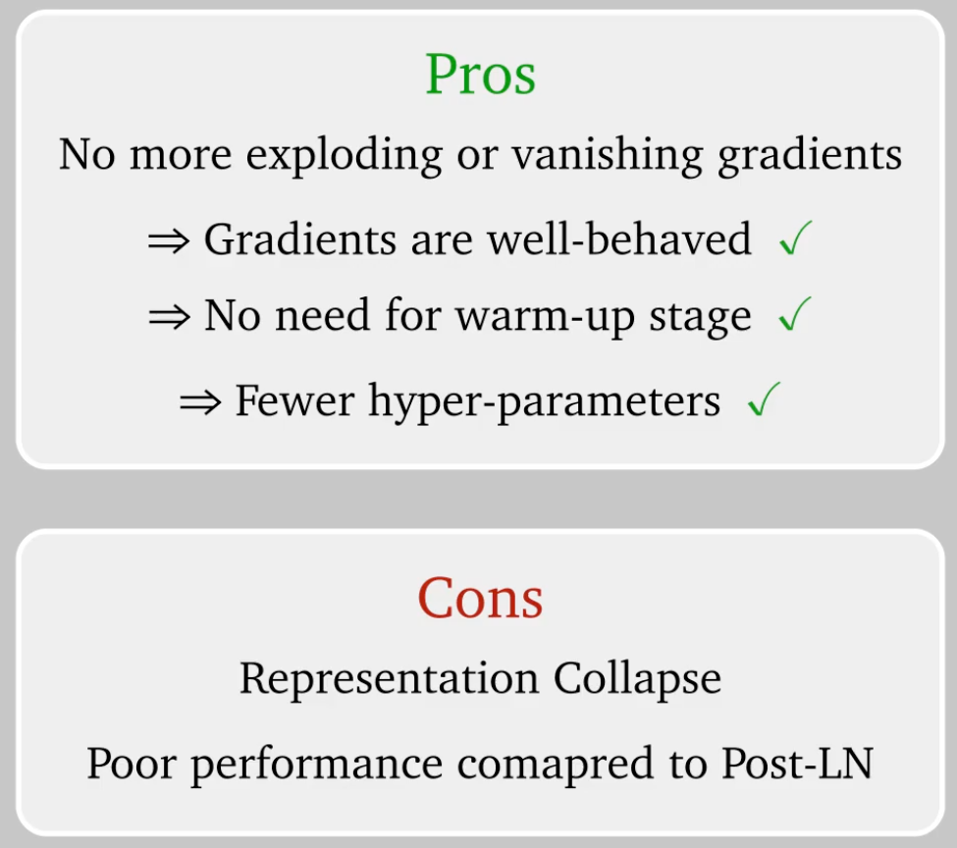
alt text
Structure: LayerNorm applied BEFORE the sublayer.
┌─────────────────────────────────────────────────────────┐
│ PRE-NORM ARCHITECTURE │
├─────────────────────────────────────────────────────────┤
│ │
│ Input (x) │
│ ↓ │
│ LayerNorm ← Applied BEFORE Attention │
│ ↓ │
│ Attention(LayerNorm(x)) │
│ ↓ │
│ Add: x + Attention(...) ← Residual outside │
│ ↓ │
│ LayerNorm ← Applied BEFORE FFN │
│ ↓ │
│ FFN(LayerNorm(x)) │
│ ↓ │
│ Add: x + FFN(...) ← Residual outside │
│ ↓ │
│ Output │
│ │
└─────────────────────────────────────────────────────────┘

Pre-Norm (Modern: GPT-3, GPT-4, LLaMA)
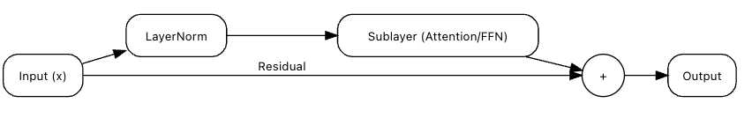
alt text
Formula:
# Pre-Norm
x = x + Attention(LayerNorm(x))
x = x + FFN(LayerNorm(x))

Post-Norm vs Pre-Norm: Representation Collapse & Stability
 | Post-Norm | Pre-Norm
Representation Collapse | Higher risk | Lower risk
Why collapse happens | Normalizes after residual → compresses token differences every layer | Residual stream never normalized → token identity preserved
Gradient flow | Vanishes in early layers → poor early representations | Clean gradient highway → all layers update well
Training stability | Unstable in deep nets, needs LR warmup | Stable, no warmup needed
Deep networks (100+ layers) | Prone to collapse without careful tuning | Preferred — used by GPT-3, LLaMA, PaLM

Root cause of Post-Norm collapse: Two compounding problems — LayerNorm squashes token differences at every layer + early layers get near-zero gradients → tokens converge to similar vectors across layers.

Pre-Norm vs Post-Norm vs ResiDual
ResiDual - Combination of Post-Norm with addition of separate Gradient
ResiDual is a hybrid architecture that combines the benefits of both Post-Norm and Pre-Norm:
The Key Innovation ResiDual adds a THIRD gradient path:
- Direct path (like Pre-Norm) → Gradient = 1
- Through LayerNorm (like Pre-Norm) → Secondary gradients
- Separate gradient branch (NEW!) → Additional learning signal with learnable α
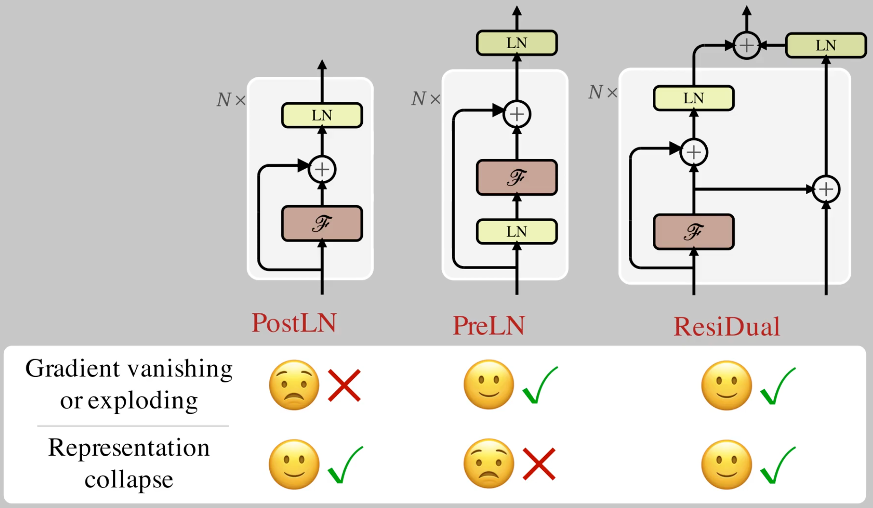
alt text

Backpropagation: Why Pre-Norm is Better
The Core Problem: During training, gradients (learning signals) must flow backward through all layers. If they get too weak, early layers can't learn.

The Key Difference
Post-Norm: Residual connection is INSIDE LayerNorm
y = LayerNorm(x + Attention(x))
↑ Add happens first, then LayerNorm
Pre-Norm: Residual connection is OUTSIDE
y = x + Attention(LayerNorm(x))
↑ Direct addition, no LayerNorm blocking

Gradient Flow Comparison
What is a gradient? During training, the model measures its mistake (loss) and sends a correction signal backward through every layer — this signal is the gradient. If it gets too weak, early layers receive almost no correction and stop learning.

POST-NORM — Gradient blocked by LayerNorm:
FORWARD PASS (top → bottom) BACKWARD PASS (bottom → top)
───────────────────────────────── ─────────────────────────────────
Input Input
↓ ↑
Attention(x) gradient = 0.05 ❌ too weak!
↓ ↑
[x + Attention(x)] ← residual add gradient shrinks at every LayerNorm
↓ ↑
LayerNorm ← bottleneck! gradient = 0.4 (shrunk here)
↓ ↑
Output gradient = 1.0 (started strong)
Problem: Every layer's gradient MUST pass through LayerNorm.
LayerNorm re-scales values → shrinks gradient each time.
After 50 layers, gradient reaching Layer 1 ≈ 0.05 → learns nothing.

PRE-NORM — Gradient has a free highway:
FORWARD PASS (top → bottom)
──────────────────────────────────────────────────────
Input (x)
↙ ↘
(Path 2) (Path 1 — residual copy)
↓ ↓
LayerNorm │ ← x passed directly, no LayerNorm
↓ │
Attention │
↓ ↓
└──────────→ Add ←───────┘
↓
Output
BACKWARD PASS (bottom → top) — gradients flow via BOTH paths
──────────────────────────────────────────────────────
Input (x)
↗ ↖
(Path 2) (Path 1 — residual)
↑ ↑
LayerNorm gradient = 1.0 always
(shrinks gradient) DIRECT — no LayerNorm!
↑ ↑
Attention │
↑ │
└────────── Add ──────────┘
↑
∂L/∂x = 1 (Path 1) + shrunk value (Path 2)
↑
"1" guarantees gradient never vanishes!
Result in a 50-layer model:
Layer 50: gradient = 1.0 + 0.0x = 1.0
Layer 25: gradient = 1.0 + 0.0x = ~0.8 (Path 1 always contributes 1)
Layer 1: gradient = 1.0 + 0.0x = ~0.6 ✅ still strong enough to learn!
alt text

Result in a 50-layer model:
Post-Norm Pre-Norm
───────── ────────
Layer 50: 1.0 1.0
Layer 25: 0.4 0.8
Layer 1: 0.05 ❌ 0.6 ✅

Simple Math Explanation
Post-Norm:
y = LayerNorm(x + f(x))
Gradient calculation:
∂y/∂x = ∂LayerNorm/∂(x+f(x)) × (1 + ∂f/∂x)
↑ This term can shrink the gradient!
→ Gradients get weaker through LayerNorm
Pre-Norm:
y = x + f(LayerNorm(x))
Gradient calculation:
∂y/∂x = 1 + ∂f/∂LayerNorm × ∂LayerNorm/∂x
↑ Direct "1" term!
→ The "1" guarantees gradient flows through

Concrete Example: 10-Layer Model
Training step with loss = 2.0
Post-Norm:
Layer 10 → gradient = 1.0
↓ passes through LayerNorm (reduces by 10%)
Layer 9 → gradient = 0.9
↓ passes through LayerNorm
Layer 8 → gradient = 0.81
↓
Layer 1 → gradient = 0.35 ❌
Early layers update slowly → Poor training
Pre-Norm:
Layer 10 → gradient = 1.0
↓ direct path via residual
Layer 9 → gradient = 0.98 (only 2% reduction)
↓ direct path
Layer 8 → gradient = 0.96
↓
Layer 1 → gradient = 0.80 ✅
All layers learn well → Good training

Comparison Table
Aspect | Post-Norm | Pre-Norm
LayerNorm position | After Add | Before sublayer
Residual position | Inside LayerNorm | Outside (direct path)
Gradient flow | Passes through LayerNorm | Direct path via residual
Deep model stability | Poor (gradients vanish) | Excellent
Training difficulty | Harder, needs warmup | Easier
Learning rate | Requires careful tuning | More robust
Used in | Original Transformer (2017) | GPT-3, GPT-4, LLaMA, modern models
Max stable depth | ~12-24 layers | 96+ layers

Why Pre-Norm Enables Deep Models
The Key Insight: Residual connection placement
Post-Norm problem:
y = LayerNorm(x + f(x))
↑ Residual INSIDE LayerNorm
→ Gradient must pass through LayerNorm derivative
→ Gradient magnitude reduced
Pre-Norm solution:
y = x + f(LayerNorm(x))
↑ Residual OUTSIDE LayerNorm
→ Gradient has direct identity path (∂y/∂x = 1)
→ Gradient magnitude preserved
Analogy:
Post-Norm = Highway with toll booths
→ Each LayerNorm is a toll booth
→ 192 toll booths slow you down ❌
Pre-Norm = Highway with express lane
→ Residual connection is the express lane
→ Direct path to destination ✅

When to Use Each
Use Post-Norm if: | Use Pre-Norm if:
Small models (≤12 layers) | Deep models (24+ layers)
Research/experimentation | Production deployment
You need exact Transformer replication | You want modern best practices
Smaller learning rates acceptable | You want training stability

Modern recommendation: Always use Pre-Norm unless you have a specific reason not to.

Code Example
# Post-Norm
class PostNormBlock(nn.Module):
def forward(self, x):
# Attention sublayer
attn_out = self.attention(x)
x = self.norm1(x + attn_out) # Norm AFTER add
# FFN sublayer
ffn_out = self.ffn(x)
x = self.norm2(x + ffn_out) # Norm AFTER add
return x
# Pre-Norm
class PreNormBlock(nn.Module):
def forward(self, x):
# Attention sublayer
x = x + self.attention(self.norm1(x)) # Norm BEFORE, add AFTER
# FFN sublayer
x = x + self.ffn(self.norm2(x)) # Norm BEFORE, add AFTER
return x

Key Takeaways
- Post-Norm: LayerNorm AFTER Add → Gradients pass through LayerNorm → Weak gradients
- Pre-Norm: LayerNorm BEFORE sublayer → Direct gradient path → Strong gradients
- Gradient formula:
- Post-Norm: Must pass through LayerNorm derivative
- Pre-Norm: ∂y/∂x = 1 + ... (identity term preserved)
- Modern practice: Pre-Norm is standard (GPT-3, GPT-4, LLaMA, etc.)
- Why it matters: Enables training 96+ layer models stably

Sparse Attention
The Problem: Standard attention computes relationships between ALL token pairs → O(n²) complexity.
- 512 tokens: 262,144 comparisons
- 4096 tokens: 16,777,216 comparisons (too expensive!)
The Solution: Compute attention only for selected token pairs (sparse patterns) → O(n√n) or O(n log n).
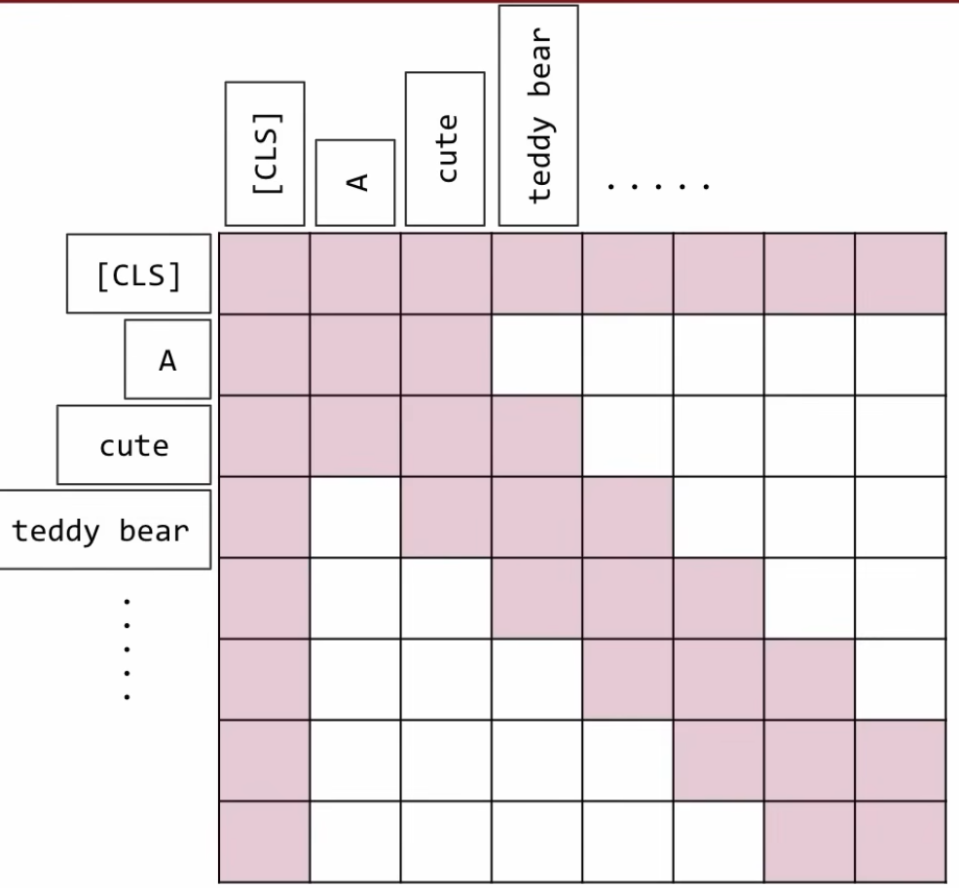

Common Sparse Attention Patterns
Pattern | How It Works | Complexity | Used In
Local (Sliding Window) | Each token attends to nearby tokens only | O(n×w) | Longformer, BigBird
Global | Special tokens attend to all, all attend to special tokens | O(n×g) | Longformer, BigBird
Strided | Attend every k-th token | O(n×n/k) | Sparse Transformer
Random | Random subset of tokens | O(n×r) | BigBird, Sparse Transformer
Block-Sparse | Divide into blocks, attend within/between blocks | O(n√n) | Sparse Transformer

Example: Longformer (Combined Patterns)
Longformer is a transformer variant designed to handle long sequences (4096+ tokens) efficiently by replacing the standard O(n²) self-attention with sparse attention patterns that reduce complexity to O(n).
The Problem with Standard Attention
Standard Transformer Attention:
- Every token attends to EVERY other token
- Complexity: O(n²)
- Memory: O(n²)
Example with 4096 tokens:
- Attention matrix: 4096 × 4096 = 16.7 million computations
- Memory: ~67 MB per attention head
- With 12 heads: ~800 MB just for attention!
- Too expensive for long documents! ❌
Longformer's Solution
Longformer Sparse Attention:
- Each token only attends to SELECTED tokens
- Complexity: O(n × w) where w is window size
- Memory: Much less!
Example with 4096 tokens, window=512:
- Each token attends to ~512 tokens (not 4096!)
- Memory: ~50 MB total (16× less!)
- Can process documents 8× longer! ✓
Task: Process 4096-token document
Standard Attention (Full):
Every token attends to all 4096 tokens
Complexity: 4096² = 16.7M comparisons ❌ Too slow!
Longformer (Sparse):
1. Local Window (w=512): Each token → 512 nearby tokens
2. Global Tokens (g=8): 8 special tokens → all 4096 tokens
3. Strided (every 64th): Long-range patterns
Complexity: 4096×512 + 4096×8 = 2.1M comparisons ✓ 8× faster!
Visual Pattern:
Full Attention: Sparse Attention (Longformer):
████████████████ ████░░░░░░░░░░░░ (local + global + strided)
████████████████ vs ░███░░░░░░░░░░░░
████████████████ ░░██░█░░░░░░░░░░
████████████████ ░░░█░░█░░░░░░░░░
(all pairs) (selected pairs only)

Three Types of Attention in Longformer

1. Local Window Attention (w=512)
Each token attends to nearby tokens within a fixed window.
Document: 4096 tokens
Token at position 1000:
Attends to: positions 744 to 1256 (512 tokens centered around 1000)
Visual:
... [744] [745] ... [999] [1000] [1001] ... [1255] [1256] ...
←──────────────────────────────────→
Window size = 512
Token 1000 can "see" these 512 neighbors
Why? Most relevant context is nearby (e.g., same sentence/paragraph)

2. Global Attention (g=8 special tokens)
A few special tokens attend to ALL tokens (and all tokens attend to them).
Special tokens: [CLS], [SEP], or task-specific tokens
Example: Document with 4096 tokens + 8 global tokens
Global token [CLS] at position 0:
Attends to: ALL 4096 tokens (full document view)
Regular token at position 1000:
Attends to: [CLS] + 512 local neighbors
Visual:
[CLS]─────────────────────────────────────→ ALL tokens
↑ ↓
└──────────────────────────────────────← ALL tokens attend back
Why? These tokens aggregate global information for classification/summarization

Understanding Special Tokens in Transformers and LLMs
Special tokens are non-vocabulary tokens with specific functions in transformer models. They mark boundaries, indicate structure, and enable special behaviors during training and inference.

Common Special Tokens Reference Table
Token | Purpose | Used In | Example
[PAD] | Padding shorter sequences to match batch length | BERT, All models | ["Hello", "world", "[PAD]", "[PAD]"]
[UNK] | Unknown/out-of-vocabulary words | BERT, Legacy models | Input: "supercalifragilisticexpialidocious" → [UNK]
[CLS] | Classification token (sentence representation) | BERT | [CLS] I love NLP [SEP]
[SEP] | Separator between segments/sentences | BERT | [CLS] Question [SEP] Answer [SEP]
[MASK] | Masked token for MLM pre-training | BERT, RoBERTa | I [MASK] coding (predict "love")
<s> | Beginning of sequence | GPT-2, LLaMA | <s> Once upon a time
</s> | End of sequence | GPT-2, LLaMA, T5 | The end. </s>
<unk> | Unknown token | GPT-2, LLaMA | Rare word → <unk>
<pad> | Padding token | GPT-2, T5 | ["Hi", "<pad>", "<pad>"]
`< | endoftext | >` | Document boundary/EOS | GPT-2/3 | `Doc1 text < | endoftext | > Doc2 text`
`< | im_start | >` | Start of chat turn | ChatGPT/GPT-4 | `< | im_start | >user\nHello< | im_end | >`
`< | im_end | >` | End of chat turn | ChatGPT/GPT-4 | `< | im_start | >assistant\nHi!< | im_end | >`
<BOS> | Beginning of sequence | LLaMA | <BOS> The capital of France
<EOS> | End of sequence | LLaMA | is Paris. <EOS>
<SYS> | System instruction marker | LLaMA 2 Chat | <SYS> You are helpful </SYS>
<INST> | User instruction marker | LLaMA 2 Chat | <INST> Explain AI </INST>
<<SYS>> | System message start | LLaMA 2 | <<SYS>> Be concise <</SYS>>

Model-Specific Formats
BERT (Encoder-only)
Single sentence: [CLS] I love transformers [SEP]
Sentence pair: [CLS] What is AI? [SEP] AI is... [SEP]
GPT-2/3 (Decoder-only)
Training: <|endoftext|> Article text... <|endoftext|> Next article... <|endoftext|>
Generation: The capital of France is → Paris
LLaMA Base (Decoder-only)
Format: <BOS> Prompt text <EOS>
LLaMA 2 Chat (Instruction-tuned)
<s>[INST] <<SYS>>
You are a helpful assistant.
<</SYS>>
What is machine learning? [/INST] Machine learning is a subset of AI... </s>
ChatGPT API Format
<|im_start|>system
You are a helpful assistant.
<|im_end|>
<|im_start|>user
Explain quantum computing.
<|im_end|>
<|im_start|>assistant
Quantum computing uses quantum mechanics...
<|im_end|>

Training Usage
Pre-training: Models learn to ignore/predict special tokens
# MLM (BERT)
input: "I [MASK] coding"
target: [MASK] → "love"
# CLM (GPT)
input: "The cat sat on the"
target: "mat <|endoftext|>"
Fine-tuning: Special tokens structure task-specific inputs
# Classification
"[CLS] This movie is amazing! [SEP]" → Sentiment: Positive
# QA
"[CLS] What is AI? [SEP] AI stands for... [SEP]" → Extract answer span
# Chat
"<|im_start|>user\nHello<|im_end|><|im_start|>assistant" → Generate: "Hi! How can I help?"

Example: Document Classification
Task: Classify a research paper (4096 tokens) as "Computer Science" or "Biology"
Paper structure:
[CLS] [Abstract tokens...] [SEP] [Introduction tokens...] [SEP]
[Methods tokens...] [SEP] [Results tokens...] [SEP] [Conclusion tokens...]
Global tokens: [CLS], [SEP] (8 total)
[CLS] token:
- Attends to entire paper (all 4096 tokens)
- Sees: "neural networks" (position 50), "GPU" (position 500),
"backpropagation" (position 1500), "accuracy" (position 3000)
- Aggregates: This is Computer Science! ✓
Regular token "networks" at position 50:
- Attends to: [CLS] (global context) + local window (nearby words)
- Benefits from both local and global information

3. Strided Attention (every 64th token)
Dilated/strided pattern: attend to tokens at fixed intervals for long-range patterns.
Token at position 1000:
Attends to: 1000 ± 64, 1000 ± 128, 1000 ± 192, ...
Positions: 1000, 936, 872, 808, ..., 1064, 1128, 1192, ...
↓ ↓ ↓ ↓ ↓ ↓ ↓
Every 64 tokens (stride = 64)
Visual (simplified, showing every 64th position):
Pos: 0 64 128 192 256 ... 936 1000 1064 1128 ... 4096
●────●────●────●────●────────●────●────●────●─────────────●
↑
Token 1000
←─────────────────────────────────────────────────────→
Attends to these positions
Why? Captures long-range dependencies (e.g., document structure, recurring themes)
Example: Legal Document Analysis
Contract (4096 tokens):
Position 0: "This Agreement..."
Position 512: "Party A shall..."
Position 1024: "Payment terms..."
Position 1536: "Party A must..."
Position 2048: "Termination..."
Position 2560: "Party A agrees..."
Position 3072: "Dispute resolution..."
Position 3584: "Party A acknowledges..."
Token "Party A" at position 1536 with stride=64:
Attends to positions: 0, 64, 128, ..., 1472, 1536, 1600, ..., 4032
Sees other mentions of "Party A" at:
- Position 512 (strided attention catches this)
- Position 2560 (strided attention catches this)
- Position 3584 (strided attention catches this)
Result: Understands "Party A" appears throughout and has consistent obligations ✓
Attention Loss in Strided Attention
You miss 63 out of every 64 tokens (98.4% of tokens are ignored). This is an intentional trade-off for efficiency.
What Gets Lost Concrete Example: 4096-token document with stride=64
Total tokens: 4096
Strided attends to: 4096 ÷ 64 = 64 tokens (only 1.6% of document!)
Tokens ignored: 4096 - 64 = 4032 tokens (98.4% lost!)
Document tokens:
0, 1, 2, 3, ..., 62, 63, 64, 65, 66, ..., 126, 127, 128, 129, ...
█ ░ ░ ░ ░ ░ █ ░ ░ ░ ░ █ ░
↑ ←────Lost─────→ ↑ ←──Lost──→ ↑
Seen Seen Seen
Only positions: 0, 64, 128, 192, ... are attended
Everything in between: LOST!

Key Models Using Sparse Attention
Model | Patterns | Max Length | Speedup
Longformer | Local + Global | 4096 tokens | 8× faster
BigBird | Local + Global + Random | 4096 tokens | 8× faster
Sparse Transformer | Strided + Block | 16,384 tokens | 100× faster
Reformer | LSH (Locality-Sensitive Hashing) | 64,000 tokens | 1000× faster

Benefits & Trade-offs
Aspect | Full Attention | Sparse Attention
Complexity | O(n²) | O(n√n) or O(n log n)
Max sequence | ~512-2048 | 4K-64K tokens
Speed | Slow for long texts | Fast
Information | Sees all relationships | Misses some relationships
Use case | Short texts | Long documents, books

Key Takeaways
- Sparse Attention reduces O(n²) → O(n√n) by computing attention for selected token pairs only
- Common patterns: Local windows, global tokens, strided, random
- Enables long contexts: 4K-64K tokens vs 512-2K in standard transformers
- Trade-off: Speed/memory vs complete information
- Used in: Longformer (documents), BigBird (long sequences), Sparse Transformer (very long texts)

Is Sparse Attention Widely Used in Modern LLMs?
Short answer: No — largely replaced by better alternatives.
Period | Status
2020–2022 | Popular research direction (Longformer, BigBird, Reformer)
2022 | FlashAttention made full attention fast enough → sparse attention lost its edge
2023–2025 | Mostly abandoned; replaced by FlashAttention + MoE

Why it faded:
- FlashAttention (2022) made full attention IO-efficient — the main problem sparse attention solved
- Sparse patterns skip token pairs — hurts reasoning quality
- Hard to parallelize on GPUs efficiently
What replaced it:
Technique | Used by
Full attention + FlashAttention | GPT-4, LLaMA 3, Gemini, Claude
Sliding window (local attention) | Mistral 7B, Gemma
Sparse MoE (experts, not attention) | Mixtral, Grok, GPT-4 (rumored)

Key insight: Industry moved from sparse attention to sparse MoE — activating only 2 of 8 FFN experts per token gives efficiency gains without sacrificing attention quality.

Sharing Attention Heads
The Problem: Standard transformers have separate attention weights for each layer → many parameters.
- BERT-base: 12 layers × 12 heads = 144 attention heads
- Each head has its own WQ, WK, W_V matrices → high memory cost
The Solution: Share attention head weights across multiple layers → reduce parameters while maintaining performance.
Context: In decoder masked attention, transformers must attend to all previous words to generate new tokens. KV (Key-Value) pairs of all previously generated words are cached for efficiency.
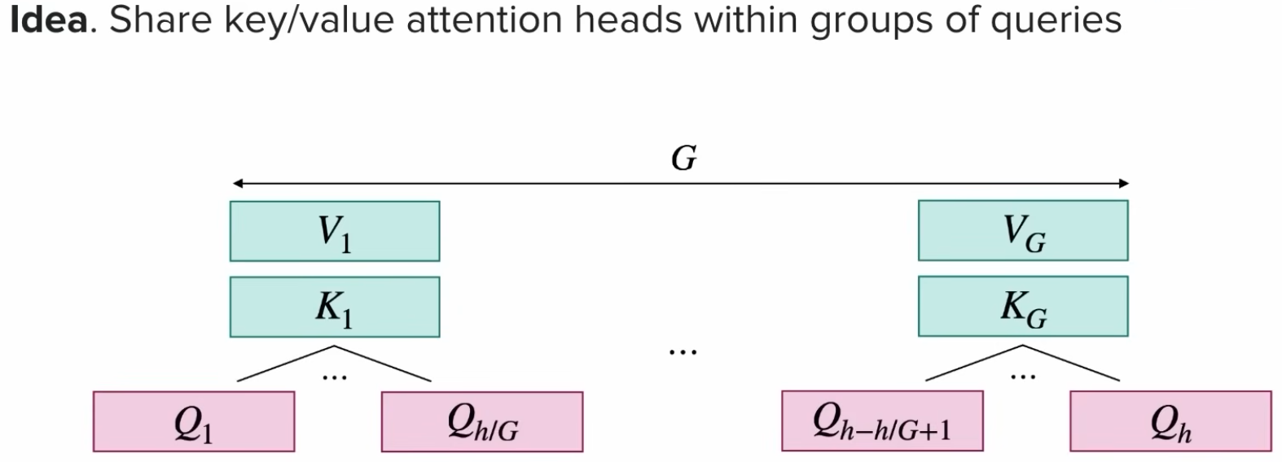
Grouped Query Attention (GQA): h = number of heads in attention, G = number of groups
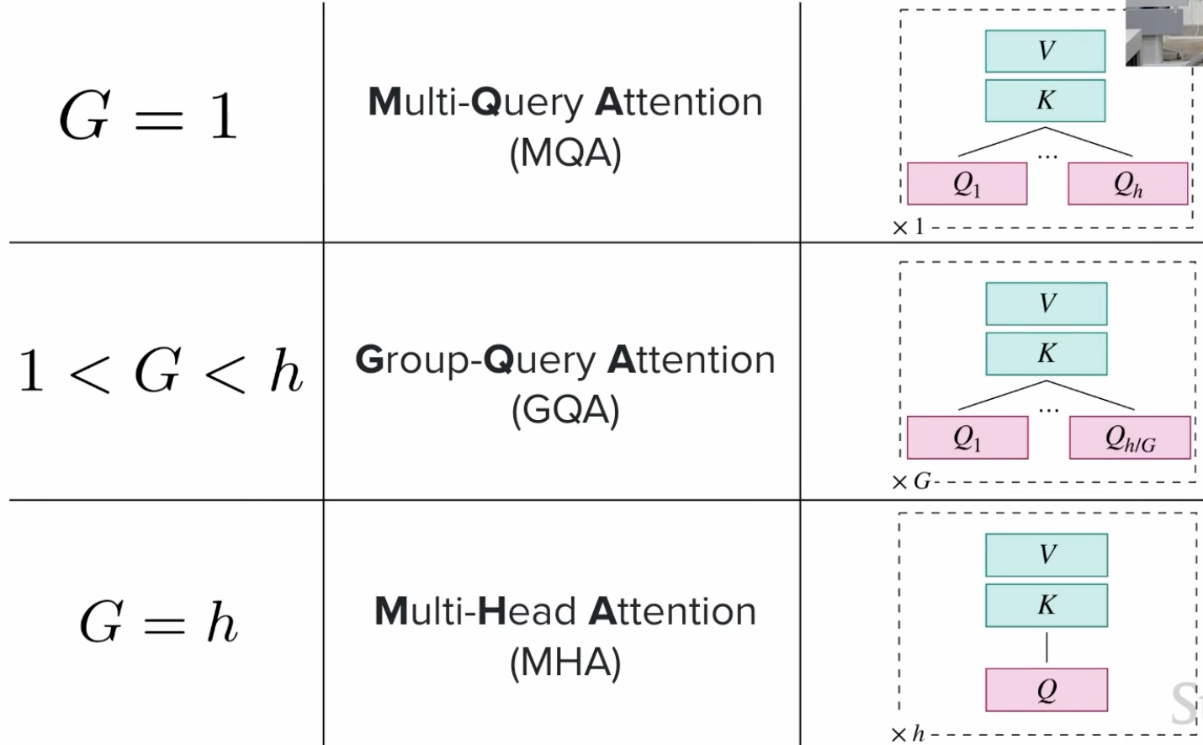

Multi-Head Attention (MHA) vs Multi-Query Attention (MQA) vs Grouped-Query Attention (GQA)

Overview
These are different strategies for organizing Query, Key, and Value matrices in attention to improve efficiency.

1. Multi-Head Attention (MHA) - Standard
What it is: Each head has its own Q, K, and V matrices.
Structure (8 heads):
Head 1: Q₁, K₁, V₁ (unique)
Head 2: Q₂, K₂, V₂ (unique)
...
Head 8: Q₈, K₈, V₈ (unique)
Total: 8 × 3 = 24 matrices
Characteristics:
- ✅ Best quality (most expressive)
- ❌ Highest memory (caches 8 K,V pairs)
- ❌ Slower inference
KV Cache per token: 8 heads × 2 (K,V) = 16 matrices

2. Multi-Query Attention (MQA) - Maximum Sharing
What it is: All heads share one K and V, but each has its own Q.
Structure (8 heads):
Head 1: Q₁ ─┐
Head 2: Q₂ ─┤
Head 3: Q₃ ─┼─→ K_shared, V_shared (ONE pair)
... │
Head 8: Q₈ ─┘
Total: 8 Q + 1 K + 1 V = 10 matrices
Characteristics:
- ✅ Minimal memory (only 1 K,V pair)
- ✅ Fastest inference (8× less memory bandwidth)
- ⚠️ Small quality drop (~1-2%)
- 🔧 Used in: PaLM, Falcon
KV Cache per token: 1 × 2 (K,V) = 2 matrices (8× reduction!)

3. Grouped-Query Attention (GQA) - Balanced
What it is: Heads divided into groups, each group shares one K,V pair.
Structure (8 heads, 4 groups):
Group 1: Head 1 (Q₁), Head 2 (Q₂) → share K₁, V₁
Group 2: Head 3 (Q₃), Head 4 (Q₄) → share K₂, V₂
Group 3: Head 5 (Q₅), Head 6 (Q₆) → share K₃, V₃
Group 4: Head 7 (Q₇), Head 8 (Q₈) → share K₄, V₄
Total: 8 Q + 4 K + 4 V = 16 matrices
Characteristics:
- ✅ Balanced memory (4× less than MHA)
- ✅ Near-MHA quality (~99%)
- ✅ Flexible (tune number of groups)
- 🔧 Used in: Llama-2, Mistral, Gemma
KV Cache per token: 4 groups × 2 (K,V) = 8 matrices (2× reduction)

Comparison Table
Aspect | MHA | GQA (4 groups) | MQA
Q matrices | 8 | 8 | 8
K,V matrices | 8 each | 4 each | 1 each
Total matrices | 24 | 16 | 10
KV Cache size | 100% | 50% | 12.5%
Inference speed | 1× | 1.5-2× | 3-5×
Quality | 100% | 99% | 97-98%
Used in | GPT-3, BERT | Llama-2, Mistral | PaLM, Falcon

Visual Comparison
MHA (No sharing):
H1:[Q₁][K₁][V₁] H2:[Q₂][K₂][V₂] ... H8:[Q₈][K₈][V₈]
KV Cache: 8 pairs → High memory
GQA (Group sharing):
Group1: H1[Q₁], H2[Q₂] → [K₁][V₁]
Group2: H3[Q₃], H4[Q₄] → [K₂][V₂]
Group3: H5[Q₅], H6[Q₆] → [K₃][V₃]
Group4: H7[Q₇], H8[Q₈] → [K₄][V₄]
KV Cache: 4 pairs → Medium memory
MQA (All share):
H1[Q₁], H2[Q₂], ... H8[Q₈] → [K_shared][V_shared]
KV Cache: 1 pair → Low memory

Why This Matters
During text generation (1000 tokens):
MHA: 1000 × 8 heads × 2 = 16,000 cached values
GQA: 1000 × 4 groups × 2 = 8,000 cached values (2× faster)
MQA: 1000 × 1 group × 2 = 2,000 cached values (8× faster)
Memory bandwidth is the bottleneck - fewer K,V pairs = faster inference!

Example: Llama-2 Uses GQA
Configuration:
- 32 attention heads
- 8 KV groups
- Each group: 4 heads share K,V
Result:
- 32 Q matrices
- 8 K matrices (4× reduction)
- 8 V matrices (4× reduction)
- KV cache 4× smaller than MHA
- Quality: ~99% of MHA

When to Use Each
Use Case | Best Choice | Why
Quality priority | MHA | Most expressive
Balanced needs | GQA | Best quality/efficiency trade-off
Speed critical | MQA | Fastest inference
Long contexts | GQA | Good quality + manageable memory
Large scale | GQA | Most practical for production

Why Sharing KV Causes Quality Drop
The Core Issue: Loss of representational diversity
Standard MHA (no sharing):
Head 1: K₁ = X · W_K1 → learns syntax patterns (grammatical roles)
Head 2: K₂ = X · W_K2 → learns semantic relationships (word meanings)
Head 3: K₃ = X · W_K3 → learns positional patterns (word order)
Head 4: K₄ = X · W_K4 → learns co-reference (pronouns, entities)
...each head has unique W_K weight matrix → specializes independently
MQA (all share K, V):
All Heads: K_shared = X · W_K_shared
Head 1: Q₁·K_shared → constrained by same K
Head 2: Q₂·K_shared → constrained by same K
Head 3: Q₃·K_shared → constrained by same K
Head 4: Q₄·K_shared → constrained by same K
...only ONE W_K weight matrix → K must compromise for all patterns
How K Works:
- "Different K" = Different weight matrices (W_K), NOT frozen values
- Training: W_K updated every step, K recomputed each forward pass
- Inference: W_K frozen, K computed fresh for each new token
- MHA: Each head's W_K specializes → diverse K representations
- MQA: Single W_K serves all heads → compromised K representation
Example: Word "bank" (input embedding = [0.5, 0.3, 0.8, ...]):
MHA (different W_K per head):
Head 1 (Financial): K₁ = [0.5, 0.3, 0.8] · W_K1 = [0.9, 0.1, 0.2] ← emphasizes money context
Head 2 (Physical): K₂ = [0.5, 0.3, 0.8] · W_K2 = [0.1, 0.8, 0.3] ← emphasizes location context
→ Different W_K → Different K representations
MQA (shared W_K):
All Heads: K_shared = [0.5, 0.3, 0.8] · W_K_shared = [0.5, 0.5, 0.3] ← compromise
→ Same W_K → Same K for all heads (must serve both financial AND physical contexts)
Analogy:
- MHA: 8 cameras with different lenses (wide, zoom, infrared) → rich perspectives
- MQA: 8 people viewing 1 photo → limited perspective, only ask different questions
Quality Impact:
- MHA: 100% - heads learn diverse attention patterns (syntax, semantics, position)
- GQA: 99% - some diversity preserved through groups
- MQA: 97-98% - single K/V bottlenecks information
Trade-off: Speed vs diversity. MQA is 8× faster but heads can't specialize as effectively.

Key Takeaway
- MHA: Every head unique → Best quality, most memory
- GQA: Heads grouped → Balanced (⭐ most popular in modern LLMs)
- MQA: All share one K,V → Fastest, some quality loss
Trend: Modern LLMs prefer GQA (Llama-2, Mistral) for optimal quality/efficiency balance!

How It Works
Standard Transformer (No Sharing):
Layer 1: Head 1 (W_Q₁, W_K₁, W_V₁) ← Unique weights
Layer 2: Head 1 (W_Q₂, W_K₂, W_V₂) ← Different weights
Layer 3: Head 1 (W_Q₃, W_K₃, W_V₃) ← Different weights
...
All 144 heads have separate weights
With Sharing (Shared Heads):
Layer 1: Head 1 (W_Q, W_K, W_V) ← Shared weights
Layer 2: Head 1 (W_Q, W_K, W_V) ← SAME weights reused
Layer 3: Head 1 (W_Q, W_K, W_V) ← SAME weights reused
...
One set of weights used across multiple layers

Sharing Strategies
Strategy | Description | Parameter Reduction | Used In
Cross-Layer Sharing | Same head weights across all layers | ~70% reduction | ALBERT, Universal Transformer
Group Sharing | Share within groups of layers | ~30-50% reduction | Some efficient transformers
Factorized Sharing | Share Q/K/V separately | ~40% reduction | ALBERT

Example: ALBERT (A Lite BERT)
BERT-base (No Sharing):
Parameters: 110M
- 12 layers × 12 heads × 3 matrices (Q,K,V)
- Each layer learns independently
Memory: High
ALBERT-base (With Sharing):
Parameters: 12M ← 90% reduction!
- 12 layers × 12 heads
- All layers share SAME attention weights
- Only embedding/output layers differ
Memory: Low
Performance Comparison:
Task: SQuAD (Question Answering)
BERT-base: 110M params → 88.5% accuracy
ALBERT-base: 12M params → 89.3% accuracy ← Better with fewer params!
Why? Cross-layer sharing acts as regularization

Benefits & Trade-offs
Aspect | Without Sharing | With Sharing
Parameters | 100M-1B | 10M-100M (10× fewer)
Memory | High | Low
Training speed | Slower | Faster (fewer params to update)
Inference speed | Same | Same (computation unchanged)
Performance | Baseline | Similar or better (regularization effect)
Flexibility | Each layer specializes | Layers more similar

Visual Comparison
Standard Transformer:
┌─────────────┐
│ Layer 12 │ W_Q₁₂, W_K₁₂, W_V₁₂ ← Unique
├─────────────┤
│ Layer 11 │ W_Q₁₁, W_K₁₁, W_V₁₁ ← Unique
├─────────────┤
│ Layer 10 │ W_Q₁₀, W_K₁₀, W_V₁₀ ← Unique
├─────────────┤
│ ... │ ...
└─────────────┘
Total: 12 sets of weights
Shared Heads (ALBERT):
┌─────────────┐
│ Layer 12 │ ─┐
├─────────────┤ │
│ Layer 11 │ ─┤
├─────────────┤ ├─→ W_Q, W_K, W_V (SHARED)
│ Layer 10 │ ─┤
├─────────────┤ │
│ ... │ ─┘
└─────────────┘
Total: 1 set of weights (reused 12 times)

Key Models Using Shared Heads
Model | Sharing Type | Params (vs BERT) | Performance
ALBERT | Full cross-layer | 12M (vs 110M) | Same or better
Universal Transformer | Full sharing + recurrence | Variable | Better for structured tasks
DeBERTa-v3 | Partial sharing | 86M (vs 110M) | Better

Key Takeaways
- Sharing Attention Heads = Reuse same attention weights across multiple layers
- Reduces parameters by 70-90% without hurting performance
- Acts as regularization → prevents overfitting, can improve accuracy
- Memory efficient → enables larger models on limited hardware
- Used in: ALBERT (90% reduction), Universal Transformer, efficient BERT variants

Transformer-Based Models
Transformers come in three architectural variants, each designed for different tasks:

Quick Comparison
Architecture | Attention Type | Primary Use | Example Models | Example Task
Encoder-Only | Bidirectional (sees all tokens) | Understanding & Classification | BERT, RoBERTa | "Is this email spam?"
Encoder-Decoder | Encoder: bidirectional<br>Decoder: causal | Transformation (seq-to-seq) | T5, BART | Translate English → French
Decoder-Only | Causal (left-to-right) | Text Generation | GPT-3, LLaMA, ChatGPT | Complete: "Once upon a time..."

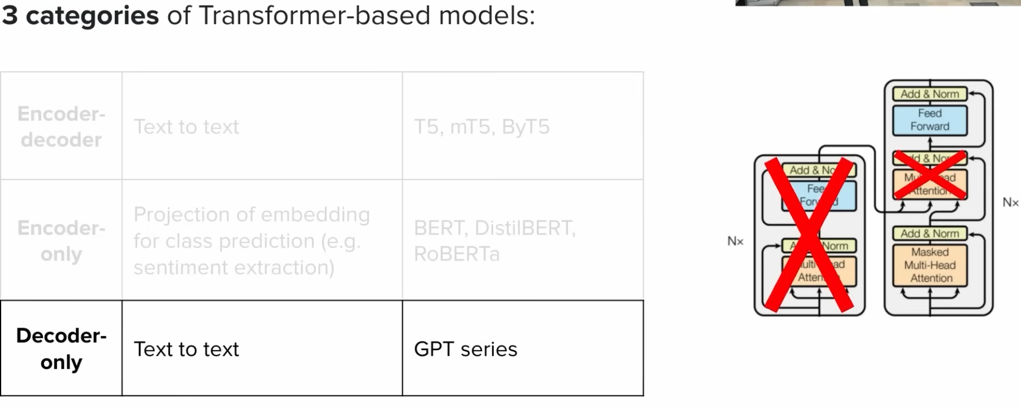

1. Encoder-Only (BERT-style)
Purpose: Deep understanding by seeing the entire sentence at once.
How it works: Each word sees ALL other words (both past and future).
Input: "The cat sat on the mat"
Processing:
The ↔ cat ↔ sat ↔ on ↔ the ↔ mat
(All tokens attend to ALL others - bidirectional)
Result: Rich understanding of each word in context
Use Cases:
- Sentiment Analysis: [CLS] This movie is amazing! [SEP] → Positive ✓
- Named Entity Recognition: "Apple announced new iPhone" → Apple=ORG, iPhone=PRODUCT
- Question Answering: Extract answer span from context
Key Point: Cannot generate new text, only understands/classifies existing text.

2. Encoder-Decoder (T5/BART-style)
Purpose: Transform one sequence into another (different language, length, or format).
How it works:
- Encoder understands input (bidirectional)
- Decoder generates output (causal, one token at a time)
ENCODER (bidirectional):
"Hello world" → [Rich understanding of English]
DECODER (causal + attends to encoder):
[BOS] → "Bonjour" → "monde" → [EOS]
Use Cases:
- Translation: English → French
- Summarization: Long article → Short summary
- Text-to-SQL: "Show customers from CA" → SELECT * FROM customers WHERE state='CA'
Key Point: Best when input and output are different (language, length, format).

3. Decoder-Only (GPT/LLaMA-style)
Purpose: Generate text by predicting the next token, one at a time.
How it works: Each token ONLY sees past tokens (left-to-right).
Input: "The cat sat on the"
↓ (only sees past) ↓
Output: "mat"
Next step:
Input: "The cat sat on the mat"
↓ (only sees past) ↓
Output: "and"
Use Cases:
- Text Completion: "Write a story: Once upon a time" → [generates full story]
- Conversational AI: ChatGPT processes entire conversation history → generates response
- Code Generation: # Function to calculate factorial → [generates Python function]
- In-Context Learning: Learn from examples in the prompt (few-shot)
Key Point: Most flexible - can do almost any task via prompting (modern LLMs like GPT-4, Claude).

Why Architecture Matters: Example Task
Task: Sentiment Analysis

Encoder-Only (BERT):
Input: [CLS] This movie is terrible but the acting is good [SEP]
↓ Sees "terrible" AND "but" AND "good" simultaneously
Output: Mixed sentiment ✓
Best: Sees full context for nuanced understanding

Decoder-Only (GPT):
Input: "Sentiment: This movie is terrible but the acting is good\nAnswer:"
↓ Processes left-to-right
Output: "Mixed"
Works: But relies on prompt engineering

Modern Trend: Decoder-Only Dominance
Evolution:
- 2018: BERT (Encoder-only) - Best for classification
- 2019: T5 (Encoder-decoder) - Best for translation
- 2023-2025: GPT-4/LLaMA (Decoder-only) - Best for EVERYTHING
Why Decoder-Only Won:
- ✅ Single unified architecture (simpler)
- ✅ Scales to massive sizes (100B+ parameters)
- ✅ In-context learning (no fine-tuning needed)
- ✅ Flexible via prompting (one model, all tasks)
Trade-off:
- Slightly less optimal for pure encoding tasks (vs BERT)
- But gains universal capability via prompting

Summary for Beginners
When you need to... | Use
Classify or understand text (spam detection, sentiment) | Encoder-Only (BERT)
Transform one sequence to another (translation, summarization) | Encoder-Decoder (T5) or Decoder-Only with prompting
Generate new text (stories, conversations, code) | Decoder-Only (GPT, LLaMA)
Do everything with one model | Decoder-Only (modern LLMs)

Key Insight: Modern LLMs (GPT-4, Claude, LLaMA) are all decoder-only because they can handle any task through clever prompting, making them the most practical choice today! 🎯

