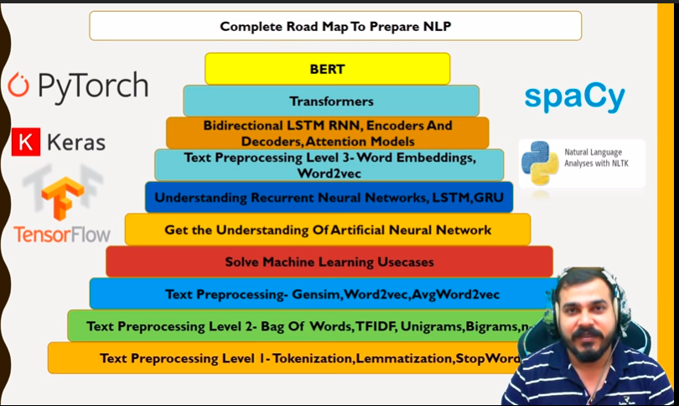
https://github.com/krishnaik06/Natural-Language-Processing

NLP

Stemming & Lemmatization
Stemming | Lemmatization
Generate non human readable(doesn’t have meaning) format. | Generates human readable(meningful) format
It doesn’t take much time since it isn’t generating meaningful word | It does take much time since it is generating meaningful word
Used in Sentimental classification, spam (or) Ham email | Used in Chatbot, Q&A

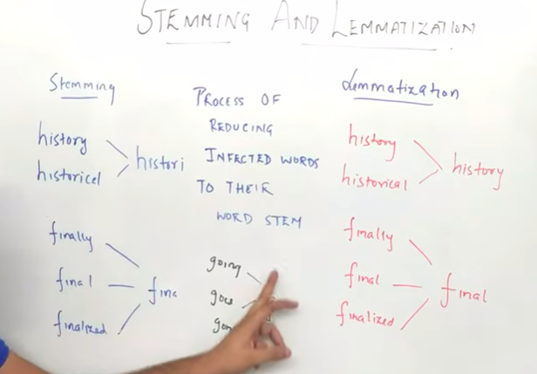
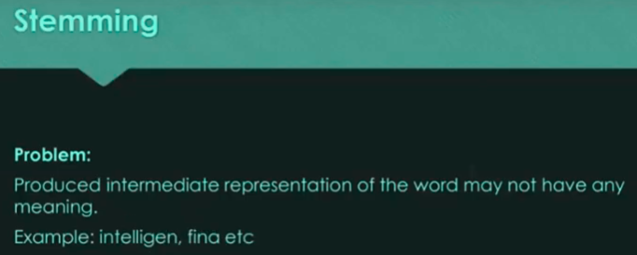

Bag Of Words(BOW)
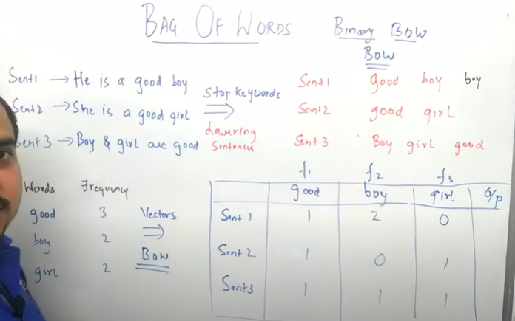
It is represented as 0 & 1. Sentence 1 contains good and boy, so its marked as ‘1’.

Disadvantages
Good and boy has equal representation(same weightage), we aren’t able to derive which word is more important. In sentiment analysis, we need to know which word is more important.
If the new sentences contain new words, then our vocabulary size would increase and thereby, the length of the vectors would increase too.
Additionally, the vectors would also contain many 0s, thereby resulting in a sparse matrix (which is what we would like to avoid)

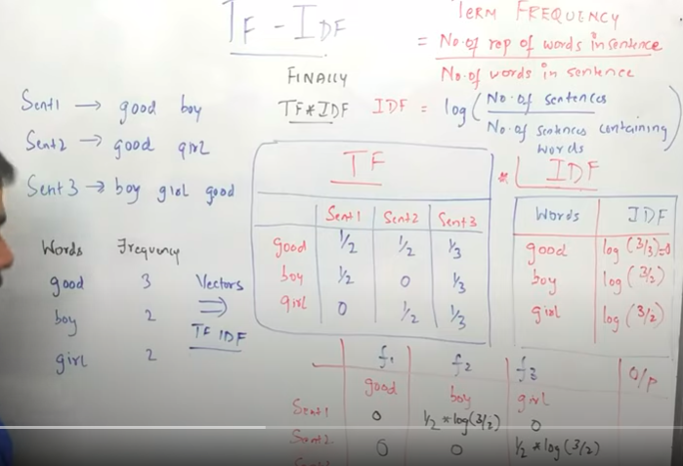
TF-IDF(Term Frequency and Inverse Document Frequency)

We apply TF-IDF after cleaning the words(stopwords etc). We get just 0 or 1 in BOW model but TF-IDF provides more important to the specific word. In Sentence 1 – boy is given more weightage than good where as in BOW both will be 1 if it occurs in the sentence. TF-IDF provides some semantic meaning.

Word2Vec
https://towardsdatascience.com/text-classification-with-nlp-tf-idf-vs-word2vec-vs-bert-41ff868d1794

Disadvantages of BOW & TF-IDF
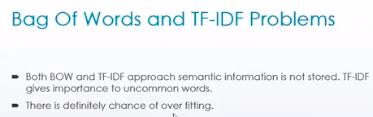

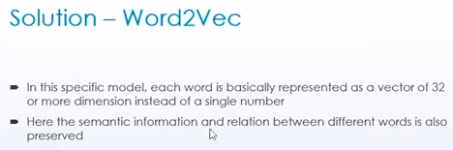

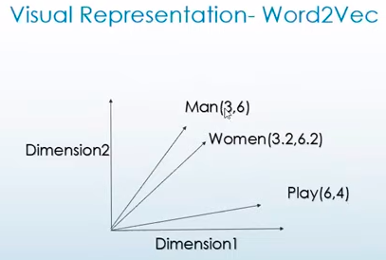

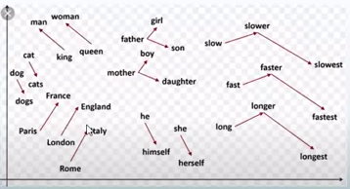

More common (or) inter related words are present near to each other. E.g. : king man. This is the major concern in BOW & TF-IDF since it doesn’t store semantic(inter related word) in it.
An n-gram is a contiguous sequence of n words, for example, in the sentence "dog that barks does not bite", the n-grams are:
unigrams (n=1): dog, that, barks, does, not, bite
- bigrams (n=2): dog that, that barks, barks does, does not, not bite
- trigrams (n=3): dog that barks, that barks does, barks does not, does not bite

CBOW(Continuous Bag Of Words)
In CBOW model, the distributed representations of context (or surrounding words) are combined to predict the word in the middle. Several times faster to train than the skip-gram, slightly better accuracy for the frequent words. The model tries to predict the target word by trying to understand the context of the surrounding words.

Skip-gram
Given a set of sentences (also called corpus) the model loops on the words of each sentence , it tries to use the current word w in order to predict its neighbors (i.e., its context). In Skip-gram model, the distributed representation of the input word is used to predict the context.
Works well with a small amount of the training data, represents well even rare words or phrases.
How training is done for the sentence
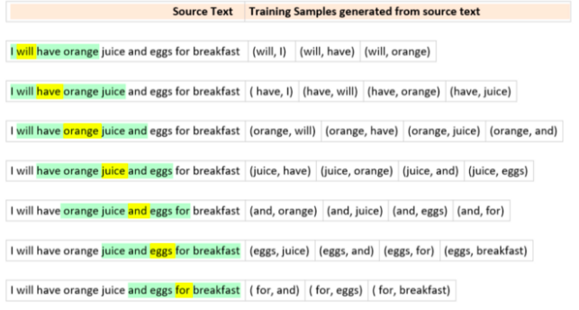
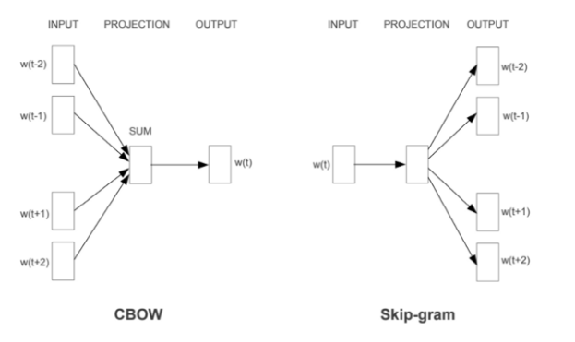

One_hot Encoding(TensorFlow)
https://machinelearningmastery.com/prepare-text-data-deep-learning-keras/
**** https://www.youtube.com/watch?v=fNxaJsNG3-s&list=PLQY2H8rRoyvzDbLUZkbudP-MFQZwNmU4S

Keras provides the one_hot() function that you can use to tokenize and integer encode a text document in one step. The one_hot() function will make the text lower case, filter out punctuation, and split words based on white space.

Deep Learning NLP
https://www.youtube.com/watch?v=fNxaJsNG3-s&list=PLQY2H8rRoyvzDbLUZkbudP-MFQZwNmU4S
Code is available in /home/vinoth/Learning/Python/Workouts/ML-Udemy-Git/Section 7:Natural Language Processing(NLP)/Tensorflow

Feature Engineering

Type of Encoding
Nominal Encoding: Dont need to care about the ordering of categorical variable. e.g: Gender, state, country
Ordinal Encoding: we need to worry about rank. e.g: Salary of person is based on degree.
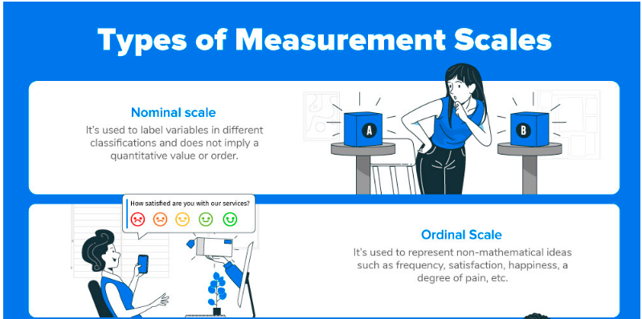
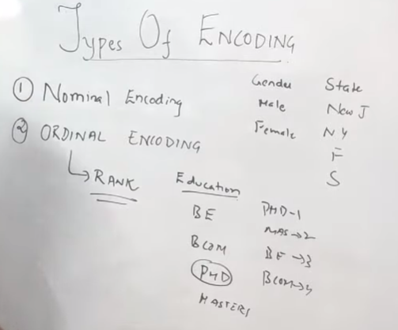
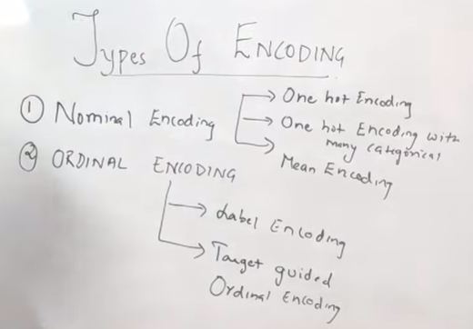

One Hot Encoding
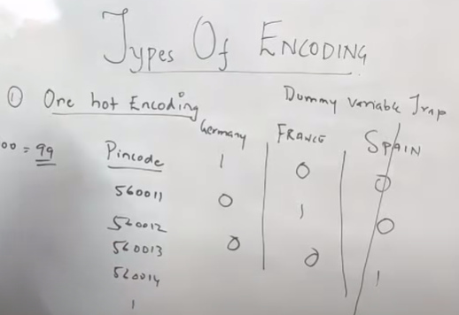
If we have 3 catagorial variable, we can choose 3-1=2 encoding column & remove other one. If Germany & France is 0 then we can conclude that its Spain.
Disadvantages
If we have more unique(many categorial) column then applying it will generate more column which will increase the dimensions of data. It leads to curse of dimensionality

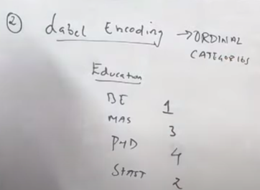
Label Encoding
Higher value will be provided based on the categorial data.

One Hot Encoding with Multiple categories
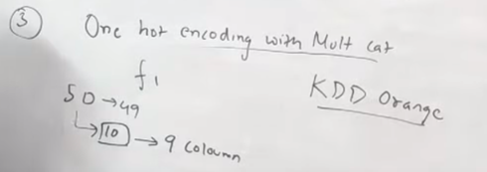
If we have more categorical data then we will take only top 10 data and apply encoding to it. If 50 categorical data(CD) are available then only top 10 CD will be encoded. Code is available below:
https://github.com/vinothg2309/ML-Udemy/blob/main/Feature%20Engineering/one_hot_encoding.ipynb
Winning the KDD Cup Orange Challenge with Ensemble Selection - the authors limit one hot encoding to the 10 most frequent labels of the variable. This means that they would make one binary variable for each of the 10 most frequent labels only. This is equivalent to grouping all the other labels under a new category, that in this case will be dropped. Thus, the 10 new dummy variables indicate if one of the 10 most frequent labels is present (1) or not (0) for a particular observation.

Why Feature Scaling
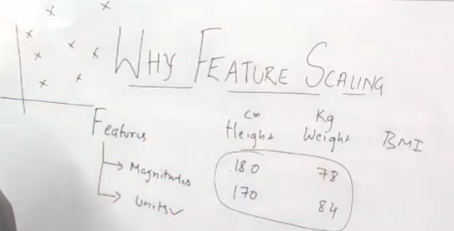
Feature or independent variable vary in magnitude and units. Height is in cm, weight in kg & both are varying a lot. If plotted in chart (or) graph, it varies a lot. Most algorithm uses eclidean distance to learn or predict the result. We need to apply feature scaling to these feature variable. It needs to apply in Linear, KNN,K-mean, ANN, CNN.
Decision Tree, Naive Bayes, Random Forest & XGBoost ensemble technique which doesn’t require feature scaling.

Missing Value in Categorical Variable
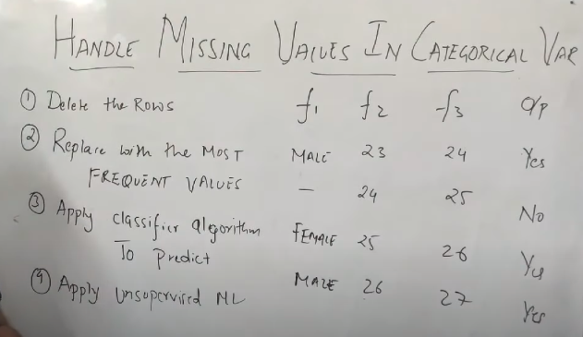

Seaborn

BoxPlot

https://github.com/krishnaik06/Machine-Learning-in-90-days/blob/master/Section%201-%20Python%20Crash%20Course/5-%20Seaborn.ipynb
https://medium.com/swlh/identify-outliers-with-pandas-statsmodels-and-seaborn-2766103bf67c
