TensorFlow

Artificial Neural Network

Activation Function
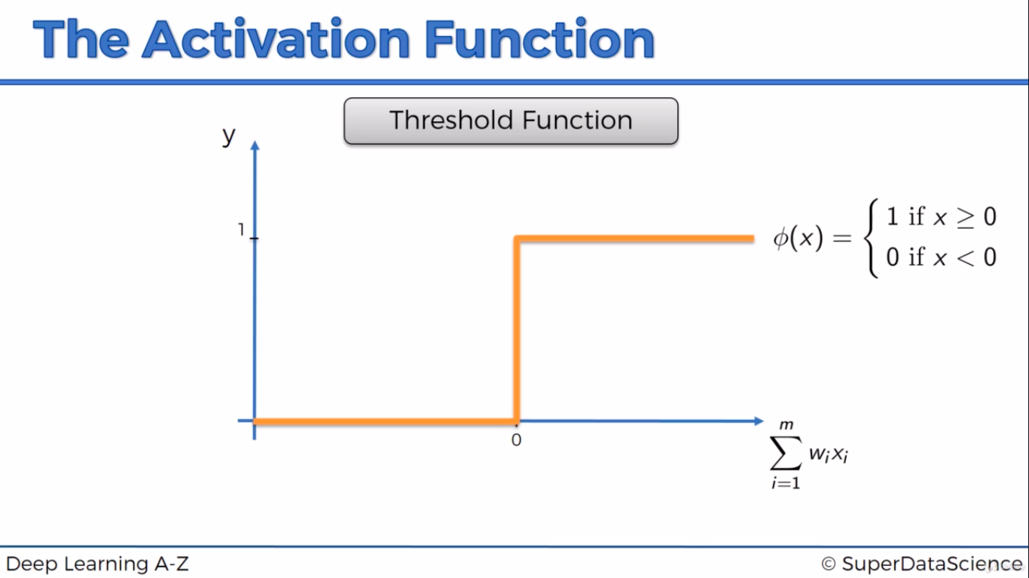

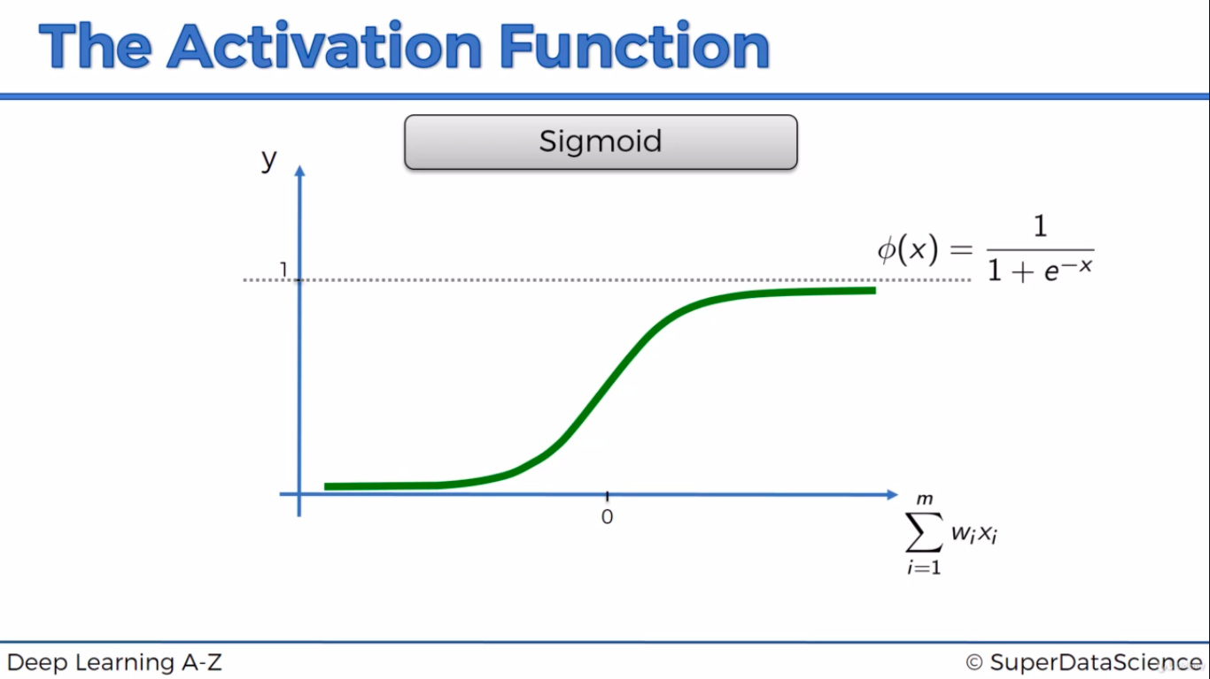
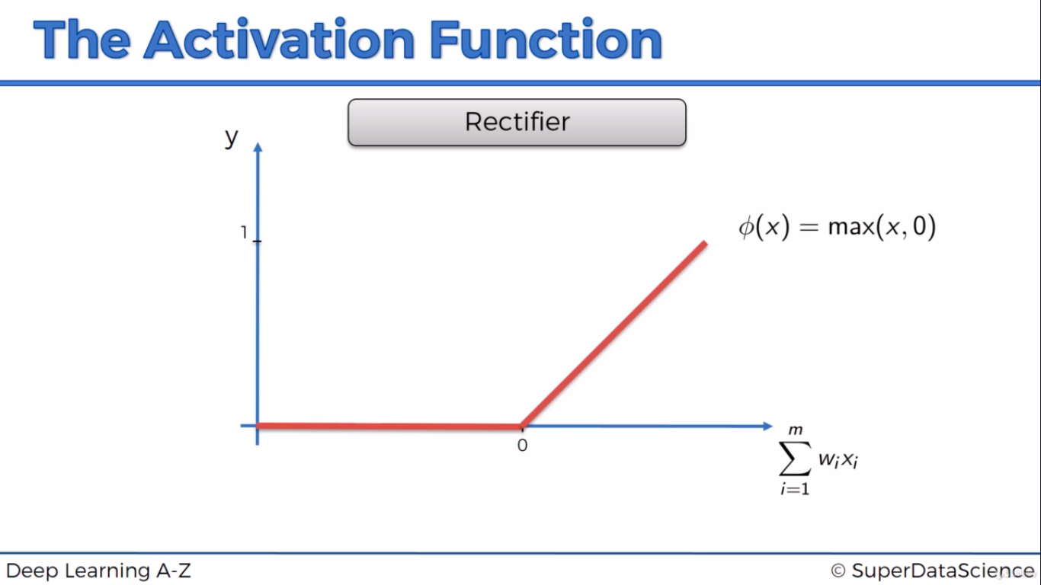

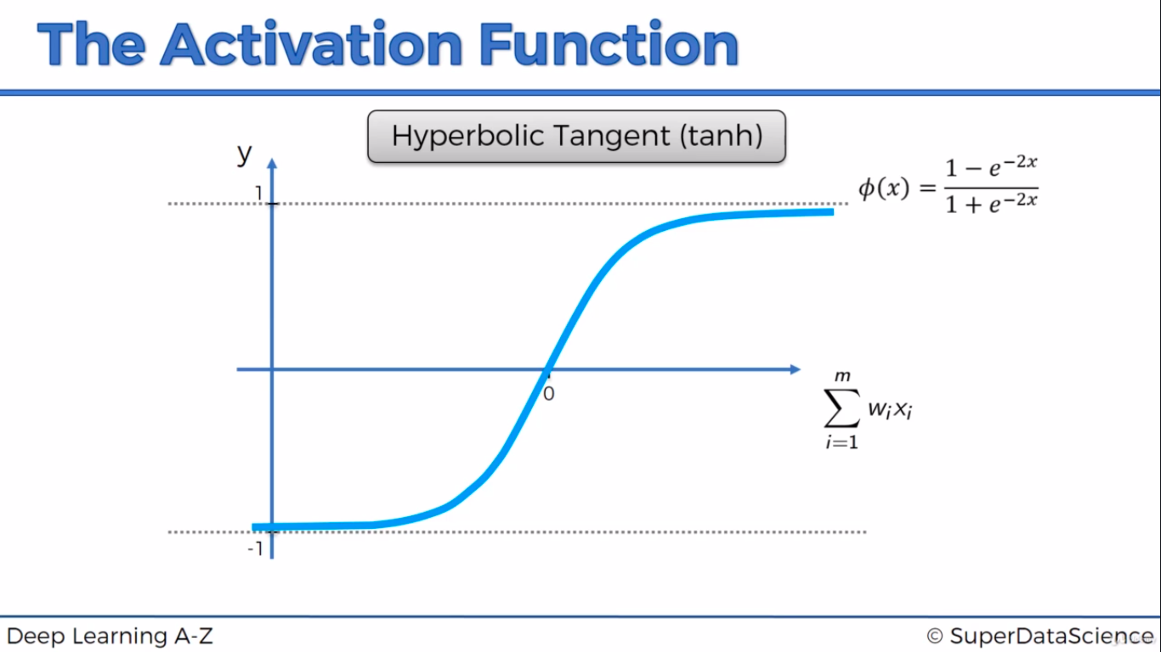
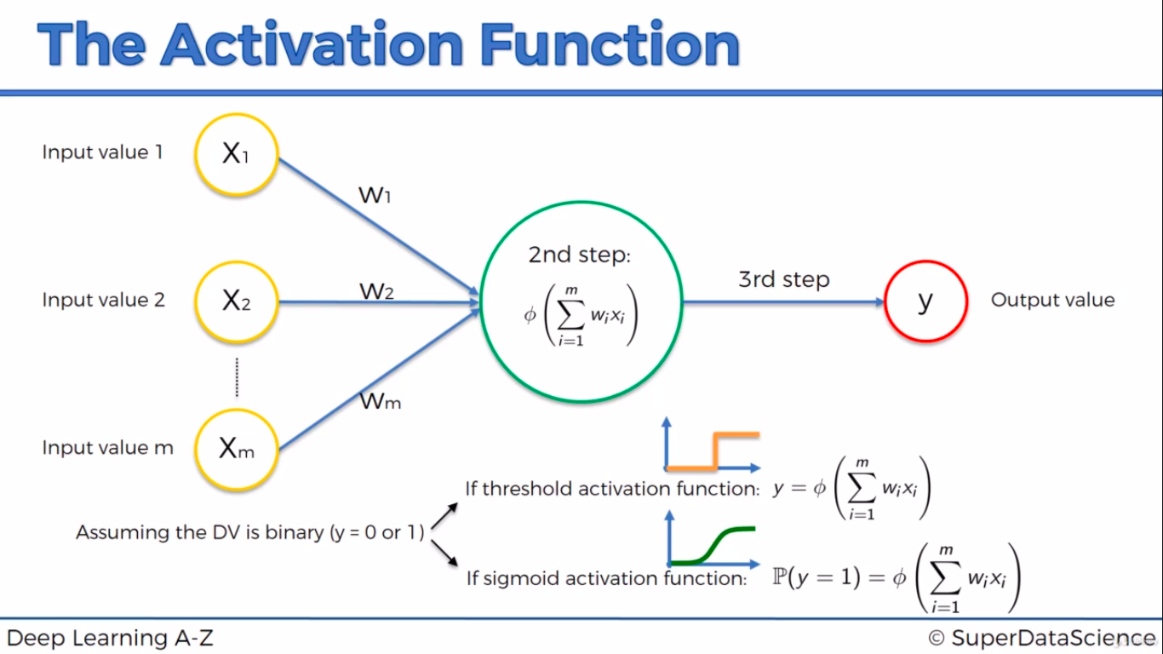

Most common scenario - We will apply rectifier function in hidden layer and we will apply sigmoid function in output layer
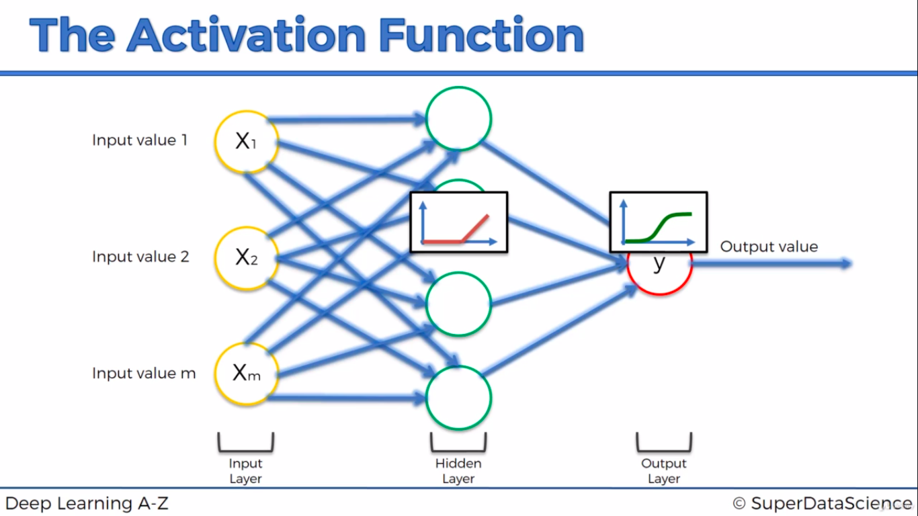

Neural network Works
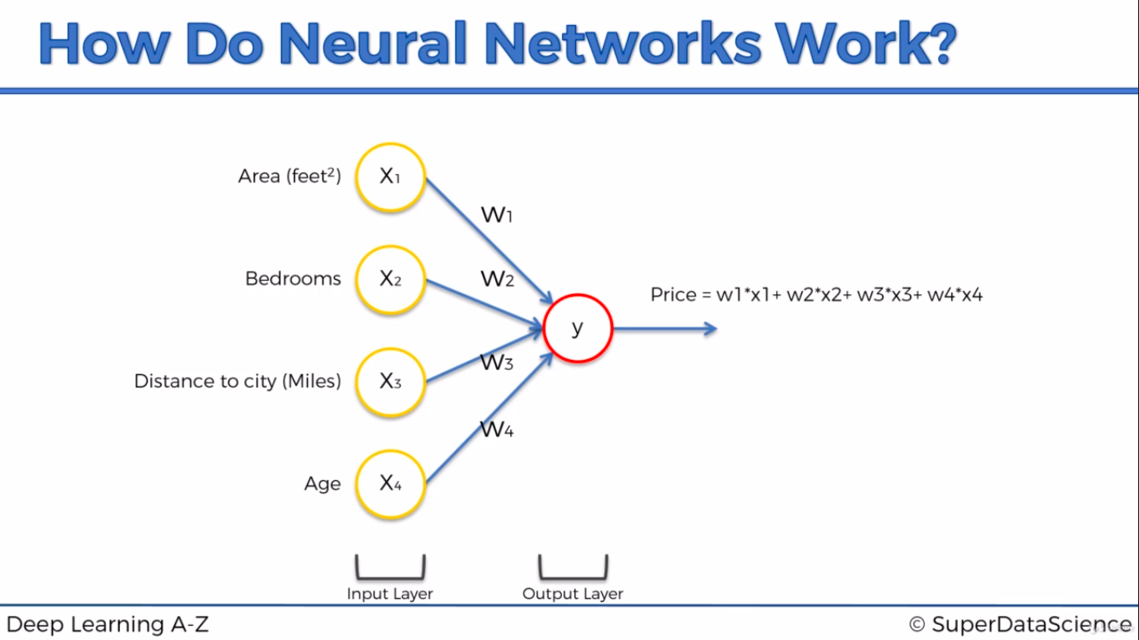
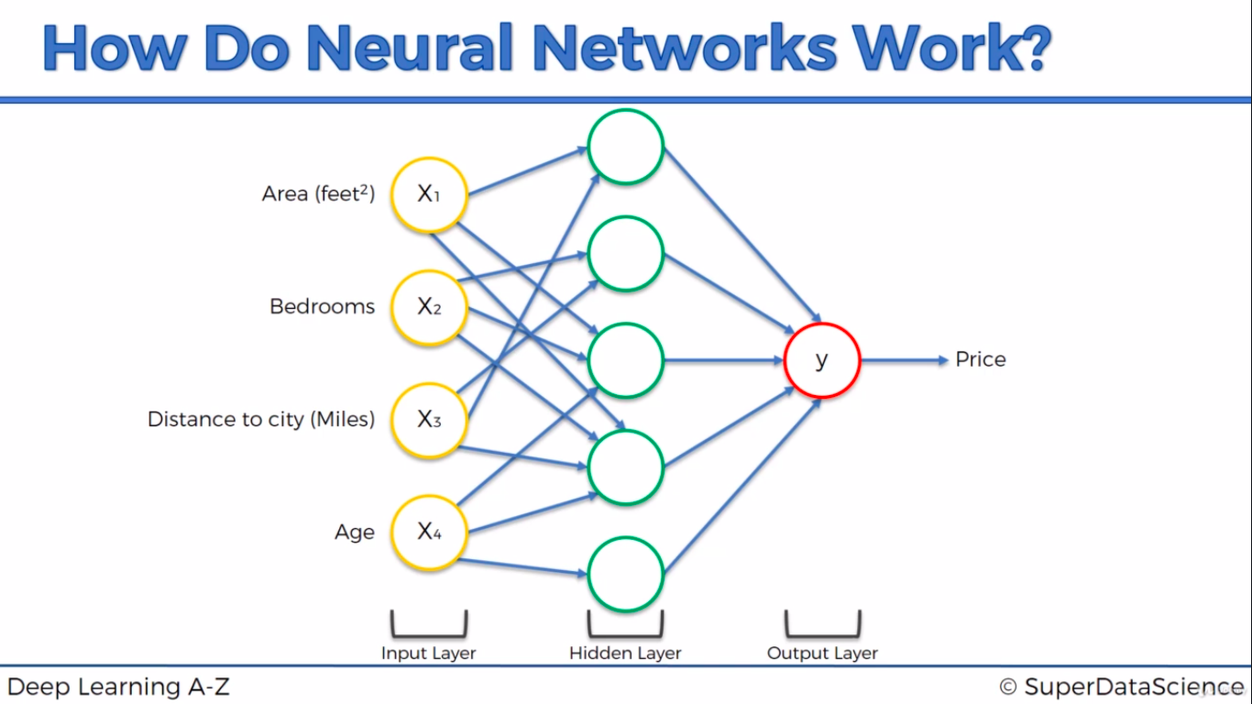

How Neural Network learns?
Cost function(c) tells what is t error v have in prediction
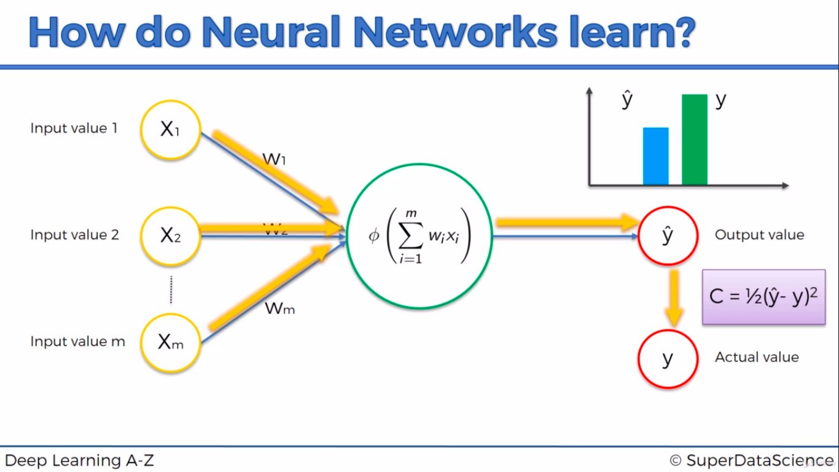
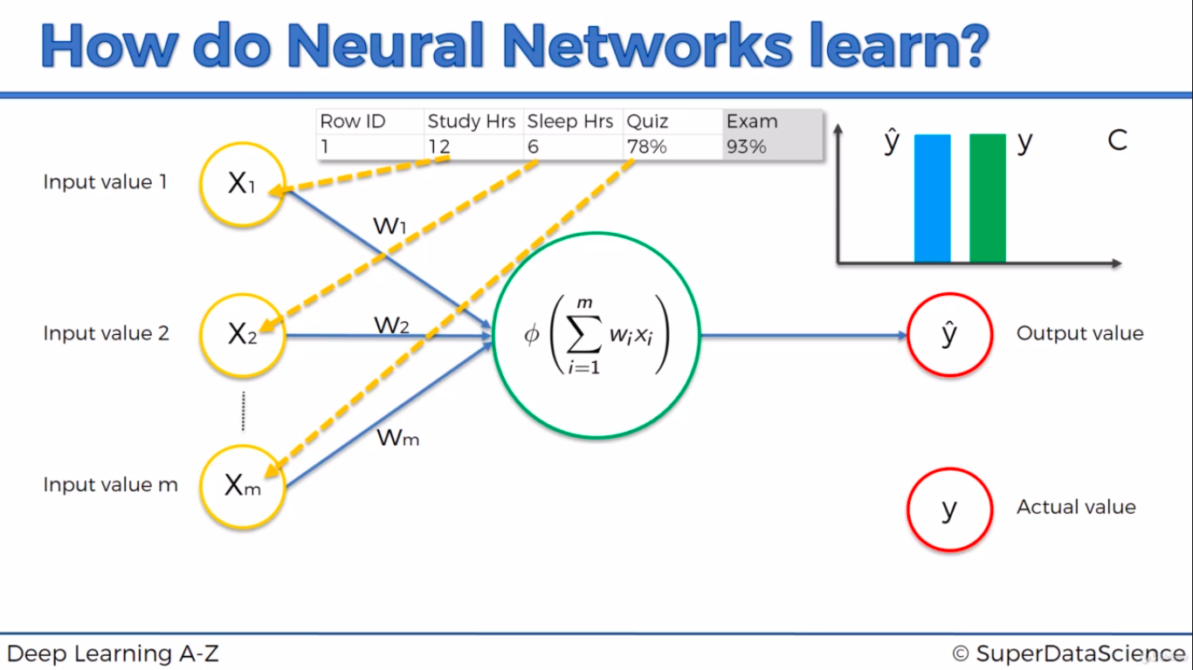

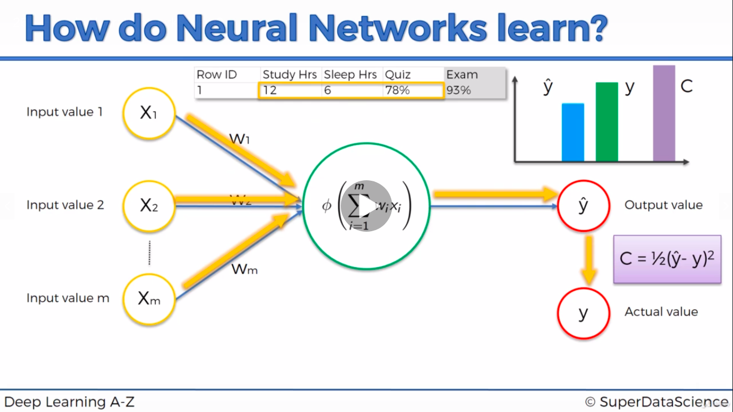

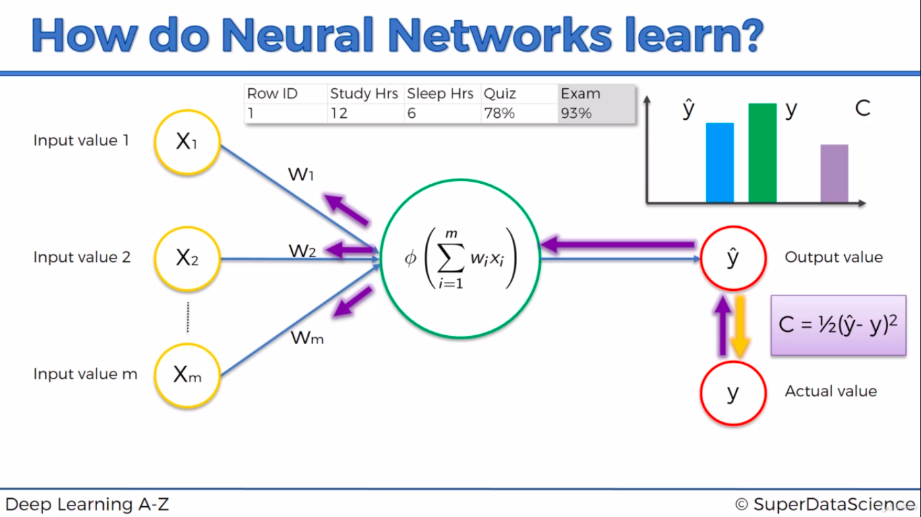
Whole training set is fed into single neural network(8 images below i just fr out understanding) in each epoch

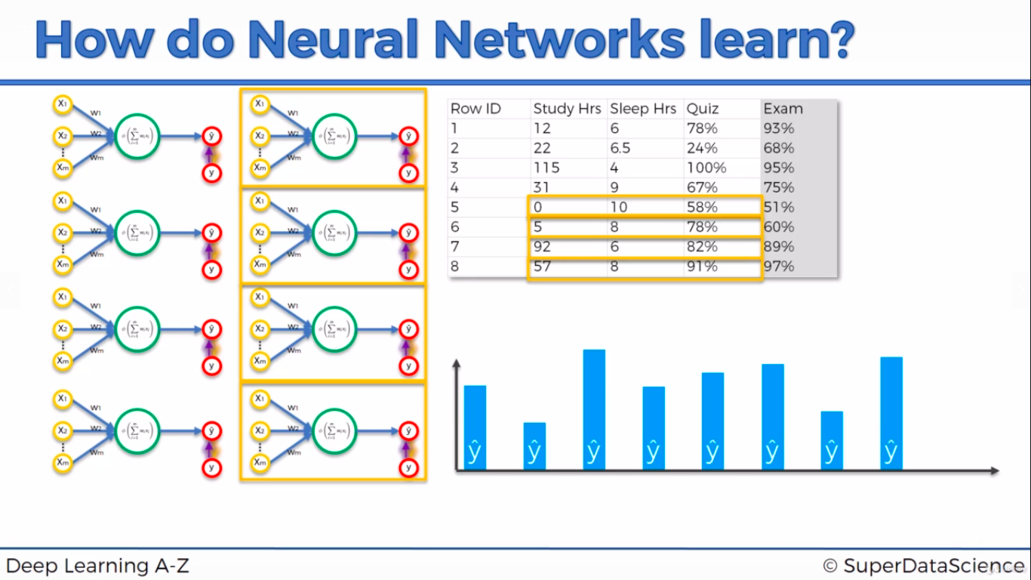

All training set will have same weight since cost function is sum of all difference. All weight will be back propagated to neural network and all signal will be forward prapogated with updated weight. This action will happen recursively until we get less cost function based on epoch count.
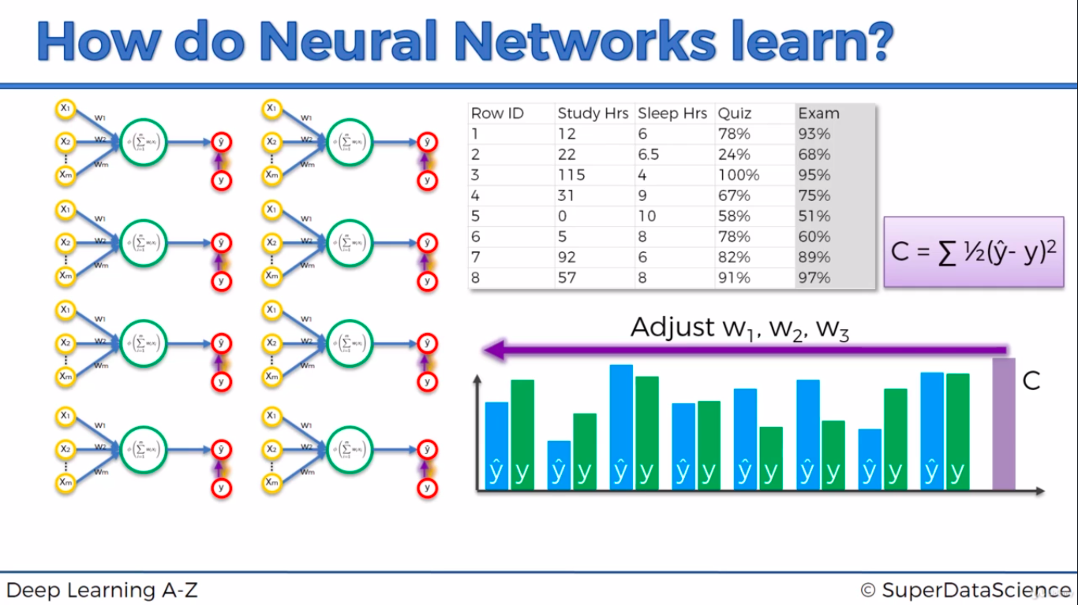

Gradient Descent
4(input)*5(hidden layer)+5(hidden to output layer) = 25
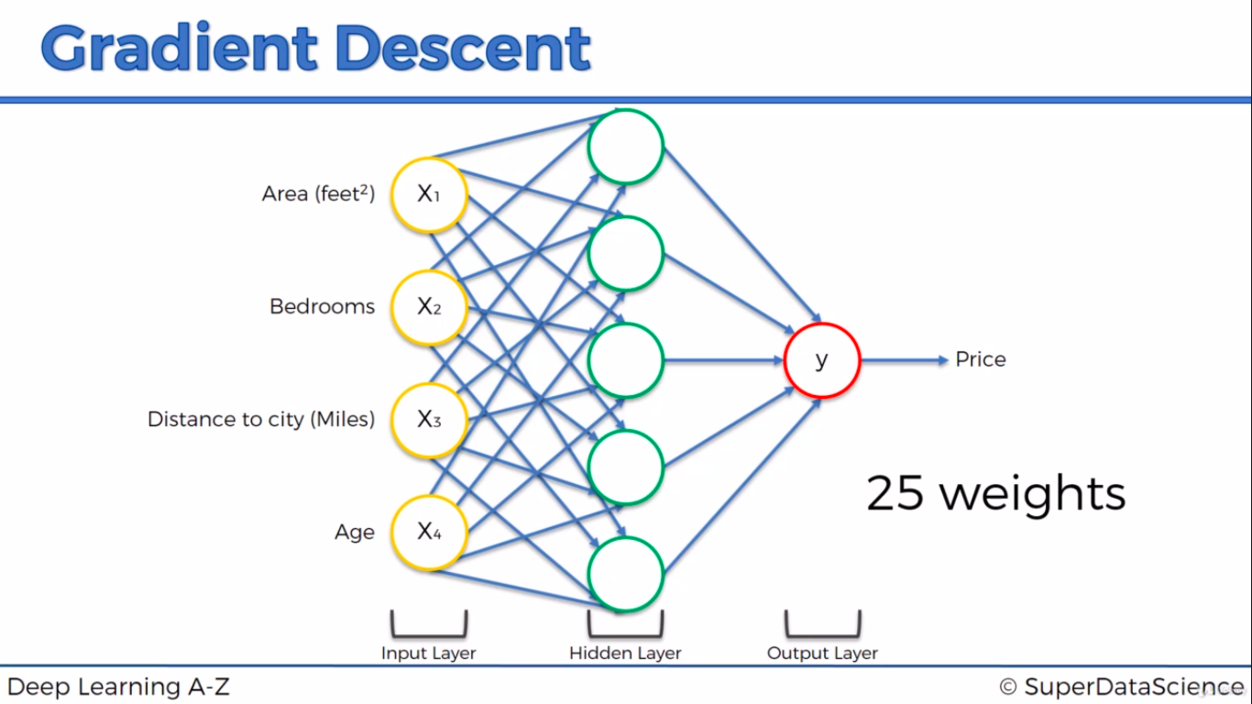
If 1000 input values and 1000 hidden layer, below is t calculation
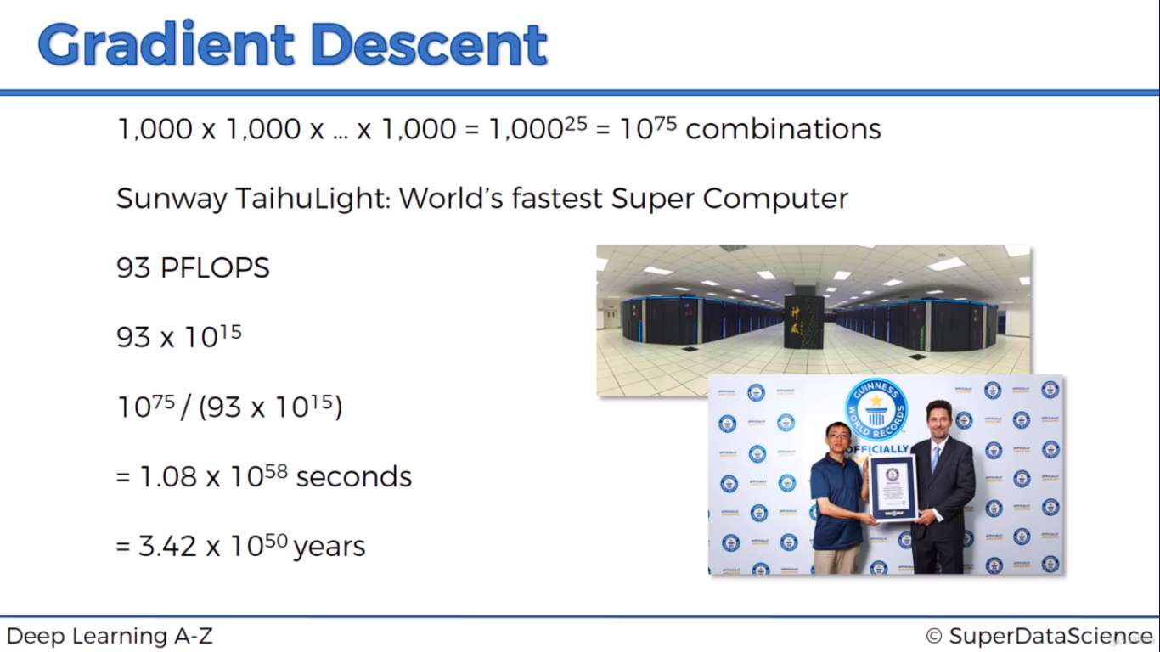
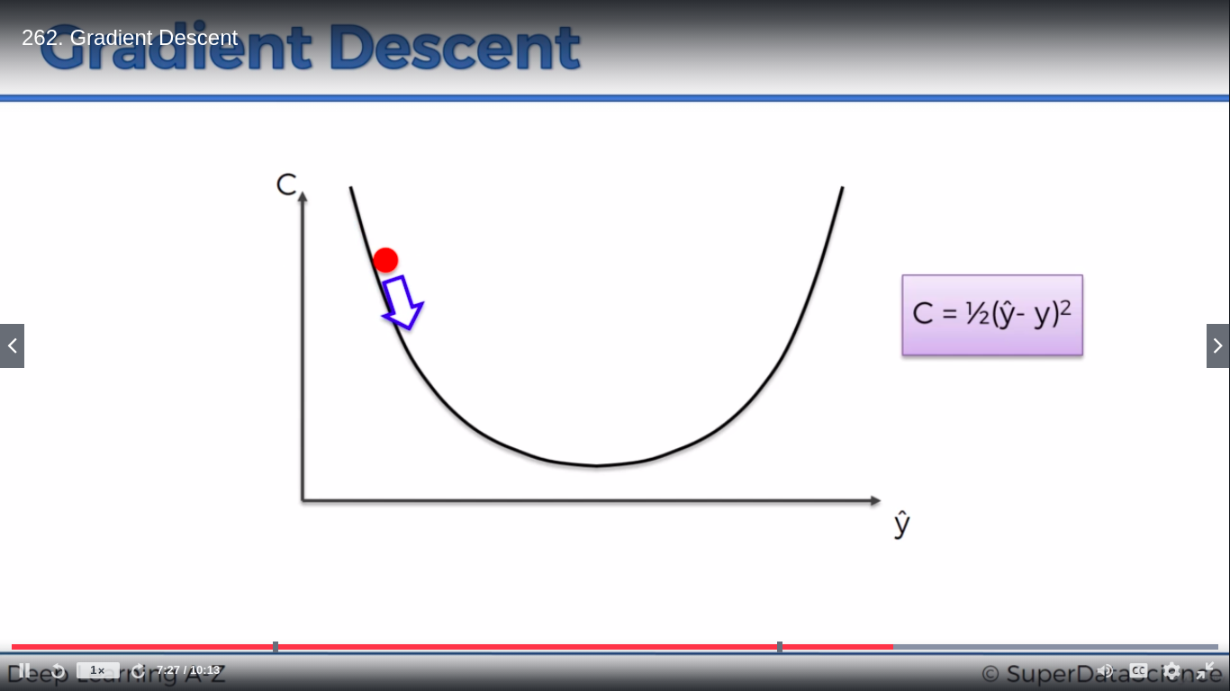
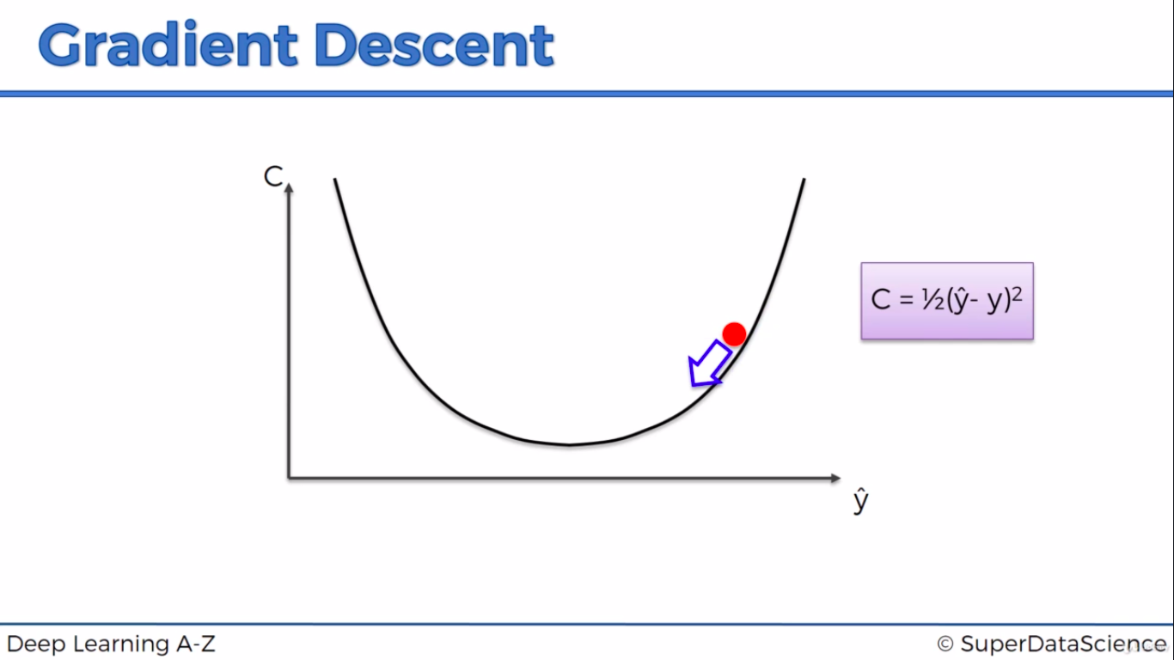
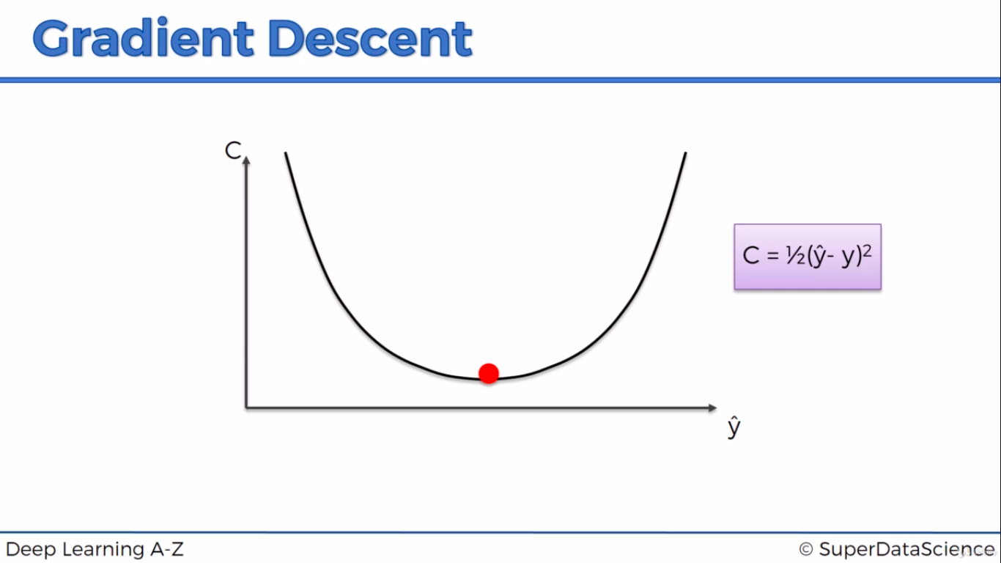
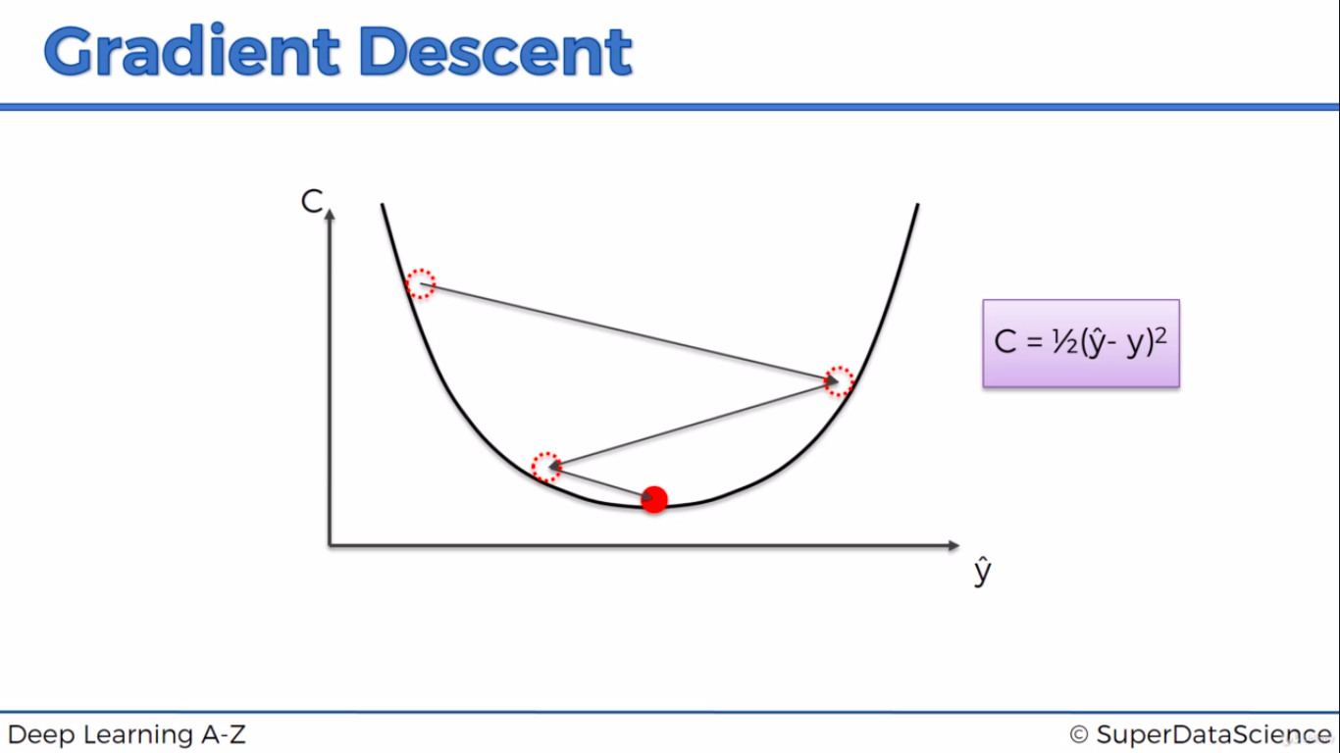

Stochastic Gradient Descent

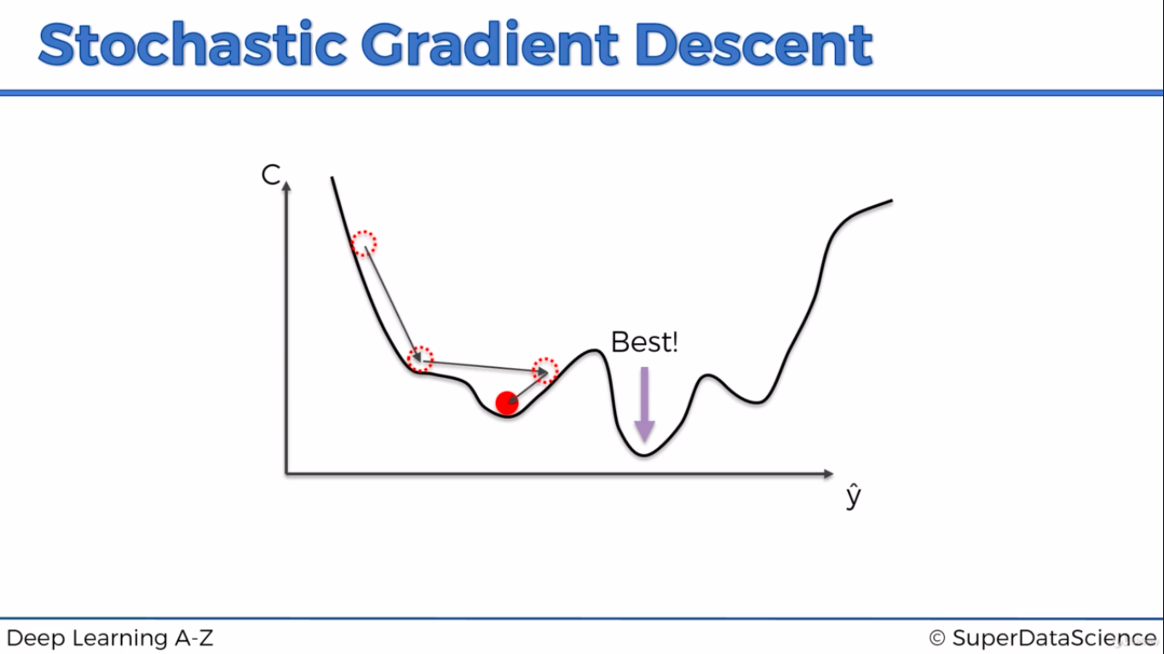

Below is the example of Gradient Descent. We take the data as a batch(whole set) and then calculate the weight. Weight is then back propagated
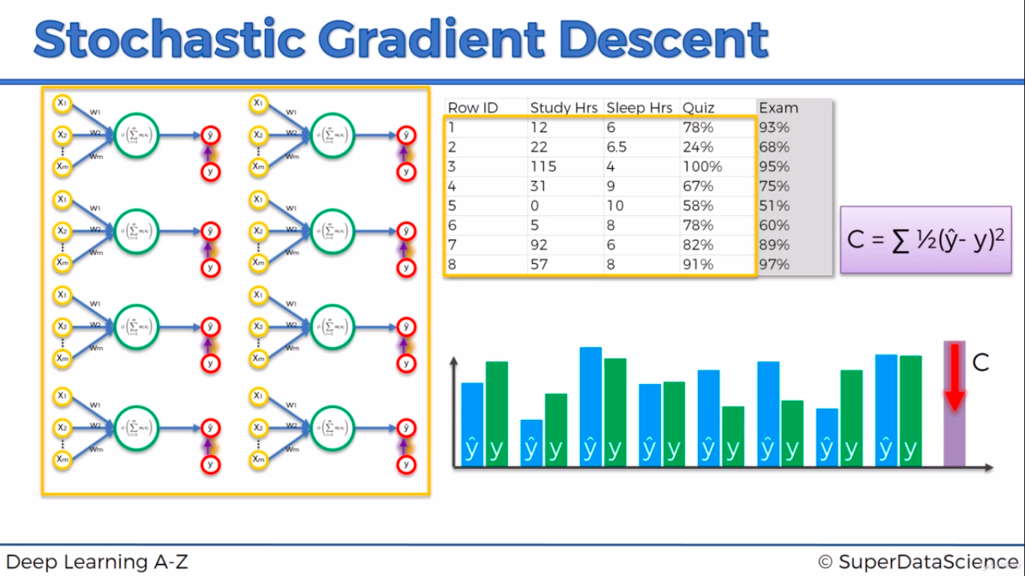
In Stochastic Gradient Descent, We take the each row of data and then calculate the weight. Weight is then back propagated for each row
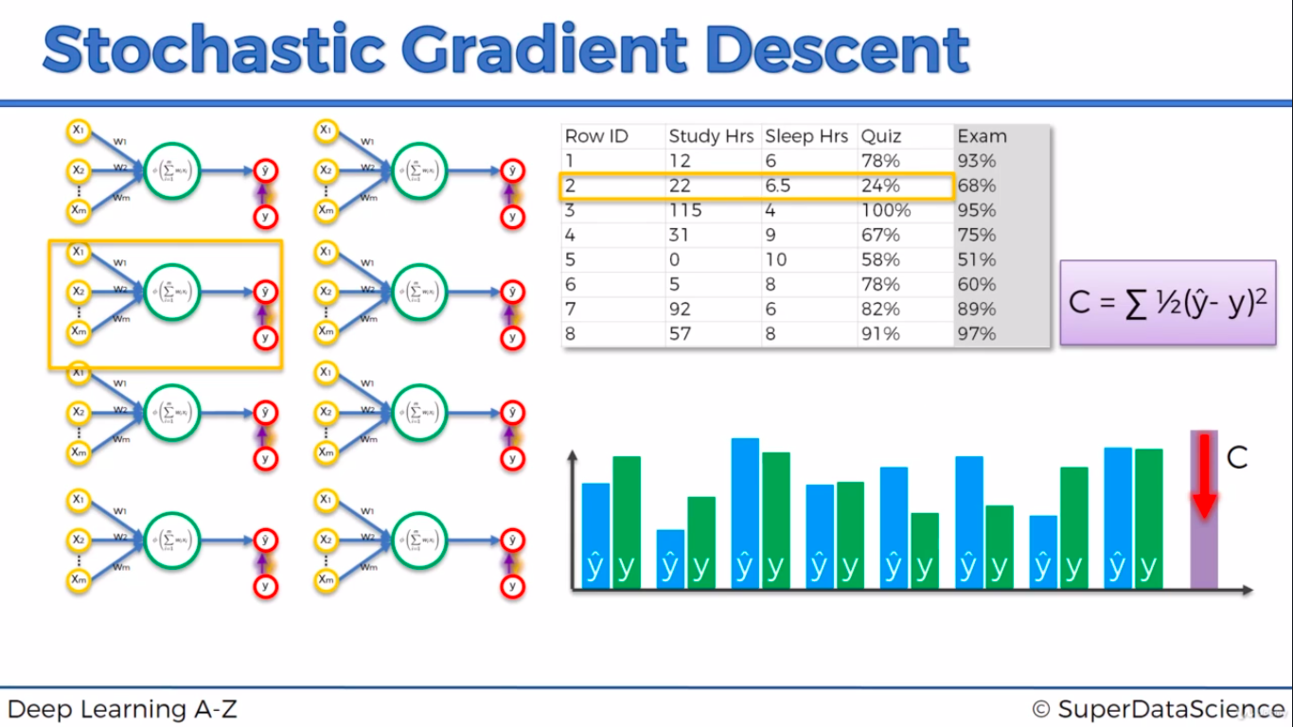

Upd w’s – Updated weight
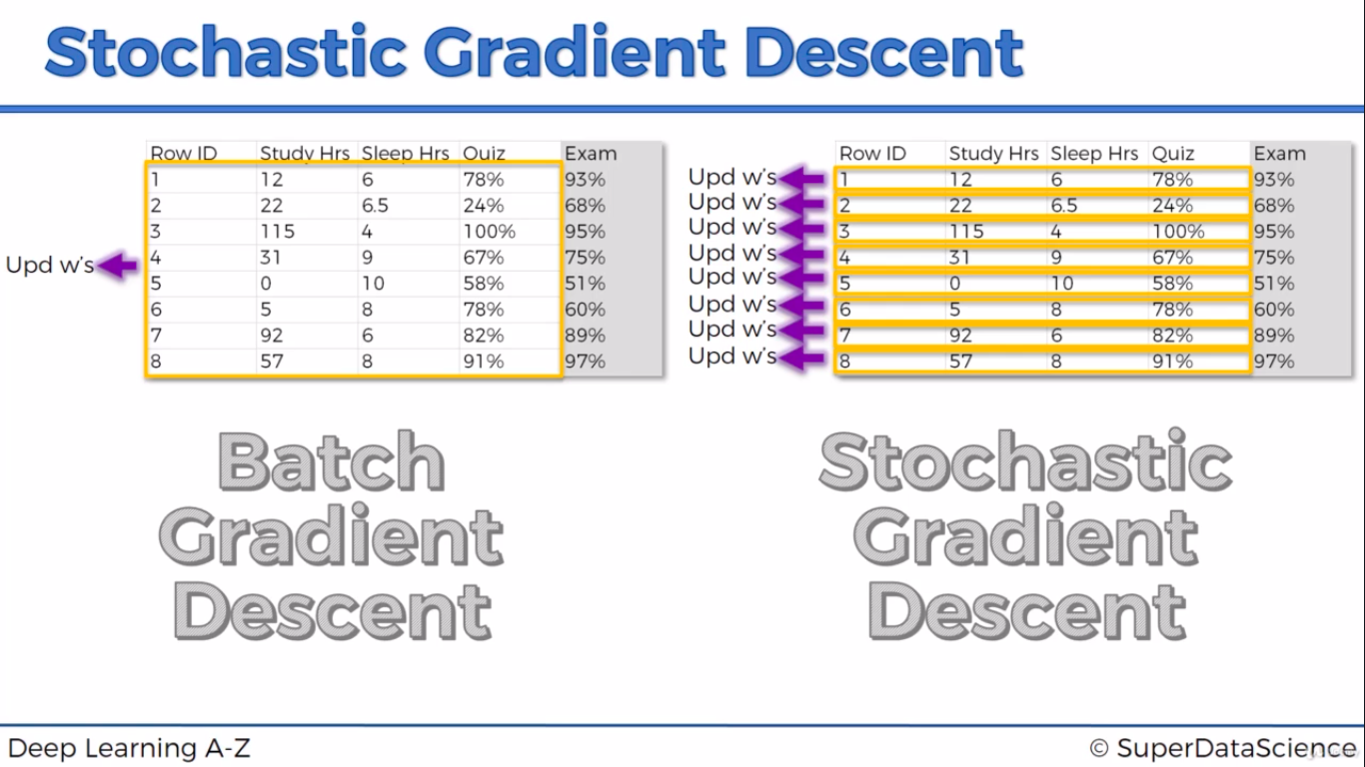

Convolutional Neural Networks
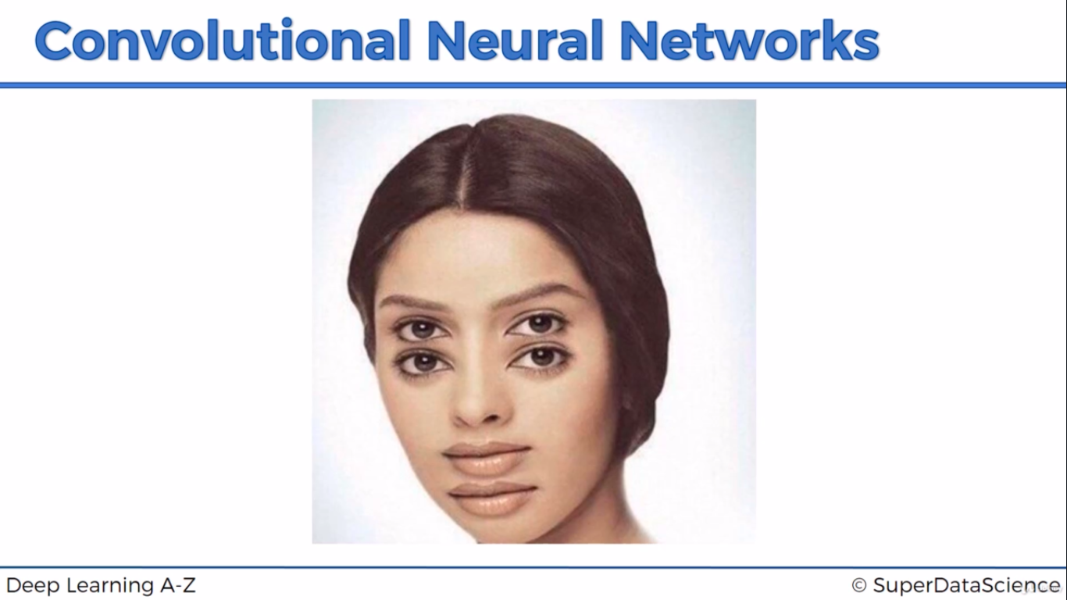
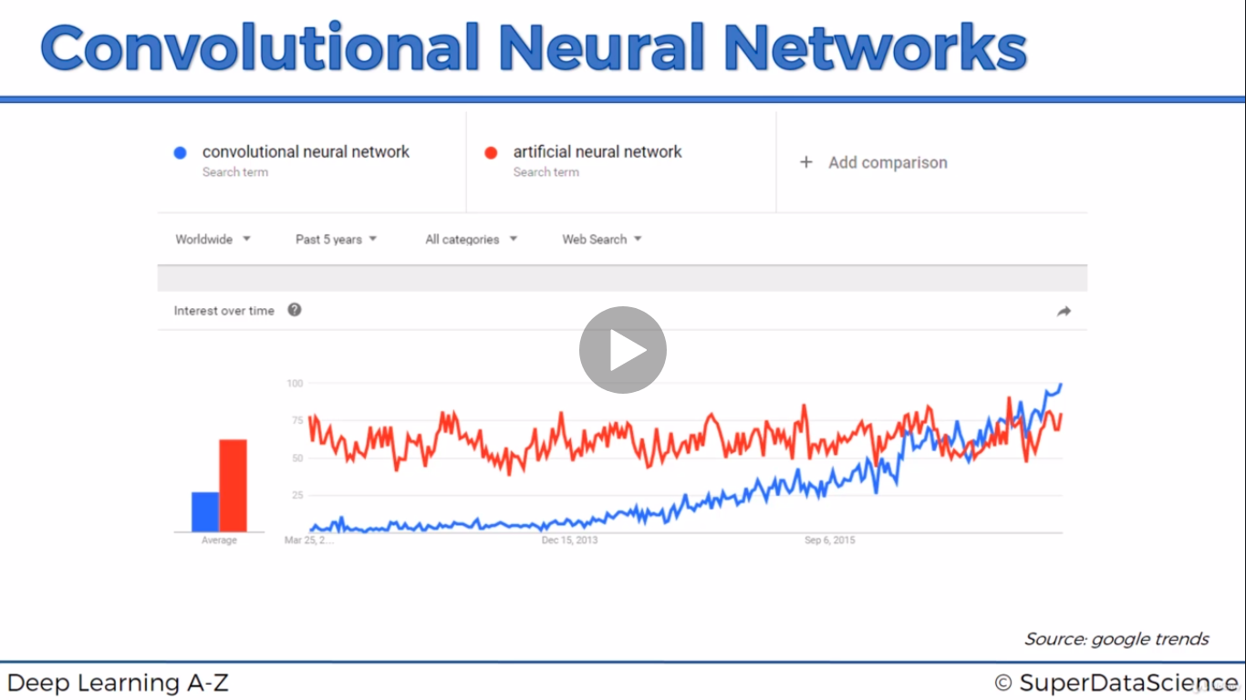
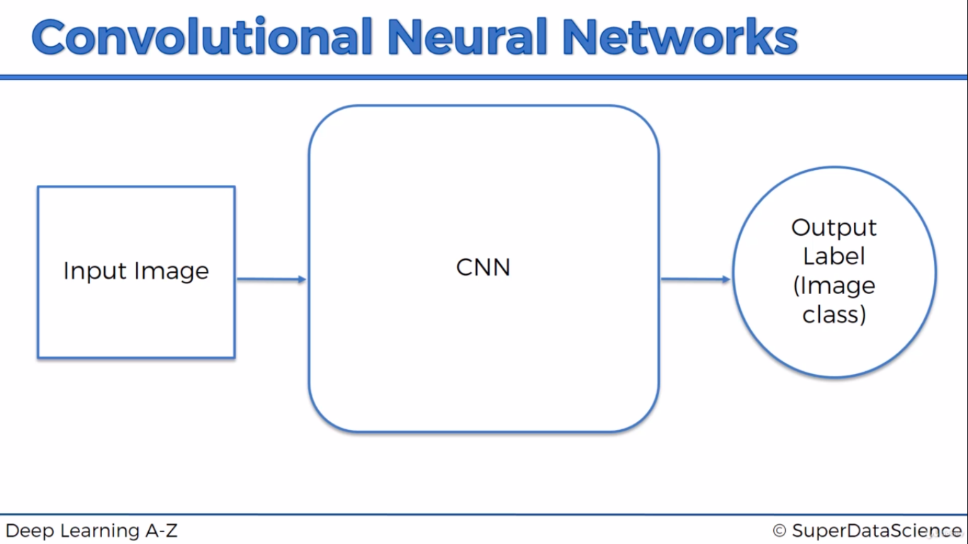
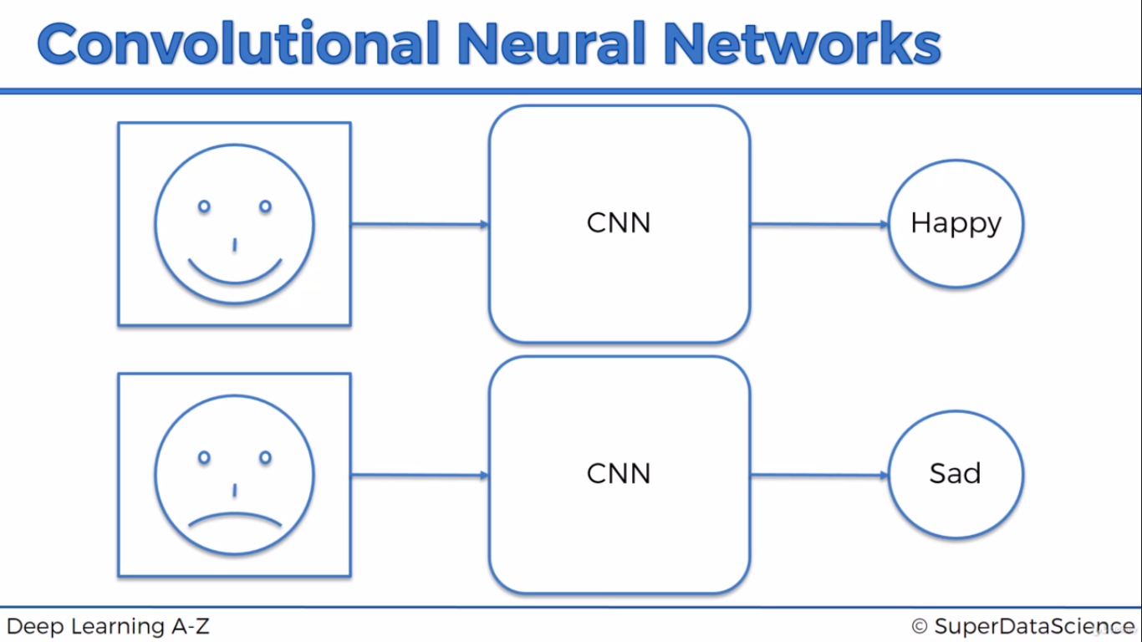

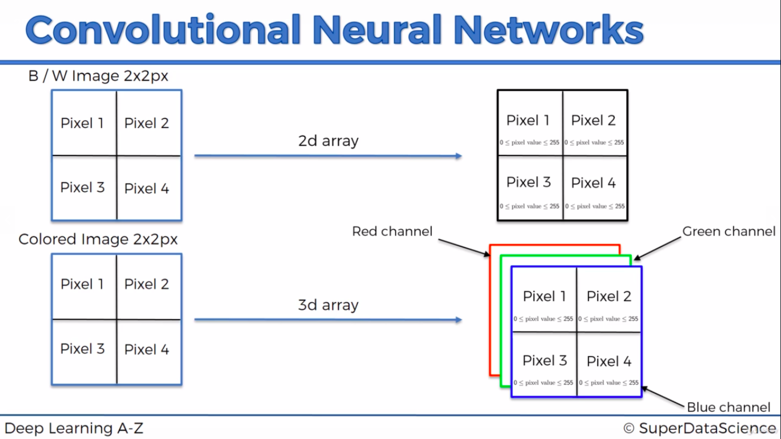
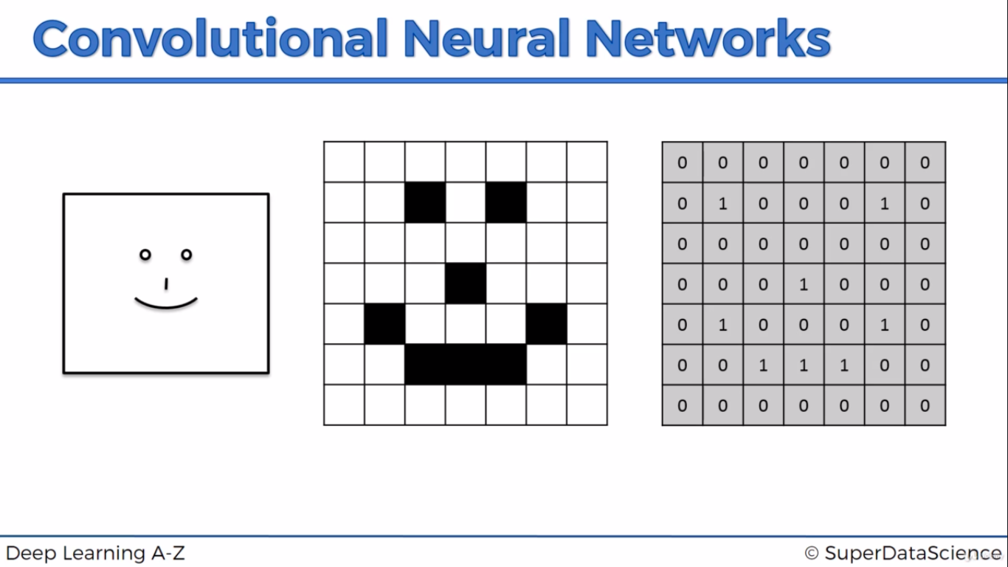

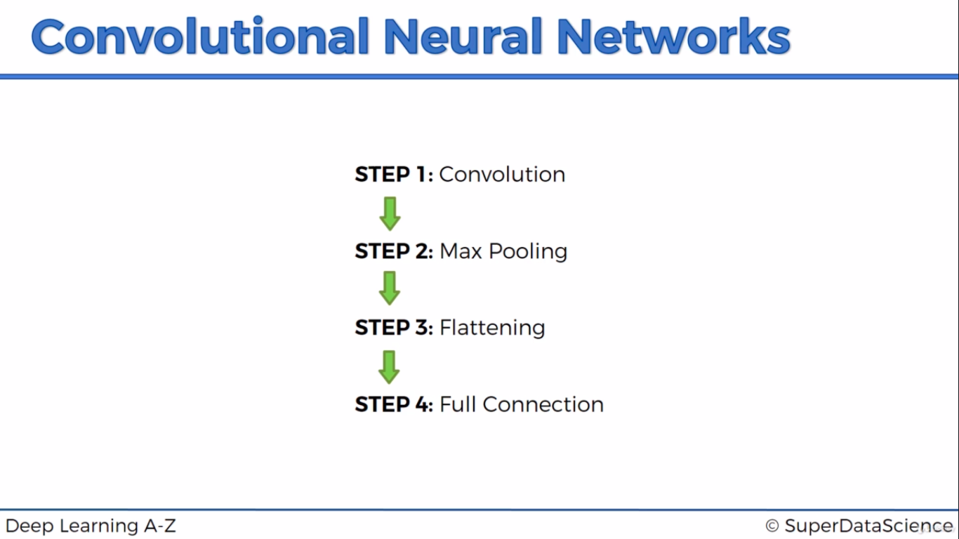

Step 1: Convolution
Primary purpose of convolution is to find features in image using feature detector and put it in feature map. Feature map still preserves spacial relationship between pixels. Sometimes it can’t be detected by human.
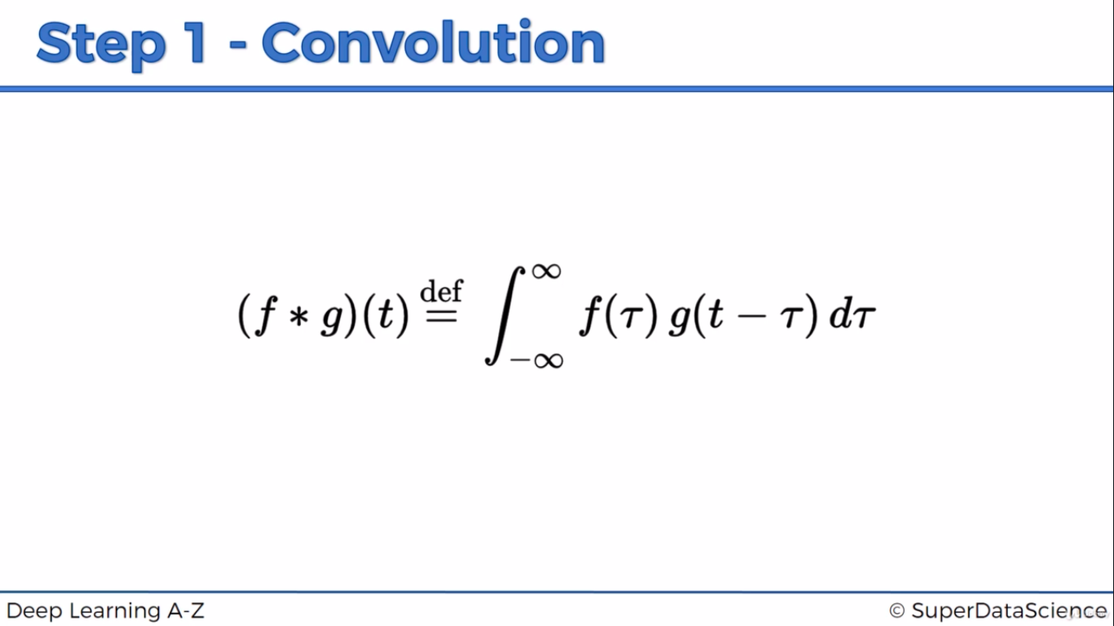
Each frame in input image compared with feature detector which has 1. If any element matches then feature map will be equal to no. Of matched row
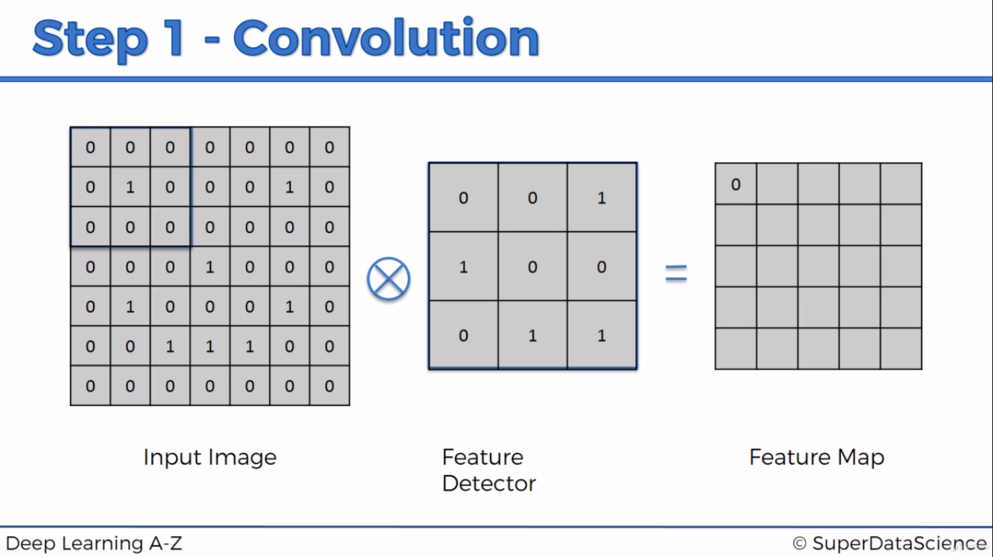

1(2x1) in input image is matched with 1(2x1) in feature detector, so feature map value will be 1
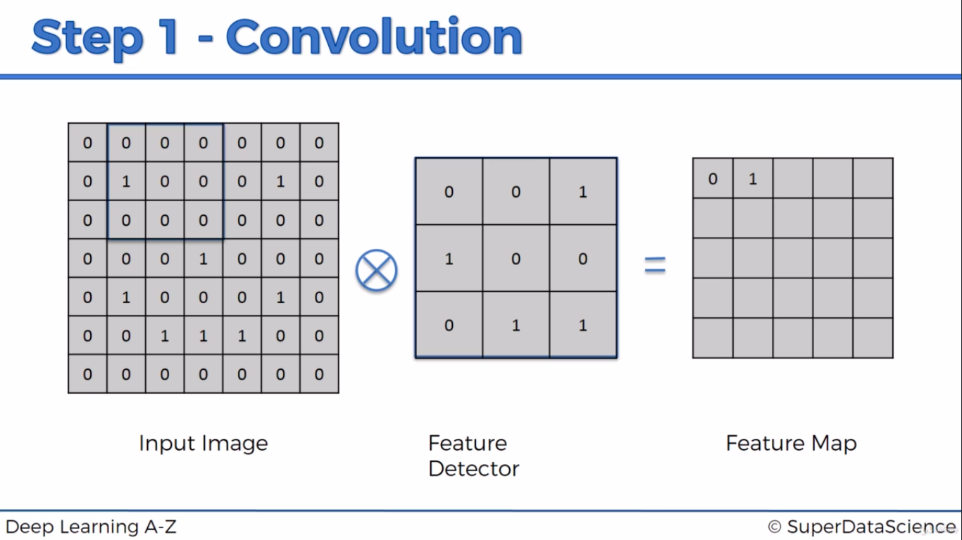

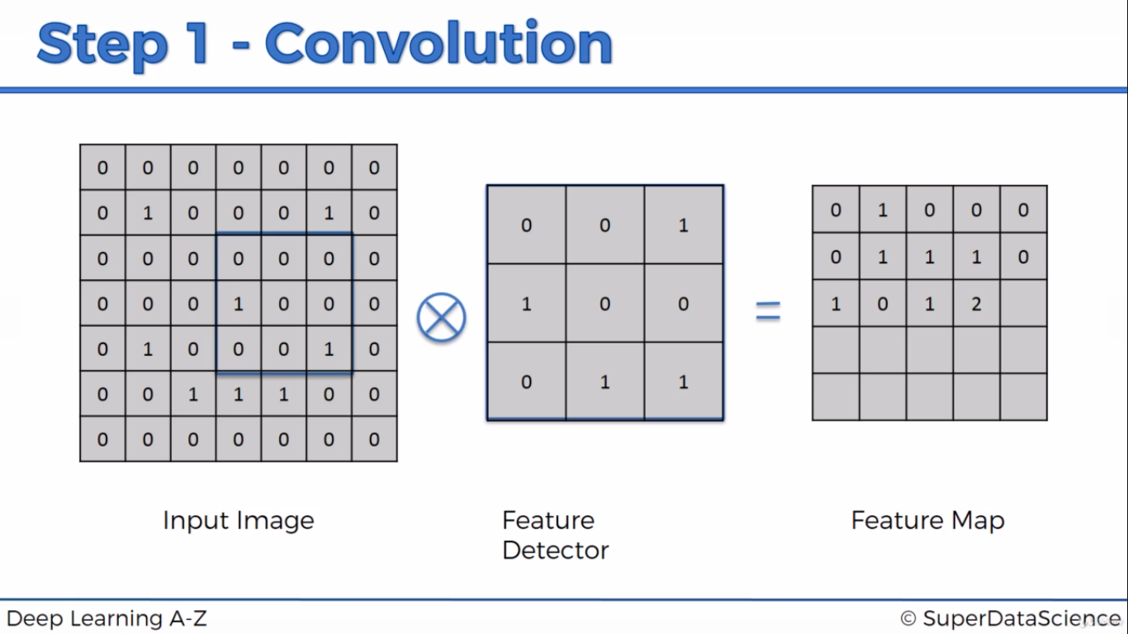
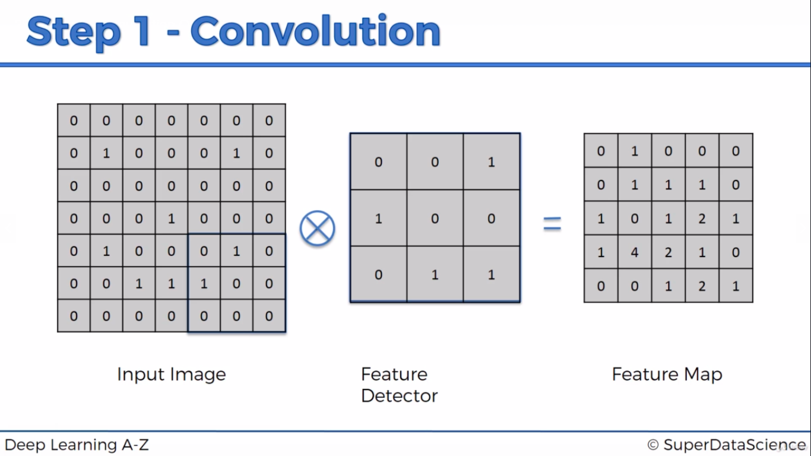
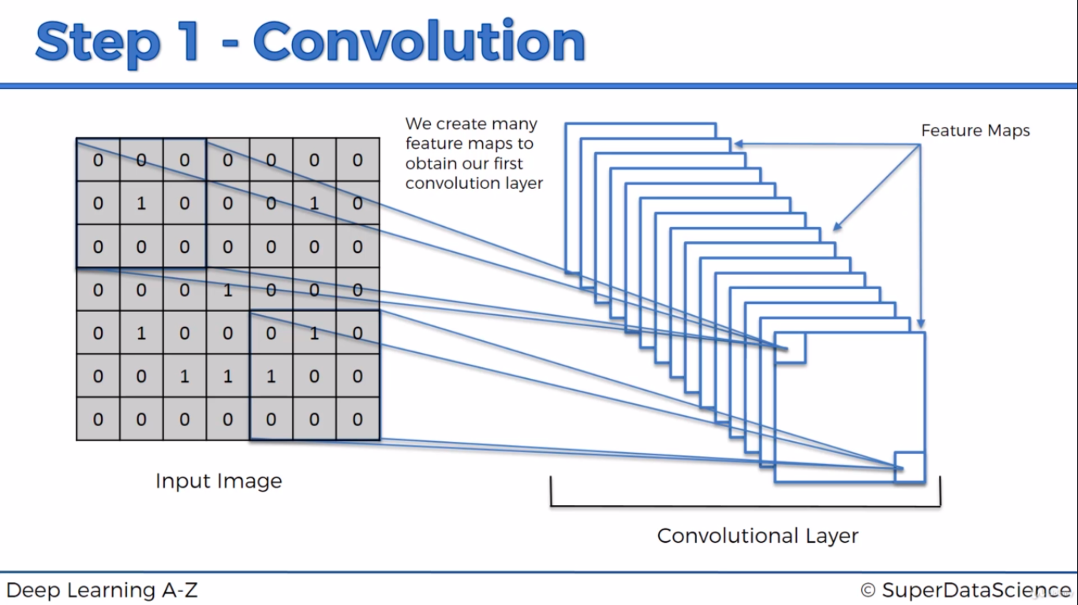
Same image(Taj Mahal) which uses different feature detector to get different set of feature maps
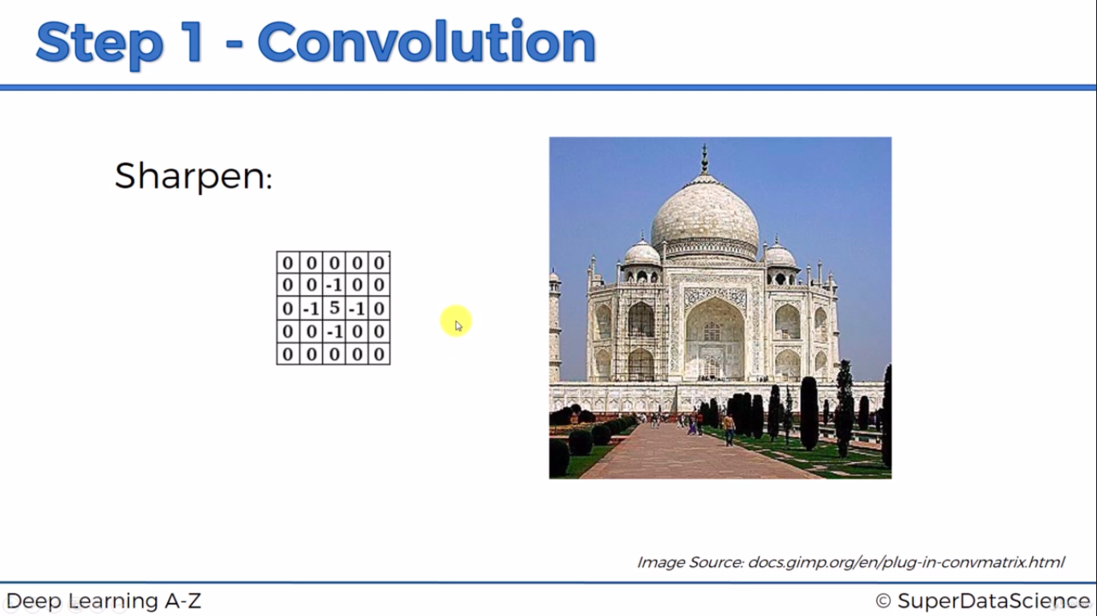
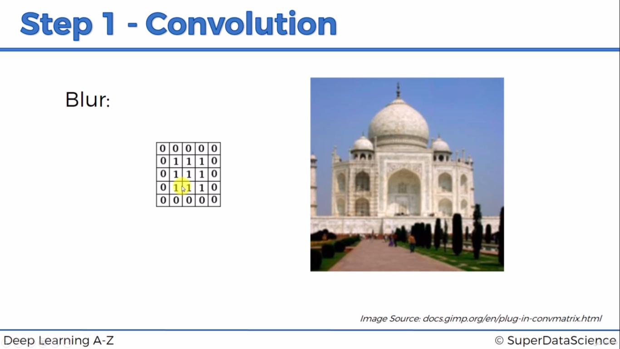
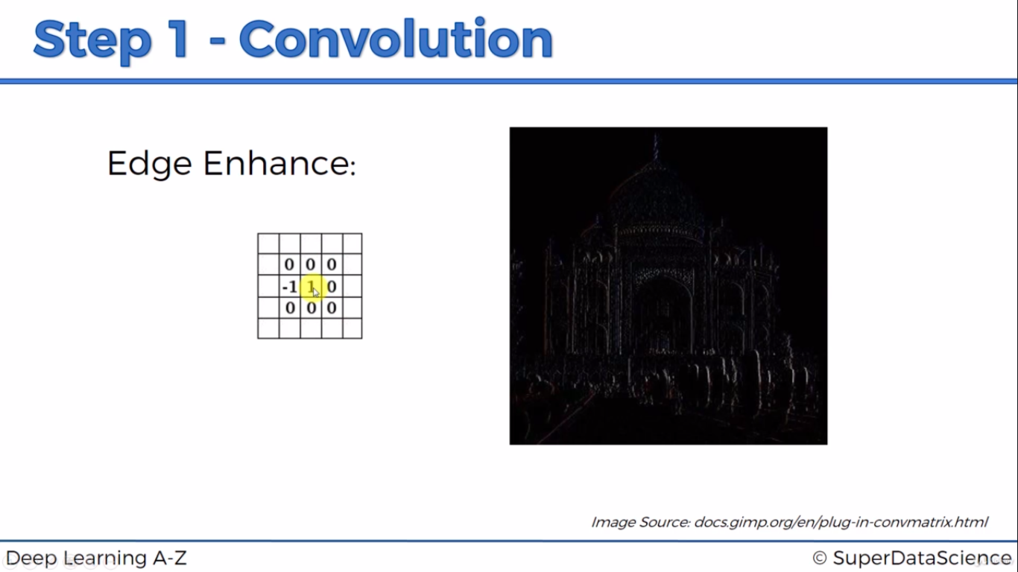
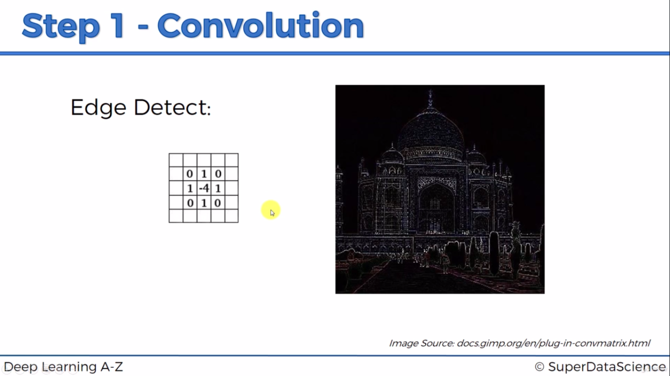
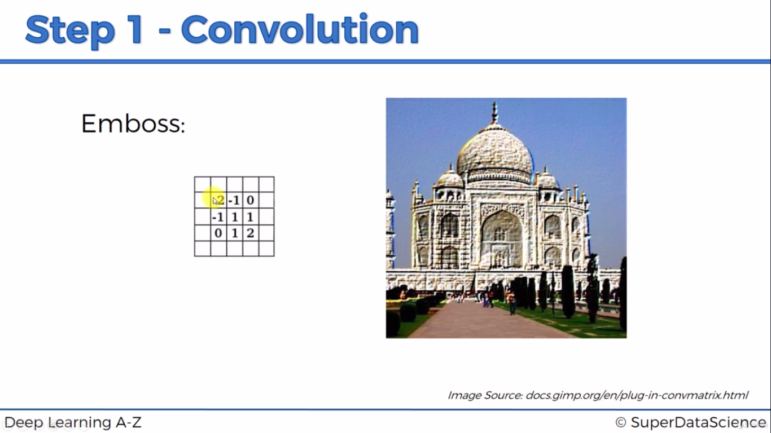
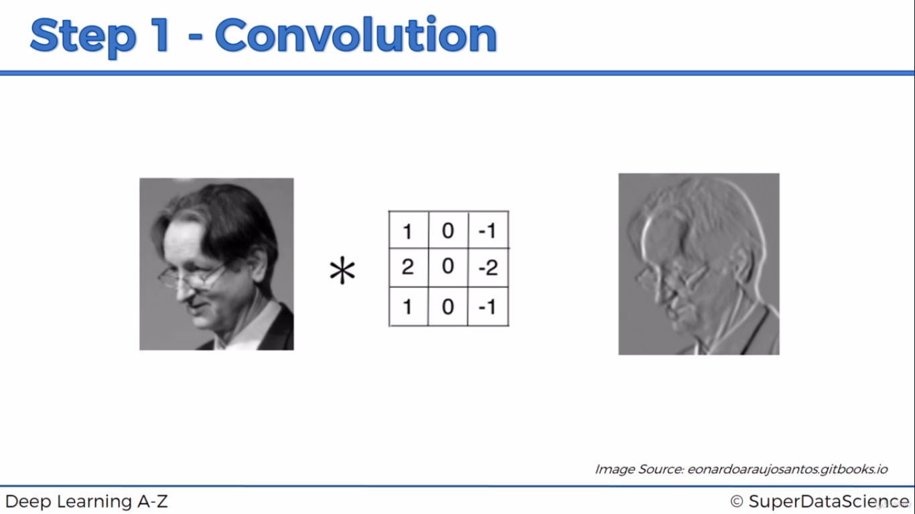

Step1(b): Relu Layer

Breakes linear to non-linear. Images are non-linear element.
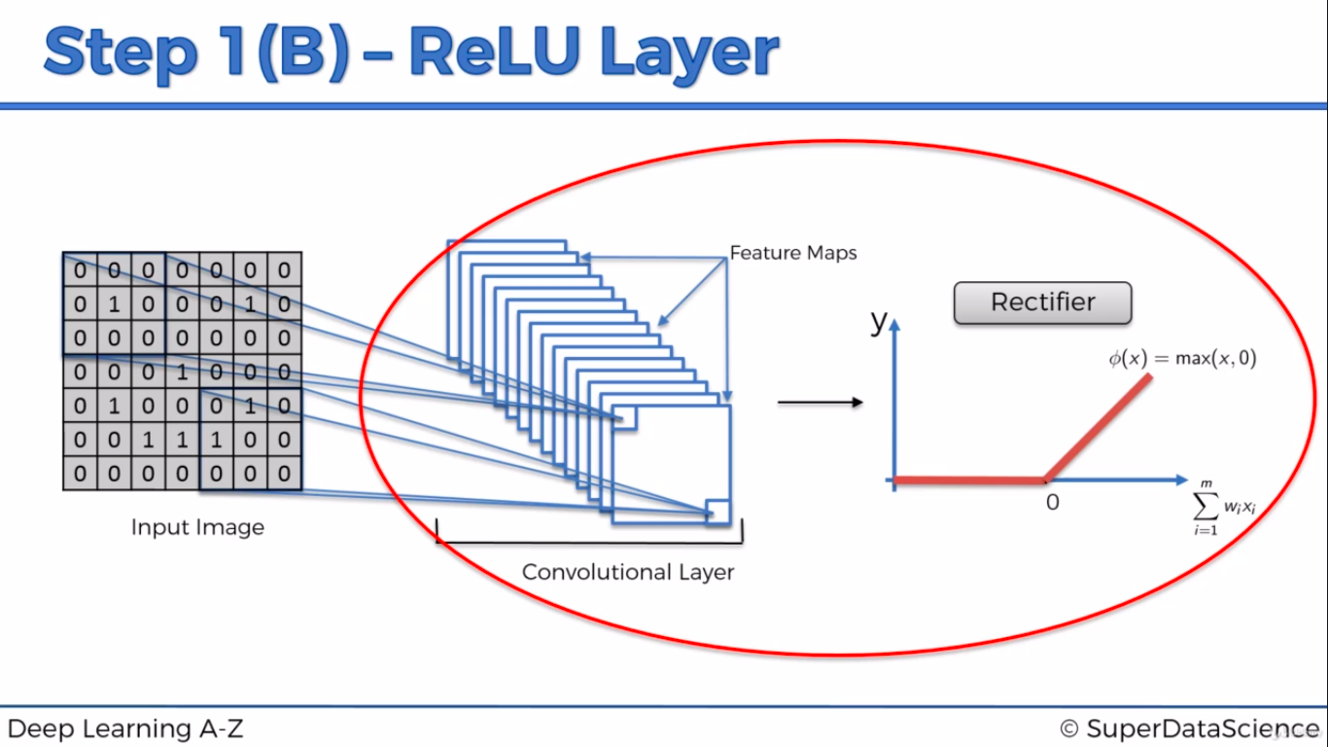
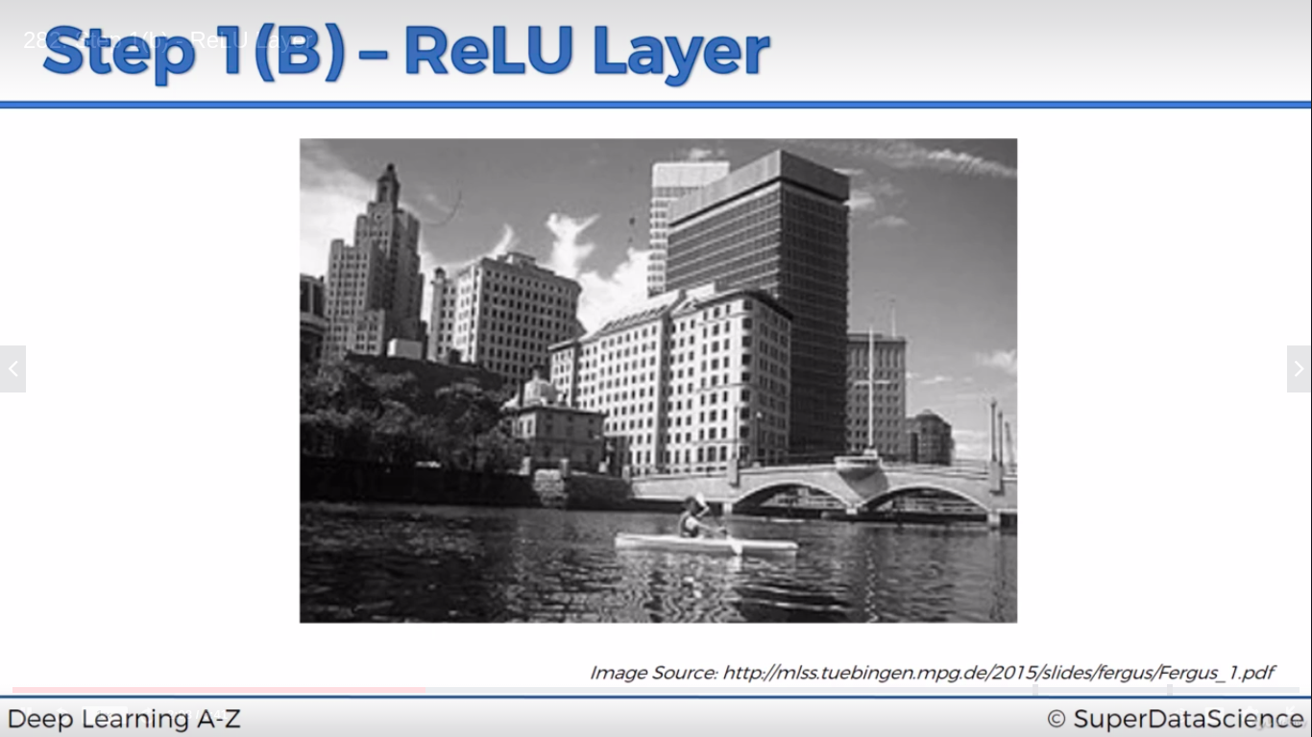
After applying feature detector:
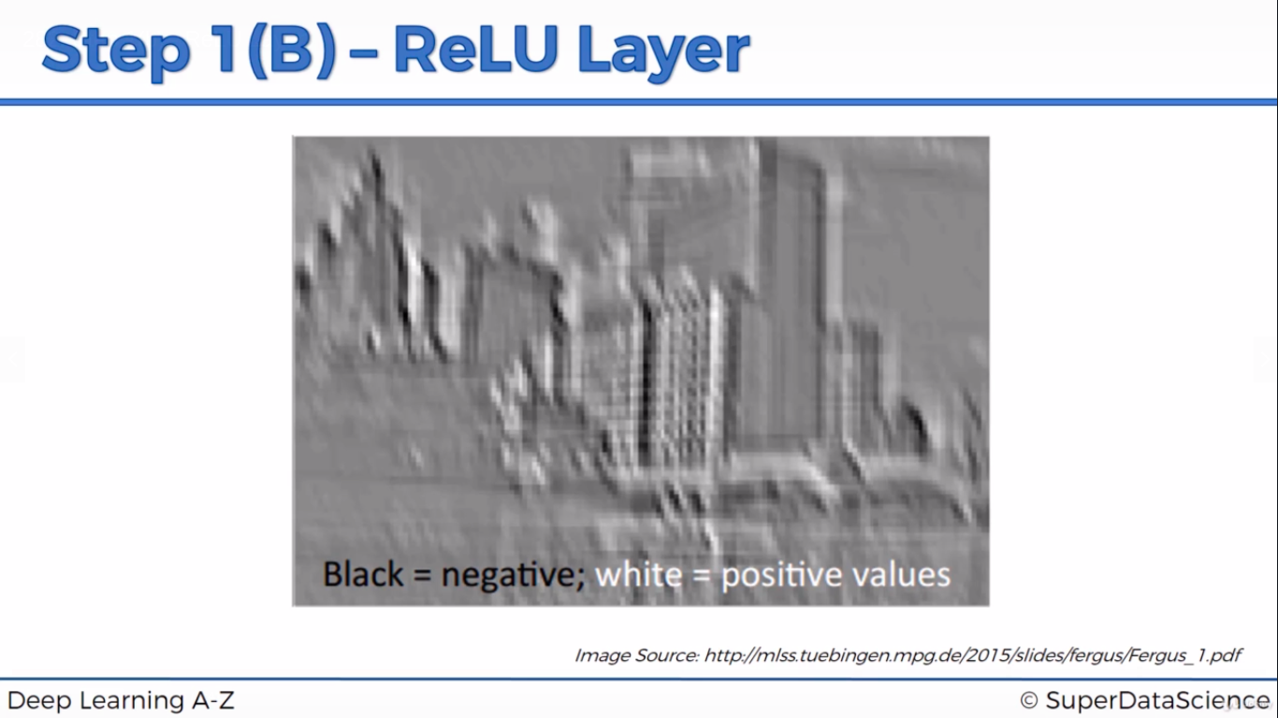
Rectified linear function will removes all blacks in pic since anything below zero will returns as 0

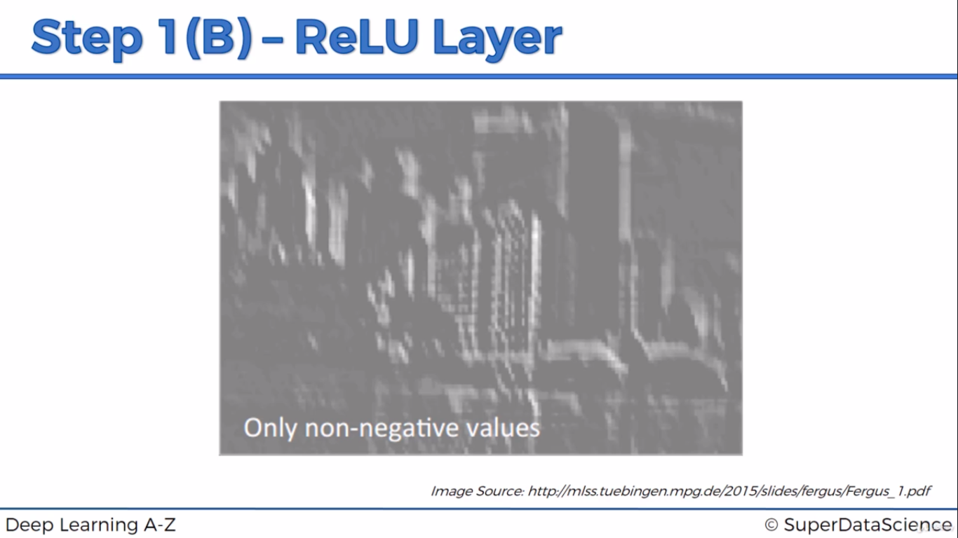

Step 2: Max pooling

We need to detect image as chettah irrespective of shape, orientation, direction, shades etc
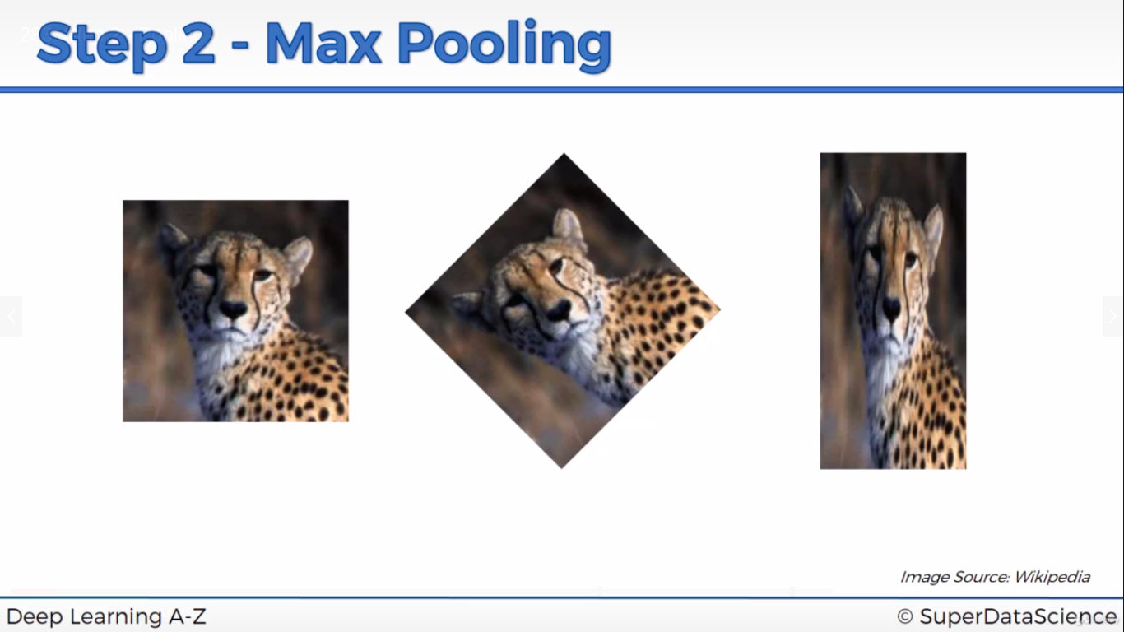
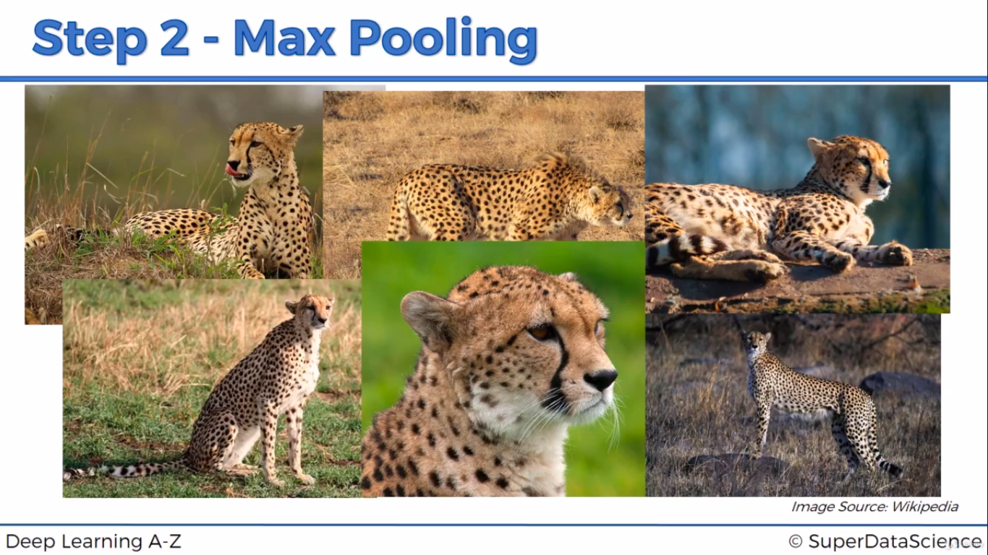

Feature Map is the result of previous convolution step. Selecting 2x2(which is commonly used) in this example. We may have nxn selection
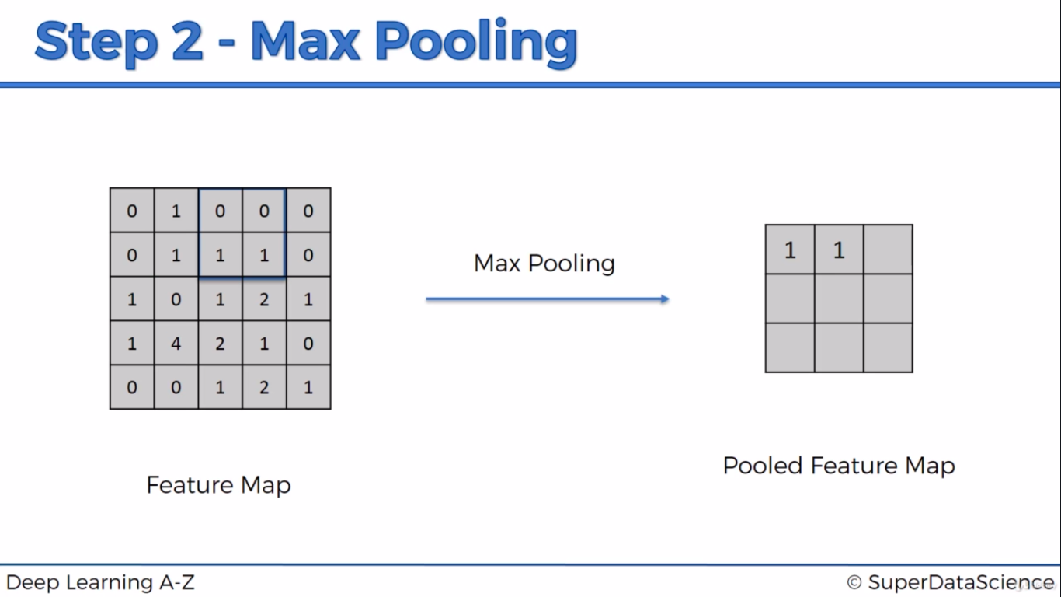
It picks maximum number in 2x2. It reduces noise to prevent overfitting. Max pooling takes only high important details in feature map by picking highest value
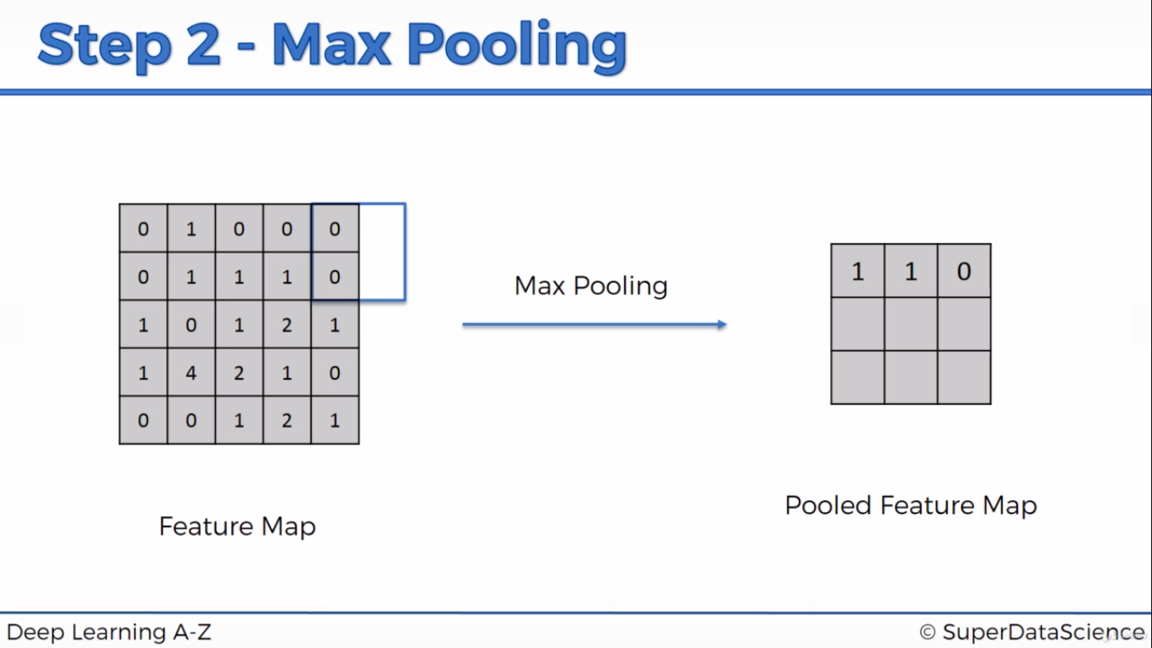
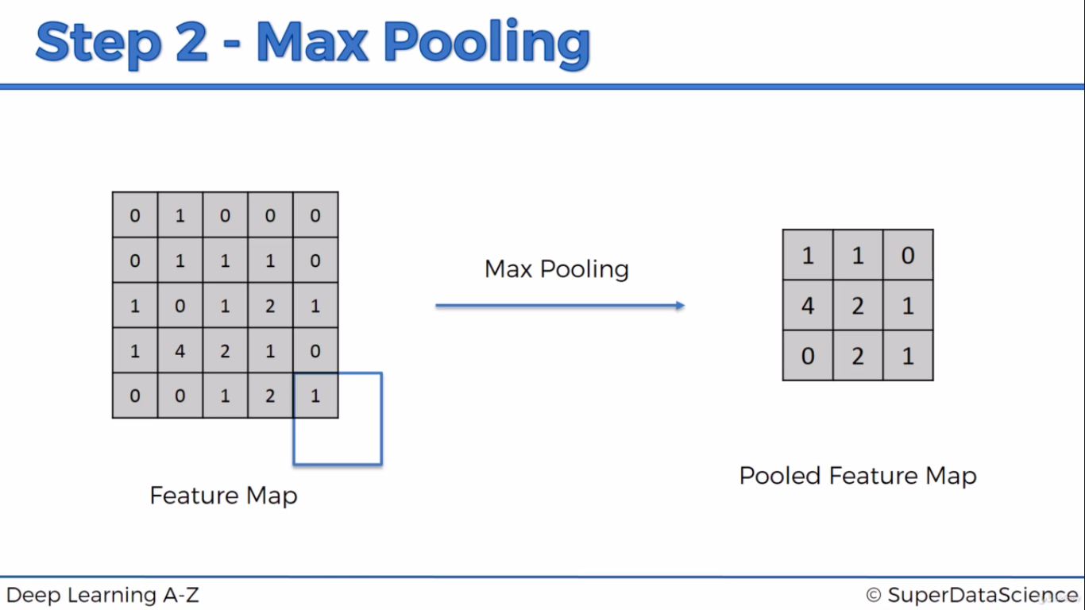
There is concept called sum pooling, mean pooling & sub-pooling. In below selection
Sum Pooling=6, Mean Pooling=6/4=1.5, sub pooling=
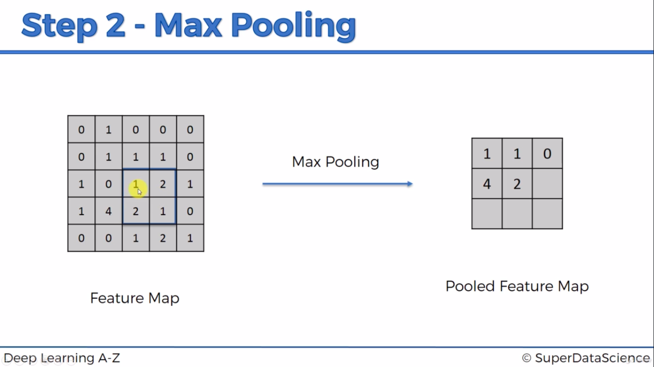
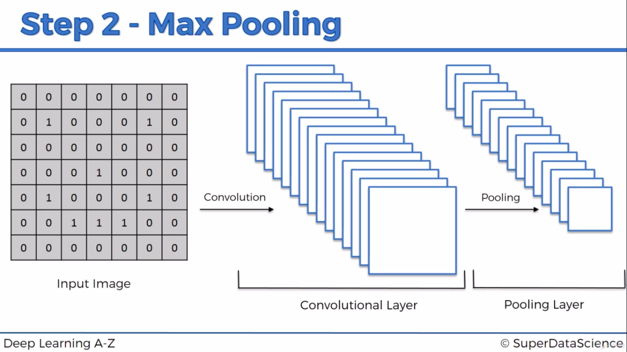

http://scs.ryerson.ca/~aharley/vis/conv/flat.html – Which provides details of all layer(Convolution, Pooling etc)

Step3: Flattening
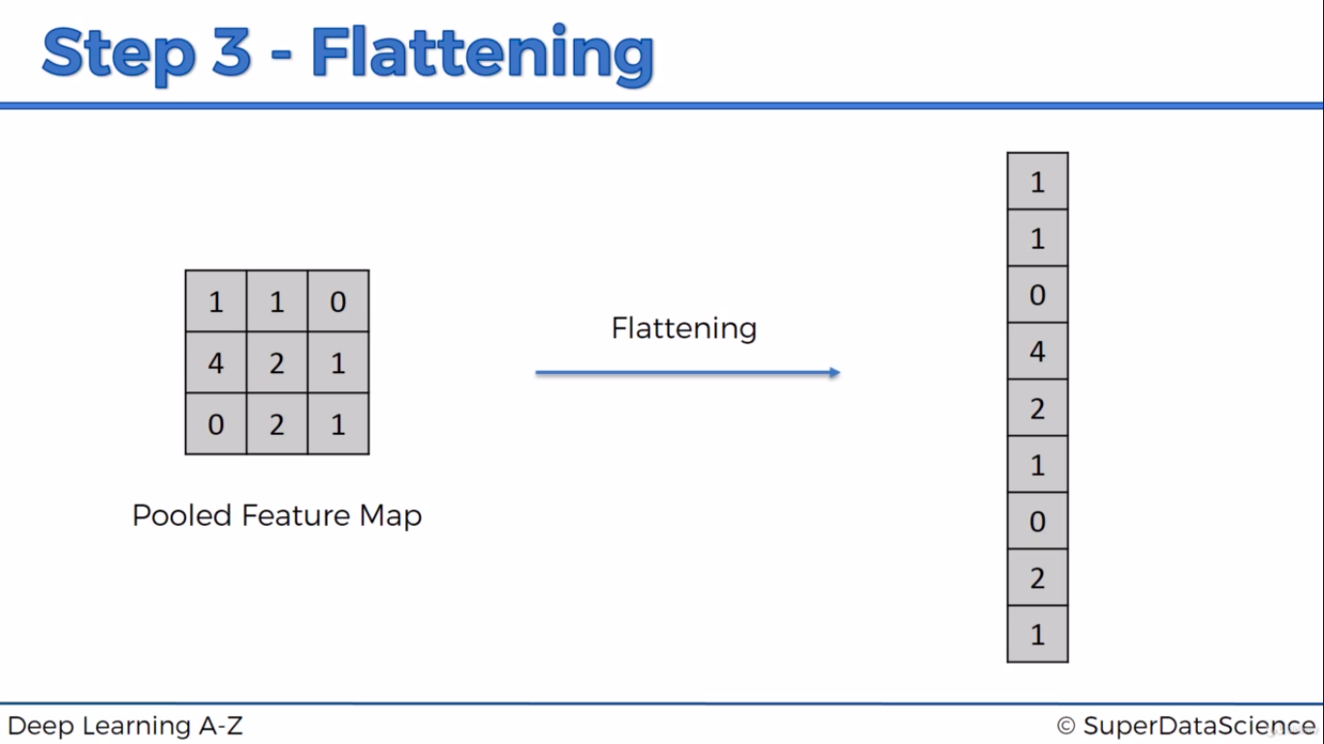
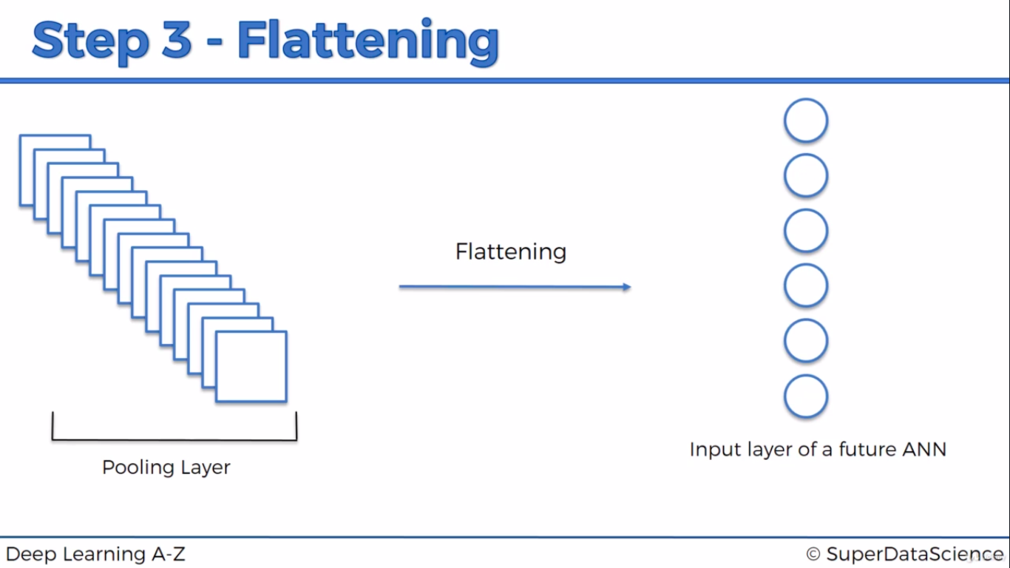
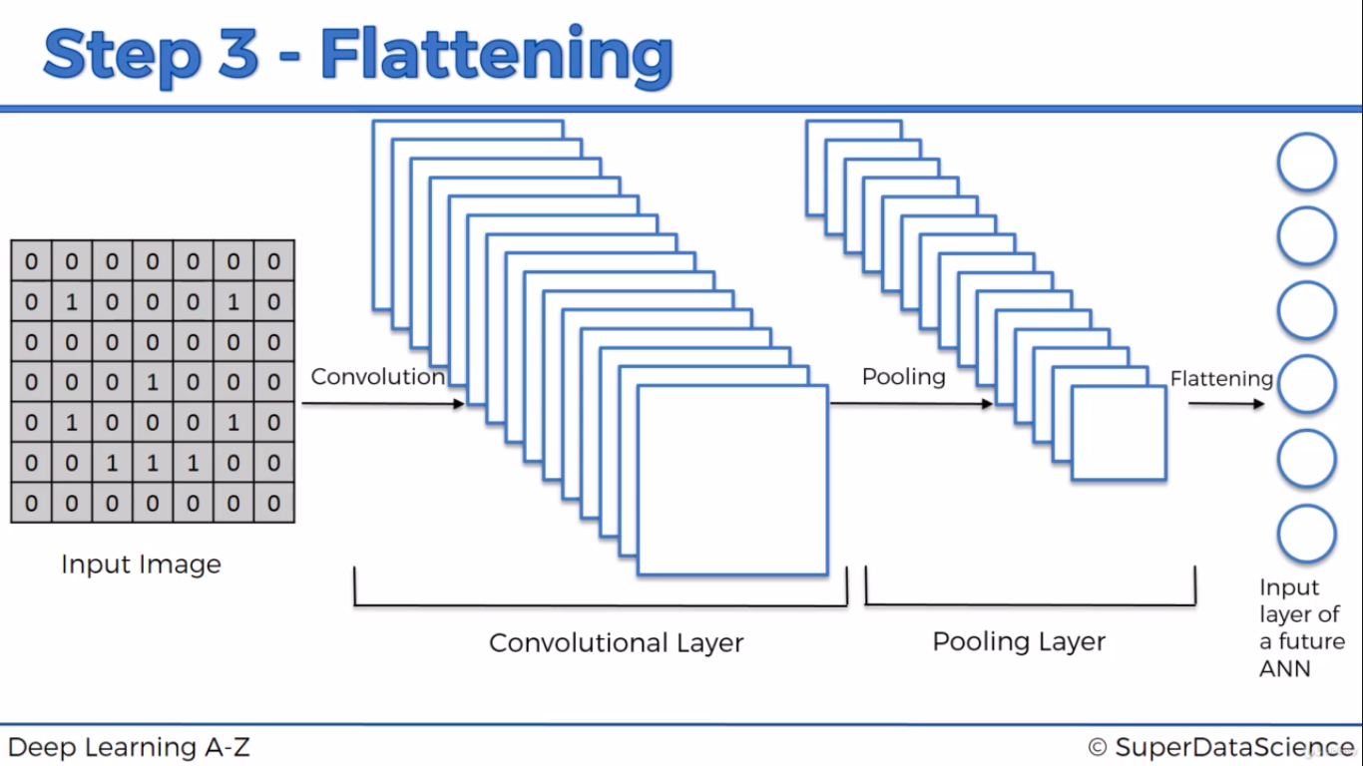

Step 4: Full connection
We have done Convolution, Pooling and Flattening which comes under convolution neutral network(CNN). Flattened object is then fed into ANN. In CNN, hidden layers should be fully connected layer.
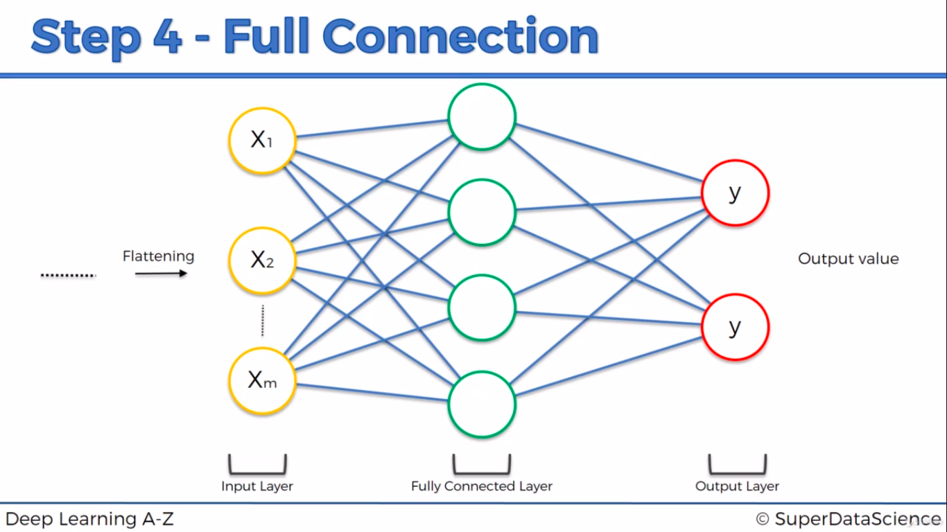

If ANN deals with Regression (or) binary classification(0 or 1), we will have only 1 output layer. If we are dealing with classification with multiple class(Dog, cat, Cow etc), we will have corresponding number of output layer
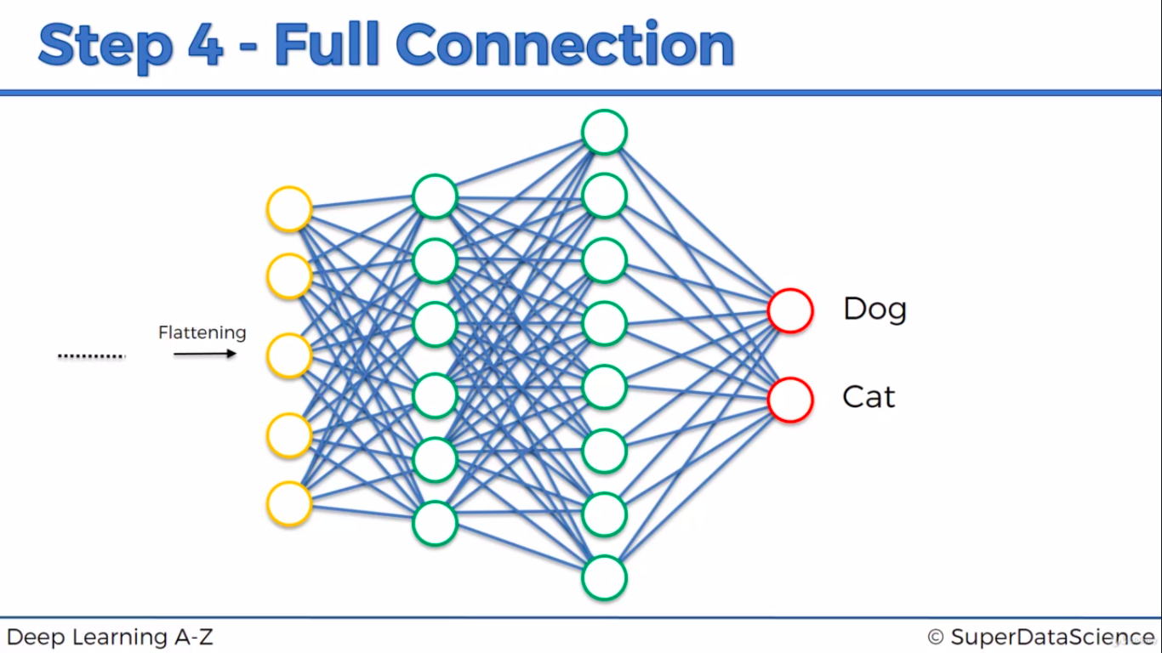
If dog pic is inputted, each neuron confidence level(it can b any value) to predict t pic as Dog(0-1 in this example). Each neuron will detecting the feature of dog(may be eyegrow, skin, eye, nose etc). These confidence level is acheived by iterating the row in dataset and doing multiple epoch.
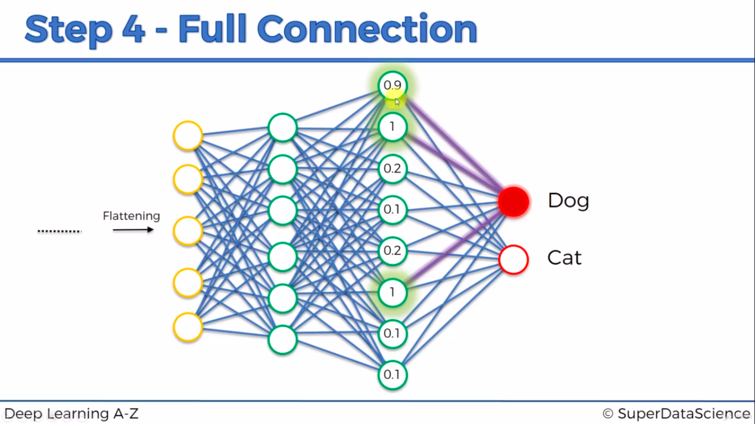

If input is cat image
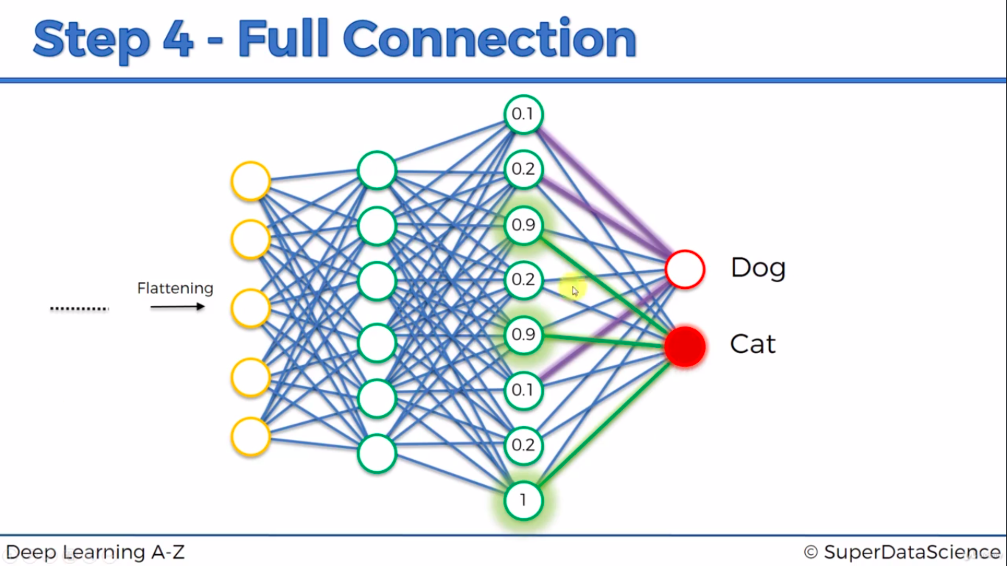
Last fully connected layer(numbered in below image) to output layer will vote it as either cat or dog
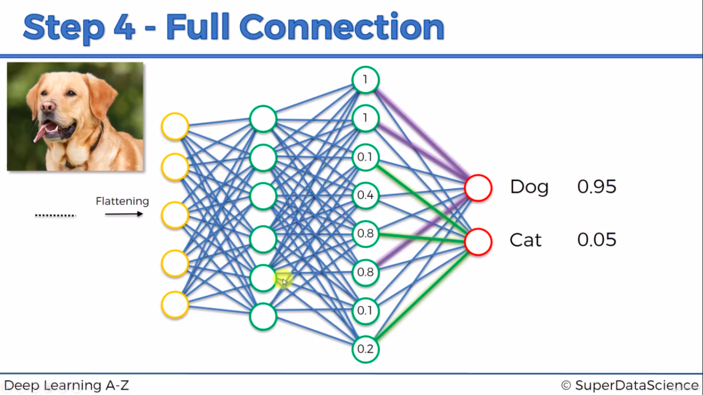
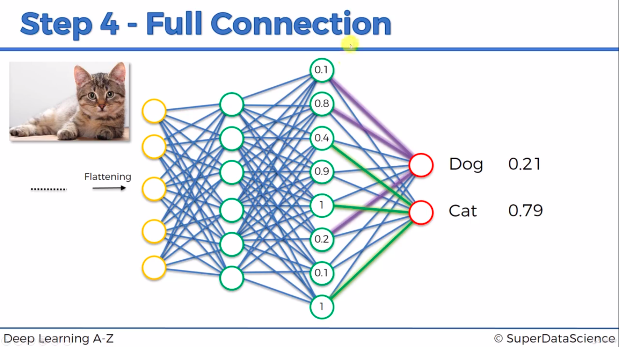
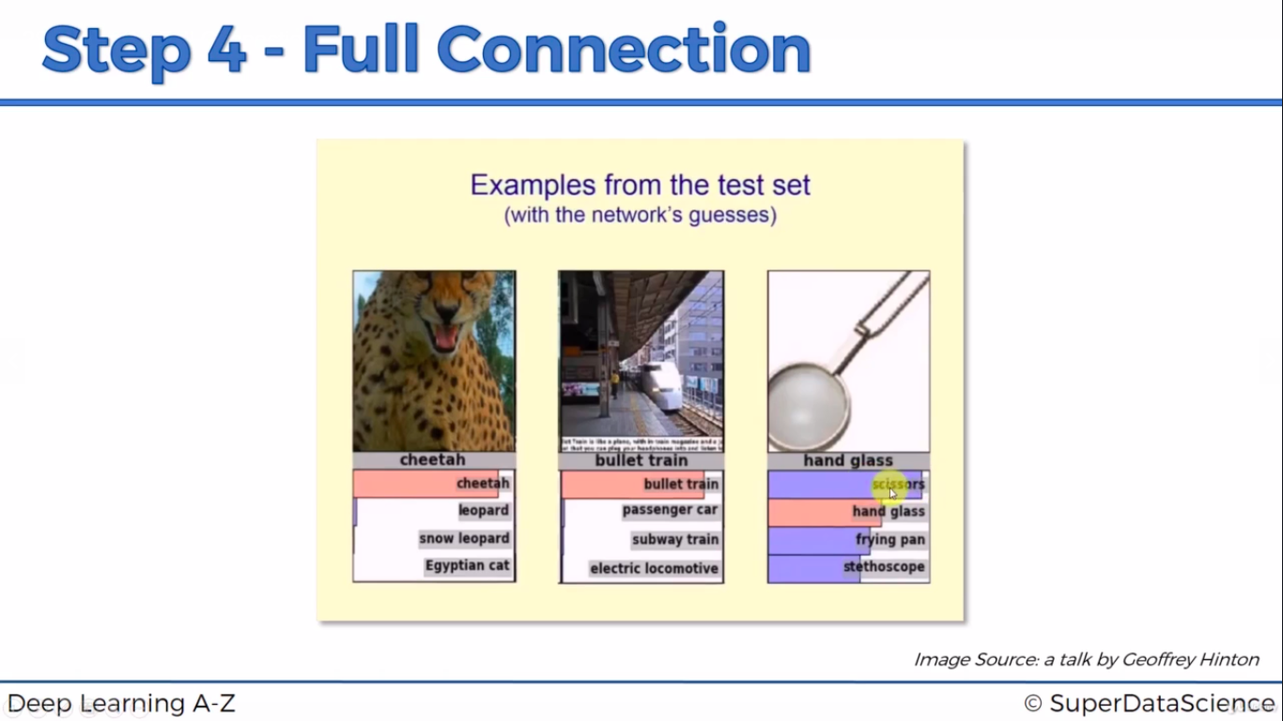

Summary


