5V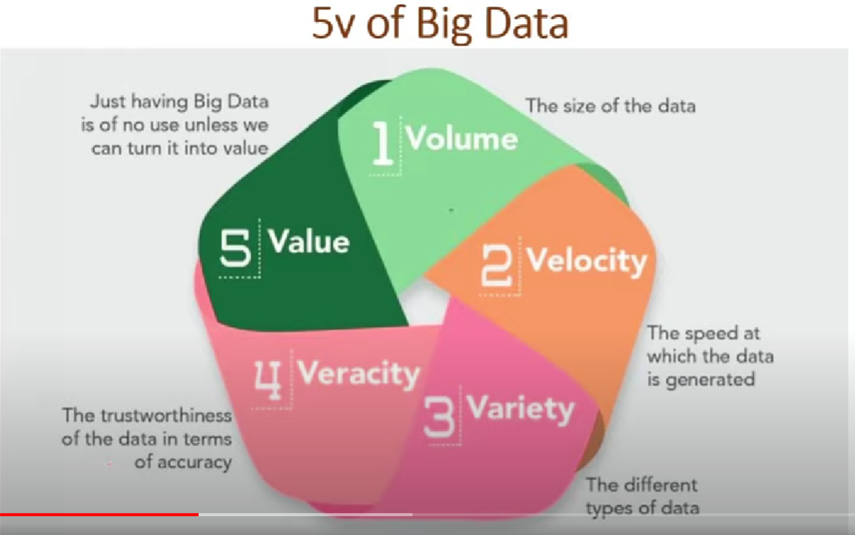

# Hadoop

HDFS – Hadoop Distributed File System. Large file is divided to multiple partitions to process further.