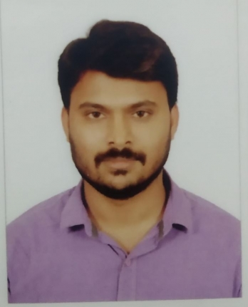

DOMAINS

Banking & Insurance

Telecom

Automotive

TOOLS

Jenkins  • TeamCity • JIRA • Xray • JAMA • Maven • Docker • Confluence • AWS• TFS • SVN • GIT

EDUCATION

Bachelor of Electronics and Communication Engineering (2009 – 2013) Govt College of Engineering - Bargur Anna University- Chennai

* KONE (Aug 2020 - Till Now)
* Test Automation Specialist
* Solution Tester via ITC InfoTech
* Hexaware Technologies (July 2018-Aug 2020)
* Senior Software Engineer
* Cognizant Technologies Solution (Sep 2016-July 2018)
* Programmer Analyst
* Pointel Solutions Pvt (Ltd) (Mar 2014-Sep 2016)
* Junior Software Tester
* Trainee Software Tester via Gadaget Solutions

Python: ⬆

Java: 

JavaScript: 

Selenium Web Driver: 

Cypress: 

REST API: 

APPIUM: 

Robot Framework: ⬆

Pytest: 

TESTNG: ⬆

Cucumber: 

SQL: 

PROFILE SUMMARY

SKILLS

A passionate Software Tester with 8 years of experience in software (IT) industry. Skilled in manual and automation testing. Extensive knowledge in Selenium with Java/Python/Robot Framework and Cypress with java script. Building scalable automated software testing frameworks, REST API, Docker and also worked as a freelancer with effective communication, leadership abilities and customer focus. Willing to learn and accept new challenges.

Phone: +(91) 900-345-0978

Email: [vinothgopal.qa@gmail.com](mailto:vinothgopal.qa@gmail.com)

LinkedIn: https://www.linkedin.com/in/vinoth-gopal-7620155a/

GitHub: <https://github.com/vinothgopal>

Hacker Raker: <https://www.hackerrank.com/VinothGopal?hr_r=1>

Portfolio: <https://vinothgopal.github.io/Portfolio>

WORK EXPERIENCE

Linkedln:

GitHub:

Portfolio:

Haker Racker:

VINOTH GOPAL