**Project**: Financial Dashboard Application – is designed to provide with a real time overview of all customer’s financial information including account balances and recent transaction history.

Application aggregates data from more than 2 APIs and displays in in User Interface.

**Back-end API:** There are 2 main API services such as Account & Transaction are used for retrieving/updating financial information via HTTP GET/POST operation. They are configured to work asynchronously, and they can be secured by using JWT token authentication. They can be further implemented to communicate with business & data layers;

**Front-end API:** The front-end APIs serves as a middle layer between Blazor UI and backend APIs.

Back-end API

1. Account

2. Transaction

Blazor Server UI

Front-end API

Shared Library

Make sure you have below settings before you run the application

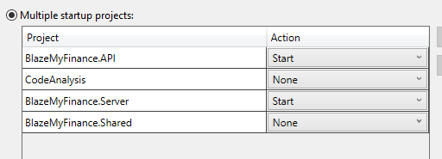

For console application, there are 2 programs/main method; comment one to test the other program.