Industrial Internship Report on
"Banking Information System"
Prepared by
vinothkumar.s

Executive Summary
This report provides details of the Industrial Internship provided by upskill Campus and The IoT Academy in collaboration with Industrial Partner UniConverge Technologies Pvt Ltd (UCT).
This internship was focused on a project/problem statement provided by UCT. We had to finish the project including the report in 6 weeks’ time.
My project was (Tell about ur Project)
This internship gave me a very good opportunity to get exposure to Industrial problems and design/implement solution for that. It was an overall great experience to have this internship.

TABLE OF CONTENTS
1 Preface 3
2 Introduction 4
2.1 About UniConverge Technologies Pvt Ltd 4
2.2 About upskill Campus 8
2.3 Objective 9
2.4 Reference 9
2.5 Glossary 10
3 Problem Statement 11
4 Existing and Proposed solution 12
5 Proposed Design/ Model 13
5.1 High Level Diagram (if applicable) 13
5.2 Low Level Diagram (if applicable) 13
5.3 Interfaces (if applicable) 13
6 Performance Test 14
6.1 Test Plan/ Test Cases 14
6.2 Test Procedure 14
6.3 Performance Outcome 14
7 My learnings 15
8 Future work scope 16

Preface
During the internship, I worked on the Banking Information System project using Java. The work involved understanding the problem statement, planning the application flow, implementing the banking operations, testing the program through different user inputs, documenting the solution, and submitting the project through GitHub.
An internship provides an opportunity to connect academic learning with practical software development. It helps students understand how programming concepts are applied to solve problems, how to test an application, how to document work, and how to use development and version-control platforms such as GitHub.
The project addresses the need for a simple banking application that can perform essential account operations through a clear menu-driven interface. The system demonstrates how account information and balance-related operations can be managed using Java classes and methods.
The internship program provided an opportunity to work on a defined project, develop a practical solution, prepare technical documentation, and submit the implementation through GitHub. The program also provided exposure to an industry-oriented workflow.
The project work was planned in stages: understand the requirement, identify the required Java concepts, design the account and menu flow, implement the operations, compile and execute the program, test normal and invalid inputs, document the results, and submit the source code and report through GitHub.
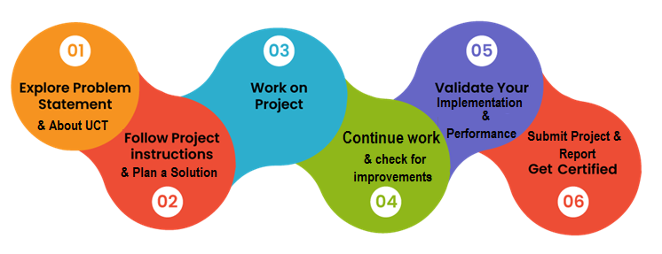
I gained practical experience in Java programming, object-oriented programming, console application development, testing, debugging, technical documentation, and GitHub-based project submission. The project also improved my confidence in converting a simple requirement into a working program.
I sincerely thank the internship organizers, mentors, faculty members, and everyone who supported and guided me during the internship and helped me complete the project and documentation.
My message to juniors and peers is to use internships as an opportunity to practice what is learned in class. Building and testing even a small project can improve programming confidence and provide useful experience with real development workflows.

Introduction

About UniConverge Technologies Pvt Ltd
A company established in 2013 and working in Digital Transformation domain and providing Industrial solutions with prime focus on sustainability and RoI.
For developing its products and solutions it is leveraging various Cutting Edge Technologies e.g. Internet of Things (IoT), Cyber Security, Cloud computing (AWS, Azure), Machine Learning, Communication Technologies (4G/5G/LoRaWAN), Java Full Stack, Python, Front end etc.

- UCT IoT Platform ()
UCT Insight is an IOT platform designed for quick deployment of IOT applications on the same time providing valuable “insight” for your process/business. It has been built in Java for backend and ReactJS for Front end. It has support for MySQL and various NoSql Databases.
- It enables device connectivity via industry standard IoT protocols - MQTT, CoAP, HTTP, Modbus TCP, OPC UA
- It supports both cloud and on-premises deployments.
It has features to
• Build Your own dashboard
• Analytics and Reporting
• Alert and Notification
• Integration with third party application(Power BI, SAP, ERP)
• Rule Engine

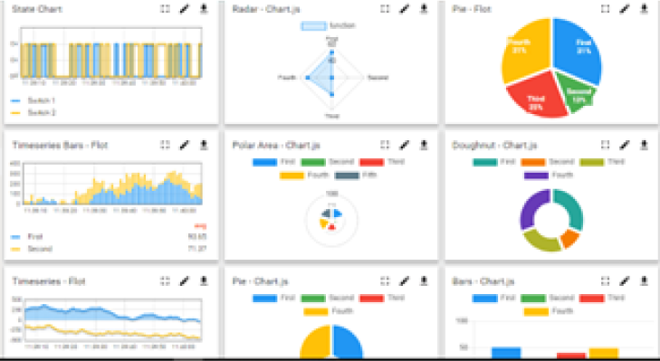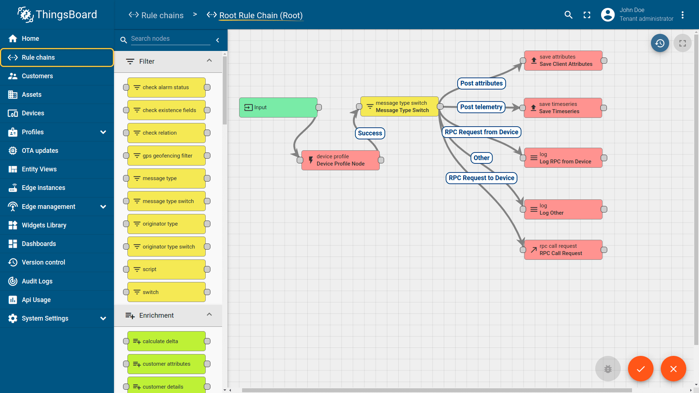

- Smart Factory Platform ()
Factory watch is a platform for smart factory needs.
It provides Users/ Factory
- with a scalable solution for their Production and asset monitoring
- OEE and predictive maintenance solution scaling up to digital twin for your assets.
- to unleased the true potential of the data that their machines are generating and helps to identify the KPIs and also improve them.
- A modular architecture that allows users to choose the service that they what to start and then can scale to more complex solutions as per their demands.
Its unique SaaS model helps users to save time, cost and money.
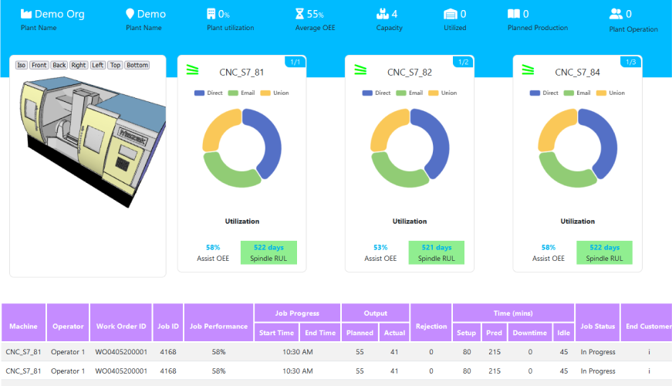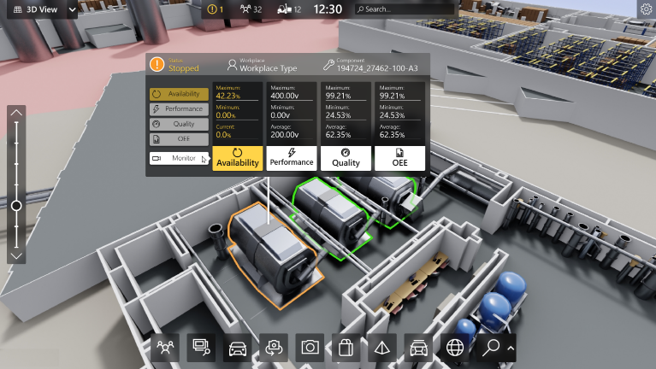

-  based Solution
UCT is one of the early adopters of LoRAWAN teschnology and providing solution in Agritech, Smart cities, Industrial Monitoring, Smart Street Light, Smart Water/ Gas/ Electricity metering solutions etc.
- Predictive Maintenance
UCT is providing Industrial Machine health monitoring and Predictive maintenance solution leveraging Embedded system, Industrial IoT and Machine Learning Technologies by finding Remaining useful life time of various Machines used in production process.
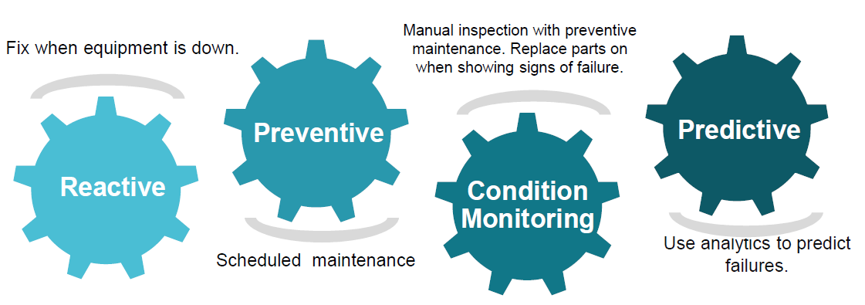

About upskill Campus (USC)
upskill Campus along with The IoT Academy and in association with Uniconverge technologies has facilitated the smooth execution of the complete internship process.
USC is a career development platform that delivers personalized executive coaching in a more affordable, scalable and measurable way.




Seeing need of upskilling in self paced manner along-with additional support services e.g. Internship, projects, interaction with Industry experts, Career growth Services
https://www.upskillcampus.com/
upSkill Campus aiming to upskill 1 million learners in next 5 year

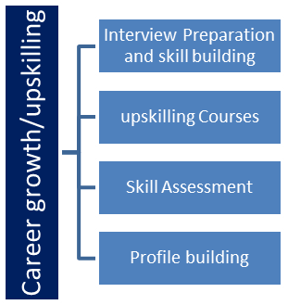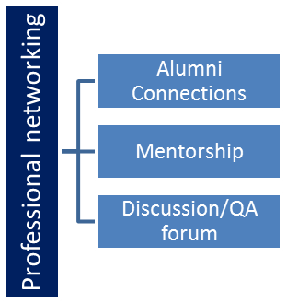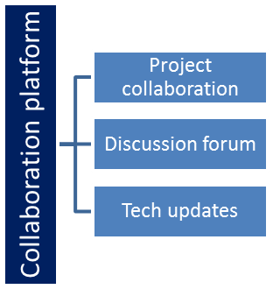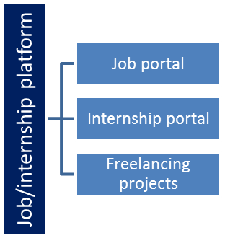

The IoT Academy
The IoT academy is EdTech Division of UCT that is running long executive certification programs in collaboration with EICT Academy, IITK, IITR and IITG in multiple domains.

Objectives of this Internship program
The objective for this internship program was to
☛ get practical experience of working in the industry.
☛ to solve real world problems.
☛ to have improved job prospects.
☛ to have Improved understanding of our field and its applications.
☛ to have Personal growth like better communication and problem solving.

Reference
[1]
[2]
[3]

Glossary
Terms | Acronym

Problem Statement
In the assigned problem statement
Basic banking operations require reliable handling of account information and balance updates. A beginner-friendly banking application should provide a simple interface for performing common operations while applying basic validation rules.
The problem addressed by this project is to design and implement a console-based Banking Information System in Java that can accept an account number and account holder name and provide the following operations:
• Deposit money into the account.
• Withdraw money when sufficient balance is available.
• Check the current account balance.
• Display account details.
• Exit the application safely.
The application is intended as a learning-oriented implementation and does not represent a production banking system. It does not use a database, online banking services, authentication, or real financial transactions.

Existing and Proposed solution

Existing banking systems are generally full-scale applications connected to databases and secure banking infrastructure. They support many features such as customer management, authentication, transaction processing, account history, and integration with financial services. Such systems are much more complex than required for a basic learning project.
For this project, the limitation of a simple console implementation is that account information exists only during the current program execution. It does not provide persistent storage, multiple-user management, authentication, or online transaction processing.
The proposed solution is a menu-driven Java application containing a BankAccount class and a BankingInformationSystem main class. The BankAccount class stores account information and provides methods for deposit, withdrawal, balance checking, and displaying details. The main class handles user input and controls the menu using a loop and switch-case statements.
The project provides a clear implementation of core Java and object-oriented programming concepts in a practical banking scenario. It also provides a base that can be extended later with persistent storage, multiple accounts, transaction history, authentication, a graphical or web interface, and stronger input validation.

Code submission (Github link): https://github.com/vinothlabs-dev/upskillcampus/blob/main/BankingInformationSystem.java

Report submission (Github link): https://github.com/vinothlabs-dev/upskillcampus/blob/main/BankingInformationSystem_vinothkumar.s_USC_UCT.docx

Proposed Design/ Model

The system starts by accepting the account number and account holder name. A BankAccount object is created with an initial balance of zero. The application then displays a menu repeatedly until the user selects Exit. For a deposit, the entered amount is validated and added to the balance. For a withdrawal, the amount is checked against the current balance before the balance is reduced. The user can also check the balance or display the complete account details.

High Level Diagram (if applicable)

Figure 1: HIGH LEVEL DIAGRAM OF THE BANKING INFORMATION SYSTEM
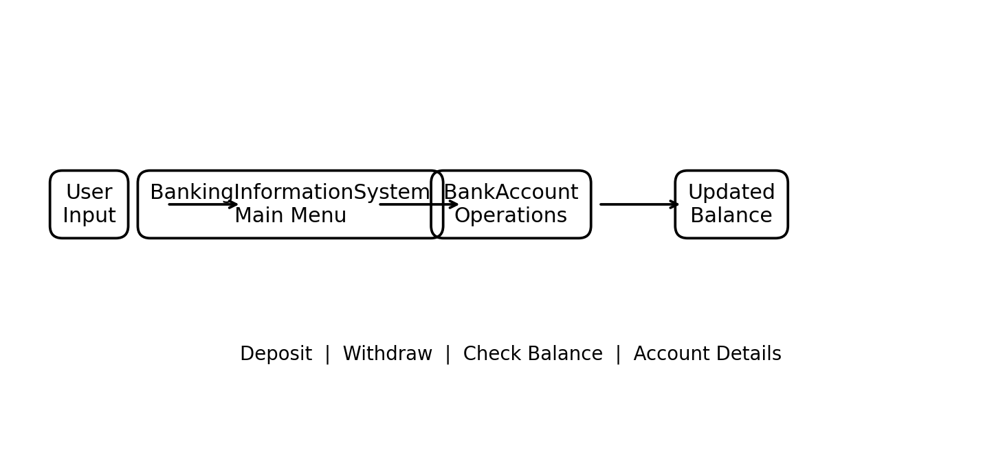

Low Level Diagram (if applicable)

Interfaces (if applicable)
The application uses console-based input and output. Data flow begins with user input, moves to the main menu, and then to the relevant BankAccount method. The method performs the operation and updates the balance when the input is valid. The resulting balance or status message is then displayed to the user. No external network protocol or persistent database is used in the current version.

Performance Test

Testing was performed to verify that the main banking operations behave correctly for normal and invalid inputs. The current project is a console-based learning implementation, so the testing focuses on functional correctness rather than industrial-scale load or performance benchmarking.
The main constraints identified are that the application runs in a console, stores the account data only in memory during execution, supports one account object per program session, and uses basic validation for deposit and withdrawal amounts.
The design keeps the implementation simple by separating account operations into methods in the BankAccount class. Conditional checks prevent invalid deposit amounts and prevent withdrawals that exceed the current balance. The menu loop allows repeated operations until the user chooses Exit.
Functional tests produced the expected results for valid deposits, valid withdrawals, balance checking, account-detail display, invalid amounts, and withdrawal attempts above the available balance. No formal stress, security, or database performance test was performed because those capabilities are outside the current project scope.
For this application, relevant constraints include memory usage, correctness of balance calculations, input validation, and persistence. The application uses a small in-memory object model and performs basic arithmetic operations. Persistence and security are identified as future requirements for a production-oriented version.
Database persistence, concurrent users, authentication, and large-scale performance were not tested in this version. A future implementation should use a database, secure authentication, transaction records, stronger validation, exception handling, and load testing before being considered for real-world banking use.

1. Valid deposit: enter a positive amount and verify that the balance increases by that amount.
2. Invalid deposit: enter zero or a negative amount and verify that the balance is not changed.
3. Valid withdrawal: enter an amount less than or equal to the balance and verify that the balance decreases correctly.
4. Insufficient balance: enter an amount greater than the balance and verify that the withdrawal is rejected.
5. Balance check: select the balance option and verify the displayed balance.
6. Account details: select account details and verify the account number, holder name, and balance.
7. Exit: select Exit and verify that the application terminates with a confirmation message.

The program was compiled using javac and executed from the Java environment. Test data was entered through the console. Each menu operation was executed separately and the displayed result was compared with the expected result. Both valid and invalid amounts were tested to verify the validation conditions.

The functional test cases produced the expected outcomes during manual execution. Deposit and withdrawal operations updated the in-memory balance correctly, insufficient-balance withdrawals were rejected, and account details displayed the current information. The application is suitable for demonstrating the intended core Java functionality. Industrial performance, security, concurrency, and persistence testing remain outside the current scope.

My learnings

This project strengthened my understanding of Java fundamentals and object-oriented programming. I practiced creating classes and objects, using constructors, encapsulating data with private fields, writing methods, using Scanner for input, applying conditions and switch-case statements, and controlling repeated execution with loops.
I also learned the importance of testing different input conditions and checking whether the program behaves correctly. In addition, I gained practical experience with GitHub by creating a repository, uploading source code, and preparing a link for technical documentation. These skills will help me in future Java, web development, and software engineering projects.

Future work scope

The current Banking Information System can be extended in several ways:
• Support multiple bank accounts.
• Add a database such as MySQL for persistent account and transaction data.
• Add secure user authentication and authorization.
• Maintain transaction history and generate account statements.
• Add transfer functionality between accounts.
• Provide stronger exception handling and input validation.
• Develop a graphical user interface or web-based interface.
• Add automated unit testing.
• Introduce logging, security controls, and audit records.
• Perform load, concurrency, and security testing before considering a production-oriented implementation.

