**CHAPTER 1**

**INTRODUCTION**

* 1. **BASIC PRINCIPLE**

Home automation is automation of the home, housework or household activity. Home automation may include centralized control of light, fan, air conditioning appliances and other systems, to provide improved convenience, comfort, energy efficiency and security. Home automation for the elderly and disabled can provide increased quality of life for persons who might otherwise require caregivers or institutional care. It can also provide a remote interface to home appliances or the automation system itself, via telephone line, wireless transmission or the internet, to provide control and monitoring via a smart phone or web browser. This project will describe the approach which we are implementing to control various home appliances with Android phone

**1.2 OBJECTIVE**

Main objective of the proposed project is given by,

* By using voice recognition of the user all the home appliances are controlled within a place.
* By using electric door strike the door is automatically closed by using android mobile phones.
* By using IP camera the home is monitored around 360 degree for 24 hours from smartphones, tablet or PC. It also have additional feature with motion detection.
* By using DC motor the gate is automatically open/close from the smart phones.

**CHAPTER 2**

**SCHEMATIC OVERVIEW**

**2.1 BLOCK DIAGRAM**

**TRANSMITTER**

The Proposed system consists of the following hardware components which is connected accordingly in which the whole process is controlled by the microcontroller as shown below,

ANDROID

Smart

Phone

Bluetooth

433MHZ RF

Transmitter

Bluetooth module

BLE 4.0

Atmega328p

Microcontroller

Fig.2.1 Block diagram of transmitter

**RECEIVER**

The Proposed system consists of following components in the receiver section in which the whole process is controlled by the microcontroller as shown below,

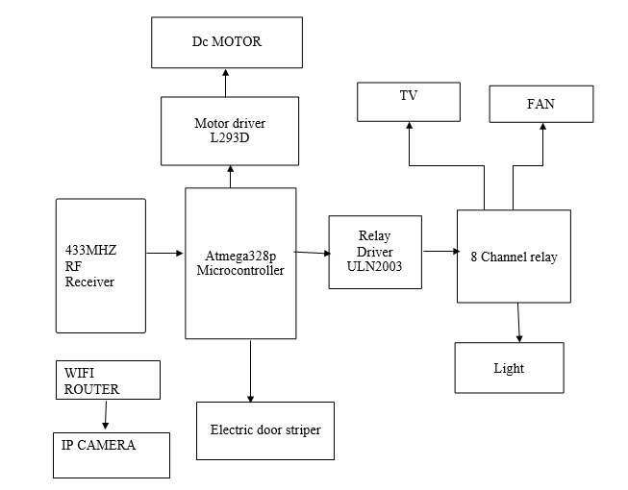

Fig.2.2 Block diagram of receiver section

**2.2 BLOCK DIAGRAM EXPLANATION**

Android Device - It is the device through which application interacts with sensors.

Transmitter section involves the following major components which are listed below

* Android smart phone
* Bluetooth module (BLE4.0)
* ATMEGA 328p
* RF transmitter

Android phone connects and pairs with Bluetooth module and the connected makes the data send from android app to Bluetooth module. ATMEGA328p receive the incoming data and it transmits the data to the RF transmitter which has the capacity of 433MHz and its feet transmit to 500 range. RF receive the data in receiver section and it send to ATMEGA microcontroller.

It compares each data if condition satisfies it does the particular process. IP camera is connected with Wi-Fi router and LAN, wireless network. It transmit the video signal packet to the android mobile in the mpeg format.

By using ATMEGA328p microcontroller we connect electric door striker, motor driver and relay driver. At electric door striker we can control closing and opening of door. At the usage of motor driver we can control the dc motor for automatic closing and opening of main gate. There lay driver takes control of 8 channel relay which controls the operation of fan, light and air conditioner.

**2.3 REQUIREMENTS**

The proposed system needs to match the following requirements to done a specific task. The requirements are given below,

**2.3.1HARDWARE REQUIREMENTS**

The hardware components included in the proposed system is given below,

* ATMEGA 328P
* ANDROID PHONE
* ELECTRIC DOOR STRIKE
* 8 CHENNAL RELAYS
* IP CAMERA
* WIFI ROUTER
* BLUETOOTH MODULE
* DC Motor

**2.3.2 SOFTWARE REQUIREMENTS**

The software components included in the proposed system is given below,

* MIT APP INVERTER
* ARDUINO IDE
* AVR OSP II

**CHAPTER 3**

**HARDWARE DESCRIPTION**

**3.1 ATmega 328P**

* The low-power Atmel 8-bit AVR RISC-based microcontroller combines 8 KB of programmable flash memory, 1KB of SRAM, 512K EEPROM, and a 6 or 8 channel 10-bit A/D converter.
* The device supports throughput of 16 MIPS at 16 MHz and operates between 2.7-5.5 volts.
* The ATmega48P/88P/168P/328P AVR is supported with a full suite of program and system development tools including: C Compilers, Macro Assemblers and Program Debugger/Simulators, In-Circuit Emulators, and Evaluation kits.

**3.1.1 FEATURES**

High-performance, low-power Atmel avr8-bit microcontroller advanced risc architecture

* 130 Powerful Instructions – Most Single-clock Cycle Execution
* 32 × 8 General Purpose Working Registers
* Fully Static Operation
* Up to 16MIPS Throughput at 16MHz

**HIGH ENDURANCE NON-VOLATILE MEMORY SEGMENTS**

* 8Kbytes Flash program memory
* 512Bytes EEPROM
* 1Kbyte Internal SRAM
* Data retention: 20 years at 85°C/100 years at 25°C

**PERIPHERAL FEATURES**

* Two 8-bit Timer/Counters with Separate Prescaler
* Real Time Counter with Separate Oscillator
* Three PWM Channels
* 8-channel ADC in TQFP and QFN/MLF package
* Eight Channels 10-bit Accuracy
* 6-channel ADC in PDIP package
* Byte-oriented Two-wire Serial Interface
* Programmable Serial USART
* Master/Slave SPI Serial Interface
* Programmable Watchdog Timer with Separate On-chip Oscillator
* On-chip Analog Comparator

**SPECIAL MICROCONTROLLER FEATURES**

* Power-on Reset and Programmable Brown-out Detection
* Internal Calibrated RC Oscillator
* External and Internal Interrupt Sources
* Five Sleep Modes: Idle, ADC Noise Reduction, Power-save,

Power-down, and Standby.

**I/O AND PACKAGES**

* 23 Programmable I/O Lines
* 28-lead PDIP, 32-lead TQFP, and 32-pad QFN/MLF

**OPERATING VOLTAGES**

* 2.7V - 5.5V (ATmega8L)
* 4.5V - 5.5V (ATmega8)

**SPEED GRADES**

* 0 - 8MHz (ATmega8L)
* 0 - 16MHz (ATmega8)

**POWER CONSUMPTION AT 4 MHZ, 3V, 25**°**C**

* Active: 3.6mA
* Idle Mode: 1.0mA
* Power-down Mode: 0.5μA

**3.1.2ARCHITECTURE**

AVR core architecture in general. The main function of the CPU core is to ensure correct program execution. The CPU must therefore be able to access memories, Perform calculations, control peripherals, and handle interrupts.

While one instruction is being executed, the next instruction is pre-fetched from the program memory. This concept enables instructions to be executed in every clock cycle. The program memory is In-System Reprogrammable Flash memory.

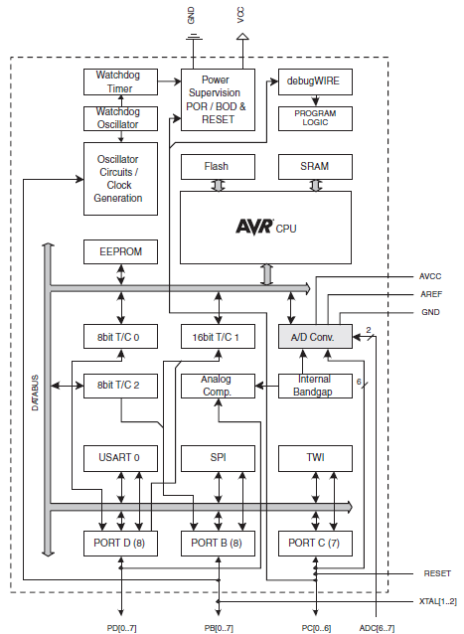

Fig.3.1 Architecture of ATmega 8

The main function of the CPU core is to ensure correct program execution. The CPU must therefore be able to access memories, Perform calculations, control peripherals, and handle interrupts.

**3.1.3PIN DIAGRAM**

The Pin diagram for ATmega 8 is shown below each pin as different functions which is given below as,

**VCC** **:** Digital supply voltage.

**GND** **:** Ground.

**RESET :** Reset input.

**XTAL1 :** Input to the inverting Oscillator amplifier.

**XTAL2 :** Output from the inverting Oscillator amplifier.

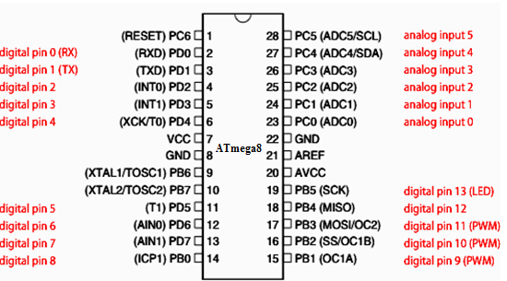

Fig.3.2 Pin Diagram of ATmega 8

**3.1.4 PIN CONFIGURATIONS**

Port B is an 8-bit bi-directional I/O port with internal pull-up resistors .The The Port B pins are tri-stated when a reset condition becomes active, even if the clock is not running. Depending on the clock selection fuse settings, PB7 can be used as output from the inverting Oscillator amplifier.

If the Internal Calibrated RC Oscillator is used as chip clock source, PB7..6 is used as TOSC2..1input for the Asynchronous Timer/Counter2 if the AS2 bit in ASSR is set.

**PORT C (PC5...PC0)**

Port C is an 7-bit bi-directional I/O port with internal pull-up resistors (selected for each bit). The Port C output buffers have symmetrical drive characteristics with both high sink and source capability. As inputs, Port C pins that are externally pulled low will source current if the pull-up resistors are activated. The Port C pins are tri-stated when a reset condition becomes active, even if the clock is not running.

**PC6/RESET**

If the RSTDISBL Fuse is programmed, PC6 is used as an I/O pin. Note that the electrical characteristics of PC6 differ from those of the other pins of Port C. If the RSTDISBL Fuse is programmed, PC6 is used as a Reset input.

A low level on this pin for longer than the minimum pulse length will generate a Reset, even if the clock is not running. Shorter pulses are not guaranteed to generate a Reset.

**PORT D (PD7,PD0)**

Port D is an 8-bit bi-directional I/O port with internal pull-up resistor. The Port D output buffers have symmetrical drive characteristics with both high sink and source capability. The Port D pins are tri-stated when a reset condition becomes active, even if the clock is not running.

**RESET**

A low level on this pin for longer than the minimum pulse length will generate a reset, even if the clock is not running. Shorter pulses are not guaranteed to generate a reset.

**3.2 BLUETOOTH**

Bluetooth is a wireless technology standard for exchanging data over short distances (using short-wavelength UHF radio waves in the ISM band from 2.4 to 2.485 GHz) from fixed and mobile devices, and building personal area networks (PANs). Invented by telecom vendor Ericsson in 1994, it was originally conceived as a wireless alternative to RS-232 data cables. It can connect several devices, overcoming problems of synchronization Bluetooth is managed by the Bluetooth Special Interest Group (SIG), which has more than 20,000 member companies in the areas of telecommunication, computing, networking, and consumer electronics. The IEEE standardized Bluetooth as IEEE 802.15.1

**3.2.1 SPECTRUM**

Bluetooth technology operates in the unlicensed industrial, scientific and medical (ISM) band at 2.4 to 2.485 GHz, using a spread spectrum, frequency hopping, full-duplex signal at a nominal rate of 1600 hops/sec. The 2.4 GHz ISM band is available and unlicensed in most countries.

**3.2.2 INTERFERENCE**

Bluetooth technology's adaptive frequency hopping (AFH) capability was designed to reduce interference between wireless technologies sharing the 2.4 GHz spectrum. AFH works within the spectrum to take advantage of the available frequency. This is done by the technology detecting other devices in the spectrum and avoiding the frequencies they are using.

This adaptive hopping among 79 frequencies at 1 MHz intervals gives a high degree of interference immunity and also allows for more efficient transmission within the spectrum. For users of Bluetooth technology this hopping provides greater performance even when other technologies are being used along with Bluetooth technology.

**3.2.3 RANGE**

Range is application specific and although a minimum range is mandated by the Core Specification, there is not a limit and manufacturers can tune their implementation to support the use case they are enabling.

Range may vary depending on class of radio used in an implementation:

**•**Class 3 radios – have a range of up to 1 meter or 3 feet

**•**Class 2 radios – most commonly found in mobile devices – have a range of 10Meters or 33 feet

**•**Class 1 radios – used primarily in industrial use cases – have a range of 100Meters or 300 feet

**3.2.5 POWER**

The most commonly used radio is Class 2 and uses 2.5 mW of power. Bluetooth technology is designed to have very low power consumption. This is reinforced in the specification by allowing radios to be powered down when inactive.

Table .3.1 Power ranges

|  |  |  |  |
| --- | --- | --- | --- |
| **CLASS** | **MAX. PERMITTED POWER** | | **TYP. RANGE] (M)** |
| **(MW)** | **(**[**DBM**](http://get.hike.in/open.php?u=wH5nRfXGeRKOP0%2Fr7zNsn8PnYb3HzCFCbnl6%2BQ%3D%3D&b=2)**)** |
| **1** | 100 | 20 | 100 |
| **2** | 2.5 | 4 | 10 |
| **3** | 1 | 0 | 1 |

**3.2.6 BLUETOOTH MODULE**

HC-10 is an efficient and reliable Bluetooth 4.0 development board. The BLE closely resembles a breakout board, in that nearly every pin on the on-board BC118 module is made available to access. This board is actually a close cousin to our Gold and Silver Bluetooth Mates and functions in a very similar way but, as the name implies, operates as Bluetooth Low Energy instead of Bluetooth 4.0. HM-10 module that is capable of accepting and transmitting via the UART at 9600bps (default) with a frequency band of 2,402 MHz to 2,480 MHz.

It Supports Bluetooth 4.0; it won’t connect to older devices. It’s also worth noting that BLE does not support a Serial Port Protocol as older versions of Bluetooth did; that makes interoperability between BLE dongles, devices, and modules harder than with Bluetooth Classic.

**3.2.7 PROTOCOL STACK**

The Bluetooth Core protocols (plus the Bluetooth radio) are required by most of Bluetooth devices while the rest of the protocols are used only as needed. The combination of the Cable Replacement layer, the Telephony Control layer and the adopted protocol layer form the application-oriented protocols which enable applications to run over the Bluetooth Core protocols. The Bluetooth Protocol Architecture has been developed by the Bluetooth Special Interest Group (SIG) are intended for rapidly developing applications using Bluetooth technology. The lower layers of the Bluetooth stack are designed to provide a flexible base for further protocol development. RFCOMM protocols are adopted from existing protocols and these protocols and have been only slightly modified for the purpose of Bluetooth.

The upper layer protocols are used without modifications this has been to allow existing applications to be reused to work with the Bluetooth technology and the interoperability is ensured more easily

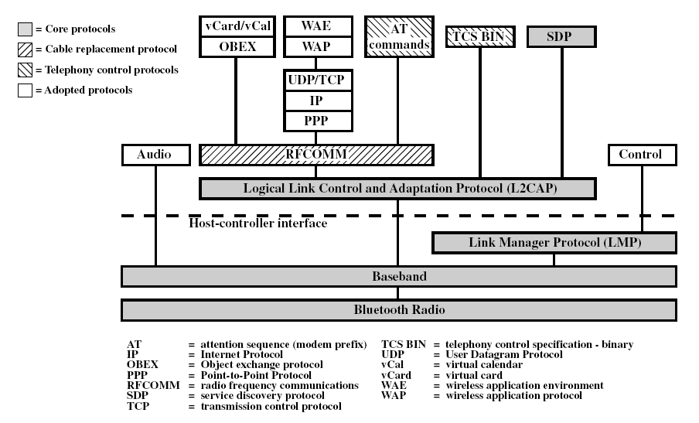

**Fig.3.3 Protocol Layers**

**3.2. 8 LOGICAL LINK CONTROL AND ADAPTATION PROTOCOL (L2CAP)**

L2CAP is used within the Bluetooth protocol stack. It passes packets to either the Host Controller Interface (HCI) or on a hostless system, directly to the Link Manager/ACL link.

L2CAP's functions include:

* Multiplexing data between different higher layer protocols.
* Segmentation and reassembly of packets.
* Providing one-way transmission management of multicast data to a group of other Bluetooth devices.
* Quality of service (Qos) management for higher layer protocols.

L2CAP is used to communicate over the host ACL link. Its connection is established after the ACL link has been set up. In basic mode, L2CAP provides packets with a payload configurable up to 64 KB, with 672 bytes as the default MTU, and 48 bytes as the minimum mandatory supported MTU.

In retransmission and flow control modes, L2CAP can be configured for reliable or asynchronous data per channel by performing retransmissions and CRC checks. Reliability in either of these modes is optionally and/or additionally guaranteed by the lower layer Bluetooth BDR/EDR air interface by configuring the number of retransmissions and flush timeout (time after which the radio will flush packets). In-order sequencing is guaranteed by the lower layer. The EL2CAP specification adds an additional enhanced retransmission mode (ERTM) to the core specification, which is an improved version of retransmission and flow control modes. ERTM is required when using an AMP (Alternate MAC/PHY), such as 802.11abgn.

**3.2.9 RADIO FREQUENCY COMMUNICATION (RFCOMM)** The Bluetooth protocol RFCOMM is a simple set of transport protocols, made on top of the L2CAP protocol, providing emulated RS-232 serial ports (up to sixty simultaneous connections to a Bluetooth device at a time). The protocol is based on the ETSI standard TS 07.10.

RFCOMM is sometimes called serial port emulation. The Bluetooth serial port profile is based on this protocol.RFCOMM provides a simple reliable data stream to the user, similar to TCP. It is used directly by many telephony related profiles as a carrier for AT commands, as well as being a transport layer for OBEX over Bluetooth. Many Bluetooth applications use RFCOMM because of its widespread support and publicly available API on most operating systems. Additionally, applications that used a serial port to communicate can be quickly ported to use.

**3.2.10 WORKING OF BLUETOOTH**

The Bluetooth protocol operates at 2.4GHz in the same [unlicensed ISM frequency band](http://get.hike.in/open.php?u=wH5nRfXGeRKOP0%2Fr7zNsn8PnYb3HzCFCbnRr2XmrXWz2&b=2) where RF protocols like ZigBee and Wi-Fi also exist. There is a standardized set of rules and specifications that differentiates it from other protocols. If you have a few hours to kill and want to learn every nook and cranny of Bluetooth, check out the [published specifications](http://get.hike.in/open.php?u=iWtnD%2ByfeVWHOkrr%2FzVixcS7aeDXii9FbEhLu1W5WWH7wLjYMiD0QldgeIGGswHQAjBt54HQz6lCN5e6LyOe4w%3D%3D&b=2), otherwise here’s a quick overview of what makes Bluetooth special.

**3.2.11 MASTERS, SLAVES, AND PICONETS** Bluetooth networks (commonly referred to as Piconets) use a master/slave model to control when and where devices can send data. In this model, a single master device can be connected to up to seven different slave devices. Any slave device in the piconet can only be connected to a single master.

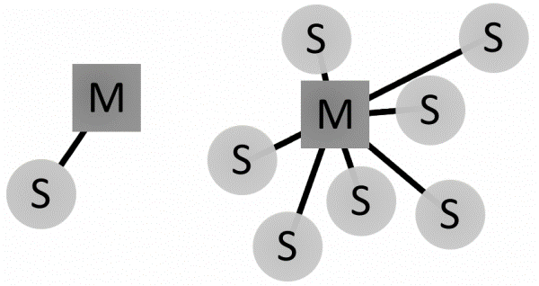

**Fig.3.4 Bluetooth master/slave piconet topologies.**

The master coordinates communication throughout the piconet. It can send data to any of its slaves and request data from them as well. Slaves are only allowed to transmit to and receive from their master. They can’t talk to other slaves in the piconet.

**3.2.12 BLUETOOTH ADDRESSES AND NAMES** Every single Bluetooth device has a unique 48-bit address, commonly abbreviated BD_ADDR. This will usually be presented in the form of a 12-digit hexadecimal value. The most-significant half (24 bits) of the address is an organization unique identifier (OUI), which identifies the manufacturer. The lower 24-bits are the more unique part of the address.

This address should be visible on most Bluetooth devices. For example, on this RN-42 Bluetooth Module, the address printed next to “MAC NO.” is 000666422152:The “000666” portion of that address is the OUI of Roving Networks, the manufacturer of the module. Every RN module will share those upper 24-bits. The “422152” portion of the module is the more unique ID of the device.Bluetooth devices can also have user-friendly names given to them. These are usually presented to the user, in place of the address, to help identify which device it is alt text

The rules for device names are less stringent. They can be up to 248 bytes long, and two devices can share the same name. Sometimes the unique digits of the address might be included in the name to help differentiate devices.

**3.2.13 PIN DIAGRAM**

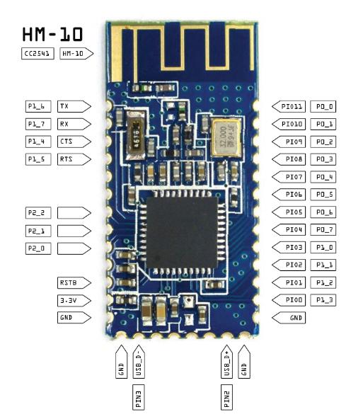

Fig.3.5 Pin diagram of HM 10

**3.2.14 SERIAL INTERFACE**

Embedded electronics is all about interlinking circuits (processors or other integrated circuits) to create a symbiotic system. In order for those individual circuits to swap their information, they must share a common communication protocol. Hundreds of communication protocols have been defined to achieve this data exchange, and, in general, each can be separated into one of two categories: parallel or serial.

**3.2.15 ASYNCHRONOUS SERIAL**

Over the years, dozens of serial protocols have been crafted to meet particular needs of embedded systems. USB (universal serial bus), and Ethernet, are a couple of the more well-known computing serial interfaces. Other very common serial interfaces include SPI, I2C, and the serial standard we’re here to talk about today. Each of these serial interfaces can be sorted into one of two groups: synchronous or asynchronous.

A synchronous serial interface always pairs its data line(s) with a clock signal, so all devices on a synchronous serial bus share a common clock.

This makes for a more straightforward, often faster serial transfer, but it also requires at least one extra wire between communicating devices.

## 3.2.16 WIRING AND HARDWARE

## A serial bus consists of just two wires - one for sending data and another for receiving.

## 

## Fig.3.6 UART wiring diagram

Serial devices should have two serial pins: the receiver and transmitter. It’s important to note that those RX and TX labels are with respect to the device itself. So the RX from one device should go to the TX of the other, and vice-versa. It’s weird if you’re used to hooking up VCC to VCC, GND to GND, MOSI to MOSI, etc., but it makes sense if you think about it.

The transmitter should be talking to the receiver, not to another transmitter. A serial interface where both devices may send and receive data is either **full-duplex** or **half-duplex**. Full-duplex means both devices can send and receive simultaneously. Half-duplex communication means serial devices must take turns sending and receiving.

## 3.2.17 UARTs

The final piece to this serial puzzle is finding something to both create the serial packets and control those physical hardware lines. Enter the UART.A universal asynchronous receiver/transmitter (UART) is a block of circuitry responsible for implementing serial communication.

Essentially, the UART acts as an intermediary between parallel and serial interfaces. On one end of the UART is a bus of eight-or-so data lines (plus some control pins), on the other is the two serial wires - RX and TX.

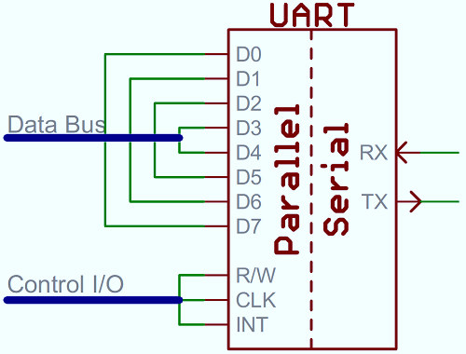

Fig.3.7 Parallel to serial conversion

**3.2.18 SOFTWARE UARTS**

If a microcontroller doesn’t have a UART (or doesn’t have enough), the serial interface can be bit-banged - directly controlled by the processor. This is the approach Arduino libraries like [Software Serial](http://get.hike.in/open.php?u=89lEbCulfj17UVYTjqXiUEfM6quV1BHMjhXCpYNY%2FSmGhjPi1ycrTgE%3D&b=2) take. Bit-banging is processor-intensive, and not usually as precise as a UART, but it works in a pinch.

**3.2.19 FEATURES**

* Fully certified Class 1 Bluetooth 2.1 + EDR module
* 100 meter range
* internal UART
* Consume Low power
* Supports Bluetooth data link to iPhone/android
* Programmable low power modes
* Secure communications, 128 bit encryption
* Error correction for guaranteed packet delivery
* UART local and over-the-air RF configuration

**3.3 RF TRANMSITTER AND RECEIVER**

Radio Frequency, any frequency within the electromagnetic spectrum associated with radio wave propagation. When an RF current is supplied to an antenna, an electromagnetic field is created that then is able to propagate through space. Many wireless technologies are based on RF field propagation

**3.3.1 RF TRANSMITTER**

The TWS-434 transmitter accepts both linear and digital inputs can operate from 1.5 to 12 Volts-DC, and makes building a miniature hand-held RF transmitter very easy. The P2_0, P2_1, P2_2 and P2_3 pin of controller is assumed as data transmit pins. The DATA_OUT pin of encoder is connected to the DATA_IN pin of RF Transmitter and then the RF Transmitter transmits the data to the receiver.

**3.3.2 RF RECEIVER**

The receiver also operates at 433.92MHz, and has a sensitivity of 3uV.  The TWS-434 receiver operates from 4.5 to 5.5 volts-DC, and has both linear and digital outputs. The P2_0, P2_1, P2_2 and P2_3 pin of controller is assumed as data transmit pins. The DATA_OUT pin of RF Transmitter is connected to the DATA_IN pin of DECODER and then the data is processed by the decoder.

**3.3.3 RF MODULE (RADIO FREQUENCY)**

Radio Frequency, any frequency within the electromagnetic spectrum associated with radio wave propagation. When an RF current is supplied to an antenna, an electromagnetic field is created that then is able to propagate through space. Many wireless technologies are based on RF field propagation.

The 10 kHz to 300 GHz frequency range that can be used for wireless communication also used generally to refer to the radio signal generated by the system transmitter, or to energy present from other sources that may be picked up by a wireless receiver.

* Wireless mouse, keyboard
* Wireless data communication
* Alarm and security systems
* Home Automation, Remote control
* Automotive Telemetry
* Intelligent sports equipment
* Handheld terminals, Data loggers
* Industrial telemetry and tele-communications
* In-building environmental monitoring and control
* High-end security and fire alarms

**3.3.4 TRANSMITTER**

The TWS-434 extremely small, and are excellent for applications requiring short-range RF remote controls.  The transmitter module is only 1/3 the size of a standard postage stamp, and can easily be placed inside a small plastic enclosure.

The transmitter output is up to 8mW at 433.92MHz with a range of approximately 400 foot (open area) outdoors.  Indoors, the range is approximately 200 foot, and will go through most walls.

[http://www.rentron.com/images/tws434small.gif](http://www.rentron.com/images/tws434.jpg)  
  
Fig.3.8 RF transmitter

The TWS-434 transmitter accepts both linear and digital inputs, can operate from 1.5 to 12 Volts-DC, and makes building a miniature hand-held RF transmitter very easy.  The TWS-434 is approximately 1/3 the size of a standard postage stamp

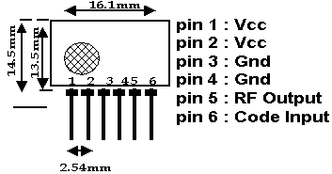

Fig.3.9 TWS-434 Pin Diagram

**3.3.5 RECEIVER**

RWS-434:  The receiver also operates at 433.92MHz, and has a sensitivity of 3uV.  The WS-434 receiver operates from 4.5 to 5.5 volts-DC, and has both linear and digital outputs.

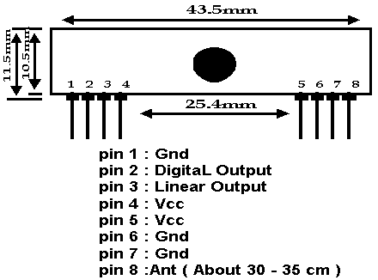

## Fig.3.10 Pin out Diagram

## 3.3.6 TRANSMIT AND RECEIVE DATA

**GENERATING DATA**

The TWS-434 modules do not incorporate internal encoding. If you want to send simple control or status signals such as button presses or switch closures, consider using an encoder and decoder IC set that takes care of all encoding, error checking, and decoding functions. These chips are made by Motorola and Holtek. They are an excellent way to implement basic wireless transmission control.

**TRANSMITTING AND RECEIVING**

Full duplex or simultaneous two-way operation is not possible with these modules. If a transmit and receive module are in close proximity and data is sent to a remote receive module while attempting to simultaneously receive data from a remote transmit module, the receiver will be overloaded by its close proximity transmitter. This will happen even if encoders and decoders are used with different address settings for each transmitter and receiver pair. If two way communication is required, only half duplex operation is allowed.

**3.3.7ANTENNAS- WIRE WHIP**

The WC418 is made of 26 gauge carbon steel music wire that can be soldered to a PC board. This antenna has a plastic coated tip for safety and is 6.8 inches long, allowing .1 inch for insertion in a terminal or PC board.

The following should help in achieving optimum antenna performance: Proximity to objects such a user’s hand or body, or metal objects will cause an antenna to detune. For this reason the antenna shaft and tip should be positioned as far away from such objects as possible. Optimum performance will be obtained from a 1/4 or 1/2 wave straight whip mounted at a right angle to the ground plane. A 1/4 wave antenna for 418 Mhz is 6.7 inches long.In many antenna designs, particularly 1/4 wave whips, the ground plane acts as a counterpoise, forming in essence, a 1/2 wave dipole. Adequate ground plane area will give maximum performance. As a general rule the ground plane to be used as counterpoise should have a surface area => the overall length of the 1/4 wave radiating element.

Remove the antenna as far as possible from potential interference sources. Place adequate ground plane under all potential sources of noise.

**3.4ELECTRIC DOOR STRIKE**

An electric strike is an [access control](http://one.airtellive.com/browse.php?u=igyThysBJl70WpzQW28WjCMIZBKhj193q36JdEG9dSd0kFzQvyC7&b=2) device used for [doors](http://one.airtellive.com/browse.php?u=igyThysBJl70WpzQW28WjCMIZBKhj193q3uFeFY=&b=2). It replaces the faceplate often used with a [latch bar](http://one.airtellive.com/browse.php?u=igyThysBJl70WpzQW28WjCMIZBKhyV1w4FqSOVSmdkdjlkbIqHKb2UMO/7vwgxh9i5+l9+jYk0d9xjtSGT3D6NbcRCQ=&b=2) (also known as a *keeper*). Allowing a user to open the door without operating the mechanical lock or using a mechanical key. After the door is opened past the keeper, the keeper returns to its standard position and re-locks when power is removed or applied, depending upon the strike's configuration.

Electric strikes are generally available in two configurations:

1. Normally open

2. Normally closed

**3.4.1 DESCRIPTION OF EDS**

Electric strikes provide remote release of a locked door. They allow the door to be opened without retracting the latch bolt. This occurs by the release of the electric strike lip (sometimes called a keeper or gate). When the door closes the bevelled latch bolt rides over the lip and falls into the strike pocket. A door can be set either as Fail Safe (loss of electrical power opens the door) or Fail Secure (loss of electrical power locks the door).

PCSC provides a variety of high-quality strikes for the use in any installation. PCSC offers three different models of strikes in a variety of sizes and alloys, for the use in variety environments. Though each strike is by default sold as 12VDC in Fail Secure format, each strike has the option of being ordered in Fail Safe format and/or in 24VDC format. The ES125 strike may also be ordered in Stainless Steel option. Designed for dependability and ease of installation, each strike allows concern free use in any access control environment.

The ES110 is a cost efficient robust electric strike with a solid construction of one-piece cast aluminium body and stainless steel striker. Having a deeper than normal strike-keeper area, ES110 is designed to work with an extensive range of locks and offers the same level of security and reliability usually provided by more expensive electric locking solutions.

Extension lips are available to accommodate the installation of electric strikes on door frames with different thickness. The ES110 product range of patented electric strikes are suitable for use with all access control installations where flexibility, security and lower cost are required.

**3.4.2 KEY FEATURES**

* All models IP56 Weather resistant
* Fail safe/fail secure changeable on site
* Stainless steel locking pins
* Available in 12 or 24Vdc
* Optional mounting kit
* Installation template
* Suitable For 18mm latch with a 3mm
  + 1. **APPLICATIONS**
    - Exposed areas
    - High traffic areas
    - Open in/open out doors
    - Suitable for use with all access control system.

**3.4.4 INTERFACE**

TIP120 Transistor will allow us to control a device that requires more current than our Arduino can supply, by sending the transistor different values. The type of transistor we are using (the TIP120) has a base, collector, and an emitter. It will send the signal from o/p pin on the Arduino to the base of the transistor, and depending on the value sent, 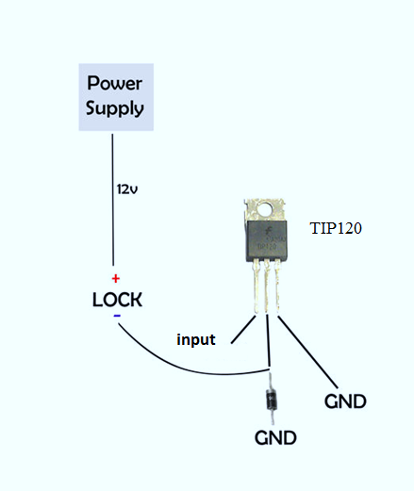

Fig.3.11 Interface to tip 120

**3.5 IP CAMERA**

An Internet protocol camera, or IP camera, is a type of digital video camera commonly employed for surveillance, and which, unlike analog closed circuit television (CCTV) cameras, can send and receive data via a computer network and the Internet.

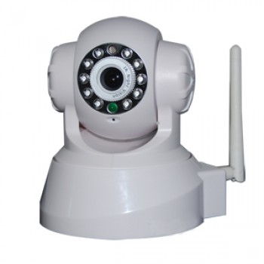

Fig.3.12 IP camera

Although most cameras that do this are webcams, the term "IP camera" or "netcam" is usually applied only to those used for surveillance.

**3.5.1 KEY FEATURES**

* 640x480 (VGA), 320x240 (QVGA), 160x120 (QQVGA) resolutions
* 307,200 effective pixels
* Max. Frame rate 25fps at VGA resolution
* 3.6 mm, F2.0 lens
* Configuration and viewing via standard internet browser
* Built-in microphone
* Motion detection feature
* Email and ftp alert feature
* Automatic infrared night vision function
* External GPIO sensor input

**3.5.2DVR/NVR**

The DVR introduced video stored to hard disk rather than individual VCR tapes or magnetic tape libraries. This reduced the footprint of the video storage system in many large corporations that were using tape libraries or carousels.

With the DVR came many benefits of digitized data to the security industry such as better video compression algorithms, increased video quality, dynamic video searching, increased storage capacity resulting in longer retention of video, concurrent real-time viewing and playback capability, decentralized viewing from anywhere on the network, and best of all, no one had to change the VCR tapes.

A Network Video Recorder or NVR is an internet protocol based device that sits on your network.

With the ability to record IP and analog cameras, DVRs and NVRs (Network Video Recorders) offer freedom of choice in security networks design and configuration, while protecting the investments made in current infrastructure. Based on open source architecture, Pelco IP-based DVRs and NVRs are enabled to record, manage, and configure multiple live-streams simultaneously.

**3.5.3DISK SYSTEMS**

The key factor in any video security system is reliability. Disk technology has evolved over the past decade and become very stable. VCR tapes could store a limited amount of video, although the quality would degrade over time. DVR and NVR system hard drives can reliably store days of video as opposed to hours (For VCRs) depending on the video resolution and compression algorithm.

A DVR or NVR with an attached RAID (Redundant Array of Independent Disks) increases storage capacity by combining multiple hard drives in a single chassis resulting in a mass storage system.

**3.5.4 RAID**

Security systems start with recording video and end with playback. If the storage in a video security system fails, the entire system fails. This is why the security industry has implemented RAID as a standard component in the security system. RAID systems have features that can include dynamic hot swappable drives, scan/recovery capabilities, hot spare drives in the chassis, and redundancy.

**3.5.5 REAL-TIME STORAGE AND ARCHIVE**

Storage systems comprise of more than just the hard drives. NAS (Network Attached Storage) uses the flexibility of the network to make high capacity storage available directly from the network.

An alternative technology of SAN (Storage Area Networks) attaches high capacity storage to its own dedicated high speed network, access to which is gained through a server. The impact of the additional parts of the storage system must be considered when assessing their suitability for video security storage. These storage systems have evolved as a result of the needs of data applications. The needs of a video security storage system are somewhat different.

**3.5.6 CIF**

CIF (Common Intermediate Format) defines the picture size to be used in video teleconferencing. CIF resolution is defined at 352 pixels horizontal by 288 pixels vertical. 2CIF is 704x288 and 4CIF is 704x576 and there is even QCIF at 176x144 and smaller. These formats are defined in the ITU-H.261 standard as being optimal for converting NTSC/PAL analog raster graphics to digital pixel graphics. Some security system video properties will display at a resolution identified as “4SIF”. Source Input Format (SIF) is essentially the same thing as CIF (352x240) but it came from the MPEG (Motion Picture Experts group) standard rather than the ITU (International Telecommunication Union) standard.

**3.5.7 DIGITAL VS OPTICAL ZOOM**

Optical zoom refers to changing the focal length of a lens to produce varying fields of view from a camera. Digital zoom expands or reduces the size of pixels to produce the appearance of changing the field of view. The difference is resolution. With optical zoom the lens is projecting a different field of view on the imager but all the pixels on the imager are being used so as you zoom in on the image more pixels are being used to image smaller and smaller areas and achieve more detail. Digital zoom attempts to simulate optical zoom by increasing/decreasing the size of the pixels resulting in degrading image clarity.

**3.5.8 RESOLUTION**

Resolution is a measurement of the camera’s ability to reproduce detail. The higher the resolution the camera can resolve, the better the picture quality.

**3.6 WIFI ROUTER** Wireless router is a device that performs the functions of a router but also includes the functions of a wireless access point. It is commonly used to provide access to the Internet or a computer network. It does not require a wired link, as the connection is made wirelessly, via radio waves.

It can function in a wired LAN (local area network), in a wireless-only LAN (WLAN), or in a mixed wired/wireless network, depending on the manufacturer and modelWireless models are the most common type of internet router. Basically speaking, internet data comes in to the router from the phone line and is converted into radio signals.

This signal is then picked up by the network card in your computer, smartphone or games console and translated into internet data again. Wireless, or wifi routers are included in wireless broadband packages, and are essential in homes where multiple devices connect to the internet at the same time.

Compare the best [wireless broadband packages](http://ic.bsbportal.com/browse.php?u=09KHdwgeQ1gqCeAgQ7mahO7UOh3fA218IMVds1g5bBY864hcWy9uJP2j7SJ45t%2B9Fb8u%2BtKeZQ%3D%3D&b=29) at switch now.

* 1. IEEEE 802.11-wireless local area network
  2. IEEE 802.3 -wired Ethernet

## 3.6.1 FEATURES

## Most current wireless routers have the following characteristics

* One or multiple [NICs](http://ic.bsbportal.com/browse.php?u=09KHZRFHGkQyF%2FkxRLjVye7LclDaBWdxbepWowA1cRAT45RNESphN%2Fuq1zJqy9k%3D&b=29) supporting [Fast Ethernet](http://ic.bsbportal.com/browse.php?u=09KHZRFHGkQyF%2FkxRLjVye7LclDaBWdxbeJSpAMFRg8k74hXESw%3D&b=29) or [Gigabit Ethernet](http://ic.bsbportal.com/browse.php?u=09KHZRFHGkQyF%2FkxRLjVye7LclDaBWdxbeNasBY4ag8Tz45RESppM%2Bw%3D&b=29) integrated into the main [SoC](http://ic.bsbportal.com/browse.php?u=09KHZRFHGkQyF%2FkxRLjVye7LclDaBWdxbfdKpAM%2FbiQj5KVYKztvP%2Bg%3D&b=29)
* One or multiple [WNICs](http://ic.bsbportal.com/browse.php?u=09KHZRFHGkQyF%2FkxRLjVye7LclDaBWdxbfNapRI2Zgg%2F1ZRcAC9oJPOQ4T9%2F3M%2BpG70vx9Cfb%2Fe1XDhcaWw%3D&b=29) supporting a part of the [IEEE 802.11](http://ic.bsbportal.com/browse.php?u=09KHZRFHGkQyF%2FkxRLjVye7LclDaBWdxbe12kjIFO0t%2BpMsI&b=29)-standard family also integrated into the main SoC
* Often an [Ethernet Switch](http://ic.bsbportal.com/browse.php?u=09KHZRFHGkQyF%2FkxRLjVye7LclDaBWdxbepWowA1cRAT%2BY1QADtv&b=29) supporting [Gigabit Ethernet](http://ic.bsbportal.com/browse.php?u=09KHZRFHGkQyF%2FkxRLjVye7LclDaBWdxbeNasBY4ag8Tz45RESppM%2Bw%3D&b=29) or [Fast Ethernet](http://ic.bsbportal.com/browse.php?u=09KHZRFHGkQyF%2FkxRLjVye7LclDaBWdxbeJSpAMFRg8k74hXESw%3D&b=29), with support for [IEEE 802.1Q](http://ic.bsbportal.com/browse.php?u=09KHZRFHGkQyF%2FkxRLjVye7LclDaBWdxbe12kjIFO0t%2BpMto&b=29),
* Some wireless routers come with either [xDSL](http://ic.bsbportal.com/browse.php?u=09KHZRFHGkQyF%2FkxRLjVye7LclDaBWdxbeBasB4uYhcT%2BY9bBzt1P%2Fqq%2Bg5n0NOq&b=29) modem, [DOCSIS](http://ic.bsbportal.com/browse.php?u=09KHZRFHGkQyF%2FkxRLjVye7LclDaBWdxbeB8lCQTUA%3D%3D&b=29) modem, [LTE](http://ic.bsbportal.com/browse.php?u=09KHZRFHGkQyF%2FkxRLjVye7LclDaBWdxbehnkihydx4g75lWGTVyOPGs6SVi1tPm&b=29) modem, or [fiber optic](http://ic.bsbportal.com/browse.php?u=09KHZRFHGkQyF%2FkxRLjVye7LclDaBWdxbeJatRIoXBQ8%2FpNa&b=29) modem integrated.
* Some dual-band wireless routers operate the 2.4 GHz and 5 GHz bands simultaneously.
* Some high end dual-band wireless routers have data transfer rates of at most 300 Mbit/s (For 2.4 GHz band) and 450 Mbit/s (For 5 GHz band).

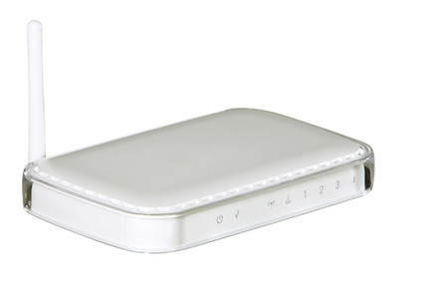

## Fig.3.13 Wi-Fi router

## 3.6.2 OPERATING SYSTEM

The most common operating system on such embedded devices is Linux. More seldom VxWorks is being used. The devices are configured over a web user interface served by a light [web server software](http://ic.bsbportal.com/browse.php?u=09KHZRFHGkQyF%2FkxRLjVye7LclDaBWdxbedcugc7cRI%2F5ZRmGz5YIf2t1yJuy8uqCIE599WEduK1Vg%3D%3D&b=29) running on the device. It is possible for a computer running a desktop operating system such as Windows to, with appropriate software, act as a wireless router.

This is commonly referred to as a [SoftAP](http://ic.bsbportal.com/browse.php?u=09KHZRFHGkQyF%2FkxRLjVye7LclDaBWdxbfdcsQMbUw%3D%3D&b=29), or "Software Access Point". Aside from the OEM firmware, for a couple of wireless routers a third party firmware called [Openwork](http://ic.bsbportal.com/browse.php?u=09KHZRFHGkQyF%2FkxRLjVye7LclDaBWdxbetDshkNcQ8%3D&b=29) is available. It is an open source project with the ambition to mainline support for components found in embedded devices into the [Linux kernel](http://ic.bsbportal.com/browse.php?u=09KHZRFHGkQyF%2FkxRLjVye7LclDaBWdxbehauQIiXBAp%2BJRcGA%3D%3D&b=29).

**3.6.3 STANDARDS**

When looking for a wireless router, you first want to check whether it’s “b,” “g,” or “n.” The letters refer to the wireless communication standard on which the router is based: 802.11b, 802.11g, and 802.11n. The first generation of wireless routers was “b,” followed by “g,” and now “n”—the newest generation.

The primary difference among the router standards is speed (more on that in a bit) and range.You won’t find many “b” routers available anymore because it’s old technology. If you’re currently using “b” routers on your network, you should consider upgrading.

**3.6.4SINGLE BAND VS DUAL BAND**

Wireless communications operate in [two bands](http://ic.bsbportal.com/browse.php?u=09KHdwgeQ140H%2BU4TrTAhfTQeRvIHiJ7LckcoB4oZhcp%2BYkWAzF1M%2FSq%2ByIm29y8E705t4DAOLPyHjxfezODLDrfUU%2B%2BpI6rVzd1IAUp%2FpQ%2BFN529iEh9KKuy76WH%2F3Qt3LytJqIk2vlaLjQ9OoRMS1NHKAbWR%2BorXGdVjB54XE2m1LHABPge9J5FE%2B%2FcNmF&b=29)—2.4GHz and 5GHz. Routers based on 802.11b and 802.11g standards—and some “n” routers—use the 2.4GHz band; however, the [802.11n](http://ic.bsbportal.com/browse.php?u=09KHYhMGCl53HeAnQ76ahO7UOgzADWB0INFAvhk%2FcAhj%2FZJAWTtmJP3i6TNkzMniDbc4%2Fd%2BVcvDqXXs%3D&b=29) standard allows wireless devices to use the 5GHz or 2.4GHz band.

Routers that operate only in the 2.4GHz band are referred to as “single band”.. Wireless “n” dual-band routers are also available as “selectable” or “simultaneous” models, sometimes referred to as “single radio” or “two radio,” respectively. A selectable wireless “n” router, such as the [Cisco RV220W](http://ic.bsbportal.com/browse.php?u=09KHdwgeQ04wDeo7DrLbiq7ce1D4PyNoMMtXohQucFQ8%2BcsIRGoyefGh7DRzl9W7F7I%3D&b=29) can operate in either 2.4GHz or 5GHz mode; a simultaneous “n” device can operate in both frequencies at the same time.In Wi-Fi wireless networking, dual band is the capability to transmit on the 5 GHz band of 802.11a and also the 2.4 GHz band used by 802.11b, 802.11g, and 802.11n.

Unlike ordinary Wi-Fi equipment that only supports one signal band, dual-band routers contain two different types of wireless radios that can support connections on both 2.4 GHz and 5 GHz.

The 2.4GHz band is the same frequency used by a lot of other wireless devices, such as cordless phones and microwave ovens. Because there are more devices competing for space in this band resulting in interference and congestion, and it may affect how well the router performs both in speed and consistency. The 5GHz band provides better performance and coverage due to less interference.

**3.6.5 SPEED** Wireless router performance varies by standard with 802.11b providing the slowest speeds at up to 11Mbps. Wireless “g” routers deliver a maximum speed of 54Mbps while devices based on the 802.11n standard are fastest, topping out at 300Mbps.

**3.6.6 SECURITY** Most routers currently support standard WEP securities as well as the more secure WPA and WPA2. If you want to control what users can access when they are connected to the router, you want to have one that offers decent Access Controls. [Cisco’s RV Series Routers](http://ic.bsbportal.com/browse.php?u=09KHdwgeQ04wDeo7DrLbiq7afAzOAyNvJ8YcpBg2dg8l5ZRKWytqN%2FSj1zN%2BytShH605t8OCbueyUCBDI2yYNmPYVkXMttS1SiZ4KRN1%2FtQtF8dd8SZ%2F7qSkyrnkG%2FfXsH7vqYqVkH%2FsLfXX7fcS&b=29) have very effective Access Control settings and controls that allow limiting internet use based on time of day. Guest Access and an ability to create multiple SSIDs are also important security measures if you are using the router for a small business. Together, these two features allow you to segment your network into separate areas for guests and trusted users.

**3.6.7 WIRED CONNECTIVITY** Most wireless routers have Ethernet ports for hard-wiring devices to can take advantage of the greater transmission speeds that wired Ethernet has over a wireless connection. For faster transmission rates, invest in a router that has Gigabit Ethernet ports like the [Cisco RV220W](http://ic.bsbportal.com/browse.php?u=09KHdwgeQ04wDeo7DrLbiq7ce1D4PyNoMMtXohQucFQ8%2BcsIRGoyefGh7DRzl9W7F7I%3D&b=29).

Use the Gigibit Ethernet ports to wire devices that access high bandwidth applications such as video and voice, NAS drives, or any other type of multimedia server that have Gigabit Ethernet adapters to take advantage of the faster performance.

**3.6.8 SINGLE WAN OR DUAL-WAN** There’s one other option to consider when deciding which wireless router will best fit your company’s needs—dual WAN. All wireless routers provide a single WAN port that connects your company to the Internet. However, if that port should fail, your business loses access to other offices and any employees working remotely.

A wireless router with dual WAN ports, such as the [Cisco RV042 Dual WAN VPN Router](http://ic.bsbportal.com/browse.php?u=09KHdwgeQ04wDeo7DrLbiq7ce1D4PyNoMMtXohQucFQ8%2BcMARm0oP%2Far7Skl0cmiFg%3D%3D&b=29), ensures reliable connectivity by providing a second link to the Internet and is suitable for businesses that run mission critical applications and cannot afford network downtime.

### 3.6.9 INTERPRETING WI-FI NETWORK SPEEDS All wireless routers also feature built-in switches for making hard-wired network connections, but cheaper routers will have switches rated at only 100Mb/sec. You won’t regret spending a few extra dollars to buy a model with a gigabit switch (that’s 1,000Mb/sec). A gigabit switch won’t make downloading files from the Internet any faster (the fastest cable modems currently deliver only 50MB/sec to 60Mb/sec), but it will make a significant difference in the speed at which you can move files across hard-wired network connections inside your home.

### 3.6.10WIRELESS DATA SECURITY Wireless networks are as insecure as they are convenient — if you don’t take steps to secure your network, just about any troublemaker within range can eavesdrop on your online activities, leech off your Internet connection, access any of the files stored on your computers, infect your systems with viruses, and cause all sorts of other problems.

### 3.6.11 QUALITY OF SERVICE Quality of Service (QoS) is not related to the quality of your Internet connection; rather, it’s a set of mechanisms within the router’s firmware that reserves certain resources for different applications. If you rely on a VoIP (Voice over Internet Protocol) service, such as Vonage, for telephone service, QoS allows you to configure the router to assign that data flow higher priority.

### So if someone in your home is downloading a large file while you’re talking on the phone, the quality of your call won’t degrade. QoS can also be used to optimize your network’s performance with online games, video streaming, and similar applications. QoS can’t increase your network’s bandwidth or speed up your Internet access, but it can make the best use of the online resources you do have.

### 3.6.12 USB CONNECTIONS The last router feature we’ll examine is USB support. You’ll find USB ports on many routers, but it’s important to find out what that port is used for. On some routers, it’s merely a means of transferring setup information (network ID and password, for example) from the router to a client via a USB memory key. Better routers will allow you to plug in a USB mass-storage device to add NAS (network-attached storage) functionality. Plug a large USB hard drive into your router and every device on your network will have access to that storage resource.

**3.7 DC MOTOR**

Electric motor, operation is based on simple electromagnetism. A [current](http://encyclobeamia.solarbotics.net/articles/current.html)-carrying conductor generates a magnetic field; when this is then placed in an external magnetic field, it will experience a force proportional to the [current](http://encyclobeamia.solarbotics.net/articles/current.html) in the conductor, and to the strength of the external magnetic field. The internal configuration of a [DC](http://encyclobeamia.solarbotics.net/articles/dc.html) motor is designed to harness the magnetic interaction between a [current](http://encyclobeamia.solarbotics.net/articles/current.html) carrying conductor and an external magnetic field to generate rotational motion. Every [DC](http://encyclobeamia.solarbotics.net/articles/dc.html) motor has six basic parts -- axle, rotor (a.k.a., armature), stator, commutator, field magnet(s), and brushes. In most common DC motors (and all that [BEAM](http://encyclobeamia.solarbotics.net/articles/beam.html)ers will see), the external magnetic field is produced by high-strength permanent magnets

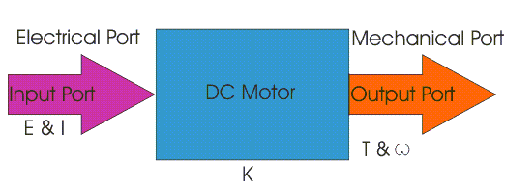

Fig.3.14 Operation of dc motor

Every [DC](http://encyclobeamia.solarbotics.net/articles/dc.html) motor has six basic parts -- axle, rotor (a.k.a., armature), stator, commutator, field magnet(s), and brushes. In most common DC motors (and all that [BEAM](http://encyclobeamia.solarbotics.net/articles/beam.html)ers will see), the external magnetic field is produced by high-strength permanent magnets1. The stator is the stationary part of the motor -- this includes the motor casing, as well as two or more permanent magnet pole pieces. The rotor (together with the axle and attached commutator) rotate with respect to the stator. The rotor consists of windings (generally on a core), the windings being electrically connected to the commutator.

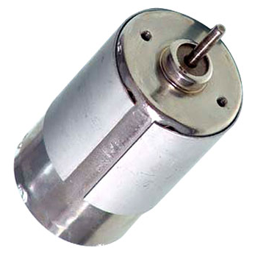

Fig.3.15 Common Motor Layout

The above diagram shows a common motor layout -- with the rotor inside the stator (field) magnets. The geometry of the brushes, commutator contacts, and rotor windings are such that when power is applied, the polarities of the energized winding and the stator magnet(s) are misaligned, and the rotor will rotate until it is almost aligned with the stator's field magnets. As the rotor reaches alignment, the brushes move to the next commutator contacts, and energize the next winding. So since most small [DC](http://encyclobeamia.solarbotics.net/articles/dc.html) motors are of a three-pole design, let's tinker with the workings of one. The use of an iron core armature is quite common, and has a number of advantages. First off, the iron core provides a strong, rigid support for the windings a particularly important consideration for high-[torque](http://encyclobeamia.solarbotics.net/articles/torque.html) motors.

The core also conducts heat away from the rotor windings, allowing the motor to be driven harder than might otherwise be the case. Iron core construction is also relatively inexpensive compared with other construction types. But iron core construction also has several disadvantages. The iron armature has a relatively high inertia which limits motor acceleration. This construction also results in high winding [inductance](http://encyclobeamia.solarbotics.net/articles/inductance.html)s which limit brush and commentator life.

In small motors, an alternative design is often used which features a 'coreless' armature winding. This design depends upon the coil wire itself for structural integrity.

The coreless design also allows manufacturers to build smaller motors; meanwhile, due to the lack of iron in their rotors, coreless motors are somewhat prone to overheating.

**3.7.1 H-BRIDGE**

An H-bridge is an [electronic circuit](http://en.wikipedia.org/wiki/Electronic_circuit) which enables a voltage to be applied across a load in either direction. These circuits are often used in [robotics](http://en.wikipedia.org/wiki/Robotics) and other applications to allow DC motors to run forwards and backwards.

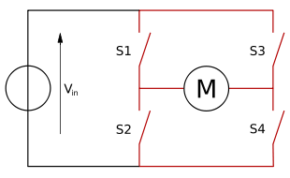

Fig.3.16 Circuit Diagram for H-Bridge

H-bridges are available as [integrated circuits](http://en.wikipedia.org/wiki/Integrated_circuits), or can be built from [discrete components](http://en.wikipedia.org/wiki/Discrete_components)

**3.7.2 DESCRIPTION**

The term "H-bridge" is derived from the typical graphical representation of such a circuit. An H-bridge is built with four switches (solid-state or mechanical). When the switches S1 and S4 (according to the first figure) are closed (and S2 and S3 are open) a positive voltage will be applied across the motor. By opening S1 and S4 switches and closing S2 and S3 switches, this voltage is reversed, allowing reverse operation of the motor.

Using the nomenclature above, the switches S1 and S2 should never be closed at the same time, as this would cause a short circuit on the input voltage source. The same applies to the switches S3 and S4. This condition is known as shoot-through.

**3.7.3 OPERATION**

The H-Bridge arrangement is generally used to reverse the polarity of the motor, but can also be used to 'brake' the motor, where the motor comes to a sudden stop, as the motor's terminals are shorted, or to let the motor 'free run' to a stop, as the motor is effectively disconnected from the circuit. The following table summarizes operation.

Table 3.2 H-bridge arrangement

|  |  |  |  |  |
| --- | --- | --- | --- | --- |
| **S1** | **S2** | **S3** | **S4** | **Result** |
| 1 | 0 | 0 | 1 | Motor moves right |
| 0 | 1 | 1 | 0 | Motor moves left |
| 0 | 0 | 0 | 0 | Motor free runs |
| 0 | 1 | 0 | 1 | Motor brakes |
| 1 | 0 | 1 | 0 | Motor brakes |

**3.7.4 H-BRIDGE MOTOR CONTROL**

Pulse width modulation is a great way of not only controlling the speed of the motor but also the power delivered to a load and the 555 astable timer circuit allows us to do just that. However, one small problem arises from the previous circuit. What if we wanted not only be able to control the speed of the motor but to be able to run the motor in either direction. In other words in both a forward and a reverse direction, then we will need more circuitry than just a single transistor or MOSFET. To control the direction of a DC motor, the polarity of the DC power applied to the motor’s connections must be reversed allowing its shaft to rotate in the opposite direction.

**3.7.5 SWITCH MOTOR CONTROL**

The first circuit uses a single double-pole, double-throw (DPDT) switch to control the polarity of the motors connections. By changing over the contacts the supply to the motors terminals is reversed and the motor reverses direction.

The second circuit is slightly more complicated and uses four single-pole, single-throw (SPST) switches arranged in an “H” configuration. The switches are arranged in pairs and must be operated in a specific combination to operate or stop the motor.

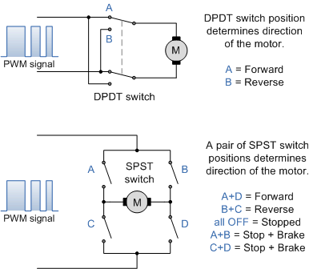

Fig.3.15 Circuit Diagram for Switch Motor Control

For example, switch combination A + D controls the forward rotation while switches B + C control the reverse rotation as shown. Switch combinations A + B or C + D shorts out the motor terminals causing it to brake quickly. However, using switches in this manner has its dangers as operating switches A + C or B + D together would short out the power supply. While the two circuits above would work very well, do we really want to operate different combinations of mechanical switches just to reverse the direction of the motor, NO!. We could change the manual switches for relays and have a single forward/reverse button or switch or even use a CMOS 4066B quad bilateral switch.

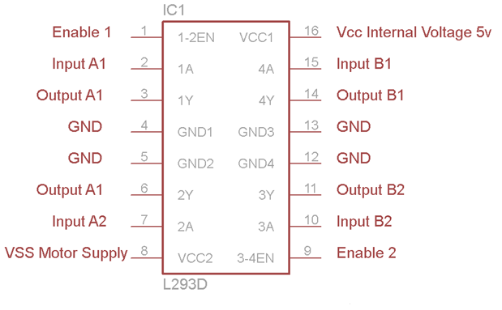

Fig.3.16 Circuit diagram for H bridge motor control

**3.7.6 CIRCUIT EXPLAINATION FOR H-BRIDGE IC**

The four transistors are connected together in a “H-bridge” configuration with the motor connected in the middle. To make the motor rotate in the forward direction, a high (logic “1″ or +5V) signal is applied to the forward input, while no signal is applied to the reverse input (applying a voltage to both inputs at the same time is not allowed). The speed of the motor is controlled by using the pulse width modulating signal as before. Transistors TR1 and TR4 conduct. Current flows from terminal A through to terminal B (left-to-right direction) of the motor. To reverse the motor’s direction a high signal is applied to the reverse input and transistors TR3 and TR2 conduct, allowing current to pass through the motor in the opposite direction from terminal B through to terminal A (right-to-left direction).

The flywheel diodes, D1 to D4 across the transistors of the H-bridge motor control circuit help to protect the transistors from any induced back emf generated by the motor during braking.

Any suitable PNP or NPN transistor can be used other than the ones above, but all the transistors should have high power ratings, if not use heatsinks. While it is possible to construct the H-bridge motor control circuit from scratch using individual components, there are lots of IC’s and “black boxes” available off-the-shelf to make motor speed control and design far easier and usually cheaper. Two H-bridge motor control IC’s that are popular and easy to connect are the National Semiconductors LMD18200 and the Texas Instruments L293D motor-driver chips. Both are easy to use with in-built diodes, shorted circuit protection and are TTL and CMOS compatible.

**3.7.7 CONSTRUCTION**

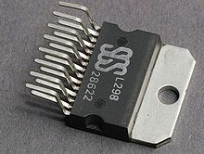

Fig.3.17 H-Bridge

A solid-state H-bridge is typically constructed using reverse polarity devices. The most efficient MOSFET designs use N-channel MOSFETs on both the high side and low side because they typically have a third of the ON resistance of P-channel MOSFETs. This requires a more complex design since the gates of the high side MOSFETs must be driven positive with respect to the DC supply rail.

However, many integrated circuit MOSFET drivers include a [charge pump](http://en.wikipedia.org/wiki/Charge_pump) within the device to achieve this. Alternatively, a switch-mode DC-DC converter can be used to provide isolated ('floating') supplies to the gate drive circuitry.

This eliminates the shoot-through failure mode, and is commonly used to drive variable/switched reluctance machines and actuators where   
bi-directional current flow is not required. A "double pole double throw" [relay](http://en.wikipedia.org/wiki/Relay) can generally achieve the same electrical functionality as an H-bridge.

**3.7.8 CIRCUIT DIAGRAM**

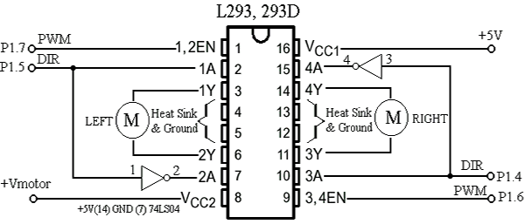

Fig.3.18 Circuit Diagram of H-Bridge

wAn H-bridge would be preferable to the relay where a smaller physical size, high speed switching, or low driving voltage is needed, or where the wearing out of mechanical parts is undesirable.

**3.8 RELAY**

A relay is an electrically controllable switch widely used in industrial controls, Automobiles and appliances.

The relay allows the isolation of two separate sections of a system with two different voltage sources.

**3.8.1 OPERATION**

When current flows through the coil, a magnetic field are created around the coil i.e., the coil is energized. This causes the armature to be attracted to the coil. The Armature’s contact acts like a switch and closes or opens the circuit. When the coil is not energized, a spring pulls the armature to its normal state of open or closed. There are all types of relays for all kinds of applications.

* The contacts can be normally open (NO) or normally closed (NC). In the NC type, the Contacts are closed when the coil is not energized. In the NO type, the contacts are closed when the coil is energized.
* There can be one or more contacts. i.e., different types like SPST (single
* pole single Throw), SPDT (single pole double throw) and DPDT (double pole double throw) relay.
* The voltage and current required to energize the coil. The voltage can vary from a revolts to 50 volts, while the current can be from a
* The minimum DC/AC voltage and current that can be handled by the contacts. This is in the range of a few volts to hundreds of volts, while the current can be from a few amps to 40A or more, depending on the relay.

**3.8.2 RELAY INTERFACING WITH THE MICROCONTROLLER**

An SPDT relay consists of five pins, two for the magnetic coil, and one as the common Terminal and the last pins as normally connected pin and normally closed pin. When the current flows through this coil, the coil gets energized. Initially when the coil is not energized, there will be a connection between the common terminal and normally closed pin.

When the coil is energized, this connection breaks and a new connection between the common terminal and normally open pin will be established.

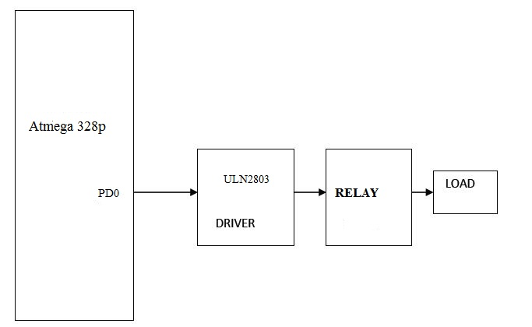

Fig.3.19 Relay interfacing with microcontroller

Thus when the relay is on, it can drive the loads connected between the common terminals and normally open pin. Therefore, the relay takes 5V from the microcontroller and drives the loads which consume high currents. Thus the relay acts as an isolation device

**3.8.3 ULN2803**

The ULN2803A each contain eight Darlington transistors with common emitters and integral Suppression diodes for inductive loads. Each Darlington features a peak load current rating of 600mA (500mA continuous) and can withstand at least50V in the off state. Outputs may be paralleled for higher current capability.

Five versions are available to simplify interfacing to standard logic families: the ULN2803Ais designed for general purpose application with a current limit resistor; theULN2802Ahas a 10.5kW input resistor and zener for 14-25VPMOS; theULN2803Ahas a 2.7kW input resistor for 5V TTL and CMOS; the ULN2804A has a 10.5Kw input resistor for 6-15V CMOS and the ULN2805A is designed to sink a minimum of 350mA for standard and Schottky TTL where higher output current is required. All types are supplied in an 18-lead plastic DIP with a copper lead.

**3.8.4FEATURES**

**•**Output current (single output)

500 mA (max)

**•**High sustaining voltage output

50 V (min)

**•**Output clamp diodes

**•**Inputs compatible with various types of logic.

**•**Package Type−APG: DIP−18pin

**•**Package Type−AFWG: SOP−18pin

**3.8.5 PIN DIAGRAM OF UML2305**

Buffer driver UML2305 pin configuration is shown below,

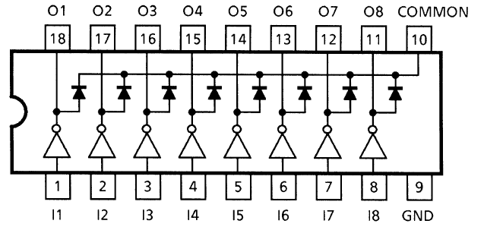

**Fig.3.20 Pin diagram of UML 2305**

Thus when the relay is on, it can drive the loads connected between the common terminals and normally open pin. Therefore, the relay takes 5V from the microcontroller and drives the loads which consume high currents. Thus the relay acts as an isolation device

**CHAPTER 4**

**SOFTWARE DESCRIPTION**

**4.1 SOFTWARE DESCRIPTION**

The software used for the proposed system is detailed below,

* + MIT APP INVERTER
  + ARDUINO IDE
  + AVR OSP II

**4.1.1 MIT APP INVERTER**

App Inventor for Android is an open-source web application originally provided by Google, and now maintained by the Massachusetts Institute of Technology (MIT).App Inventor and the projects on which it is based are informed by constructionist learning theories, which emphasizes that programming can be a vehicle for engaging powerful ideas through active learning.

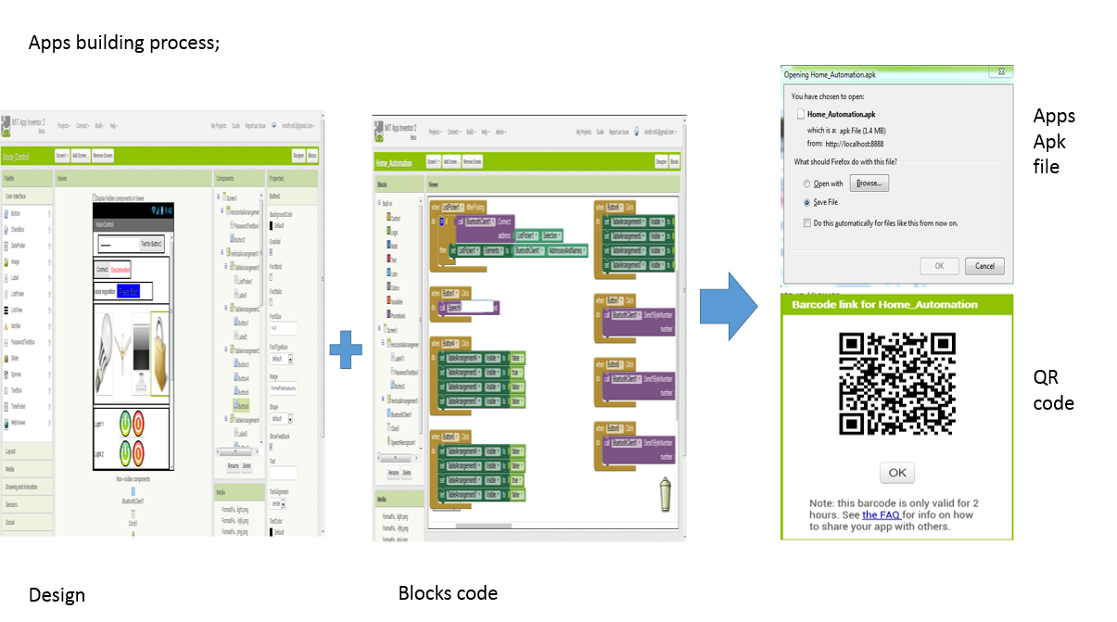

Fig.4.1 Design of app

**4.2ARDUINO IDE:**

Arduino is an open-source electronics prototyping platform based on flexible, easy-to-use hardware and software. It's intended for artists, designers, hobbyists, and anyone interested in creating interactive objects or environments. Arduino can sense the environment by receiving input from a variety of sensors and can affect its surroundings by controlling lights, motors, and other actuators.

**4.2.1 INTRODUCTION**

The micro controller on the board is programmed using the Arduino programming language (based on Wiring) and the Arduino development environment (based on Processing). Arduino projects can be stand-alone or they can communicate with software running on a computer (e.g. Flash, Processing, MaxMSP).

**4.2.2 DEVELOPMENT BOARD:**

Arduino is a popular open-source single-board micro controller, descendant of the open source Wiring platform, designed to make the process of using electronics in multidisciplinary projects more accessible. The hardware consists of a simple open hardware design for the Arduino board with an Atmel AVR processor and on-board input/output support. The software consists of a standard programming language compiler and the boot loader that runs on the board.

**4.3 AVR OSP II**

The Atmel AVR Open Source Programmer (AVROSP) is an AVR programmer application equivalent to the AVR Prog tool included in the AVR Studio. It is a command-line tool, using the same syntax as the other command-line tools in the AVR Studio.

The open source code and its modular design make it easy to port the application to other platforms and to add support for other programmer types and communication channels. AVR109 and AVR910 application notes, through the standard PC serial port.

**4.3.1IMPLEMENTATION**

This section assumes that the reader has some knowledge of object-oriented programming concepts, and the C++ programming language in particular. The source code is free in all ways, meaning that users can modify and enhance the application and redistribute it as they wish.

**4.3.2AVROSP CLASS DIAGRAM**

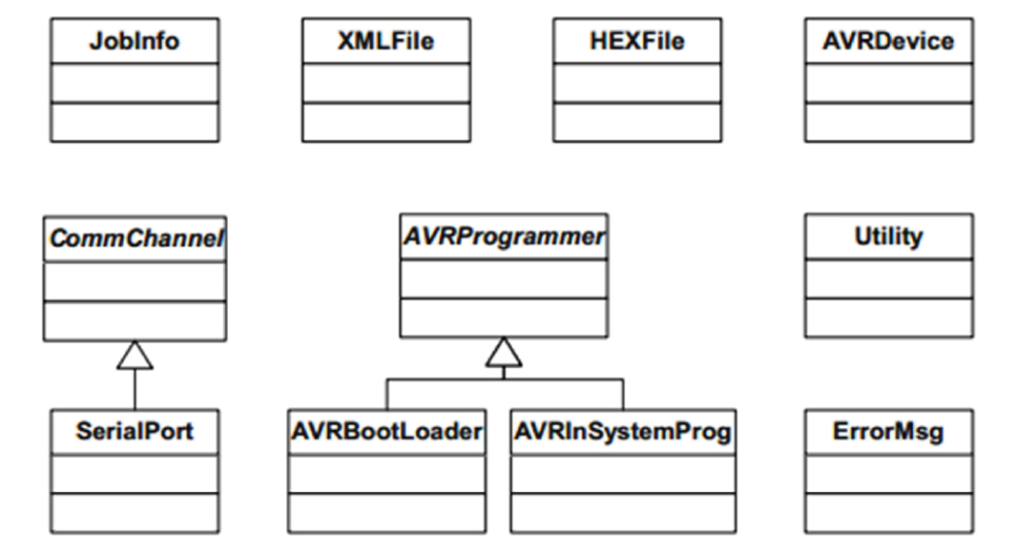 Fig.4.2 avrosp class diagram

Most of the top-level work is encapsulated in the Job Info class. It uses objects of class XML File, HEX File and AVR Device to read and write XML and HEX files and to extract device information from the Part Description Files. The part of Job Info that communicates with the programmer does not need to know what kind of communication channel to use.

It decodes the command line and creates an instance of the required derived class, e.g. the Serial Port class. Currently, only a class for the PC COM port is implemented, but to use e.g. USB or TCP/IP communication, you could derive a specialized class from the Channel base class, and add a check for this channel type in the command line parser. The rest of the code operates through the generalized AVR Programmer interface. Currently, only classes for the Boot loader described in the Atmel AVR910 application note and the In-System Programmer described in the AVR910 application note are implemented.

This design makes the application very flexible. Future extension with other communication channels and programmer types is an easy task.

**4.3.3 FEATURES**

* Open source C++ code
* Modular design
* Reads device information from the Atmel AVR Studio XML files
* Supports the Boot loader in the Atmel AVR 109
* Supports the In-System Programmer in the Atmel AVR910
* Command-line equivalent to AVR Studio command-line tools
* Expandable to other programmer types
* Expandable to other communication channels, e.g. USB

**4.3.4 ADVANTAGES**

* No need of physical movement
* Highly reliable
* Voice interactive

**4.3.5 APPLICATIONS**

* Hazardous environment
* complex environment
* defense

**CHAPTER 5**

**CONCLUSION**

This is an ongoing project. The prime objective is to assist handicapped/old aged people. This paper gives basic idea of how to control various home appliances and provide a security using Android phone/tab. This project is based on Android and Arduino platform both of which are FOSS (Free Open Source Software).

So the overall implementation cost is very cheap and it is affordable by a common person. Looking at the current scenario we have chosen Android platform so that most of the people can get benefit.

The design consists of Android phone with home automation application, Arduino UNO. User can interact with the android phone and send control signal to the Arduino which in turn will control other embedded devices/sensors. We have discussed a simple prototype in this paper but in future it can be expanded to many other areas.

**APPENDIX 1**

**SOFTWARE IMPLEMENTATION**

**TRANSMITER**

#include <VirtualWire.h>

char *controller;

byte serialA;

void setup() {

Serial.begin(9600);

pinMode(8,OUTPUT);

digitalWrite(8, HIGH);

delay(1000);

digitalWrite(8, LOW);

delay(1000);

digitalWrite(8, HIGH);

delay(500);

digitalWrite(8, LOW);

delay(100);

vw_set_ptt_inverted(true);

vw_set_tx_pin(9);

vw_setup(2000);

Serial.print("start");

}

void loop(){

if (Serial.available() > 0)

{

serialA = Serial.read();

if(serialA==7)

{

Serial.print("ok");

controller="A1" ;

vw_send((uint8_t *)controller, strlen(controller));

vw_wait_tx();

}

else if(serialA==8)

{

controller="B1" ;

vw_send((uint8_t *)controller, strlen(controller));

vw_wait_tx();

}

else if(serialA==9)

{

controller="C1" ;

vw_send((uint8_t *)controller, strlen(controller));

vw_wait_tx();

}

else if(serialA==10)

{

controller="D1" ;

vw_send((uint8_t *)controller, strlen(controller));

vw_wait_tx();

}

else if(serialA==11)

{

controller="E1" ;

vw_send((uint8_t *)controller, strlen(controller));

vw_wait_tx();

}

else if(serialA==12)

{

controller="F1" ;

vw_send((uint8_t *)controller, strlen(controller));

vw_wait_tx();

}

// fan controlling

else if(serialA==13)

{

controller="G1" ;

vw_send((uint8_t *)controller, strlen(controller));

vw_wait_tx();

}

else if(serialA==14)

{

controller="H1" ;

vw_send((uint8_t *)controller, strlen(controller));

vw_wait_tx();

}

else if(serialA==15)

{

controller="I1" ;

vw_send((uint8_t *)controller, strlen(controller));

vw_wait_tx();

}

else if(serialA==16)

{

controller="J1" ;

vw_send((uint8_t *)controller, strlen(controller));

vw_wait_tx();

}

//for tv controlling

else if(serialA==17)

{

controller="K1" ;

vw_send((uint8_t *)controller, strlen(controller));

vw_wait_tx();

}

else if(serialA==18)

{

controller="L1" ;

vw_send((uint8_t *)controller, strlen(controller));

vw_wait_tx();

}

// for gate contrlling

else if(serialA==19)

{

controller="M1" ;

vw_send((uint8_t *)controller, strlen(controller));

vw_wait_tx();

}

else if(serialA==20)

{

controller="N1" ;

vw_send((uint8_t *)controller, strlen(controller));

vw_wait_tx();

}

else if(serialA==21)

{

controller="O1" ;

vw_send((uint8_t *)controller, strlen(controller));

vw_wait_tx();

}

else if(serialA==22)

{

controller="P1" ;

vw_send((uint8_t *)controller, strlen(controller));

vw_wait_tx();

}

else if(serialA==23)

{

controller="Q1" ;

vw_send((uint8_t *)controller, strlen(controller));

vw_wait_tx();

}

}

}

**RECEIVER**

#include <VirtualWire.h>

int live_light=2;

int light2=3;

int light3=4;

int fan1=5;

int fan2=6;

int tv=7;

int maindoor=8;

int gateA=9;

int gateB=10;

void setup()

{

Serial.begin(9600);

Serial.print("start");

vw_set_ptt_inverted(true);

vw_set_rx_pin(11);

vw_setup(2000);

pinMode(live_light,OUTPUT);

pinMode(light2,OUTPUT);

pinMode(light3,OUTPUT);

pinMode(fan1,OUTPUT);

pinMode(fan2,OUTPUT);

pinMode(tv,OUTPUT);

pinMode(gateA,OUTPUT);

pinMode(gateB,OUTPUT);

pinMode(maindoor,OUTPUT);

vw_rx_start();

digitalWrite(gateA,LOW);

digitalWrite(gateB,LOW);

}

void loop()

{

uint8_t buf[VW_MAX_MESSAGE_LEN];

uint8_t buflen = VW_MAX_MESSAGE_LEN;

if (vw_get_message(buf, &buflen)) // Non-blocking

{

if((buf[0]=='A')&&(buf[1]=='1'))

{

Serial.print("ok");

digitalWrite(live_light,HIGH);

Serial.println("light 1 on");

}

else if((buf[0]=='B')&&(buf[1]=='1'))

{

digitalWrite(live_light,LOW);

Serial.println("light 1 off");

}

else if((buf[0]=='C')&&(buf[1]=='1'))

{

digitalWrite(light2,HIGH);

Serial.println("light 2 on");

}

else if((buf[0]=='D')&&(buf[1]=='1'))

{

digitalWrite(light2,LOW);

Serial.println("light 2 off");

}

else if((buf[0]=='E')&&(buf[1]=='1'))

{

digitalWrite(light3,HIGH);

Serial.println("light 3 on");

}

else if((buf[0]=='F')&&(buf[1]=='1'))

{

digitalWrite(light3,LOW);

Serial.println("light 3 off");

}

else if((buf[0]=='G')&&(buf[1]=='1'))

{

digitalWrite(fan1,HIGH);

Serial.println("fan 1 on");

}

else if((buf[0]=='H')&&(buf[1]=='1'))

{

digitalWrite(fan1,LOW);

Serial.println("fan 1 off");

}

else if((buf[0]=='I')&&(buf[1]=='1'))

{

digitalWrite(fan2,HIGH);

Serial.println("fan 2 on");

}

else if((buf[0]=='J')&&(buf[1]=='1'))

{

digitalWrite(fan2,LOW);

Serial.println("fan 2 off");

}

else if((buf[0]=='K')&&(buf[1]=='1'))

{

digitalWrite(tv,HIGH);

Serial.println("tv on");

}

else if((buf[0]=='L')&&(buf[1]=='1'))

{

digitalWrite(tv,LOW);

Serial.println("tv off");

}

else if((buf[0]=='M')&&(buf[1]=='1'))

{

digitalWrite(gateA,HIGH);

digitalWrite(gateB,LOW);

Serial.println("gate open");

delay(5000);

digitalWrite(gateA,LOW);

digitalWrite(gateB,LOW);

delay(100);

}

else if((buf[0]=='N')&&(buf[1]=='1'))

{

digitalWrite(gateA,LOW);

digitalWrite(gateB,HIGH);

Serial.println("gate close");

delay(5000);

digitalWrite(gateA,LOW);

digitalWrite(gateB,LOW);

delay(100);

}

else if((buf[0]=='O')&&(buf[1]=='1'))

{

digitalWrite(maindoor,HIGH);

Serial.println("LOCK");

}

else if((buf[0]=='P')&&(buf[1]=='1'))

{

digitalWrite(maindoor,LOW);

Serial.println("UNLOCK");

}

}

}

**REFERENCES**

1. N. Sriskanthan and Tan Karand. “Bluetooth Based Home Automation System”. Journal of Microprocessors and Microsystems,
2. Muhammad Izhar Ramli, Mohd Helmy Abd Wahab, Nabihah, “TOWARDS SMART HOME: CONTROL ELECTRICAL DEVICES ONLINE” ,Nornabihah Ahmad International Conference on Science and Technology: Application in Industry and Education (2012)
3. Al-Ali, Member, IEEE & M. AL-Rousan,“Java-Based Home Automation System R.” IEEE Transactions on Consumer Electronics
4. Rana, Jitendra Rajendra and Pawar, Sunil N., Zigbee Based Home Automation (April 10, 2010).

**WEBSITES**

http://developer.android.com/about/index.html

http://research.microsoft.com/en-us/projects/homeos/

http://source.android.com/tech/accessories/index.html .

http://developer.android.com/guide/topics/connectivity/usb/accessory.htm l#manifest

http://source.android.com/tech/accessories/aoap/aoa.html

http://source.android.com/tech/accessories/aoap/aoa2.html