Caching Technique in Spring Boot Application

The first request will be handled by the request handler method. That point no data is present with Ehcache , subsequent requests, the data will be retrieved from the cache itself.

will first check the cache *addresses* before actually invoking the method and then caching the result.

@CachePut(value="userCache")

The @CachePut annotation places the result of method into the cache. In your case there is no result so nothing is put to the cache.

So change the Method return Type into User.

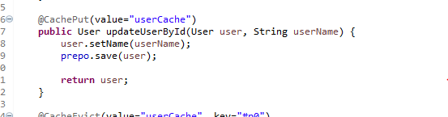

@CacheEvict(value="userCache", key="#p0")

@CacheEvict evict values based on a particular key.

For this, all we have to do is to pass the cache key as an argument to the annotation.

