* Spandana’s endeavour to become a one-stop shop for financial requirements of its borrowers led to the launch and expansion of three new products
* Loans against Property (AP, Telangana and TN),
* Housing Loans (AP, Telangana and TN) and
* Business Loans (across India).
* These products have scaled to an outstanding Rs. 484.5 million within a short span and we expect it to grow further due to the huge potential available in these markets.
* Today, we have 28 lender partners compared to 3 partners a couple of years ago.

Mission
We want to be one of the most significant microfinance service provider by offering a range of financial and non financial products and services to low income households and individuals to improve the quality of life. We constantly endeavour to deliver quality services to our clients and remunerative returns to our Investors by maintaining highest levels of transparency and integrity. We strive to be the most preferred Employer in the Industry.

Background
* The micro-credit programme of Spandana started in 1997 when Spandana operated as a Society (Spandana Urban and Rural development Organisation – SRUDO).
* Later, our founder Mrs Padmaja Reddy promoted a company licensed as an NBFC – first named as Spandana Sphoorty Innovative Financial Services Limited (SSIFL) and the microfinance program of Spandana was then conducted under SSIFSL.
* Later the name of SSIFL was abridged to Spandana Sphoorty Financial Limited.
* Besides micro-credit, it has offered various other loan products in its journey as an MFI. This includes the Agri-Family Loans, Farm Equipment loans, Small Mortgages, loans against Gold jewellery etc.
* Spandana has been successfully operating across 925 branches across 17 states catering to the needs of 2.5 million customers.

Operational Growth
* Expanded our operations to 2 new states and 42 new districts in FY19 marking our presence in a total of 17 states and 264 districts.
* There has been a 33% increase in the number of branches as compared to the previous year
* Added a total of 0.9 Million customers in FY19, an increase of 55% in the customer base compared to previous year.
* In terms of value, disbursement increased by 29% on a year-on-year basis.
* Spandana has a total of 6,656 employees.
* During the year, the employee base increased by 65%, which led to an increase in the staff per branch ratio from 5.8 in 2018 to 7.2 in 2019. Despite this, we have the least number of employees per branch among major MFIs indicating high levels of automation and efficiency.

Credit Rating
* Rating agency ICRA upgraded our long products. term credit rating from [ICRA] BBB+ (Stable) to [ICRA] A- (Stable) on March 29 2019.

Portfolio Mix
* Average ticket size has increased by 15% to Rs.26,279 during FY19 from Rs. 22,826 during FY18
* Rolling on the path of growth, we had 51% of our customers having first cycle loan portraying our ease of access to the under-served customers. Also, more than 34% of our customers are in 3rd cycle and above, showing our continual bond with customers year after year and a seasoned portfolio.
* Currently our exposure is divided as 95% Rural and 5% Urban.
* Also we have observed that rural customers are more disciplined about managing their finances and using their money judiciously.

Developments
* In order to leverage our branch network, we strengthened our feet on the street – loan officer base.
* As this sales force starts to operate at an optimum level, the efficiency will further improve.
* Also, due to lack of funds during CDR and disciplined approach post CDR exit, the AUM per customer is lower compared to the industry. As we improve this metric, opex ratio will further come down.
* We shifted to cashless disbursements in December 2018 and by March 2019, we were able to disburse 99% of the total loans cashless.
* An android application, FinS, has been developed in-house to onboard and to update collections from customers. It has been developed in such a way that it can be used on any smart phone.
* Loan officers can access the app on their mobile and credit bureau check can be done instantly in two minutes. This has significantly reduced TAT for loan disbursement. We are piloting this in the states of Kerala and Rajasthan.

PRODUCTS

Abhilasha (JLG Loans)
* The primary objective of this loan is to empower women in setting up and expanding income generating activities, smoothen household cash flows and acquire productive assets. A hassle free Weekly/Bi-Weekly/Monthly repayment option ensures that clients can save from their daily cash-flows and do not face repayment stress.
* The loan size is up to 65,000 with tenure of 1 to 3 Years.
* The interest rate of this product is 24% with 1% upfront processing fee exclusive of GST.

Loan Against Property (LAP)
* Offered in the states of Andhra Pradesh, Telangana, Karnataka and Tamilnadu , this one of its kind loan with an easy monthly repayment mode is crafted to support non BPL(Below Poverty Line) customers. The idea behind this product is to support them during their business expansion or, working capital requirements or to acquire assets. Loan size is up to 50,00,000 with tenure of 1 to 10 years.
* The interest rate of this product is 22% to 24% with 2% upfront processing fee exclusive of GST.

Personal Loans
* These Loans are given exclusively to
Business Development- meeting with the working capital requirements, increasing the scale of business.
Purchase of livestock- practicing animal husbandry, dairy business, etc.
Purchase of stock/raw materials for business activity.
Completion of under construction house/ renovation.
Margin money towards purchase of any asset (provided applicant has balance money available with him).
Repayment of expensive loans.
* The loan amount is up to 1,50,000 with tenure of 1 to 3 years.
* The interest rate of this product is 24% with 2% upfront processing fee exclusive of GST.

Gold Loans (Keertana)
* Gold Loans are given against the mortgage of Jewellery. Indian housewives hold 11% of the world's gold. That is more than the reserves of the USA, the IMF, Switzerland, and Germany put together.
* Our loan size is up to 50,00,000 with tenure up to 1 year.The repayment frequency is flexible/Monthly. The interest rate on this product varies between 16% to 24%.
* Loans are given for Agriculture, Business and short term liquidity needs. This loan is currently offered in the states of Andhra Pradesh and Telangana.

Interim Loans
* These are top up loans given to existing borrowers to meet their working capital needs, business expansion, children’s school fees, health care or any other emergency needs.
* This loan is offered to an individual on a group guarantee. The loan amount is up to 18,000 with loan tenure of 1 to 3 years. The repayment frequency is Weekly/Bi-Weekly/Monthly. Our Interim Loan scheme is of great help to the borrower during tough times.
* The interest rate of this product is 24% with 1% upfront processing fee exclusive of GST.
Portfolio Diversification
* We have been very conscious of the risks associated with geographical concentration of portfolio.
* We have been making efforts to diversify our exposures at every level possible while leveraging on the knowledge gained in each territory wherever we have entered.
STATE LEVEL:
* Considering the saturated nature of microfinance market in TN, Spandana offers only loans against property and business loans in the state.
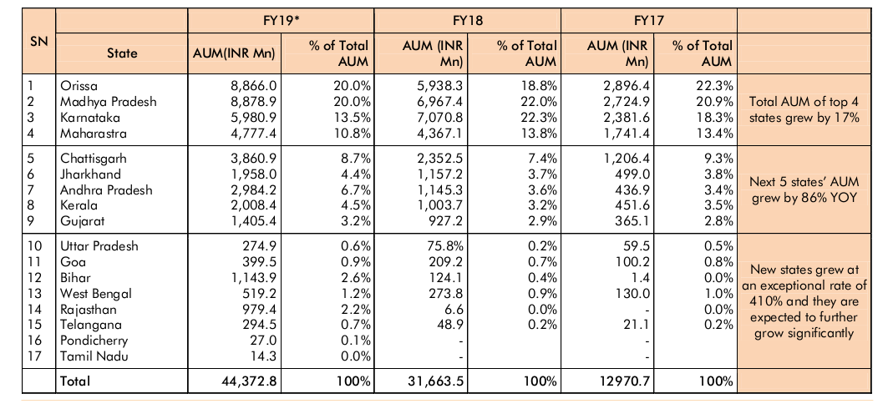
DISTRICT LEVEL:
* None of the Districts comprised of more than 2% of the total AUM.
* 94% of our districts contribute to less than 1% of the total AUM showing lesser concentration risk.
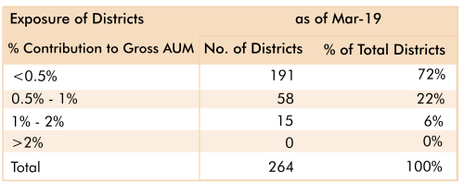

BRANCH LEVEL:
* Exposure risk cap applies with no branch to exceed 0.40% of the total AUM
* The branch network grew by 231 from 694 branches in March 2018 to 925 in March 2019.
* The branch expansion was supported by addition of 1,928 loan officers.

