Git - Cherry-pick

**Overview:**

Cherry picking in git means to choose a commit from one branch and apply it onto another.

|  |
| --- |
| *Note that it is different from merge and rebase which normally applies many commits onto a another branch.* |

**Before Cherry-pick -Target branch**

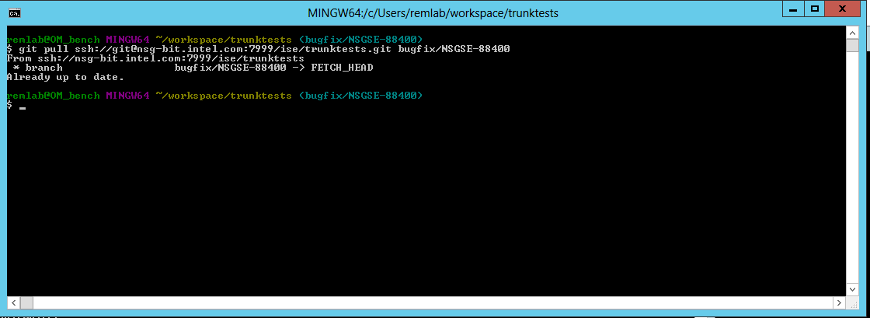

**Target branch- git log**

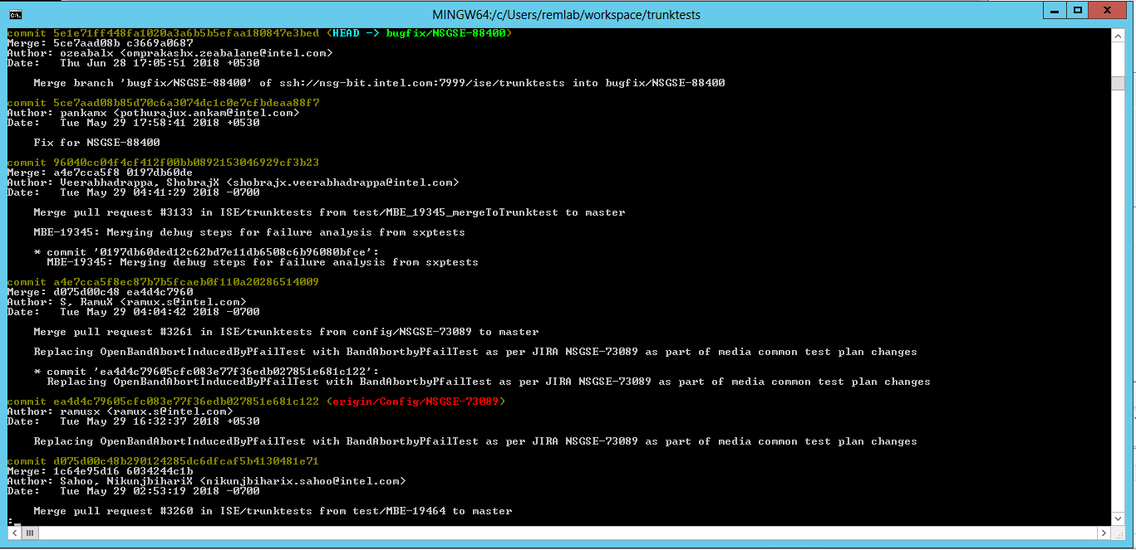

**Master branch –git log**

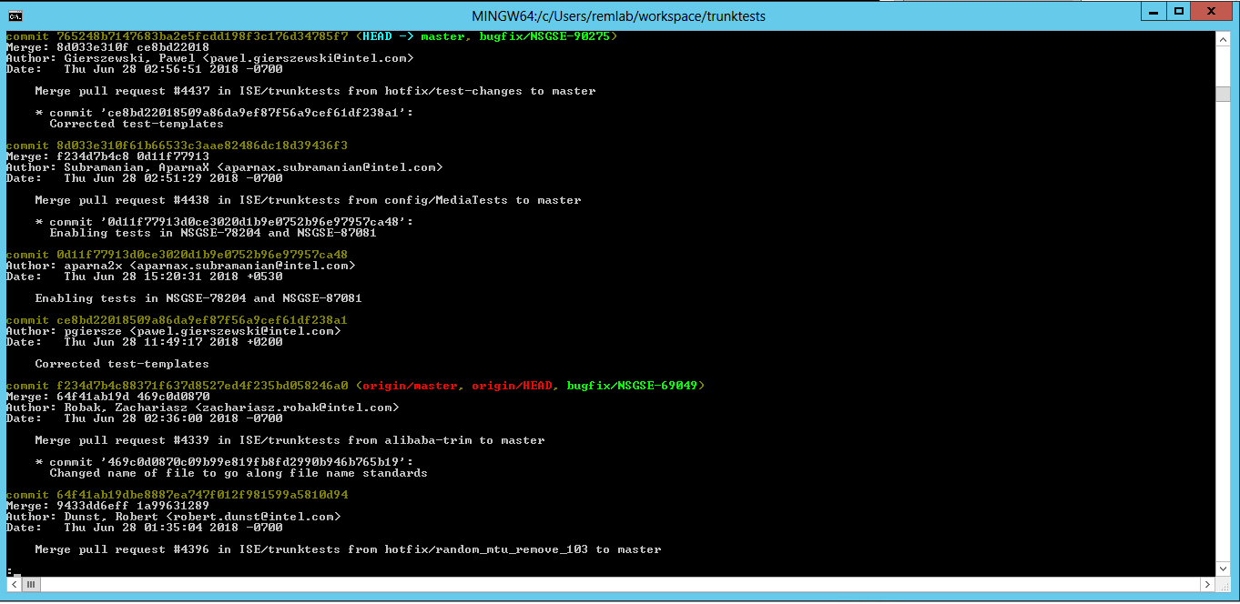

**Eclipse Log history**

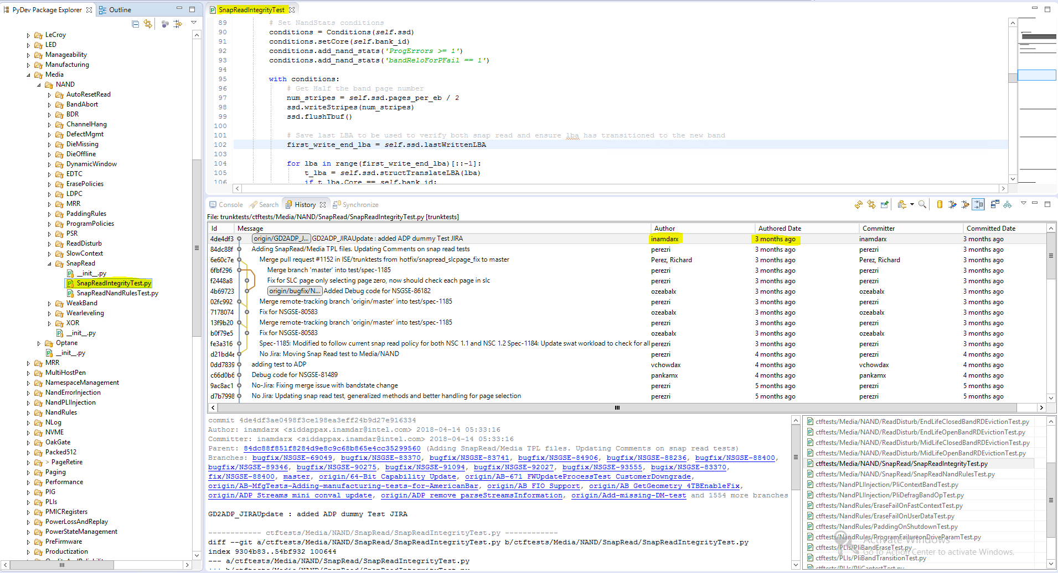

**Meld Tool (Resolving conflicts)**

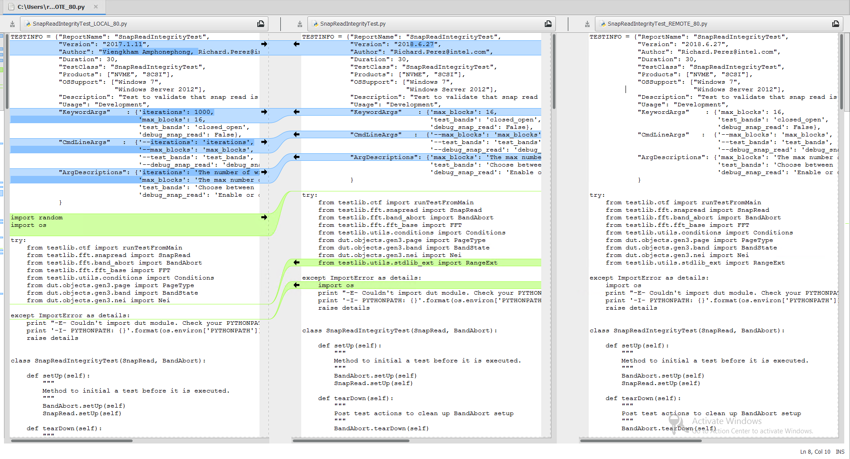

**Git add and commit the changes.**

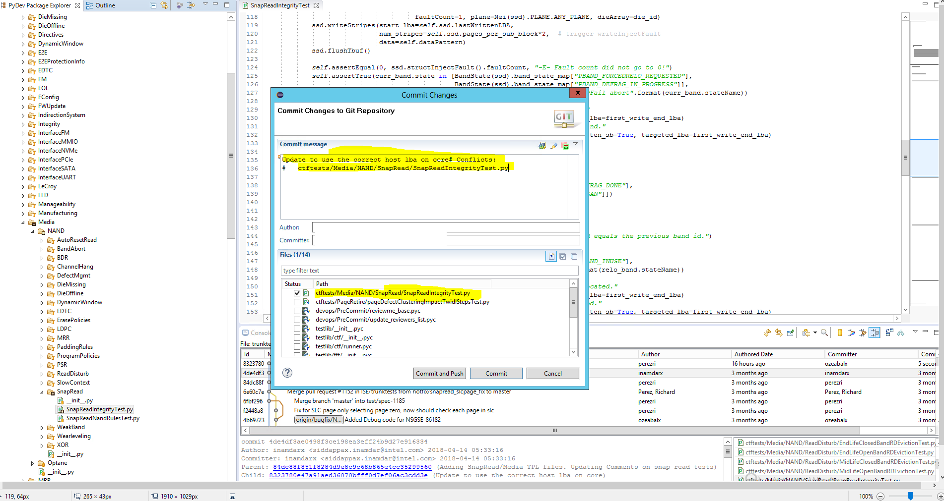

**Push the changes to target branch**

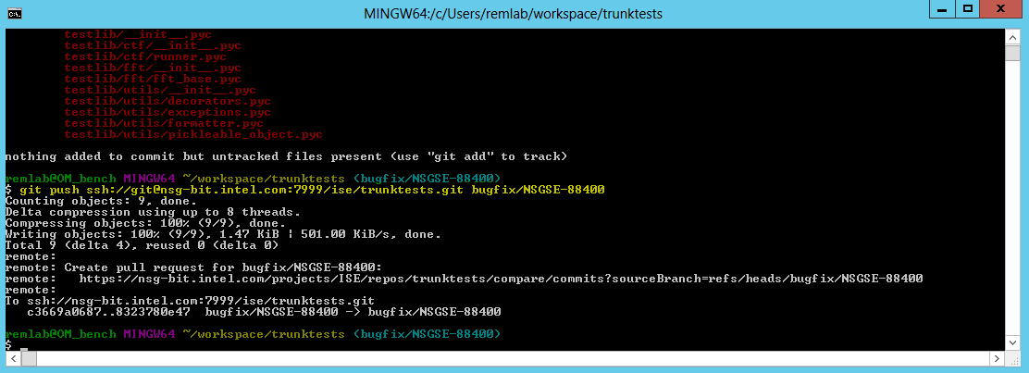

**Target branch – git log**

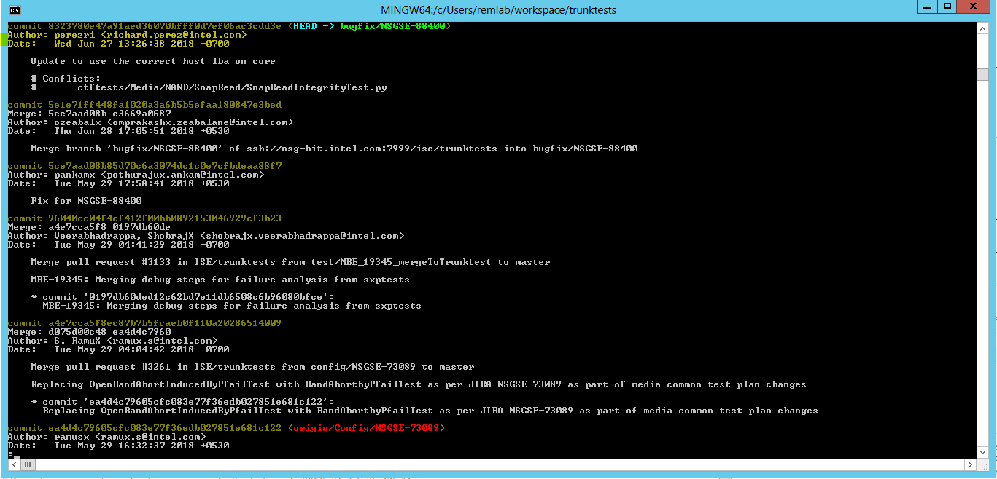

**BitBucket**

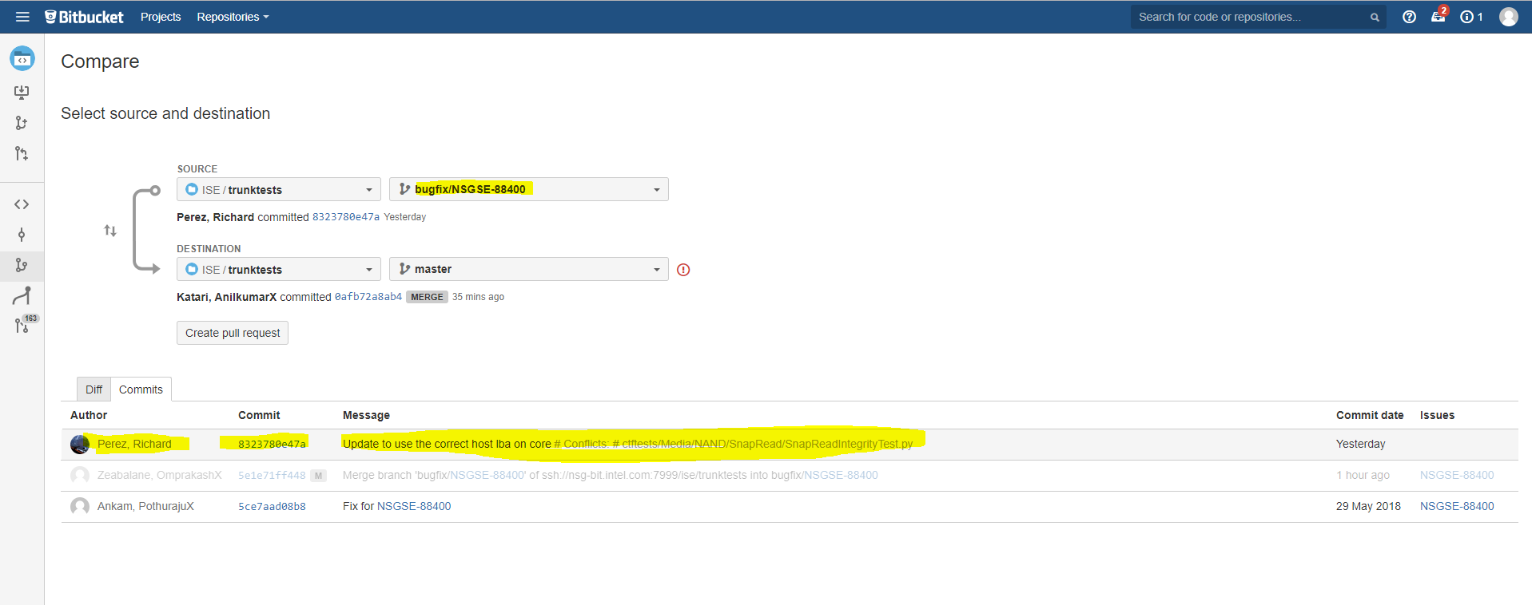

Reference URL :

<https://git-scm.com/docs/git-cherry-pick>

<http://www.w3lc.com/2017/03/fatal-bad-object-error-in-git-cherry.html>

<https://mike42.me/blog/2015-09-fix-merge-conflicts-in-git-with-meld>