**Jenkins**

**Definition**

Jenkins is an open-source continuous integration software tool written in the Java programming language for testing and reporting on isolated changes in a larger code base in real time. The software enables developers to find and solve defects in a code base rapidly and to automatetesting of their builds.

**Installation of Jenkins on CentOS**

**Pre-Request:**

**Step1:** Install the latest stable packages using command **“sudo yum install epel-release -y”**

**Step2:** Update the system using the command “**yum update -y**”

Before installation of Jenkins, you need to setup a Java virtual machine on your system.

|  |
| --- |
| * Check whether java installed on your machine using command “**java -version**” * If java not installed on your machine, install java using command “**sudo yum install java-1.8.0-openjdk.x86_64**” |

There are two ways to install Jenkins through repository or via war file

**Install from the repo:**

**Step1:** sudo wget -O /etc/yum.repos.d/jenkins.repo <http://pkg.jenkins-ci.org/redhat-stable/jenkins.repo>

**Step2:** sudo rpm --import http://pkg.jenkins-ci.org/redhat-stable/jenkins-ci.org.key

**Step3:**  sudo yum install jenkins

**Step4:** sudo systemctl start jenkins.service

**Step5:** sudo systemctl enable jenkins.service

**Step6:** In order to allow visitors access to Jenkins, you need to allow inbound traffic on port 8080

sudo firewall-cmd --zone=public --permanent --add-port=8080/tcp

sudo firewall-cmd –reload

Finally reboot the machine and open Jenkins from your web browser using URL http://<your ipaddress>:8080

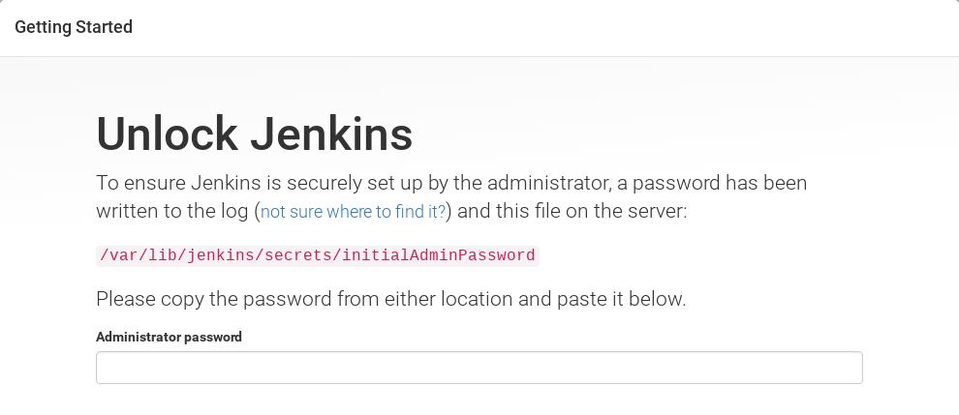

To unlock jenkins copy the password from **/var/lib/jenkins/secrets/initialAdminPassword**, paste it on Administrator password and click on continue.

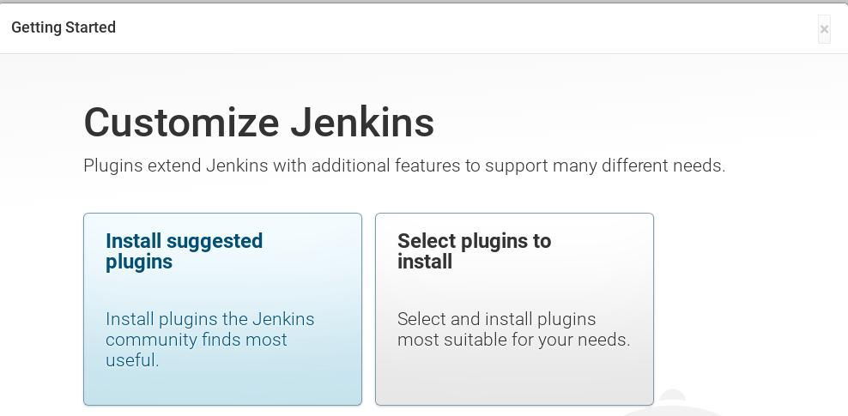

Select the option “**Install suggested plugins”** . As we can see required plugin installation is in progress for Jenkins. Once it is done with plugin installation. It will ask to create Admin User.

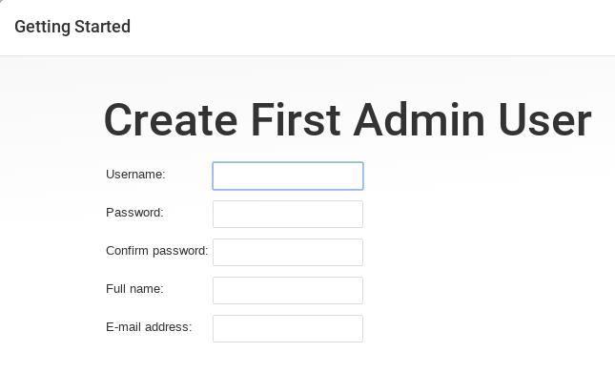

Once the details are filled, Click on “**Save and Finish**”

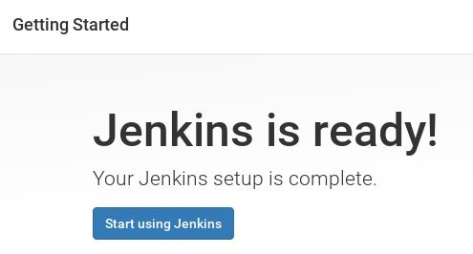

Click on “**Start using Jenkins**”

**Configuration**  
 Now Configure GitHub project using git plugin in Jenkins. Let’s first install git package on your machine on which you have installed Jenkins because Jenkins use git command to pull the GitHub project code.

**yum install git**

Login to GitHub and get the web url for the project.

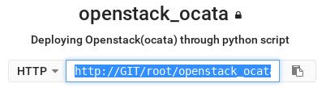

Login to Jenkins and click on New Item.

Specify the name for the project and choose Freestyle project.

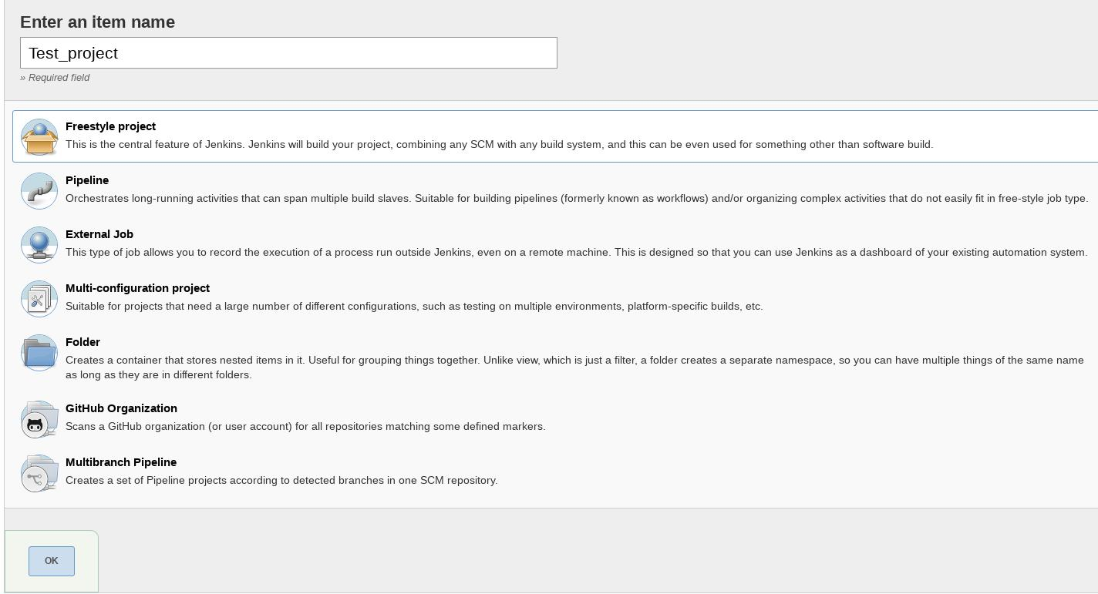

click on OK.

Specify the Project Description and Select Git option in Source Code Management Tab and specify the Web URL of GitHub Project and its credentials. In the Build Tab select the option that suits your setup and then finally click on Apply.

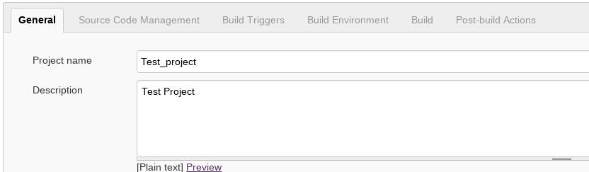

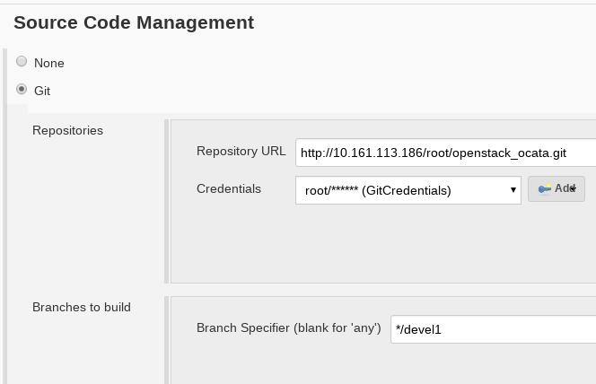

In the Next step click on the “**Build Now**” option from Jenkins Dashboard to pull the GitHub Project Code.

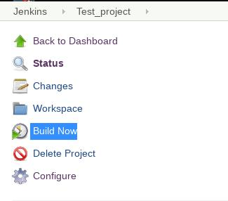

Click on the Workspace Option to view Code or files of GitHub Project. Whenever a new code is pushed on the GitHub project it will be automatically push to Jenkins workspace with new versions.

